# Birla Institute of Technology and Science, Pilani (BITS Pilani)

**DevOps Assignment**

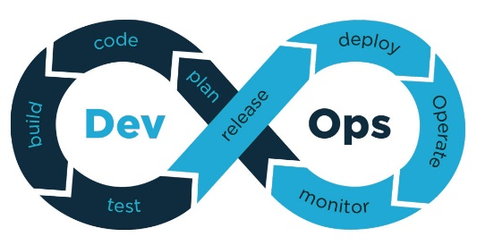

**Project Report**

**Presented By:**

**Team Members**

Palash Das – 2020HS70002

Deepika Sharma – 2020HS70016

Renu Rachael Johnson – 2020HS70049

Naima Ismail – 2020HS70034

Anil Krishnan – 2020HS70023

**Title of the Project:**

**Co-SAP Vaccine Management**

**CoSAP (Vaccine Management System for SAP Labs) -** Web Application Implementation with Microservices.

**Application UI:**

**Login Page**

**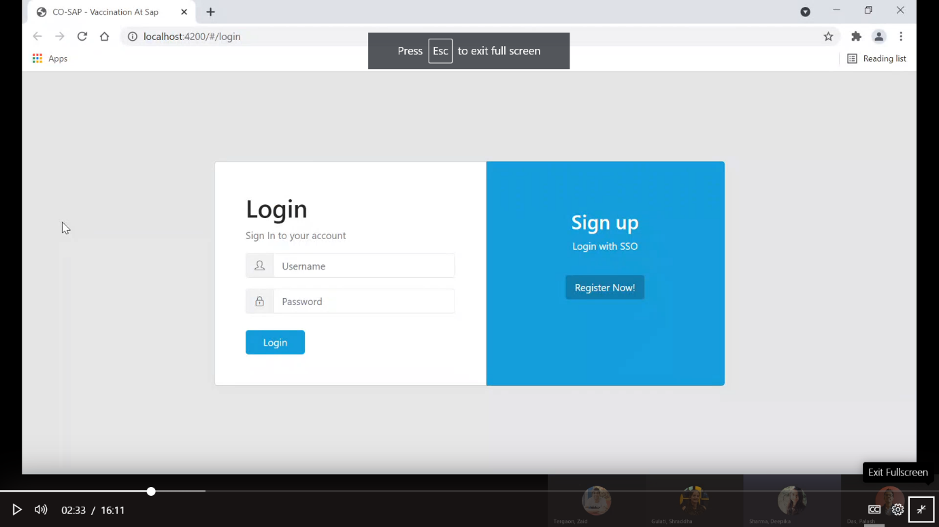**

**Registration Page:**

**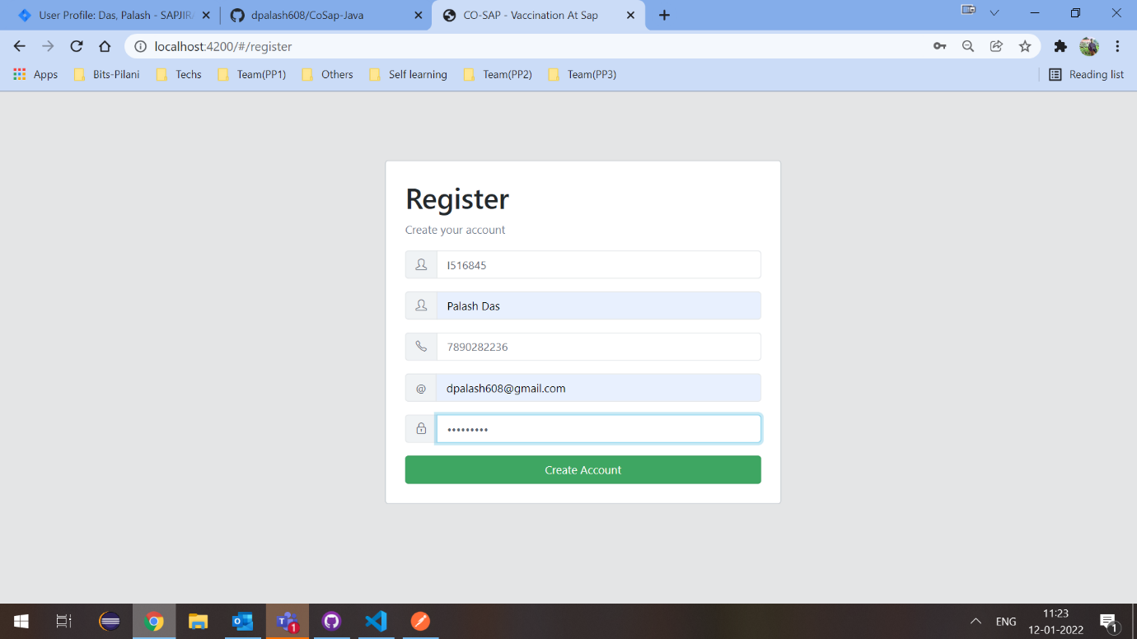**

**Dashboard:**

**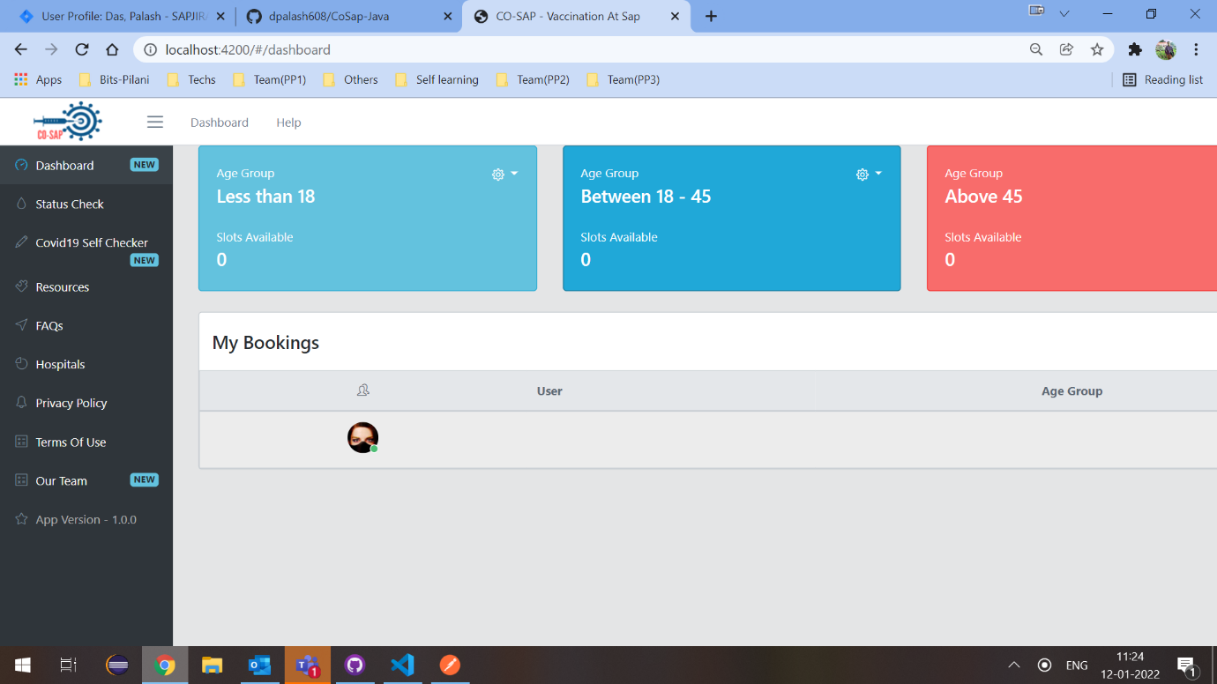**

**View all Bookings Page:**

**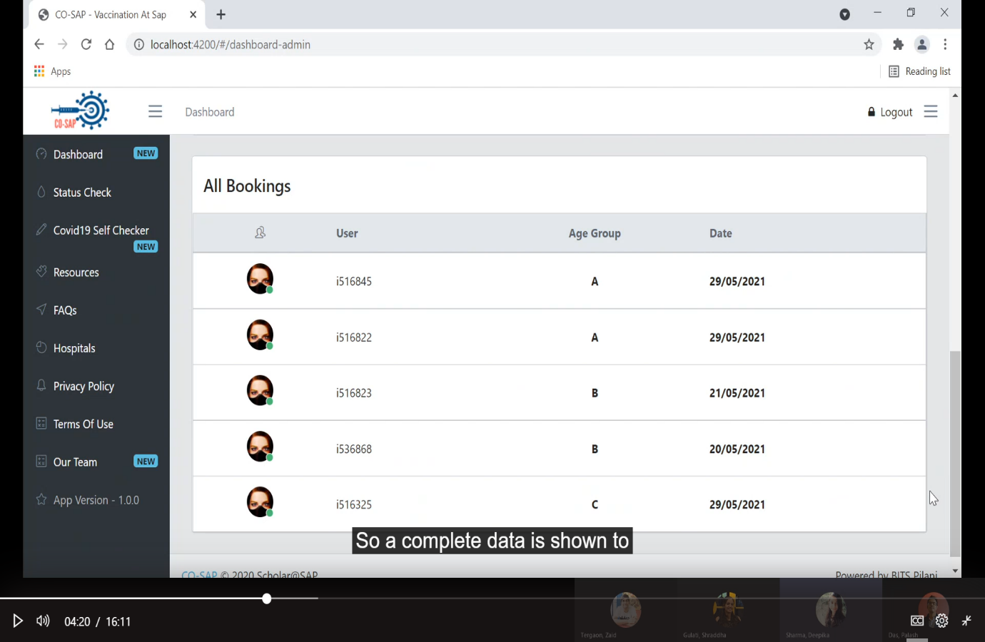**

**Book the slot page:**

**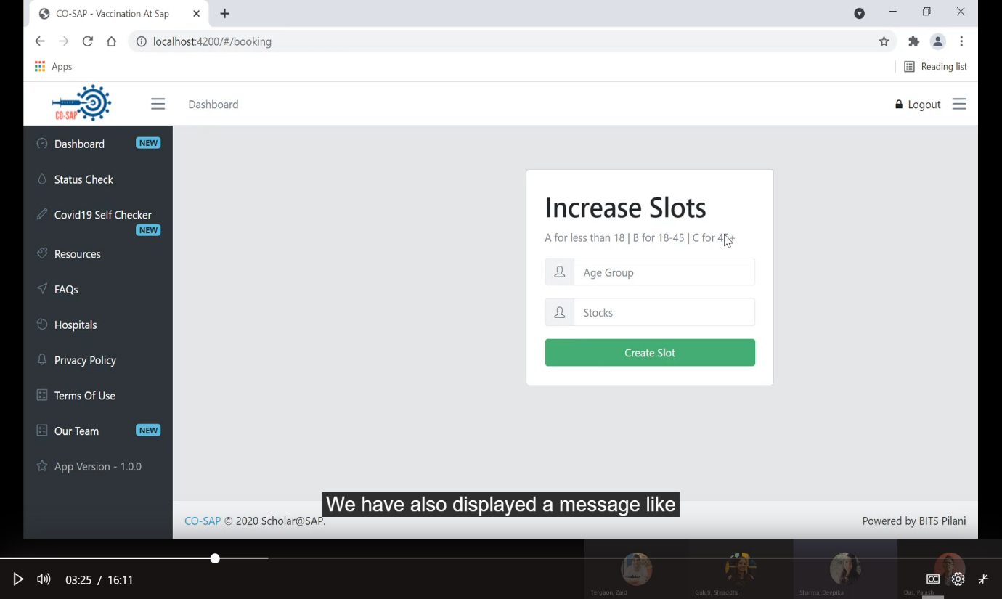**

**Graph for data analyzing:**

**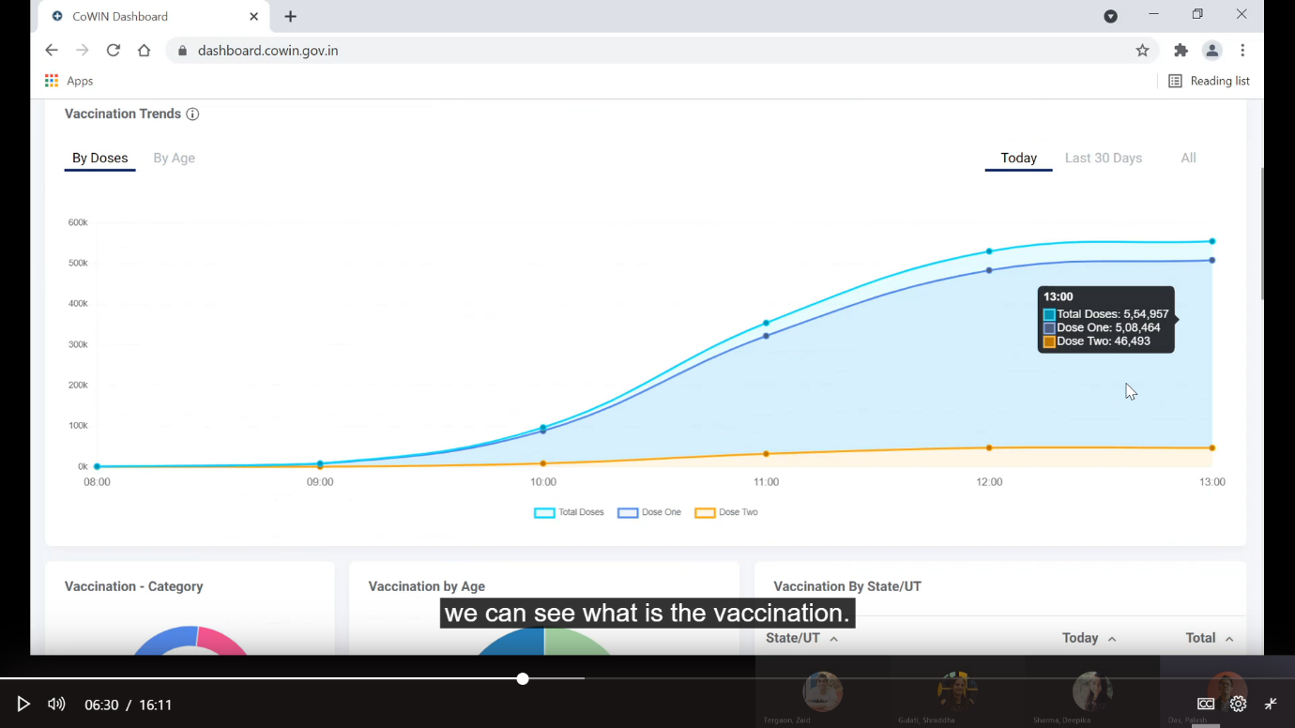**

**Define Git/GitHub Workflow**

[Repository Link](https://github.com/dpalash608/CoSap-Java) – CoSAP Web Application

**Show evidence of having followed the same**

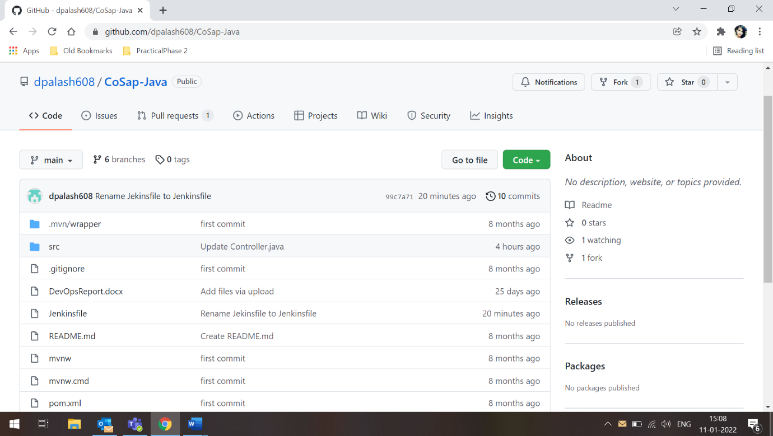

**Branches:**

**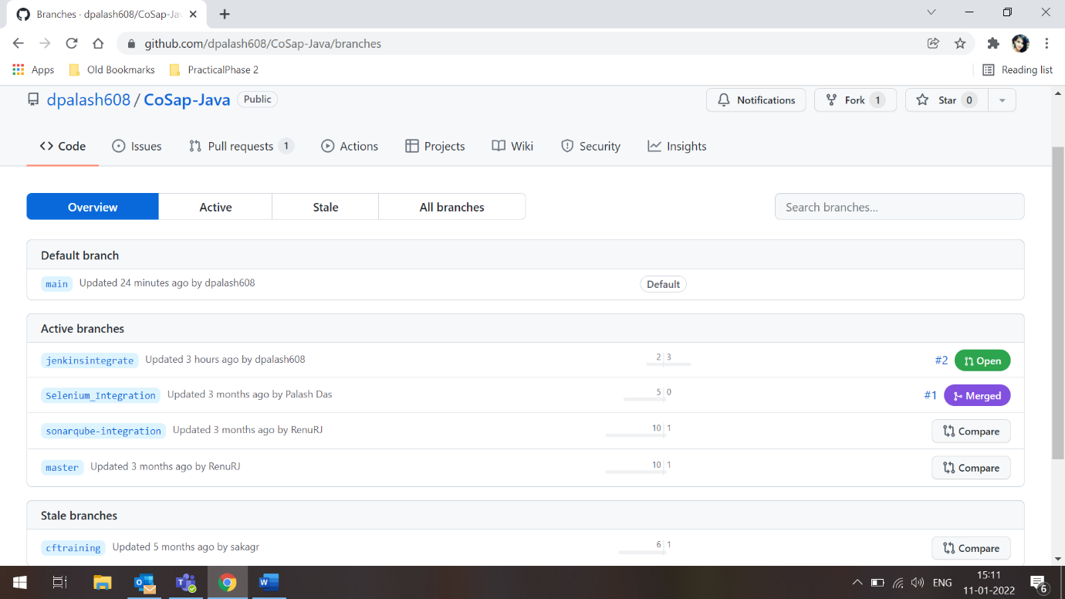**

**Steps to run the application**

1. Clone the repository mentioned above.
2. Import it in any of the suitable IDE (VSCode/Eclispe).
3. Run mvn clean install on the project.
4. In the main application file cosapapplication.java, run this file as a JAVA application.
5. In the console, you will see the server getting started.
6. Now paste the below content in the json file and import it in postman.
7. You will see in the imported collection set of APIs which you can use.

**Problem Statement:**

The following problems due to which our application will provide solutions:

* Management of Vaccine for all the employees within SAP.
* Maintaining data and records of both the doses.
* Continuous integration and deployment.

**Why is the particular topic chosen?**

**Web Application – Co-SAP (Vaccine Management System for SAP Labs)**

Considering the need of such a system in the current scenario of the pandemic, the topic is chosen to resolve the above problem to help increase the vaccine drive.

**Features:**

* Register with I number (unique identification number for employees of SAP).
* Book vaccine – option for both dose 1 and dose 2.
* Add, delete, and update status reports.
* View count of vaccinated people across India
* Edit profile and personal details
* Logout and delete account option

**Hardware and Software Used**

**Developer End**

* Intel Core i7
* 4GB Ram
* Windows 7 and above
* Languages- Spring Boot
* Visual Studio Code
* H2 embedded database

**Integrated environment for the project:**

* IDE – Eclipse / Visual Studio …
* Git
* GitHub
* Maven/Gradle
* SonarQube
* Selenium

[**Git**](https://git-scm.com/about)

Git is a [DevOps tool](https://www.simplilearn.com/tutorials/devops-tutorial/devops-tools) used for source code management. It is a free and open-source version control system used to handle small to very large projects efficiently. Git is used to tracking changes in the source code, enabling multiple developers to work together on non-linear development. Git is used to tracking changes in the source code

* The distributed version control tool is used for source code management
* It allows multiple developers to work together
* It supports non-linear development through its thousands of parallel branches

[**GitHub**](https://github.com/about)

At its core, GitHub is a platform where hundreds of millions of private, public, and open-source repositories are hosted and reviewed. Not only is GitHub is the #1 hosting service in our DevOps report, it came in at #7 in our report of the Top 20 Developer Tools for 2020.

GitHub is increasingly expanding its offerings to align with more and more processes in the DevOps workflow. To interface with GitHub repositories, many developers use the GitKraken Git GUI, which seamlessly integrates with GitHub.com and GitHub Enterprise. GitHub offers basic project management with Projects and Issues. View, edit, and create branches tied to these issues directly from GitKraken through the GUI’s robust issue tracking integration.

[**VS Code**](https://code.visualstudio.com/)

VS Code is a very popular code editor for writing, building, and debugging web and cloud applications on Windows, Mac, and Linux.

As a Microsoft tool, it has the added advantage of tight integration with Azure, AWS, .NET, and a vast ecosystem of extensions which allow you to connect, build and debug many tools and technologies. Streamline your DevOps workflow by using VS Code with Azure to easily deploy and host sites built on React, Angular, Vue, Node, Python, etc.

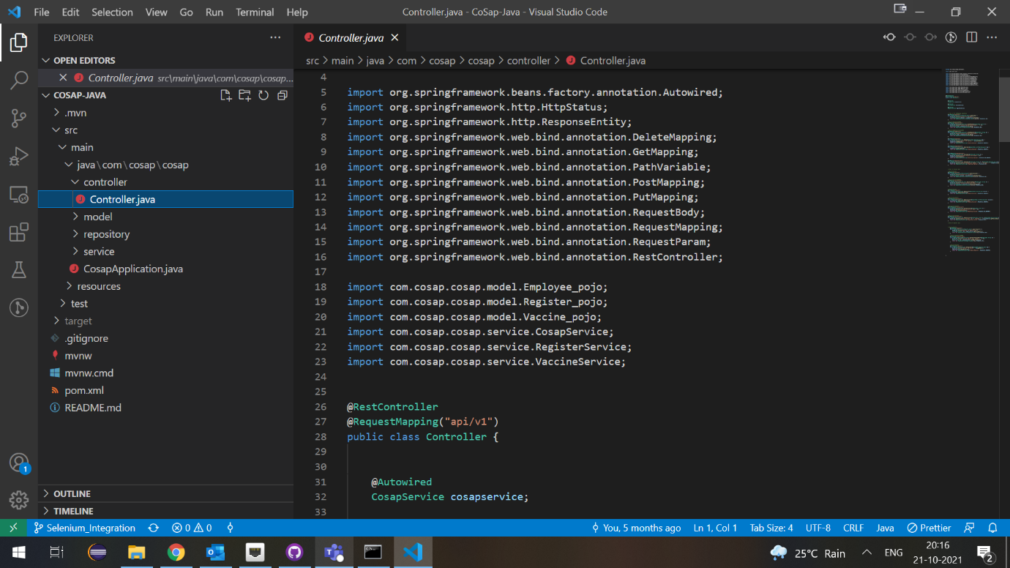

[**Maven**](https://maven.apache.org/)

Maven is a build automation tool used primarily for Java projects but can also be used to build and manage projects written in C#, Ruby, Scala, and other languages. The Maven project is hosted by the Apache Software Foundation.

Teams can use Maven’s project object model (POM) and set of plugins to build projects with a unified build system. Once your team is familiar with how one Maven project builds, you’ll know how all Maven projects build, saving time when trying to navigate numerous projects.

**[Selenium](https://www.selenium.dev/" \t "_blank)**

Selenium is a suite of tools for automating web browsers. It provides a playback tool for authoring functional tests without the need to learn a test scripting language.

Selenium WebDriver is a collection of language-specific bindings to drive a browser. It helps QA teams create robust, browser-based regression automation suites and tests, and scale/distribute scripts across many environments.

Selenium IDE is a Chrome and Firefox add-on that will do simple record-and-playback of interactions with a browser. It helps QA teams create quick bug reproduction scripts and scripts for automation-aided exploratory testing.

Selenium Grid is ideal for QA teams who want to scale by distributing and running tests on several machines while managing multiple environments from a central point. This makes it easy to run tests against a variety of browsers and operating systems.

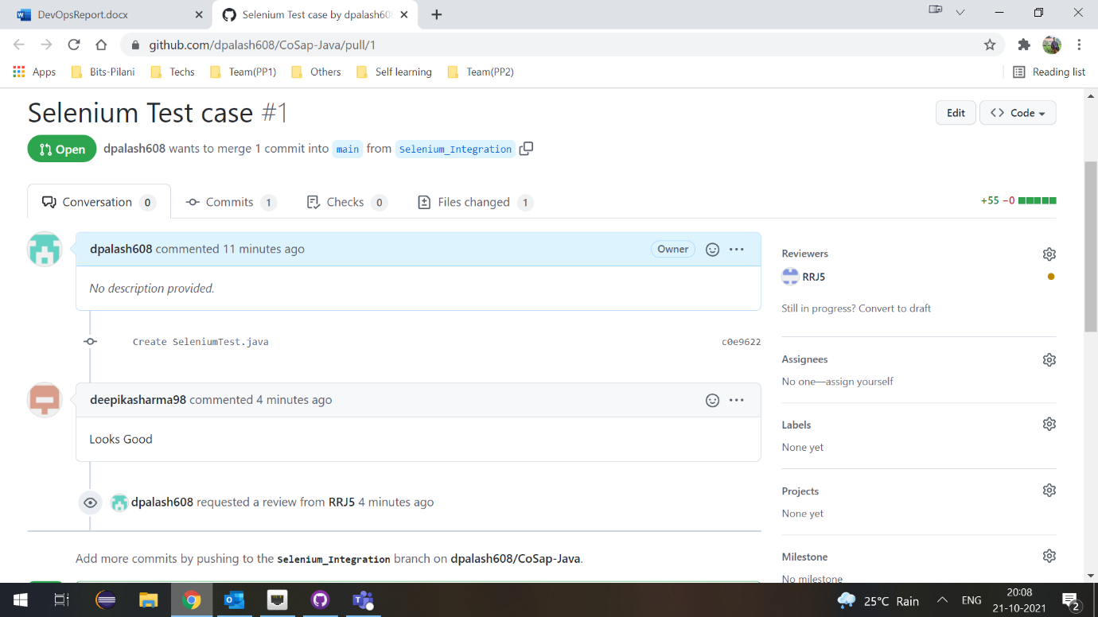

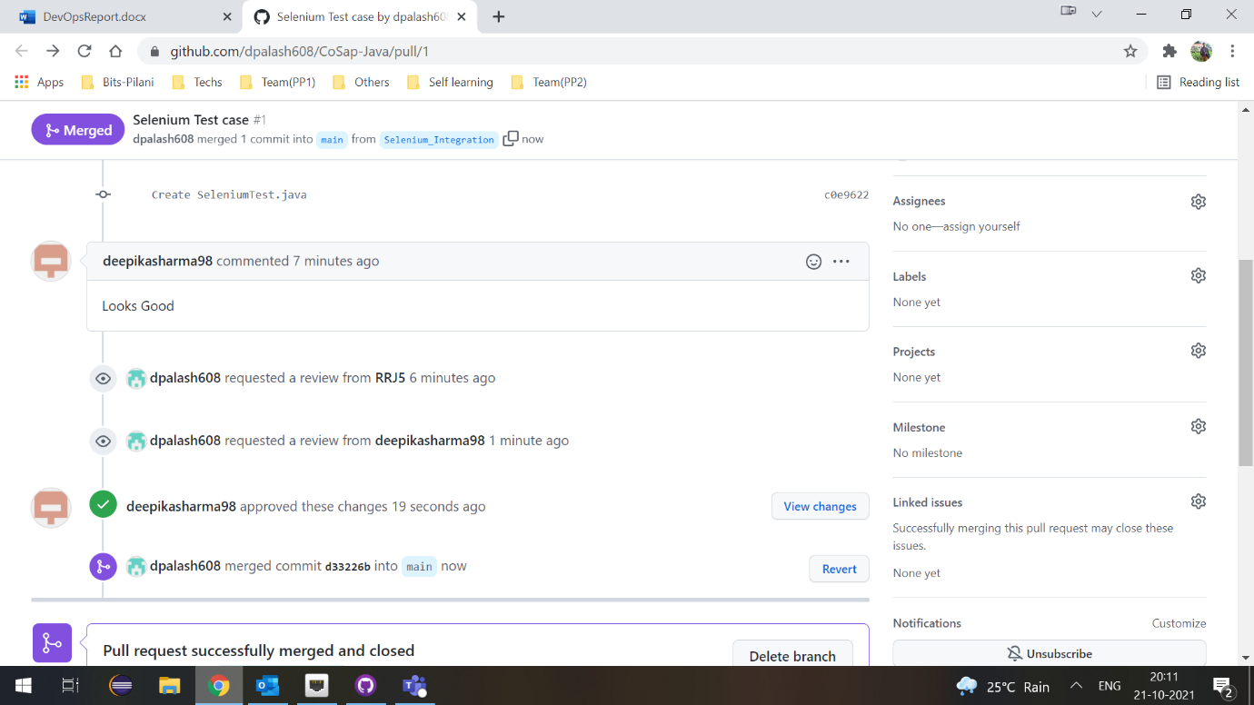

[**SonarQube**](https://www.sonarqube.org/about/)

SonarQube is the leading tool for continuously inspecting the Code Quality and Security of your codebases and guiding development teams during Code Reviews.

Fully integrated with DevOps tool chains it comes with:

* Built-in integration with most build tools, which enables in most cases a no configuration approach
* Easy integration with continuous integration engines such as Jenkins, Azure DevOps, TeamCity, Bamboo.
* Support for numerous source configuration management tools such as Git,

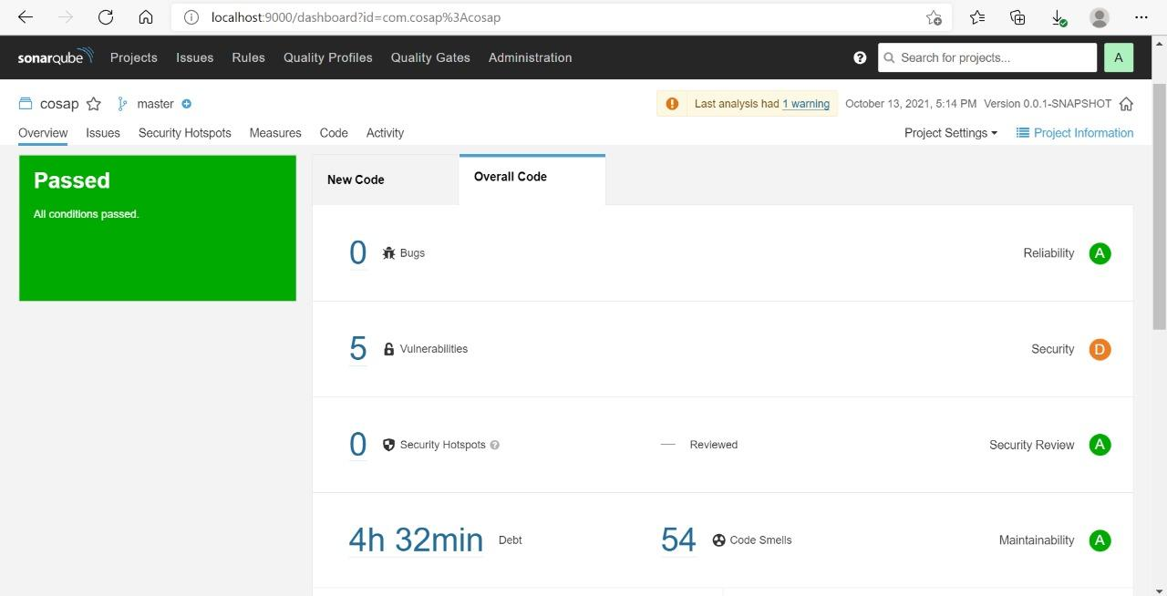Subversion, CVS, Mercurial.

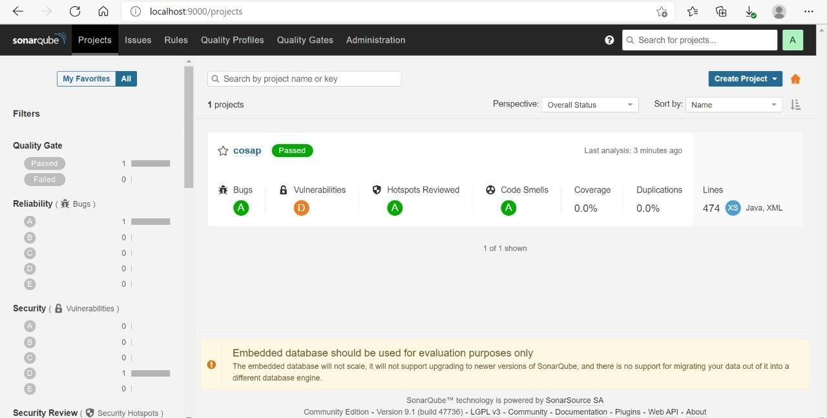

[**Jenkins**](https://www.jenkins.io/doc/book/pipeline/)

Jenkins is an open-source automation server. It helps automate the parts of software development related to building, testing, and deploying, facilitating continuous integration and continuous delivery. It is a server-based system that runs in servlet containers such as Apache Tomcat.

Jenkins has become the open-source standard for managing the dev side of devops, from source code management to delivering code to production. The idea of CI is to merge code from individual developers into a project multiple times per day and test continuously to avoid downstream problems.

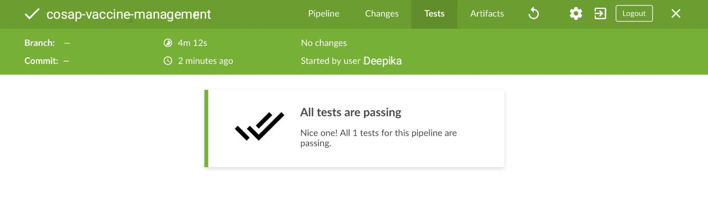

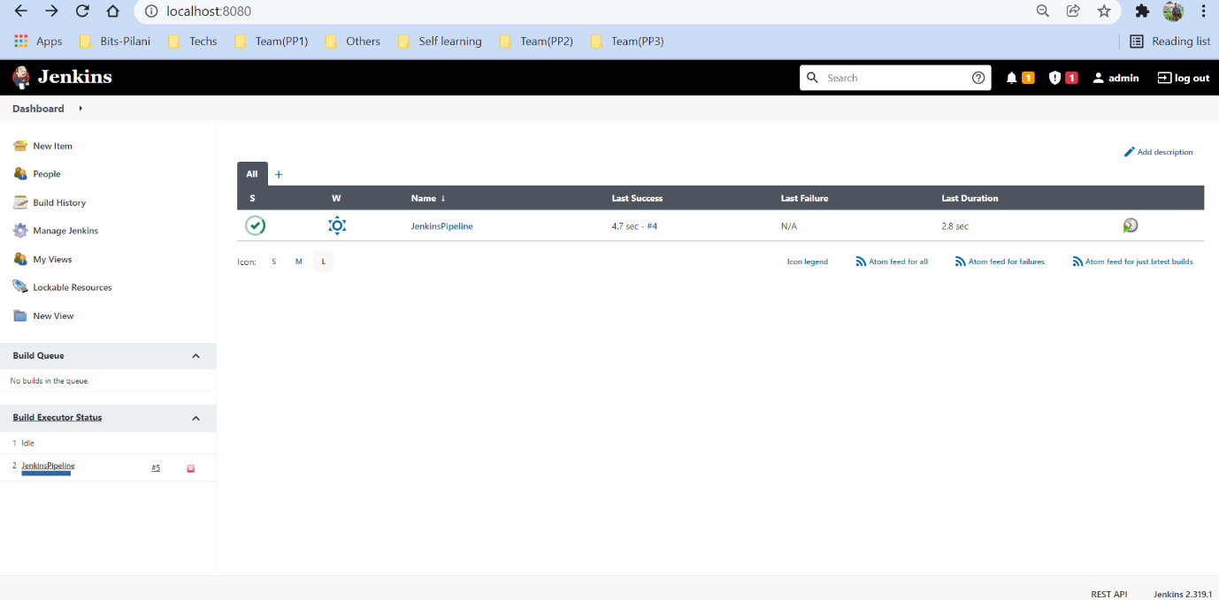

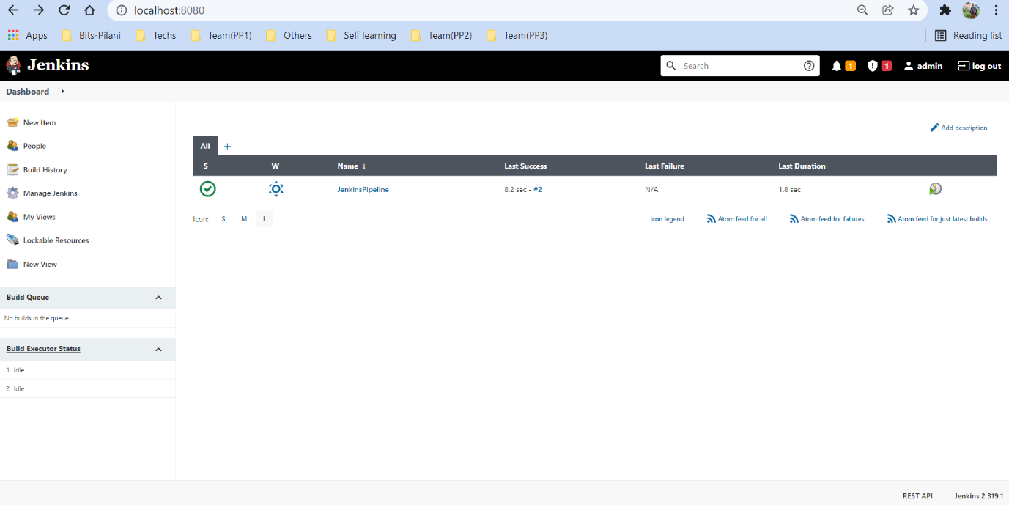

**Trying to add Jenkins Web-hook**

{

  "zen": "Encourage flow.",

  "hook\_id": 337644898,

  "hook": {

    "type": "Repository",

    "id": 337644898,

    "name": "web",

    "active": true,

    "events": [

      "pull\_request",

      "push"

    ],

    "config": {

      "content\_type": "json",

      "insecure\_ssl": "0",

      "url": <http://10.76.106.45:8080/github-webhook>

    },

    "updated\_at": "2022-01-11T09:11:00Z",

    "created\_at": "2022-01-11T09:11:00Z",

    "url": <https://api.github.com/repos/dpalash608/CoSap-Java/hooks/337644898>,

    "test\_url": <https://api.github.com/repos/dpalash608/CoSap-Java/hooks/337644898/test>,

    "ping\_url": <https://api.github.com/repos/dpalash608/CoSap-Java/hooks/337644898/pings>,

    "deliveries\_url": <https://api.github.com/repos/dpalash608/CoSap-Java/hooks/337644898/deliveries>,

    "last\_response": {

      "code": null,

      "status": "unused",

      "message": null

    }

  },

  "repository": {

    "id": 370314062,

    "node\_id": "MDEwOlJlcG9zaXRvcnkzNzAzMTQwNjI=",

    "name": "CoSap-Java",

    "full\_name": "dpalash608/CoSap-Java",

    "private": false,

    "owner": {

      "login": "dpalash608",

      "id": 66236044,

      "node\_id": "MDQ6VXNlcjY2MjM2MDQ0",

      "avatar\_url": <https://avatars.githubusercontent.com/u/66236044?v=4>,

      "gravatar\_id": "",

      "url": <https://api.github.com/users/dpalash608>,

      "html\_url": <https://github.com/dpalash608>,

      "followers\_url": <https://api.github.com/users/dpalash608/followers>,

      "following\_url": [https://api.github.com/users/dpalash608/following{/other\_user}](https://api.github.com/users/dpalash608/following%7b/other_user%7d),

      "gists\_url": [https://api.github.com/users/dpalash608/gists{/gist\_id}](https://api.github.com/users/dpalash608/gists%7b/gist_id%7d),

      "starred\_url": [https://api.github.com/users/dpalash608/starred{/owner}{/repo}](https://api.github.com/users/dpalash608/starred%7b/owner%7d%7b/repo%7d),

      "subscriptions\_url": <https://api.github.com/users/dpalash608/subscriptions>,

      "organizations\_url": <https://api.github.com/users/dpalash608/orgs>,

      "repos\_url": <https://api.github.com/users/dpalash608/repos>,

      "events\_url": [https://api.github.com/users/dpalash608/events{/privacy}](https://api.github.com/users/dpalash608/events%7b/privacy%7d),

      "received\_events\_url": <https://api.github.com/users/dpalash608/received_events>,

      "type": "User",

      "site\_admin": false

    },

    "html\_url": <https://github.com/dpalash608/CoSap-Java>,

    "description": null,

    "fork": false,

    "url": <https://api.github.com/repos/dpalash608/CoSap-Java>,

    "forks\_url": <https://api.github.com/repos/dpalash608/CoSap-Java/forks>,

    "keys\_url": [https://api.github.com/repos/dpalash608/CoSap-Java/keys{/key\_id}](https://api.github.com/repos/dpalash608/CoSap-Java/keys%7b/key_id%7d),

    "collaborators\_url": [https://api.github.com/repos/dpalash608/CoSap-Java/collaborators{/collaborator}](https://api.github.com/repos/dpalash608/CoSap-Java/collaborators%7b/collaborator%7d),

    "teams\_url": <https://api.github.com/repos/dpalash608/CoSap-Java/teams>,

    "hooks\_url": <https://api.github.com/repos/dpalash608/CoSap-Java/hooks>,

    "issue\_events\_url": [https://api.github.com/repos/dpalash608/CoSap-Java/issues/events{/number}](https://api.github.com/repos/dpalash608/CoSap-Java/issues/events%7b/number%7d),

    "events\_url": <https://api.github.com/repos/dpalash608/CoSap-Java/events>,

    "assignees\_url": [https://api.github.com/repos/dpalash608/CoSap-Java/assignees{/user}](https://api.github.com/repos/dpalash608/CoSap-Java/assignees%7b/user%7d),

    "branches\_url": [https://api.github.com/repos/dpalash608/CoSap-Java/branches{/branch}](https://api.github.com/repos/dpalash608/CoSap-Java/branches%7b/branch%7d),

    "tags\_url": <https://api.github.com/repos/dpalash608/CoSap-Java/tags>,

    "blobs\_url": [https://api.github.com/repos/dpalash608/CoSap-Java/git/blobs{/sha}](https://api.github.com/repos/dpalash608/CoSap-Java/git/blobs%7b/sha%7d),

    "git\_tags\_url": [https://api.github.com/repos/dpalash608/CoSap-Java/git/tags{/sha}](https://api.github.com/repos/dpalash608/CoSap-Java/git/tags%7b/sha%7d),

    "git\_refs\_url": [https://api.github.com/repos/dpalash608/CoSap-Java/git/refs{/sha}](https://api.github.com/repos/dpalash608/CoSap-Java/git/refs%7b/sha%7d),

    "trees\_url": [https://api.github.com/repos/dpalash608/CoSap-Java/git/trees{/sha}](https://api.github.com/repos/dpalash608/CoSap-Java/git/trees%7b/sha%7d),

    "statuses\_url": [https://api.github.com/repos/dpalash608/CoSap-Java/statuses/{sha}](https://api.github.com/repos/dpalash608/CoSap-Java/statuses/%7bsha%7d),

    "languages\_url": <https://api.github.com/repos/dpalash608/CoSap-Java/languages>,

    "stargazers\_url": <https://api.github.com/repos/dpalash608/CoSap-Java/stargazers>,

    "contributors\_url": <https://api.github.com/repos/dpalash608/CoSap-Java/contributors>,

    "subscribers\_url": <https://api.github.com/repos/dpalash608/CoSap-Java/subscribers>,

    "subscription\_url": <https://api.github.com/repos/dpalash608/CoSap-Java/subscription>,

    "commits\_url": [https://api.github.com/repos/dpalash608/CoSap-Java/commits{/sha}](https://api.github.com/repos/dpalash608/CoSap-Java/commits%7b/sha%7d),

    "git\_commits\_url": [https://api.github.com/repos/dpalash608/CoSap-Java/git/commits{/sha}](https://api.github.com/repos/dpalash608/CoSap-Java/git/commits%7b/sha%7d),

    "comments\_url": [https://api.github.com/repos/dpalash608/CoSap-Java/comments{/number}](https://api.github.com/repos/dpalash608/CoSap-Java/comments%7b/number%7d),

    "issue\_comment\_url": [https://api.github.com/repos/dpalash608/CoSap-Java/issues/comments{/number}](https://api.github.com/repos/dpalash608/CoSap-Java/issues/comments%7b/number%7d),

    "contents\_url": [https://api.github.com/repos/dpalash608/CoSap-Java/contents/{+path}](https://api.github.com/repos/dpalash608/CoSap-Java/contents/%7b+path%7d),

    "compare\_url": [https://api.github.com/repos/dpalash608/CoSap-Java/compare/{base}...{head}](https://api.github.com/repos/dpalash608/CoSap-Java/compare/%7bbase%7d...%7bhead%7d),

    "merges\_url": <https://api.github.com/repos/dpalash608/CoSap-Java/merges>,

    "archive\_url": [https://api.github.com/repos/dpalash608/CoSap-Java/{archive\_format}{/ref}](https://api.github.com/repos/dpalash608/CoSap-Java/%7barchive_format%7d%7b/ref%7d),

    "downloads\_url": <https://api.github.com/repos/dpalash608/CoSap-Java/downloads>,

    "issues\_url": [https://api.github.com/repos/dpalash608/CoSap-Java/issues{/number}](https://api.github.com/repos/dpalash608/CoSap-Java/issues%7b/number%7d),

    "pulls\_url": [https://api.github.com/repos/dpalash608/CoSap-Java/pulls{/number}](https://api.github.com/repos/dpalash608/CoSap-Java/pulls%7b/number%7d),

    "milestones\_url": [https://api.github.com/repos/dpalash608/CoSap-Java/milestones{/number}](https://api.github.com/repos/dpalash608/CoSap-Java/milestones%7b/number%7d),

    "notifications\_url": [https://api.github.com/repos/dpalash608/CoSap-Java/notifications{?since,all,participating}](https://api.github.com/repos/dpalash608/CoSap-Java/notifications%7b?since,all,participating%7d),

    "labels\_url": [https://api.github.com/repos/dpalash608/CoSap-Java/labels{/name}](https://api.github.com/repos/dpalash608/CoSap-Java/labels%7b/name%7d),

    "releases\_url": [https://api.github.com/repos/dpalash608/CoSap-Java/releases{/id}](https://api.github.com/repos/dpalash608/CoSap-Java/releases%7b/id%7d),

    "deployments\_url": <https://api.github.com/repos/dpalash608/CoSap-Java/deployments>,

    "created\_at": "2021-05-24T10:30:58Z",

    "updated\_at": "2021-12-17T11:07:37Z",

    "pushed\_at": "2022-01-11T06:30:42Z",

    "git\_url": "git://github.com/dpalash608/CoSap-Java.git",

    "ssh\_url": [git@github.com:dpalash608/CoSap-Java.git](mailto:git@github.com:dpalash608/CoSap-Java.git),

    "clone\_url": <https://github.com/dpalash608/CoSap-Java.git>,

    "svn\_url": <https://github.com/dpalash608/CoSap-Java>,

    "homepage": null,

    "size": 933,

    "stargazers\_count": 0,

    "watchers\_count": 0,

    "language": "Java",

    "has\_issues": true,

    "has\_projects": true,

    "has\_downloads": true,

    "has\_wiki": true,

    "has\_pages": false,

    "forks\_count": 1,

    "mirror\_url": null,

    "archived": false,

    "disabled": false,

    "open\_issues\_count": 1,

    "license": null,

    "allow\_forking": true,

    "is\_template": false,

    "topics": [

    ],

    "visibility": "public",

    "forks": 1,

    "open\_issues": 1,

    "watchers": 0,

    "default\_branch": "main"

  },

  "sender": {

    "login": "dpalash608",

    "id": 66236044,

    "node\_id": "MDQ6VXNlcjY2MjM2MDQ0",

    "avatar\_url": <https://avatars.githubusercontent.com/u/66236044?v=4>,

    "gravatar\_id": "",

    "url": <https://api.github.com/users/dpalash608>,

    "html\_url": <https://github.com/dpalash608>,

    "followers\_url": <https://api.github.com/users/dpalash608/followers>,

    "following\_url": [https://api.github.com/users/dpalash608/following{/other\_user}](https://api.github.com/users/dpalash608/following%7b/other_user%7d),

    "gists\_url": [https://api.github.com/users/dpalash608/gists{/gist\_id}](https://api.github.com/users/dpalash608/gists%7b/gist_id%7d),

    "starred\_url": [https://api.github.com/users/dpalash608/starred{/owner}{/repo}](https://api.github.com/users/dpalash608/starred%7b/owner%7d%7b/repo%7d),

    "subscriptions\_url": <https://api.github.com/users/dpalash608/subscriptions>,

    "organizations\_url": <https://api.github.com/users/dpalash608/orgs>,

    "repos\_url": <https://api.github.com/users/dpalash608/repos>,

    "events\_url": [https://api.github.com/users/dpalash608/events{/privacy}](https://api.github.com/users/dpalash608/events%7b/privacy%7d),

    "received\_events\_url": <https://api.github.com/users/dpalash608/received_events>,

    "type": "User",

    "site\_admin": false

  }

}

[**Puppet:**](https://puppet.com/docs/continuous-delivery/4.x/cd_user_guide.html)

Puppet is a cross-platform client-server-based application used for configuration management. It handles the software and its configurations on multiple servers.

There are two versions available. One is open source, the other is a commercial version.

* It grants DevOps admins the ability to create unique configurations for each host and layouts and configuration designs for multiple hosts.
* Puppet is an inexpensive means of solving configuration bottlenecks and speed delays.
* It easily integrates with other tools and infrastructures.

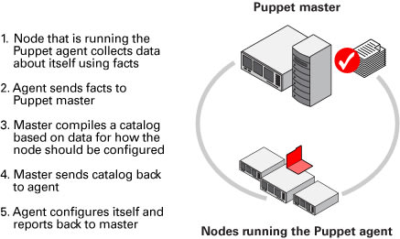

**For Apache Maven, we need to download the modules using a vagrant shell command before the puppet provisioner runs.**

config.vm.provision :shell do |shell|

shell.inline = "mkdir -p /etc/puppet/modules;

puppet module install puppetlabs/nodejs;

puppet module install puppetlabs/apache"

end

config.vm.provision : puppet do |puppet|

puppet.manifests\_path = "puppet/manifests"

puppet.manifest\_file = "manifest.pp"

end

**For java, we can define it in manifest.pp file directly**

node default{  
        include lamp  
        class {   
           'java':  
           distribution => 'jre',  
        }  
}

**Snapshot of Java installed in slave server using puppet configuration**

**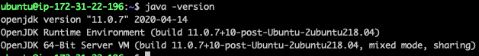**

[**ELK:**](https://www.elastic.co/webinars/elk-stack-devops-environment)

ELK is a log management platform that helps DevOps engineers in making better decisions for the company. ELK comprises of Elastic search, Logstash, and Kibana open-source software offered by the elastic company. Logstash collects different types of logs and sends them into a pipeline of events.

What is elk tool?

"ELK" is the acronym for three open-source projects: Elasticsearch, Logstash, and Kibana.

* Elasticsearch for deep search and data analytics
* Logstash for centralized logging, log enrichment and parsing
* Kibana for powerful and beautiful data visualizations

[**Docker**](https://docs.docker.com/)**/**[**Kubernetes**](https://kubernetes.io/docs/tutorials/)

Docker is a set of platforms as a service product that use OS-level virtualization to deliver software in packages called containers. Containers are isolated from one another and bundle their own software, libraries, and configuration files; they can communicate with each other through well-defined channels.

Through Docker DevOps, developers can pack all parts of an application like libraries and other dependencies easily and ship it out as a single package.

Kubernetes is an open-source container orchestration system for automating software deployment, scaling, and management. Originally, Google designed Kubernetes, but now, the Cloud Native Computing Foundation maintains the project.

The Benefits Kubernetes Have Stored-in To Enable DevOps Workflow Easy Which Includes: Hassle-free solution for making development, testing and production environment consistent