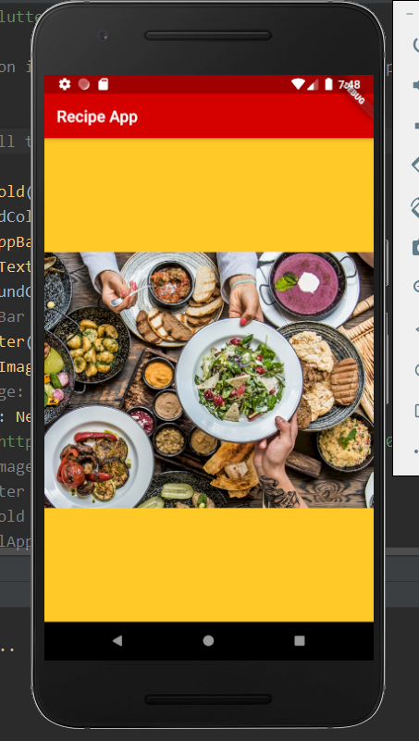Basic Splash (Needs to be revised)