**Project Health**

**Meal Planner**

**Members:**

Yaoheng Mo, Domenic Palucci

Meal Planner Application in which a user enters their Name, selects their nutritional level and plans each of their meal for the day. It tracks Calorie, Fat & Protein count, and meal type. If the application is followed, it will also provide notifications of exceeding the total daily calorie count.

**Concepts and Technologies Covered**

1. Visual studio C#. NET

2. SQL via Azure

3.Printing

4. WPF

5. StackPanel , Gridsplitter

Challenge:

Implementing the above technologies.

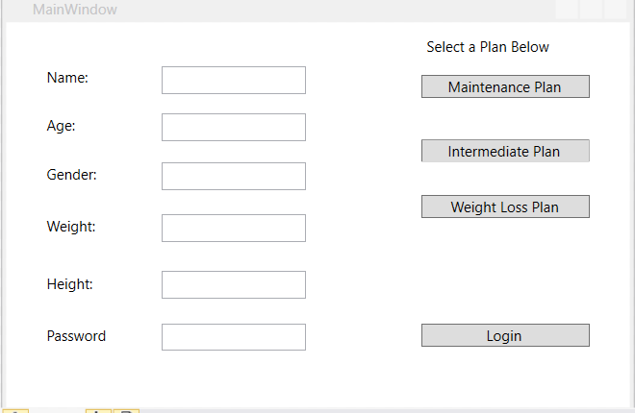

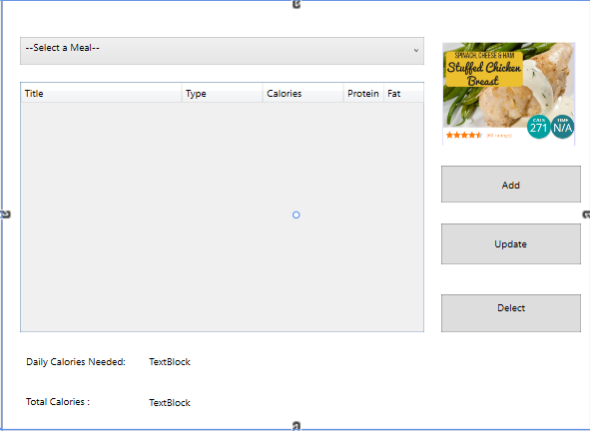

Database

