Industrial Ontology for AI-Led Engineering
Foundation for Digital Thread, Knowledge Graphs, and AI Services

Incorporating the Enterprise-Level Governance Framework
Based on ISO 11179 Metadata Registry Principles
Tata Consultancy Services | Industrial Autonomy & Engineering Practice
July 2026

Table of Contents
Executive Summary
Industrial Ontology in the Digital Thread Framework
Ontology Layers in Digital Thread Architecture
1. Upper Ontology Layer – Common Enterprise Semantics
2. Domain Ontology Layer – Engineering Discipline Knowledge
3. Application Ontology Layer – Business Process Intelligence
4. Metadata and Governance Layer
4.1 Enterprise-Level Governance Framework
4.2 Governance Framework Components
4.3 ISO 11179 Principles — Foundational Standard
4.4 Governance Roles and Responsibilities
4.5 Integration with Industrial Ontology Architecture
5. Enterprise Knowledge Graph Layer
AI Services Enabled by Industrial Ontology
Conclusion
References

Executive Summary

Industrial organizations are increasingly adopting Artificial Intelligence (AI) to accelerate product development, improve engineering productivity, optimize manufacturing operations, and enhance lifecycle decision-making. However, engineering information is often fragmented across Product Lifecycle Management (PLM), CAD, ERP, MES, simulation, software engineering, quality, and service systems. This fragmentation limits the effectiveness of AI because critical context and relationships are lost.

Industrial Ontology addresses this challenge by providing a semantic framework that defines engineering concepts, relationships, constraints, and business rules across the enterprise. Combined with Digital Threads, Enterprise Knowledge Graphs, and Digital Twins, Industrial Ontology creates an AI-ready foundation that enables intelligent search, lifecycle traceability, impact analysis, engineering copilots, predictive intelligence, and autonomous engineering workflows.

According to the Industrial Ontologies Foundry (IOF), industrial ontologies provide formal semantic representations of industrial assets, products, processes, and lifecycle relationships, enabling interoperability and machine reasoning across enterprise systems.

Key Addition in This Edition:
This document now incorporates the Enterprise-Level Governance Framework as a formal sub-layer within the Metadata and Governance Layer (Section 4). The framework — grounded in ISO 11179 Metadata Registry Principles — defines the governance roles, tooling, and processes required to sustain semantic consistency across the industrial ontology landscape.

Industrial Ontology in the Digital Thread Framework

A Digital Thread is a communication framework that connects authoritative information throughout the product lifecycle, from requirements through design, manufacturing, quality, operations, and service.

ISO/IEC/IEEE 15288 defines lifecycle processes that span the entire engineering lifecycle, while ISO 23247 establishes the Digital Twin framework that relies on connected lifecycle information. Together, these standards form the basis for Digital Thread implementations.

The Digital Thread architecture flows through the following layers:

Enterprise Systems
↓ Data Platform
↓ Semantic Integration Layer
↓ Industrial Ontology
↓ Enterprise Knowledge Graph
↓ Digital Product Model
↓ Digital Thread
↓ Digital Twin
↓ AI Services

The ontology provides the semantic meaning that allows AI systems to understand how requirements, designs, software, manufacturing processes, quality records, and operational assets are connected.

Semantic Integration and Lambda-Style Data Pipeline
This architecture extends the Digital Thread through two synchronized processing paths: a governed batch path for complete lifecycle reconstruction and a low-latency speed path for recent events. Both paths apply the same canonical model, identity rules, ontology mappings, validation constraints, and access policies. Their outputs converge in a shared semantic serving layer, providing consistent, traceable knowledge to engineering applications, Digital Twins, copilots, and AI agents.
Enterprise Engineering Sources
CAD / PLM / ALM / ERP / MES / QMS / IoT / Documents / Standards
Connectors and Ingestion
APIs • OSLC / TRS • CDC • Message Bus • File Drop • Event Gateway
Parser and Extraction Layer
STEP / AP242 / AP239 • SysML / XMI • ReqIF • XML / JSON • CSV • PDF / OCR • Telemetry Parser
Batch Path — Complete and Accurate |  | Speed Path — Low-Latency Events
Immutable Raw Zone  Source payload, version, timestamp, provenance and checksum | Semantic Batch Pipeline  Canonicalize → resolve identity → enrich metadata → map standards → transform RDF / OWL → validate SHACL → reason | Event Stream  Changes, telemetry, quality events and workflow notifications | Semantic Stream Pipeline  Parse → normalize → resolve identity → apply ontology mapping → validate incremental graph update
Trusted Batch View  Reconciled lifecycle graph, indexes, lineage and quality status |  | Near-Real-Time View  Recent changes, alerts, inferred impacts and provisional relationships
Semantic Serving Layer
Enterprise Knowledge Graph • Graph / SPARQL / Search APIs • Vector Index • Digital Thread Services • Digital Twin Context
Consumers and Closed-Loop Actions
Engineering Search • Impact Analysis • Configuration and Compliance Intelligence • Copilots • Agents • Workflow Orchestration
Cross-Cutting Semantic Control Plane
ISO 11179 Metadata Registry • Industrial Ontology • SKOS Taxonomies • Persistent IDs • Mapping Registry • Versioning • SHACL Rules • Stewardship • Security • Observability

How the Architecture Operates
- Capture source data and events. Connectors ingest engineering records, documents, telemetry, and lifecycle events while preserving source identifiers, versions, timestamps, security classifications, checksums, and provenance.
- Parse heterogeneous formats. Format-specific parsers extract structures, attributes, relationships, units, document sections, and embedded references into a common staging contract.
- Apply semantic transformation. The pipeline canonicalizes representations, resolves enterprise identities, enriches metadata, aligns concepts to the industrial ontology, and produces RDF, OWL, or property-graph structures.
- Validate and infer. SHACL rules verify completeness and conformance. Reasoning services classify entities, infer relationships, and route conflicts or unresolved mappings to stewardship workflows.
- Publish through two coordinated paths. The speed path publishes recent changes for immediate operational context. The batch path periodically recomputes the complete lifecycle view and reconciles provisional stream results.
- Serve knowledge and enable action. The unified serving layer supports graph queries, semantic search, Digital Thread traversal, Digital Twin context, copilots, and agents. Approved decisions are returned to operational systems through governed APIs and workflows.

Processing Paths
- Batch path — completeness and accuracy: Reprocesses immutable source data to produce a reconciled lifecycle graph with approved lineage, quality status, and indexes.
- Speed path — low-latency awareness: Processes recent changes, telemetry, quality events, and workflow notifications to deliver alerts, inferred impacts, and provisional relationships.
- Serving layer — unified consumption: Merges trusted historical and near-real-time views behind common graph, search, semantic, and vector interfaces.

Core Design Principles
- One semantic contract: Batch and speed processing use the same approved identifiers, ontology versions, mappings, validation rules, and access policies.
- Replayability: Immutable raw data and retained events allow the batch path to rebuild trusted views and correct stream-processing drift.
- Traceability by design: Every semantic assertion retains its source, transformation history, validation status, and version lineage.
- Governed closed loop: AI recommendations and automated actions return to enterprise systems only through authorized APIs, workflows, and approval controls.

Solution Differentiators
The solution combines semantic governance, industrial data integration, and controlled AI enablement into one operating model.
• Governed semantic publication: Only the canonical publication API writes to the enterprise knowledge graph. Ingestion services, data jobs, connectors, and AI agents submit evidence and approved change proposals rather than performing uncontrolled graph mutations.
• Extensible industrial ingestion: A reusable parser and mapping framework supports engineering standards, XML and JSON schemas, documents, telemetry, and future connectors without redesigning the core semantic control plane.
• Versioned semantic data products: Each approved batch is packaged with an event identifier, canonical model version, mapping digest, validation status, provenance, and quality evidence so published knowledge is reproducible and explainable.
• Embedded data quality and reconciliation: Completeness, validity, consistency, conflict, and identity-resolution gates operate within the data job. Rejected, quarantined, and review records retain diagnostic evidence instead of being silently overwritten.
• Unified batch and speed semantics: Complete lifecycle reconstruction and low-latency event processing use the same persistent identifiers, ontology versions, mappings, validation rules, and access policies, avoiding divergent graph models.
• Open semantic and agent serving: Modular graph, linked-data, query, search, and agent-context APIs expose governed knowledge to engineering applications while enforcing policy approval for any downstream mutation or action.

Ontology Layers in Digital Thread Architecture

1. Upper Ontology Layer – Common Enterprise Semantics
The Upper Ontology establishes foundational concepts shared across the enterprise:
- Product
- Component
- Asset
- Requirement
- Function
- Process
- Document
- Organization
- Location
- Event
- Time

Standards such as RDF and OWL provide formal mechanisms for defining these concepts and relationships.

Example: A vehicle requirement, CAD model, manufacturing BOM, and maintenance asset all represent different lifecycle views of the same product. The Upper Ontology creates semantic consistency across these representations, enabling traceability throughout the Digital Thread.

Business Benefits:
- Enterprise-wide interoperability
- Common engineering vocabulary
- Elimination of semantic ambiguity
- Improved AI understanding

2. Domain Ontology Layer – Engineering Discipline Knowledge
Domain ontologies capture knowledge specific to engineering disciplines:
- Systems Engineering
- Mechanical Engineering
- Electrical Engineering
- Software Engineering
- Manufacturing Engineering
- Quality Engineering
- Service Engineering

Example: An electric vehicle battery requirement can be linked to system requirements, mechanical design models, battery management software, manufacturing processes, validation tests, and service procedures. Using OMG SysML v2 and ISO/IEC/IEEE 15288 lifecycle constructs, these relationships become machine-readable and AI-accessible.

Business Benefits:
- Cross-domain collaboration
- Faster root cause analysis
- Enhanced knowledge reuse
- Improved engineering efficiency

3. Application Ontology Layer – Business Process Intelligence
Application ontologies encode business-specific rules and workflows, including:
- Change Management
- Variant Management
- Configuration Management
- Compliance Management
- Supplier Management
- Digital Twin Management

Example: If a supplier changes a battery component specification, the ontology can identify all affected requirements, impacted CAD models, manufacturing processes, compliance certifications, and customer configurations.

Business Benefits:
- Reduced change cycle time
- Improved product governance
- Automated impact assessment
- Faster decision-making

4. Metadata and Governance Layer
Semantic governance ensures consistency across enterprise information. This layer manages business glossaries, taxonomies, ontology versions, standard mappings, data quality rules, and master data definitions. SHACL (Shapes Constraint Language) can be used to validate semantic models and ensure ontology quality.

Business Benefits:
- Trusted enterprise data
- Consistent reporting
- Reliable AI outputs
- Reduced integration effort

4.1 Enterprise-Level Governance Framework
The Enterprise-Level Governance Framework operationalizes the Metadata and Governance Layer by defining the people, processes, tools, and standards required to manage semantic artifacts — vocabularies, taxonomies, ontologies, and metadata — at enterprise scale. This framework is grounded in ISO 11179 Metadata Registry Principles and provides the structural backbone for sustainable ontology governance.

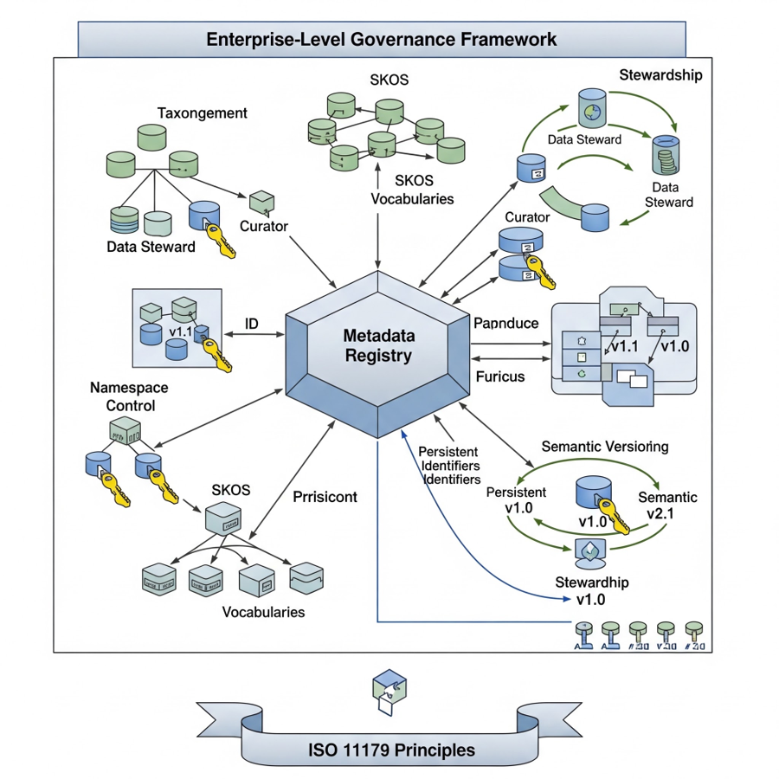
Figure 1: Enterprise-Level Governance Framework — ISO 11179–Based Metadata Registry Architecture
The framework positions the Metadata Registry as the central hub through which all semantic artifacts are registered, versioned, and resolved. Eight tightly coupled governance functions surround the registry, each fulfilling a distinct governance role while operating in concert to ensure semantic coherence across the digital thread.

4.2 Governance Framework Components
The following table describes each component of the Enterprise-Level Governance Framework, its governance role, and its function within the ontology management lifecycle:

Framework Component | Governance Role | Description & Function
Metadata Registry | Central Repository | The authoritative hub that stores, manages, and resolves all registered semantic artifacts — ontologies, vocabularies, taxonomies, and metadata schemas. Implements the ISO 11179 registry model to ensure globally unique, resolvable identifiers for every registered element.
Stewardship (Data Steward) | Data Steward | Assigns accountability for the quality, accuracy, and lifecycle management of semantic artifacts. Data Stewards are responsible for approving ontology changes, validating metadata quality, and ensuring semantic assets remain aligned to business definitions.
Taxonomy Management (Taxonomist) | Taxonomist / Curator | Manages the creation, curation, and maintenance of taxonomic structures using SKOS (Simple Knowledge Organization System). Taxonomists work with Curators to ensure controlled vocabularies reflect current domain knowledge and business terminology.
SKOS Vocabularies | Vocabulary Curator | Implements W3C Simple Knowledge Organization System for defining and managing controlled vocabularies. Provides concept schemes, broader/narrower relationships, and preferred/alternate labels that power semantic interoperability across systems.
Namespace Control | Namespace Administrator | Manages URI namespaces to prevent identifier collisions across ontology modules and enterprise systems. Ensures every ontology element is uniquely and unambiguously addressable across the enterprise and in external federated systems.
Semantic Versioning | Version Controller | Applies versioned change management (v1.0, v1.1, etc.) to ontology and vocabulary releases. Tracks the evolution of semantic artifacts, maintains backward compatibility rules, and ensures downstream AI services reference stable, validated ontology versions.
Persistent Identifiers | Identity Manager | Issues and maintains permanent, globally unique identifiers (such as enterprise URIs) for all registered ontology elements. Persistent identifiers guarantee long-term resolvability and support cross-system traceability in the digital thread.
Fairdom / Porticus | Access Governance | Fairdom controls access to registered semantic artifacts through policy-based governance, defining which systems and users are permitted to query, consume, or publish ontology content. Porticus acts as the governed publishing portal through which validated ontology versions are made available to authorized consumers — supporting controlled external sharing and federation.

4.3 ISO 11179 Principles — Foundational Standard
ISO 11179 (Information Technology — Metadata Registries) is the foundational international standard upon which the Enterprise-Level Governance Framework is built. It defines a formal model for registering, classifying, and managing metadata elements within an organization.

The key ISO 11179 principles applied in this framework are:
- Registry Model: A formal structure for registering data elements, value domains, and conceptual domains with unique identifiers.
- Applied: The Metadata Registry implements the ISO 11179 registry schema for all ontology artifacts
- Stewardship: Accountability for the lifecycle of registered items.
- Applied: Data Stewards maintain custodianship over registered semantic elements
- Classification: Systematic organization of registry items into meaningful categories.
- Applied: SKOS Vocabularies and Taxonomists implement classification through controlled concept schemes
- Naming and Definition: Consistent naming conventions and unambiguous definitions.
- Applied: Namespace Control and Vocabulary Curation enforce naming conventions
- Representation: Formal representation of data elements and their permissible values.
- Applied: Persistent Identifiers ensure all representations are uniquely resolvable
- Versioning: Controlled change management for registered items.
- Applied: Semantic Versioning governs ontology releases with full change traceability

4.4 Governance Roles and Responsibilities
Effective governance requires clearly defined human roles in addition to technical components. The framework defines the following governance roles:

Role | Responsibilities | Collaboration Touchpoints
Data Steward | Ontology quality assurance, change approval, metadata lifecycle ownership, compliance with data governance policies | Taxonomist, Namespace Admin, Version Controller, enterprise data governance committee
Taxonomist | Design and maintain taxonomy hierarchies, manage SKOS concept schemes, ensure vocabulary alignment with domain knowledge | Curator, Data Steward, domain subject matter experts
Curator | Curate and quality-check vocabulary entries, validate term definitions, manage preferred and alternate labels in SKOS | Taxonomist, Metadata Registry, engineering domain leads
Namespace Admin | Register and manage URI namespaces, prevent namespace conflicts, maintain namespace registry, coordinate with external standards bodies | Metadata Registry, enterprise IT architecture, W3C/ISO standards liaison
Version Controller | Manage ontology release cycles, enforce semantic versioning standards, coordinate deprecation of retired terms, maintain version compatibility matrix | Data Steward, Metadata Registry, AI service consumers, downstream system integrators

4.5 Integration with Industrial Ontology Architecture
The Enterprise-Level Governance Framework integrates vertically with all five ontology layers and horizontally with the Enterprise Knowledge Graph. The integration touchpoints are:

- Upper Ontology Layer: The Metadata Registry governs foundational concept definitions; Namespace Control ensures URI uniqueness for all upper-level entities.
- Domain Ontology Layer: Taxonomists and Curators maintain domain-specific controlled vocabularies via SKOS, enabling discipline-aligned semantic interoperability.
- Application Ontology Layer: Semantic Versioning and Data Stewards govern the lifecycle of business rule ontologies, ensuring change management procedures are applied before AI systems consume updated rules.
- Enterprise Knowledge Graph Layer: Persistent Identifiers enable stable graph node resolution; Fairdom / Porticus controls which systems and users can query and write to the graph.
- AI Services Layer: AI services consume only registry-approved, versioned ontology artifacts, ensuring all intelligent reasoning is grounded in governed semantic definitions.

Governance Maturity Note:
Organizations implementing this framework should target progressive maturity across four stages: (1) Ad-hoc vocabulary management → (2) Centralized Metadata Registry adoption → (3) Role-based stewardship and versioning → (4) Automated governance with AI-assisted vocabulary validation. Each stage unlocks higher-confidence AI services in the digital thread.

5. Enterprise Knowledge Graph Layer
The Enterprise Knowledge Graph operationalizes the ontology by connecting lifecycle information across products, requirements, functions, software, manufacturing, quality, suppliers, and operational assets. The Knowledge Graph becomes the contextual foundation for AI-assisted engineering decisions.

Example Digital Thread traversal:
- Requirement → System Function → Component → CAD Model → Simulation → Manufacturing Process → Inspection Record → Service Asset → Maintenance Event

Business Benefits:
- Lifecycle traceability
- Semantic interoperability
- Engineering search
- Knowledge reuse

AI Services Enabled by Industrial Ontology

Industrial Ontology transforms disconnected engineering data into machine-understandable knowledge that powers a comprehensive portfolio of AI services:

AI Service | Description | Business Value
Engineering Semantic Search | Ontology-driven search understands engineering context beyond keywords — e.g., 'Find thermal validation reports for battery systems from Vendor A that failed safety requirements.' | Faster information retrieval; reduced engineering effort
Engineering Question Answering | AI answers lifecycle-aware questions: which requirements are impacted by a design change, which simulations used a given material, which suppliers support a subsystem. | Faster decision-making; improved productivity
Engineering Copilot | Context-aware copilot providing design recommendations, requirements analysis, compliance guidance, and root cause investigation grounded in ontology and knowledge graph. | Reduced design cycle times; faster onboarding
Lifecycle Traceability Intelligence | Automatically traces relationships across: Requirements → Design → Manufacturing → Quality → Operations → Service; identifies all affected downstream artifacts on change. | Reduced rework; improved change management
AI-Powered Impact Analysis | Traverses ontology relationships to evaluate impact of design changes, supplier disruptions, material substitutions, and manufacturing modifications. | Reduced engineering risk; operational resilience
Configuration Intelligence | Captures product options, compatibility constraints, variant rules, and regulatory requirements; automatically generates and validates configurations. | Faster quotation cycles; reduced configuration errors
Compliance Intelligence | Continuously evaluates compliance against regulatory requirements, industry standards, and internal engineering policies using ontology-based rules. | Reduced compliance risk; faster audits
Predictive Engineering Intelligence | AI models on ontology-aligned data predict product failures, quality defects, maintenance needs, and supply chain risks. | Increased reliability; reduced downtime
Digital Twin Intelligence | Leverages semantic relationships for monitoring performance, detecting anomalies, simulating future behaviour, and recommending optimizations. | Improved asset performance; faster root-cause analysis
Agentic AI & Industrial Autonomy | Highest maturity level: autonomous change impact analysis, workflow orchestration, compliance validation, BOM synchronization, and simulation execution. | Significant productivity gains; accelerated innovation

Conclusion

Industrial Ontology serves as the semantic backbone of AI-led engineering. By integrating engineering knowledge across the Digital Thread, it enables Enterprise Knowledge Graphs, Digital Twins, Engineering Copilots, Predictive Analytics, and Agentic AI. The result is an intelligent engineering ecosystem capable of understanding, reasoning, predicting, and acting across the entire product lifecycle.

The incorporation of the Enterprise-Level Governance Framework — grounded in ISO 11179 Metadata Registry Principles — ensures that this semantic backbone is not merely a technical artefact but a governed, trusted, and maintainable enterprise asset. With defined roles for Data Stewards, Taxonomists, Curators, Namespace Administrators, and Version Controllers operating through a central Metadata Registry, and with Fairdom / Porticus enforcing access governance, organizations can sustain semantic quality at scale.

Organizations adopting ontology-driven AI, supported by formal governance, can achieve greater interoperability, lifecycle traceability, compliance, operational efficiency, and innovation — while building a scalable foundation for Industrial Autonomy.

References

Standards and Specifications:
- ISO 23247:2021 – Automation Systems and Integration — Digital Twin Framework for Manufacturing
- ISO/IEC/IEEE 15288:2023 – Systems and Software Engineering — System Life Cycle Processes
- ISO 15926 – Integration of Lifecycle Data for Process Plants
- ISO 10303 AP242 – Managed Model-Based 3D Engineering
- ISO 10303 AP239 – Product Lifecycle Support (PLCS)
- ISO 11179 – Information Technology — Metadata Registries (MDR)
- IEC 62264 (ISA-95) – Enterprise-Control System Integration
- IEC 62541 – OPC Unified Architecture (OPC UA)
- IEC 63278 – Asset Administration Shell (AAS)

W3C Semantic Web Standards:
- W3C RDF 1.1 Concepts and Abstract Syntax
- W3C OWL 2 Web Ontology Language
- W3C SHACL Shapes Constraint Language
- W3C SKOS Simple Knowledge Organization System

Modelling Languages and Frameworks:
- OMG Systems Modeling Language (SysML v2)
- ISO/IEC 22989:2022 – Artificial Intelligence Concepts and Terminology
- ISO/IEC 23053:2022 – Framework for AI Systems Using Machine Learning
- NIST AI Risk Management Framework (AI RMF 1.0)
- Industrial Ontologies Foundry (IOF) Core Ontology Specification

Attached Source Document:
- [1] Industrial ontology.docx

