20 things that tell that your slides/project were vibe coded
Every one of these is a sentence shape a language model reaches for by default. None of them are wrong, exactly. They are just the same eight sentences everyone else shipped this year, so a reader clocks them before they read the claim.
The fix is always the same: say the specific thing that happens.
This isn't a budgeting app, it's a behaviour change tool.
It shows you the four subscriptions you forgot about.
Same idea, half the words, and the second one can be checked.

Sentence shapes 1 to 8
These are structural, not vocabulary. You can swap every word and the tell survives, which is why find and replace never fixes them.

01 Not X, but Y [ on camera ]
Defining your product by what it isn't makes the reader hold two things in their head to learn one. Cut the first half.
Never  Not a dashboard, but a decision engine.  Not just the chart, but the story behind it. | Instead  It tells you which invoice to chase first.  See which category moved, and by how much.

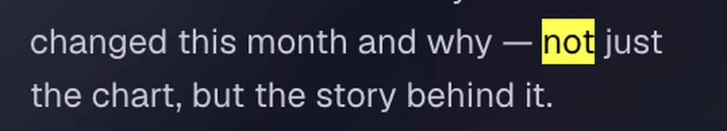
Spotted in the wild: two tells in one line, the em dash and the not-just-X-but-Y.

02 A. Not B. [ on camera ]
The contrarian full stop is the same move as number one, dressed as a slogan. It reads as certainty with nothing behind it.
Never  We build trust. Not features.  Let the AI do the work, not your Sundays. | Instead  Every change is logged and reversible.  Your monthly review takes four minutes.

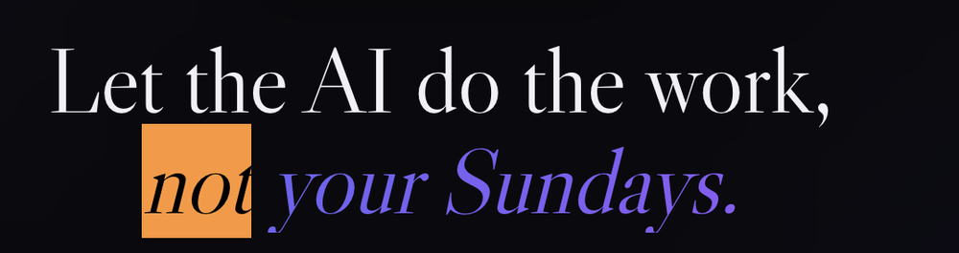
Spotted in the wild: the Sundays line is doing rhythm, not information.

03 Noun, past participle [ on camera ]
The two word fragment slogan. No subject, no verb, and no claim anyone could disagree with.
Never  Analytics, reimagined.  Hidden insights, surfaced. | Instead  See your churn before it happens.  Flags all merchants that raised prices.

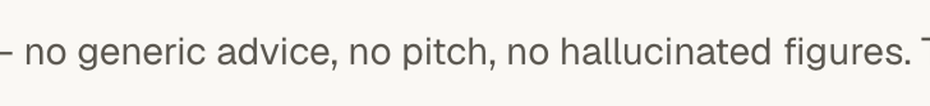
Spotted in the wild: what insight, surfaced where, and how would you know.

04 Em dashes [ on camera ]
The single fastest tell in a deck. Use a comma, a colon or a full stop. If the sentence collapses without one, it was two sentences.
Never  The boring 90% — automated.  Our model is fast — and accurate. | Instead  We handle the 90% you don’t want to touch.  Returns in 200ms, with a 3% error rate.


Spotted in the wild: em dash and fragment slogan stacked in five words.

05 Triplets [ on camera ]
Three items means you could not decide which one was true. This holds for negative triplets too, which feel like honesty but are still just rhythm.
Never  Fast, simple, powerful.  No generic advice, no pitch, no hallucinated figures. | Instead  Loads in under 200ms on a 4G connection.  Every figure can be traced back to your source.

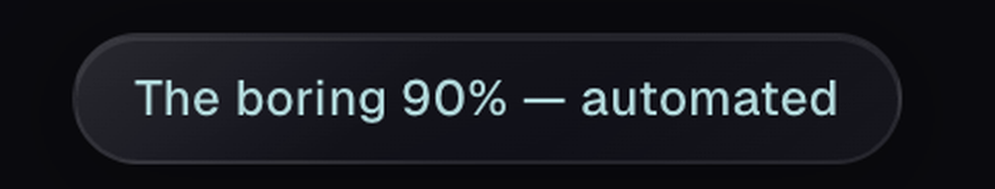
Spotted in the wild: the negative triplet is the most common one in AI copy.

06 Cryptic metaphor before the benefit [ on camera ]
Metaphor is fine once the reader knows what the thing does. Leading with it costs you the slide.
Never  Your data, unchained.  Your month reads like a closed set of books. | Instead  Export everything to CSV in one click.  Every dollar tracked from inflow to outflow.

07 Sentences you cannot say in one breath [ on camera ]
On a slide, a subordinate clause is a wall. One idea per sentence, one idea per slide.
Never  By leveraging a unified data layer that connects your existing tools, teams can finally move away from manual reconciliation and toward a single source of truth. | Instead  We directly take reports from your existing tools and reconcile them nightly, so you don't touch a single sheet.

08 The rhetorical question opener [ on camera ]
You are asking the audience to guess your point. Open with the fact that made you build the thing.
Never  What if your CRM could think?  Ever wondered where your money goes? | Instead  Your CRM loses 60% of your call notes.  The average user has 11 active subscriptions.

Vocabulary 9 to 13
Words almost nobody says out loud. Read the slide aloud, and if you would not say it to a colleague at a pub, cut it.

09 Soft power adverbs
Quietly, calmly, gently, effortlessly, seamlessly, magically. They describe an experience the reader has not had yet.
Never  A platform that quietly does the work of four apps. | Instead  Replaces four apps and three spreadsheets.

Spotted in the wild: delete one word and the line gets stronger and more specific.

10 Violence verbs
Kills, crushes, obliterates, destroys, slays. Your product does not kill anything, and the word buys no credibility.
Never  Kills busywork.  Crush your quarterly close. | Instead  Removes about six hours of data entry a week.  Close the quarter in three days, not nine.

11 Thesaurus words
Delve, realm, landscape, tapestry, testament, myriad, robust, harness. These cluster in machine written text and nowhere else.
Never  Let's delve into the compliance landscape. | Instead  Three rules changed in July. Here is what each one costs you.

12 Escalation verbs
Unlock, empower, elevate, supercharge, revolutionise, transform. Swap in the literal verb, which is nearly always shorter.
Never  Unlock the full potential of your data.  Empower your team to do their best work. | Instead  Query five years of data without SQL.  Your analyst stops rebuilding the same report.

13 Transition filler
The result? Here's the thing. Let that sink in. But there's a catch. Delete them and the paragraph improves every time.
Never  The result? A 40% lift. Let that sink in. | Instead  Conversion went from 2.1% to 2.9%.

Claims 14 to 16
The highest stakes group. Everything above is taste. Being wrong here is a trust problem, and in a pitch it is the thing that ends the meeting.

14 Unsourced superlatives
Ten times faster than what, measured how? A smaller number with a source beats a big one without.
Never  10x faster. Industry leading accuracy. | Instead  2.4x faster than our own v1, on the same 10k row test file.

15 Social proof you do not have
Invented user counts, generated headshots on testimonials, and a logo bar of companies you have never worked with. This is the only item here that can actually get you in trouble.
Never  Trusted by thousands of teams. | Instead  Trusted by 1,400 accountants. Or say nothing, and show the product working.

16 Capabilities the build does not have
The specific risk of vibe coding. The model writes copy for the app it imagined, not the one that compiled. Anything that claims the product runs itself deserves a second look before you present.
Never  Goals that track themselves.  Rename any merchant across your history. | Instead  Update a goal in two taps, from the home screen.  Claim only what you clicked yourself this morning.


Spotted in the wild: a self-running claim. The user still has to enter the goal.

Layout and leftovers 17 to 20
Visual tells. People spot these before they read a word, which means they are already discounting the copy by the time they get to it.

17 Enter: ProductName
A stage direction, not an introduction. Introduce the product by the job it does.
Never  Enter: Kleev. | Instead  Kleev reads your bank CSV and finds what is recurring.

18 Whether you're X or Y
This construction admits you do not know who you are talking to. Name one audience and speak only to them.
Never  Whether you're a freelancer or a Fortune 500, we've got you. | Instead  Built for solo contractors who invoice fewer than 20 clients.

19 The alliterative three icon grid
Build, Blend, Broadcast. The alliteration gives away that the steps were named for sound rather than for what they do.
Never  Capture. Curate. Convert. | Instead  Upload a CSV. Tag the recurring ones. Cancel from the app.

20 Scaffolding left in the build
Lorem ipsum below the fold, placeholder avatars, a chart with the sample data still in it, and a contact form that goes nowhere. Click every link before you post the demo.
Never  john.doe@example.com in the testimonial. | Instead  Delete the section rather than fill it with fake content.

The one line version. If a sentence could sit on any other company's slide without editing, it is not doing work. Replace it with a number, a name or a verb.
Reading it aloud is the test. Every item here fails the same way: it sounds fine on screen and strange in your mouth. Read the deck out before you send it, and the tells announce themselves.

