**Land Information New Zealand**

**(LINZ)**

**Software Test Description (STD)**

**Version 1.1**

logo-linz

|  |  |  |
| --- | --- | --- |
| **Prepared By** | **Reviewed By** | **Approved By** |
| PVP | GSK | EDK |
|  |  |  |

|  |  |  |
| --- | --- | --- |
| **Version No.** | **Issue Date** | **Details of Revision & Remarks** |
| Version 1.0  Version 1.1 | 21/07/2017  17/06/2020 | Initial Submission  Added one test results  1)Expected Test Results NMEdition_preview-for-word.xsl |

Table of Contents

**1.** **Introduction** 4

**1.1.** **Objective** 4

**1.2.** **Resources** 4

**1.3.** **References** 4

**1.4.** **Glossary** 4

**1.5.** **Abbreviations** 4

**1.6.** **LINZ Unit Test Cases:** 5

# **Introduction**

IIC has been engaged in providing product support to the customized product CARIS Publication Module and also customized Bonitasoft workflow application and BPMN model.

## **Objective**

Provide support to the Jira tickets based on need basis.

## **Resources**

* CARIS HPD Publication Module
* CARIS Project Editor
* CARIS Product Editor
* CARIS Paper Chart Editor
* CARIS Source Editor

## **References**

* JIRA-295

## **Glossary**

LINZ Land Information NewZealand

NtoM Notices to Mariners

PM Publication Module

## **Abbreviations**

| **Abbreviations** | **Full Form** |
| --- | --- |
| NZ | New Zealand |
| NTM | Notices to Mariners |
| HPD | CARIS Hydrographic Production Database |
| HYD | Hydrographic |

## **LINZ Unit Test Cases:**

**Identifier: NTM_Pub_Module-Sprint11_Test Case295**

**JIRA NO:**

NTM-295

**Test Case Description**

PM - For New ENC Published Notice please update URL to Please update the highlighted link on the image below to : https://www.linz.govt.nz/sea/charts/information-about-charts#enc. This is hard wired in the Style sheet

**Requirement Traceability**

Refer NTM-295

**Test Inputs**

Updated Style sheet, Exported XML and PM.

**Expected Test Results NMEdition_preview4.0.xsl**

|  |  |  |  |  |
| --- | --- | --- | --- | --- |
| **S.No** | **Title** | **Test Description** | **Input** | **Expected Results** |
| 1 | **NTM_Pub_Module-Sprint11_Test Case_NTM-295** | PM - For New ENC Published Notice please update URL to Please update the highlighted link on the image below to : https://www.linz.govt.nz/sea/charts/information-about-charts#enc. This is hard wired in the Style sheet | Stylesheet | Achieved |

* Test Results are achieved by updating URL to https://www.linz.govt.nz/sea/charts/information-about-charts#enc. in NMEdition_preview and NMEdition_preview_word stylesheet.

**Test_Input:**

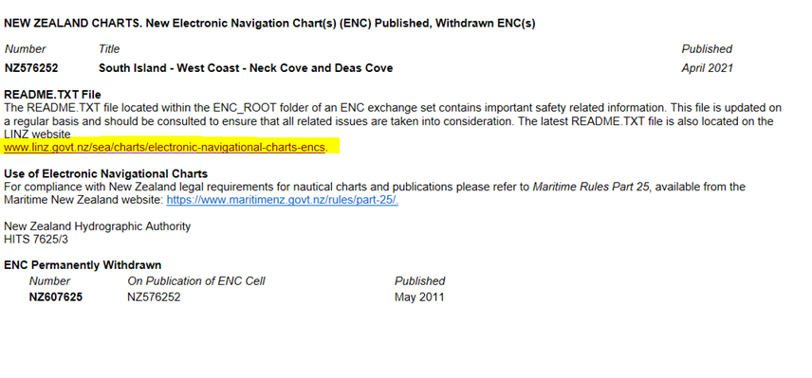

**Test_output:**

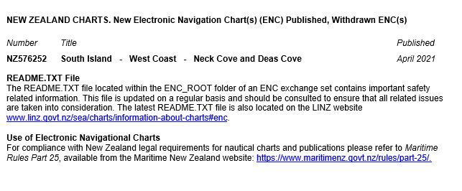

**Criteria for evaluating the results**

Open XML and apply stylesheet.

**Test Procedure**

1. Open the publication xml.
2. Apply the stylesheet.

Review the above corrections in updated style sheets which allow which allow display of the miscellaneous section of the NtM edition.