**No-load motor (stepper) for 4G63 engine.**

**The idle motor** (**MXX**) is designed to control the position of the air damper at speed XX. Depending on the load on the engine (air conditioning, low / high beam, rear window heating, etc.), the MXX changes the position of the air damper to stabilize the rpm of the XX.

**Symptoms of** MXX malfunction:

1. dips/revving XX when turning on the air conditioner or other significant load,
2. insufficient speed xx when warming up the engine,
3. the drop in rpm below the XX after the gas was discharged.

For the 4G 63 engine**, two types of** MXX were produced:

1. Until 1992, the MXX has a 10cm wiring harness with a connector at its end,
2. after 1992, the connection connector is located directly on the MXX housing.

Fig.1 and Fig.2 depict the MXX of the second type.

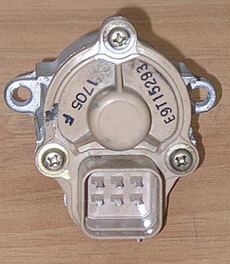

rice. 1

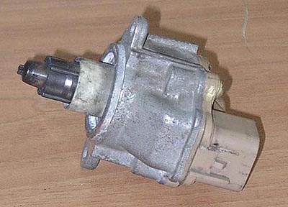

fig.2

MXX can have either **mechanical** (souring of the rotor due to the ingress of coolant, etc.) or **electrical** incorrectness (breakdown of one of the motor windings). To determine the integrity of the MXX windings, it is necessary to measure their resistance with the help of a tester (from the central terminals of the connector to the extreme ones). This resistance should be ~ 30 Ohms. To determine a mechanical malfunction, it is necessary to disassemble the body of the MXX (note that not all cases can be collapsible).

In Fig. Fig. 3 shows parts of the MXX.

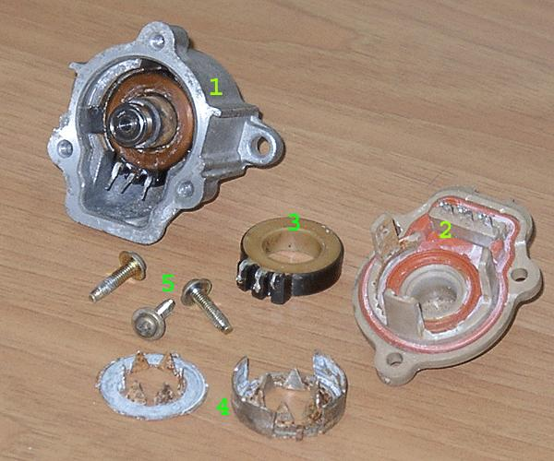

rice. 3

1 – body, lower winding, rotor;

2 – back cover with connector;

3 – upper winding;

4 – casing of the upper winding;

5 – mounting screws of the cover.

The design  **of the upper** and lower windings are  **identical,** so they are **interchangeable**. If you have two electrically faulty MXX (in each one of the windings burned out), then you can assemble one serviceable MXX.

**The price** of the new MXX is $170... 200, serviceable used - ~$50.

Michael Vorobiev

XX adjustment

1. Warm up the engine, not just turn, but drive around the city.   
2. Stop.   
2.1. Silence the engine.   
3. Open the hood.   
4. We find a small motor near the throttle valve, there is a connector (on the opposite side of the connector of the throttle position sensor, this is not that) we need a power connector for this motor.   
5. Turn it off.   
6. Find two adjustment screws 1st rests on the iron (you can see it), the 2nd rests on the drive rod (this is not visible).   
7. Unscrew the 2nd so that it is guaranteed not to rest on the rod.   
8. Release the fasteners of the cable of the throttle so that its tension does not affect, it should sag.   
Note - preparatory work to do quickly, but without fanaticism, just so as not to cool down the engine.   
9. Start, pause for a couple of minutes, warm up.   
10. Install 1 850 rpm screw.   
11. Screw in the second until a slight increase in rpm.   
12. At 1/4 of the turn, screw in the 1st screw. I.e. the position of the screws should be such that when the control is disabled, the 2nd screw rests on the rod, and the 1st should stand with a minimum gap, if not the same. It would be even more correct to check and set the voltage of the throttle position sensor, but this is quite correct, I honestly did not do this. At the starting point of  
the throttle position sensor, it is desirable to set  
0.6-0.65V, but no more (This is from the words of Icars)  
13. The result xx = 900 rpm. (in general, you need 750-850) But 900 works better for me, which I advise you, especially for the winter. And the engine growls smoother, and the climb is faster.   
14. Silence.   
15. Connect the connector.   
16. Adjust the position of the throttle cable, it should not be stretched, slight sagging.   
17. Check the full press on the pedal should open the throttle to the stop.   
18. Finally fix the position of the cable.   
19. Check the operation of the system. Starting, XX jumps to 1500-1700 and immediately with a jam falls to the nominal value.   
20. Close the hood and go for beer regardless of the result of the :)