###### Summary of the dataset

Number of patients: 131

Train X shape: (11397, 256, 256, 1) Train Masked: (11397, 256, 256)

Train Y shape: (11397, 256, 256, 1)

Val X shape: (3352, 256, 256, 1) Val X Masked: (3352, 256, 256)

Val Y shape: (3352, 256, 256, 1)

Test X shape: (4414, 256, 256, 1) Test X Masked: (4414, 256, 256)

Test Y shape: (4414, 256, 256, 1)

###### End Summary ##########

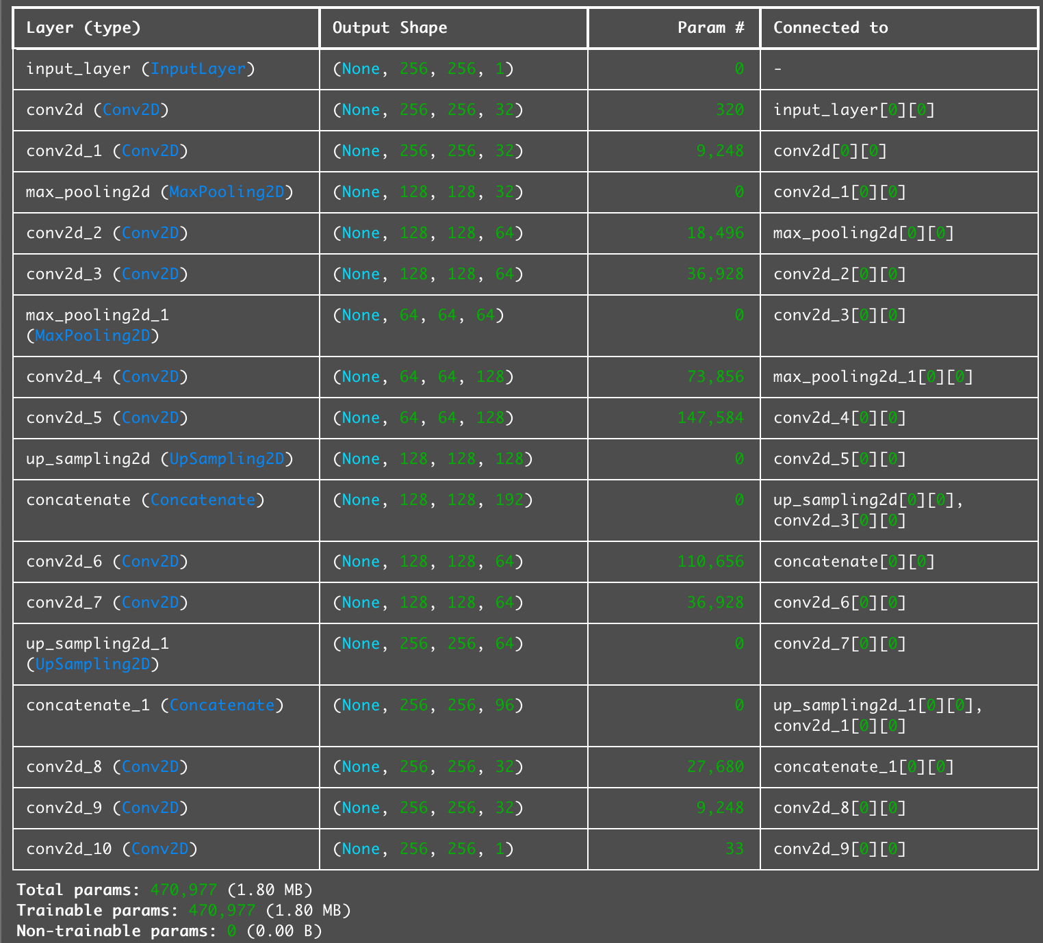

105/105 ━━━━━━━━━━━━━━━━━━━━ 6s 34ms/step - dice_coef: 0.5871 - iou_metric: 0.4190 - loss: 0.7360

Validation Dice and IoU: [0.7339532971382141, 0.5883432030677795, 0.4203396141529083]

Model saved to UNet_Model/saved_models/unet_ssl_ct_liver_131.keras

Training history saved to UNet_Model/saved_models/unet_ssl_ct_history_131.json

Total params: 470,977 (1.80 MB)

Trainable params: 470,977 (1.80 MB)

Non-trainable params: 0 (0.00 B)

90/90 - 106s - 1s/step - dice_coef: 0.5275 - iou_metric: 0.3627 - loss: 0.9031 - val_dice_coef: 0.5921 - val_iou_metric: 0.4228 - val_loss: 0.7440

Epoch 2/100

90/90 - 46s - 510ms/step - dice_coef: 0.6301 - iou_metric: 0.4601 - loss: 0.6995 - val_dice_coef: 0.6399 - val_iou_metric: 0.4729 - val_loss: 0.6912

Epoch 3/100

90/90 - 46s - 512ms/step - dice_coef: 0.6435 - iou_metric: 0.4744 - loss: 0.6736 - val_dice_coef: 0.6282 - val_iou_metric: 0.4603 - val_loss: 0.6878

Epoch 4/100

90/90 - 46s - 512ms/step - dice_coef: 0.6508 - iou_metric: 0.4824 - loss: 0.6564 - val_dice_coef: 0.6342 - val_iou_metric: 0.4668 - val_loss: 0.6551

Epoch 5/100

90/90 - 46s - 511ms/step - dice_coef: 0.6522 - iou_metric: 0.4840 - loss: 0.6553 - val_dice_coef: 0.6340 - val_iou_metric: 0.4666 - val_loss: 0.6566

Epoch 6/100

90/90 - 46s - 512ms/step - dice_coef: 0.6600 - iou_metric: 0.4926 - loss: 0.6381 - val_dice_coef: 0.6496 - val_iou_metric: 0.4835 - val_loss: 0.6369

Epoch 7/100

90/90 - 46s - 512ms/step - dice_coef: 0.6639 - iou_metric: 0.4969 - loss: 0.6293 - val_dice_coef: 0.6577 - val_iou_metric: 0.4925 - val_loss: 0.6362

Epoch 8/100

90/90 - 46s - 512ms/step - dice_coef: 0.6673 - iou_metric: 0.5008 - loss: 0.6234 - val_dice_coef: 0.6489 - val_iou_metric: 0.4828 - val_loss: 0.6601

Epoch 9/100

90/90 - 46s - 512ms/step - dice_coef: 0.6670 - iou_metric: 0.5004 - loss: 0.6238 - val_dice_coef: 0.6645 - val_iou_metric: 0.5000 - val_loss: 0.6372

Epoch 10/100

90/90 - 46s - 513ms/step - dice_coef: 0.6700 - iou_metric: 0.5038 - loss: 0.6179 - val_dice_coef: 0.6605 - val_iou_metric: 0.4957 - val_loss: 0.6234

Epoch 11/100

90/90 - 46s - 511ms/step - dice_coef: 0.6522 - iou_metric: 0.4843 - loss: 0.6570 - val_dice_coef: 0.6350 - val_iou_metric: 0.4677 - val_loss: 0.6554

Epoch 12/100

90/90 - 46s - 512ms/step - dice_coef: 0.6640 - iou_metric: 0.4971 - loss: 0.6289 - val_dice_coef: 0.6562 - val_iou_metric: 0.4908 - val_loss: 0.6278

Epoch 13/100

90/90 - 46s - 514ms/step - dice_coef: 0.6695 - iou_metric: 0.5033 - loss: 0.6203 - val_dice_coef: 0.6588 - val_iou_metric: 0.4938 - val_loss: 0.6221

Epoch 14/100

90/90 - 46s - 513ms/step - dice_coef: 0.6713 - iou_metric: 0.5053 - loss: 0.6141 - val_dice_coef: 0.6550 - val_iou_metric: 0.4895 - val_loss: 0.6285

Epoch 15/100

90/90 - 46s - 512ms/step - dice_coef: 0.6729 - iou_metric: 0.5071 - loss: 0.6139 - val_dice_coef: 0.6418 - val_iou_metric: 0.4751 - val_loss: 0.6305

Epoch 16/100

90/90 - 46s - 511ms/step - dice_coef: 0.6749 - iou_metric: 0.5093 - loss: 0.6076 - val_dice_coef: 0.6698 - val_iou_metric: 0.5060 - val_loss: 0.6134

Epoch 17/100

90/90 - 46s - 510ms/step - dice_coef: 0.6736 - iou_metric: 0.5079 - loss: 0.6125 - val_dice_coef: 0.6415 - val_iou_metric: 0.4747 - val_loss: 0.6410

Epoch 18/100

90/90 - 46s - 511ms/step - dice_coef: 0.6755 - iou_metric: 0.5100 - loss: 0.6063 - val_dice_coef: 0.6601 - val_iou_metric: 0.4952 - val_loss: 0.6117

Epoch 19/100

90/90 - 46s - 513ms/step - dice_coef: 0.6776 - iou_metric: 0.5124 - loss: 0.6018 - val_dice_coef: 0.6610 - val_iou_metric: 0.4962 - val_loss: 0.6208

Epoch 20/100

90/90 - 46s - 511ms/step - dice_coef: 0.6773 - iou_metric: 0.5121 - loss: 0.6026 - val_dice_coef: 0.6622 - val_iou_metric: 0.4975 - val_loss: 0.6104

Epoch 21/100

90/90 - 46s - 511ms/step - dice_coef: 0.6789 - iou_metric: 0.5139 - loss: 0.5987 - val_dice_coef: 0.6659 - val_iou_metric: 0.5017 - val_loss: 0.6071

Epoch 22/100

90/90 - 46s - 513ms/step - dice_coef: 0.6794 - iou_metric: 0.5145 - loss: 0.5979 - val_dice_coef: 0.6574 - val_iou_metric: 0.4922 - val_loss: 0.6154

Epoch 23/100

90/90 - 46s - 513ms/step - dice_coef: 0.6795 - iou_metric: 0.5147 - loss: 0.5967 - val_dice_coef: 0.6671 - val_iou_metric: 0.5031 - val_loss: 0.6059

Epoch 24/100

90/90 - 46s - 512ms/step - dice_coef: 0.6809 - iou_metric: 0.5162 - loss: 0.5956 - val_dice_coef: 0.6712 - val_iou_metric: 0.5078 - val_loss: 0.6052

Epoch 25/100

90/90 - 46s - 511ms/step - dice_coef: 0.6807 - iou_metric: 0.5160 - loss: 0.5951 - val_dice_coef: 0.6667 - val_iou_metric: 0.5027 - val_loss: 0.6052

Epoch 26/100

90/90 - 46s - 512ms/step - dice_coef: 0.6820 - iou_metric: 0.5175 - loss: 0.5940 - val_dice_coef: 0.6599 - val_iou_metric: 0.4950 - val_loss: 0.6062

Epoch 27/100

90/90 - 46s - 513ms/step - dice_coef: 0.6722 - iou_metric: 0.5064 - loss: 0.6142 - val_dice_coef: 0.6340 - val_iou_metric: 0.4663 - val_loss: 0.8707

Epoch 28/100

90/90 - 46s - 510ms/step - dice_coef: 0.6679 - iou_metric: 0.5015 - loss: 0.6271 - val_dice_coef: 0.6646 - val_iou_metric: 0.5002 - val_loss: 0.6130

Epoch 29/100

90/90 - 46s - 510ms/step - dice_coef: 0.6784 - iou_metric: 0.5134 - loss: 0.6030 - val_dice_coef: 0.6724 - val_iou_metric: 0.5091 - val_loss: 0.6117

Epoch 30/100

90/90 - 46s - 509ms/step - dice_coef: 0.6800 - iou_metric: 0.5152 - loss: 0.5981 - val_dice_coef: 0.6689 - val_iou_metric: 0.5051 - val_loss: 0.6039

Epoch 31/100

90/90 - 46s - 512ms/step - dice_coef: 0.6815 - iou_metric: 0.5170 - loss: 0.5949 - val_dice_coef: 0.6561 - val_iou_metric: 0.4907 - val_loss: 0.6054

Epoch 32/100

90/90 - 46s - 512ms/step - dice_coef: 0.6818 - iou_metric: 0.5172 - loss: 0.5928 - val_dice_coef: 0.6735 - val_iou_metric: 0.5103 - val_loss: 0.6098

Epoch 33/100

90/90 - 46s - 512ms/step - dice_coef: 0.6828 - iou_metric: 0.5184 - loss: 0.5915 - val_dice_coef: 0.6641 - val_iou_metric: 0.4998 - val_loss: 0.6006

Epoch 34/100

90/90 - 46s - 513ms/step - dice_coef: 0.6831 - iou_metric: 0.5188 - loss: 0.5903 - val_dice_coef: 0.6650 - val_iou_metric: 0.5007 - val_loss: 0.6033

Epoch 35/100

90/90 - 46s - 512ms/step - dice_coef: 0.6794 - iou_metric: 0.5145 - loss: 0.5993 - val_dice_coef: 0.6778 - val_iou_metric: 0.5152 - val_loss: 0.6072

Epoch 36/100

90/90 - 46s - 510ms/step - dice_coef: 0.6830 - iou_metric: 0.5187 - loss: 0.5914 - val_dice_coef: 0.6660 - val_iou_metric: 0.5019 - val_loss: 0.6016

Epoch 37/100

90/90 - 46s - 511ms/step - dice_coef: 0.6836 - iou_metric: 0.5193 - loss: 0.5896 - val_dice_coef: 0.6766 - val_iou_metric: 0.5139 - val_loss: 0.6034

Epoch 38/100

90/90 - 46s - 511ms/step - dice_coef: 0.6842 - iou_metric: 0.5201 - loss: 0.5885 - val_dice_coef: 0.6718 - val_iou_metric: 0.5084 - val_loss: 0.5983

Epoch 39/100

90/90 - 46s - 510ms/step - dice_coef: 0.6843 - iou_metric: 0.5202 - loss: 0.5881 - val_dice_coef: 0.6773 - val_iou_metric: 0.5147 - val_loss: 0.5997

Epoch 40/100

90/90 - 46s - 511ms/step - dice_coef: 0.6840 - iou_metric: 0.5198 - loss: 0.5899 - val_dice_coef: 0.6556 - val_iou_metric: 0.4903 - val_loss: 0.6154

Epoch 41/100

90/90 - 46s - 511ms/step - dice_coef: 0.6829 - iou_metric: 0.5185 - loss: 0.5927 - val_dice_coef: 0.6652 - val_iou_metric: 0.5010 - val_loss: 0.6071

Epoch 42/100

90/90 - 46s - 512ms/step - dice_coef: 0.6841 - iou_metric: 0.5199 - loss: 0.5888 - val_dice_coef: 0.6729 - val_iou_metric: 0.5097 - val_loss: 0.5984

Epoch 43/100

90/90 - 46s - 512ms/step - dice_coef: 0.6851 - iou_metric: 0.5211 - loss: 0.5874 - val_dice_coef: 0.6610 - val_iou_metric: 0.4962 - val_loss: 0.6023

Epoch 44/100

90/90 - 46s - 511ms/step - dice_coef: 0.6849 - iou_metric: 0.5209 - loss: 0.5874 - val_dice_coef: 0.6766 - val_iou_metric: 0.5139 - val_loss: 0.5971

Epoch 45/100

90/90 - 46s - 510ms/step - dice_coef: 0.6862 - iou_metric: 0.5224 - loss: 0.5859 - val_dice_coef: 0.6692 - val_iou_metric: 0.5055 - val_loss: 0.5987

Epoch 46/100

90/90 - 46s - 511ms/step - dice_coef: 0.6856 - iou_metric: 0.5217 - loss: 0.5850 - val_dice_coef: 0.6780 - val_iou_metric: 0.5154 - val_loss: 0.5986

Epoch 47/100

90/90 - 46s - 512ms/step - dice_coef: 0.6864 - iou_metric: 0.5225 - loss: 0.5845 - val_dice_coef: 0.6716 - val_iou_metric: 0.5082 - val_loss: 0.5971

Epoch 48/100

90/90 - 46s - 514ms/step - dice_coef: 0.6868 - iou_metric: 0.5230 - loss: 0.5833 - val_dice_coef: 0.6734 - val_iou_metric: 0.5102 - val_loss: 0.5939

Epoch 49/100

90/90 - 46s - 513ms/step - dice_coef: 0.6872 - iou_metric: 0.5236 - loss: 0.5823 - val_dice_coef: 0.6667 - val_iou_metric: 0.5026 - val_loss: 0.5956

Epoch 50/100

90/90 - 46s - 511ms/step - dice_coef: 0.6882 - iou_metric: 0.5247 - loss: 0.5816 - val_dice_coef: 0.6627 - val_iou_metric: 0.4982 - val_loss: 0.6055

Epoch 51/100

90/90 - 46s - 511ms/step - dice_coef: 0.6876 - iou_metric: 0.5240 - loss: 0.5814 - val_dice_coef: 0.6724 - val_iou_metric: 0.5091 - val_loss: 0.5941

Epoch 52/100

^[[C90/90 - 46s - 512ms/step - dice_coef: 0.6881 - iou_metric: 0.5245 - loss: 0.5807 - val_dice_coef: 0.6759 - val_iou_metric: 0.5131 - val_loss: 0.5966

Epoch 53/100

90/90 - 46s - 510ms/step - dice_coef: 0.6885 - iou_metric: 0.5250 - loss: 0.5804 - val_dice_coef: 0.6788 - val_iou_metric: 0.5164 - val_loss: 0.5965

Epoch 54/100

90/90 - 46s - 512ms/step - dice_coef: 0.6879 - iou_metric: 0.5243 - loss: 0.5805 - val_dice_coef: 0.6698 - val_iou_metric: 0.5060 - val_loss: 0.5964

Epoch 55/100

90/90 - 46s - 514ms/step - dice_coef: 0.6882 - iou_metric: 0.5247 - loss: 0.5802 - val_dice_coef: 0.6700 - val_iou_metric: 0.5064 - val_loss: 0.5946

Epoch 56/100

90/90 - 46s - 512ms/step - dice_coef: 0.6891 - iou_metric: 0.5257 - loss: 0.5789 - val_dice_coef: 0.6654 - val_iou_metric: 0.5011 - val_loss: 0.5984

Epoch 57/100

90/90 - 46s - 511ms/step - dice_coef: 0.6884 - iou_metric: 0.5249 - loss: 0.5792 - val_dice_coef: 0.6711 - val_iou_metric: 0.5076 - val_loss: 0.5930

Epoch 58/100

90/90 - 46s - 510ms/step - dice_coef: 0.6876 - iou_metric: 0.5239 - loss: 0.5822 - val_dice_coef: 0.6567 - val_iou_metric: 0.4914 - val_loss: 0.6218

Epoch 59/100

90/90 - 46s - 510ms/step - dice_coef: 0.6844 - iou_metric: 0.5203 - loss: 0.5895 - val_dice_coef: 0.6673 - val_iou_metric: 0.5033 - val_loss: 0.5969

Epoch 60/100

90/90 - 46s - 512ms/step - dice_coef: 0.6879 - iou_metric: 0.5243 - loss: 0.5817 - val_dice_coef: 0.6748 - val_iou_metric: 0.5119 - val_loss: 0.5963

Epoch 61/100

90/90 - 46s - 513ms/step - dice_coef: 0.6881 - iou_metric: 0.5245 - loss: 0.5813 - val_dice_coef: 0.6662 - val_iou_metric: 0.5021 - val_loss: 0.5974

Epoch 62/100

90/90 - 46s - 514ms/step - dice_coef: 0.6899 - iou_metric: 0.5267 - loss: 0.5784 - val_dice_coef: 0.6716 - val_iou_metric: 0.5082 - val_loss: 0.5924

Epoch 63/100

90/90 - 46s - 512ms/step - dice_coef: 0.6902 - iou_metric: 0.5270 - loss: 0.5772 - val_dice_coef: 0.6721 - val_iou_metric: 0.5088 - val_loss: 0.5955

Epoch 64/100

90/90 - 46s - 510ms/step - dice_coef: 0.6899 - iou_metric: 0.5266 - loss: 0.5773 - val_dice_coef: 0.6752 - val_iou_metric: 0.5123 - val_loss: 0.5912

Epoch 65/100

90/90 - 46s - 510ms/step - dice_coef: 0.6739 - iou_metric: 0.5086 - loss: 0.6131 - val_dice_coef: 0.6691 - val_iou_metric: 0.5053 - val_loss: 0.6130

Epoch 66/100

90/90 - 46s - 511ms/step - dice_coef: 0.6840 - iou_metric: 0.5198 - loss: 0.5901 - val_dice_coef: 0.6769 - val_iou_metric: 0.5142 - val_loss: 0.6017

Epoch 67/100

90/90 - 46s - 512ms/step - dice_coef: 0.6867 - iou_metric: 0.5229 - loss: 0.5841 - val_dice_coef: 0.6723 - val_iou_metric: 0.5090 - val_loss: 0.5981

Epoch 68/100

90/90 - 46s - 510ms/step - dice_coef: 0.6885 - iou_metric: 0.5250 - loss: 0.5799 - val_dice_coef: 0.6657 - val_iou_metric: 0.5015 - val_loss: 0.6002

Epoch 69/100

90/90 - 46s - 510ms/step - dice_coef: 0.6885 - iou_metric: 0.5250 - loss: 0.5793 - val_dice_coef: 0.6693 - val_iou_metric: 0.5056 - val_loss: 0.5950

Epoch 70/100

90/90 - 46s - 510ms/step - dice_coef: 0.6895 - iou_metric: 0.5262 - loss: 0.5773 - val_dice_coef: 0.6682 - val_iou_metric: 0.5043 - val_loss: 0.5943

Epoch 71/100

90/90 - 46s - 512ms/step - dice_coef: 0.6904 - iou_metric: 0.5272 - loss: 0.5764 - val_dice_coef: 0.6742 - val_iou_metric: 0.5112 - val_loss: 0.5922

Epoch 72/100

90/90 - 46s - 513ms/step - dice_coef: 0.6906 - iou_metric: 0.5275 - loss: 0.5759 - val_dice_coef: 0.6668 - val_iou_metric: 0.5027 - val_loss: 0.5927

Epoch 73/100

90/90 - 46s - 511ms/step - dice_coef: 0.6913 - iou_metric: 0.5283 - loss: 0.5754 - val_dice_coef: 0.6684 - val_iou_metric: 0.5046 - val_loss: 0.5924

Epoch 74/100

90/90 - 46s - 511ms/step - dice_coef: 0.6849 - iou_metric: 0.5209 - loss: 0.5885 - val_dice_coef: 0.6667 - val_iou_metric: 0.5026 - val_loss: 0.6004

Epoch 75/100

90/90 - 46s - 514ms/step - dice_coef: 0.6898 - iou_metric: 0.5266 - loss: 0.5780 - val_dice_coef: 0.6706 - val_iou_metric: 0.5070 - val_loss: 0.5926

Epoch 76/100

90/90 - 46s - 512ms/step - dice_coef: 0.6907 - iou_metric: 0.5276 - loss: 0.5763 - val_dice_coef: 0.6741 - val_iou_metric: 0.5111 - val_loss: 0.5935

Epoch 77/100

90/90 - 46s - 510ms/step - dice_coef: 0.6911 - iou_metric: 0.5281 - loss: 0.5754 - val_dice_coef: 0.6606 - val_iou_metric: 0.4958 - val_loss: 0.6017

Epoch 78/100

90/90 - 46s - 510ms/step - dice_coef: 0.6907 - iou_metric: 0.5276 - loss: 0.5749 - val_dice_coef: 0.6750 - val_iou_metric: 0.5120 - val_loss: 0.5896

Epoch 79/100

90/90 - 46s - 510ms/step - dice_coef: 0.6920 - iou_metric: 0.5291 - loss: 0.5736 - val_dice_coef: 0.6808 - val_iou_metric: 0.5187 - val_loss: 0.5891

Epoch 80/100

90/90 - 46s - 511ms/step - dice_coef: 0.6916 - iou_metric: 0.5287 - loss: 0.5737 - val_dice_coef: 0.6705 - val_iou_metric: 0.5069 - val_loss: 0.5979

Epoch 81/100

90/90 - 46s - 510ms/step - dice_coef: 0.6921 - iou_metric: 0.5293 - loss: 0.5732 - val_dice_coef: 0.6694 - val_iou_metric: 0.5056 - val_loss: 0.5902

Epoch 82/100

90/90 - 46s - 510ms/step - dice_coef: 0.6923 - iou_metric: 0.5295 - loss: 0.5722 - val_dice_coef: 0.6736 - val_iou_metric: 0.5104 - val_loss: 0.6039

Epoch 83/100

90/90 - 46s - 510ms/step - dice_coef: 0.6919 - iou_metric: 0.5290 - loss: 0.5738 - val_dice_coef: 0.6676 - val_iou_metric: 0.5036 - val_loss: 0.5978

Epoch 84/100

90/90 - 46s - 510ms/step - dice_coef: 0.6927 - iou_metric: 0.5299 - loss: 0.5718 - val_dice_coef: 0.6738 - val_iou_metric: 0.5106 - val_loss: 0.5884

Epoch 85/100

90/90 - 46s - 510ms/step - dice_coef: 0.6931 - iou_metric: 0.5303 - loss: 0.5710 - val_dice_coef: 0.6723 - val_iou_metric: 0.5090 - val_loss: 0.5896

Epoch 86/100

90/90 - 46s - 512ms/step - dice_coef: 0.6932 - iou_metric: 0.5305 - loss: 0.5708 - val_dice_coef: 0.6768 - val_iou_metric: 0.5141 - val_loss: 0.5877

Epoch 87/100

90/90 - 46s - 512ms/step - dice_coef: 0.6937 - iou_metric: 0.5311 - loss: 0.5705 - val_dice_coef: 0.6726 - val_iou_metric: 0.5093 - val_loss: 0.5894

Epoch 88/100

90/90 - 46s - 511ms/step - dice_coef: 0.6933 - iou_metric: 0.5306 - loss: 0.5699 - val_dice_coef: 0.6867 - val_iou_metric: 0.5255 - val_loss: 0.5905

Epoch 89/100

90/90 - 46s - 510ms/step - dice_coef: 0.6940 - iou_metric: 0.5314 - loss: 0.5703 - val_dice_coef: 0.6698 - val_iou_metric: 0.5061 - val_loss: 0.5951

Epoch 90/100

90/90 - 46s - 510ms/step - dice_coef: 0.6938 - iou_metric: 0.5312 - loss: 0.5707 - val_dice_coef: 0.6702 - val_iou_metric: 0.5066 - val_loss: 0.5954

Epoch 91/100

90/90 - 46s - 510ms/step - dice_coef: 0.6934 - iou_metric: 0.5308 - loss: 0.5703 - val_dice_coef: 0.6738 - val_iou_metric: 0.5106 - val_loss: 0.5911

Epoch 92/100

90/90 - 46s - 510ms/step - dice_coef: 0.6936 - iou_metric: 0.5310 - loss: 0.5694 - val_dice_coef: 0.6781 - val_iou_metric: 0.5155 - val_loss: 0.5894

Epoch 93/100

90/90 - 46s - 510ms/step - dice_coef: 0.6950 - iou_metric: 0.5326 - loss: 0.5685 - val_dice_coef: 0.6761 - val_iou_metric: 0.5133 - val_loss: 0.5874

Epoch 94/100

90/90 - 46s - 510ms/step - dice_coef: 0.6947 - iou_metric: 0.5322 - loss: 0.5683 - val_dice_coef: 0.6717 - val_iou_metric: 0.5082 - val_loss: 0.5943

Epoch 95/100

90/90 - 46s - 511ms/step - dice_coef: 0.6952 - iou_metric: 0.5329 - loss: 0.5681 - val_dice_coef: 0.6636 - val_iou_metric: 0.4992 - val_loss: 0.5944

Epoch 96/100

90/90 - 46s - 511ms/step - dice_coef: 0.6948 - iou_metric: 0.5323 - loss: 0.5677 - val_dice_coef: 0.6684 - val_iou_metric: 0.5046 - val_loss: 0.5936

Epoch 97/100

90/90 - 46s - 510ms/step - dice_coef: 0.6957 - iou_metric: 0.5334 - loss: 0.5672 - val_dice_coef: 0.6724 - val_iou_metric: 0.5092 - val_loss: 0.5891

Epoch 98/100

90/90 - 46s - 511ms/step - dice_coef: 0.6926 - iou_metric: 0.5298 - loss: 0.5730 - val_dice_coef: 0.6796 - val_iou_metric: 0.5173 - val_loss: 0.5945

Epoch 99/100

90/90 - 46s - 514ms/step - dice_coef: 0.6942 - iou_metric: 0.5317 - loss: 0.5687 - val_dice_coef: 0.6742 - val_iou_metric: 0.5110 - val_loss: 0.5956

Epoch 100/100

90/90 - 46s - 513ms/step - dice_coef: 0.6947 - iou_metric: 0.5322 - loss: 0.5682 - val_dice_coef: 0.6562 - val_iou_metric: 0.4909 - val_loss: 0.6282

105/105 ━━━━━━━━━━━━━━━━━━━━ 6s 34ms/step - dice_coef: 0.6504 - iou_metric: 0.4860 - loss: 0.6356

Validation Dice and IoU: [0.6320587992668152, 0.6535157561302185, 0.4890926778316498]

Model saved to UNet_Model/saved_models/unet_ssl_ct_liver_131.keras

Training history saved to UNet_Model/saved_models/unet_ssl_ct_history_131.json

Model: "functional"

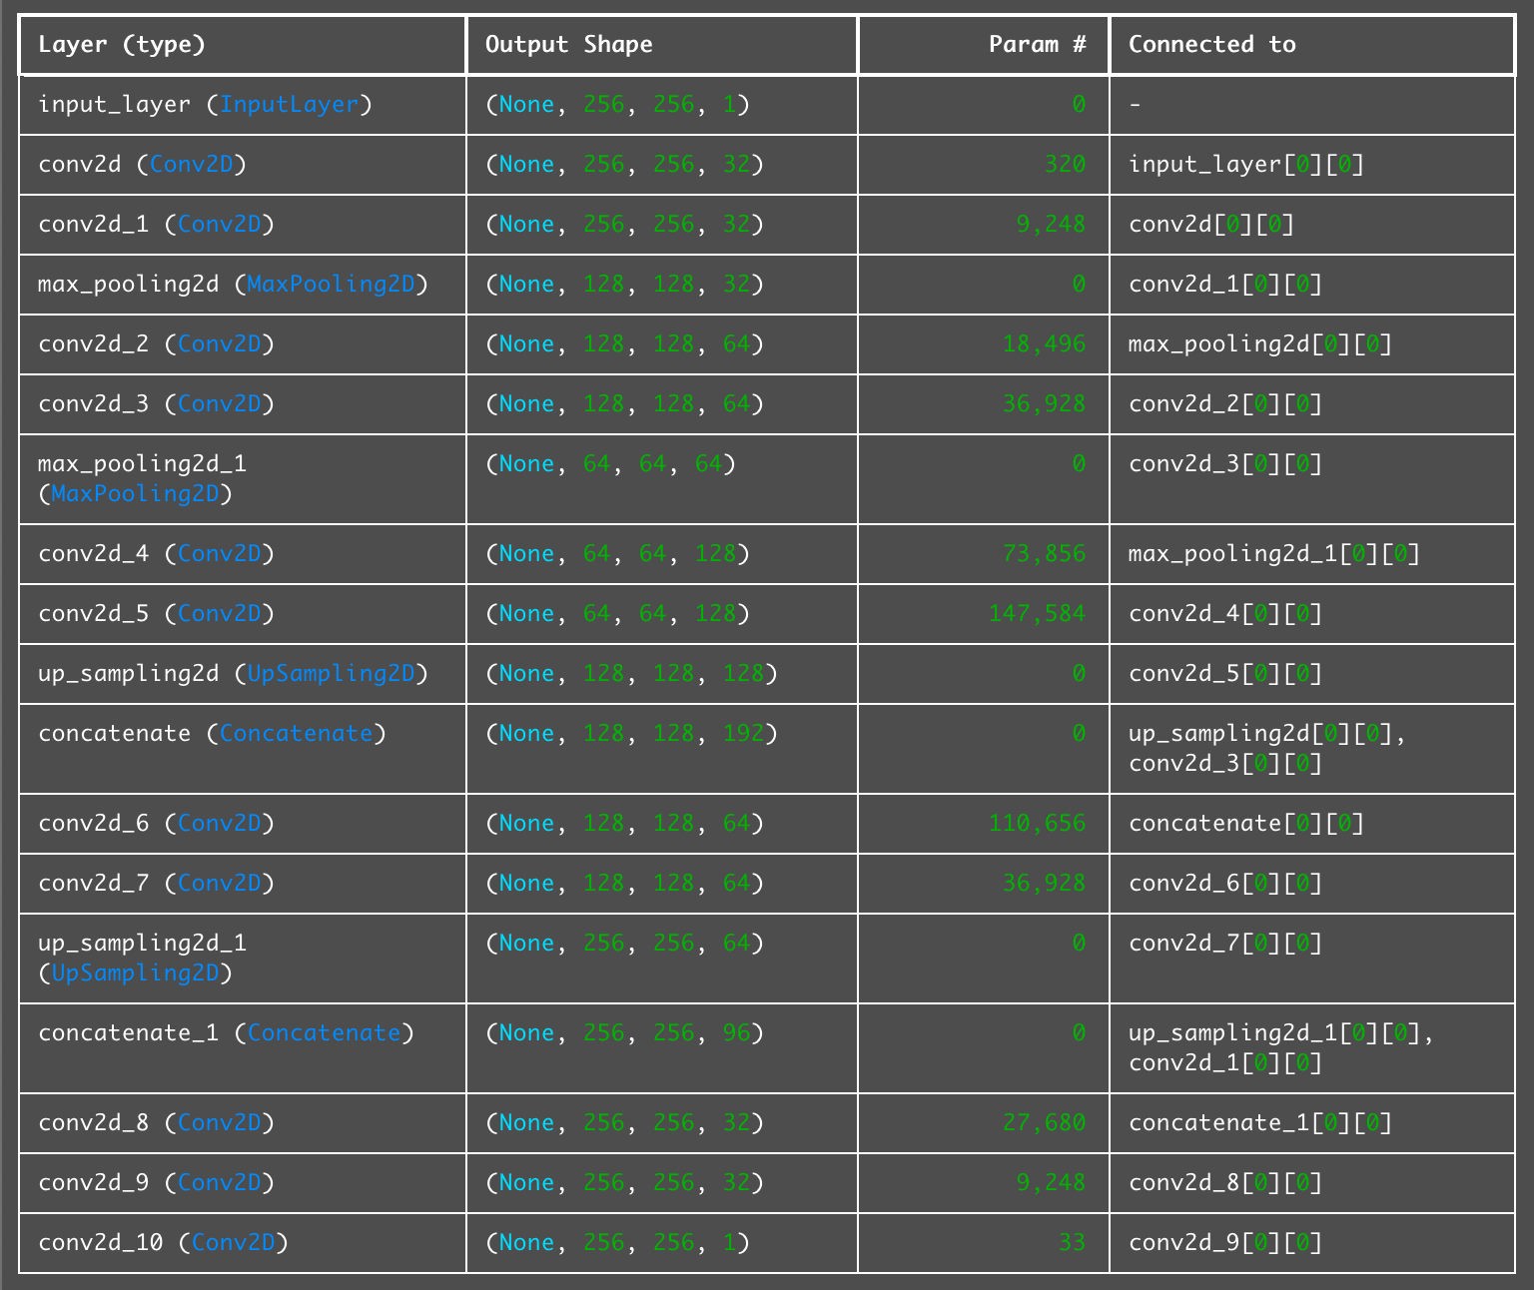

Total params: 1,412,933 (5.39 MB)

Trainable params: 470,977 (1.80 MB)

Non-trainable params: 0 (0.00 B)

Optimizer params: 941,956 (3.59 MB)

total patients for testing: 27

Evaluating...

Mean Dice score per slice: 0.6821

Mean IoU score per slice: 0.5222

Mean Dice score per patient: 0.6837

Mean IoU score per patient: 0.5243