EXPERIMENT 8
End-to-End Machine Learning Pipeline and Deployment
SMS Spam Detection using TF-IDF and Logistic Regression

Divy Pashine
J042
Website link- https://spam-classifier.dpashine.tech
Github url- https://github.com/dpashine10/end-to-end_MLOPS

1. Aim
To develop an end-to-end machine learning application that classifies SMS text as spam or not spam, packages the inference API for deployment, uses GitHub Actions for continuous integration, and monitors application behavior and offline model evaluation with Prometheus and Grafana.

2. Technologies used
- Python 3.11 and uv for environment and dependency management.
- Git and GitHub Actions for version control and CI checks.
- TF-IDF and Logistic Regression for text classification.
- FastAPI and Uvicorn for the prediction API.
- HTML, CSS, and JavaScript for the frontend.
- Docker and Docker Compose for containerization and service orchestration.
- Prometheus for collecting metrics and Grafana for dashboard visualization.

3. Implementation procedure

Project setup and version control
Initialize the project directory as a Git repository and create the Python project with uv. This establishes source-code history and a managed Python environment.

Continuous integration and code-quality checks
GitHub Actions runs the configured workflow. Ruff reports an import-ordering issue in one captured run. Such findings should be fixed and the workflow rerun. The workflow history records later iteration, with both successful and failed runs visible.

Containerize the API
The Dockerfile installs project dependencies, copies application files, creates a non-root user, exposes the API port, defines a health check, and starts the FastAPI service.

Define the deployment stack
Docker Compose describes the API, Prometheus, and Grafana services and passes configuration through environment variables. The displayed port mappings bind to loopback.

Start the stack
Use the Docker Compose startup command from the project directory. Confirm container status and health separately; a screenshot of the command itself is not proof of a successful launch.

Use the web interface
Open the frontend, enter or paste an SMS message, and submit it to the API for inference.

Review prediction output
The example output shows a “Likely spam” classification, a 51.8% spam probability, and model version 1.0.0. This demonstrates the prediction flow but does not measure generalization performance.

Inspect Prometheus metrics
Query the request counter to inspect traffic grouped by endpoint and HTTP status.

Review Grafana dashboard
Use the final dashboard to review request rate, model-loaded status, offline spam F1, errors, latency, and prediction counts.

4. Results visible in the supplied evidence
- Git and uv project initialization are shown.
- GitHub Actions executes CI checks and surfaces a Ruff import-ordering issue.
- Docker and Compose configuration is shown for the API and monitoring services.
- The browser interface displays an example classification.
- The example prediction displays a spam probability of 51.8%.
- Prometheus displays request-counter series for multiple endpoints and statuses.
- Grafana displays an offline spam F1 value of 0.864 for the selected dashboard view.

5. Limitations and verification notes
- The screenshots do not show the full dataset download and training process, so dataset size, split details, and training parameters are not asserted here.
- The 51.8% spam probability is an individual prediction score, not model accuracy.
- The displayed offline spam F1 value of 0.864 is reported as shown; the screenshots do not include the evaluation dataset or calculation details.
- The CI history includes failures as well as successes. The current commit should be checked to confirm that all required jobs pass.
- The Compose command screenshot alone does not prove all services are healthy. Check with docker compose ps and inspect logs if needed.
- The Grafana error-rate panel shows no data in the selected time range. This is not equivalent to a measured zero error rate.
- Before exposing services publicly, configure HTTPS and appropriate access controls. Prometheus and Grafana should not be exposed without suitable protection.

6. Conclusion
The evidence demonstrates the main stages of the SMS Spam Detection MLOps project: project setup, automated code checks, container configuration, a web-based inference interface, and monitoring with Prometheus and Grafana. The screenshots have been reorganized into a step-by-step sequence, with Prometheus and the Grafana dashboard at the end. Final verification should include rerunning CI on the current commit and confirming the health of the deployed services.

7. Screenshots in workflow order
Each screenshot is placed on its own page to keep the evidence readable. The monitoring evidence is intentionally last, ending with the Grafana dashboard.

Figure 1. Initialize the Git repository
The project directory is initialized as a local Git repository. Git provides version control for source files and configuration changes.
Figure 2. Initialize the Python project with uv
The Python project is initialized with uv and Python 3.11, establishing the project environment and dependency-management workflow.
Figure 3. CI detects a Ruff import-ordering issue
The GitHub Actions job reaches the Ruff check and reports I001 in main.py, indicating that the import block needs sorting or formatting. This is a CI finding that should be corrected; it is not evidence that this particular run passed.
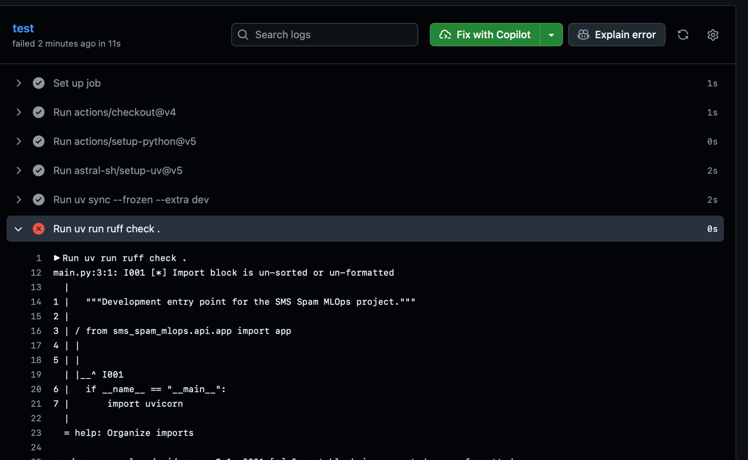

Figure 4. GitHub Actions workflow history after iterative changes
The workflow history shows six runs on the main branch, including successful and failed runs. It documents iterative development and troubleshooting; the image does not mean every run succeeded.
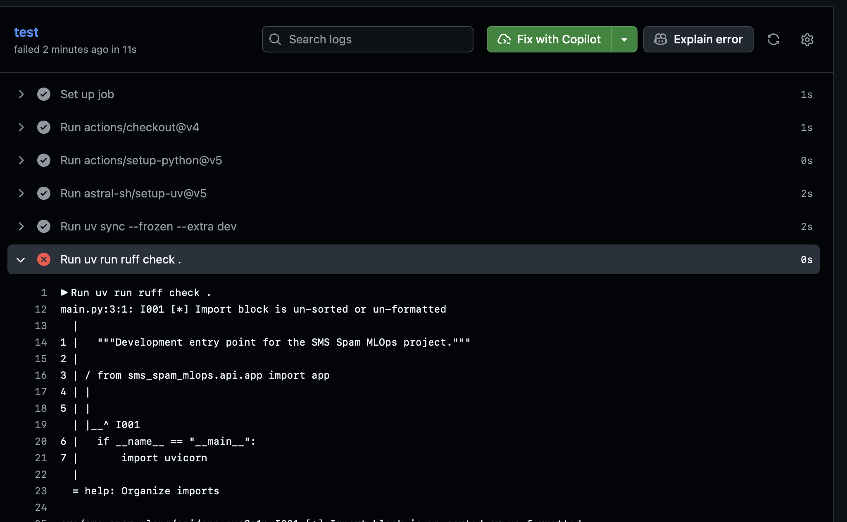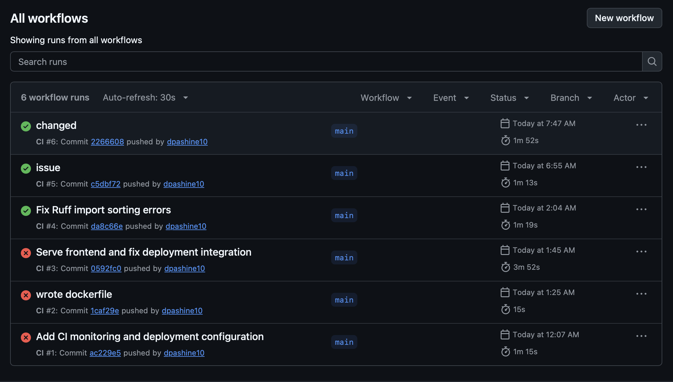
Figure 5. Configure the application Docker image
The Dockerfile installs dependencies using uv, copies the source code and supporting directories, creates a non-root application user, exposes port 8000, defines a health check, and starts the FastAPI application using Uvicorn.
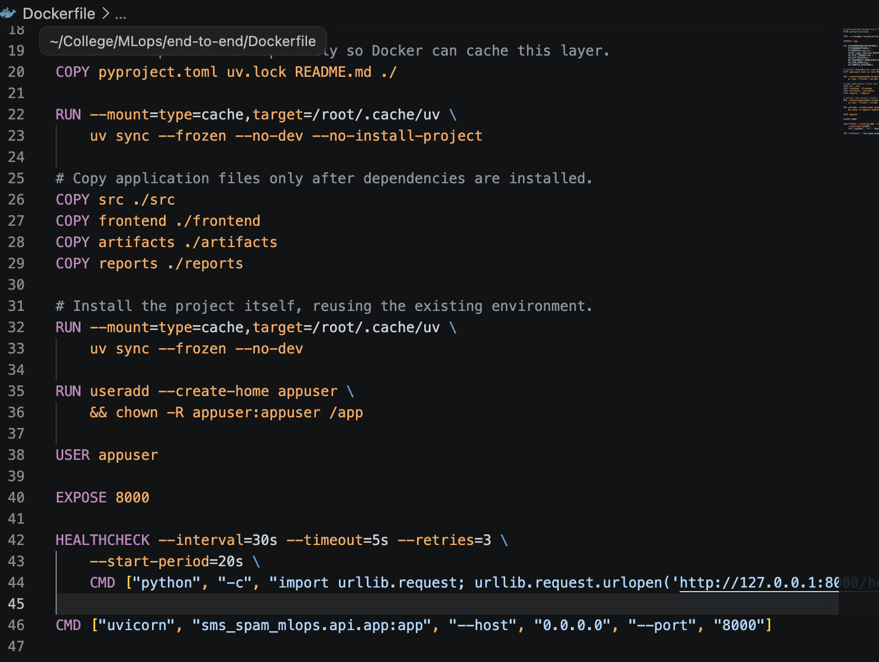
Figure 6. Define API, Prometheus, and Grafana services
The Docker Compose configuration defines the API, Prometheus, and Grafana services. The API receives CORS and model-quality threshold settings through environment variables. The shown host-port mappings bind to loopback, so they are not directly exposed on all network interfaces.

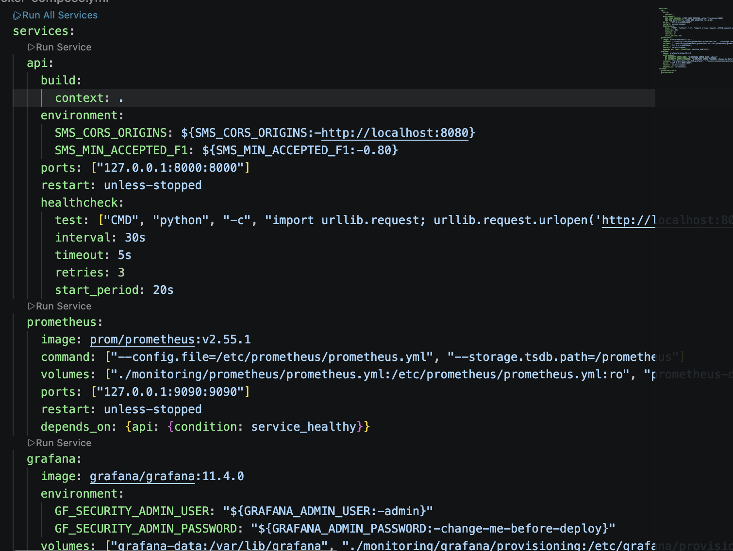
Figure 7. Prepare to start the Docker Compose stack
The terminal shows the Docker Compose startup command being entered. This records the intended launch step, but the command screenshot alone does not establish that every container became healthy.
Figure 8. Open the SMS Spam Detector interface
The browser displays the SMS Spam Detector website. The page contains a message-entry field, character counter, example-message controls, and a button for submitting a message for classification.
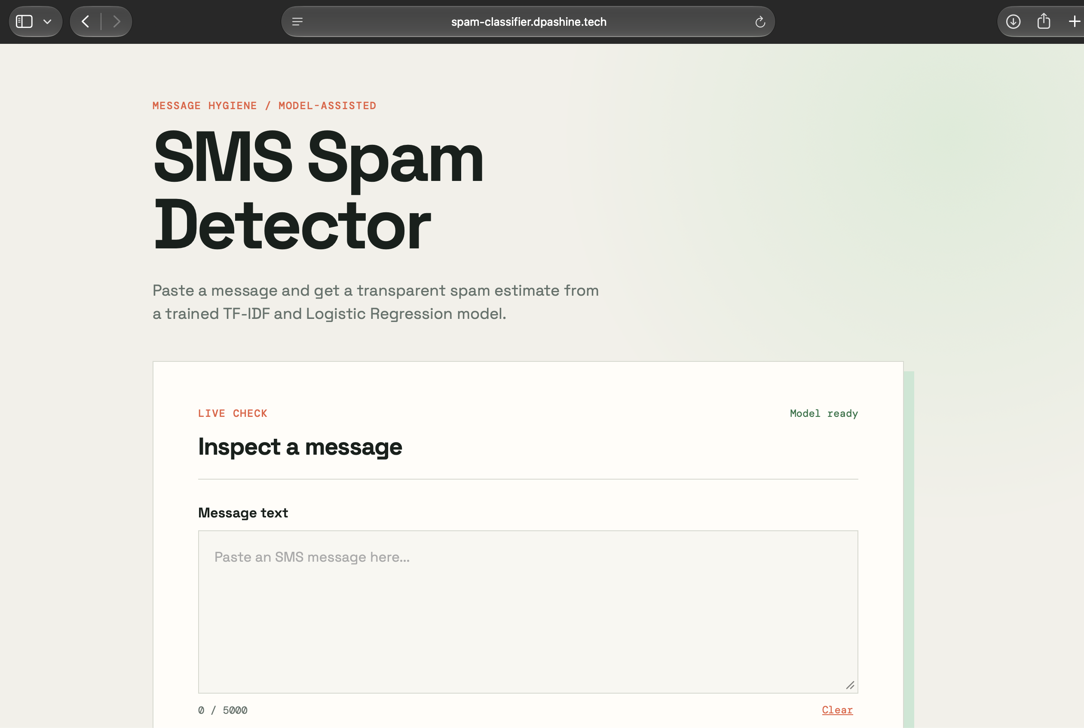

Figure 9. Display a model prediction in the frontend
The submitted example is displayed as “Likely spam,” with a spam probability of 51.8% and model version 1.0.0. The interface states that the score is an estimate rather than a guarantee. This is one prediction example, not an overall accuracy measurement.

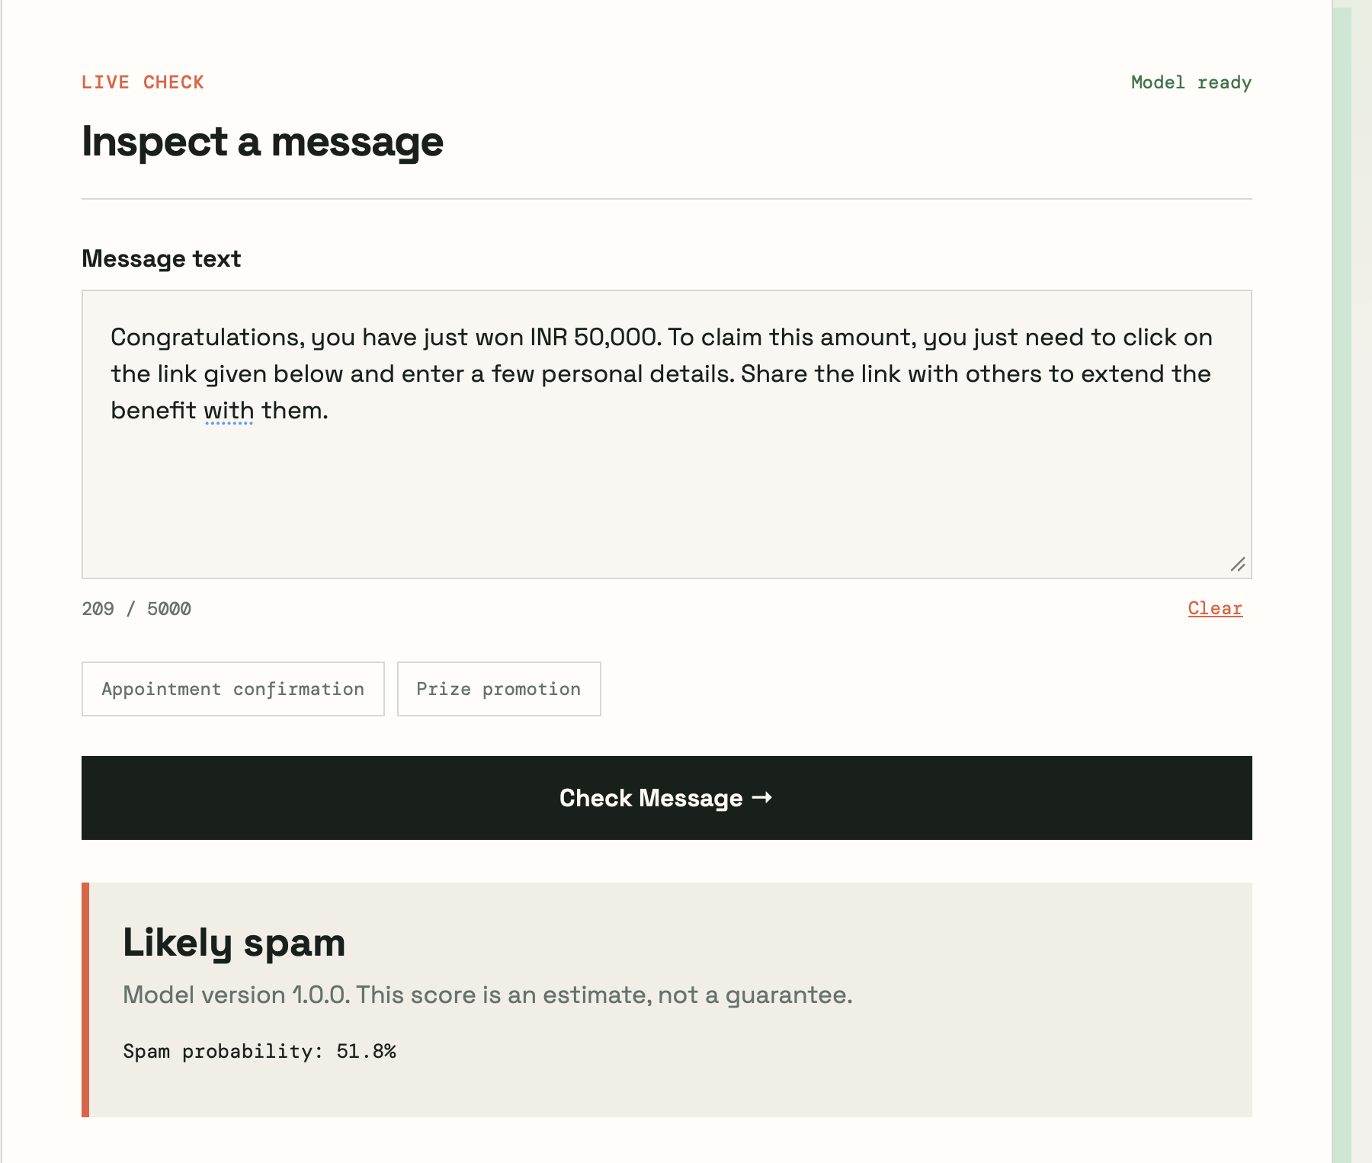
Figure 10. Inspect API request counters in Prometheus
The Prometheus query result for sms_http_requests_total shows request counters grouped by endpoint and HTTP status. The listed series include requests to /health, /metrics, /predict, and other routes, with both successful and non-200 responses.

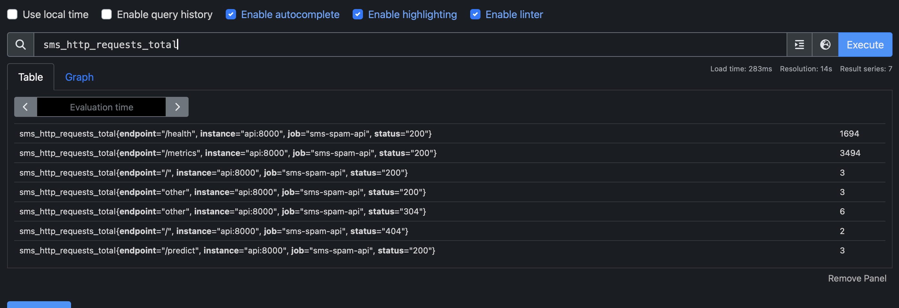
Figure 11. Review the monitoring dashboard in Grafana
The Grafana dashboard is placed last as the final monitoring view. It contains panels for API request rate, model-loaded status, offline spam F1, error rate, p95 latency, and prediction counts. The displayed offline spam F1 is 0.864. The error-rate panel shows “No data” for the selected time range, which should not be interpreted as proof that no errors occurred.


