knitr output

Devin

November 7, 2014

libraries <- c("dplyr",  
 "ggplot2",  
 "knitr",  
 "PKPDdatasets",  
 "PKPDmisc"  
 )  
suppressMessages(sapply(libraries, require, character.only=T))

## dplyr ggplot2 knitr PKPDdatasets PKPDmisc   
## TRUE TRUE TRUE TRUE TRUE

opts_chunk$set(cache=T)

oral_data <- dapa_IV_oral %>% filter(FORMULATION == "ORAL")  
head(oral_data)

## ID TIME TAD COBS AMT_IV AMT_ORAL OCC AGE WEIGHT GENDER FORMULATION  
## 1 1 168.00 0.00 0.0000 0 5000 2 44 70.5 0 ORAL  
## 2 1 168.05 0.05 13.7152 0 0 2 44 70.5 0 ORAL  
## 3 1 168.35 0.35 62.3357 0 0 2 44 70.5 0 ORAL  
## 4 1 168.50 0.50 67.9444 0 0 2 44 70.5 0 ORAL  
## 5 1 168.75 0.75 66.3308 0 0 2 44 70.5 0 ORAL  
## 6 1 169.00 1.00 86.3231 0 0 2 44 70.5 0 ORAL

### Plot 1

pdf

ggplot(oral_data, aes(x = TAD, y = COBS, group = interaction(ID, OCC), color = factor(OCC))) + geom_line() +   
 facet_wrap(~ID)



png (default dpi - 96)

ggplot(oral_data, aes(x = TAD, y = COBS, group = interaction(ID, OCC), color = factor(OCC))) + geom_line() +   
 facet_wrap(~ID)

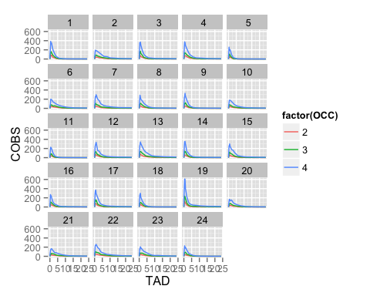

png 300

ggplot(oral_data, aes(x = TAD, y = COBS, group = interaction(ID, OCC), color = factor(OCC))) + geom_line() +   
 facet_wrap(~ID)

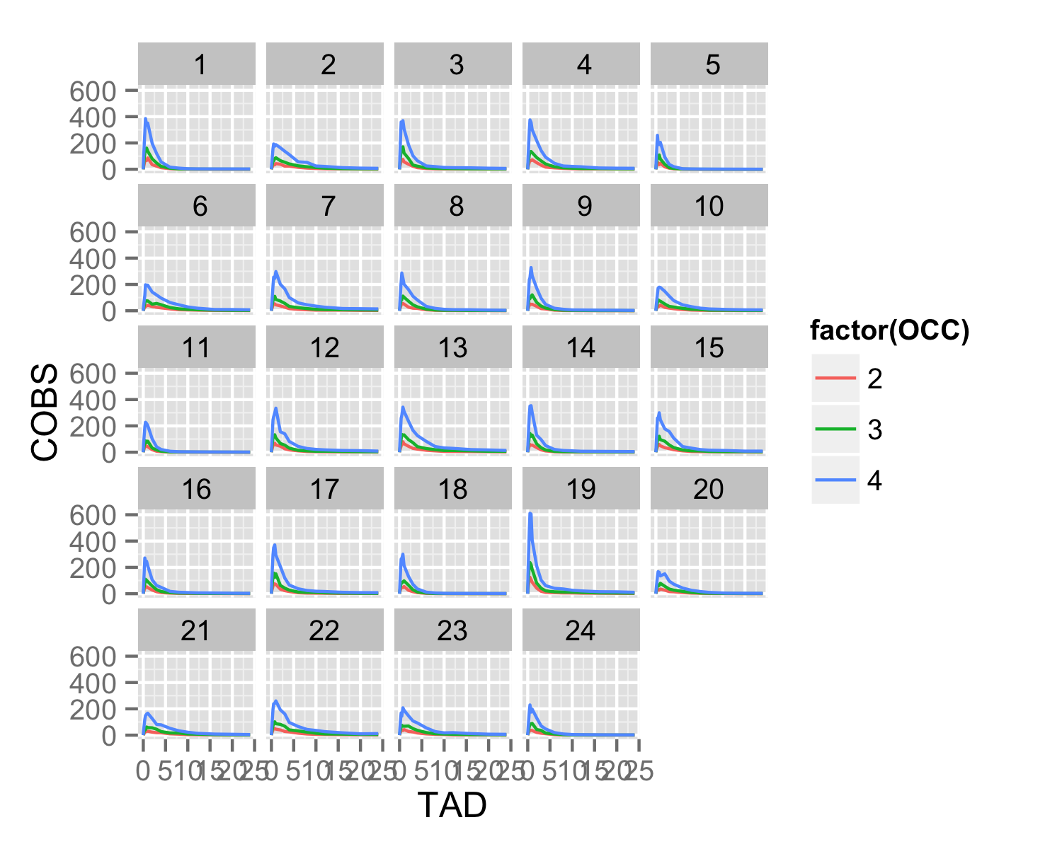

devtools::session_info()

## Session info--------------------------------------------------------------

## setting value   
## version R version 3.1.1 (2014-07-10)  
## system x86_64, darwin13.1.0   
## ui X11   
## language (EN)   
## collate en_US.UTF-8   
## tz America/New_York

## Packages------------------------------------------------------------------

## package * version date source   
## assertthat 0.1 2013-12-06 CRAN (R 3.1.0)   
## codetools 0.2.9 2014-08-21 CRAN (R 3.1.1)   
## colorspace 1.2.4 2013-09-30 CRAN (R 3.1.0)   
## DBI 0.3.1 2014-09-24 CRAN (R 3.1.1)   
## devtools 1.6.1 2014-10-07 CRAN (R 3.1.1)   
## digest 0.6.4 2013-12-03 CRAN (R 3.1.0)   
## dplyr * 0.3.0.2 2014-10-11 CRAN (R 3.1.1)   
## evaluate 0.5.5 2014-06-01 Github (hadley/evaluate@b8f960b)   
## formatR 1.0 2014-08-25 CRAN (R 3.1.1)   
## ggplot2 * 1.0.0 2014-05-21 CRAN (R 3.1.0)   
## gtable 0.1.2 2012-12-05 CRAN (R 3.1.0)   
## htmltools 0.2.6 2014-09-08 CRAN (R 3.1.1)   
## knitr * 1.7 2014-10-13 CRAN (R 3.1.1)   
## labeling 0.3 2014-08-23 CRAN (R 3.1.1)   
## magrittr 1.0.1 2014-05-15 CRAN (R 3.1.0)   
## MASS 7.3.35 2014-09-30 CRAN (R 3.1.1)   
## munsell 0.4.2 2013-07-11 CRAN (R 3.1.0)   
## PKPDdatasets * 0.1.0 2014-09-21 local   
## PKPDmisc * 0.1.0 2014-08-21 local   
## plyr 1.8.1 2014-02-26 CRAN (R 3.1.0)   
## proto 0.3.10 2012-12-22 CRAN (R 3.1.0)   
## Rcpp 0.11.3 2014-09-29 CRAN (R 3.1.1)   
## reshape2 1.4 2014-04-23 CRAN (R 3.1.0)   
## rmarkdown 0.3.10 2014-10-23 Github (rstudio/rmarkdown@82a063d)  
## rstudioapi 0.1 2014-03-27 CRAN (R 3.1.0)   
## scales 0.2.4 2014-04-22 CRAN (R 3.1.0)   
## stringr 0.6.2 2012-12-06 CRAN (R 3.1.0)   
## yaml 2.1.13 2014-06-12 CRAN (R 3.1.0)