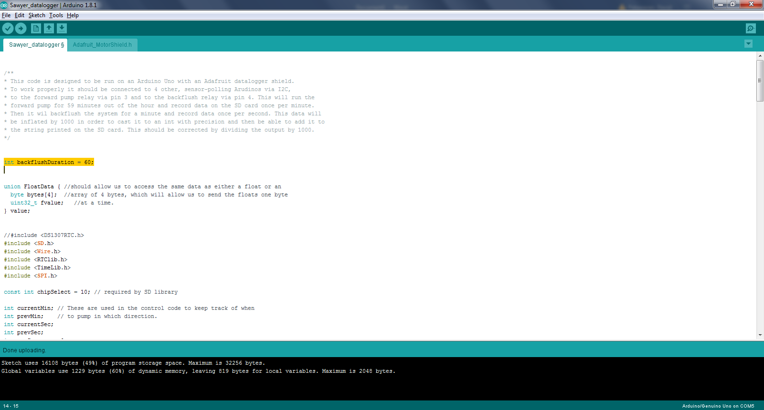To change duration of backflush change this line in the code

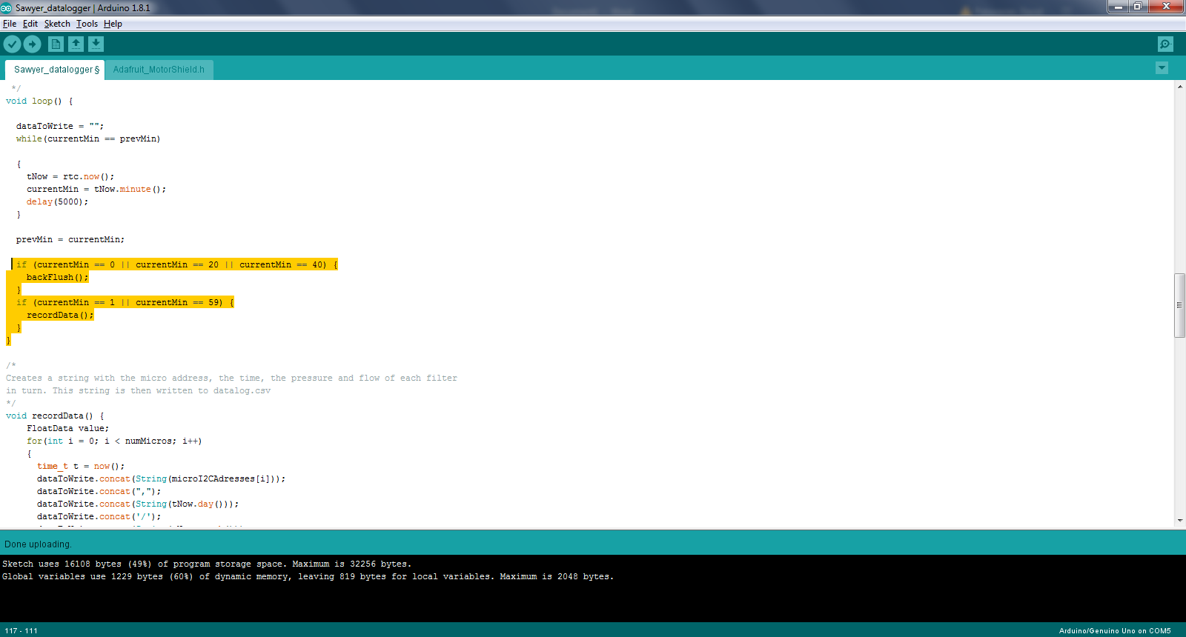To change the system backflush and data recording times edit these lines (back flush currently every 20 minutes)

When the code has been changed, plug the USB cable from the laptop into the Arduino controller and follow the picture instructions below, selecting the UNO, uploading the code, and waiting for the code to finish uploading. The Arduino IDE can be downloaded from the Arduino website.

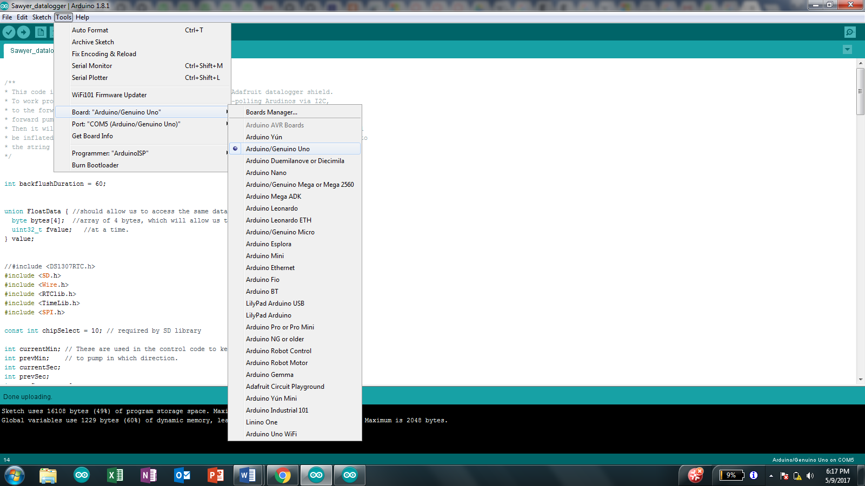

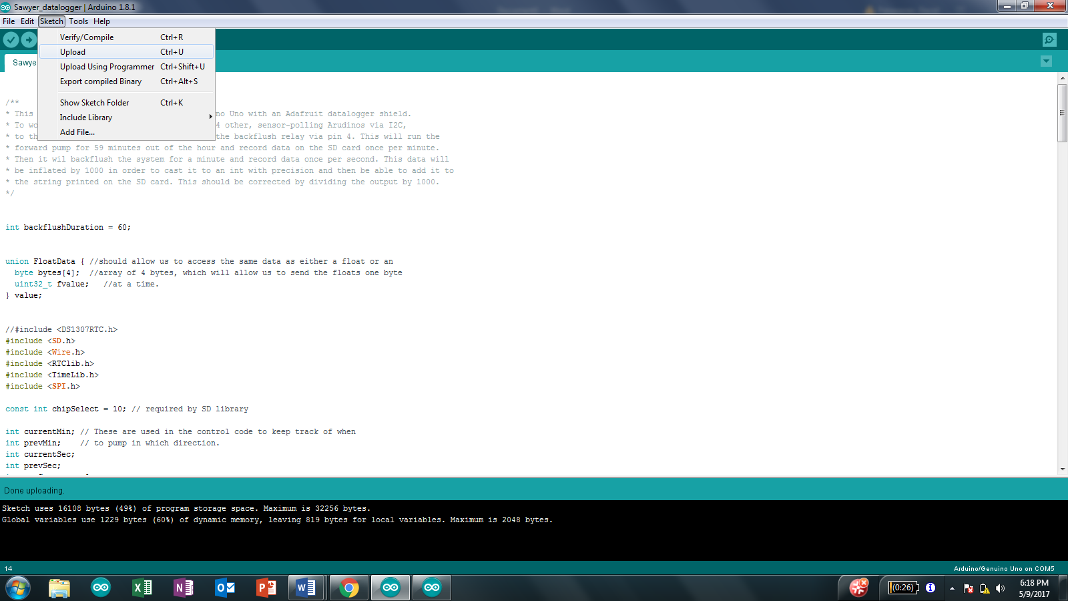

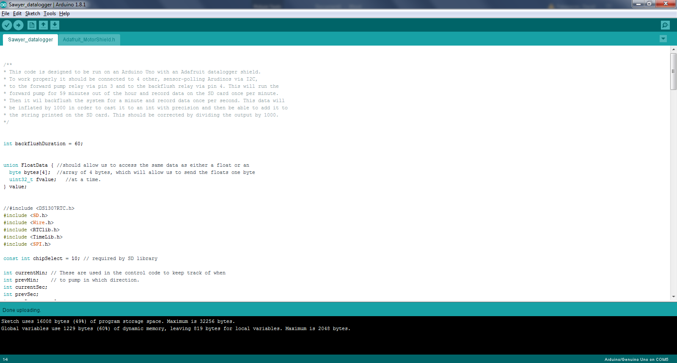

**Reading the data**

The SD card can be removed (**system must be restarted after the card is replaced or data will not be logged**) and the data can be viewed in the “DATALOG” excel file

Each measurement recording will have four rows corresponding to 6 micros each, the filters corresponding to each micro are shown below:

9: 24, 23, 22, 21, 20, 19

10: 18, 17, 16, 15, 14, 13

11: 12, 11, 10, 9, 8, 7

12: 6, 5, 4, 3, 2, 1

Each Filter has two columns, with the pressure value coming first and the flow value coming second

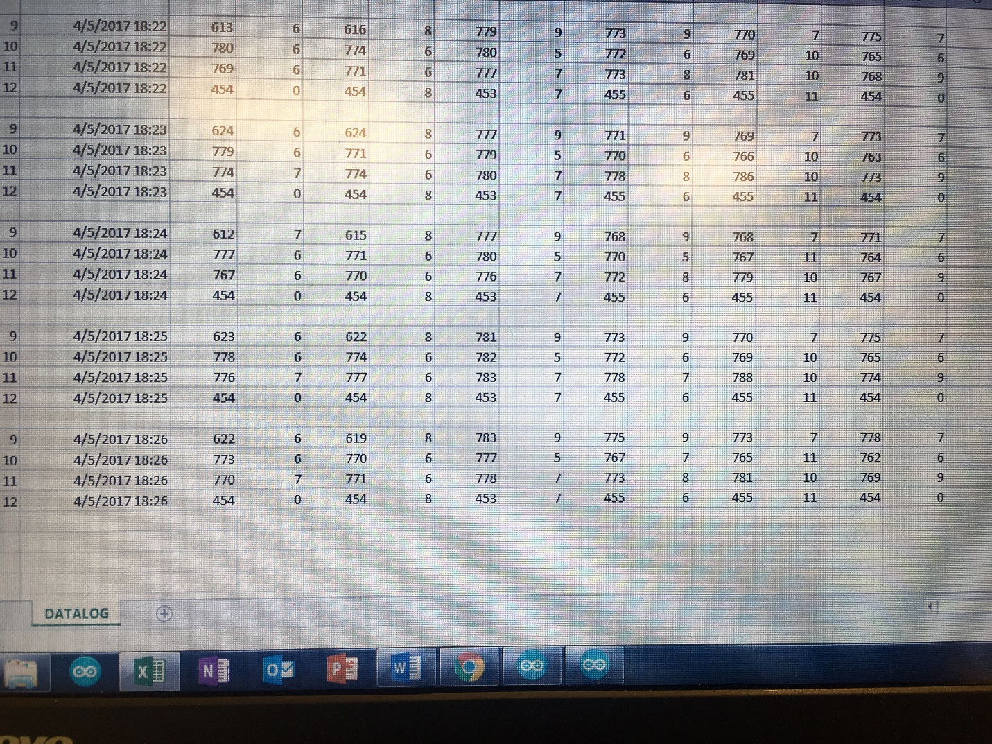

Pressure Flow

Filter 6

Flow values correspond to frequency in Hz output by the flow sensors, Pressure values correspond to voltage output by pressure sensors in 0.00488 Volt increments.

**Flow in liters per minute = flow value * .0221574344**

**Pressure in PSI = (pressure value * 0.0366) - 17.574**

**Troubleshooting**

Clock resets/pauses every time the system is restarted, may need to remove / comment out this line of code, or possibly replace on chip battery (see adafruit datalogger RTC timing chip battery)

