Master Code Overview (Datalogger)

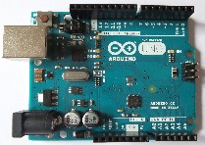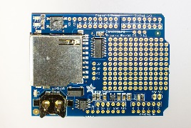

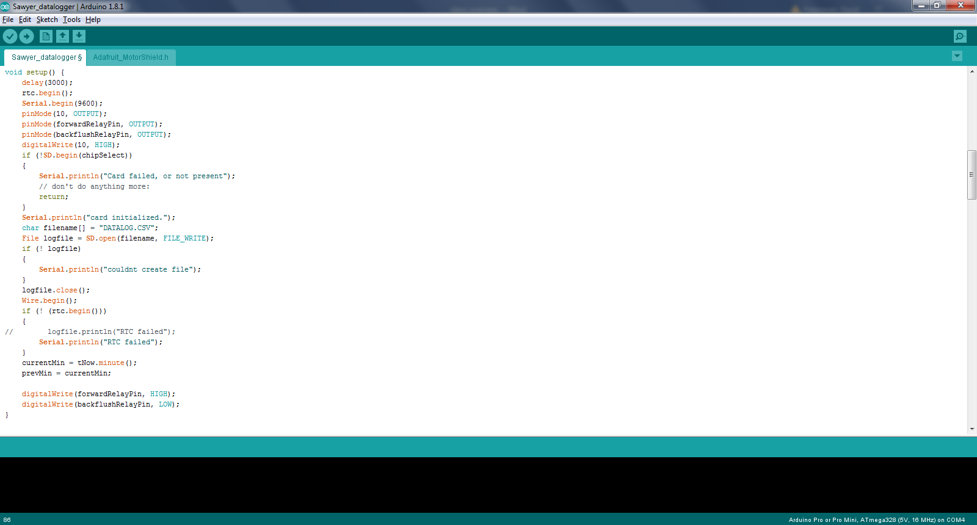

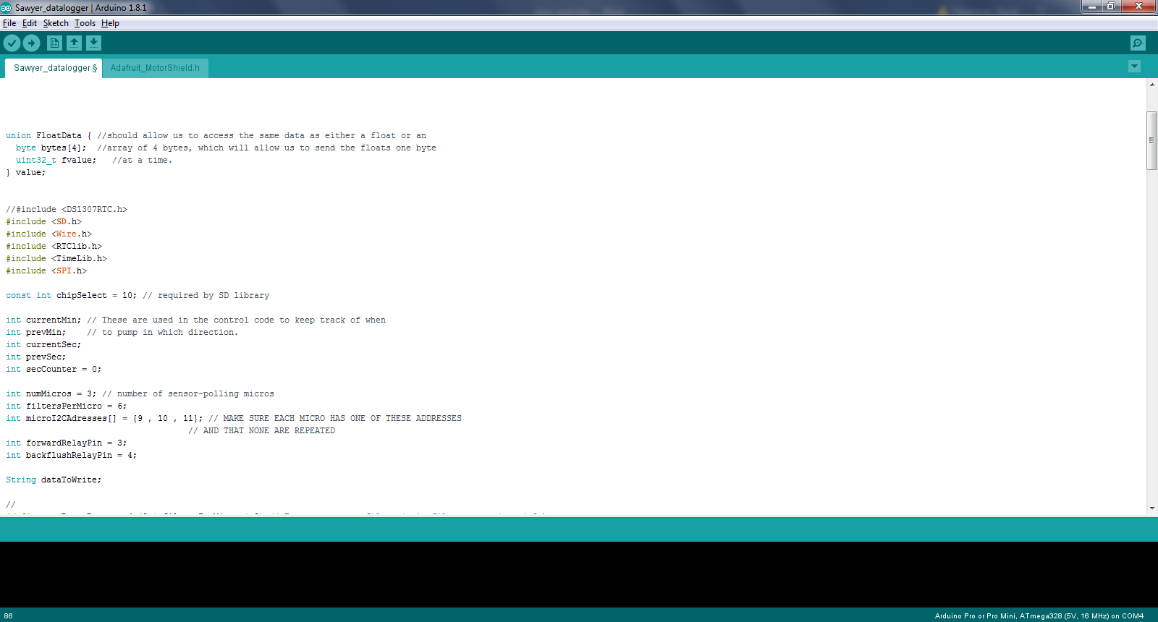

Initialize variables, pin states, storage devices (SD card), and libraries

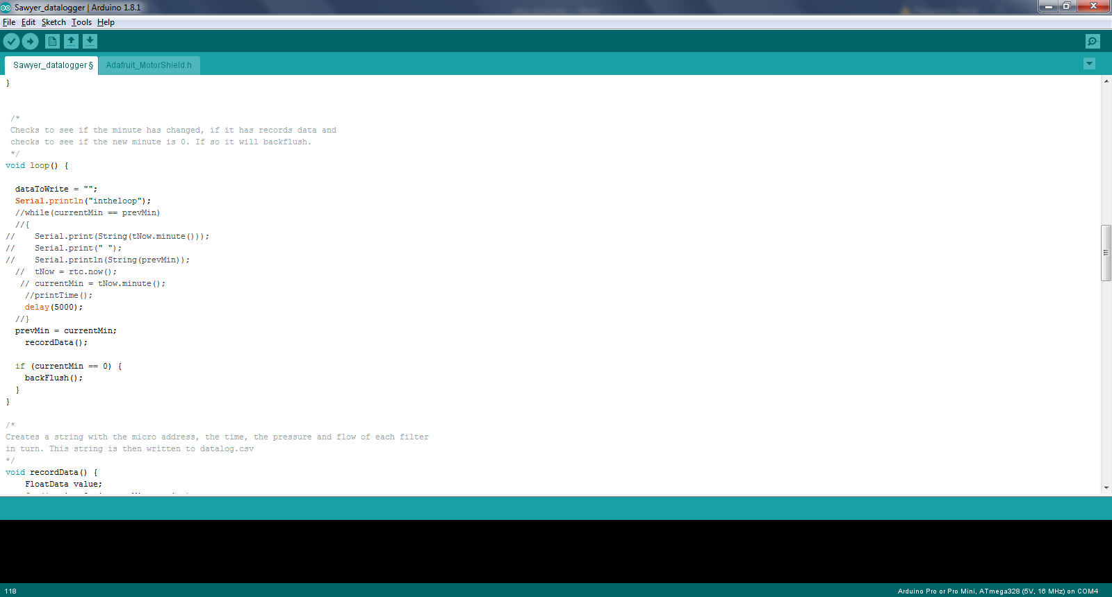

After a set period of filtration switch the output pin values to backflush the system for a set duration

After a set time, request data from the slave-chips