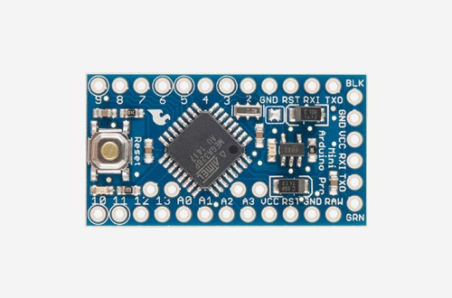

Slave Code Overview

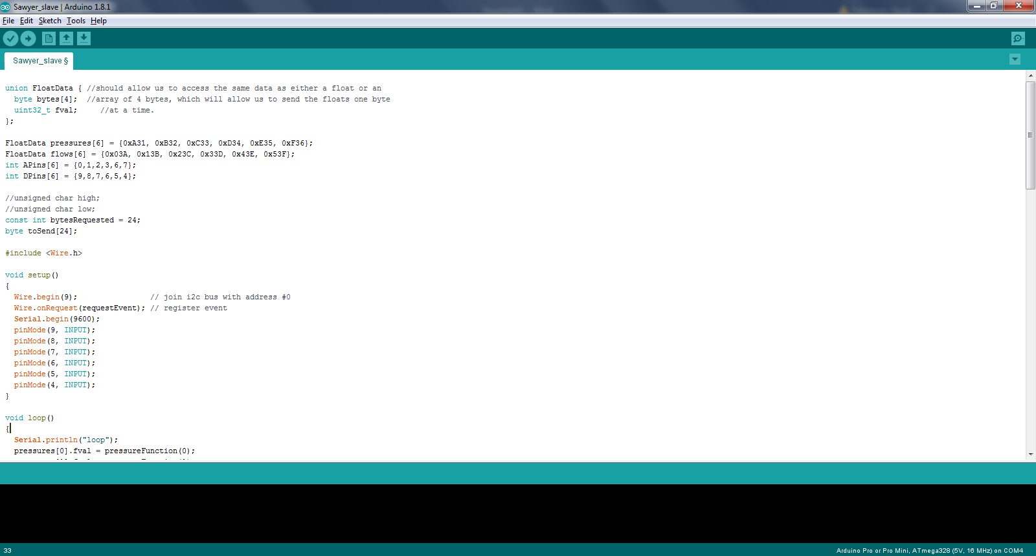

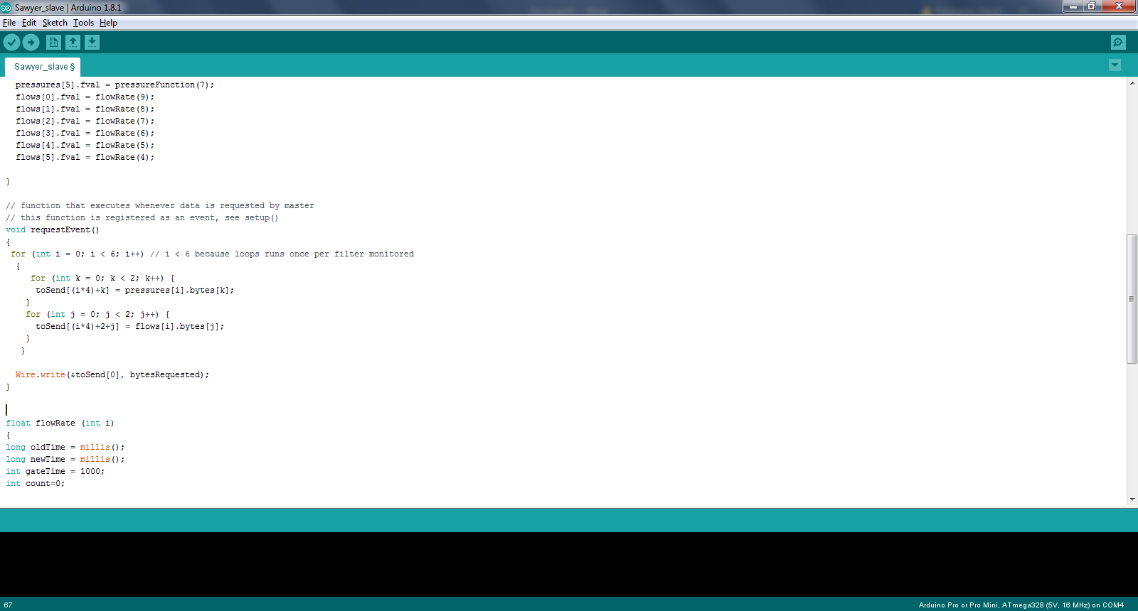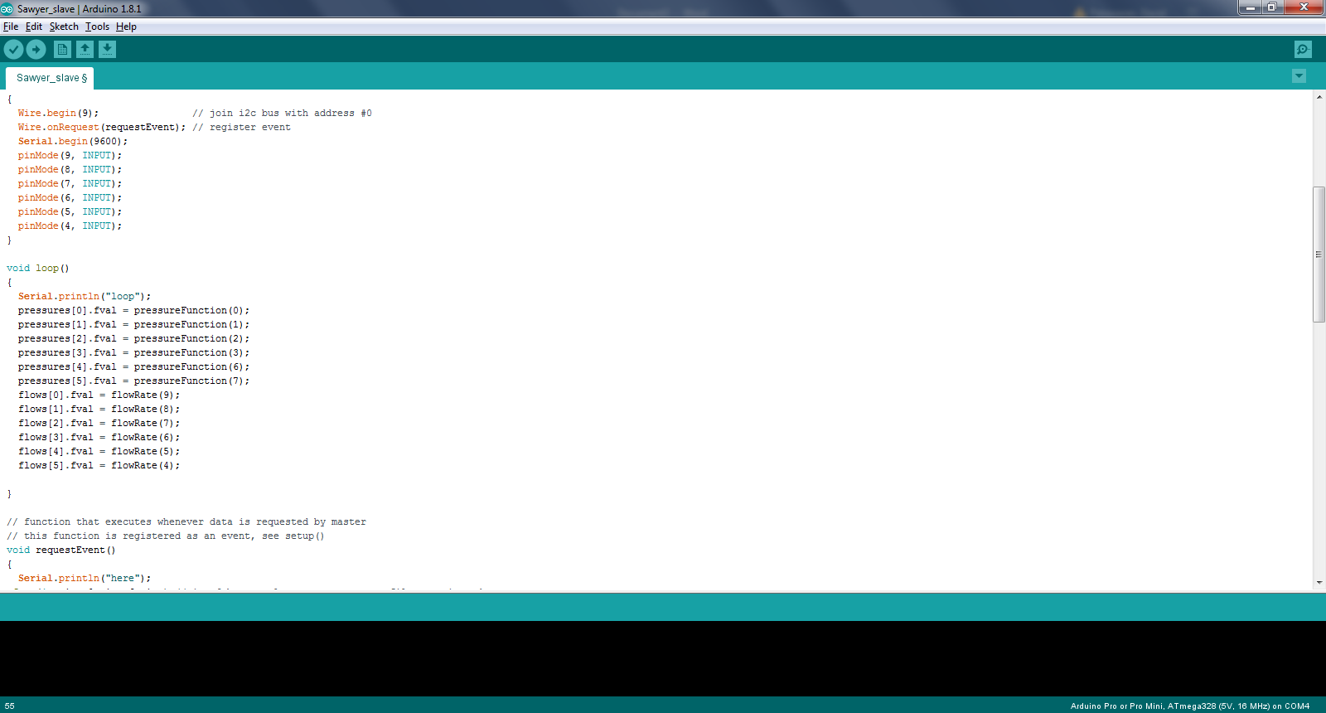

Break out of loop to respond to a request from the master-chip. The most recent values stored for flow and pressure are sent in byte form to the master chip

Poll flow and pressure sensors and store values as variables

Initialize variables, pin states, and libraries