Aussie EcoLens
Multi-Cloud Serverless Wildlife Observation Platform
FIT5225 2026 S1 — Assignment 2 | Team Report
Submitted: 8 June 2026
1. Team Members

Name & Student ID | Contribution | What I worked on
Diya Vishalkumar Patel  36782378 | 33% | Designed and built the entire React frontend SPA deployed on GCP Cloud Run. Integrated AWS Cognito authentication, built all UI pages (upload, search, tags, delete, alerts), managed the GitHub repo and handled end-to-end deployment testing.
Kalana Sasanka Kannangara  36626007 | 33% | Set up AWS infrastructure including Cognito user pool, API Gateway, IAM roles and Lambda functions. Configured GCP credentials within Lambda for secure Cloud Run communication and handled cross-cloud authentication token flow.
Kiran Kumar Pallanti  37008811 | 33% | Built and deployed the GCP Cloud Run ML service for species detection using the YOLOv5 model. Implemented the email notification service on Cloud Run, file deduplication, thumbnail generation, video frame extraction and GCP Firestore database integration.

2. System Architecture

The system is built across AWS and GCP. AWS handles authentication and the API layer, while GCP handles the frontend hosting, ML inference, notifications and metadata storage. The two clouds communicate through Lambda, which holds GCP service account credentials to securely call Cloud Run services.

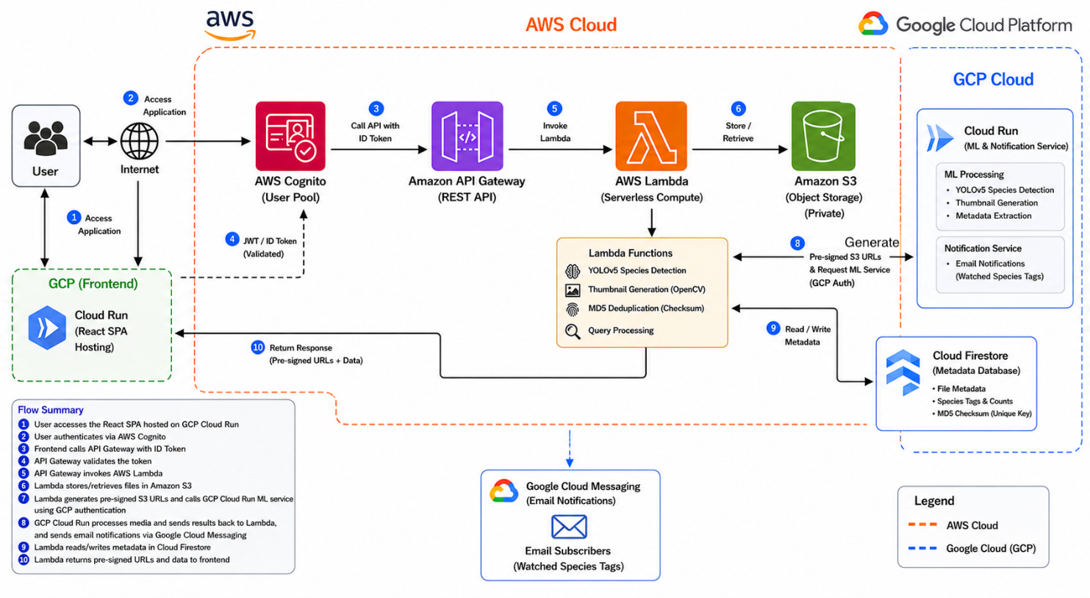

Figure 1: Aussie EcoLens Multi-Cloud Architecture (AWS + GCP)
How it works end to end
The React frontend is deployed as a GCP Cloud Run service. When a user logs in, the request goes to AWS Cognito which returns a JWT ID token. That token is attached to every API call the frontend makes. Requests hit AWS API Gateway which validates the token and passes them through to Lambda functions.

Lambda is the bridge between the two clouds. It holds GCP service account credentials so it can securely call the ML and notification service running on GCP Cloud Run. When a file gets uploaded, Lambda generates a pre-signed S3 URL and passes it to Cloud Run. Cloud Run uses that URL to fetch the file, run the YOLOv5 species detection model on it, and write the results back to GCP Firestore.

Email notifications are also handled by the Cloud Run service rather than AWS SNS. When a file is tagged with a species that a user is subscribed to, Cloud Run sends out the notification email directly. All media files sit in a private S3 bucket and are only accessible via temporary pre-signed URLs generated by Lambda.

Component summary
GCP Cloud Run (Frontend): Hosts the compiled React SPA. Once loaded in the browser the app runs client-side and communicates with the AWS backend via REST calls.
AWS Cognito: Manages user registration and login. Issues JWT ID tokens on successful authentication which are used to authorise all subsequent API requests.
AWS API Gateway: Acts as the single entry point for all API calls from the frontend. Validates Cognito tokens and routes requests to the appropriate Lambda function.
AWS Lambda: Handles business logic including file upload, deduplication, pre-signed URL generation, and query processing. Also holds GCP credentials to communicate with Cloud Run.
GCP Cloud Run (ML + Notifications): Runs the YOLOv5 species detection model on uploaded files. Also handles email notifications when new files match a user's subscribed tags.
Amazon S3: Stores all uploaded media files and thumbnails in a private bucket. Files are only accessible via pre-signed URLs with a one-hour expiry.
GCP Firestore: Stores all file metadata including detected species and their counts, file URLs, thumbnail URLs, and file type. Documents are keyed by MD5 checksum to prevent duplicates.

3. User Guide

Creating an account
Open the app URL in your browser. You'll see the sign in page. Click 'Sign up', enter your first name, last name, email and a password (at least 8 characters) and hit 'Create Account'. Check your inbox for a verification email and click the link before trying to log in.

Signing in and out
Enter your email and password and click 'Sign In'. Your name will appear in the top right once you're logged in. Click 'Sign Out' to log out.

Uploading a file
Click the 'Upload' tab. Drag and drop a JPG, PNG, MP4 or MOV file onto the upload area, or click to browse. Hit 'Upload & Tag'. The system checks the file checksum first — if the file already exists it won't be stored again. Otherwise it uploads to S3, triggers the ML pipeline on Cloud Run, and shows you the detected species tags when done.

Searching for files
The Search tab has four modes. 'By Tags & Counts' finds files containing specific species with a minimum count using AND logic across multiple tags. 'By Species' returns all files with at least one of that species. 'By Thumbnail URL' gives you the full size image from a thumbnail link. 'By File Content' lets you upload a file to find matches — that file won't be stored. Click any thumbnail in results to see the full size image.

Managing tags
Under 'Tags', paste file URLs (one per line), enter tags separated by commas, pick Add or Remove and submit. Works on multiple files at once. Tags not present on a file during removal are ignored. When a tag is updated a notification will be send to users who are subscribed.

Deleting files
Under 'Delete', paste the URLs of files to remove and click delete. This removes the file and thumbnail from S3 and all records from Firestore. Can't be undone so check the URLs carefully.

Notifications
Click 'Alerts', enter your email and a species tag you want to watch, then click Subscribe. The Cloud Run notification service will email you whenever a new file tagged with that species is added to the system.

4. Source Code

All code is on GitHub. Every team member has committed their own work directly to the repo.

Repository: https://github.com/dpat0112/FIT5225-74A2

5. Key Design Decisions

Lambda as the cross-cloud bridge
Rather than exposing GCP services directly to the frontend, all cross-cloud communication goes through Lambda. Lambda validates the Cognito token, then uses a GCP service account to call Cloud Run. This keeps the architecture secure the frontend only ever talks to AWS, and GCP is never directly exposed to the client.

ML on Cloud Run instead of Lambda
Running the YOLOv5 model on Lambda would hit memory and timeout limits pretty quickly, especially for video files. Cloud Run scales independently and can handle longer running inference jobs without the constraints of Lambda's execution limits. It also made it easier to keep the model file separate from the API code.

Notifications on Cloud Run
We kept notifications on the same Cloud Run service as the ML pipeline since notifications are triggered right after tagging completes. This avoided needing to set up a separate messaging service and kept the GCP side of the system self-contained.

Checksum deduplication
We use MD5 checksums instead of filenames for deduplication. The checksum is computed from the file content itself and used as the Firestore document ID. So even if someone renames a file and uploads it again, it gets caught.

Pre-signed URLs for secure access
S3 buckets are kept fully private. Lambda generates temporary pre-signed URLs whenever a file needs to be accessed and passes them to Cloud Run or the frontend. URLs expire after one hour so even if one gets leaked it stops working quickly.

Generative AI Use Declaration
In completing this assignment, our team used Generative AI tools (specifically Claude by Anthropic) in the following ways:
- As a learning aid to understand cloud concepts and AWS Cognito documentation
- To suggest ideas for structuring our React application
- To help debug code errors during development
- As a writing assistant to check grammar and sentence structure in our reports
All code submitted was written, reviewed, understood, and tested by our team members. We are able to explain and modify any part of our implementation. All architectural decisions, design choices, and technical implementations were made by the team.
AI was not used to directly complete any assessed component without human oversight and understanding. All AI-generated suggestions were critically evaluated before use.
Team Members:
- Diya Vishalkumar Patel - 36782378
- Kalana Sasanka Kannangara - 36626007
- Kiran Kumar Pallanti – 37008811

We acknowledge this declaration in line with Monash University's academic integrity policy and the unit's Generative AI guidelines.

