The Organization Is the Product
One architecture for multi-agent AI, and who it's actually built for
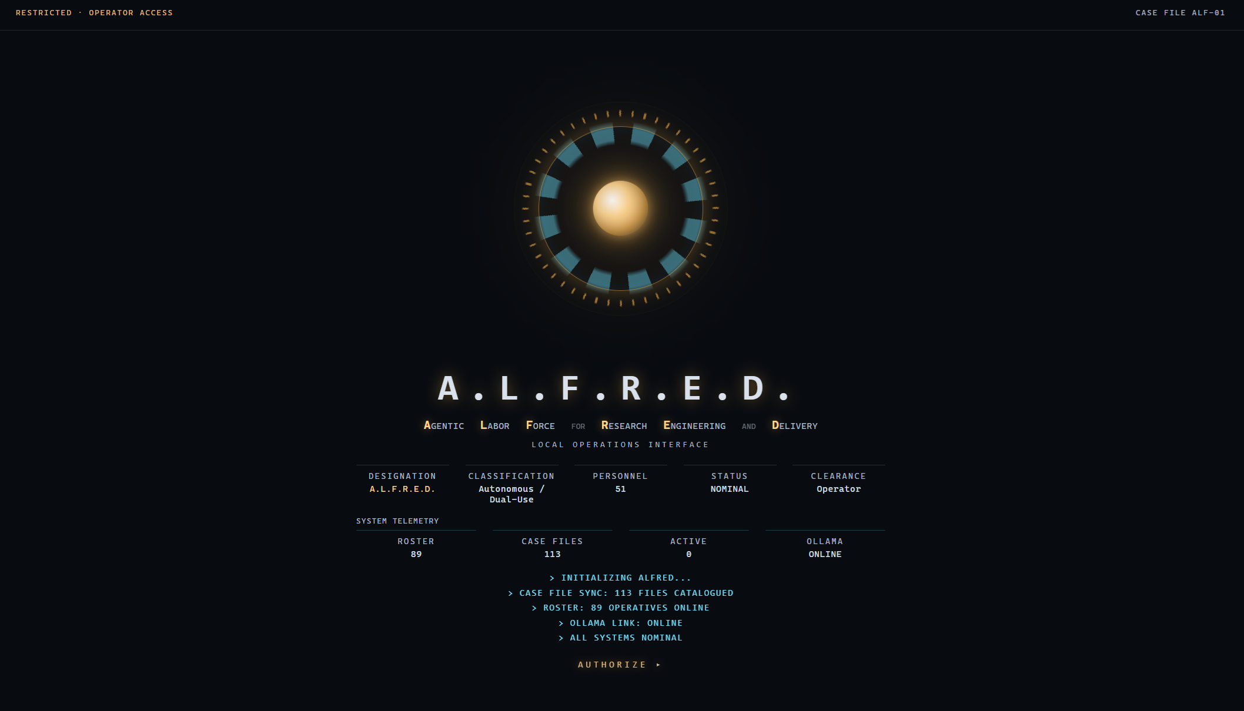

The thesis
Enterprise AI does not primarily need more powerful agents. It needs an operating model for how agents work: scoped context, explicit responsibility, model-tier discipline, review and persistent institutional memory.
A caveat up front: this is one way to build that operating model, not the only one — and it is tuned for a specific kind of operator. More on both below.

Enterprise AI has a scaling problem that has very little to do with model intelligence.
The natural response to a difficult task is to reach for the best model available, give it more context, more tools, more instructions and let it work.
That works. But it is not how enterprises operate anywhere else.
You do not staff a company entirely with senior architects. You do not give every employee access to every document, every system and every decision. You do not ask the same person to research a problem, implement the solution, review it and approve their own assumptions.
You create structure.
You define responsibilities. You control access. You route work to the right level. You create review mechanisms. You make expensive decisions visible and auditable.
We have done this for people for decades. AI agents need the same thing.
That is the idea behind A.L.F.R.E.D. — Agentic Labor Force for Research, Engineering and Delivery. It is an intelligence layer over Claude Code that gives AI work an operating model: local knowledge, scoped context, hierarchical delegation, model-tier discipline, review and observability.
The interesting part is not that it has 53 chartered roles.
The interesting part is that none of them sit on disk as a standing file waiting to be used — and even so, they still do not all have the same job, the same authority, the same context or the same cost. More on that in a moment.
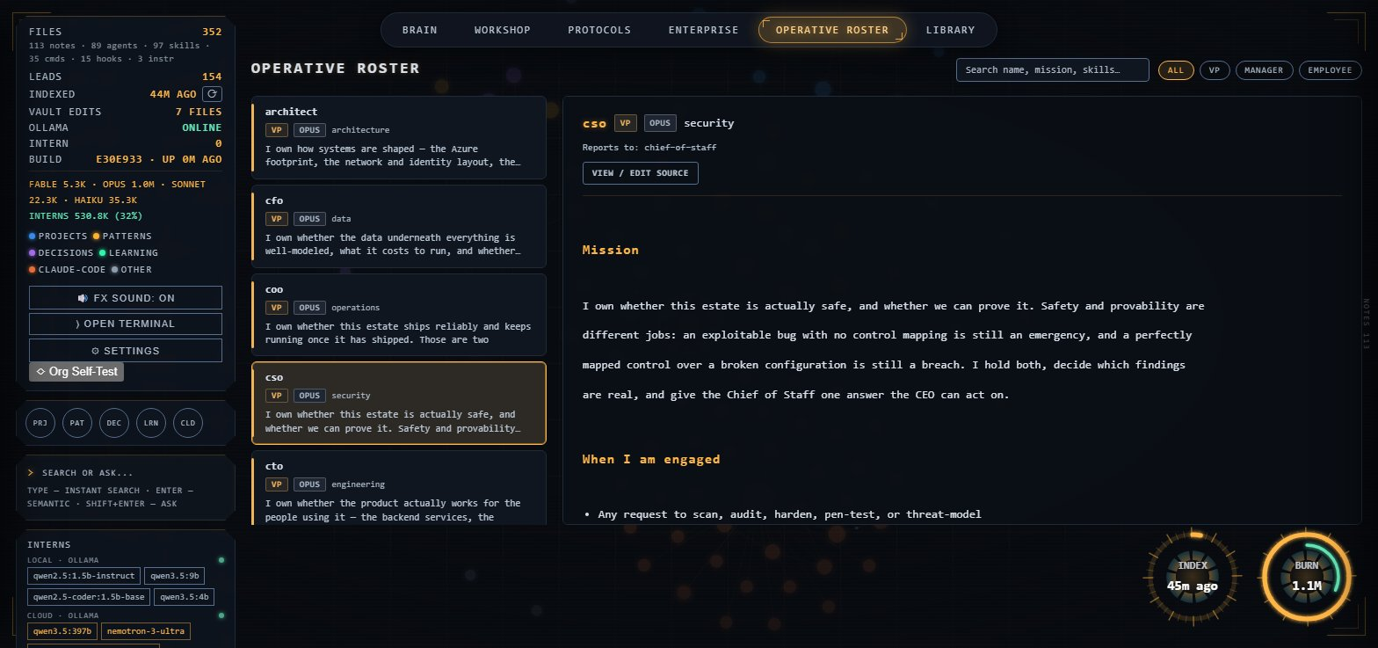
The operative roster — each role's actual mission, tier and reporting line, not a generic prompt.

The problem with today's AI architecture
Most AI implementations still look surprisingly similar:
Human → powerful model → everything else
The model gets a large context window containing instructions, code, documentation, history, tools and whatever else might be useful.
When the problem becomes more complex, we add more context. When the answer needs to be better, we use a better model. When reliability matters, we add another prompt telling the model to check its work.
The question should not be “How do we give one model everything?” It should be “How do we give each piece of work exactly what it needs, to the level of intelligence it requires, with the appropriate level of review?”
That is an organizational problem.

Four things change the economics of AI work

1. Localize everything. Preload almost nothing.
A.L.F.R.E.D. keeps the knowledge that agents can use — charters, skills, commands, instructions and a personal knowledge vault — local and indexed. Nothing is automatically dumped into every context window. An agent retrieves the slice of information it actually needs.
Think of the difference between handing an employee a four-hundred-page binder before every task and handing them the one page that matters.
This is not just about token cost. It is about attention, relevance and context boundaries. The system treats context as a resource that should be allocated, not accumulated.
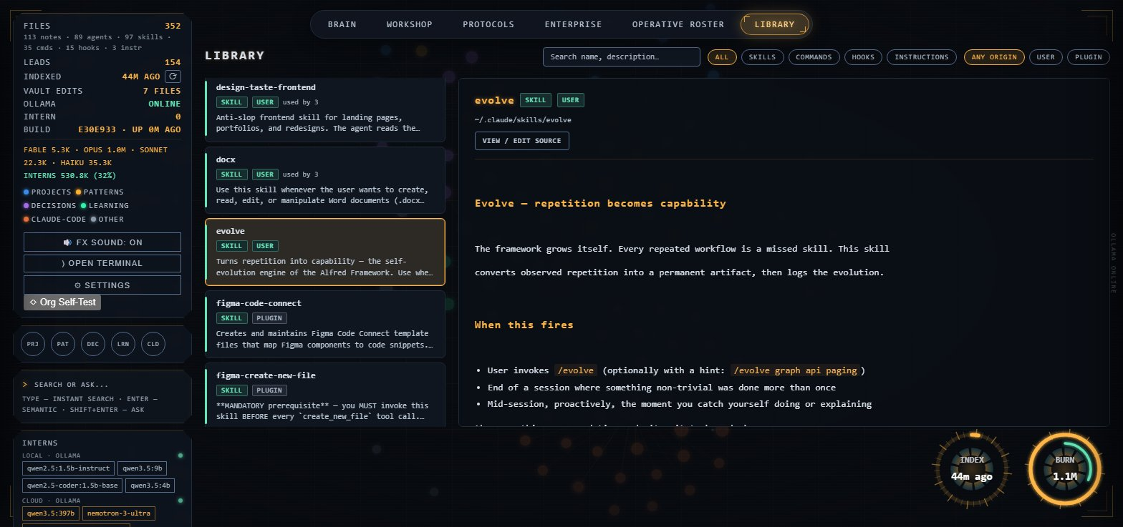
The library — skills, commands and instructions, indexed and retrieved on demand, never preloaded.

2. Give AI work a real chain of command.
Agents are not a flat list of prompts. There is a hierarchy. The human sets direction. The main session acts as Chief of Staff. Work moves through model-tiered executives, managers and specialists. Each delegated task runs in its own context and returns a synthesized result rather than dragging every intermediate step back into the top-level conversation.
That structure solves something most AI systems currently leave implicit: Who should actually do this work?
A simple file search does not need the same reasoning capability as a systems architecture decision. A mechanical transformation does not need the same model as adversarial security review. A draft does not need the same model as the person signing off on what ships.
So why would we architect them that way?
A.L.F.R.E.D. makes model selection part of the organization itself. Frontier reasoning is reserved for the work that genuinely requires it. Work that does not require it moves down the organization. And the model tier is enforced at runtime rather than written down as a recommendation.
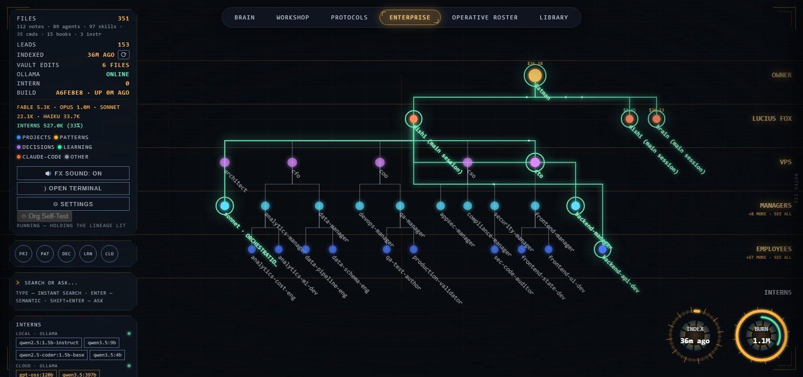
Owner → VPs → Managers → Specialists — delegation with a visible, auditable lineage, read from real transcripts.

Policy vs. control
A policy says what the system should do. A control makes it happen. A.L.F.R.E.D. uses a runtime gate to correct the model tier at agent creation time rather than relying on a sentence in a style guide.
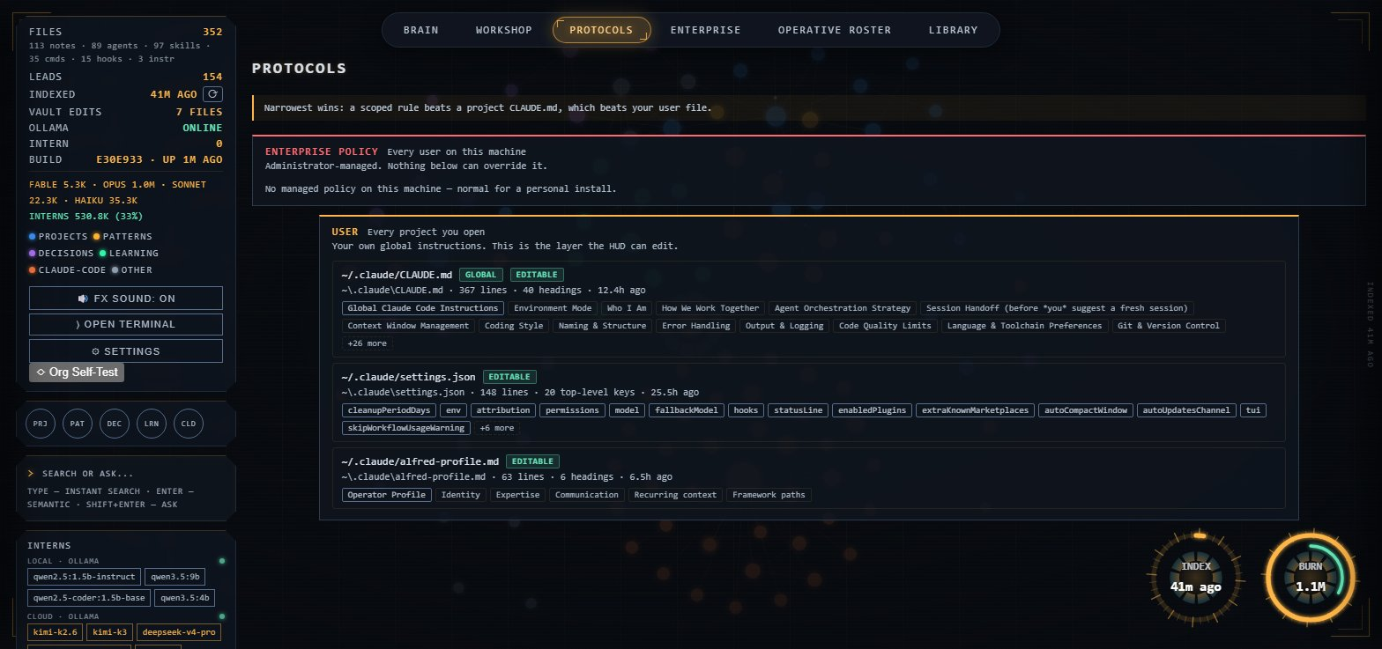
Protocols — enterprise policy, user instructions and project rules, layered and enforced, narrowest scope wins.

3. Don't staff until the work is real.
For a long time, the organization chart was a folder of standing agent files — one file per role, sitting on disk whether or not that role did anything on a given day. It worked, but it was headcount: every role cost context and tokens simply by existing.
The organization now works the other way. The roster is carried as knowledge in a single indexed reference, not as standing files. Nothing is staffed until a piece of work is actually delegated. At that point the role is composed on demand — a scope, a model tier, a done-test, and the sources it is allowed to read — then it runs, answers, and is gone.
That is also a measured change, not just a tidier architecture. Run head-to-head against the old standing-roster model on ten identical scenarios — a false-premise rollback request, a secret buried in git history, a reachable vulnerability hidden behind a decoy import, a missing lockfile, a “broken login” claim that turned out to be false — the on-demand model produced the same verified answers, fact for fact, at 30% lower cost. Nobody was staffed for a job that did not need staffing.

Arm | Tokens (10 scenarios) | Cost
Standing roster (old) | 5,131,225 | $9.72
On-demand (current) | 3,614,607 | $6.85
Delta | −30% | −30%

4. Let knowledge compound instead of starting from zero.
Every serious enterprise has institutional memory. The problem is that much of that memory is trapped in people, Slack threads, tickets, code reviews, documents and meetings.
AI agents face the same problem. Every new session risks rediscovering the same decisions, the same architecture, the same constraints and the same hard-won lessons.
A.L.F.R.E.D. treats knowledge as a persistent local layer. Decisions, project state, patterns and hard-won gotchas are captured into ordinary Markdown files. The next session can retrieve them rather than reconstructing them.
The important principle is simple: the agent workforce gets a memory. And because that memory is just files, it remains yours.
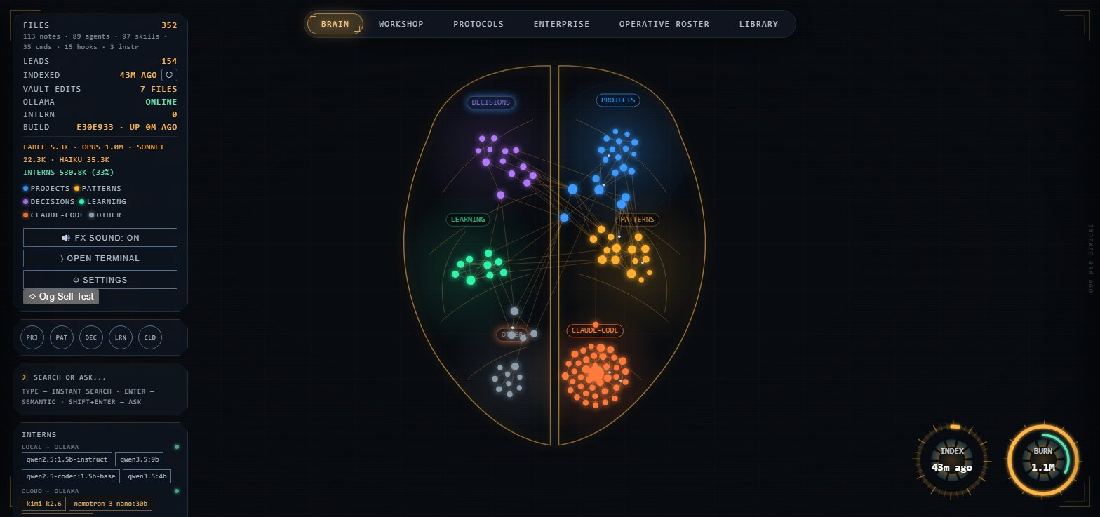
The brain — decisions, projects, learning and patterns, indexed as persistent institutional memory.

This is not “more agents”
A.L.F.R.E.D. is not trying to win by having the largest collection of specialist prompts. There are already agent frameworks with enormous rosters. There are plugin marketplaces targeting multiple coding assistants from one source tree. There are knowledge-management products with graphs, backlinks, semantic search and AI assistants.
A.L.F.R.E.D. takes a different position: AI work should be organized, not merely augmented.
- Hierarchy over an agent free-for-all.
- Scoped context over indiscriminate context.
- Model tiers over “use the best model just in case.”
- On-demand staffing over standing headcount.
- Enforcement over written guidance.
- Review over blind delegation.
- Persistent knowledge over session-by-session rediscovery.
And the system makes the whole thing observable. You can see which roles ran, which models were used, how work moved through the hierarchy and where the cost accumulated.
That starts to look less like an AI assistant. It looks like an AI operating system.
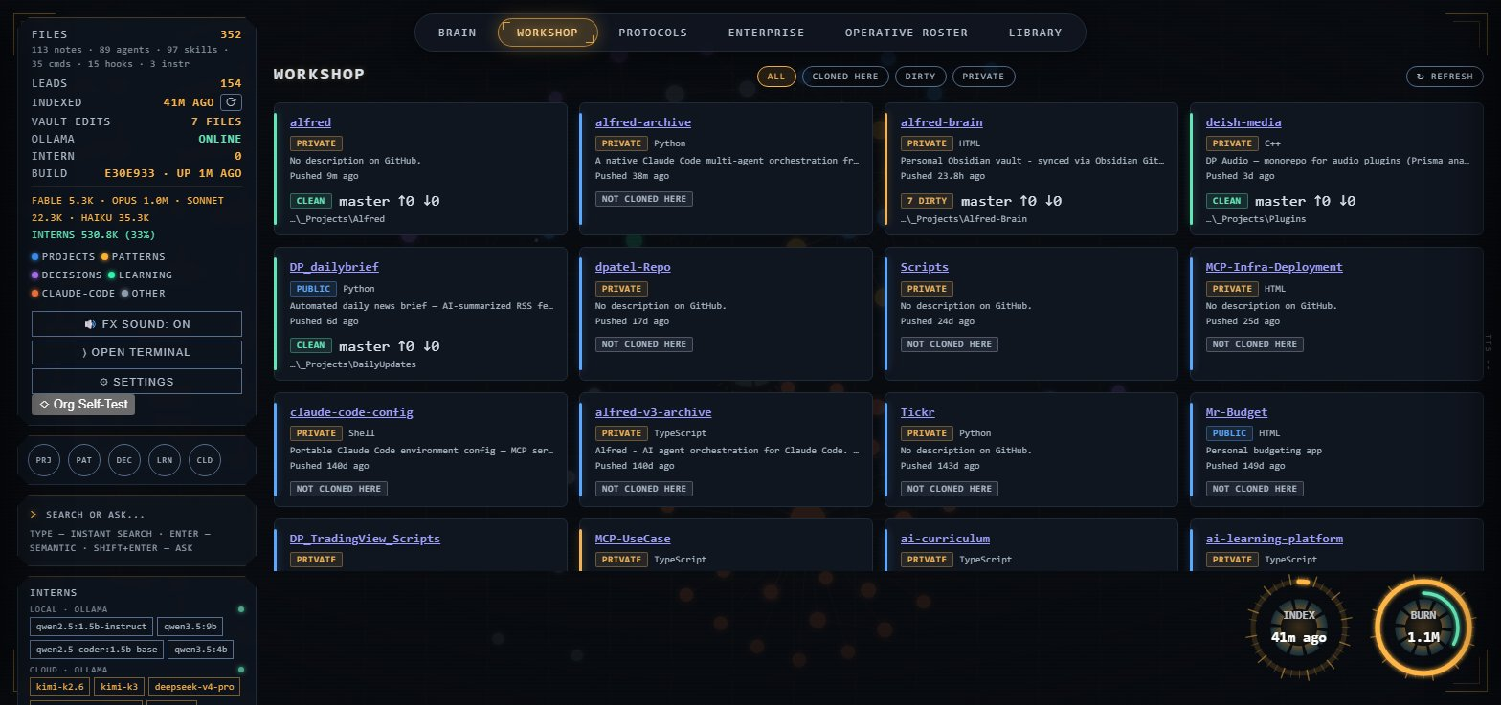
The workshop — every repository the workforce touches, tracked, clean-or-dirty, visible at a glance.

Not the only answer
Multi-agent AI is being built several different ways right now, and hierarchy is not the only credible one.
Some frameworks go wide: a large, flat roster of specialist prompts, activated by name, with no reporting structure, optimized for covering as many frameworks and platforms as possible. Others go cross-platform: a plugin marketplace with its own validation tooling, built to target several coding assistants from one source tree. Both are legitimate, and better suited than a hierarchy if what you actually want is maximum breadth or reach across tools.
A.L.F.R.E.D. optimizes for something narrower: a small, curated chain of command inside one tool, sized to the person actually running it — with restraint counted as a real outcome, not an afterthought. Knowing when *not* to engage the organization at all, because a task is small enough that one direct answer is correct, is a deliberate, scored decision here, not a fallback.

Who this actually fits
Given that tradeoff, this is not really built for the largest enterprises. An organization with a dedicated AI platform team can absorb the complexity — and the standing cost — of a bigger, flatter swarm, and may get more out of one.
It is built for the operator who cannot absorb that complexity: a small or mid-sized business running lean, a solo technical founder, a team without a platform group, or an individual using AI as a genuine second set of hands on real work. For that operator, not paying for a role until it actually does something is not a nice-to-have — it is the difference between a workable monthly bill and one that isn't.
And the governance question does not go away just because the team is small. If anything it gets sharper: how do you govern a workforce made of software rather than people, when you are the only one watching it?

The question | The operating principle
What work is being performed? | Make AI activity explicit.
Which model is performing it? | Make model selection deliberate and observable.
What information did it have access to? | Make context and knowledge boundaries explicit.
Who or what reviewed the result? | Make review part of the workflow.
Where is institutional memory stored? | Make knowledge persistent and reusable.
How much expensive reasoning are you using? | Make cost visible while the work is happening.

Traditional AI implementations tend to answer these questions with policies, permissions and prompts. Those are necessary. They are not sufficient.
A.L.F.R.E.D. treats them as part of the execution architecture itself. The model tier is enforced. The hierarchy is explicit. Context is scoped. Staffing happens on demand. Delegation is observable. Knowledge persists. And lower-tier output can be treated as a draft until a higher tier reviews it.
It will not be the right model for every team. But for the operator who has to be their own platform team, security team and reviewer, it is the tradeoff that makes multi-agent AI something they can actually run and trust.

The most important lesson so far
The most interesting result from building A.L.F.R.E.D. was not that cheaper models can handle a lot of work. We already suspected that.
It was what happened when those cheaper models were asked to do real work.
One delegated agent produced a working feature with full test coverage and green tests — but it had built the feature on a false premise. The tests were correct. The implementation was correct. The assumption was wrong.
A higher-level review discovered that the supposedly empty plugin directory actually contained 74 skill files.
Another agent produced an API-key validator that reported success because the endpoint it was testing did not actually authenticate anything.
Again, the code worked. Again, the conclusion was wrong.
Both problems were caught through review, not through the test suite.
That is also why review is not applied everywhere by default now. A reviewer that rereads the same reasoning validates nothing on its own; a deterministic check — a test, a diff, a command that either passes or doesn't — is what a wrong answer cannot talk its way past. Independent review is reserved for exactly the cases with no cheap check available and real stakes attached. Anywhere a machine can falsify the claim, the machine gets the job, because it is both cheaper and harder to fool.

A different role for expensive models
You are not necessarily paying the senior model to write the code. You are paying it to ask: “Are we sure?”

The numbers make the case tangible
A representative rolling 24-hour window from building A.L.F.R.E.D. itself (snapshot 2026-08-10) produced this distribution across the organization:
Tier | Role | Output tokens | Share
Fable | Top-tier adjudication — gated behind explicit confirmation | 5.2k | <1%
Opus | Hard debugging, design review, adversarial verification | 863.3k | ~43%
Sonnet | Default build tier — coding, generation, moderate complexity | 106.3k | ~18%
Haiku | Search, file sweeps, bulk mechanical work | 53.6k | ~6%
Local / Ollama | Drafts, summaries, embeddings — free, always reviewed | 530.8k | ~32%

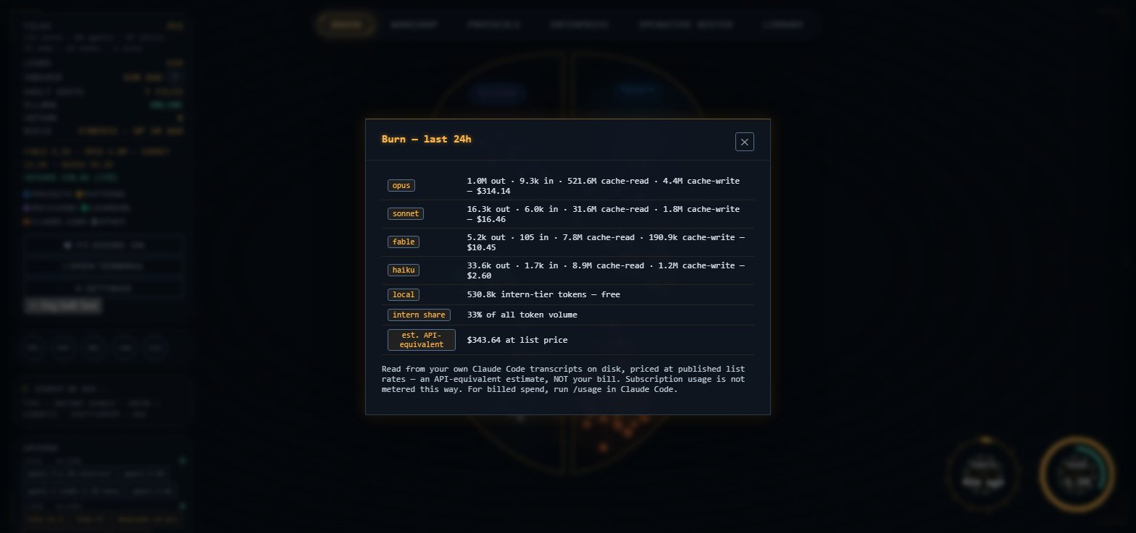
Burn by tier, last 24h — cost made visible while the work is happening, not after the invoice.
Two numbers carry the argument. The frontier tier, Fable, produced only 5.2k tokens — not because it was rationed, but because almost nothing genuinely required it. And roughly a third of all volume ran on a local model, never touching a paid API, because a model on the same machine is good enough to draft, summarize and embed, provided something above it reviews the output.
A third number is easy to miss but may be the most useful: Opus read 515.9M cache tokens against that 1.0M of output. Cached context is re-sent on every turn, so the dominant term in a bill is usually not what the model wrote — it is how much you asked it to carry. Which model you pick matters less than how much you load before it starts.
The point is not that every operator will see this exact split — an architecture-and-debugging day pulls hard toward Opus, a day of building against a settled design inverts it. The point is that the organization itself becomes the mechanism for deciding where intelligence is economically valuable, which matters most when there is no platform team making that call for you.
Instead of asking, “Why aren’t we using the smartest model everywhere?” you start asking, “Where does intelligence actually create leverage?”
That is a much more scalable question — and a more affordable one.

One shape this could take
I do not think a giant AI agent with access to everything is the only future. For the operator this is built for, I think it looks much more like a small organization:
- A human executive sets direction.
- A senior reasoning layer interprets the problem.
- Specialists handle domains — composed on demand, not kept on payroll.
- Local models handle inexpensive mechanical work.
- Senior models review the assumptions that matter.
- The knowledge layer remembers what the organization has learned.
- The entire system is observable.
That is what A.L.F.R.E.D. is trying to make concrete.
Not a smarter chatbot. Not another collection of prompts. Not another graph of notes.
An operating model for a small AI workforce, sized to the person actually running it.
Other teams, with more scale and more infrastructure, are solving this differently — and for them, a flatter, larger swarm may well be the better answer. This is what worked for one operator building alone. It is one way to make a multi-agent workforce something a single person can actually organize, afford and trust — not the only way.

