15 slide ppt (pdf or ppt)

Github link

Recommender systems in python 101: <https://www.kaggle.com/code/gspmoreira/recommender-systems-in-python-101>

There is a class project that is done by each student. The purpose of the project is to test the students’ ability to apply the machine learning techniques and tools presented in the class to diverse practical problems and interpret & apply the results.

The class project covers:

Choose a real-world machine learning problem with an objective

• Procure and analyze the data

Source: <https://dachang.github.io/CocktailViz/>

Columns:

Count: 48 rows

First 5 Rows:

• Develop at a deep learning or recommender system model

* Content-based filtering: suggesting cocktails based on other cocktails
  + Cosine similarity
* Collaborative filtering: with user ratings you can recommend cocktails based on user similarity
  + SVD
* Deep learning model: if you have a large amount of data
  + Neural Networks
    - SVD
    - kNN

• Outline data / model assumptions & limitations / hypotheses

• Evaluate model metrics such as overfitting / underfitting

• Select final model based on selection criteria

• Determine how the model can be improved

• Effectively communicate analytical work

For the class project, students are graded on 8 criteria outlined below. Each criterion is 5 points for a total of 40 points. The criteria are:

1. Problem Statement

2. Assumptions/Hypotheses about data and model

3. Exploratory Data Analysis

4. Feature Engineering & Transformations

5. Proposed Approaches (Model) with checks for overfitting/underfitting

6. Proposed Solution (Model Selection) with regularization, if needed

7. Results (Accuracy) and Learnings from the methodology

8. Future Work

Feedback Loop- retraining based on new data (either new cocktails recipes added or user preferences change)

Synthetic dataset: training 90k, validation 10k

Testing: Survey data 100 records, use up-sampling to create total of 10k records

To do:

1. Create a survey and send out to friends and family
2. De-identify and use user_id

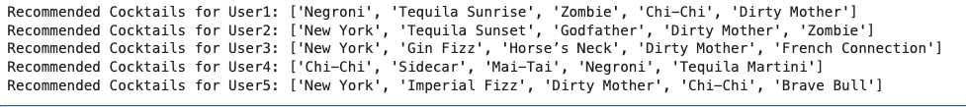

PPT

Slide 1: Title Slide

- Project Title

- Your Name

- Date

Slide 2: Problem Statement

- Description of the problem

- Objective of the project

Slide 3: Assumptions and Hypotheses

- Assumptions about the data

- Hypotheses for the model

Slide 4: Exploratory Data Analysis (EDA)

- Key insights from EDA

- Visualizations

Slide 5: Feature Engineering and Transformations

- Description of features used

- Feature selection process

Slide 6: Model Approaches

- Description of different models used

- Overfitting/Underfitting checks

Slide 7: Model Selection and Regularization

- Criteria for selecting the final model

- Regularization techniques used

Slide 8: Results and Learnings

- Accuracy and other metrics for train/val/test sets

- Key learnings from the methodology

Slide 9: Future Work

- Suggestions for future improvements

- Potential next steps