**Installing Python and needed libraries for data analysis in your machine**

If python is already installed in your machine, go to step 3. If you don’t have python installed start at step 1.

*If you are not sure if python is installed you can always open your **Terminal**, type in *python* and press **Enter**



The dollar sign will be already there. You only need to type python.

If python is installed in your computer a message will appear with the python version you have installed. Something like this:

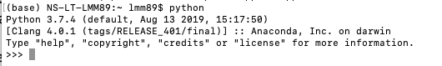

Note that you can see the version running in the computer (3.7.4). And there is no error message. If you got a similar message, your python is ready to use. Make sure you exit python by pressing Ctrl + d . These will bring you back to the command terminal with the $. Now move to step 3.*

1. Download and install anaconda <https://www.anaconda.com/products/individual>. Scroll all the way down, you will have three options (windows, MacOS and Linux). Choose the one that applies to your machine. Note that when you install Anaconda, you will also be installing Python version 3.8. Anaconda is a free and open-source distribution of Python programming language and it comes with Jupyter Notebook and Spyder which are IDEs (**I**ntegrated **D**evelopment **E**nvironment) for Python that facilitates user interface. If you are familiar with RStudio for R then Spyder will be the equivalent of RStudio but for pyhton. The Jupyter notebook will be similar to Rmarkdown. Notebooks will have the output displayed directly in the notebook, i.e., it will include code, comments and results.
2. **For Mac users only**, you also need to download and install Xcode (developer tools to create applications for Mac). You can download it from your App Store or use the link: <https://apps.apple.com/us/app/xcode/id497799835?mt=12>.
3. Install the library pandas to help us read and handle spreadsheets. Pandas is a library written for the python to support data manipulation and analysis. The name is derived from the term "panel data", an econometrics term for data sets that include observations over multiple time periods for the same individuals.

From your **Terminal** use the command

$ pip install pandas

You will also need to install another two libraries *xlrd* and *openpyxl* that help with Excel reading and writing.

$ pip install xlrd openpyxl

If the libraries are successfully installed you will see a text and the last line will state “Successfully installed”.

You are all set!

Now to check if everything is working, you can write a command to display a simple sentence “Hello World”. Open your terminal and from your **Terminal** use the command below to enter the Python environment



Then use a **print()** function to print the sentence on the screen:



This will output the following:



Notice that “>>>” is used to differentiate input codes and return values of the program. And the quote mark is to enclose a sequence of characters, i.e. *Hello World!* in it. This together is called a string. You’ll learn more about it later in the course.

If you get the same output above, then you’ve finished your first, and probably the simplest program using Python! Feel free to play with it and write anything else you want!

Finally, if you want to exit the python environment, enter “**quit()**” and close the Anaconda prompt.



Note: If you need to update yoru Anaconda version from your **Terminal** type:



**Your first code in Jupyter:**

1. From your **Terminal** type:



Your browser should launch, and you will see:

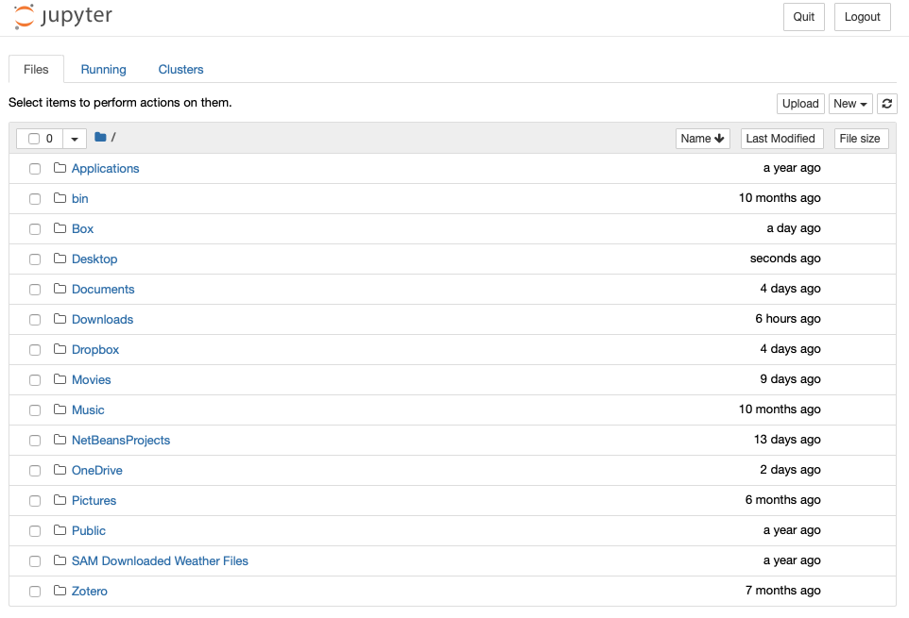

1. The folders that you see here are part of your primary directory. Click on new as highlighted above and select “Python 3”. Another tab should open, and you should see:

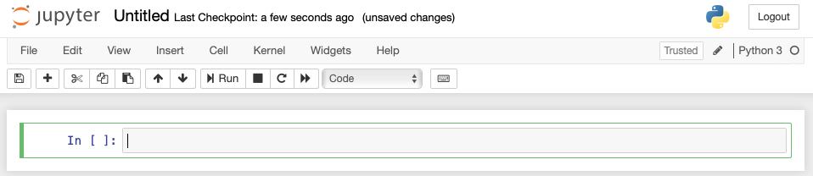

1. “Untitled” will be the file name for your Jupyter file. You can change it by clicking on it. You are now ready to write your first line of code.
2. Take your cursor to the code editor and type in **print(‘Hello World’,1 + 1)**.



Press the run button highlighted below. And you should get the result “Hello World 2”

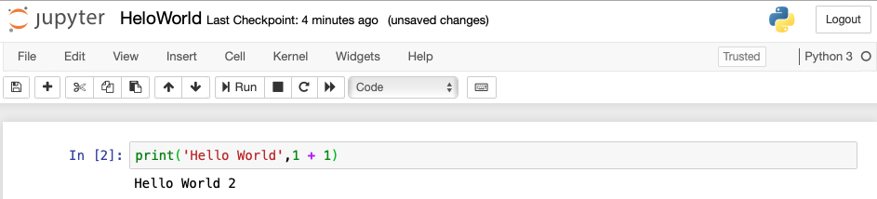

1. Congratulations. You have now introduced yourself to the world, performed an arithmetic operation in python and printed two things together.