**Installing Python and necessary libraries for data analysis in your machine**

Note: If python is already installed in your machine, go to step 2. If you don’t have python installed start at step 1.

How can I check if Python is available on my machine?

If you are not sure if python is installed you can always open your **Command prompt** (use the “**Win**” + “**R**” keys, then enter “**cmd**” and hit “**Enter**” key), type in *python* and press **Enter**



The default path will be already there. You only need to type python.

If python is installed in your computer a message will appear with the python version, you have installed. Something like this:

Note: See the version running in the computer (3.8.3). And there is no error message. If you got a similar message, python is ready to use. Make sure you exit python by entering **quit()** . This will bring you back to the command terminal with the default path. Now move to step 2. *

1. Download and install anaconda <https://www.anaconda.com/products/individual>. Scroll all the way down, you will have three options (windows, MacOS and Linux). Choose the one that applies to your machine. Note that when you install Anaconda, you will also be installing Python version 3.8. Anaconda is a free and open-source distribution of Python programming language and it comes with Jupyter Notebook and Spyder which are IDEs (**I**ntegrated **D**evelopment **E**nvironment) for Python that facilitates user interface. If you are familiar with RStudio for R then Spyder will be the equivalent of RStudio but for python. The Jupyter notebook will be similar to Rmarkdown. Notebooks will have the output displayed directly in the notebook, i.e., it will include code, comments and results.
2. Install the library pandas to help us read and handle spreadsheets. Pandas is a library written for the python to support data manipulation and analysis. The name is derived from the term "panel data", an econometrics term for data sets that include observations over multiple time periods for the same individuals.

Press “**Win**” key and find **Anaconda Prompt**

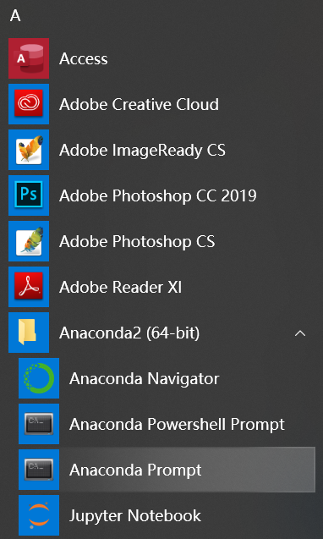

Enter prompt and use the command



You will also need to install another two libraries *xlrd* and *openpyxl* that help with Excel reading and writing.

pip install xlrd openpyxl

If the libraries are successfully installed, you will see a text and the last line will state “Successfully installed”. Then you are all set!

1. Now, if you want to check with the syntax of the language, you can write a simple sentence to display “Hello World!” (this is often the first sentence programmers do after setting up a new environment, through which they can confirm the environment is successfully set up and working)

Press “**Win**” and enter **Anaconda Prompt** again, then use the command below to enter the python environment:



Prompt will return a message showing the python version you have installed.

Then use a **print()** function to print the sentence on the screen:



This will output the following:



Notice that “>>>” is used to differentiate input codes and return values of the program. And the quote mark is to enclose a sequence of characters, i.e. *Hello World!* in it. This together is called a string. You’ll learn more about it later in the course.

If you get the same output above, then you’ve finished your first, and probably the simplest program using Python! Feel free to play with it and write anything else you want!

Finally, if you want to exit the python environment, enter “**quit()**” and close the Anaconda prompt.

**Your first code in Jupyter:**

1. Search for anaconda prompt on your computer. Open it.
2. Type in “jupyter notebook” and press enter.
3. After some gibberish appears on your screen, your browser should launch, and you should see:

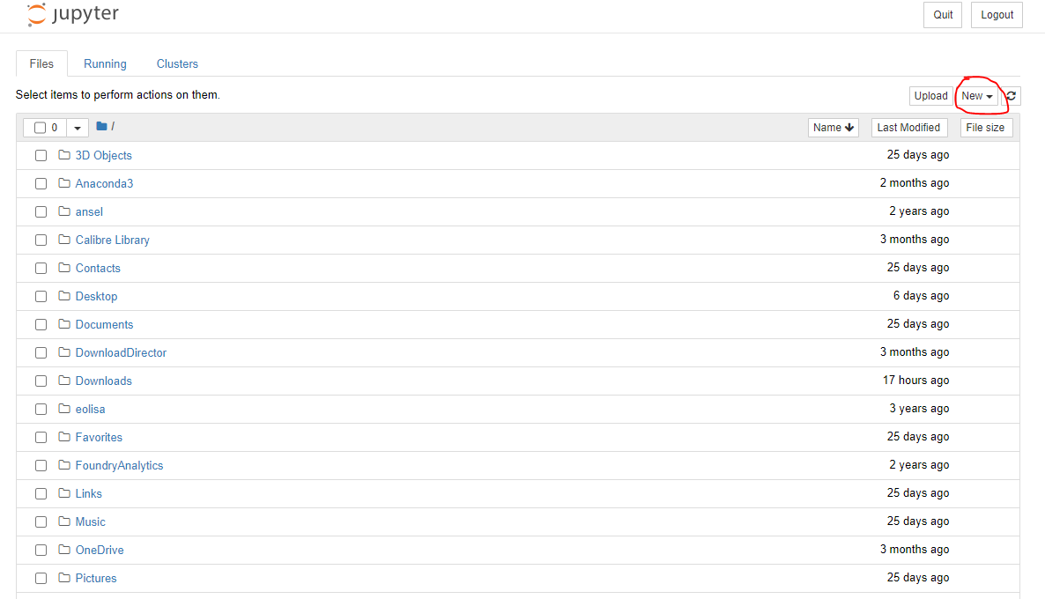

1. The folders that you see here are part of your primary directory. Click on new as highlighted above and select “Python 3”. Another tab should open, and you should see:

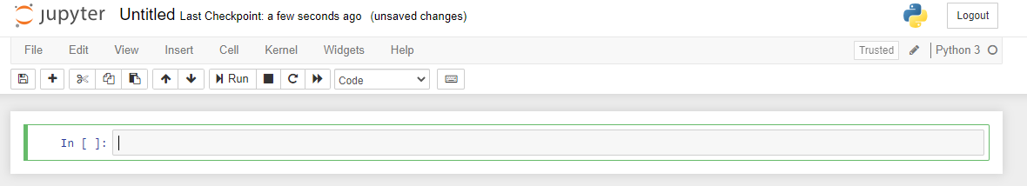

1. “Untitled” will be the file name for your Jupyter file. You can change it by clicking on it. You are now ready to write your first line of code.
2. Take your cursor to the code editor and type in **print(“Hello World”,1 + 1)**. Press the run button above.
3. Congratulations. You have now introduced yourself to the world, performed an arithmetic operation in python and printed two things together.

