2018
Santendar Value

David pazmno
Predict 454

Objective

The project is to predict dollar amounts from a matrix of hidden descriptors. The data we want to predict is in a variable called target. The data we use for the predictions are stored in a numeric data matrix

Data Analysis

We are given test data in csv file format. I read this into a data frame and found we have 4,459 rows with 4,993 columns.

ID | target | X48df886f9 | X0deb4b6a8 | X34b15f335 | a8cb14b00 | X2f0771a37 | X30347e683 | d08d1fbe3 | X6ee66e115 | X20aa07010 | dc5a8f1d8 | X11d86fa6a | X77c9823f2
000d6aaf2 | 38000000 | 0 | 0 | 0 | 0 | 0 | 0 | 0 | 0 | 0 | 0 | 0 | 0
000fbd867 | 600000 | 0 | 0 | 0 | 0 | 0 | 0 | 0 | 0 | 2200000 | 0 | 0 | 0
0027d6b71 | 10000000 | 0 | 0 | 0 | 0 | 0 | 0 | 0 | 0 | 0 | 0 | 0 | 0
0028cbf45 | 2000000 | 0 | 0 | 0 | 0 | 0 | 0 | 0 | 0 | 0 | 0 | 0 | 0
002a68644 | 14400000 | 0 | 0 | 0 | 0 | 0 | 0 | 0 | 0 | 2000000 | 0 | 0 | 0
002dbeb22 | 2800000 | 0 | 0 | 0 | 0 | 0 | 0 | 0 | 0 | 17020000 | 0 | 8000 | 0
003925ac6 | 164000 | 0 | 0 | 0 | 0 | 0 | 0 | 0 | 0 | 0 | 0 | 0 | 0
003eb0261 | 600000 | 0 | 0 | 0 | 0 | 0 | 0 | 0 | 0 | 0 | 0 | 0 | 0
004b92275 | 979000 | 0 | 0 | 0 | 0 | 0 | 0 | 0 | 0 | 58000 | 0 | 0 | 0
0067b4fef | 460000 | 0 | 0 | 0 | 0 | 0 | 0 | 0 | 0 | 0 | 0 | 0 | 0

A sample of the data is above. We see the target can have large values but most of the data is zero. This matrix is an extremely sparse and I believe we will need to do some sort of dimension reduction, like LDA or Lasso to create a model.

train_df <- read.csv ("C:/Users/david/Downloads/train.csv/train.csv")
test_df <- read.csv ("C:/Users/david/Downloads/test.csv/test.csv")

head(train_df[,1:20], n = 10)

Next, I looked at the means of each column to see if I could observe anything of significance.

Column | Mean
target | 5,944,923
X48df886f9 | 14,654.93
X0deb4b6a8 | 1,390.895
X34b15f335 | 26,722.45
a8cb14b00 | 4,530.164
X2f0771a37 | 26,409.96
X30347e683 | 30,708.11
d08d1fbe3 | 16,865.22
X6ee66e115 | 4,669.208
X20aa07010 | 25,69,407
dc5a8f1d8 | 155,215.8
X11d86fa6a | 195,050
X77c9823f2 | 8.52209
X8d6c2a0b2 | 3,595.874
X4681de4fd | 2,258,015
adf119b9a | 268,084.3
cff75dd09 | 45,882.55
X96f83a237 | 44,514.78
b8a716ebf | 396,896.1

Looking at the table above, we can see that the numbers do not show anything out of the ordinary.
When we look at the histogram of the data we do see that there are some zero column means.
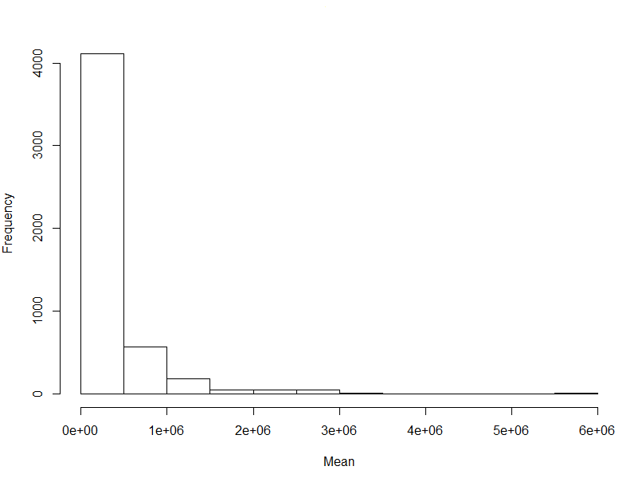
Our plot above shows us that we are dealing with some columns with no values.

The table below represents the columns that have only zero values. At first, I thought about removing them but then I am thinking that the fact they are zero may mean something. We will have to see with our models.

d5308d8bc | X8b1372217 | a4346e2e2 | X10350ea43 | c506599c8 | e37b65992 | X316423a21
c330f1a67 | X68322788b | X1af366d4f | X3c7c7e24c | X99de8c2dc | X2308e2b29 | X2e52b0c6a
eeac16933 | X2288ac1a6 | cfff5b7c8 | X7585fce2a | b05f4b229 | c342e8709 | X8bdf6bc7e
X7df8788e8 | dc7f76962 | da215e99e | X64d036163 | X5e0834175 | X708471ebf | X8f523faf2
X5b91580ee | X467044c26 | X5acd26139 | f25d9935c | eb1cc0d9c | f614aac15 | X4758340d5
X6f29fbbc7 | X39ebfbfd9 | X9be9c6cef | d98484125 | b281a62b9 | X15ecf7b68 | X8411096ec
X46dafc868 | X9a5ff8c23 | X1210d0271 | X95c85e227 | X00fcf67e4 | X3bfe540f1 | X9678b95b7
ae41a98b6 | f6fac27c8 | X21b0a54cb | X9a5273600 | X7a0d98f3c | X3d7780b1c | a185e35cc
f416800e9 | X664e2800e | da35e792b | X746cdb817 | e642315a5 | X113fd0206 | fa980a778
X6d07828ca | ae28689a2 | X754c502dd | X6377a6293 | c16d456a7 | X5e5894826 | c8d90f7d7
X7ac332a1d | d87dcac58 | X0b346adbd | X7d944fb0c | X0c9b5bcfa | cb36204f9 | X080540c81
X70ee7950a | X4065efbb6 | X0f196b049 | X87eb21c50 | b778ab129 | bc4e3d600 | X32591c8b4
X833b35a7c | f944d9d43 | b603ed95d | X5ea313a8c | X2ace87cdd | c66e2deb0 | X5779da33c
X2f9969eab | c2c4491d5 | X2a50e001c | X0987a65a1 | ce573744f | c25851298 | bb425b41e
X2fb7c2443 | ca4ba131e | X1e81432e7 | X992e6d1d3 | X1c4ea481e | a7f6de992 | X01599af81
f5dde409b | X1352ddae5 | X76f135fa6 | X90a742107 | fbd6e0a0b | X3f93a3272 | X1654ab770
X1ae50d4c3 | X2b601ad67 | X7d7182143 | X08b9ec4ae | X69831c049 | c1b95c2ec | d334a588e
X2b21cd7d8 | X6e42ff7c7 | f88e61ae6 | d95203ded | b87e3036b | X6bda21fee | b4353599c
X0db8a9272 | X22196a84c | X378ed28e0 | X58ad51def | X54ba515ee | X4a64e56e7 | X51b53eaec
X804d8b55b | X0e410eb3d | f006d9618 | X9f69ae59f | a09ba0b15 | X943743753 | X2cc0fbc52
X863de8a31 | X7fa4fcee9 | a7e39d23d | e06b9f40f | X90f77ec55 | X20854f8bf | X45ffef194
be10df47c | X5e0571f07 | X5ed0abe85 | e0907e883 | fb02ef0ea | ac2e428a9 | c15ac04ee
X697a566f0 | fd5659511 | X6c578fe94 | c586d79a1 | X3b0cccd29 | X5ee7de0be | X5b055c8ea
X97b1f84fc | X34cc56e83 | dc9a54a3e | e15e1513d | fe9ed417c | f5179fb9c | d0466eb58
X34eff114b | X93e98252a | X748168a04 | a06067897 | X589e8bd6f | X97428b646 | a80633823
X5281333d7 | X2b6cef19e | bba8ce4bb | X643e42fcb | X17b5a03fd | f684b0a96 | a117a5409
c89f3ba7e | c7f70a49b | ff6f62aa4 | X217cd3838 | X80e16b49a | e4b2caa9f | X86f843927
cd6d3c7e6 | X0d29ab7eb | b06fe66ba | X047ebc242 | a3d5c2c2a | X2c2d9f267 | ecd16fc60
fc7c8f2e8 | e4a0d39b7 | ae87ebc42 | X9b6ce40cf | X1bd3a4e92 | X96eb14eaf | X801c6dc8e
abbbf9f82 | a4d1a8409 | f26589e57 | X3b2c972b3 | X611d81daa | cb2cb460c | f859a25b8
X24a233e8f | bc694fc8f | X963bb53b1 | X17a7bf25a | X7ddac276f | e7af4dbf3 | ae846f332
X8e26b560e | X3a36fc3a2 | a531a4bf0 | c9028d46b | X8c32df8b3 | X16a5bb8d2 | X2252c7403
a28ac1049 | X4ffba44d3 | X9fc79985d | X9e0473c91 | e5649663e | fd6347461 | fb9e07326
X504502ce1 | X9bfdec4bc | X9350d55c1 | X6b041d374 | X6c16efbb8 | X5beff147e | d196ca1fd
d9a8615f3 | X66a866d2f | de06e884c | X783c50218 | X9118fd5ca | X52b347cdc | a8e562e8e
X4efd6d283 | f941e9df7 | fc10bdf18 | X19122191d | ca8d565f1 | e29d22b59 | eb6bb7ce1
X4600aadcf | X408021ef8 | X43d70cc4d | X6fa0b9dab

as.data.frame(colMeans(train_df[,2:20]))
mean_df <- data.frame(colMeans(train_df[,2:4993]))
mean_df$ID <- rownames(mean_df)
names(mean_df) <- c("means", "ID")
hist(mean_df$means, main="Colmumn Means", xlab="Mean")
mean_df <- mean_df[mean_df$means == 0,]
mean_df

Looking at the “target’ data, we get the following histogram.

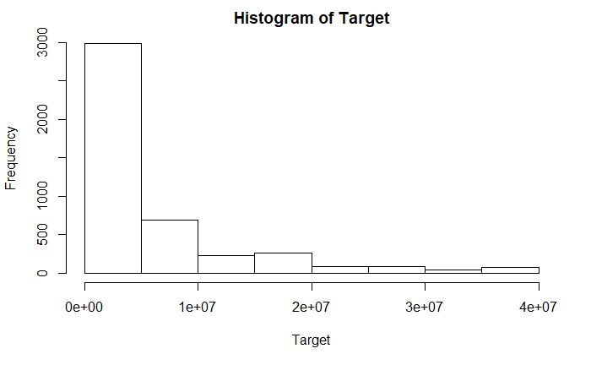

I see the poison distribution with the data being skewed right. The data is going to have problems with outlier data. At first, my train of thought was to bin the data to see if I can create different equations to use as predictions. For example:

pred_bin | target | X48df886f9 | X0deb4b6a8 | X34b15f335 | a8cb14b00 | X2f0771a37 | X30347e683 | d08d1fbe3 | X6ee66e115 | X20aa07010 | dc5a8f1d8 | X11d86fa6a | X77c9823f2 | adf119b9a
1 | 78190 | 13561 | 0 | 1852 | 0 | 0 | 17444 | 2682 | 19283 | 985030 | 189018 | 54918 | 0 | 6368
2 | 284455 | 16176 | 8163 | 8431 | 0 | 302 | 69304 | 0 | 0 | 1292385 | 24191 | 119232 | 0 | 72771
3 | 620215 | 2367 | 0 | 50567 | 0 | 0 | 35379 | 0 | 1478 | 1329395 | 106152 | 406294 | 0 | 185118
4 | 1144786 | 22593 | 13.2 | 505 | 0 | 0 | 8374 | 13.2 | 22857 | 1708071 | 125569 | 213257 | 0 | 36413
5 | 1917784 | 12009 | 0 | 4037 | 0 | 5912 | 61298 | 69284 | 0 | 1662034 | 101889 | 151447 | 0 | 72762
6 | 3305630 | 1167 | 0 | 4849 | 9800 | 0 | 37800 | 0 | 2214 | 2028985 | 141648 | 149625 | 0 | 246174
7 | 5187209 | 25253 | 0 | 25253 | 37374 | 0 | 47399 | 0 | 0 | 2591770 | 281414 | 280995 | 0 | 109556
8 | 8674379 | 0 | 0 | 64239 | 0 | 30229 | 1064 | 0 | 0 | 2392804 | 186785 | 133408 | 0 | 67602
9 | 15901249 | 49366 | 2033 | 95522 | 0 | 203252 | 19520 | 89431 | 0 | 3885168 | 228413 | 349079 | 0 | 141760
10 | 29836576 | 0 | 4096 | 103 | 0 | 0 | 2536 | 0 | 0 | 10617799 | 194233 | 93649 | 130 | 2572671

The above table represents breaking the target into 10 deciles. Each column value is the mean of the cluster. Some columns have more data to cover each decile.

There are 2049 columns that do not cover each decile. We may come back to this observation to see if we can remove these rows when training a model.

We can also log the data and try to predict that “target”. Our logged data looks like the following.

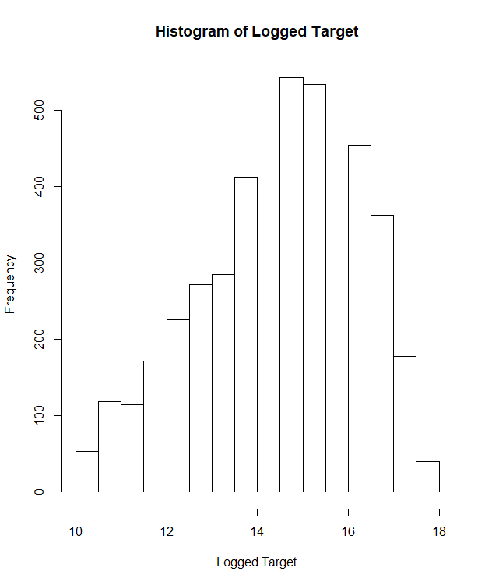

We see a more normal distribution. I am more comfortable trying to predict this data. I do have some worries about converting data back and forth from the exponent to log when I do the submissions.

Our test data set has 49,342 rows making it extremely larger than the training set. This fact is important as any type of clustering must be mimicked over a larger matrix.

train_df$pred_bin <- with(train_df, cut(target,
breaks=quantile(target, probs=seq(0,1, by=0.10), na.rm=TRUE),
include.lowest=TRUE, labels = c(1,2,3,4,5,6,7,8,9,10)))
table(as.integer(train_df$pred_bin))

dec_df <- train_df %>%
group_by(pred_bin) %>%
summarise_all(funs(mean(.)))

dec_df$ID <- NULL
dec_df[dec_df == 0] <- NA
dec_df <- dec_df[,apply(dec_df, 2, function(x) !any(is.na(x)))]
dec_df_name <- names(dec_df)

train_df$pred_bin <- NULL
############################################
# take the log of the data
############################################

train_df$log_target <- log(train_df$target)
hist(train_df$log_target, main="Histogram of Logged Target", xlab="Logged Target")

Duplicates
Our next step is to check for duplicates in our data and we do not find any.
train_df_uni <- train_df[!duplicated(train_df),]

sum(duplicated(train_df))

NA Values
There are also no empty or missing values in the test data.
sum(is.na(train_df))

Non Zero Predictors
There is a chance that variables have no predictive power because they do not have many unique values across the samples. This event can happen when we auto encode dummy variables and end up with a lot of zero values. This data set has many, many zero variables. Some models such as principle component analysis require us to remove the non-zero variables before continuing.
The caret package has a way to show us which variables are non-zero predictors.

 | freqRatio | percentUnique | zeroVar | nzv
ID | 1 | 100 | FALSE | FALSE
target | 1.040201 | 31.68872 | FALSE | FALSE
X48df886f9 | 736.6667 | 0.71765 | FALSE | TRUE
X0deb4b6a8 | 4455 | 0.112133 | FALSE | TRUE
X34b15f335 | 1475.333 | 0.65037 | FALSE | TRUE
a8cb14b00 | 4457 | 0.06728 | FALSE | TRUE
X2f0771a37 | 4454 | 0.134559 | FALSE | TRUE
X30347e683 | 441.2 | 0.560664 | FALSE | TRUE
d08d1fbe3 | 4454 | 0.134559 | FALSE | TRUE
X6ee66e115 | 4454 | 0.134559 | FALSE | TRUE
X20aa07010 | 52.01754 | 16.01256 | FALSE | FALSE
dc5a8f1d8 | 206.4762 | 1.255887 | FALSE | TRUE
X11d86fa6a | 153.3571 | 1.928684 | FALSE | TRUE

The frequency ratio represents the ratio of the most common value to the second. Percent Unique is the number of unique data points over total data points. We eliminated the near zero predictors using this method, leaving us with only 44 columns.
nzv_cols <- nearZeroVar(train_df_uni)
if(length(nzv_cols) > 0) train_df_uni <- train_df_uni[, -nzv_cols]

Creating the Clusters

Hierarchical Clustering

To group the data, I created a hierarchical cluster on the non-zero data. I ran different iterations of cluster methods and distance methods. A summary of this analysis is in the below table.

Distance Method | Cluster Method | Cluster
 |  | 1 | 2 | 3 | 4 | 5 | 6 | 7 | 8 | 9 | 10
Canberra | Complete | 476 | 306 | 1113 | 588 | 420 | 880 | 189 | 238 | 111 | 138
Pearson | Complete | 539 | 263 | 2055 | 508 | 187 | 544 | 52 | 165 | 76 | 95
Pearson | Average | 3271 | 505 | 101 | 185 | 38 | 76 | 97 | 82 | 54 | 50
Pearson | McQuitty | 335 | 276 | 2259 | 651 | 382 | 204 | 124 | 84 | 43 | 10
Correlation | McQuitty | 1401 | 323 | 640 | 357 | 215 | 439 | 180 | 252 | 309 | 343
Abscorrelation | Complete | 349 | 614 | 485 | 699 | 334 | 340 | 333 | 567 | 498 | 240

For the clusters, I chose abscorrelation and complete for the clustering because there is an even distribution. Because of the amount of data, I have not yet attempted to graph the data.

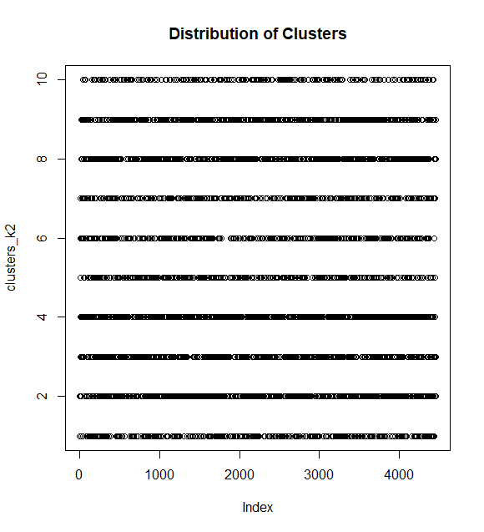
We do see that the clusters are almost evenly distributed.

cluster_df <- train_df_uni
cluster_df$target <- NULL
cluster_df$ID <- NULL
cluster_df$pred_bin <- NULL
cluster_df$log_target <- NULL
cluster_df$h_cluster <- NULL

sc_cluster_df <- scale(cluster_df, center = T, scale = T)

cl <- makeCluster(1)
registerDoParallel(cl)
dist_sc_cluster_df <- Dist(sc_cluster_df, method = "abscorrelation", nbproc = 5)
stopCluster(cl)

saveRDS(dist_sc_cluster_df, "E:/sc_cluster_df.rd")

hc_cluster_complete <- hclust(dist_sc_cluster_df, method="complete")

df_sc <- as.data.frame(sc_cluster_df)
clusters_k2 <- cutree(hc_cluster_complete, k = 10)

table(clusters_k2)
plot(clusters_k2, main = "Distribution of Clusters")

train_df_uni <- mutate(train_df_uni, h_cluster = as.factor(clusters_k2))

KMeans

We also created a k-means cluster. This process was simpler in that we had the tools to tell us what the optimal clusters is.

Using Factoextra, we were able to come up with the below plot.
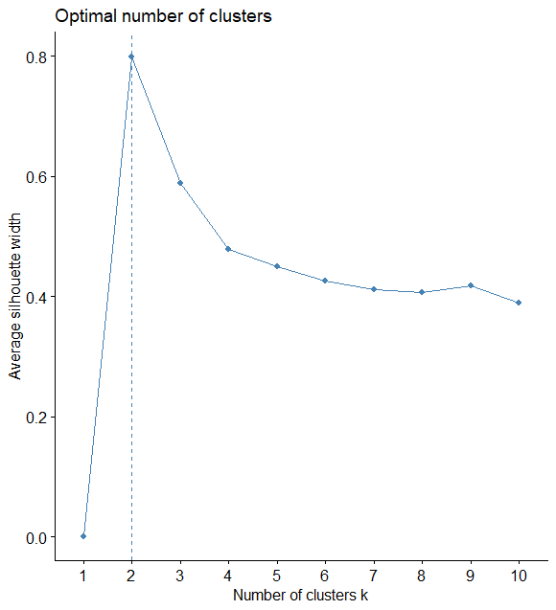
We used the silhouette method for determining clusters. In this case, the optimal number of clusters is two. We want high average silhouette widths and as we go over 2 clusters, our averages decrease.

Because of these results, we split our data into two clusters but as from the experiments we have done, we have determined that the k-means clusters did not provide as much value as the hclust.

# Compute and plot wss for k = 2 to k = 15
k.max <- 30 # Maximal number of clusters
wss <- sapply(1:k.max,
function(k){ kmeans(df_sc, k, nstart=25 )$tot.withinss})

plot(1:k.max, wss,
type="b", pch = 19, frame = FALSE,
xlab="Number of clusters K",
ylab="Total within-clusters sum of squares")

library(factoextra)
fviz_nbclust(df_sc, kmeans, method = "silhouette")

kmean.fit <- (kmeans(df_sc, 2, nstart = 25))
train_df_uni <- mutate(train_df_uni, k_cluster = as.factor(kmean.fit$cluster))

Models

Regsubsets

The first model I tried was with regsubsets with only the data that had non -zero decile means. We did not use clustering in this case because of lack of resources to create clusters on a 2000 by 2000 matrix. We are trying to predict the log_target of the data which is the log of target.

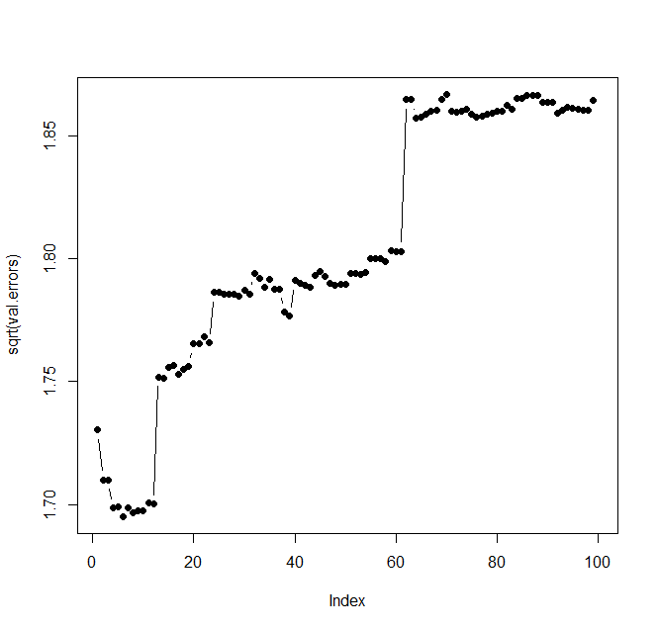
The best result was 6 coefficients with an RMSLE score of 1.70.
The summary of this model is:
(Intercept) | X6eef030c1 | X5f341a818 | X58e2e02e6 | X9fd594eec | X939f628a7 | de104af37
14.24541999 | 2.41E-08 | 3.74E-08 | 2.57E-08 | 2.91E-08 | 6.94E-09 | 3.44E-08

temp_df_temp <- train_df[, names(train_df)%in% dec_df_name]
temp_df_temp$log_target <- train_df$log_target
cluster_df3 <- temp_df_temp
cluster_df3$ID <- NULL
cluster_df3$target <- NULL

library(caret)

inTrain <- createDataPartition(
y = cluster_df3$log_target,
## the outcome data are needed
p = .75,
## The percentage of data in the
## training set
list = FALSE
)

training_df <- cluster_df3 [inTrain,]
testing_df <- cluster_df3 [-inTrain,]

regfit.foward <- regsubsets(log_target ~ ., data = training_df, nvmax = 100, method = "forward")

val.errors = rep(NA, 100)
x.test <- model.matrix(log_target ~ . , data = testing_df)

for (i in 1: 99){

coefi = coef(regfit.foward, id = i)
pred = x.test[,names(coefi)]%*%coefi
val.errors[i] = mean((log(exp(testing_df$log_target) + 1)- log(exp(pred) + 1)) ^2)

}

plot(sqrt(val.errors), ylag = "Root MSE", pch = 19, type = "b")

print (sqrt(val.errors[which.min(val.errors)]))
#1.60
which.min(val.errors)

coefi = coef(regfit.foward, id = 6)
xx.test <- model.matrix(ID ~ . , data = test_df)

pred = mutate(test_df, target = exp(xx.test[,names(coefi)]%*%coefi))

Next, I used the clusters and the non-zero value removed fields and received the following results.
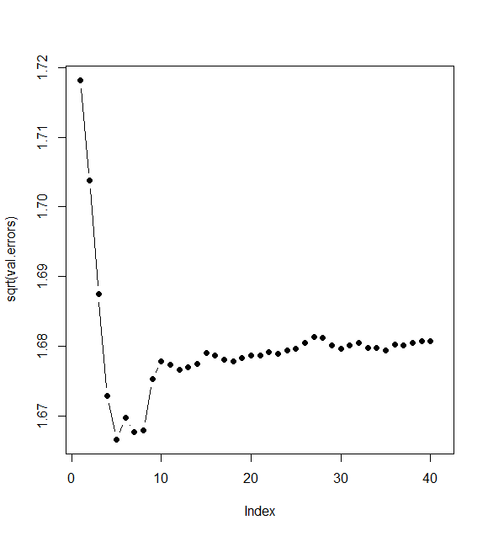
The lowest RMSLE here is 1.67. After five values, we start increasing our error.
The result above shows to me that maybe the near zero values with the clusters have a better chance of predicting the data using the whole data set or even half of the data set. The formula for our data is:
(Intercept) | X6eef030c1 | X58e2e02e6 | X9fd594eec | f190486d6 | h_cluster4
14.42486422 | 1.92E-08 | 2.55E-08 | 2.12E-08 | 1.76E-08 | -0.87972

cluster_df3 <- train_df_uni
cluster_df3$ID <- NULL
cluster_df3$target <- NULL

library(caret)

inTrain <- createDataPartition(
y = cluster_df3$log_target,
## the outcome data are needed
p = .75,
## The percentage of data in the
## training set
list = FALSE
)

training_df <- cluster_df3 [inTrain,]
testing_df <- cluster_df3 [-inTrain,]

regfit.foward <- regsubsets(log_target ~ ., data = training_df, nvmax = 41, method = "forward")

val.errors = rep(NA, 41)
x.test <- model.matrix(log_target ~ . , data = testing_df)

for (i in 1: 40){

coefi = coef(regfit.foward, id = i)
pred = x.test[,names(coefi)]%*%coefi
val.errors[i] = mean((log(exp(testing_df$log_target) + 1)- log(exp(pred) + 1)) ^2)

}

plot(sqrt(val.errors), ylag = "Root MSE", pch = 19, type = "b")

print (sqrt(val.errors[which.min(val.errors)]))

VIF
I was worried about the variance inflation factor because I was not sure if regsubsets accounted for correlations when creating the formulas. I ran a couple of different formulas and found that the VIF was accounted for. The VIF for 5 coefficients was 1.1. We are only concerned when a VIF of over 10 is produced.
library(fmsb)

VIF(lm(log_target ~ X6eef030c1 + X58e2e02e6 + X9fd594eec + f190486d6 + h_cluster, data = training_df))

PCA

The next step was to try principal components analysis to try to get a better model. Again, we will start with the data that have means for our ten bins.

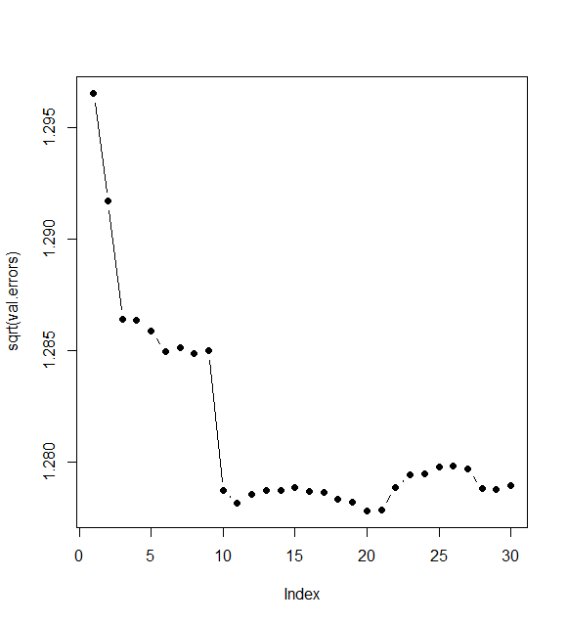

Our lowest score of 1.28 was with 20 components. This score is only for the train set. When we apply the predictions to the test set, we get an RMSLE of 1.89. This does make sense when we look at one of the plots of the pca data.

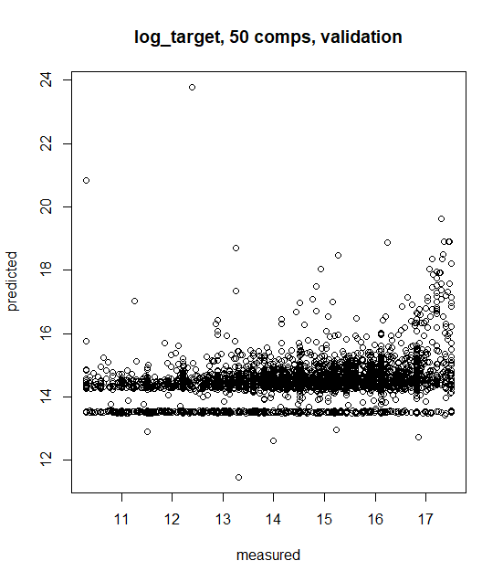

Our plot above shows predicted vs measured and you can see it is not homoscedastic. There is some over dispersion on the right side of the graph, meaning we are not predicting those correctly.

cluster_rr <- train_df_uni
cluster_rr$ID <- NULL
cluster_rr$target <- NULL

library(pls)
set.seed(107)
inTrain <- createDataPartition(
y = cluster_rr$log_target,
## the outcome data are needed
p = .75,
## The percentage of data in the
## training set
list = FALSE
)

training_df <- cluster_rr [inTrain,]
testing_df <- cluster_rr [-inTrain,]

pcr_model <- pcr(log_target~., data = training_df,scale =TRUE, validation = "CV")
val.errors = rep(NA, 30)
for (i in (1:30)){
pcr_pred <- predict(pcr_model, testing_df, ncomp = i)
val.errors[i] = (sqrt(mean((pcr_pred - testing_df$log_target)^2)))
}

plot(sqrt(val.errors), ylag = "Root MSE", pch = 19, type = "b")

which.min(val.errors)

hh <- predict(pcr_model, training_df, ncomp = 11)
(sqrt(mean((hh - testing_df$log_target)^2)))

#summary(pcr_model)

#validationplot(pcr_model)

#validationplot(pcr_model, val.type="MSEP")

predplot(pcr_model)

I tried running PCA with the newer data with no results as the machine ran out of resources.

Regression Trees
The next model I chose was regression trees. I used rpart and a cp of .0001. The tree did well of a RMSLE of 1.67, which was my lowest score. I believe I could use variable importance here to feed other models. My cut tree was:
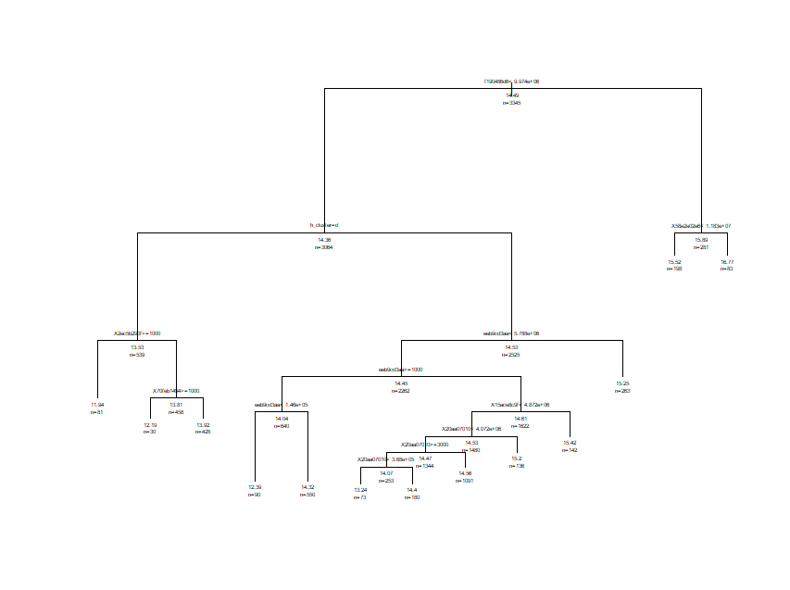
set.seed(107)
cluster_rr <- train_df_uni
cluster_rr$ID <- NULL
cluster_rr$target <- NULL

inTrain <- createDataPartition(
y = cluster_rr$log_target,
## the outcome data are needed
p = .75,
## The percentage of data in the
## training set
list = FALSE
)

training_df <- cluster_rr [inTrain,]
testing_df <- cluster_rr [-inTrain,]
library(rpart)
tree <- rpart(log_target ~ ., data = training_df, control = rpart.control(cp = 0.0001))

bestcp <- tree$cptable[which.min(tree$cptable[,"xerror"]),"CP"]

# Step3: Prune the tree using the best cp.
tree.pruned <- prune(tree, cp = bestcp)
print (sqrt(mean((predict(tree.pruned, testing_df) - testing_df$log_target)^2)))
plot(tree.pruned)
text(tree.pruned, use.n=TRUE, all=TRUE, cex=.4)

Random Forest
The random forest did well with a score of 1.43. The reason I chose Random Forests was to optimize the value on regression trees.
require(randomForest)
set.seed(107)
cluster_rr <- train_df_uni
cluster_rr$ID <- NULL
cluster_rr$target <- NULL

inTrain <- createDataPartition(
y = cluster_rr$log_target,
## the outcome data are needed
p = .75,
## The percentage of data in the
## training set
list = FALSE
)

training_df <- cluster_rr [inTrain,]
testing_df <- cluster_rr [-inTrain,]
library(rpart)
tree <- randomForest(log_target ~ ., data = training_df, control = rpart.control(cp = 0.0001))

print (sqrt(mean((predict(tree, testing_df) - testing_df$log_target)^2)))
plot(tree)
text(tree.pruned, use.n=TRUE, all=TRUE, cex=.4)

Partial Least Squares
The last model I wanted to try was the partial least squares model. I wanted to try this model because this data should be ideal for this situation. PLS should do well with highly correlated predictors and keep a supervised context in developing the model, unlike PCA.
I used the caret package to help me zero and scale the data before running a PLS model.

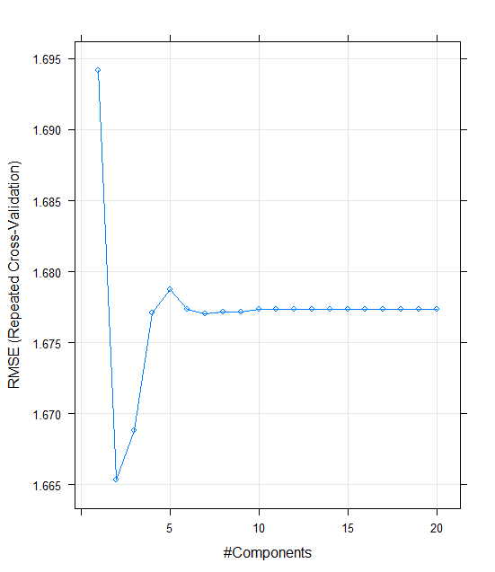

We can see that after 6, components, we even out with a score around 1.68. I submitted this score but the rpart score was by far the best.
# Compile cross-validation settings
set.seed(100)

cluster_df3 <- train_df_uni
cluster_df3$log_target <- log(train_df$target)
cluster_df3$ID <- NULL
cluster_df3$target <- NULL

inTrain <- createDataPartition(
y = cluster_df3$log_target,
## the outcome data are needed
p = .75,
## The percentage of data in the
## training set
list = FALSE
)

training_df <- cluster_df3 [inTrain,]
testing_df <- cluster_df3 [-inTrain,]

myfolds <- createMultiFolds(training_df$log_target, k = 5, times = 10)
control <- trainControl("repeatedcv", index = myfolds, selectionFunction = "oneSE")

# Train PLS model
mod1 <- train(log_target ~ ., data = training_df,
method = "pls",
metric = "RMSE",
tuneLength = 20,
trControl = control,
preProc = c("center","scale"))

# Check CV profile
plot(mod1)
print(getTrainPerf(mod1))

Conclusion
What we wanted to do was create a regression model to predict numeric data. Our problem was complicated by the fact that we did not know what the data represented and that the data contained many zero values. These zero values created many correlations between the predictor variables and the target variable.
My first insight was to use dimension reduction without consideration for the variables. After some careful thought, I tried different approaches to see where the models led me. I also did some research on which model to use for this type of data. I found articles stating that PLS would do well.
In “OPLS statistical model versus linear regression to assess sonographic predictors of stroke prognosis”, the author state that brain imaging studies suffer the fate of multicollinearity as in this data. In their paper, the authors show how PLS (and OPLS) had more predictors and a higher statistical power in stroke prognosis. The authors go on to recommend that PLS can be used instead of linear regression with the caveats that the user understand that PLS models are harder to interpret and that the methodology is new (paper was written in 2012).

Sources

R-bloggers. (2018). Near-zero variance predictors. Should we remove them?. [online] Available at: https://www.r-bloggers.com/near-zero-variance-predictors-should-we-remove-them/ [Accessed 5 Aug. 2018].
Uc-r.github.io. (2018). K-means Cluster Analysis · UC Business Analytics R Programming Guide. [online] Available at: https://uc-r.github.io/kmeans_clustering#silo [Accessed 5 Aug. 2018].

https://www.ncbi.nlm.nih.gov/pmc/articles/PMC3433323/

Submissions



