Hi everyone, my name is Delaney! I work on the Shadow Scope project to create educational materials and activities to go along with our scope. However, right now, we are going to be talking about *how to build your own shadow scope at home for under $30!* I am going to walk you through my first attempt at building a shadow scope at home, so that you all can learn from my successes and failures and streamline the process if you want to build your own 😊 let’s get started!

To start out, let’s talk about the supplies that are required in order to build a scope:

1. A webcam with USB connectivity
   * This allows us to visualize our samples on the computer screen
2. A container that could go over the webcam and create a dark environment
   * Needs to be made of material that can have a pinhole poked into it)
3. Silicone
   * Used to seal the light sensor of the webcam so it doesn’t get damaged from looking at water samples
4. A flashlight
   * Preferably with a single LED so that our light is concentrated
5. Small flathead and Philips screwdrivers
6. Tape
7. Scissors
8. Thumbtack
9. Pencil

Seems pretty straight forward, right?

I wanted to try to build this scope with supplies that I could find at local stores, so I could avoid having to wait for my items to get delivered. So for that reason, I started my journey at place that seems to have everything: Walmart.

So, I headed off to my local Walmart (it was a nice snowy day) and started looking around for the supplies I needed!

I began my search in the Paint & Hardware section, looking for Silicone to help keep the internal components of the webcam sealed away from any water samples we were going to look at with the at-home scope. I was able to find a good tube for only $3.77! Really you are looking for one that is waterproof and is safe to use indoors.

After the silicone success, I went over to Sporting Goods to find a flashlight. There was one with a single LED that was B-R-I-G-H-T and only cost $1… perfect!

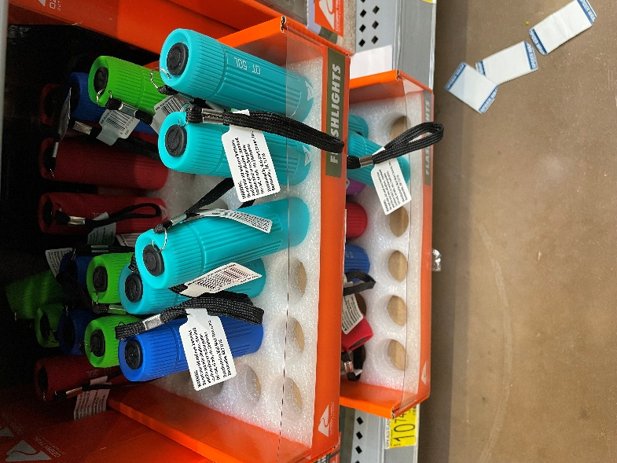

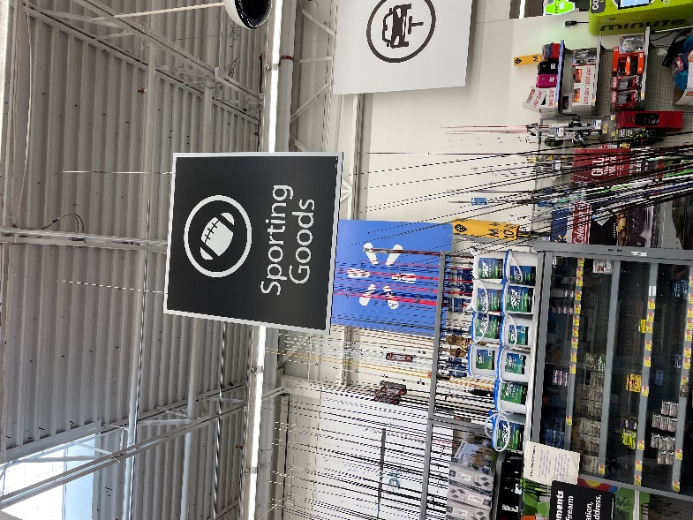

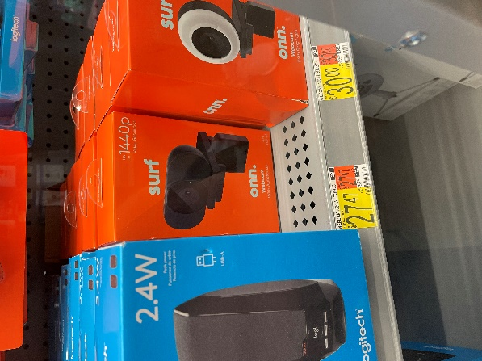Now, this is where my search got a little tougher… I wandered over to the Technology department in the Computer Accessories isle to look for a cheap webcam that I could disassemble for the shadow scope. However, the cheapest I could find was a $27 webcam, which wasn’t going to work, because that would have cost almost the entire $30 budget. So, that was not going to work, and I planned to do some online research for where I could purchase a cheaper webcam in-store after I completed the rest of my shopping!

After the disappointment with the webcam, I looked for a container that could cover the webcam to create the dark environment we need for the shadow scope. I was specifically looking for one of the cylindrical frozen limeade cans with aluminum tops because I felt this would be the perfect size and material for what we need. Plus, limeade would make a perfect refreshment while building the scope 😊 Yet again, though, Walmart let me down. There were no frozen limeade cans in sight. So, I decided to cut my losses ant purchased the silicone and the flashlight for a grand total of $5.56 (with tax).

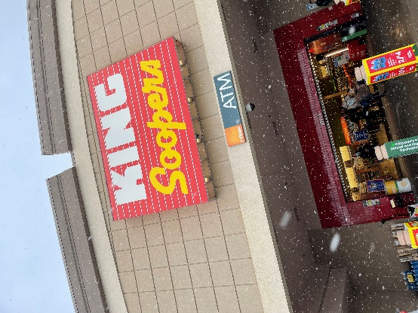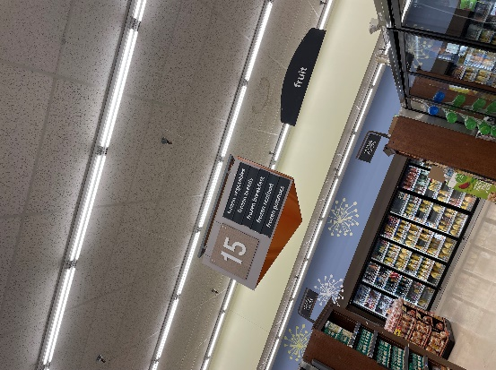At this point, I knew I would have to do some research about where I could pick up a webcam, but I knew for sure that my local grocery store would have the limeade cans that I needed, so I headed that way! I entered the frozen fruit section, and immediately found what I was looking for… LIMEADE! It’s the little wins, right? The total came out to $1.99, putting me at a $7.55 grand total so far. That left me with around $22.00 to purchase a webcam! Research time!

Turned out that a USB-enabled, 1080p (720p would work too) webcam that was in stores for less than $22 was harder than expected to come by.. but I did find a few options:

[BigLots $11 (sale) Webcam Link](https://www.biglots.com/product/1080p-light-up-webcam/p810523914) [Microcenter $5 Webcam Link](https://www.microcenter.com/product/624556/VWC103-BLK_Digital_Webcam_-_Black?storeID=181) [Microcenter $10 (sale) Webcam Link](https://www.microcenter.com/product/624557/VWC104-BLK_Digital_Webcam_-_Black?storeID=181)

I decided to go with the $10 Microcenter option because it was available in-store and was close-by. The other two cameras would have worked too, keep an eye on Mac vs. PC compatibility depending on what type of computer you have!

I went to microcenter and purchased the camera which rang up to $10.87. That brought my grand total to $17.55!

I had the remaining supplies already available to me at home, so I called it quits on my shopping spree and went hope to start building! You can find out how to build the shadow scope in part 2!