HALIFAX AREA ENERGY DEMAND FORECASTING
API Automation & Integration Guide
Layer mapping · Connection patterns · Script configuration · Scheduling
Dylan Bray · NSCC DBAS 3090 · March 2026 · v1.0

Overview
This document maps every external API endpoint to the exact pipeline layer where it connects, the Python script that handles it, the connection mechanism (HTTP / ODBC / SQLAlchemy), and the SQL Server table it writes to. It is the implementation companion to the Data Source Reference Guide — where that document answers "which source?", this one answers "how do I automate it into the system?".

STACK | Python 3.x · requests · pandas · sqlalchemy · pyodbc · geopandas  SQL Server (HalifaxEnergyProject) · SSIS (HalifaxEnergy_ETL.dtsx) · SQL Server Agent  R 4.x · DBI · odbc · xgboost · Rscript.exe  Power BI REST API · GitHub Actions · PowerShell (daily_refresh.ps1)

1. Layer Architecture — Where Each API Connects
The diagram below shows all five pipeline layers. Each coloured API box at the top connects down to the Python script that ingests it, then through SQL staging, SSIS transform, the gold fact table, and finally the model and presentation layers. Dashed lines are HTTP calls; solid lines are database connections.
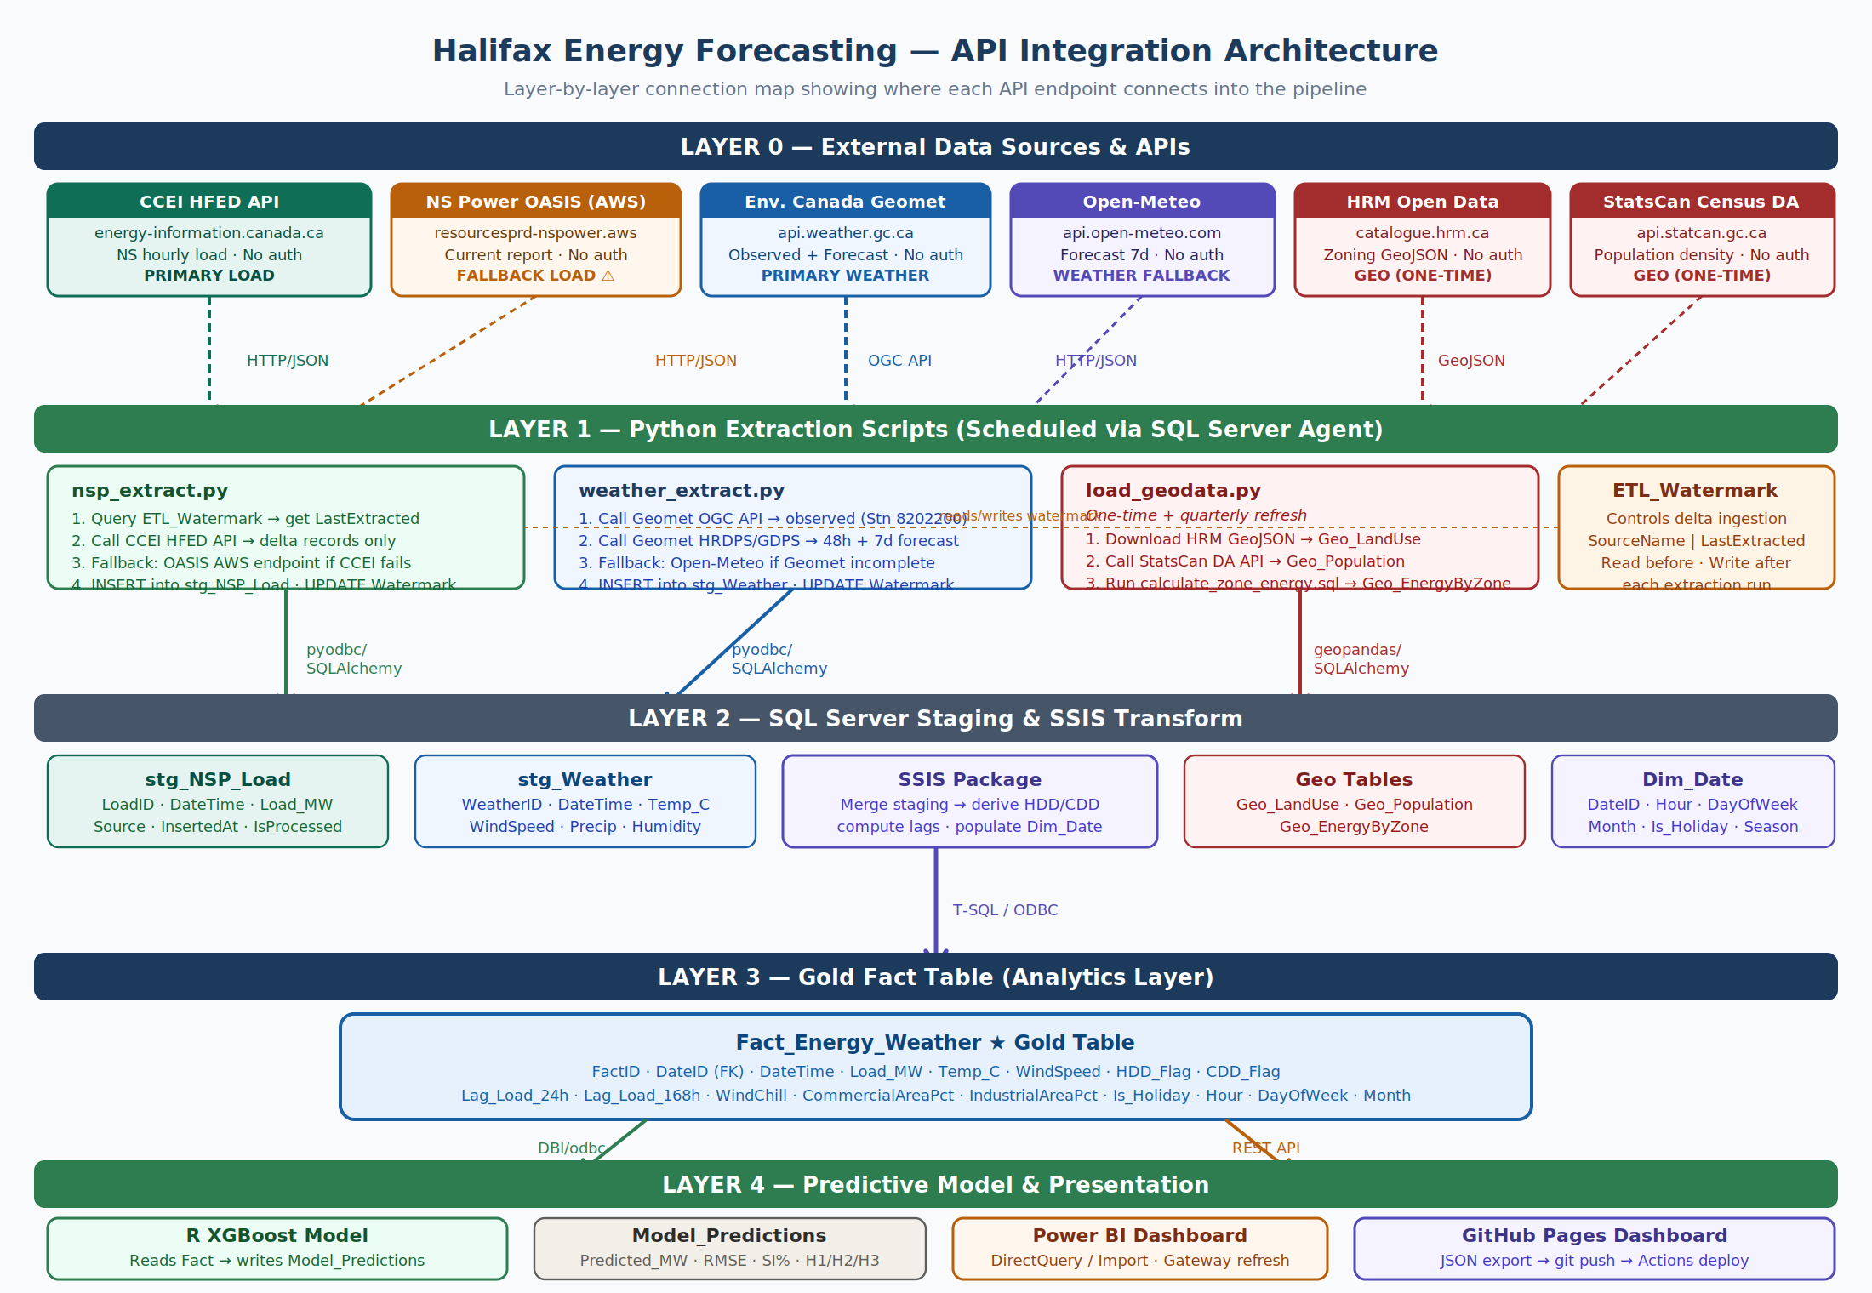

READ THIS FIRST | Layer 0 = External APIs (Internet). No auth required for primary sources.  Layer 1 = Python scripts running on your local/server machine via SQL Agent CmdExec step.  Layer 2 = SQL Server staging tables + SSIS package running on the same SQL Server instance.  Layer 3 = Fact_Energy_Weather — the gold table. Everything above feeds this; everything below reads it.  Layer 4 = R model + Power BI + GitHub Pages. These are consumers, not producers.

2. Daily Automation Timeline
The Gantt chart below shows the sequenced daily run triggered at 06:00 AM by the SQL Server Agent job HalifaxEnergy_DailyRun. Steps 1 (extraction) run in parallel. All subsequent steps are chained — each step's success gate triggers the next.
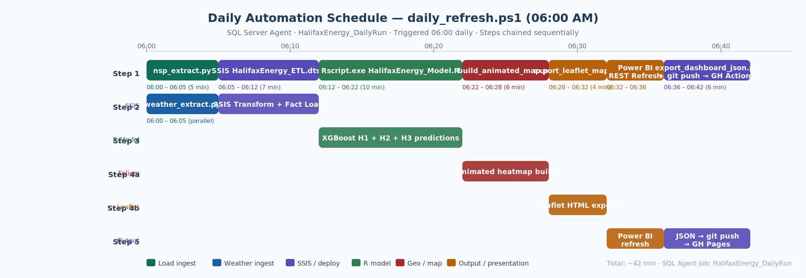

FAILURE HANDLING | On any step failure: SQL Agent writes to the Logs table and sends email via Database Mail.  Step 3 (R model): if SI% > 10%, the model writes a warning flag to Model_Predictions — the pipeline continues.  Steps 4a/4b (map build): failure here is non-critical. The pipeline continues to Power BI and git push.  Step 5b (git push): if GitHub is unreachable, the JSON files remain on disk and will push on the next run.

3. Script-by-Script Integration Details
3.1 | nsp_extract.py — Load Data Extraction  Layer 0 → Layer 1 → stg_NSP_Load · Runs daily 06:00 AM

Extracts hourly NS load data from CCEI HFED (primary) with OASIS AWS as fallback. Uses the ETL_Watermark table to perform delta loading — only records newer than the last successful run are fetched.

API / Source | Endpoint URL | Auth | Layer | Script
CCEI HFED API | energy-information.canada.ca/en/resources/high-frequency-electricity-data (API link on page) | None — public | Layer 0 → L1 | nsp_extract.py
OASIS AWS endpoint | resourcesprd-nspower.aws.silvertech.net/oasis/current_report.shtml | None — public | Layer 0 → L1  (fallback) | nsp_extract.py

Connection pattern
HTTP GET via requests library. Response parsed with pandas. Written to SQL Server via SQLAlchemy + pyodbc.

# nsp_extract.py — key connection logic
import requests, pandas as pd
from sqlalchemy import create_engine, text

ENGINE = create_engine(
"mssql+pyodbc://./HalifaxEnergyProject?driver=ODBC+Driver+17+for+SQL+Server"
)

# 1. Read watermark
with ENGINE.connect() as conn:
row = conn.execute(text(
"SELECT LastExtracted FROM ETL_Watermark WHERE SourceName='CCEI_HFED'"
)).fetchone()
last_dt = row[0] # datetime

# 2. Call CCEI HFED (replace URL with actual API link from HFED tool)
CCEI_URL = "https://energy-information.canada.ca/...api...?province=NS&after={dt}"
try:
resp = requests.get(CCEI_URL.format(dt=last_dt), timeout=30)
df = pd.read_csv(resp.content) # or pd.read_json()
except Exception:
# 3. Fallback: OASIS AWS current report
resp = requests.get("https://resourcesprd-nspower.aws.silvertech.net/oasis/current_report.shtml", timeout=20)
df = pd.read_html(resp.text)[0]

# 4. INSERT new rows
df.to_sql("stg_NSP_Load", ENGINE, if_exists="append", index=False)

# 5. Update watermark
with ENGINE.begin() as conn:
conn.execute(text(
"UPDATE ETL_Watermark SET LastExtracted=GETDATE(), RowsInserted=:n WHERE SourceName='CCEI_HFED'"
), {"n": len(df)})

ODBC DRIVER | Requires "ODBC Driver 17 for SQL Server" installed on the machine running the script.  Enable TCP/IP in SQL Server Configuration Manager for non-local connections.  Use Windows Authentication (./HalifaxEnergyProject) for SQL Agent context — no password in code.

3.2 | weather_extract.py — Weather Feature Extraction  Layer 0 → Layer 1 → stg_Weather · Runs daily 06:00 AM (parallel with nsp_extract)

Fetches observed hourly weather actuals and forward forecasts. Two endpoint types: observed (for H1 features) and forecast (for H2 day-ahead and H3 7-day). Both run in the same script, different query parameters.

API / Source | Endpoint URL | Auth | Layer | Script
Env. Canada Geomet  (Observed) | api.weather.gc.ca/collections/climate-hourly/items  ?CLIMATE_IDENTIFIER=8202200 | None | Layer 0 → L1 | weather_extract.py
Env. Canada Geomet  (HRDPS Forecast) | api.weather.gc.ca — HRDPS WMS layer  bbox Halifax, TT+UV params, 48h forward | None | Layer 0 → L1 | weather_extract.py
Env. Canada Geomet  (GDPS 7-day) | api.weather.gc.ca — GDPS layer  bbox Halifax, 7d forward | None | Layer 0 → L1 | weather_extract.py
Open-Meteo  (fallback) | api.open-meteo.com/v1/forecast  ?lat=44.65&lon=-63.60  &hourly=temperature_2m,windspeed_10m  &forecast_days=7&past_days=2 | None | Layer 0 → L1  (fallback) | weather_extract.py

Connection pattern
OGC API standard (GeoJSON response). Both observed and forecast use the same Geomet base URL with different collection and parameter paths.

# weather_extract.py — key connection logic
import requests, pandas as pd
from sqlalchemy import create_engine, text
from datetime import datetime, timedelta

ENGINE = create_engine(
"mssql+pyodbc://./HalifaxEnergyProject?driver=ODBC+Driver+17+for+SQL+Server"
)

GEOMET_BASE = "https://api.weather.gc.ca/collections/climate-hourly/items"
STATION_ID = "8202200" # Halifax Stanfield
now = datetime.utcnow()

# 1. Observed actuals (last 48h)
start = (now - timedelta(hours=48)).strftime("%Y-%m-%dT%H:%M:%SZ")
end = now.strftime("%Y-%m-%dT%H:%M:%SZ")
try:
params = {
"CLIMATE_IDENTIFIER": STATION_ID,
"datetime": f"{start}/{end}",
"limit": 336,
"f": "json"
}
r = requests.get(GEOMET_BASE, params=params, timeout=30)
features = r.json()["features"]
obs_df = pd.json_normalize([f["properties"] for f in features])
except Exception:
# Fallback: Open-Meteo
r = requests.get(
"https://api.open-meteo.com/v1/forecast",
params={"latitude":44.65,"longitude":-63.60,
"hourly":"temperature_2m,windspeed_10m,precipitation",
"past_days":2,"forecast_days":1,"timezone":"America/Halifax"},
timeout=20)
obs_df = pd.DataFrame(r.json()["hourly"])

# 2. INSERT observed + forecast rows
obs_df.to_sql("stg_Weather", ENGINE, if_exists="append", index=False)

# 3. Update watermark
with ENGINE.begin() as conn:
conn.execute(text(
"UPDATE ETL_Watermark SET LastExtracted=GETDATE() WHERE SourceName='Geomet'"
))

3.3 | load_geodata.py — Geospatial Data Load  Layer 0 → Layer 1 → Geo_LandUse / Geo_Population · One-time + quarterly

Downloads and loads HRM zoning GeoJSON and StatsCan DA population data. Not part of the daily run — executed manually on project setup, then re-run quarterly when HRM publishes updated zoning data.

API / Source | Endpoint URL | Auth | Layer | Script
HRM Open Data  (Zoning GeoJSON) | catalogue.hrm.ca — Socrata GeoJSON export  Search "zoning" → Export → GeoJSON link | None | Layer 0 → L1  → Geo_LandUse | load_geodata.py
StatsCan Census DA | api.statcan.gc.ca/census-recensement/profile  /w/2021/EN/data/DA  ?geo_level=DA&geo_code=1209&f=JSON | None | Layer 0 → L1  → Geo_Population | load_geodata.py

# load_geodata.py — geospatial ingest
import geopandas as gpd, pandas as pd, requests
from sqlalchemy import create_engine

ENGINE = create_engine(
"mssql+pyodbc://./HalifaxEnergyProject?driver=ODBC+Driver+17+for+SQL+Server"
)

# 1. HRM Zoning → Geo_LandUse
HRM_URL = "https://catalogue.hrm.ca/dataset/.../export.geojson" # Socrata export URL
gdf = gpd.read_file(HRM_URL)
gdf["CommercialPct"] = (gdf["ZoneCategory"] == "Commercial").astype(float)
gdf["IndustrialPct"] = (gdf["ZoneCategory"] == "Industrial").astype(float)
gdf[["ZoneCode","ZoneCategory","CommercialPct","IndustrialPct","geometry"]] \
.to_sql("Geo_LandUse", ENGINE, if_exists="replace", index=False)

# 2. StatsCan DA Population → Geo_Population
STAT_URL = ("https://api.statcan.gc.ca/census-recensement/profile/w"
"/2021/EN/data/DA?geo_level=DA&geo_code=1209&f=JSON")
r = requests.get(STAT_URL, timeout=30)
da_df = pd.json_normalize(r.json()["data"])
da_df.to_sql("Geo_Population", ENGINE, if_exists="replace", index=False)

# 3. Run zone energy calculation
# execute: calculate_zone_energy.sql (distributes load by pop+comm weighting)

3.4 | SSIS — HalifaxEnergy_ETL.dtsx  Layer 2 → Layer 3 · Triggered by SQL Agent Step 2 (dtexec)

The SSIS package transforms staging data into the gold Fact_Energy_Weather table. It derives all engineered features that Python does not produce — HDD_Flag, CDD_Flag, lag features, WindChill, and the Dim_Date FK. No external API calls. Connection is internal SQL Server only.

SSIS Task | Input | Output | Connection Type
OLE DB Source (×2) | stg_NSP_Load + stg_Weather | Raw row stream | OLE DB (SQL Server)
Merge Join | Staged load + weather rows | Joined stream on DateTime | In-memory SSIS
Derived Column | Joined stream | HDD_Flag, CDD_Flag, WindChill | In-memory SSIS
Lookup — Dim_Date | DateTime value | DateID (FK) | OLE DB (SQL Server)
Lag Features (SQL CMD) | Fact_Energy_Weather (self) | Lag_Load_24h, Lag_Load_168h | T-SQL / OLE DB
OLE DB Destination | Transformed stream | Fact_Energy_Weather INSERT | OLE DB (SQL Server)
Execute SQL (Watermark) | Completed run | IsProcessed = 1 on stg_ rows | OLE DB (SQL Server)

SQL Agent invocation
-- SQL Agent Step 2: Run SSIS
-- Type: SQL Server Integration Services Package
-- Package: File System path to HalifaxEnergy_ETL.dtsx

-- Alternative via dtexec (CmdExec step):
"C:\Program Files\Microsoft SQL Server\160\DTS\Binn\dtexec.exe"
/F "C:\Projects\HalifaxEnergy\SSIS\HalifaxEnergy_ETL.dtsx"
/Rep EW

3.5 | HalifaxEnergy_Model.R — XGBoost Prediction Engine  Layer 3 → Layer 4 · Triggered by SQL Agent Step 3 (CmdExec Rscript.exe)

Reads from Fact_Energy_Weather, trains/loads the XGBoost model, generates H1 (24h), H2 (48h), and H3 (7-day) predictions, and writes all results to Model_Predictions with a ForecastHorizon column. No external HTTP calls — pure SQL Server DBI connection.

# SQL Agent Step 3: Run R model
# Type: Operating System (CmdExec)
"C:\Program Files\R\R-4.4.0\bin\Rscript.exe"
"C:\Projects\HalifaxEnergy\model\HalifaxEnergy_Model.R"

# Inside HalifaxEnergy_Model.R — connection pattern:
library(DBI); library(odbc)

con <- dbConnect(odbc::odbc(),
Driver = "ODBC Driver 17 for SQL Server",
Server = ".",
Database = "HalifaxEnergyProject",
Trusted_Connection = "Yes")

df <- dbReadTable(con, "Fact_Energy_Weather")

# ... feature engineering, model load/train ...

# Write predictions for all three horizons
for (horizon in c("H1_24h", "H2_48h", "H3_7d")) {
preds_df$ForecastHorizon <- horizon
dbWriteTable(con, "Model_Predictions", preds_df, append=TRUE, row.names=FALSE)
}

xgb.save(model, "C:\Projects\HalifaxEnergy\model\halifax_energy_model.xgb")
dbDisconnect(con)

3.6 | export_dashboard_json.py + git push  Layer 3/4 → GitHub Pages · SQL Agent Step 5b

Reads Model_Predictions and Fact_Energy_Weather, serialises to JSON files in the dpbray79.github.io repo, then commits and pushes. GitHub Actions automatically re-deploys the Pages site on every push to the data/ path.

# export_dashboard_json.py — export + git pattern
import pandas as pd, json
from sqlalchemy import create_engine
import subprocess, os

ENGINE = create_engine(
"mssql+pyodbc://./HalifaxEnergyProject?driver=ODBC+Driver+17+for+SQL+Server"
)

REPO = "C:\Users\dylan\dpbray79.github.io\halifax-energy"

# 1. Read + serialize
forecast = pd.read_sql("SELECT * FROM Model_Predictions WHERE ForecastHorizon='H2_48h' ...", ENGINE)
actuals = pd.read_sql("SELECT TOP 168 * FROM Fact_Energy_Weather ORDER BY DateTime DESC", ENGINE)
health = pd.read_sql("SELECT TOP 1 Run_RMSE, Run_SI_Pct, ModelRunAt FROM Model_Predictions ORDER BY ModelRunAt DESC", ENGINE)

with open(os.path.join(REPO, "data", "forecast.json"), "w") as f:
json.dump(forecast.to_dict(orient="records"), f)
with open(os.path.join(REPO, "data", "actuals.json"), "w") as f:
json.dump(actuals.to_dict(orient="records"), f)
with open(os.path.join(REPO, "data", "model_health.json"), "w") as f:
json.dump(health.iloc[0].to_dict(), f, default=str)

# 2. Git push (requires SSH key or PAT configured)
os.chdir(REPO)
subprocess.run(["git", "add", "data/"], check=True)
subprocess.run(["git", "commit", "-m", f"data: daily refresh {pd.Timestamp.now().date()}"], check=True)
subprocess.run(["git", "push"], check=True)

GIT AUTH | Configure SSH keys or a PAT (Personal Access Token) in Git credential manager so the push runs without a password prompt.  For SSH: ssh-keygen → add public key to GitHub → test with: ssh -T git@github.com  For PAT: git config --global credential.helper manager-core → push once interactively to cache token.  GitHub Actions deploy.yml triggers on push to halifax-energy/** path — no additional configuration needed.

4. PowerShell Master Script — daily_refresh.ps1
This script is the orchestration layer. SQL Agent runs it as a CmdExec step. It chains all pipeline steps sequentially, checks exit codes between steps, and logs failures.

# daily_refresh.ps1 — Master orchestration script
$logPath = "C:\Projects\HalifaxEnergy\logs\refresh_$(Get-Date -f yyyyMMdd).log"
$python = "C:\Python312\python.exe"
$rscript = "C:\Program Files\R\R-4.4.0\bin\Rscript.exe"
$dtexec = "C:\Program Files\Microsoft SQL Server\160\DTS\Binn\dtexec.exe"
$scripts = "C:\Projects\HalifaxEnergy\scripts"

function Run($label, $cmd, $args) {
Write-Host "[$(Get-Date -f HH:mm:ss)] Starting: $label"
& $cmd @args | Tee-Object -FilePath $logPath -Append
if ($LASTEXITCODE -ne 0) { throw "FAILED: $label" }
Write-Host "[$(Get-Date -f HH:mm:ss)] Done: $label"
}

try {
# Step 1a + 1b: Python extraction (parallel)
$j1 = Start-Job { & $using:python "$using:scripts\nsp_extract.py" }
$j2 = Start-Job { & $using:python "$using:scripts\weather_extract.py" }
Wait-Job $j1, $j2 | Receive-Job

# Step 2: SSIS
Run "SSIS ETL" $dtexec @("/F","$scripts\..\SSIS\HalifaxEnergy_ETL.dtsx","/Rep","EW")

# Step 3: R Model
Run "XGBoost Model" $rscript @("$scripts\..\model\HalifaxEnergy_Model.R")

# Step 4a: Animated heatmap
Run "Folium Heatmap" $python @("$scripts\..\geo\build_animated_map.py")

# Step 4b: Leaflet export
Run "Leaflet Export" $python @("$scripts\..\geo\export_leaflet_map.py")

# Step 5a: Power BI REST API refresh
Invoke-PowerBIRestMethod -Url "datasets/{datasetId}/refreshes" -Method Post

# Step 5b: JSON export + git push
Run "Dashboard JSON + Push" $python @("$scripts\export_dashboard_json.py")

Write-Host "Pipeline complete: $(Get-Date -f HH:mm:ss)"
}
catch { Write-Error $_; exit 1 }

5. SQL Server Agent Job Configuration
The following table gives the exact configuration for each SQL Agent job step.

# | Step Name | Type | Command / Path | On Success → On Failure
1 | Run daily_refresh.ps1 | CmdExec | powershell.exe -ExecutionPolicy Bypass -File "C:\Projects\HalifaxEnergy\scripts\daily_refresh.ps1" | Success → Quit · Failure → Email + Quit

SCHEDULE | Job name: HalifaxEnergy_DailyRun  Schedule: Daily · 06:00 AM · Recurs every 1 day  Weekly retraining: separate job HalifaxEnergy_WeeklyRetrain — Sundays 06:00 AM  On failure notification: Database Mail → NSPSOAdmin contact + your NSCC email  Alert: if Run_SI_Pct > 0.10 in Model_Predictions → additional email alert via R script

Halifax Energy Forecasting · API Automation & Integration Guide v1.0 · Dylan Bray · NSCC DBAS 3090 · March 2026

