5/24/2013 2:32:23 PM: DPC
Need to test on Windows 8; high priority; test on Vista (DPC)
I put all maintenance files in a folder (C:\JAFROC_C\JAFROC_C\JAFROC\JAFROC\HelpAndMaintenanceFiles) so it gets copied between computers; otherwise we are getting out of sync.

5/23/2013 8:41:39 PM: DPC (resolved)
Release mode build failure: I need to set all project to release mode;

The window is not sizing right and the symbols are not lining up properly

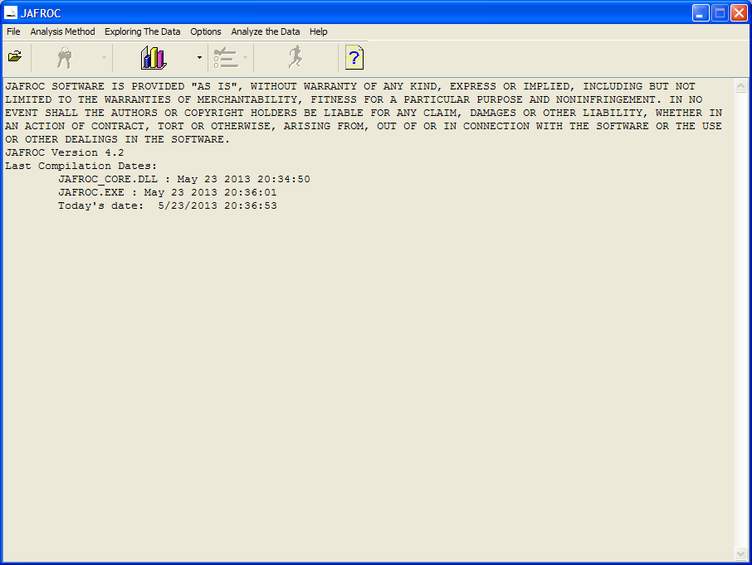

Thursday, May 23, 2013, DPC
Thank you very much; nice work; in fact great work!
I noticed some of the Build and Release configurations are different for the 4 projects; take a look and make sure it will compile successfully in all configurations.
I put the maintenance doc. in the shared folder and added it to the project under solution. Also the other doc and txt files. This way we can readily see these files as we go along, and add to them, to further document the code. All of these are in your shared folder, so use the JAFROC and JAFROC_CORE that I will put in there later this evening as your starting point for tomorrow. That way we will stay up to date;
I will also put JAFROC1 and JAFROC_CORE1: these have the code for the custom analysis that I worked on yesterday (this is not in your code); please make the other version consistent with it.

Thursday, May 23, 2013: XZ
I resolved the dependencies error. Just right-click on the "Detected Dependencies" node(in the setup project) then click "Refresh Dependencies" if that error appears again. One more thing, several configurations have been changed and I also put a txt file in the dropbox, which shows you what configurations you need to change.

Build output: can’t get rid of red warning
------ Starting pre-build validation for project 'Setup' ------
WARNING: File 'plot_template.xls' should not be installed into a User's Profile folder because it may not be available to all users.
WARNING: File 'DataFile.xls' should not be installed into a User's Profile folder because it may not be available to all users.
WARNING: File 'ROI example.xls' should not be installed into a User's Profile folder because it may not be available to all users.
WARNING: File 'TestFile_NH_PASS.txt' should not be installed into a User's Profile folder because it may not be available to all users.
WARNING: File 'ROI example.xls' should not be installed into a User's Profile folder because it may not be available to all users.
WARNING: File 'DataFile.xls' should not be installed into a User's Profile folder because it may not be available to all users.
------ Pre-build validation for project 'Setup' completed ------
1>------ Build started: Project: Setup, Configuration: Debug ------
Building file 'C:\JAFROC_C\JAFROC_C\JAFROC\Setup\Debug\Setup.msi'...
WARNING: The target version of the .NET Framework in the project does not match the .NET Framework launch condition version '.NET Framework 4 Client Profile'. Update the version of the .NET Framework launch condition to match the target version of the.NET Framework in the Advanced Compile Options Dialog Box (VB) or the Application Page (C#, F#).
Packaging file 'plot_template.xls'...
Packaging file 'ANOVA_DLL.dll'...
Packaging file 'DataFile.xls'...
Packaging file 'JAFROC.exe'...
Packaging file 'pokcd5cu.dll'...
Packaging file 'JAFROC_CORE.dll'...
Packaging file 'mfc100d.dll'...
Packaging file 'plot_template.xls'...
Packaging file 'JAFROC_V4_ReadMe_1_18_11.pdf'...
Packaging file 'JAFROC_CORE.h'...
Packaging file 'DCDFLIB.dll'...
Packaging file 'JAFROC_CORE.lib'...
Packaging file 'JAFROC Development Kit Guide.pdf'...
Packaging file 'mfcm100d.dll'...
Packaging file 'mfc100ud.dll'...
Packaging file 'ROI example.xls'...
Packaging file 'TestFile_NH_PASS.txt'...
Packaging file 'gdiplus.dll'...
Packaging file 'TestFile_NH_PASS.txt'...
Packaging file 'wnx7ark1.dll'...
Packaging file 'DataFile.xls'...
Packaging file 'ROI example.xls'...
Packaging file 'mw2dsezf.dll'...
Packaging file 'Sample Size Calculator.exe'...
Packaging file 'ROI example.xls'...
Packaging file 'Operating Characteristics.exe'...
Packaging file 'DataFile.xls'...

5/18/2013 6:11 PM: DPC changes
Checked installation on laptop

5/18/2013 6:09 PM: DPC changes
Moved NR files into c:\
To compile these look in C:\NR\legacy\nr2\CPP_211\nr_cpp for solution file
Setting the paths for the projects:
Include directories
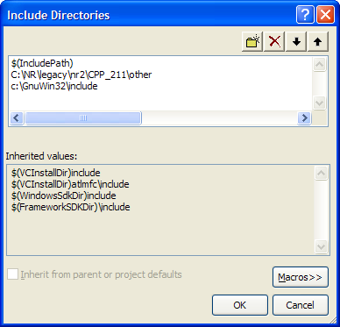
Libraries
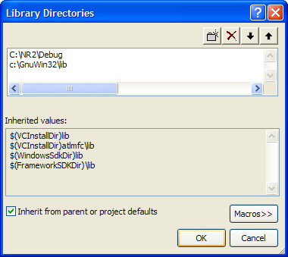

Moved distribution files to location shown below:
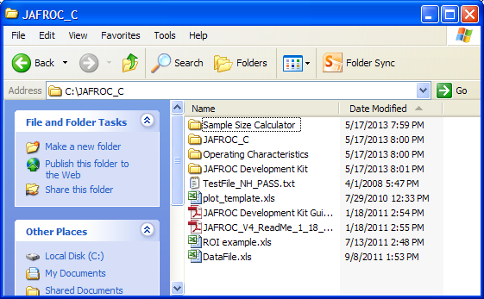

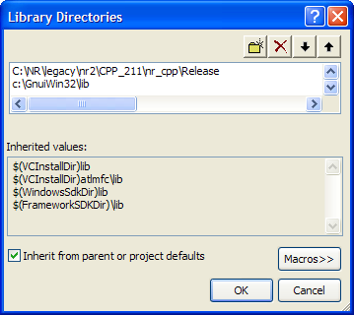

Must check “Inherit …” otherwise link error “can’t find mfc100d.lib”

5/11/2013 11:58:58 AM How to add a new method
- Add a new menu item
- Give it a good ID. Its property of “Enabled” should be “False”, and “prompt” is the hover message for this item.
- Define its ID in “Resource.h”. The number stands for its position in the menu.
For example, “#define IDM_FROC_JAFROC1_WEIGHTED 211”, and its position is “Analysis Method >> FROC >> JAFROC1 Weighted”, the number means the “Analysis Method” locates in position 2 (starts from 1, because the first digit of integers cannot be 0) of main menu, “FROC” locates in position 1 (starts from 0) of submenu “Analysis Method” and “JAFROC1 Weighted” locates in position 1 (starts from 0) of submenu “FROC”. Except that the position in main menu starts from 1, all positions of items in submenu starts from 0.

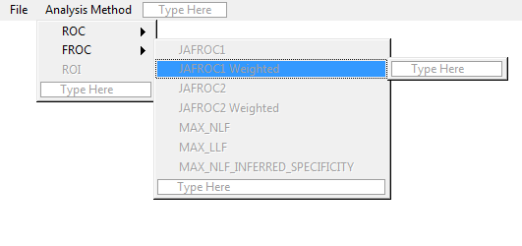
- Define its method name in “common.h”. For example,
“#define ANALYSIS_METHOD_JAFROC1_WEIGHTED IDM_FROC_JAFROC1_WEIGHTED”, the value of its name and ID should be same.
- In “JAFROCDlg.cpp”, enable it in the function “void CJAFROCDlg::EnableComponents( bool enable )” when MAX_CASES[ 0 ] > 0, and disable it in the “else” part except that it can be applied when MAX_CASES[ 0 ] = 0, if so enable it here.
- Add help information string in “MyStrings.h”.
- Add command handler code. It should be like this:
void CJAFROCDlg::OnMnCheckedFrocMaxInferredSpecificityAnalysis()
{
if( analysis_method != ANALYSIS_METHOD_EXP_TRNSFM_SPECIFICITY ) {
UnCheckMethodMenu(analysis_method);
analysis_method = ANALYSIS_METHOD_EXP_TRNSFM_SPECIFICITY ;
CheckMethodMenu(analysis_method);
WriteToConsole(HelpStrOnMnCheckedExpTransformSpecificityAnalysis ) ;
MessageBox(HelpStrOnMnCheckedExpTransformSpecificityAnalysis,NULL,MB_OK);
}
}

Just change corresponding method name and string name.
- Add codes for data analysis in “Analysis\ANOVA_DLL.cpp”, “Report\Print_JK_Results.cpp”, “Report\PrintDataSummary.cpp”, “Sample Size Estimation\SampleSizeEstimation.cpp”, “SampleSizeDialog.cpp”, “” and “JAFROC_CORE\MyFOM.cpp” if it is necessary.

5/8/2013 10:52:43 AM Add a new menu item
1. When cursor hovers, show appropriate message

How to add new menu
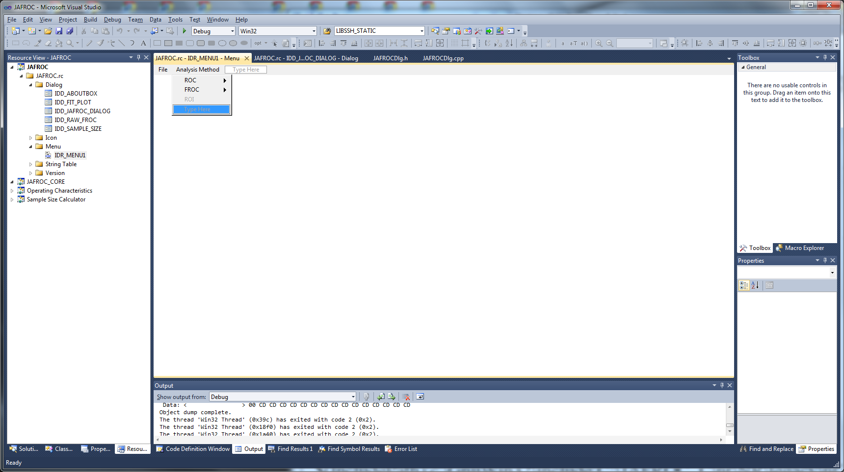
2. Type in new menu item name.

Then right click and select add event handler
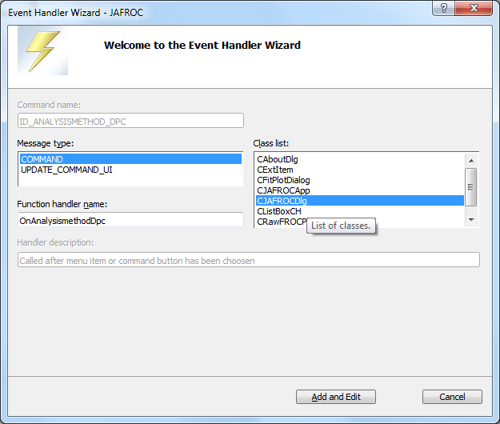

Then click add and edit

void CJAFROCDlg::OnAnalysismethodDpc()
{
// TODO: Add your command handler code here
}

Add handler code;

5/6/2013 11:22:10 AM Directories settings
DPC:
$(IncludePath);c:\GnuWin32\include;C:\JAFROC_C\nr\NR\legacy\nr2\CPP_211\other;
C:\JAFROC_C\nr\NR\legacy\nr2\CPP_211\nr_cpp\Debug;c:\GnuWin32\lib;$(LibraryPath)
C:\JAFROC_C\nr\NR\legacy\nr2\CPP_211\nr_cpp\Release;c:\GnuWin32\lib;$(LibraryPath)

