Chapter 18: Analyzing FROC data

Table of contents
- Introduction
- Analyzing a FROC dataset: an example
- Plotting empirical plots
- Reporting a study
- Single fixed-factor analysis
- Crossed treatment analysis
- FROC sample size estimation
- Discussion / Summary
- References

Online Appendices
Online Appendix 18.A: Instructive correspondence with a user (identifiers suppressed)
Online Appendix 18.B: FROC sample size estimation using ORH analysis

18.1: Introduction
The focus of this chapter is on analyzing multiple-reader multiple-case (MRMC) FROC datasets. Analyzing such data is, apart from a single crucial difference, similar to analyzing ROC data. The difference is the selection of the appropriate figure of merit. The reason is that the DBMH and ORH methods are applicable to any scalar figure of merit. A FOM, e.g., the empirical AUC under the wAFROC, reduces the mark rating data for a single-treatment single-reader dataset to a single scalar figure of merit. No assumptions are made regarding independence of ratings on the same case – an often-misunderstood point. The author recommends usage of the weighted AFROC figure of merit, where the lesions are weighted, the RJafroc default, unless there are strong clinical reasons for assigning unequal weights. [Experience has shown that the important results, e.g., p-values, are, barring extreme examples, rather insensitive to the actual choice of weights.]

The chapter shows analysis of a sample MRMC-FROC dataset, including visualization of the relevant operating characteristic. Examples are given using the RJafroc package implemented functions. Suggestions are made on how to report the results of a study (the suggestions apply equally to ROC studies). Single fixed factor analysis is described, followed by a newly developed method called crossed-treatment analysis, applicable when one has two treatment factors and their levels are crossed and interest is in the effect of each treatment independent of the other. The chapter concludes with sample size estimation for FROC studies using the wAFROC FOM. This requires one to first fit the inferred ROC plots to the RSM, a topic addressed in Chapter 19.

18.2: Analyzing a FROC dataset: an example
Open software.Rproj in the software directory corresponding to this chapter. Datasets included with RJafroc are described in the documentation. Four of these are ROC datasets, one is an LROC dataset and the rest (nine) are FROC datasets. Make sure the package is loaded – execute line 2 (the library command). See Chapter 03 Online Appendix for how to access the help files of any package. Open the help file for RJafroc to show the datasets (Packages > RJafroc > View), Fig. 18.1.
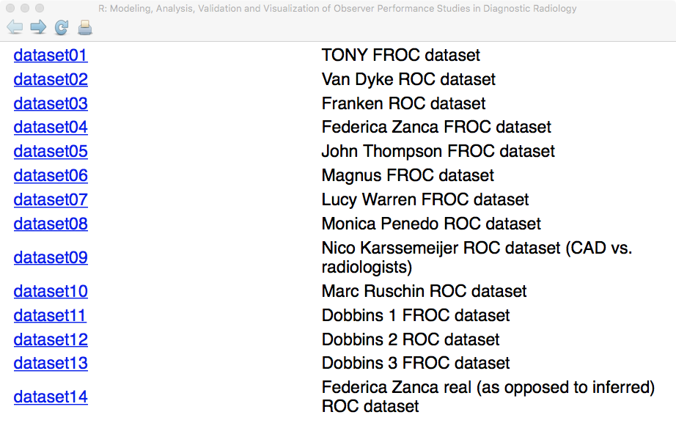
Fig. 18.1: Partial help file screen shot showing datasets included with the RJafroc package.

18.2.1: Code explanation
File "mainAnalyzewAFROC.R" performs both wAFROC and inferred ROC analyses of an FROC dataset. The results are saved to Excel tables similar to those shown for DBMH analysis of ROC data in Chapter 9. Line 3 sets the string name of the dataset to be analyzed to "FED"; this is done to create meaningful data file names, see below. The dataset is embedded in the package as dataset04 (line 6). This is a 5 treatment 4 radiologist FROC dataset acquired by Dr. Federica Zanca.¹ See sample code below.

> library(RJafroc)
> str(dataset04)
List of 8
$ NL : num [1:5, 1:4, 1:200, 1:7] -Inf -Inf 1 -Inf -Inf ...
$ LL : num [1:5, 1:4, 1:100, 1:3] 4 5 4 5 4 3 5 4 4 3 ...
$ lesionNum : int [1:100] 1 1 1 1 1 1 1 1 1 1 ...
$ lesionID : num [1:100, 1:3] 1 1 1 1 1 1 1 1 1 1 ...
$ lesionWeight: num [1:100, 1:3] 1 1 1 1 1 1 1 1 1 1 ...
$ dataType : chr "FROC"
$ modalityID : Named chr [1:5] "1" "2" "3" "4" ...
..- attr(*, "names")= chr [1:5] "1" "2" "3" "4" ...
$ readerID : Named chr [1:4] "1" "3" "4" "5"
..- attr(*, "names")= chr [1:4] "1" "3" "4" "5"

Line 4 of "mainAnalyzewAFROC.R" constructs the name of the wAFROC output file and line 5 does the same for the ROC output data file. Lines 7 - 13 uses function UtilOutputReport() to generate the output file after performing DBMH significance testing (stMethod = "DBMH") using FOM = "wAFROC". Line 14 – 21 uses FOM = "HrAuc" to perform DBMH inferred ROC analysis. In both examples, results of random-reader random-case (RRRC), fixed-reader random-case (FRRC) and random-reader fixed-case (RRFC) are calculated. [If the output files already exist, the program will halt and prompt the user to enter y to overwrite an existing output file or n to not overwrite the existing output file. The user should enter y both times when prompted.]

The parameters supplied to UtilOutputReport() are described in the RJafroc documentation. A screen shot of the help page follows, Fig. 18.2. The parameter names, all case sensitive, should be clear from the accompanying descriptions. For example, DataFileName ("FED" in the current example) is the name of the data file while ReportFileName is the name of the (output) report file ("FEDwAfroc.xlsx" or "FEDHrAuc.xlsx" in the current example).

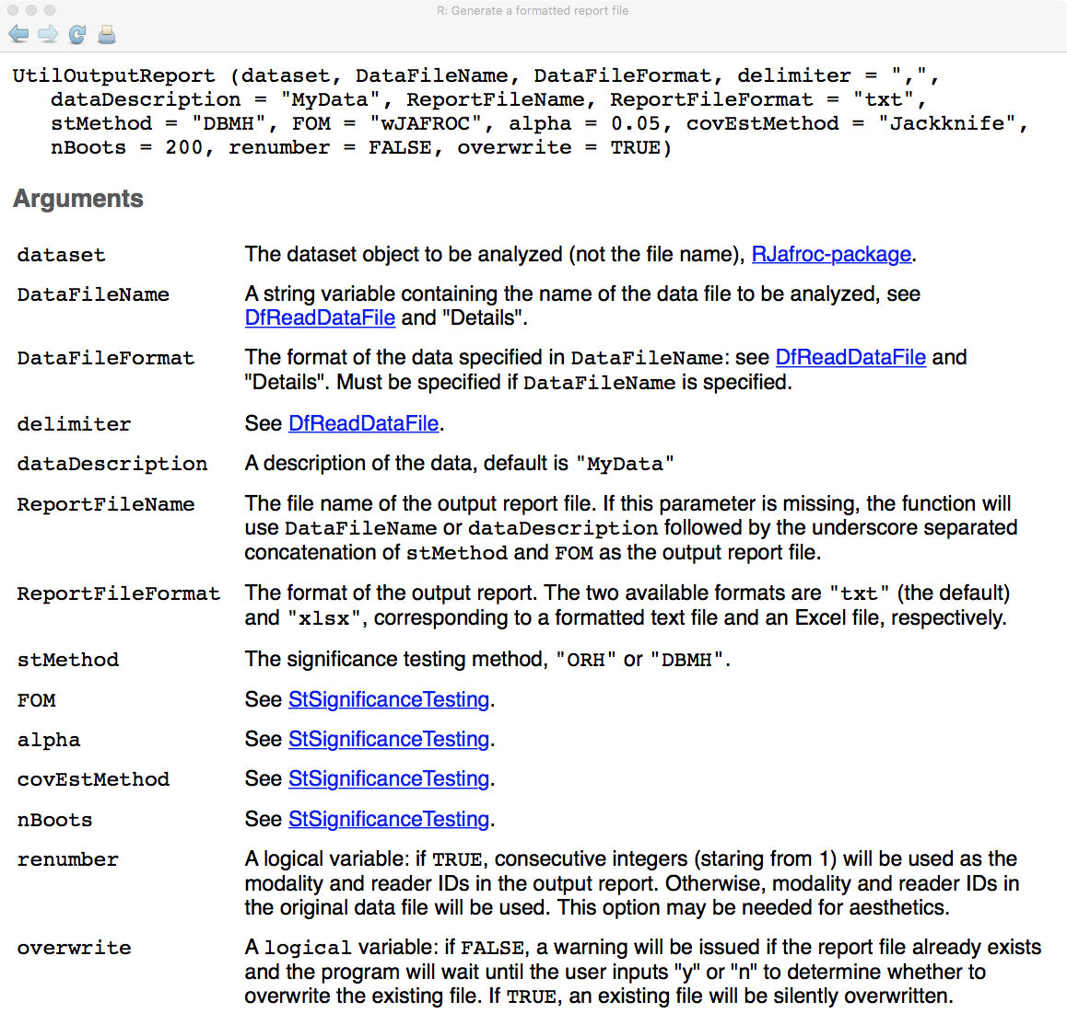
Fig. 18.2: Partial help file screen shot for UtilOutputReport.

The results of wAFROC analysis are saved to FEDwAfroc.xlsx and that of inferred ROC analysis are saved to FEDHrAuc.xlsx.

In the Excel data file the readers are named 1, 3, 4 and 5 – the software treats the reader names as labels. The author's guess is that for some reason complete data for reader 2 could not be obtained. The renumber = TRUE option has the effect of renumbering the readers 1 through 4. Without renumbering, the output would be aesthetically displeasing, but the conclusions (p-values, etc.) are unaffected.

For both analyses, figures of merit, empirical wAFROC-AUC and empirical ROC-AUC, and corresponding reader averages are summarized in Table 18.1. The weighted AFROC results (columns 2 - 6) were obtained by copy and paste operations from worksheet FOMs in file FedwAfroc.xlsx. The highest rating AUC results (columns 7 - 11) were obtained by similar operations from worksheet FOMs in file FedHrAuc.xlsx. [As expected, each wAFROC-AUC is smaller than the corresponding ROC-AUC.]

Table 18.1: Empirical wAFROC-AUC and ROC-AUC for all combinations of treatments and readers, and reader-averaged AUCs for each treatment (Rdr. Avg.).
Trt | wAFROC-AUC |  |  |  |  | ROC-AUC
Trt | Rdr-1 | Rdr-2 | Rdr-3 | Rdr-4 | Rdr. Avg. | Rdr-1 | Rdr-2 | Rdr-3 | Rdr-4 | Rdr. Avg.
1 | 0.77927 | 0.72489 | 0.70362 | 0.80509 | 0.75322 | 0.90425 | 0.79820 | 0.81175 | 0.86645 | 0.84516
2 | 0.78700 | 0.72690 | 0.72262 | 0.80378 | 0.76007 | 0.86425 | 0.84470 | 0.82050 | 0.87160 | 0.85026
3 | 0.72969 | 0.71576 | 0.67231 | 0.77266 | 0.72260 | 0.81295 | 0.81635 | 0.75275 | 0.85730 | 0.80984
4 | 0.81013 | 0.74312 | 0.69436 | 0.82941 | 0.76925 | 0.90235 | 0.83150 | 0.78865 | 0.87980 | 0.85058
5 | 0.74880 | 0.68227 | 0.65517 | 0.77125 | 0.71437 | 0.84140 | 0.77300 | 0.77115 | 0.84800 | 0.80839

Table 18.2 shows results for RRRC analysis using the wAFROC FOM. The overall F-test of the null hypothesis that all treatments have the same reader-averaged FOM, rejected the NH: F(4, 36.8) = 7.8, p = 0.00012. The numerator degree of freedom ndf is I - 1 = 4 (this is not shown in the output). Since the null hypothesis is that all treatments have the same FOM, this implies that at least one pairing of treatments yielded a FOM difference that is significantly different from zero. The control for multiple testing is in the formulation of the null hypothesis and no further Bonferroni-like² correction is needed. To determine which pairings are significantly different one examines the p-values (listed under Pr>t) in the "95% CI's FOMs, treatment difference" portion of the table. It shows that the following differences are significant at the 5% level, namely "1 – 3", "1 – 5", "2 – 3", "2 – 5", "3 – 4" and "4 – 5" - these are indicated by red font. The values listed under the "95% CI's FOMs, each treatment" portion of the table show that treatment 4 yielded the highest FOM (0.769) followed closely by treatments 2 and 1, while treatment 5 had the least FOM (0.714), slightly worse than treatment 3. This explains why the p-value for the difference 4 - 5 is the smallest (0.00007) of all the listed p-values in the "95% CI's FOMs, each treatment" portion of the table.

Each instance of the p-value for the individual treatment comparison yielding a significant p-value is accompanied by a 95% confidence interval that does not include zero. The two statements of significance, one in terms of a p-value and one in terms of a CI, are completely equivalent. When it comes to presenting results for treatment FOM differences, the author prefers the 95% CI but some journals insist on a p-value, even when it is not significant. Note that two sequential tests are involved, an overall F-test of the NH that all treatments have the same performance and only if this yields a significant results is one justified in looking at the p-values of treatment pairings.

Table 18.2: Results of random-reader random-case (RRRC) analysis using the wAFROC-AUC FOM. The upper part of the table shows results for treatment FOM differences and the lower part applies to individual treatment FOMs. The overall F-test yielded F(4,36.8) = 7.8, p-value = 0.00012. For each paired difference standard error = 0.0122 and degrees of freedom of the t-distribution = 36.8 (this information is in the output Excel table). The numerator degrees of freedom is (always) one less than the number of treatments, i.e., 5 – 1 = 4.
F-statistic |  | ddf | p-value
7.800 |  | 36.79 | 0.000117
95% CI's FOMs, treatment difference
Difference | Estimate |  |  | t | Pr>t | Lower | Upper
1 - 2 | -0.00686 |  |  | -0.56265 | 0.57709 | -0.03155 | 0.01784
1 – 3 | 0.03061 |  |  | 2.51234 | 0.01651 | 0.00592 | 0.05531
1 - 4 | -0.01604 |  |  | -1.31592 | 0.19634 | -0.04073 | 0.00866
1 – 5 | 0.03884 |  |  | 3.18766 | 0.00292 | 0.01415 | 0.06354
2 – 3 | 0.03747 |  |  | 3.07499 | 0.00396 | 0.01278 | 0.06217
2 - 4 | -0.00918 |  |  | -0.75328 | 0.45608 | -0.03387 | 0.01552
2 – 5 | 0.04570 |  |  | 3.75031 | 0.00061 | 0.02100 | 0.07040
3 – 4 | -0.04665 |  |  | -3.82827 | 0.00048 | -0.07135 | -0.02195
3 - 5 | 0.00823 |  |  | 0.67532 | 0.50370 | -0.01647 | 0.03292
4 – 5 | 0.05488 |  |  | 4.50358 | 0.00007 | 0.03018 | 0.07957
95% CI's FOMs, each treatment
Treatment | Estimate |  |  | StdErr | df | Lower | Upper
1 | 0.75322 |  |  | 0.02976 | 7.70845 | 0.68413 | 0.82231
2 | 0.76007 |  |  | 0.02843 | 10.69208 | 0.69727 | 0.82288
3 | 0.72260 |  |  | 0.02692 | 8.61918 | 0.66128 | 0.78392
4 | 0.76925 |  |  | 0.03572 | 5.24242 | 0.67870 | 0.85981
5 | 0.71437 |  |  | 0.03325 | 6.58542 | 0.63473 | 0.79402
[CI = confidence interval; red font = Significantly different at alpha = 0.05; Pr>t is the p-value of the test; StdErr = standard error of FOM estimate; df = degrees of freedom of t-distribution.]

Table 18.3 shows results for the inferred ROC-AUC FOM. Again the null hypothesis was rejected: F(4, 16.8) = 3.46, p = 0.031. This means at least two treatments have significantly different FOMs. Looking down the table, one sees that the same 6 pairs (as compared to wAFROC analysis) are significantly different, 1 – 3, 1- 5, etc., as indicated by the asterisks. The last five rows of the table show that treatment 4 had the highest performance while treatment 5 had the lowest performance. At the 5% significance level, both methods yielded the same significant differences. While it is incorrect to conclude from a single dataset that a smaller p-value is indicative of higher statistical power, simulation testing under controlled conditions has consistently shown higher statistical power for the wAFROC-AUC FOM^{3,4} as compared to the inferred ROC-AUC FOM.

Table 18.3: Similar to Table 18.2, except that this reports results of inferred ROC-AUC analysis. For each paired difference standard error = 0.0165 and degrees of freedom of the t-distribution = 16.8 (this information is in the output Excel table).
F-statistic |  | ddf |  | p-value
3.46 |  | 16.8 |  | 0.0305
95% CI's FOMs, treatment difference
Difference | Estimate | t | Pr>t | Lower | Upper
1 - 2 | -0.00510 | -0.30840 | 0.76157 | -0.04002 | 0.02982
1 – 3 | 0.03533 | 2.13611 | 0.04769 | 0.00040 | 0.07025
1 - 4 | -0.00541 | -0.32729 | 0.74749 | -0.04033 | 0.02951
1 – 5 | 0.03678 | 2.22379 | 0.04017 | 0.00185 | 0.07170
2 – 3 | 0.04043 | 2.44450 | 0.02584 | 0.00550 | 0.07535
2 - 4 | -0.00031 | -0.01890 | 0.98515 | -0.03523 | 0.03461
2 – 5 | 0.04188 | 2.53218 | 0.02161 | 0.00695 | 0.07680
3 – 4 | -0.04074 | -2.46340 | 0.02487 | -0.07566 | -0.00582
3 - 5 | 0.00145 | 0.08768 | 0.93117 | -0.03347 | 0.03637
4 – 5 | 0.04219 | 2.55108 | 0.02079 | 0.00727 | 0.07711
95% CI's FOMs, each treatment
Treatment | Estimate | StdErr | df | Lower | Upper
1 | 0.84516 | 0.02858 | 5.45748 | 0.77351 | 0.91681
2 | 0.85026 | 0.01993 | 27.72258 | 0.80942 | 0.89110
3 | 0.80984 | 0.02665 | 7.03714 | 0.74689 | 0.87278
4 | 0.85058 | 0.02941 | 5.40326 | 0.77664 | 0.92451
5 | 0.80839 | 0.02576 | 6.77565 | 0.74707 | 0.86971
[CI = confidence interval; red font = Significantly different at alpha = 0.05; Pr>t is the p-value of the test; StdErr = standard error of FOM estimate; df = degrees of freedom of t-distribution.]

18.2.2: Comments
In this example both FROC and ROC analyses yielded identical results for declaring significant treatment-pairings. This is because the difference between treatments 4 and 5 is relatively large. With a large enough difference, the statistical penalty of ignoring localization information is not enough to change the conclusion of significant differences. The p-values in Table 18.3 are larger than in Table 18.1, but not large enough so as to exceed 0.05. The statistical power of the two analyses is investigated in section 18.7, where the power penalty paid by ROC analysis will become clear.

18.3: Plotting empirical plots
It is important to display empirical plots, not just for publication purposes, but to get a better feel for the data. Since treatments 4 and 5 showed the largest difference, the corresponding plots are displayed. The code is in file mainAllPlots.R, which generates all empirical plots possible with FROC data (see Chapter 13 for definitions of the plots). To produce higher quality plots use the Export tab under Plots, increase the resolution and save the image in the desired format, e.g., tiff, or jpeg.

[Aside: mainwAfrocRocPlots.R produces "pretty-plot" versions of the wAFROC and ROC plots. It illustrates techniques for producing aesthetically pleasing plots; the user may wish to see the code to understand these techniques that work with ggplot2 plots. The author is no expert on ggplot2. A book authored by Hadley Wickham, which may be freely available on the web, describes techniques for producing publication quality plots using this R package.]

18.3.1: Code listing
Lines 5 – 76 generate 18 individual treatment-reader plots; each group of 4 lines generates a plot (72/4 = 18). Consider for example, lines 5 – 8:

ret <- PlotEmpiricalOperatingCharacteristics(
dataset = dataset04, trts = 4, rdrs = c(1:4),
opChType = "ROC")
print(ret$Plot);Sys.sleep(0.2) # slow down, as otherwise sometimes I get an error

The function being used, Fig. 18.3, is RJafroc:: PlotEmpiricalOperatingCharacteristics(), whose help file follows:

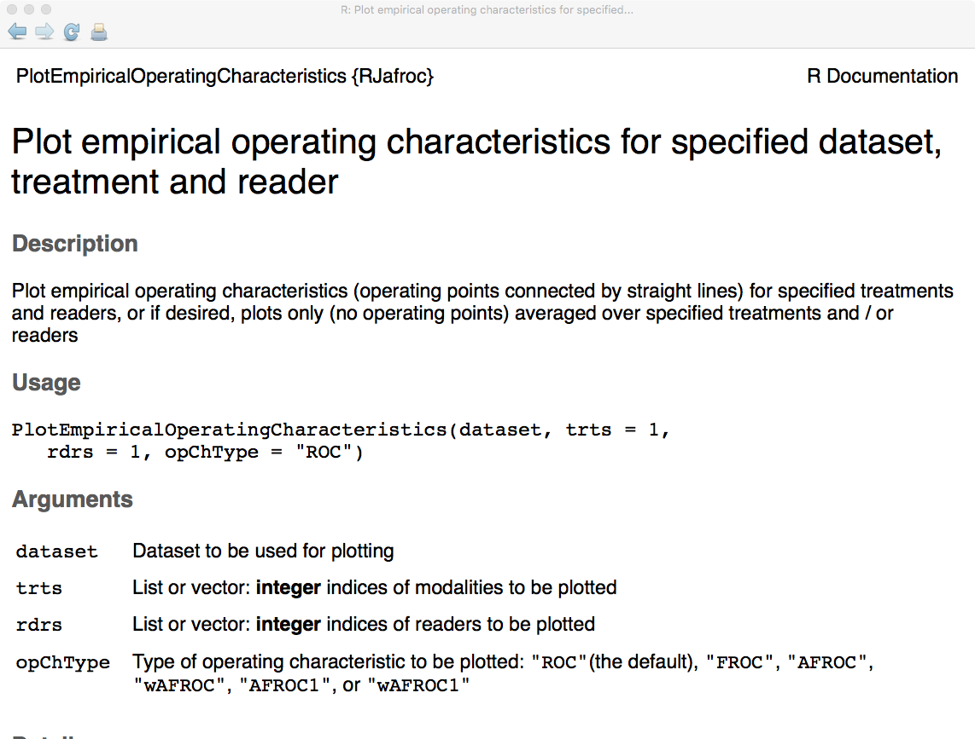
Fig. 18.3: Partial help file screen shot for PlotEmpiricalOperatingCharacteristics.

Lines 6 – 7 supply the needed parameters:
- dataset = dataset04
- trts = 4 (i.e., treatment 4)
- rdrs = c(1:4) (i.e., all 4 readers in the dataset)
- opChType = "ROC" (i.e., the empirical ROC plot is desired)

The return value of the function is saved in ret, which is a list of two objects, Points and Plot. Line 8 prints, i.e., displays, the plot, followed by a brief pause (as otherwise sometimes the program produces an error). Lines 1 - 80 generate 18 plots for individual treatment-reader pairing. Execute line 1 - 80, one line at a time, by clicking on Run. This way one sees the plots as they are generated. The plots are produced in the following order, from left to right (the bold font indicates the one for which a figure is shown, Fig. 18.4):

- Lines 5 – 8: ROC plot for treatment 4 and all 4 readers; four sub-plots (one per reader)
- Lines 9 – 12: ROC plot for treatment 5 and all 4 readers;
- Lines 13 – 16: FROC plot for treatment 4 and all 4 readers;
- Lines 17 – 20: FROC plot for treatment 5 and all 4 readers;
- Lines 21 – 24: AFROC plot for treatment 4 and all 4 readers;
- Lines 25 – 28: AFROC plot for treatment 5 and all 4 readers;
- Lines 29 – 32: AFROC1 plot for treatment 4 and all 4 readers;
- Lines 33 – 36: AFROC1 plot for treatment 5 and all 4 readers;
- Lines 37 – 40: wAFROC plot for treatment 4 and all 4 readers;
- Lines 41 – 44: wAFROC plot for treatment 5 and all 4 readers;
- Lines 45 – 48: wAFROC1 plot for treatment 4 and all 4 readers;
- Lines 49 – 52: wAFROC1 plot for treatment 5 and all 4 readers;
- Lines 53 – 56: ROC plot for treatments 4 and 5 and all 4 readers; eight sub-plots.
- Lines 56 – 60: FROC plot for treatments 4 and 5 and all 4 readers;
- Lines 61 – 64: AFROC plot for treatments 4 and 5 and all 4 readers;
- Lines 65 - 68: AFROC1 plot for treatments 4 and 5 and all 4 readers;
- Lines 69 – 72: wAFROC plot for treatments 4 and 5 and all 4 readers; Fig. 18.4. Plot (A)
- Lines 73 – 76: wAFROC1 plot for treatments 4 and 5 and all 4 readers;

Lines 80 – 151 generate 18 reader – averaged plots. As an example, lines l44 – 147, displays the reader averaged wAFROC plot, Fig. 18.4 (B). The corresponding reader averaged ROC plot is produced by lines 128 - 131. Keep clicking Run to execute these lines and display the plots.

ret <- PlotEmpiricalOperatingCharacteristics(
dataset = dataset04, trts = list(4,5), rdrs = list(c(1:4),c(1:4)),
opChType = "wAFROC")
print(ret$Plot);Sys.sleep(0.1)

18.3.2: On producing reader averaged plots
The treatments and readers are coded as list variables. The lengths of the two lists, trts and rdrs, must be identical, 2 in the present example – trts contains two elements in the list, the integers 4 and 5, while rdrs contains two identical elements, each containing the array c(1:4). This causes treatment 4 to be associated with all 4 readers and an average is performed over them. Likewise, treatment 5 is associated with all 4 readers, and again, an average is performed over them.

If one changes ret$Plot to ret$Points, the code will output the coordinates of the points describing the curve, which gives the user the option to copy and paste the operating points into alternative plotting software. The reader is encouraged to understand these examples by coding from first principles, i.e., starting from the definitions of the plots in Chapter 13.

18.3.3: Operating points on reader averaged plots
Meaningful operating points on the reader average curves cannot be defined. This is because ratings are treatment and reader specific labels, so one cannot for example, average bin counts over all readers to construct a table like ROC Table 4.1 or its AFROC counterpart, Table 13.3.

Instead, the following procedure is used internal to PlotEmpiricalOperatingCharacteristics(). The reader-averaged plot for a specified treatment is obtained by dividing the FPF range from 0 to 1 into finely spaced steps of 0.005. For each FPF value the wLLF values for that treatment are averaged over all readers, yielding the reader-averaged ordinate. Calculating confidence intervals on the reader-averaged curve is possible – using the bootstrap technique - but cumbersome and unnecessary. The relevant information, namely the 95% confidence interval for the difference in reader-averaged AUCs, is already contained in the program output, see Table 18.2, row labeled "4 – 5*". The difference is 0.05488 with a 95% confidence interval (0.0302, 0.0796).

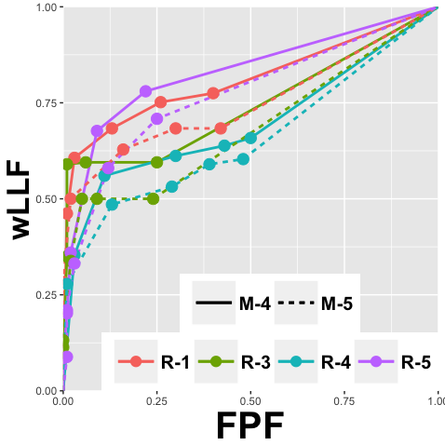  (A) | 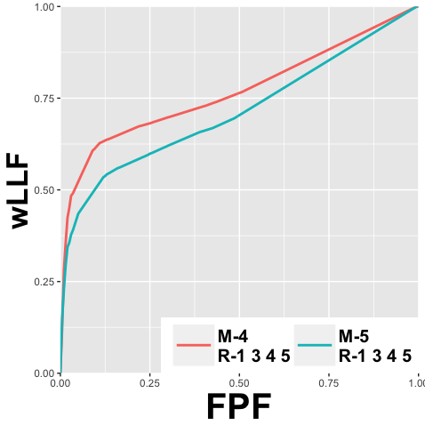  (B)
Fig. 18.4: wAFROC plots for dataset04; (A): individual reader plots for treatments 4 and 5. All readers performed better in treatment 4: each solid line is above the corresponding dashed lines. (B): reader-averaged plots for treatments 4 and 5. The performance superiority of treatment 4 is fairly obvious in this curve. The difference is significant, p = 0.00012, Table 18.2.

18.3.4: Inferred ROC plots
Inferred ROC plots corresponding to Fig. 18.4 are shown in Fig. 18.5. From Table 18.3 the difference in reader-averaged AUCs is 0.04219 with a 95% confidence interval (0.00727, 0.07711). The observed wAFROC effect-size, 0.05488, is larger than the corresponding inferred ROC effect-size, 0.04219. [This is a common observation, but sampling variability compounded with small differences, could give different results.]

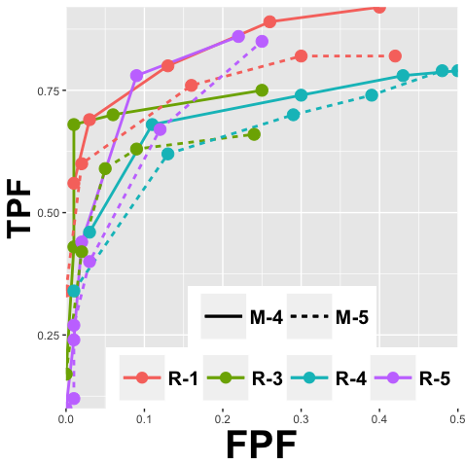  (A) | 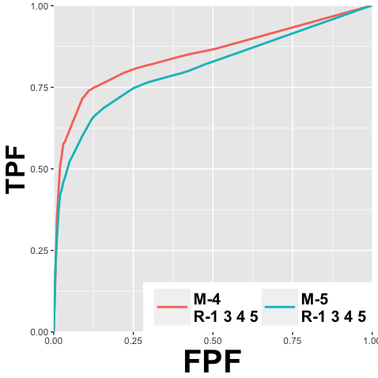  (B)
Fig. 18.5: ROC plots for dataset04; (A): individual reader ROC plots for treatments 4 and 5. All readers performed better in treatment 4. (B): reader-averaged ROC plots for treatments 4 and 5. The performance superiority of treatment 4 is fairly obvious in this curve. The difference is significant, p = 0.0305, Table 18.3.

18.4: Reporting a study
Perhaps the single largest misunderstanding of FROC, next to ignoring location information altogether, is use of the 1 rating to mean that the this location is definitely non-diseased. If this were the literal meaning, the reader should fill up the image with 1s, especially locations outside the anatomy, where they are sure to be correct in stating, these locations are definitely non-diseased. In an FROC study only locations that are positive (>0) for suspicion of disease are indicated. The 1-rating is the lowest confidence level of a mark, and that is the sense in which it should be used. If there is nothing to report the radiologist should have the option of clicking a button to the effect: Show me the next image or I am done with this image, I have nothing further to report on this image.

The methods section should make it clear exactly how the study was conducted. The information should be enough to allow some one else to replicate the study. How many readers, how many cases, how many treatments were used. How was ground truth determined and if the FROC paradigm was used, how were true lesion locations determined? The instructions to the readers should be clearly stated. Precautions to minimize reading order effects should be stated – usually this is accomplished by interleaving cases from different treatments so that the chances that cases from a particular treatment is always seen first by every reader are minimized. Additionally, images from the same case, but in different treatments, should not be viewed in the same reading session. Reading sessions are usually about an hour, and the different sessions should ideally be separated by at least one day. It is recommended that at least 25% of the total number of interpretations be training cases and cases used for training should not be used in the main study. Feedback should be provided during training session to allow the reader to become familiar with the range of difficulty levels regarding diseased and non-diseased cases in the dataset. Deception, e.g., stating a higher prevalence than is actually used, is not good practice – the reader will inevitably become aware that deception is involved and their performance may not be stable over the duration of the study. The whole purpose of the training sessions is to get the readers onto their steady state performance, i.e., past any learning effects. The user-interface should be explained carefully. The best user interface is intuitive, minimizes keystrokes and requires the least explanation.

In publications, the paradigm used to collect the data (ROC, FROC, etc.) and the figure of merit used for analysis should be stated. If FROC, the proximity criterion should be stated. The analysis should state the NH and the alpha of the test, and the desired generalization. The software used and appropriate references should be cited. The results of the overall F-test, the p-value, the observed F-statistic and its degrees of freedom should be stated. If the NH is not rejected, one should cite the observed inter-treatment FOM differences, confidence intervals and p-values and ideally provide preliminary sample size estimates. This information could be useful to other researchers attempting to conduct a larger study. If the NH is rejected, a table of inter-treatment FOM differences such as Table 18.3 should be summarized. Reader averaged plots of the relevant operating characteristics for each treatment should be provided. In FROC studies it is recommended to vary the proximity criterion, perhaps increasing it by a factor of 2, to test if the main conclusions (is NH rejected and if so which treatment is highest) are unaffected.

Assuming the study has been done with sufficiently large number of cases, at least 50 total in the author's opinion, the results should be published in some form, even if the NH is not rejected. The dearth of datasets to allow reasonable sample size calculations is a real problem in this field. The dataset set should be made available, perhaps on Research Gate, or if communicated to the author, they will be included in the Online Appendix material. Datasets acquired via NIH or other government funding must be made available upon request, in an easily decipherable format. Subsequent users of these datasets must cite the original source of the data. Given the high cost of publishing excess pages in some journals, an expanded version, if appropriate for clarity, should be made available using online posting avenues.

18.5: Single fixed-factor analysis
So far our interest has been in comparing two or more treatments, the interest being whether the reader-averaged inter-treatment FOM differences are significantly different from zero. What does one do if there is only data for a single treatment? Now interest is in whether the readers, treated as a fixed effect, have significantly different performances in this treatment. Alternatively, one could have a single reader interpreting a common set of cases in multiple treatments, in which case interest is in whether the reader's performances on the treatments are significantly different. Both of these problems fall under the category of single fixed-factor analysis. In the 1st example reader is regarded as a fixed-factor and in the 2nd example treatment is regarded as a fixed-factor. [For a random factor, all conclusions apply to population parameters, such as mean and variance, not to individual levels of the factor ("thou shalt not compare two random variables"). If an effect is treated as random, which is possible with readers, but not with treatments, then it would not make sense to ask the question whether the random reader samples are significantly different from each other.]

Assume J (> 1) readers interpret the same cases in a single treatment. Interest then in in determining if the performance of the readers are significantly different. The null hypothesis is that the reader performances are identical, and if it can be rejected then at least one pair of readers have significantly different performances. This is illustrated for the same dataset used earlier, except this time one needs to create a single treatment dataset from a multiple treatment dataset. The function DfExtractDataset() serves that purpose. The code is in file “mainAnalyzeSingleModality.R” which implements methods described in Ref. 5:

18.5.1: Code explanation
At line 8 the data for treatment 1 is extracted to singleModData. Line 9 applies single fixed-factor analysis, StSignificanceTestingSingleFixedFactor, and the next line prints the results. Consult the help page on this function to see the meaning of the parameters. The output of sourcing the above code is shown below (the red font denotes significant differences, i.e., p-value < 0.05). Again, a two step procedure is involved. Because the result of the overall F-test is < 0.05, one looks at diffFomStats to determine which comparisons are significant.

18.5.2: Code output
> source('~/Dropbox/RJafrocDownloads/book/Ch18/software/mainAnalyzeSingleModality.R')
fileName = FED
$f
[1] 4.061743

$ddf
[1] 597

$pValue
[1] 0.007138494

$fomStats
Reader Area stdErr DF CI Lower CI Upper
1 1 0.779266666666642 0.0290760972817202 199 0.721929866350653 0.836603466982631
2 3 0.724891666666683 0.0289304427174434 199 0.66784209082192 0.781941242511446
3 4 0.70362499999997 0.0328362871862356 199 0.638873268594143 0.768376731405798
4 5 0.805091666666654 0.0273679011845831 199 0.751123354823281 0.859059978510028

$diffFomStats
Reader Difference t DF Pr > t CI Lower CI Upper
1 1 - 3 0.05437500 1.9029963 199 0.058484576 -0.001970427 0.11072043
2 1 - 4 0.07564167 2.0891448 199 0.037966151 0.004243034 0.14704030
3 1 - 5 -0.02582500 -0.7897104 199 0.430636857 -0.090311647 0.03866165
4 3 - 4 0.02126667 0.5888557 199 0.556625916 -0.049951027 0.09248436
5 3 - 5 -0.08020000 -2.7307762 199 0.006885879 -0.138114271 -0.02228573
6 4 - 5 -0.10146667 -2.9704526 199 0.003339588 -0.168826051 -0.03410728

The F-statistic is 4.06 with 597 denominator degrees of freedom. The numerator degree of freedom, not shown, is the number of readers minus 1, i.e., 3. The corresponding p-value is 0.0071 = 1 - pf(4.06, 3 ,597), which is significant at alpha = 0.05. This means that one can reject the null hypothesis that all readers have identical performance in treatment 1. From the $fomStats one sees that reader FOMs are ordered, in increasing order of performance, as follows: 4 < 3 < 1 < 5 (there is no reader 2 in this dataset). The $diffFomStats values show that only differences between readers 1 and 4, 3 and 5 and 4 and 5 are significant (indicated by red fonts).

18.6: Crossed-treatment analysis
This analysis was developed for a particular application⁶ in which nodule detection in an anthropomorphic chest phantom in computed tomography (CT) was evaluated as a function of tube charge and reconstruction method. The phantom was scanned at 4 values of mAs and images were reconstructed with adaptive iterative dose reduction 3D (AIDR^{3D}) and filtered back projection (FBP) algorithms. Thus there are two treatment factors and the factors are crossed since for each value of the mAs factor there were two values of the reconstruction algorithm factor. Interest was in determining if whether performance depends on mAs and/or reconstruction method independent of the other treatment factor.

In a typical analysis of MRMC ROC or FROC study, treatment is considered as a single factor with I levels, where I is usually small. The figure of merit for treatment i (i =1,2,...,I) and reader j ( j =1,2,...,J) is (the case set index is suppressed). MRMC analysis compares the observed magnitude of the difference in reader-averaged figures of merit between treatments i and i', where , to the estimated standard deviation of the difference. For example, the reader-averaged difference in figures of merit is , where the dot symbol represents the average over the corresponding (reader) index. The standard deviation of the difference is estimated using the DBMH or the ORH method, using for example jackknifing to determine the variance components and/or covariances. With I levels, the number of distinct i vs. i' comparisons is I (I −1)/2. If the study described in the previous paragraph were analyzed in this manner, where I =8 (4 levels of mAs and two image reconstruction methods), then this would imply 28 comparisons. The large number of comparisons leads to loss of statistical power in detecting the effect of a specific pair of treatments, and, more importantly, does not address the main points of interest: whether performance depends on mAs and/or reconstruction method independent of the other treatment. For example, if a significant difference is found between a pair of the 28 comparisons the two reconstruction algorithms might be compared at different mAs levels, and one is in the dark as to which factor (algorithm or mAs) caused the observed significant difference. Since averaging has its benefits, one would like to average over all levels of the mAs factor before comparing the two algorithms, and likewise, average over the two algorithms before comparing the different levels of the mAs factor. Indeed, this is the essential idea behind the analysis to be described below.

Unlike conventional ROC type studies, the images in this study are defined by two treatment factors. The first treatment factor, tube charge, had four levels: 20, 40, 60 and 80 mAs. The second treatment factor, reconstruction method, had two levels: FBP and AIDR^{3D}. The figure of merit is represented by , where represents the levels of the first factor (mAs), and represents the levels of the second factor (reconstruction method), . Two sequential analyses were performed: (i) mAs analysis, where the figure of merit was averaged over (i.e., the reconstruction index); and (ii) reconstruction analysis, where the figure of merit was averaged over (i.e., the mAs index). For example, the mAs analysis figure of merit is , where the dot represents the average over the reconstruction index, and the corresponding reconstruction analysis figure of merit is , where the dot represents the average over the mAs index. Thus in either analysis, the figure of merit is dependent on a single treatment factor, and therefore standard DBMH or ORH analyses apply.

The mAs analysis determines whether tube charge is a significant factor and in this analysis the number of possible comparisons is six. The reconstruction analysis determines whether AIDR^{3D} offers any advantage over FBP and in this analysis the number of possible comparisons is one. Multiple testing on the same dataset increases the probability of Type I error, therefore a Bonferroni correction is applied by setting the threshold for declaring significance at 0.025; this is expected to conservatively maintain the overall probability of a Type I error at α = 0.05. Crossed-treatment analysis is used to describe this type of analysis of ROC/FROC data, which yields clearer answers on which of the two factors effects performance. The averaging over the other treatment has the effect of increasing the power of the study in detecting differences in each of the two factors.

Since the phantom is unique, and conclusions are only possible that are specific to this one phantom, the case (or image) factor was regarded as fixed. For this reason only results of random-reader fixed-case analyses are reported.

18.6.1: Example of crossed-treatment analysis
The file containing the crossed modality data is CrossedModalitiesDataFile.xlsx. It is included to illustrate the extended-JAFROC format used to enter the data. The essential difference is the presence of two treatment factors, as opposed to a single treatment factor in the standard JAFROC format. This file, Fig. 18.6, reveals that it has two treatment ID fields, Modality_ID1, the reconstruction algorithm with two levels, I and F, abbreviating AIDR^{3D} and FBP, respectively, and Modality_ID2, the mAs factor with four levels, 20, 40, 60 and 80 mAs. This file can be read by DfReadCrossedModalities() which returns a crossed modality dataset object – the reader should confirm this. However, this dataset object is already included in the package as datasetCrossedModality. The following code snippet shows the structure of this object:

> str(datasetCrossedModality)
List of 9
$ NL : num [1:2, 1:4, 1:11, 1:68, 1:5] -Inf -Inf -Inf -Inf -Inf ...
$ LL : num [1:2, 1:4, 1:11, 1:34, 1:3] -Inf 1 2 8 7 ...
$ lesionNum : int [1:34] 1 2 1 1 1 1 2 2 1 1 ...
$ lesionID : num [1:34, 1:3] 1 1 1 1 1 1 1 1 1 1 ...
$ lesionWeight: num [1:34, 1:3] 1 0.5 1 1 1 1 0.5 0.5 1 1 ...
$ dataType : chr "FROC"
$ modalityID1 : Named chr [1:2] "F" "I"
..- attr(*, "names")= chr [1:2] "F" "I"
$ modalityID2 : Named chr [1:4] "20" "40" "60" "80"
..- attr(*, "names")= chr [1:4] "20" "40" "60" "80"
$ readerID : Named chr [1:11] "1" "10" "11" "2" ...
..- attr(*, "names")= chr [1:11] "1" "10" "11" "2" ...

The code for this analysis is in file mainCrossedModalities.R.

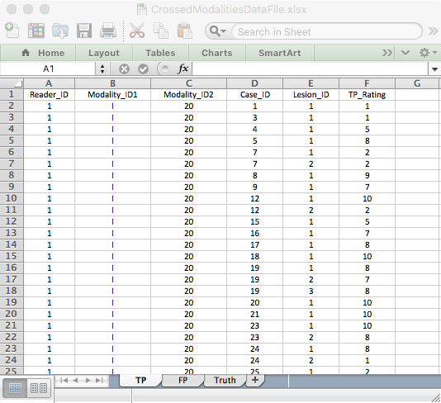
Fig. 18.6: The only change from a standard JAFROC format data file is the presence of the additional modality column. This figure shows the structure of the TP worksheet for a crossed modality dataset. The "I" in column B denotes iterative reconstruction; the other possibility if "F" for filtered back-projection. Column C lists the mAs values. A similar structure applies to the FP worksheet.

18.6.2: Code explanation
Line 6 defines FOM, i.e., the figure of merit, as "wAFROC". Line 11 uses the included crossed modality dataset datasetCrossedModality to initialize the dataset object (alternatively one could have read the crossed modality data file using DfReadCrossedModalities). Line 12 performs the mAs analysis. The second argument (which happens to be 1) tells the function to average the FOM over the first modality index, i.e., over the reconstruction index. The third argument passes the FOM argument and the option argument requests RRFC analysis, as this is a phantom study. To only show results of averaging over the reconstruction index, insert a break point at line 17 and click Source.

18.6.3: Code output: res1
Browse[2]> res1
***Data file is CrossedModalitiesDataFile , and time is Wed Apr 26 17:05:29 2017 ***
fom = wAFROC
******* Averaging over reconstruction index ********
******* Averaging over reconstruction index ********
$fomArray
[,1] [,2] [,3] [,4] [,5] [,6] [,7] [,8] [,9]
[1,] 0.7900087 0.8175822 0.8196006 0.7892157 0.8861015 0.8913279 0.9471237 0.8688725 0.8207540
[2,] 0.8763336 0.7941176 0.9058896 0.8109141 0.9272275 0.9021410 0.9621540 0.8725490 0.8566176
[3,] 0.9107194 0.8239259 0.9171352 0.8480392 0.9226499 0.9012039 0.9485655 0.8840830 0.8643310
[4,] 0.8761174 0.8478230 0.9139273 0.8602220 0.9501514 0.9334991 0.9583694 0.9203431 0.8517878
[,10] [,11]
[1,] 0.7320141 0.8268815
[2,] 0.7552984 0.8765499
[3,] 0.7869449 0.8512471
[4,] 0.7930003 0.9007353

$msT
[1] 0.006286043

$msTR
[1] 0.0003938919

$varComp
varCov
Var(R) 2.419778e-03
Var(T*R) 6.212086e-05
COV1 5.838726e-04
COV2 4.686406e-04
COV3 3.880314e-04
Var(Error) 9.962529e-04

$fRRFC
[1] 15.9588

$ddfRRFC
[1] 30

$pRRFC
[1] 2.185176e-06

$ciDiffTrtRRFC
Treatment Estimate StdErr DF t Pr > t CI Lower CI Upper
1 20 - 40 -0.03184636 0.008462666 30 -3.763160 7.288819e-04 -0.04912943 -0.014563292
2 20 - 60 -0.04266934 0.008462666 30 -5.042068 2.068729e-05 -0.05995241 -0.025386271
3 20 - 80 -0.05604488 0.008462666 30 -6.622603 2.482288e-07 -0.07332795 -0.038761809
4 40 - 60 -0.01082298 0.008462666 30 -1.278909 2.107339e-01 -0.02810605 0.006460090
5 40 - 80 -0.02419852 0.008462666 30 -2.859444 7.650363e-03 -0.04148159 -0.006915447
6 60 - 80 -0.01337554 0.008462666 30 -1.580535 1.244717e-01 -0.03065861 0.003907532

$ciAvgRdrEachTrtRRFC
Treatment Area StdErr DF CI Lower CI Upper
1 20 0.8354075 0.01784716 10 0.7956415 0.8751734
2 40 0.8672539 0.01826069 10 0.8265665 0.9079412
3 60 0.8780768 0.01451201 10 0.8457421 0.9104116
4 80 0.8914524 0.01522482 10 0.8575293 0.925375

This shows that for random reader fixed case analysis (RRFC), the F-test yields F(3,30) = 15.9588; p = 2.185176 x 10⁻⁶. All mAs differences are significant, shown in red font, except "40 – 60" and "60 – 80". The reader averaged FOMs show that FOM, averaged over both reconstruction methods, increases with mAs. [The reader should repeat the results using random-reader random-case analysis where only two out of the 6 mAs pairings are significantly different. Allowing case to be a random factor increases variability, and differences that were significant are no longer significant.]

Line 13 performs the reconstruction algorithm analysis. The second argument (2) tells the function to average the FOM over the second modality index, i.e., over the mAs index. Click Continue to display the results shown below.

18.6.4: Code output: res2
Browse[2]> res2
******* Averaging over mAs index ********
******* Averaging over mAs index ********
$fomArray
[,1] [,2] [,3] [,4] [,5] [,6] [,7] [,8] [,9]
[1,] 0.8758470 0.8274942 0.8939230 0.8313149 0.9143058 0.9029159 0.9537377 0.8811275 0.8298551
[2,] 0.8507425 0.8142301 0.8843534 0.8228806 0.9287594 0.9111700 0.9543685 0.8917964 0.8668901
[,10] [,11]
[1,] 0.7573349 0.8723147
[2,] 0.7762940 0.8553922

$msT
[1] 1.268641e-05

$msTR
[1] 0.0001676095

$varComp
varCov
Var(R) 2.426193e-03
Var(T*R) 1.823035e-05
COV1 6.091068e-04
COV2 4.113551e-04
COV3 4.050123e-04
Var(Error) 7.648287e-04

$fRRFC
[1] 0.07569028

$ddfRRFC
[1] 10

$pRRFC
[1] 0.7888258

$ciDiffTrtRRFC
Treatment Estimate StdErr DF t Pr > t CI Lower CI Upper
1 F - I -0.001518756 0.005520367 10 -0.2751187 0.7888258 -0.0138189 0.01078139

$ciAvgRdrEachTrtRRFC
Treatment Area StdErr DF CI Lower CI Upper
1 F 0.8672883 0.01604584 10 0.8315359 0.9030406
2 I 0.8688070 0.01585054 10 0.8334898 0.9041242

Unlike mAs, the reconstruction method does not have a significant effect. The FOM difference, 0.00152 with confidence interval (-0.014, 0.011), is not significant: F(1,10) = 0.07569 and p = 0.7888. The reader should compare the above results to those obtained using the ROC figure of merit, which uses the trapezoidal ROC-AUC, and confirm that they are consistent with the wAFROC FOM (the p-values for the mAs analysis are slightly larger). Because the mAs effect was so large, both wAFROC and ROC analyses declared the same significant differences for levels of mAs while not finding reconstruction algorithm to have a significant effect.

18.6.5: Why report both FROC and ROC analysis
The only reason is the desire to accommodate those unfamiliar with FROC analysis, which happens to include a lot of reviewers of journal articles in this field. Seeing similar results to that obtained using ROC analysis makes them feel less suspicious of the results of FROC analysis. There is no scientific reason for reporting both analyses. If FROC data is acquired, only wAFROC analysis should be reported. A downside of reporting both analysis is that one then needs to Bonferroni-reduce alpha by half (from 0.05 to 0.025) to include the effect of multiple testing. This will have the effect of reducing statistical power to detect a genuine difference.

18.7: FROC sample size estimation
FROC sample size estimation is not fundamentally different from the procedure outlined in Chapter 11 for the ROC paradigm. To recapitulate: based on analysis of a pilot dataset and using a specified FOM, e.g., the ROC-AUC, and either the DBMH or the ORH method for significance testing, one estimates the intrinsic variability of the data, expressed as variance components. For DBMH analysis, these are the FOM-pseudovalue variance components, while for ORH analysis these are the FOM treatment-reader variance component and the FOM covariances. The second step is to postulate a clinically realistic effect-size, e.g., the AUC difference between the two modalities. Given these values, the sample size functions implemented in RJafroc allow one to estimate the number of readers and cases necessary to detect (i.e., reject the null hypothesis) at specified Type II error rate, typically chosen to be 20% and specified Type I error rate, typically chosen to be 5%.

In FROC analysis the only difference, indeed the critical difference, is the choice of FOM; e.g., the wAFROC-AUC instead of the inferred ROC-AUC. The FROC dataset is analyzed using either DBMH or ORH method. This yields the necessary variability parameters corresponding to the wAFROC-AUC. The next step is to specify an effect-size in wAFROC-AUC units, and therein lays the rub. What value does one use? The ROC-AUC has a historically well-known interpretation: the classification ability at separating diseased patients from non-diseased patients. Needed is a way of relating an effect-size in ROC-AUC units to one in wAFROC-AUC units.

One could take the attitude to hell with ROC, I will just specify the wAFROC effect-size. The problem with that approach is that the wAFROC effect-size is a complex mixture of case-classification, search and lesion-classification performances (predicted by the RSM, see below). One would have a hard time convincing others that the choice of effect-size is reasonable, especially, as it turns out, when the correct wAFROC effect-size is almost double the ROC effect-size. Using, for example, 0.03 (a common ROC effect-size) as the wAFROC effect-size would result in a severe underestimate of statistical power.

To summarize:
            - One specifies an ROC-AUC effect-size that is realistic, one that everyone, especially clinicians, understand and can therefore participate in, in the effect-size specification process.
            - One converts the ROC effect-size to a wAFROC-AUC effect-size using the method described in the next section.
            - One uses the sample size tools in in RJafroc, i.e., functions with names beginning with Ss, to determine the necessary sample size.

It is important to recognize is that all quantities have to be in the same "units". The quotes are used since the units are not like units in physics, e.g., the MKS vs. CGS systems. When doing ROC analysis, everything (variance components and effect-size) has to be in units of the selected FOM, e.g., ROC-AUC. When doing wAFROC analysis, everything has to be in units of the wAFROC-AUC. The variance components and effect-size in wAFROC-AUC units will be different from their corresponding ROC counterparts. In particular, as shown next, an ROC-AUC effect-size of 0.05 generally correspond to a larger effect-size in wAFROC-AUC units. The reason for this is that the range over which wAFROC-AUC can vary, namely 0 to 1, is twice the corresponding ROC-AUC range.

Converting an ROC effect-size to a wAFROC-AUC effect-size requires a model of the data. The author recommends the RSM. Therefore it is necessary to estimate the parameters of the RSM from the observed data. The procedure for estimating RSM parameters is the subject of the next chapter. For now we assume that this can be done – in fact it is implemented in a package function called FitRsmRoc(), whose help page is summarized in Fig. 18.7.

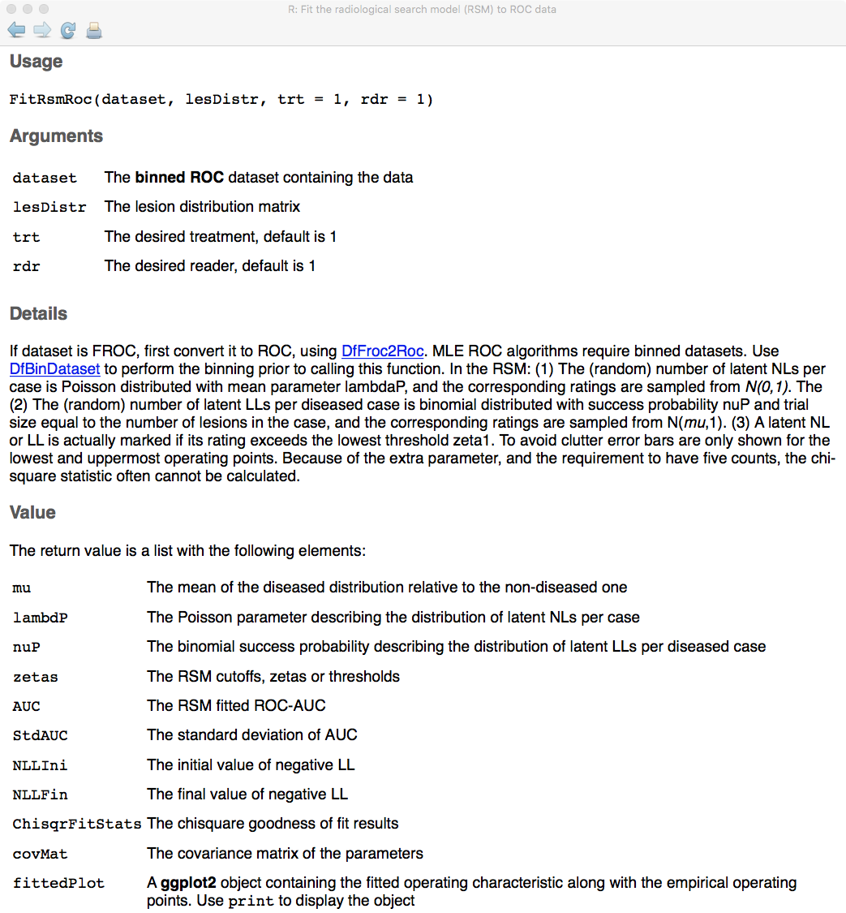
Fig. 18.7: Partial help page of FitRsmRoc() showing the input and output values. The values needed for sample-size estimation are mu, lambdaP and nuP.

The next section explains the steps used to implement step #2 above.

18.7.1: Relating an ROC effect-size to a wAFROC effect-size
For each treatment-reader (ij) dataset, the inferred ROC data is fitted by the RSM function described above, yielding estimates of the parameters (notice these are the intrinsic RSM parameters, not the physical values yielded by FitRsmRoc; it is easy to converted between intrinsic and physical values using UtilPhysical2IntrinsicRSM and UtilIntrinsic2PhysicalRSM).

The pilot study represents an "almost" null hypothesis dataset: if a significance difference had been observed one would not be going through the exercise of samples size estimation. The author recommends taking the median of the parameters, over all indices, as representing the average NH dataset. The reason for this is that the median is less sensitive to outliers than the average (the RSM parameter estimates are noisy and taking an average would be inappropriate).

.

Using these values ROC-AUC and wAFROC-AUC, for the NH condition are calculated by numerical integration of the RSM predicted ROC and wAFROC curves, Chapter 17. As before, is the lesion distribution vector, i.e., the normalized histogram of the numbers of lesions per diseased case.

.

To induce the alternative hypothesis condition (i.e., better performance) one increments by . The resulting ROC-AUC and wAFROC-AUC are calculated, again by numerical integration of the RSM predicted ROC and wAFROC curves, leading to the following effect-sizes (note that in each equation below one takes the difference between the AH value minus the NH value):

.

Equation , evaluated for different values of , provides a calibration curve between the effect-sizes expressed in the two units, Fig. 18.8(A). This allows one to interpolate the appropriate wAFROC effect-size corresponding to any postulated ROC effect-size.

One could propose other ways of inducing the alternative hypothesis condition. For example, one could increase and / or decrease and / or increase . An approach similar to this was indeed used in one of the author's publications⁴, before the distinction between intrinsic and physical RSM parameters was fully understood. Given the infinite number of combinations of three parameters yielding the same effect-size, in retrospect this does not seem a logical and reproducible approach. The advantage of dealing with intrinsic parameters is that increasing only automatically results in changes to the physical parameters in the expected directions: i.e., decreases and increases (see Chapter 16) and the solar analogy in Chapter 12.

18.7.2: Example using DBMH analysis
The following example uses the first two modalities of the "FED" dataset acquired by Dr. Federica Zanca¹. The code is in mainwAFROCPowerDBMH.R. Line 13 sets f to 4, causing line 15 to select dataset04. Using package function UtilLesionDistribution, line 17 obtains the lesion distribution vector for this dataset, nLesDistr. The steps are shown below (step through the code line by line using Run).

> str(theData)
List of 8
$ NL : num [1:5, 1:4, 1:200, 1:7] -Inf -Inf 1 -Inf -Inf ...
$ LL : num [1:5, 1:4, 1:100, 1:3] 4 5 4 5 4 3 5 4 4 3 ...
$ lesionNum : int [1:100] 1 1 1 1 1 1 1 1 1 1 ...
$ lesionID : num [1:100, 1:3] 1 1 1 1 1 1 1 1 1 1 ...
$ lesionWeight: num [1:100, 1:3] 1 1 1 1 1 1 1 1 1 1 ...
$ dataType : chr "FROC"
$ modalityID : Named chr [1:5] "1" "2" "3" "4" ...
..- attr(*, "names")= chr [1:5] "1" "2" "3" "4" ...
$ readerID : Named chr [1:4] "1" "3" "4" "5"
..- attr(*, "names")= chr [1:4] "1" "3" "4" "5"
> # RSM ROC fitting needs to know lesionDistribution
> nLesDistr <- UtilLesionDistribution(theData)
> nLesDistr
[,1] [,2]
[1,] 1 0.69
[2,] 2 0.20
[3,] 3 0.11

The dataset has 200 cases, 5 treatments and 4 readers. Sixty nine (69) percent of diseased cases contain one lesion, 20% contain 2 lesions and 11% contain 3 lesions.

Lines 19 – 25 extract the results of the pre-analysis. The actual extraction occurs at line 25. As soon as this is executed (this is best appreciated by stepping through the code line by line using the Run button) the object allResults is magically created. The next two lines extract the number of treatments I and readers J, respectively. Lines 29 – 33 assign memory for saving the parameters, including both physical and intrinsic values. Lines 35 – 46 extract the needed parameters from allResults. Within this loop, lines 41 – 44 convert from physical (primed) to intrinsic (un-primed) values of the two search-related parameters. Highlighting values and clicking Run yields following values:

Browse[2]> mu
[,1] [,2] [,3] [,4]
[1,] 3.658304 5.476106 2.605346 0.3982731
[2,] 4.092881 2.966000 4.559528 0.9129679
[3,] 3.043098 4.151180 1.692845 1.9537647
[4,] 3.107034 3.084518 2.232046 1.4181427
[5,] 2.600410 2.149311 2.311198 1.3595438
Browse[2]> lambda
[,1] [,2] [,3] [,4]
[1,] 36.345524 11.1401989 25.6263201 0.1056688
[2,] 38.775701 1.3679493 6.3578411 0.2285772
[3,] 2.065973 36.8752517 0.8129091 3.5119646
[4,] 28.258770 0.8308554 1.4218553 0.3506984
[5,] 1.609884 0.5258240 1.5942490 1.5988416
Browse[2]> nu
[,1] [,2] [,3] [,4]
[1,] 0.4345338 0.1315519 0.5291324 10.185535
[2,] 0.2630441 0.3477071 0.1740659 1.638894
[3,] 0.2949193 0.1984143 0.3966960 1.036738
[4,] 0.6641450 0.3027101 0.3801275 1.012119
[5,] 0.4027006 0.3263145 0.3000433 2.984071

Since they were not found to be significantly different, it makes sense to regard the first two treatments as "almost" NH treatments. At line 52 – 53, using DfExtractDataset, a dataset object corresponding to treatments 1 and 2, only, is extracted and saved to frocData. Click Run a few times to connect with the following output:

Browse[2]> str(frocData)
List of 8
$ NL : num [1:2, 1:4, 1:200, 1:7] -Inf -Inf -Inf -Inf -Inf ...
$ LL : num [1:2, 1:4, 1:100, 1:3] 4 5 3 5 5 5 4 4 5 5 ...
$ lesionNum : int [1:100] 1 1 1 1 1 1 1 1 1 1 ...
$ lesionID : num [1:100, 1:3] 1 1 1 1 1 1 1 1 1 1 ...
$ lesionWeight: num [1:100, 1:3] 1 1 1 1 1 1 1 1 1 1 ...
$ dataType : chr "FROC"
$ modalityID : Named chr [1:2] "1" "2"
..- attr(*, "names")= chr [1:2] "1" "2"
$ readerID : Named chr [1:4] "1" "3" "4" "5"
..- attr(*, "names")= chr [1:4] "1" "3" "4" "5"

Lines 57 – 70 collects the NH arrays corresponding to mu, lambda and nu and calculates medians. The final values are shown below (the reader should confirm):

Browse[2]> muMed
[1] 3.312152
Browse[2]> lambdaMed
[1] 8.74902
Browse[2]> nuMed
[1] 0.3911205

Lines 73 – 77 assigns the lesion weights, assuming equally weighted lesions (this is recommended).

Browse[2]> lesionWeights
[,1] [,2] [,3]
[1,] 1.0000000 -Inf -Inf
[2,] 0.5000000 0.5000000 -Inf
[3,] 0.3333333 0.3333333 0.3333333

[Negative infinity is being used as a missing value] Lines 79 – 84 calculates, using the median values, the wAFROC and ROC NH-AUCs.

Browse[2]> aucRocNH
[1] 0.8847208
Browse[2]> aucAfrocNH
[1] 0.7200758

Lines 87 – 106 calculates the effect-sizes for different values of , Eqn. . Stepping through these lines the following output:

Browse[2]> f
ES ROC, wAFROC = 0.0006729598 0.001409476
ES ROC, wAFROC = 0.001340109 0.00280962
ES ROC, wAFROC = 0.002001502 0.004200505
ES ROC, wAFROC = 0.002657196 0.005582205
ES ROC, wAFROC = 0.003307246 0.006954793
ES ROC, wAFROC = 0.003951706 0.008318342
ES ROC, wAFROC = 0.004590633 0.009672924
ES ROC, wAFROC = 0.005224079 0.01101861
ES ROC, wAFROC = 0.0058521 0.01235548
ES ROC, wAFROC = 0.00647475 0.01368359
ES ROC, wAFROC = 0.007092083 0.01500303
ES ROC, wAFROC = 0.007704151 0.01631385
ES ROC, wAFROC = 0.008311009 0.01761614
ES ROC, wAFROC = 0.008912709 0.01890996
ES ROC, wAFROC = 0.009509303 0.02019539
ES ROC, wAFROC = 0.01010084 0.02147248
ES ROC, wAFROC = 0.01068738 0.02274132
ES ROC, wAFROC = 0.01126897 0.02400197
ES ROC, wAFROC = 0.01184567 0.02525449
ES ROC, wAFROC = 0.01241751 0.02649896

The two columns are the effect-sizes in ROC and wAFROC AUC units; this is the effect-size-calibration data. It allows conversion of an effect-size in ROC units to one in wAFROC units. Lines 108 – 110 fits these points to a linear model constrained to have zero intercept. The coefficient of the slope is listed below:

Browse[2]> a$coefficients[1]
esRoc
2.124189

In other words, the wAFROC effect is 2.12 times the corresponding ROC effect-size. Using StSignificanceTesting lines 112 – 121 calculate the DBMH variance components for ROC and wAFROC analysis, respectively. Lines 123 and 124 initializes two arrays to hold the results of the power calculations.

Line 126 assumes 5 readers and 100 cases (half non-diseased) in the pilot study. Lines 129 – 131 extract the 3 needed pseudovalue variance components for ROC analysis. Using SsPowerGivenJK lines 132 – 141 calculates powerROC[i], where i indexes the different effect-size values. Lines 143 – 154 repeats the procedure for wAFROC analysis. Lines 161 – 170 produce two plots, Fig. 18.8.

Note the consistent usage of ROC variance components and effect-sizes in lines 129 – 131 and line 136. Likewise, note the consistent usage of wAFROC variance components and effect-sizes and in lines 143 – 145 and line 149. This is the critical difference between ROC and wAFROC sample size estimation.

Remove any break points and Source the code, yielding Table 18.4 and Fig 18.8 (A, B).

18.6.2.1 Code explanation, details
The critical part is how the sample size estimation function is called, as it is rather unforgiving at the time of writing. In the first call to SsPowerGivenJK(), line 132, method is specified as "DBMH" and it is followed by 3 arguments; the Y symbol designates pseudovalue based variance components and the order and names of the arguments are important; they stand for , and [as calculated by a previous call to StSignificanceTesting() with FOM set to "HrAuc"] and effectSize specified as effectSizeROC[i]. The second call, line 146, looks similar but note the usage of variance components [calculated by a previous call to StSignificanceTesting() with FOM set to "wAFROC"] and effectSize specified as effectSizewAFROC[i].

Shown in the first two columns of Table 18.4 is the effect-size calibration data. The values of the two effect-sizes listed in the left hand side of Equation for values of ranging from 0.01 to 0.2 in steps of 0.01 (see line 87 in code file). These are fitted to a straight-line constrained to go through the origin, Figure 18.8 (A). The slope of the fit (2.12, i.e., the wAFROC effect-size is about twice the ROC effect-size) was used to convert the ROC effect-sizes listed in the third column of Table 18.4 (ranging from 0.01 to 0.10) to the corresponding wAFROC effect-sizes listed in the fourth column. DBMH analysis of the inferred ROC data yields pseudovalue variance components, which, when used with the ROC effect-size, yields the predicted ROC power for 5 readers and 50/50 cases listed under "Power ROC". Likewise, DBMH analysis using the wAFROC FOM yields pseudovalue variance components, which, when used with the wAFROC effect-size, yields the predicted wAFROC power for 5 readers and 50/50 cases listed under "Power wAFROC".

Table 18.4: Sample size estimation for FROC and inferred ROC studies. Shown in the first two columns is a listing of the effect-size calibration data. The remaining columns list different ROC effect-sizes, the corresponding AFROC effect-sizes, and statistical power for ROC and corresponding power for wAFROC FOM. Note the substantial statistical power penalty when using the ROC FOM.
ES calibration data |  | Power table for 5 readers and 100 cases
 |  | ES-ROC | ES-wAFROC | Power ROC | Power wAFROC
0.00067 | 0.00141 | 0.01 | 0.0212 | 0.0644 | 0.1234
0.00134 | 0.00281 | 0.02 | 0.0425 | 0.1088 | 0.3484
0.00200 | 0.00420 | 0.03 | 0.0637 | 0.1847 | 0.6508
0.00266 | 0.00558 | 0.04 | 0.0850 | 0.2908 | 0.8770
0.00331 | 0.00695 | 0.05 | 0.1062 | 0.4195 | 0.9731
0.00395 | 0.00832 | 0.06 | 0.1275 | 0.5574 | 0.9965
0.00459 | 0.00967 | 0.07 | 0.1487 | 0.6882 | 0.9997
0.00522 | 0.01102 | 0.08 | 0.1699 | 0.7984 | 1.0000
0.00585 | 0.01236 | 0.09 | 0.1912 | 0.8810 | 1.0000
0.00647 | 0.01368 | 0.1 | 0.2124 | 0.9361 | 1.0000
0.00709 | 0.01500
0.00770 | 0.01631
0.00831 | 0.01762
0.00891 | 0.01891
0.00951 | 0.02020
0.01010 | 0.02147
0.01069 | 0.02274
0.01127 | 0.02400
0.01185 | 0.02525
0.01242 | 0.02650

Because the effect-size enters the sample size formulae as the square, the effect is dramatic. For an ES-ROC = 0.03, considered a small ROC effect size⁷, the power of the ROC method is 18.5% while that of the wAFROC method is 65.1%. Ignoring location information incurs a big statistical power penalty.

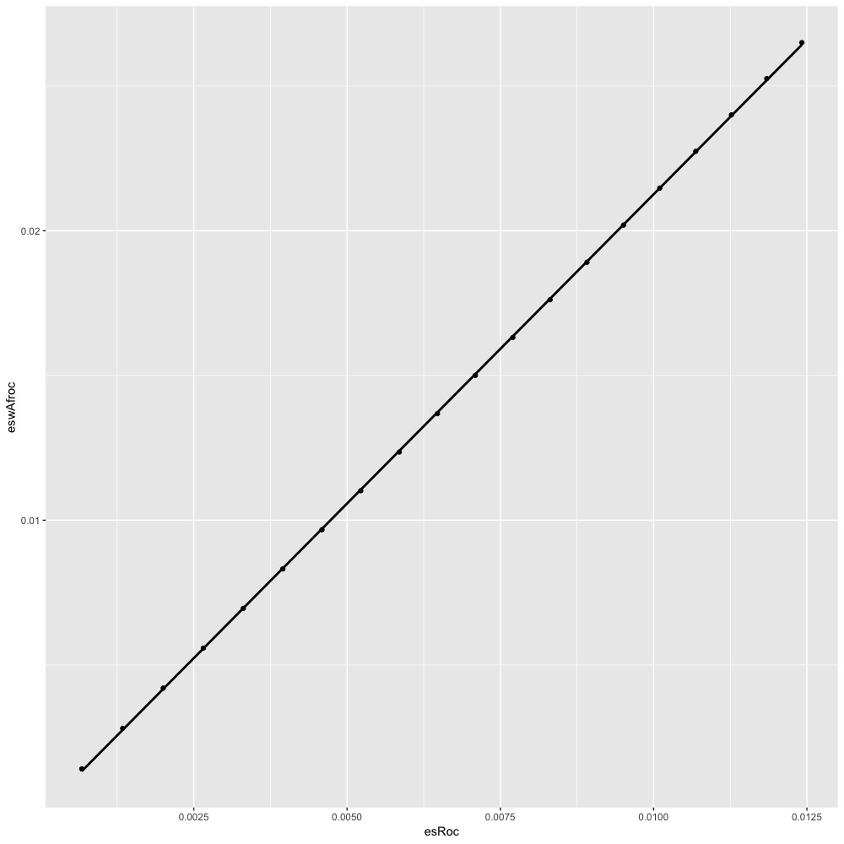  (A) | 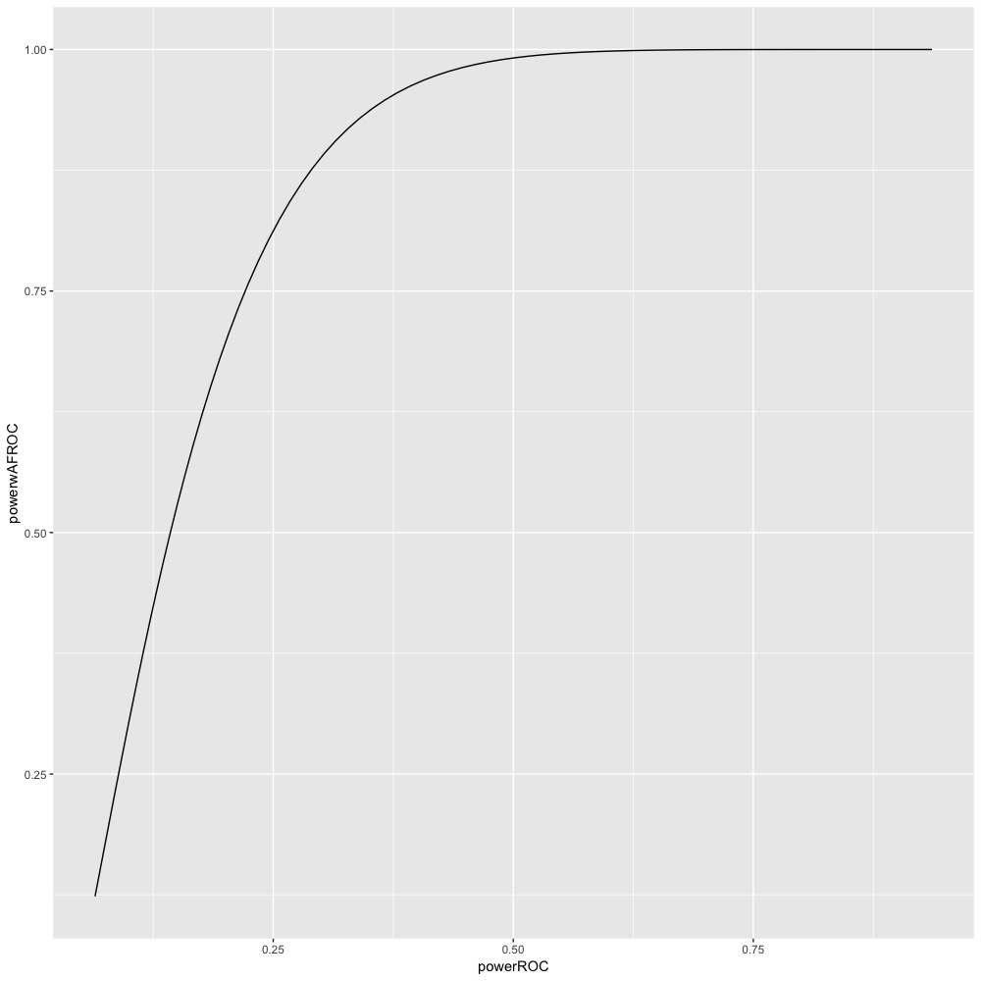  (B)
Fig. 18.8: (A): This panel shows the effect-size calibration plot generated by computing the ROC and wAFROC effect-sizes for different values of , Equation . A straight line, with zero intercept, fits the points, which makes it easy to interpolate the wAFROC effect-size for any specified ROC effect-size. In this example, the slope of the fitting line is 2.12, which translates to a more than doubling of the effect-size in wAFROC units relative to ROC units. (B) This panel shows a comparison of statistical power between ROC and wAFROC FOMs, for 100 cases and 5 readers. The increased power of the wAFROC is due in main part to the larger effect-size. [eswAFROC = effect-size using wAFROC FOM; esROC = effect-size using ROC FOM; powerwAFROC = statistical power using wAFROC FOM; powerROC = statistical power using ROC FOM.] These plots were produced by sourcing mainwAFROCPowerDBMH.R.

18.7.3: Analyzing a new dataset
In the previous example the allResults object contained pre-analyzed results. With a new dataset one needs to replace lines 19 – 27 with a call to FitRsmRoc. Be prepared for a short wait while the RSM algorithm calculates the needed values. Skeleton code is shown below:

frocDataAll <- DfReadDataFile(yourDataFileName) # get all treatments
# following line is needed if there are more than 2 treatments
# define nhTrts here; example nhTrts <- c(1,3)
frocDataNh <- DfExtractDataset(frocDataAll, trts = nhTrts) # extract NH treatments here
rocDataNh <- DfFroc2Roc(frocDataNh) # convert to ROC data
# allocate memory for mu, lambdaP and nuP here
for (i in 1:I) {
for (j in 1:J) {
ret <- FitRsmRoc(rocDataNh, lesDistr = nLesDistr, trt = i, rdr = j)
mu[i,j] <- ret$mu
lambdaP[i,j] <- ret$lambdaP
nuP[i,j] <- ret$nuP
}
}
# next convert lambdaP and nuP to intrinsic values and proceed as before

A point to keep in mind is that FitRsmRoc requires ROC data before it can do the RSM fitting. However, StSignificanceTesting requires the FROC data when called with the wAFROC FOM.

An example using the ORH method is described in the Online Appendix 18.B.

18.8: Discussion / Summary
An IDL (Interactive Data Language, currently marketed by Exelis Visual Information Solutions, www.exelisvis.com) version of JAFROC was first posted to a now obsolete website on 4/16/2004. This software required a license for IDL, which most users did not have. Subsequently, (9/27/2005) a version was posted which allowed analysis using the freely downloadable IDL Virtual Machine software (a method for freely distributing compiled IDL code). On 1/11/2011 the standalone (i.e., exe) version was posted to www.devchakraborty.com. JAFROC is windows compatible (XP, Vista and Windows 7, 8 and 10). To our knowledge JAFROC is the only easily accessible software currently available that can analyze FROC data. Workstation software for acquiring ROC and FROC data is available from several sources⁸⁻¹⁰. However, for reasons stated below, usage of this software is deprecated.

The Windows version is no longer actively supported. Current effort to conduct research and distribute software uses the R platform¹¹. There are several advantages to this. R is an open-source platform and we stand to benefit from bugs pointed out by users. R runs on practically any platform (Windows, OSX, Linux, Solaris, etc.). Also, developing an R package benefits from other contributed R-packages, which allow easy computation of probability integrals, random number generation, and parallel computing to speed up computations, etc. [A drawback with R, and this has to with its open source philosophy, is that one cannot readily integrate existing legacy ROC code, developed on other platforms and other programming languages like FORTRAN].

Due to the random number of marks per image, data entry in the FROC paradigm is inherently more complicated and error-prone than in ROC analysis, and consequently, and in response to feedback from users, much effort has gone into error checking. The users have especially liked the feature where the program indicates the Excel sheet name and line-number where an error is detected. User-feedback has also been very important in detecting program bugs and inconsistencies in the documentation and developing additional features (e.g., crossed modality analysis).

Interest in the FROC paradigm is evidenced by the fact that Ref. 3 describing the JAFROC method has been cited over 273 times. Over 25,000 unique visitors have viewed the author's website, at least 73 have downloaded the software and over 107 publications using JAFROC have appeared. The list is available on the author's website. JAFROC has been applied to magnetic resonance imaging, virtual computerized tomography colonoscopy, digital tomosynthesis (chest and breast), mammography dose and image processing optimization, computer aided detection (CAD), computerized tomography, and other applications.

Since confusion still appears to exist, especially among statisticians, regarding perceived neglect of intra-image correlations of ratings and how true negatives are handled in FROC analysis¹², we close with a quote from respected sources ¹³ "(Chakraborty and Berbaum) have presented a solution to the FROC problem using a jackknife resampling approach that respects the correlation structure in the images … their paradigm successfully passes a rigorous statistical validation test".

18.9: References
1. Zanca F, Jacobs J, Van Ongeval C, et al. Evaluation of clinical image processing algorithms used in digital mammography. Medical Physics. 2009;36(3):765-775.
2. Bland JM, Altman DG. Multiple significance tests: the Bonferroni method. Bmj. 1995;310(6973):170.
3. Chakraborty DP, Berbaum KS. Observer studies involving detection and localization: Modeling, analysis and validation. Med Phys. 2004;31(8):2313-2330.
4. Chakraborty DP. Validation and Statistical Power Comparison of Methods for Analyzing Free-response Observer Performance Studies. Acad Radiol. 2008;15(12):1554-1566.
5. Hillis SL, Obuchowski NA, Schartz KM, Berbaum KS. A comparison of the Dorfman-Berbaum-Metz and Obuchowski-Rockette methods for receiver operating characteristic (ROC) data. Statistics in Medicine. 2005;24(10):1579-1607.
6. Thompson JD, Chakraborty DP, Szczepura K, et al. Effect of reconstruction methods and x-ray tube current-time product on nodule detection in an anthropomorphic thorax phantom: a crossed-modality JAFROC observer study. Medical Physics. 2016;43(3):1265-1274.
7. Beiden SV, Wagner RF, Campbell G, Metz CE, Jiang Y. Components-of-variance models for random-effects ROC analysis: The case of unequal variance structures across modalities. Academic Radiology. 2001;8:605-615.
8. Thompson J, Hogg P, Thompson S, Manning D, Szczepura K. ROCView: prototype software for data collection in jackknife alternative free-response receiver operating characteristic analysis. British Journal of Radiology. 2012;85(1017):1320-1326.
9. Håkansson M, Svensson S, Zachrisson S, Svalkvist A, Båth M, Månsson LG. ViewDEX: an efficient and easy-to-use software for observer performance studies. Radiation Protection Dosimetry. 2010;139(1-3):42-51.
10. Jacobs J, Zanca F, Bosmans H. A novel platform to simplify human observer performance experiments in clinical reading environments. Proc SPIE. 2011;7966:79660B.
11. R: A language and environment for statistical computing. R Development Core Team 2011; http://www.R-project.org/.
12. Levine D, Bankier AA, Halpern EF. Submissions to Radiology: Our Top 10 List of Statistical Errors. Radiology. 2009;253(2):288-290.
13. Wagner RF, Metz CE, Campbell G. Assessment of Medical Imaging Systems and Computer Aids: A Tutorial Review. Acad Radiol. 2007;14(6):723-748.

Non-parametric methods work only with the empirical ROC-AUC.
Wickham, H. (2009). ggplot2: Elegant Graphics for Data Analysis. In Applied Spatial Data Analysis with R (pp. 21–54). http://doi.org/10.1007/978-0-387-98141-3.
x::y means that function y is contained in package x.
In nuclear medicine there is a phenomenon called "pulse-pile-up" wherein a detector drops counts at high-count rates; something similar apparently happens with plots, which one could call "plot-pile-up". This is an RStudio issue.
A future update of the software will include this value.
The author thanks Dr. John Thompson and Prof. Peter Hogg, University of Salford, for the dataset.
One should not blindly expect the p-value for ROC analysis to be always larger than the corresponding wAFROC analysis p-value. After all, the observed p-value is a realization of a random variable. See Online Appendix 18.A for a recent instructive correspondence with a new user of the software.
The author thanks Dr. Lucy D'Agostino McGowan for pointing out an error and the fix in an early version of the software posted to CRAN.

