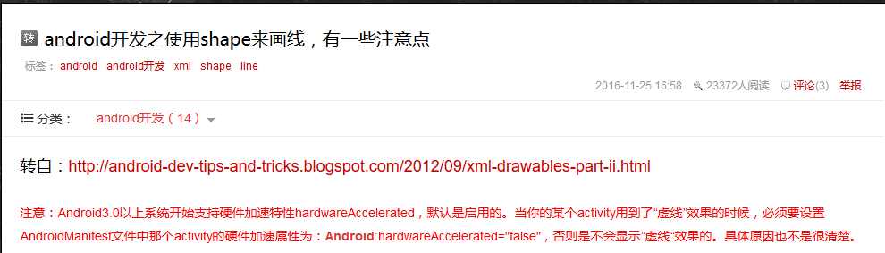

<http://blog.csdn.net/piglovesula/article/details/24318739>

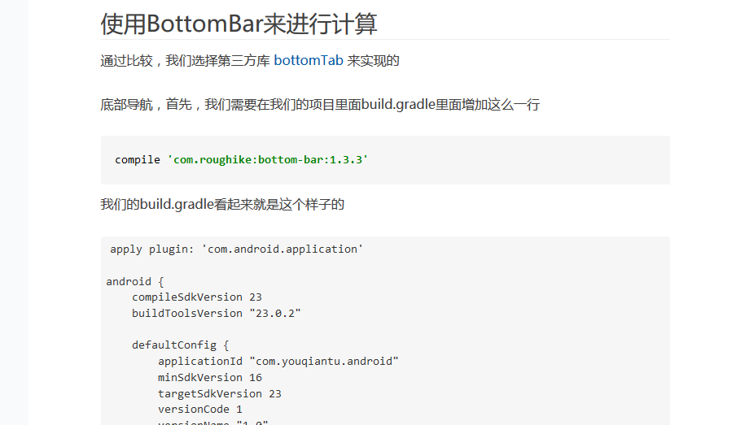

http://www.open-open.com/lib/view/open1477809833540.html



<http://www.jb51.net/article/81403.htm>



<http://www.jianshu.com/p/0550500f8f56>

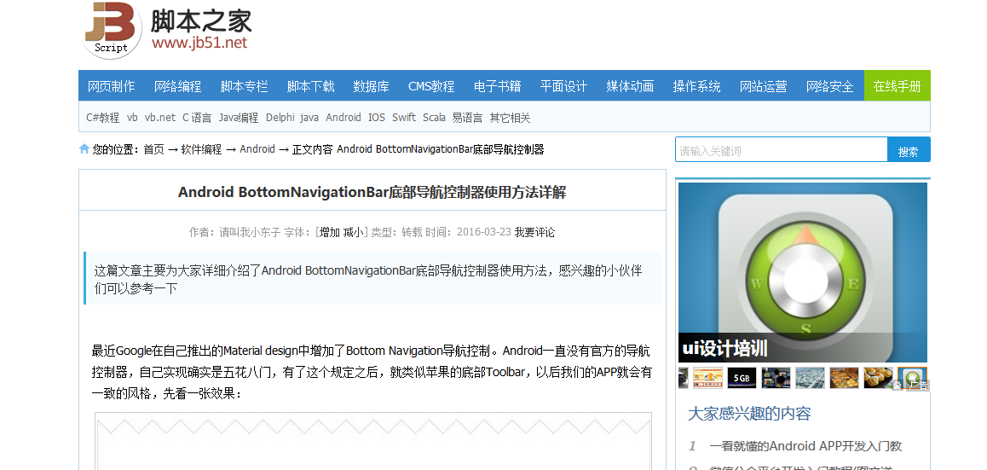

<http://www.jb51.net/article/81403.htm>

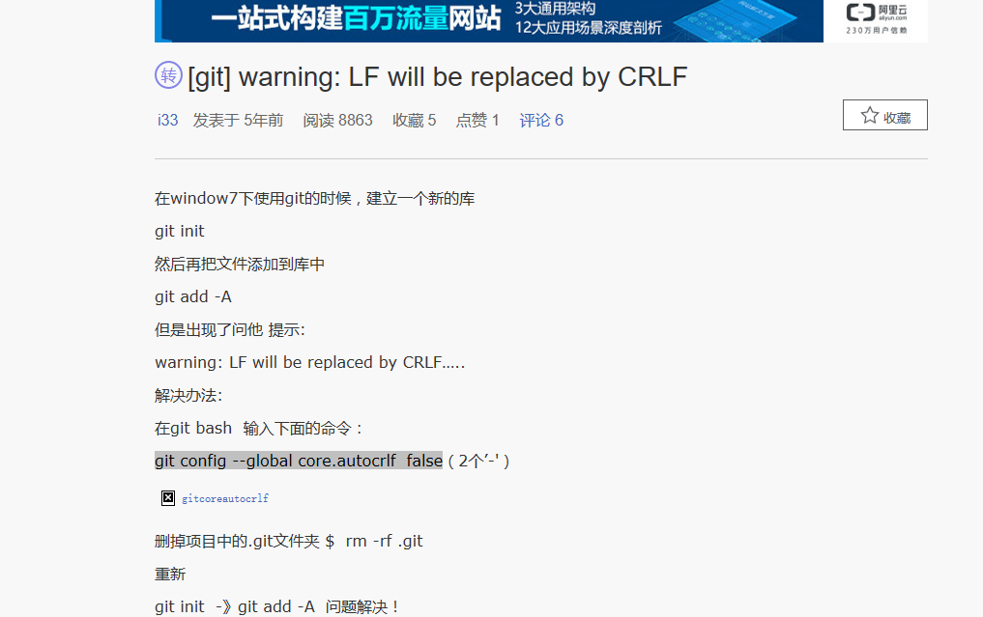

<https://my.oschina.net/i33/blog/49705>

<http://www.jcodecraeer.com/a/anzhuokaifa/androidkaifa/2014/0925/1713.html>

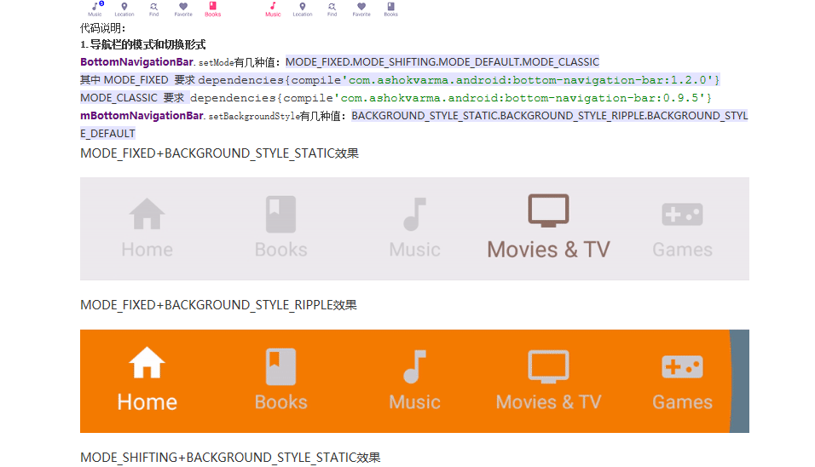

<http://blog.csdn.net/a549742320/article/details/52452356?locationNum=4>



<http://blog.csdn.net/mimi5821741/article/details/50149779>



<http://www.cnblogs.com/top5/archive/2012/05/04/2482328.html>



http://blog.csdn.net/q532433419/article/details/44281095



<https://my.oschina.net/moziqi/blog/363709?p=1>



<http://www.oschina.net/question/54100_34020>



<http://blog.csdn.net/yelangjueqi/article/details/8875806>

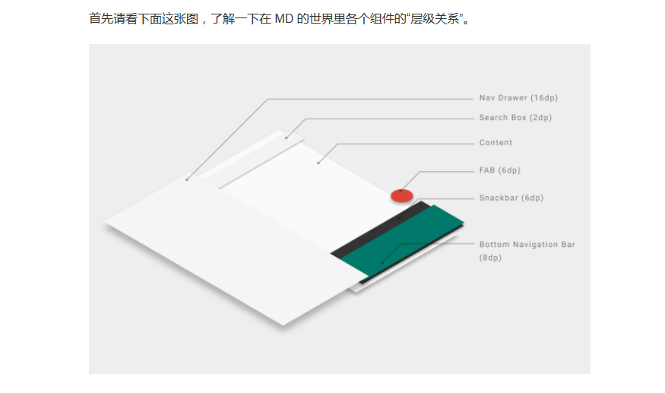

<https://zhuanlan.zhihu.com/p/23711456>



<http://blog.csdn.net/jdsjlzx/article/details/41789835>



http://www.jcodecraeer.com/a/anzhuokaifa/androidkaifa/2015/0105/2264.html