Ceibal Assessment 2010 Summary Document

Ceibal Assessment 2010
DOCUMENT SUMMARY

Caution:
This is an automatic translation of
Evaluación del Plan Ceibal 2010 DOCUMENTO RESUMEN
http://www.anep.edu.uy/anepweb/servlet/main004?403
There may be significant translation errors

National Public Education Administration
Educational Sectoral Planning Directorate
Assessment Area Ceibal
ceibal@anep.edu.uy

Ceibal Assessment 2010 Summary Document

Assessment Area Ceibal DSPE-ANEP.
Montevideo, March 2011.

Evaluation Team:
Coordinator: Mg. Martín Pérez Burger.
Teachers: Prof.. Helena Ferro, Prof.. Baraibar analytical, Prof.. Laura Perez.
TA: Ignacio Salamano, Paul Pagés Soc.

National Public Education Administration
Educational Sectoral Planning Directorate
Assessment Area Ceibal
ceibal@anep.edu.uy

Ceibal Assessment 2010 Summary Document

Index

Introduction 1
Universal access to computers 2
The school and field of expertise 3
Maintenance of equipment 4
Using computers 7
Domain 11
User profiles 13
Digital production experience 14
Training 15
Experience rating 19
Conclusions 23
Recommended Bibliography 25

Ceibal Assessment 2010 Summary Document
1
Introduction
Since 2009 the Ceibal is monitored and evaluated regularly through an operation
carried out jointly between the Centre and Ceibal2 ANEP1. This operation relieves
information annually on a sample of 200 schools across the country. In July
2010, held the second round of assessment Ceibal nationwide.
The goal of monitoring and evaluation Ceibal from ANEP, is to produce information
valid and reliable over the course of the incorporation of Ceibal and results in
education.
Evaluation rounds are aimed at principals, teachers, students and parents.
Additionally, we propose activities for children involving the use of
computers. It also visit and systematized experiences in schools.
The indicators considered in this approach have been adjusted to the characteristics of
implementation of the Plan in the local environment and the role of stakeholders, focus on
conditions of access to computers and the Internet, frequency of use of these resources,
perception domain of digital technologies and proven skills in
use, integrating new technologies into teaching practice and justification of
people to develop different activities using these resources.
These indicators monitor the course of the experience in terms of access,
frequency of use and trends in the use of computers and internet in the target population.
At the same time assessing the impact of the implementation of the Plan on the practices Ceibal
teaching and learning in school.
It also intends to investigate specific aspects of this experience, so as
identify emerging phenomena can become important inputs for
enhance the objectives of this policy.
The sample of schools was drawn up on the universe of public schools
common education with at least 20 students from around the country3. We consider three layers:
Interior urban, rural Interior, Montevideo and the metropolitan area, within which
made a systematic sampling of groups. This sample is representative of students
public schools nationwide and allows inferences about grades
access and use practices Ceibal computers.
The second round of monitoring and evaluation of national Ceibal (2010), obtained
responses (in individual questionnaires, self-administered) of 198 directors, 1031

_______________________________________
1 National Public Education Administration.
2 Before CITS: Center for Technology and Social Inclusion.
3 This sample of schools (2009 and 2010) has been estimated by the Division of Research, Evaluation and Statistics
(DIEE) of the ANEP. Teachers who applied assessment tools have been provided by the
Department of Evaluation of Learning in the same division.

Ceibal Assessment 2010 Summary Document
2
teachers, 5670 children, 7559 children's families. Parallel proposed and developed activities with the XO in 251 school groups. And in addition is conducted a qualitative approach, based on interviews with school stakeholders in four schools in Montevideo and Canelones between October and November. This document summarizes the main results from the second round of monitoring and evaluation of national Ceibal.
Universal access to computers.
Ceibal Plan is a policy that since 2007 seeks to influence in reducing the digital divide
factor of inequity in Uruguay, through universal access to computers and Internet in education.
The following chart shows the impact that produced this policy on access to computers in homes inside the country with school-age children, affecting material base of the digital divide: access to computers.
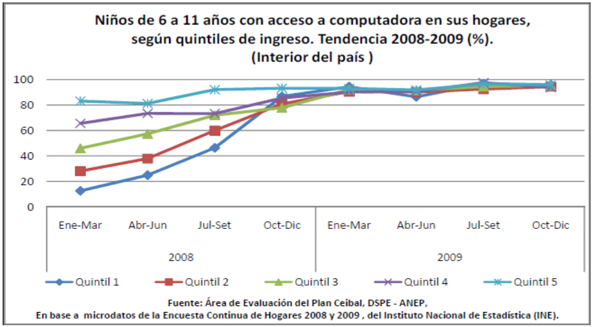

Children 6 to 11 years with computer access at home,
income quintiles. Trends 2008-2009 (%).
(Home)
Quintile 1 Quintile 2 Quintile 3 Quintile 4 Quintile 5
Source: Assessment Area Ceibal, DSPE - ANEP
Based on microdata from the Continuous Household Survey 2008 and 2009, the National Statistics Institute (INE).

The vertical axis is the percentage of children 6 to 11 years with access to at least one
computer at home, and the horizontal axis represents time, ordered by quarters.
The graph allows you the percentage of children within the country which happened to have
computer at home (at least) in 2008, in each quintile of ingreso⁴.
_____________________________________
4
Income quintiles are constructed here based on per capita household income, tidy and subsequently assigned each of the people of the target population (children aged 6 to 11 years).
Ceibal Assessment 2010 Summary Document
3
As developed the mass surrender of computers in 2008 and 2009, quintiles begin to bridge the gap that separates them, to almost match the last quarter of 2008.
A similar process took place in Montevideo and Canelones by 2009. At the end of this past year,
vast majority of households with school-age children across the country, have at
least one computer.
The school and field of expertise
Once substantive change occurs that affects the basis of access to computers
individual level, the primary focus is turning to the use that can make this
resource and where will this experience. In this sense, a point
essential item for Ceibal its implementation has been through
public education institutions.
In the educational field, various official programs from the 90s were aimed at
bring the "information" to the classroom. However, access to computers for educational use
was still a rarity in schools. With the expansion of private access
Internet and personal computers, particularly after 2000, the experience of
information technology and communications for most children and young people
tended to be framed in the private sector through the acquisition of equipment increased
laptops, personal services and mobile telephony and Internet access at home, and -
particularly for the disadvantaged, in the cafe.
Ceibal broke into this scenario distributing computers to all children 1 to
Grade 6 public elementary schools and their teachers, and installing connectivity in the
Almost all schools.
One of the indicators already in 2009 showed the impact of the Plan in this regard was the
change in the basic behavior of children using the Internet: where connecting. Before
Ceibal Plan, according to data processed Continuous Household Survey 5,
children Uruguayan public schools were connected to the Internet mainly in the
"Cyber", and secondly at school or at home.
The following table shows the main places where Internet access in 2009 children
6 to 11 years (public and private schools), by income quintiles.
The trend lines reflect the specific situation of the school, and home
respectively.

5 National Household Survey, Expanded (ENHA) 2006, Household Survey (CHS) 2008,
National Statistics Institute (INE)

Ceibal Assessment 2010 Summary Document
4
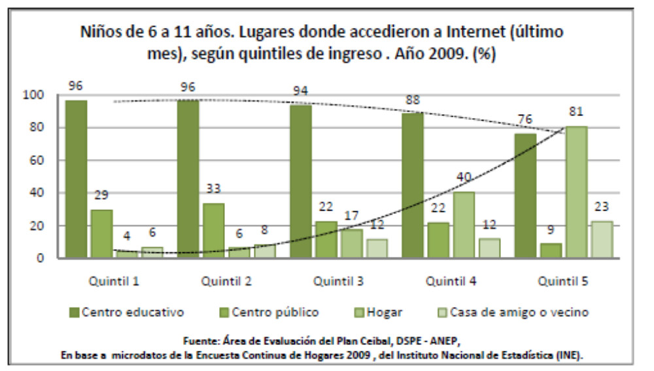
Quintile 1 Quintile 2 Quintile 3 Quintile 4 Quintile 5
Children 6 to 11 years. Places where accessed the Internet (last
month), by income quintiles. 2009. (%)
Home Public Education Center Center House of friend or neighbor
Source: Assessment Area Ceibal, DSPE - ANEP
Based on microdata from the Continuous Household Survey 2009, National Statistics Institute (INE).

As can be seen, for children of lower income quintiles, which in
Most public schools, the school is about 2009 its principal place of
access to the network.
In two years succeeded not only about the conditions of access to technology among individuals
from different social strata, but also alter a scene hitherto monopolized
by local private provision and raise new areas of digital experience around
schools.
Equipment maintenance
Ceibal has positively impacted on the conditions of access and use
computers and internet in the target population, within and outside the school, despite its
consolidation and development faces many challenges.
In the foreground is the challenge material: maintenance of equipment.
In 2009, when he made the first round of assessment Ceibal, according to
indicated for children from 3 º to 6 º at that time, 80% of the computers was
running. The remaining 20%, 13% said they had sent for repair and 7%
the computer was not working and at home.
These difficulties in turn is more acute among those with longer exposure to
Plan (some children had received the computers had more than a year) and the
school contexts less favorable, with only 56% of the teams still in
funcionamiento.⁶
________________________________________________
6
Base: categorization School in 2005. Division of Research, Evaluation and Statistics ANEP.
Ceibal Assessment 2010 DOCUMENT SUMMARY

In 2010, in the second round of evaluation, average indicated by the computers running children from 3 º to 6 º was 70%. According to reports of mothers, most computers do not work for more than a month that are in that situation. Between 2009 and 2010 increased the percentage of computers that do not work and remain in the child's home, ie not yet been sent for repair.
The issue of computer maintenance persists and affects a greater extent
children of school context ⁷
Given this difficulty, the children find alternatives to overcome the disadvantage
temporary. The following table shows the children's response to the question
use the most? "

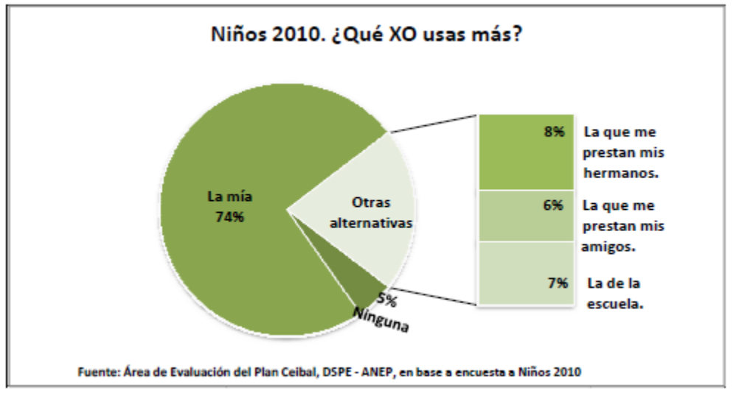
Children 2010. What XO use most?
Mine 74% Alternatives
8% I pay my brothers. 6% The one I lend my friends.
7% of the school.
Source: Assessment Area Ceibal, DSPE - ANEP, based on survey of 2010 children
Three of every four children use their own computer first. However 21% of children report that the computer you use most is not his, but that and provide your brothers, your friends, or school loan This dynamic partially restores the difficulties of maintaining the equipment. In turn, this dynamic in "loans" becomes more prevalent in schools in less favorable environments.

For their part, teachers in the classroom, combining various options to overcome the difficulty. A 74% indicates that, in the missing computers in your classroom, suggests that children who have no work to those who did have. 51% choose to use the computer s school loan and 40% provided their own computers to children. Only 15% of teachers said that before this problem because children choose to do their work in the notebook.

_______________________________________________________
7 Since 2010 has strengthened the support services and repair from the Ceibal in the areas of Call Center (0800 2342) which was added * 2342 from cell-free, the Ceibal Mobile increased the number of phones; Repair Centers were decentralized, the Portal Ceibal (www.ceibal.edu.uy) implemented the answers to common questions and was implemented (reparaciones@plan.ceibal.edu.uy E-mail support).

Ceibal Assessment 2010 Summary Document
6
These solutions are presented as alternatives in the school setting, where-mediated
of teacher-can be managed more easily. Outside of school loans are
less frequent and some proposals as homework assignments are limited by the
lack of computers and connectivity in homes. This means that, in fact, the use of
XO computers tend to concentrate on school time and space.
It was observed in turn from the qualitative approach, these alternatives implemented
within the school can find new challenges: children who used
borrowed machines can not use it later to continue his work
developing it. When several children working around a computer, usually a
who handles the keyboard is taking a more active role while the others assume roles
more passive and restricted to review or observe the activity. Finally, the size
screen limits the ability to effectively share the job.
Beyond these difficulties, in general terms, the XO machines are still the
used by children, against the "common computers." Latter are also
occupying an important place in their experience. More than half of children as well
XO have a common computer at home, when asked "Which of these
computers (XO or common) use more at home? "point to the common computer.
In terms of connectivity there has been no substantive changes between 2009 and 2010.
A connectivity test conducted in schools on the day of the assessment confirmed the
operation in 76% of the centers. And according to the perception of managers in
69% of schools with Internet connection "works correctly." In the particular case
rural schools are still disadvantaged in terms of Internet connection: through July
of 2010 almost half of these schools (rural, with over 20 students) could not be
connection. Also there have been improvements over 2009.
Currently being implemented special projects from the Plan infrastructure
Ceibal in partnership with other agencies estatales.8

________________________________________________________________
8 In 2010 from the Plan have been implemented Ceibal special infrastructure projects to provide electricity the short or medium term in rural schools. The plan of "solar schools" provides solar panels on some of these schools.
It has also signed an agreement with the state agency of electricity (UTE) to ensure the arrival of the grid to all schools that are less than 3000 meters of cabling.
Ceibal Assessment 2010 Summary Document
7
Using computers
Beyond the availability of computers among students in 2010 is lower than
recorded in 2009, according to teachers has increased the frequency with which these
Computers are used in class.

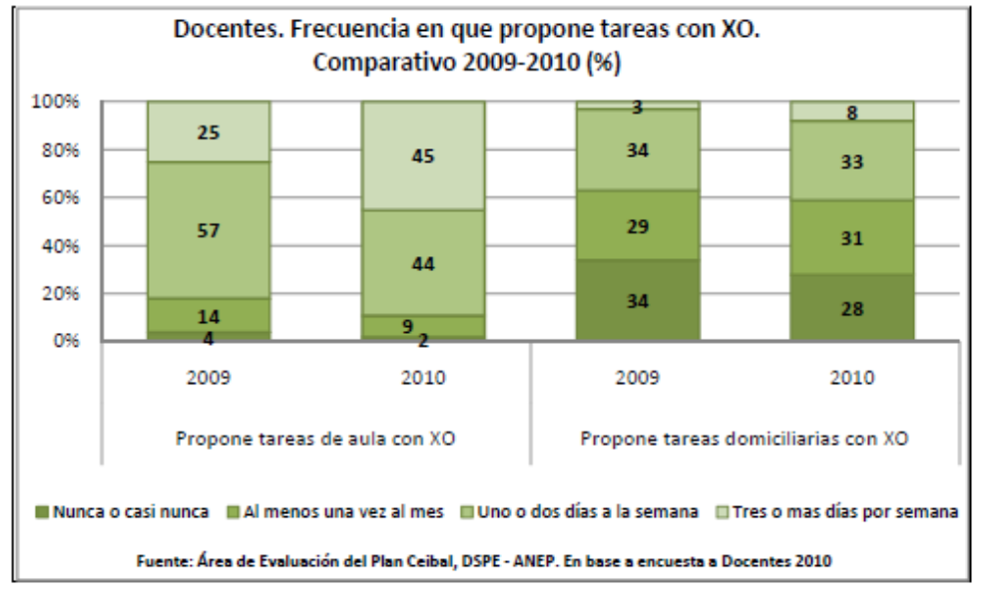
Suggests classroom tasks suggests homework with XO XO
Teachers. Frequency XO proposed tasks.
Comparative 2009-2010 (%)
Never or almost never, at least once a month or two days a week Three or more days per week
Source: Assessment Area Ceibal, DSPE - ANEP. Based on 2010 survey of Teachers
In 2009 only 25% of teachers proposed tasks in the classroom with the XO three or more days
week, and in 2010 indicate it 45% of teachers. The proposed tasks
home, however, has hardly increased between 2009 and 2010.
Although with different intensities, the proposed computer-classroom activities
becomes part of your weekly routine for most teachers.

Ceibal Assessment 2010 Summary Document
8
Among children, unlike the claims of teacher-intensive use in the classroom ("three
or more days a week) decrease between 2009 and 2010.
In 2009, the interior could be seen that 60% of children said they used three or
more times per week the XO in the classroom, in 2010, makes 49%.

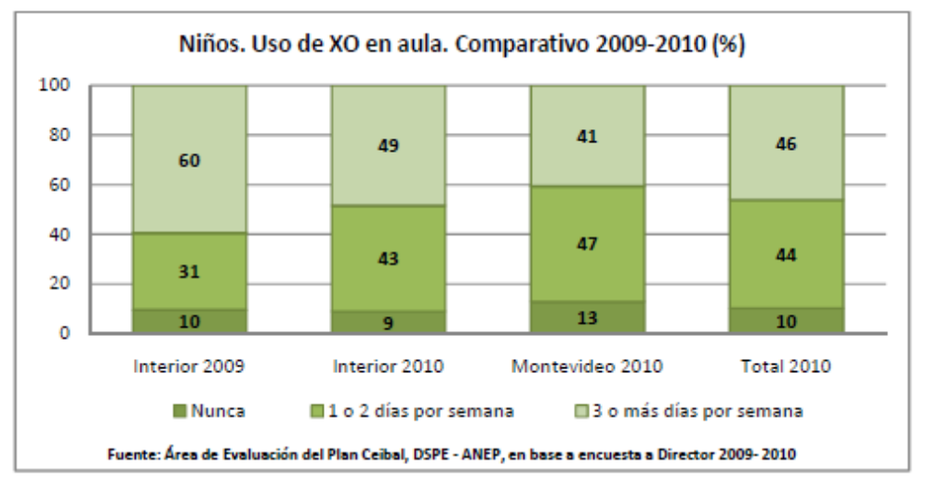
2010 Montevideo Interior 2009 Interior 2010 Total 2010
Children. Use of XO in the classroom. Comparative 2009-2010 (%)
Never 1 or 2 days per week 3 or more days per week
Source: Assessment Area Ceibal, DSPE - ANEP, based on survey of Director 2009 - 2010
Ceibal Assessment 2010
In Montevideo to 2010 there was a lower proportion of children reporting they use as
XO intensive class (41%).
Despite these variations, both teachers and children show similar frequency of use:
45% of teachers reporting they use in the XO class three or more days per week, and 46% of
Children instructed to do so with the same intensity.
Consulted children about what resources used to perform the work as requested
teacher, she notes that access the Internet primarily for information. In
a secondary use traditional media such as paper dictionary or textbook, and
a third access to the books of the library of the XO. In this regard, it should be noted
this resource in 2011 will be enhanced through the inclusion of digital libraries that are
hosted on servers in the school and will have over 100 titles. This resource
benefit all children but especially those that are unfavorable contexts
those most in use.
Referring to the frequency of computer use XO in and out of school for
of children, is almost similar to the frequency of Internet use. 90% of children between 3 º to
6 th using the XO weekly and 87% use the internet. Three out of ten children use
computer "six or seven days a week, another three in ten people use" three to five days
per week, and three are used by "one or two days a week."

DOCUMENT SUMMARY
9

In terms of preferences Internet use, search for games is the starting point more frequent for children.
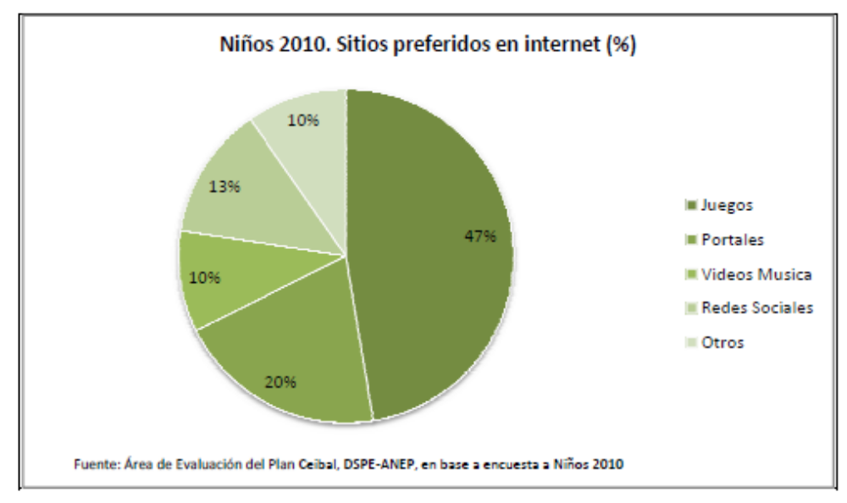
Games Portales Music Videos Social Networks Other
Children 2010. Favorite sites on the Internet (%)
Source: Assessment Area Plan Ceibal, DSPE-ANEP, based on survey of 2010 children

Games (47%) of sports, action and racing-sought directly through Google search terms, in most cases - are preferred by men. Girls on the other hand prefer alternatives such as dolls dress up games, cooking and child portals where they find a greater variety of possibilities: videos, photos, games, chat, forums, screen savers, blogs, music and posting to contend.
More than half of the portals (20%)-all types-mentioned by children, providing content developed for the XO, as XOplanet or wiki.laptop.org
Finally, the preference for social networks (13%) as Facebook or Metroflog gains importance among children in higher grades, favorable contexts, standing alongside the search for "games. "

The ability to access various resources and speed of access, Internet made ​​the appeal preferred by children and adults, and the most valued of Ceibal.
Browse In 2009 was the preferred activity of all children, and secondly Write. 64% of teachers reported in 2009 having sailed on the Internet with their students in class, in the last 30 days, and correspondingly only 24% indicated that they had used to write the last 30 days.

Ceibal Assessment 2010 Summary Document
10
The chart below shows the relative weight of each activity was then, between
"Most used" by teachers.

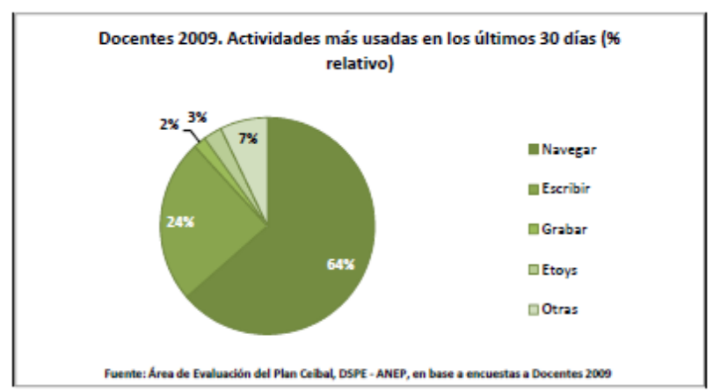
Teachers 2009. Activities most commonly used in the past 30 days (% relative)
Browse Write Record Etoys Other
Source: Assessment Area Ceibal, DSPE - ANEP, based on surveys of Teachers 2009
The following chart compares the variety of activities that teachers reporting they use more (in
the last thirty days) in 2010.
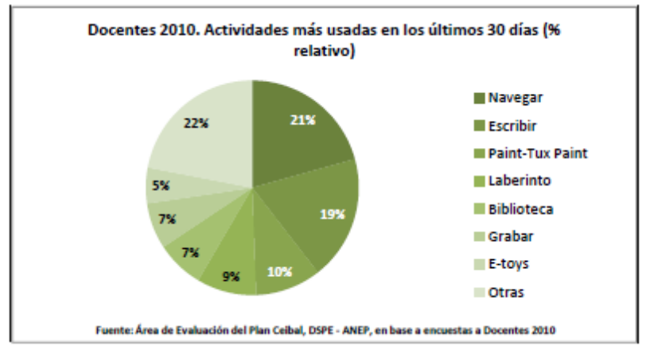
Teachers 2010. Activities most commonly used in the past 30 days (% relative)
Browse Write Paint, Tux Paint Maze Library Record E-toys Other
Source: Assessment Area Ceibal, DSPE - ANEP, based on surveys of Teachers 2010
As can be seen, from 2009 to 2010 there has been significant diversification in the use
of the activities available on the XO. Browse and Write, which in 2009 together have
90% of the attention in class, in 2010 only 40% concentrate, resulting in the use of other
activities such as Paint and Tux-Paint (drawing and image editing), Labyrinth (put map
concept) or the Library, but with a smaller presence, have become part of the
basket of resources used in school.

Ceibal Assessment 2010 Summary Document
11
The qualitative approach allowed the evaluation noted that, beyond instances
training of teachers that have made significant use of computers
ultimately supported in their own trial and error to get closer to the computer
and its programs. This exploration often requires having extra time outside the
classroom that is not always possible. As discussed below, some of the new strategies
raised in the school, as the implementation of energizing teachers has also
helped to overcome these difficulties and has strengthened the efforts of teachers to
approach to technology and producing its adequacy to classroom practice.
Teachers show around 2010 greater attention to the selection and use of activities
specific, consistent to the degree to which they will work. Activities such as talking to Sara
(Text to speech translator), Painting and Record, for example-are used by teachers
1 º and 2 º, while I know Uruguay (compiled from national territory) is mostly
used by teachers of 3 and 4, and the Labyrinth is the most common use for teachers of 5 º
and 6.
Domain
As noted, the use of computers in the classroom has increased, it has expanded use of the variety of resources available on computers, and teachers begin to find greater meaning to the use of specific activities geared to the grade requirements.
It is expected that this experience since then impinges on the perception of people
particularly children, to their own skills when using a computer
The following chart shows the extent to which children of the Interior expressed know-how
certain activities with a computer in 2009, and what they reveal in 2010.
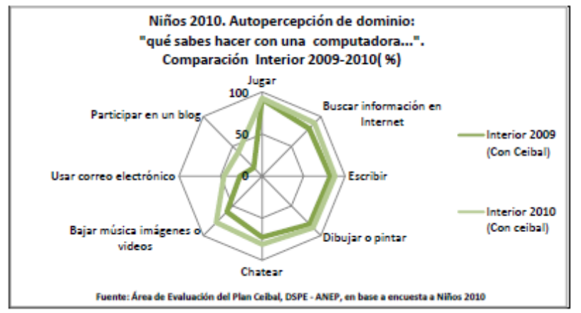
Play Searching Internet Write Draw or paint Chat Downloading music or images
videos Using e-mail Participating in a blog
Children 2010. Perception domain: "What can you do with a computer ...".
Compare Interior 2009-2010 (%)
Interior 2009 (With Ceibal)
Interior 2010 (With ceibal)
Source: Assessment Area Ceibal, DSPE - ANEP, based on survey of 2010 children
Ceibal Assessment 2010 Summary Document
12
Here we observed significant positive changes in items such as downloading music, images or
videos (60% in 2009 to 78% in 2010), using email (27% to 46%), and participate in a
blog (14% to 40%).
For its part, in Montevideo and Canelones, where assessment allows comparison 2009-2010
an initial time which had not yet arrived Ceibal computers, and a second
time when they were already part of the experience of these children can be observed
most significant changes in the perception domain.

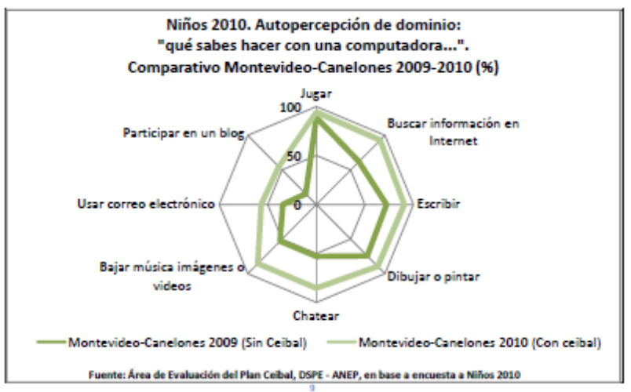

Play Searching Internet Write Draw or paint Chat Downloading music or images
videos Using e-mail Participating in a blog
Children 2010. Perception domain: "What can you do with a computer ...".
Comparative Montevideo, Canelones 2009-2010 (%)
Montevideo, Canelones 2009 (No Ceibal) Montevideo, Canelones 2010 (With ceibal)
Source: Assessment Area Ceibal, DSPE - ANEP, based on survey of 2010 children
In this case the most important positive changes have occurred in those activities
involve the use of connectivity, browse the Internet, chat, downloading
images or videos, and participate in a blog.
Participating in a blog, is one of the activities for which, comparatively, children
Montevideo and Canelones signal having lower perceived control, but that records
higher growth between 2009 and 2010, indicating 15% know it in 2009 to 55%
in 2010.
Also seek information on the Internet increased from 62% to 93%, and chat and download
pictures or videos passed away (both) from 53% to 85%
With regard to email, there was an increase of 22% of children who show know
use reaching about 60%.

_________________________________________________
9 The category "Participating in a blog" was raised in the questionnaire as: "Put something on a blog, facebook, metroflog. "
Ceibal Assessment 2010 Summary Document
13
Determine the competencies of children in the use of new technologies is a task
requires a complex approach. Permanently displayed new equipment, networks and
ways of working, new applications available to the public and
the skills necessary for their implementation, are diffuse, and the limit between what is
to know, and what you need to know.
In this scenario in motion, perception and conviction of the persons to be able to
use new technologies, and project aspects of their lives rely on them
stores a value in itself. Allows a positive starting point at the level of security and
people's expectations for the integration of technologies.
User Profiles
Some of the indicators considered in the evaluation can build categories
particular analysis, such as user profiles. Based on the frequency with which children
indicate use computers can be identified, for example, a group of "users
intensive ", children who use them daily," 6 or 7 days a week. "
In 2010, among children from 3 º to 6 º can be identified as "heavy users" to 34%
children surveyed, children who reported using a computer daily, is a common,
an XO, or both. 30% are heavy users, exclusively, the XO, and 4% points
daily use both XO and other common computer.
These heavy users mostly correspond to higher degrees (5 and 6). Are
mostly male (54%). Besides indicating greater intensity of use
computers, are more interested in technology in general than their peers girls and
receive further dominate other digital resources in addition to the computer as
cell phones, DVDs and digital cameras.
Heavy users are more in schools and enabling environments
in urban environments. 38% of children in schools identified as Montevideo
heavy users, 33% in inner city schools and 28% in rural schools.
In the context of schools and Very Favorable Favorable 4 in 10 children are users
intensive, while Very Unfavorable context are 3 out of 10.
Heavy users of computers have increased perception of this domain
resource and general technologies (computers, DVDs, cell phones, pen drive
MP3 players, etc.).. However, the perception of mastery of the XO is the aspect
where there are minor differences between heavy users and common users.
Heavy users have learned to use computers mainly alone
while for other users of the learning experience takes place primarily
in schools and adult-mediated, particularly by the teacher.
Ceibal Assessment 2010 Summary Document
14
Almost half of children (48%) who are heavy users, connect to Internet
every day, while the most common among children who are not heavy users
is to connect one or two times a week (43%). In turn, in Montevideo, show greater
preference for activities related to communication such as e-mail and
social networks in the interior. 25% of users indicated intensive Montevideo
participate daily in a blog or a social network, while their peers inside
only 16% of daily access to a network.
Finally, according to the perceptions of their mothers, users do not receive intensive
school results substantially different from other children, however, show
more active than others when searching for information and materials on the computer
to bring to class, read less paper and more material online, and look -
comparatively-less TV than the common computer users.
Experience in digital production
Considering the fact that literacy skills are linked to a domain
cross indispensable for social and cultural development of any individual, and
for primary domain of reading and writing are presented as axes
cognitive development were proposed for children of 3 º to 6 º two practical experiences
digital production. The first focused on developing a narrative based on
a slogan, in class, with the computer and the second, proposed to write and send an email
mail.
The aim of these proposals is to observe and describe the use of computers and internet
do children applied to the development of a text, see how they address and
develop the task, the ICT skills that come into play and describe the results of
task.
The observation and analysis of the first activity, production of text, identified
programs that children use and the actions they take to develop this
slogan; also establish to what extent these issues vary in different degrees and
school contexts.
Most children (75%) use more than one program while you prepare your text,
mostly write and seek information on the Internet, but also draw, record
images or videos with the recorded program, or seek other alternatives for presentation
information programs such as E-toys. Comparatively, when the present activity
in 2009, most of the children using a single program (3 rd only 22% used two or more
programs, and 6 º 58% did). In 2010 the use of two or more programs predominated
all grades alike, and was above 70%.
The results of this activity allowed us to visualize the main features
texts produced as grades, identifying from the alphabetic text
aspects such as the inclusion of images and font changes.
Ceibal Assessment 2010 Summary Document
15
As for the valuation of these texts, according to assessments of teachers
applicators, 84% of children failed to produce a text according to the reference. That is, did
submit a text on the same processor or other text editors suitable for the task,
as a result, and this text was noted by the teacher and tried as an applicator
"Relevant" or "somewhat relevant" to the objective of the slogan.
In 2009, a similar result was reached only 62% of children.
The second activity, in sending an email, in addition to exploring
aspects of the way they communicate through this medium, was aimed at
verify to what extent it is possible to elicit responses from children through the mail
mail from a slogan addressed to the group.
The answer was no regular school, ranged from where they sent some one
Email to a case of a center from which came 58 posts. The average was 7
e per center.
The total response was 76% of schools were able to meet the
slogan of sending email (ie: they had connectivity) that day. And
mail received (assuming that each represents at least one child) represented the
36% of students attending that day to the target groups, in schools
able to participate in this experience.
Children in higher grades were those who managed to send further
your emails correctly and who most often were enriched
e-mail text with font changes and inclusion of graphics.
Training
In 2009, the evaluation found in training one of the most critical issues from
perspective of teachers. For most teachers received training for
initiated in this experiment had proved inadequate, limited, or no other
cases. Some of these teachers said they had received as a "duty" to integrate
XO in the classroom, without sufficient support for this work, which resulted in first
term insecurity in the performance of their role.
The themes in the training were relevant from the perspective of
teachers, but did not have enough depth to ensure an integral domain
computer, their activities and their educational use. The latter was the point of greatest
controversy over training in 2009, ie, what should be the "educational use"
of this resource.
The perception of teachers about the difficulties at this point, tend to reappear in
2010.
Ceibal Assessment 2010 Summary Document
16
The following table shows the extent to which teachers report having participated
different levels of training related to Ceibal, from 2008 to 2010.

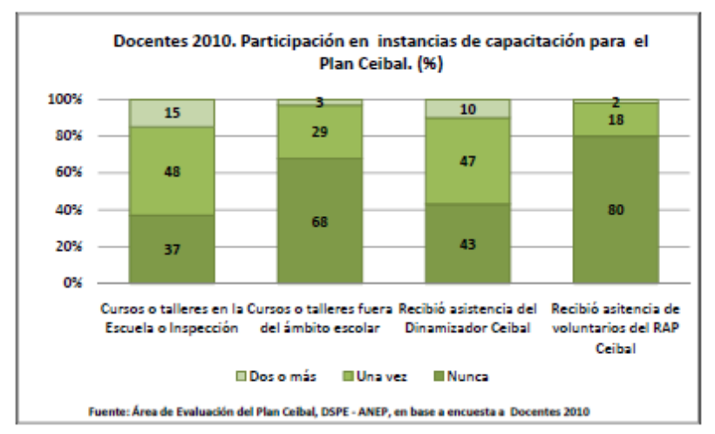
Courses or workshops in School / Inspection
Courses or workshops outside of school
Received assistance
Revitalizing Ceibal
ATTENDANCE received from RAP volunteers Ceibal
Teachers 2010. Participation in the training instances Ceibal. (%)
Once two or more Never
Source: Assessment Area Ceibal, DSPE - ANEP, based on 2010 survey of Teachers
Teachers say they have had much training instances
directly linked to school-courses or workshops, or the Facilitator, which assistance
beyond.
63% of teachers participated in at least one training course or workshop related to
Ceibal. The remaining 37% said they had received any training in the field
school since it began Ceibal experience.
Teachers also stress the importance of regular training in other instances the
school and individual exploration of the computer, with students, and exchange
with colleagues. According to teachers, these elements have also played an
important learning experience.
During 2009-2010, the specific strategies that had been training
proposed within and outside of school, joined the presence of Ceibal Facilitators
in schools (in June 2010 for 52% of schools had a Facilitator).
According to the perception of teachers, the figure of the Revitalizing Ceibal in particular
was of importance for training and support of their task. Six out of ten
teachers indicated that they had received support at some point Facilitator.
Moreover, the initiative of teachers to seek support materials available through
Internet, also has a place in the learning process.
The portal Ceibal (www.ceibal.edu.uy) among others, offers activities and proposals
general for teachers, children and families.
Ceibal Assessment 2010 Summary Document
17
In 2010, 70% of teachers claimed to have used the portal in the last Ceibal
30 days.
The following table shows the different uses that teachers made within Argentina
portal in 2009 and 2010, and the use made by teachers in Montevideo in 2010.

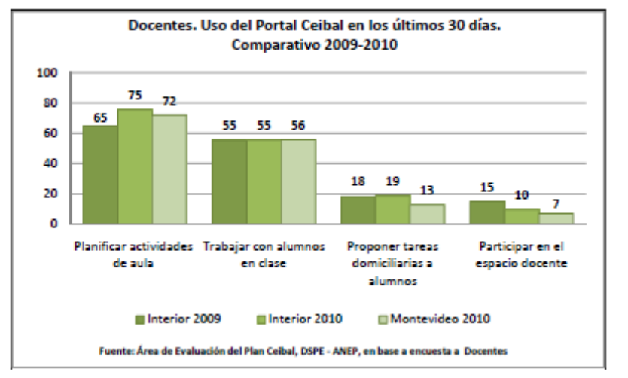
Planning activities classroom
Working with students in class
Suggest tasks home to students
Participate in the educational space
Teachers. Using the Portal Ceibal in the last 30 days.
Comparison 2009-2010
2009 Interior 2010 Interior 2010 Montevideo
Source: Assessment Area Ceibal, DSPE - ANEP, based on survey of Teachers
33% of teachers say they have also used other sites apart from the educational
Ceibal. In first place is the website of the ANEP: www.uruguayeduca.edu.uy, then the
Argentine Ministry of Education: www.educ.ar, and lastly Wikipedia.
Like Ceibal portal, its use has been primarily for planning activities
classroom and work with students in class.
In relation to training, it was found that the number of instances to face
accessing the teachers have a genuine positive effect on their perception
about the difficulties of working with XO, and the integration of computers to
classroom practice.
Among teachers who use more frequently the XO in class (three or more days per week)
58% reported having two or more instances of training Ceibal, 38%
had a single instance of training and 3% did not have any.
Families, meanwhile, also recognize training needs in relation to Plan
Ceibal, in order to support their children in this experiment.
34% of families do not know the site indicates institutional Ceibal, and another 43%
shows but never have come to know. Only 21% reported having visited the site.
Ceibal Assessment 2010 Summary Document
18
The proposed communication on TV - "Channel Ceibal" - is in a situation
similar: 39% of mothers do not know this proposal on television and 22% say they know
but have never looked, looked at 21% once and 17% more than once.
According to the mothers, the best ways to inform parents about the Ceibal
remain in school meetings and communications over the child's notebook.
85% of mothers never participated in a traditional instance training. 14% yes
did, almost entirely attended workshops at the school.
Finally, we asked the principals what were the main factors
that hindered the use of Ceibal in their centers. From your perspective
noted that technical problems and training are the factors that generate greater
difficulty in exploiting Ceibal in their schools. 44% of
directors ranked first as the technical difficulty of computers,
connectivity and broken computers, 38% assigned the top of the difficulties
insufficient training of teachers, and 8% identified main difficulty, methods
education. To a much lesser extent prioritized issues such as lack of interest
teachers (3%) or resistance to innovation (2%).
Furthermore, a qualitative approach to evaluation through school visits and interviews
allowed stakeholders to see a deeper difficulties
institutional development of this experience, and to identify factors
determining the inclusion of Ceibal in schools: about positioning
Proactive director-and particularly the teacher in the classroom, to the integration of
computers, the history of each teacher's relationship with technology in
school and in everyday life, the existence of training instances, and the possibility of
teachers to share and exchange experience at the school bus, for
have required school days to coordinate actions.
The same approach has allowed us to visualize the situation of uncertainty created for
teachers-especially those in Montevideo and Canelones, have launched over
recently-Ceibal experience not feeling able to address the use of
computers in its specificity (each program) with a pedagogical, framed
within the objectives and strategies of teaching, and yet see clearly how it fits
overall school organization to a new way of working: "What will happen in the
recess? "," Will we know how to handle this new tool? "," How do you generate
learning environment? ".
Ceibal Assessment 2010 Summary Document
19
Evaluation of experience
From the educational perspective, the integration of the XO to the various aspects of the task
training has different situations, as seen in the chart below
comparison between 2009 and 2010.

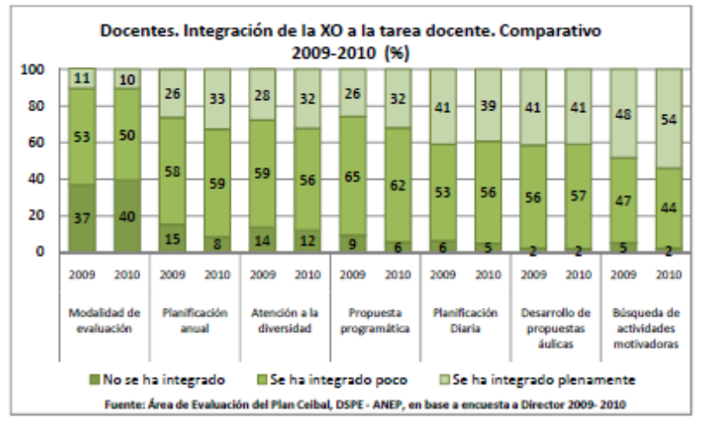

Mode evaluation Planning Annual Care diversity Proposal program
Planning Daily Developent proposals aulic Search activities motivating
Teachers. XO Integrating the teaching task.
Comparative 2009-2010 (%)
Has not been built has been built recently been fully integrated
Source: Assessment Area Ceibal, DSPE - ANEP, based on survey of Director 2009 - 2010
As in 2009, the main areas in which teachers report having
the computer integrated Ceibal their practice have to do with planning
daily courtly proposal development, and motivational aspects of search activity
in which at least 4 of every 10 teachers acknowledge that you have fully integrated the use of
XO. The last aspect mentioned (search for stimulating activities) is the only
shows an increase between 2009 and 2010.
Moreover, other aspects such as attention to diversity, annual planning and
integration into the proposed program, but do not yet have a full integration
the use of the XO, show themselves greater integration by 2010.
The integration of the computer to the evaluation mode is the only aspect in which
fell in the same period. However, teachers say they have found other opportunities through
computers.
63% of teachers (3 º to 6 º) recognizes that the presence of the XO have been
consider possible changes in the way they develop their classroom practice.
These changes in practice, are recognized more on the social and
Language first, then the nature area and fourth in mathematics.

DOCUMENT SUMMARY
20

For teachers of 1 st and 2 nd year integrating the use of the XO to practice has been somewhat
minor, 4 in 10 teachers in this case acknowledges that aspects of their practice changed
from computers, mostly in the area of ​​language.
Art is the area in general lowest recorded level of integration of computers.
From the perception of managers, some of the positive effects attributable to Ceibal
have varied between 2009 and 2010. The following table compares the findings of directors
the interior in 2009 and 2010 on the influence of Ceibal, and the perception of managers
Montevideo in 2010.

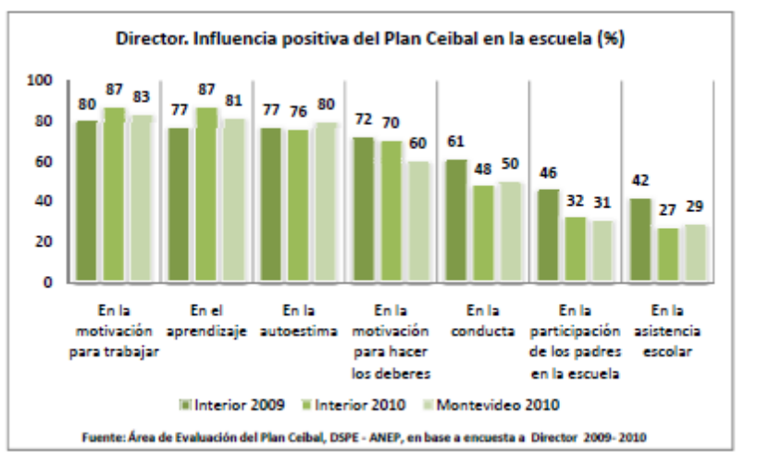
In the motivation to work
In the learning
In the self-esteem
In the motivation to duties
In the behavior
In the participation of parents school
2009 Interior 2010 Interior 2010 Montevideo
Source: Assessment Area Ceibal, DSPE - ANEP, based on survey of Director 2009 -2010
Director. Ceibal positive influence in school (%)

As can be seen most consistent directors since 2009 that the Plan Ceibal positive influence on motivation and self-esteem of children, and even in their learning.
However, except these three items (motivation for work, learning and self-esteem) of more generally, in the other items proposed , the perception has positive influence significantly decreased interior directors of the country.
The influence on the conduct of children seem to be the most remarkable decrease perception of impact, it was good for most of the directors in 2009 61% and happened to be for 48% of directors of Interior to 2010, figure very close to that envisaged by the directors of Montevideo (50%) to 2010.
For his part, although there was a general expectation that parents become more involved in
school, or to improve school attendance, the perception of it has fallen
significantly to 2010 between directors of the country.
Ceibal Assessment 2010 Summary Document
21
In Montevideo, the proportion of managers who attributed positive effects Ceibal
on the care of children and their parents, is similar to that envisaged by the
directors of the interior.
Overall, from the perspective of directors, to 2010 levels decrease
high motivation and motivation tends toward a midpoint. Likewise, directors
more motivated Ceibal respect what they perceive their teachers. 76%
Directors noted that it has incorporated the use of the XO to its center project.
Montevideo managers (with less exposure time Ceibal), are
comparatively less motivated with respect to the Plan than their peers within Argentina, a
10% of these states have "low" motivation, whereas their peers in Interior more
time experience for less than 5%.
From the perspective of children, their assessment of this experience can be seen through
specific questions regarding what beneficiaries use them as daily:
computer (mouse and keyboard) and the programs of the XO. The following chart compares this
assessment of children in 2009 and 2010, on a scale family of evaluation: "What grade would you
would place .... "

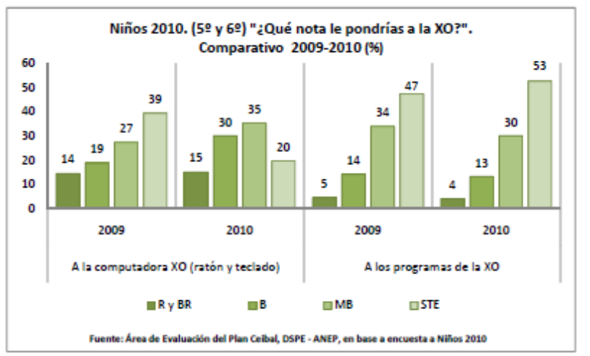
The XO computer (mouse and keyboard) to the programs of the XO
Children 2010. (5 & 6) "What grade would you give the XO?".
Comparative 2009-2010 (%)
R and B MB STE BR
Source: Assessment Area Ceibal, DSPE - ANEP, based on survey of 2010 children
As for the hardware components of the computer (keyboard and mouse) remain
mostly-approval for 85% of children given a passing grade, but have lost
some popularity compared to 2009.
Programs or activities "of the XO, however have improved their acceptance among children
2010. Several factors converge in the improvement of the ratings: higher
exploration by the children themselves and teachers in these activities of Sugar, the

Ceibal Assessment 2010 Summary Document
22
expansion and improvement of the activities available in the updated versions of the desktop;
and further exploration (and unloading) of other content and programming over the Internet.
Moreover, the children had the opportunity to get some ideas about
what things you could switch to the XO for improvement. They were asked to choose a
raised five alternatives: "to be able to connect more things," that is faster,
"Dam not programs," which has more memory "," not to disconnect so
followed. "
Most children chose to expand the potential of the machine first, in the
meaning you can connect other devices (peripherals) and integrate to other resources
Digital those who may have regular access. Secondly, storage capacity and
data processing are important requirements according to the children
improve their XO.
As noted above, the approach of families to the school is not recognized
as one of the strengths of influence Ceibal far.
In this sense we can highlight some of the main concerns of mothers regarding
which aspects Ceibal should change, for improvement.

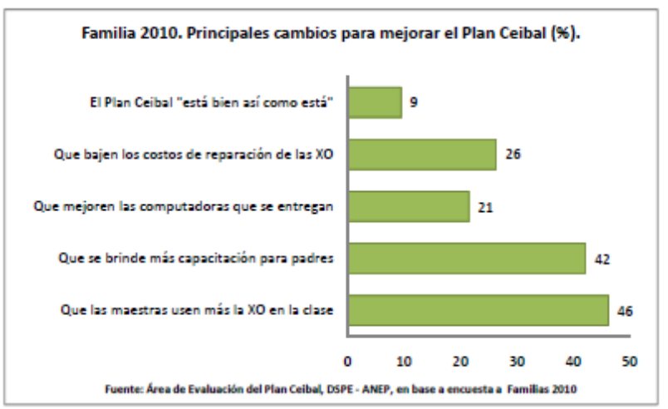
That teachers use more than the XO in the classroom
Which provide more training for parents
To improve the computers that are delivered
Down the costs of repairing the XO
Ceibal "is fine as is"
Family 2010. Major changes to improve the Ceibal (%).
Source: Assessment Area Ceibal, DSPE - ANEP, based on household surveys 2010
Changes in families place greater emphasis is not focused on computers,
but stakeholders, mainly teachers and parents themselves.
Mothers are betting that the strengthening of Ceibal should be based on the use of
computer in class, but without neglecting their own participation in this experience.

Ceibal Assessment 2010 Summary Document
23
Conclusions
This year we plan to launch the third round of assessment Ceibal 2011. Topics
addressed by the evaluation will be analyzed from the perspective of a third year
Ceibal experience.
It is worth reviewing some of the main findings and challenges identified Ceibal
2010.
In terms of access to computers has virtually achieved universal access to
computers in households with school-age children. Also from Ceibal the
public school has become the hub of the digital experience for schoolchildren.
However, by 2010 we see an increasing difficulty in maintaining the
equipment by beneficiaries. Although various alternatives have been implemented
to overcome the difficulty, the situation is not without a problem, both
individual-personal-for children, and institutional levels, for school-in
school routine planning integrating the use of computers. This difficulty is a
challenge in terms of consolidating the plan as a 1:1 model.
Also, access to connectivity in rural areas remains a pending matter.
Beyond the difficulties noted, has increased the use of computers and
Internet in the classroom by 2010. We could see how progressive this application meets the
potential offered by computers, their programs and the specificity for degrees and
knowledge areas.
Have also been able to observe trends in how children are linked to
computers, in some cases becoming "power users" and defining
individual attitudes and perceptions about technology and their own
capabilities.
Have been implemented with children two production experience with computers
(Text production and mailing address) that let you see a development
successful children using these new resources and most importantly, has brought
elements for reflection on the integration of technology into classroom practice.
In relation to the different stages of implementation that cross the interior of the country and
Montevideo, as already seen recurrences in the process of adaptation to
experience. Those who have traveled less time to show greater Ceibal
uncertainties regarding the Plan and increased demand for training, while those
have longer experience tend to overcome some of this uncertainty and
building strategies applicable in every context.
Despite the critical findings, we found a willingness of the actors
school to the development of these experiences in education. The criticisms raised
are related to positive demand more and better equipment and support resources
Ceibal Assessment 2010 Summary Document
24
conceptual travel experience. Not generally pose a reactive position
to the proposal.
Most teachers felt they have been able to implement changes in practice
from professional Ceibal. This encourages one of the greatest expectations: the possibility
to develop new strategies for teaching and learning, adapted to the media and
contemporary ways of linking with the knowledge.
Once circumvent the limitations on access to technology, the key factor for good
association of children with the technologies, lies in the possibility of their use: at ease
access, in its practical application and finally the ability to generate a link
Flexible child with the technology.
At the subjective level, not least, this use must tend to maintain
from a perception that technology can do things you did not seem
possible and plan personal goals supported by these tools.
Ceibal Assessment 2010 Summary Document
25
Recommended Bibliography
· Pittaluga, Lucia and Sienra Mariana (2007):
Thematic report. Use of Information Technology and Communications
in Uruguay, National Household Survey Expanded. ICT module. Second quarter
2006. Montevideo: UNFPA / UNDP / INE. Available at: www.ine.gub.uy/enha2006/
Doc% 20Final% 20mayo2.pdf 20TIC-25%
• UNESCO-CEIBAL ANEP (2010),
On the Road Ceibal, UNESCO, Montevideo, 2010.
· Dussel, Inés y Quevedo, Luis Alberto (2010)
Education and new technologies: the pedagogical challenges to the digital world
Fundación Santillana, Buenos Aires, 2010. Available at: www.fundacionsantillana.com
· Sánchez, Jaime, and Mendoza, Claudius (2010)
Gender differences and ICT in education in Chile,
University of Chile, Department of Computer Science, Center
Advanced Research in Education, Santiago, 2010. Available at:
www.ciie2010.cl/docs/doc/.../325_CMendoza_Diferencia_genero_TICs.pd
· Miranda de Larra, Rocío (2005)
Children in the Red: Behavior and safe navigation
Fundación Auna, Notebooks / Information Society No. 6, 2005.
· Presnky, Marc, (2001):
"Digital natives Digital immigrants", in: On the Horizon.
MCB University Press, Vol.9, No. 5, October 2001.
· EducaRed, 2010.
Generations Forum interactive
Available at: http://www.educared.org.ar/tecnologia/generacion-i/
° Garcia Fernandez, Fernando. (2009)
Interactive native. Teens and screens: educational thoughts.
Spread-educate library. Generation No. 1 Interactive Forum, EducaRed, 2009.
· Buckingham, David (2005):
Media Education: literacy, learning and contemporary culture.
Polity Press, Barcelona, ​​2005.
· Area Assessment Ceibal, DSPE-ANEP-CODICEN, Eastern Republic of Uruguay
(2009):
Plan Assessment Report Ceibal 2009. Available at:
http://www.anep.edu.uy/anepweb/servlet/main004?403
· Area Assessment Ceibal, DSPE-ANEP-CODICEN, Eastern Republic of Uruguay
(2011):
Assessment Report Ceibal 2010.
· Buckingham, David, (2008):
Beyond Technology. Early Learning in the Age of culture
Digital. Buenos Aires, Ed Spring, 2008.
Ceibal Assessment 2010 Summary Document
National Public Education Administration
Educational Sectoral Planning Directorate
Assessment Area Ceibal
ceibal@anep.edu.uy

