Step-Up Jobs in the Salt Lake Area
An experienced, highly reliable custodian moving into seated, bench and desk work that uses crafts and tech. Collected November 01, 2026. Salt Lake, Davis, north Utah and Tooele counties.

Takeaways
- 20 current postings in the Salt Lake region fit this profile; 12 are seated or bench work with no physical demands listed in the ad.
- The largest track is Dispatch & Scheduling (7 postings).
- Where pay is listed, the median is $21.50/hr; Dispatch & Scheduling pays best (median $23.25/hr, 6 postings with pay).
- 20 of 20 postings do not mention a college degree.
- 10 postings are with hospitals, schools, universities, libraries or government, where benefits and tuition help are most common.
- 8 postings need a question to HR about lifting, stairs or standing before applying (see the physical-fit column).

Where the openings are
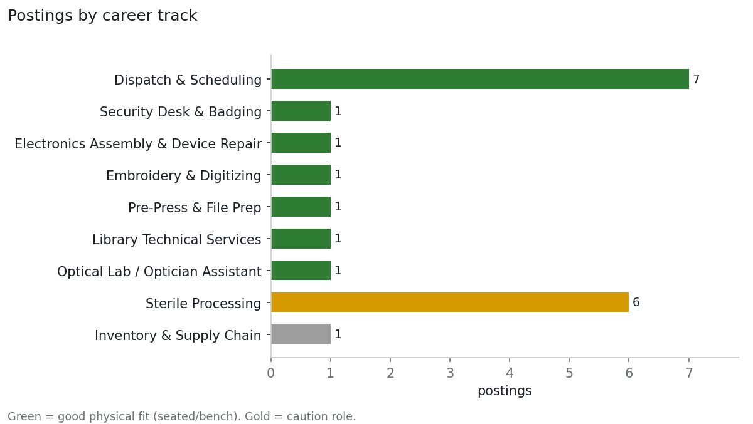
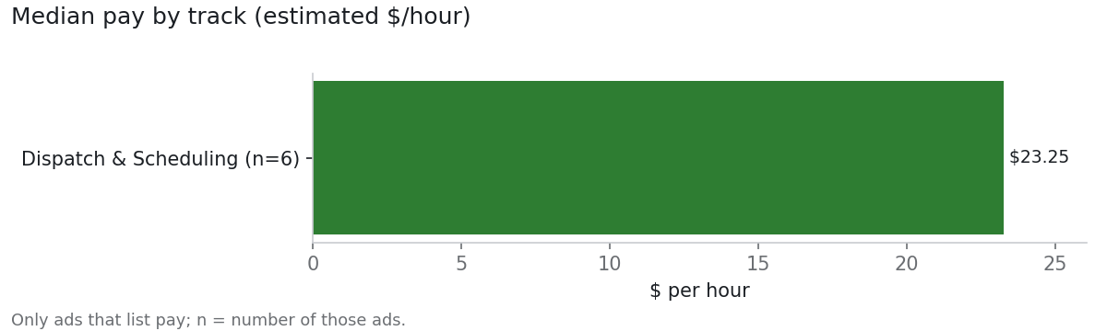
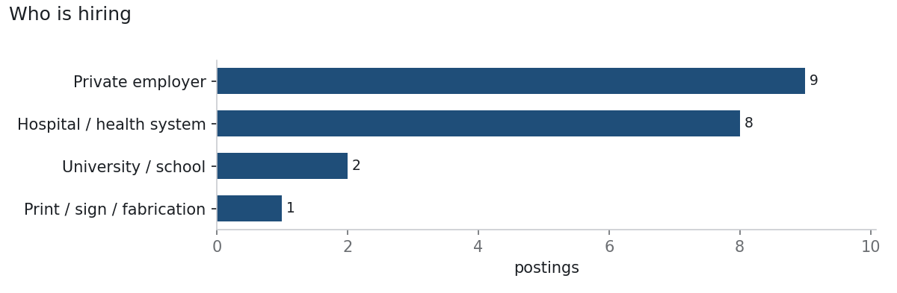
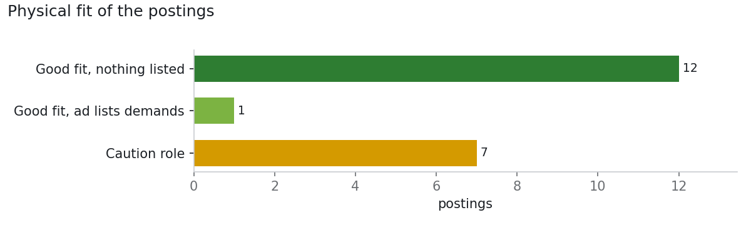

Career tracks

Dispatch & Scheduling
Physical fit: good · Operations · 7 postings · median $23.25/hr
Seated desk work: calls, technician routing, appointment and work-order queues
How to qualify: Diploma; 911 dispatch has a paid academy and strong benefits
Top employers: Apex Clean Air (1), Archer Mechanical & Maintenance Contractors (1), Mountain West Truck Center (1), GSH Materials Testing & Inspections Inc. (1)
- HVAC Home Service Dispatcher Coordinator — Apex Clean Air · $17 - $23 an hour
- Service Dispatcher — Archer Mechanical & Maintenance Contractors · $48,000 - $58,000 a year
- DISPATCHER HEAVY DUTY DIESEL SERVICE SHOP — Mountain West Truck Center · $65,000 - $110,000 a year
- Administrative Assistant/Dispatcher — GSH Materials Testing & Inspections Inc. · $23 - $25 an hour

Security Desk & Badging
Physical fit: good · Operations · 1 postings · median —
Front desk or monitor bank: IDs, badges, keycard access, cameras — no patrol
How to qualify: Utah security licensing is handled through the employer
Top employers: University of Utah (1)
- Health Security Dispatcher — University of Utah · 12.02 to 21.63

Electronics Assembly & Device Repair
Physical fit: good · Creative & maker · 1 postings · median $19.50/hr
Seated anti-static bench: small boards, soldering, phone and laptop repair
How to qualify: A $20 soldering practice kit; iFixit repair guides
Top employers: Codinix (1)
- Soldering Technician — Codinix · $19.50 Per Hour

Embroidery & Digitizing
Physical fit: good · Creative & maker · 1 postings · median $18.00/hr
Light bench work running multi-needle machines, or seated stitch-file design
How to qualify: Ink/Stitch (free, inside Inkscape); any sewing or textile work
Top employers: Stitch Print (Inked Wear) (1)
- Embroidery Specialist — Stitch Print (Inked Wear) · $16.00 - $20.00 Per Hour

Pre-Press & File Prep
Physical fit: good · Creative & maker · 1 postings · median —
Pure desk work: checking files, bleeds and color before printing
How to qualify: InDesign, Illustrator, Acrobat Pro (target file prep, not press operator)
Top employers: Cricut (1)
- Digital Content Production Artist — Cricut

Library Technical Services
Physical fit: good · Creative & maker · 1 postings · median —
Back-office mending, jacketing, labeling and catalog records — not shelving
How to qualify: Bookbinding/paper-craft neatness; spreadsheet basics
Top employers: University of Utah (1)
- Acquisitions Assistant — University of Utah · 20.70 - 21.70

Optical Lab / Optician Assistant
Physical fit: good · Creative & maker · 1 postings · median —
Bench lens edging and frame adjustments; flat clinic floor
How to qualify: Apply directly to optometry offices and optical labs
Top employers: University of Utah Health (1)
- 86460 - Optician — University of Utah Health

Sterile Processing
Physical fit: caution · Operations · 6 postings · median —
Certified hospital role, but standing all shift and lifting instrument trays
How to qualify: CRCST; ask about tray weights
Top employers: University of Utah Health (6)
- 75630 - Sterile Processing Coordinator — University of Utah Health
- 86603 - Sterile Processing Technician — University of Utah Health
- 86688 - Sterile Processing Coordinator — University of Utah Health
- 86747 - Sterile Processing Technician — University of Utah Health

Inventory & Supply Chain
Physical fit: avoid · Operations · 1 postings · median —
Stock counts and supply rooms — usually lifting boxes
How to qualify: Avoid unless the ad says data entry or purchasing
Top employers: University of Utah Health (1)
- 86132 - Coordinator, Materials Management M-F 0500-1400 — University of Utah Health

Apply this week
Job | Employer | Pay | Physical fit
Health Security Dispatcher | University of Utah | 12.02 to 21.63 | Good fit
Soldering Technician | Codinix | $19.50 Per Hour | Good fit
HVAC Home Service Dispatcher Coordinator | Apex Clean Air | $17 - $23 an hour | Good fit
Service Dispatcher | Archer Mechanical & Maintenance Contractors | $48,000 - $58,000 a year | Good fit
DISPATCHER HEAVY DUTY DIESEL SERVICE SHOP | Mountain West Truck Center | $65,000 - $110,000 a year | Good fit
Digital Content Production Artist | Cricut | — | Good fit
Acquisitions Assistant | University of Utah | 20.70 - 21.70 | Good fit
Administrative Assistant/Dispatcher | GSH Materials Testing & Inspections Inc. | $23 - $25 an hour | Good fit
86460 - Optician | University of Utah Health | — | Good fit
DISPATCHER |  | — | Good fit
HVAC/R DISPATCHER/ACCOUNT MANAGER |  | $20–$25/hr | Good fit
Office Assistant/Dispatcher |  | $18–$23/hr | Good fit

Resume tips
- Lead with reliability as a number: “99%+ attendance across X years, zero unexcused absences.”
- Translate custodial work into operations terms: supply ordering and inventory, SDS/OSHA chemical safety, key and alarm control, finishing routes on deadline without supervision.
- For craft and bench roles, attach a simple portfolio: 5–10 well-lit photos of finished pieces.
- Read each ad's Physical Requirements section. “Lift 50 lbs” is often copied boilerplate on desk jobs; ask HR, and ask large employers for an elevator-accessible workstation.
- Apply first to hospitals, universities, school districts and government: steady benefits, internal promotion, and often tuition help for design, CAD or IT classes.

Search these by hand
- Utah DWS Job Board — State workforce board; many local employers post only here
- State of Utah jobs — Facilities, inventory, security and safety roles with state benefits
- Salt Lake County — Careers page: facilities, parks/rec ops, code enforcement
- Salt Lake City Corporation — Careers page: also hires for the SLC International Airport
- Utah Transit Authority — Dispatch, facilities and inventory roles
- University of Utah (campus) — Facilities Management, Housing & Residential Ed, Campus Security
- University of Utah Health — EVS supervisor, supply chain, sterile processing
- Intermountain Health — Largest Utah employer: EVS leads, supply chain, sterile processing, security
- HCA MountainStar (St. Mark's, Lakeview, Jordan Valley) — EVS and sterile processing
- Salt Lake Community College — Facilities and custodial supervisor roles
- Granite / Canyons / Jordan / Salt Lake City / Davis school districts — District custodial supervisor and warehouse/inventory roles; check each district's HR page
- Church of Jesus Christ employment — Facilities management for meetinghouses and Temple Square; large SLC employer
- JLL / CBRE / Cushman & Wakefield — Facilities coordinator roles on corporate campuses (Draper, Lehi, downtown)
- ABM / Aramark / Sodexo / Crothall — Custodial and EVS supervisor roles at hospitals, campuses, airports
- Allied Universal / Securitas — Security officer and access-control posts
- Salt Lake County Library — Creative/maker spaces at several branches; library assistant and lab jobs post through the county
- The City Library (Salt Lake City) — Creative Lab at the Main Library; jobs post through Salt Lake City
- University of Utah Marriott Library — Makerspace and digital-fabrication staff; campus jobs include tuition benefits
- Utah Museum of Fine Arts — Collections-database and digitization roles (University of Utah jobs); skip preparator posts
- Natural History Museum of Utah — Collections and imaging roles (University of Utah jobs); skip exhibit installation
- FamilySearch (Church of Jesus Christ) — Record digitization and imaging roles in Salt Lake; search 'FamilySearch'
- Utah State Archives / State History — Archives and digitization technicians (State of Utah jobs)
- University of Utah Marriott Library (Digital Library) — Digitization, cataloging and technical services; seated work
- Dental labs, optical labs, device-repair shops — Mostly small shops: search 'dental lab', 'optical lab', 'phone repair' near Salt Lake City and read the Physical Requirements section
- Indeed — Search each track with location 'Salt Lake City, UT'; export and use --import. Sign, print and engraving shops mostly post here
- LinkedIn Jobs — Same; good for facilities coordinator roles at tech campuses

