Jobs That Use German and Russian
Students and graduates of German and Russian. Collected November 01, 2026.

Overview
- 850 postings in all: 794 use German and 66 use Russian (5 need both; 201 need regional knowledge without naming a language).
- The largest field is International Business, Sales & Support (619 postings).
- Most postings are in Germany, —, Remote.
- The largest field is Translation, Interpreting & Localization (19 postings).
- Most postings are in —, Remote, Germany.
Field | German only | Russian only | German + Russian | Region only | Total
International Business, Sales & Support | 451 | 5 | 2 | 169 | 627
Law, Compliance & Finance | 53 | 0 | 0 | 10 | 63
Translation, Interpreting & Localization | 17 | 17 | 1 | 7 | 42
Teaching & Academia | 22 | 13 | 2 | 0 | 37
Research, Policy & Journalism | 15 | 5 | 0 | 8 | 28
Other | 21 | 0 | 0 | 0 | 21
Linguistics & Language Technology | 8 | 5 | 0 | 4 | 17
Travel, Tourism & Hospitality | 5 | 1 | 0 | 0 | 6
Government, Defense & Diplomacy | 3 | 1 | 0 | 2 | 6
NGO, Humanitarian & Refugee Services | 0 | 2 | 0 | 1 | 3
All fields | 595 | 49 | 5 | 201 | 850
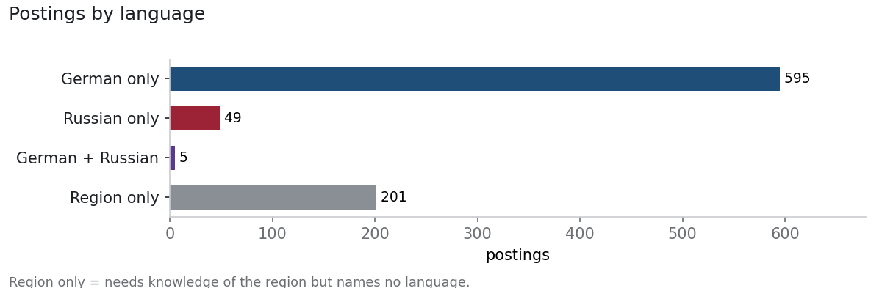
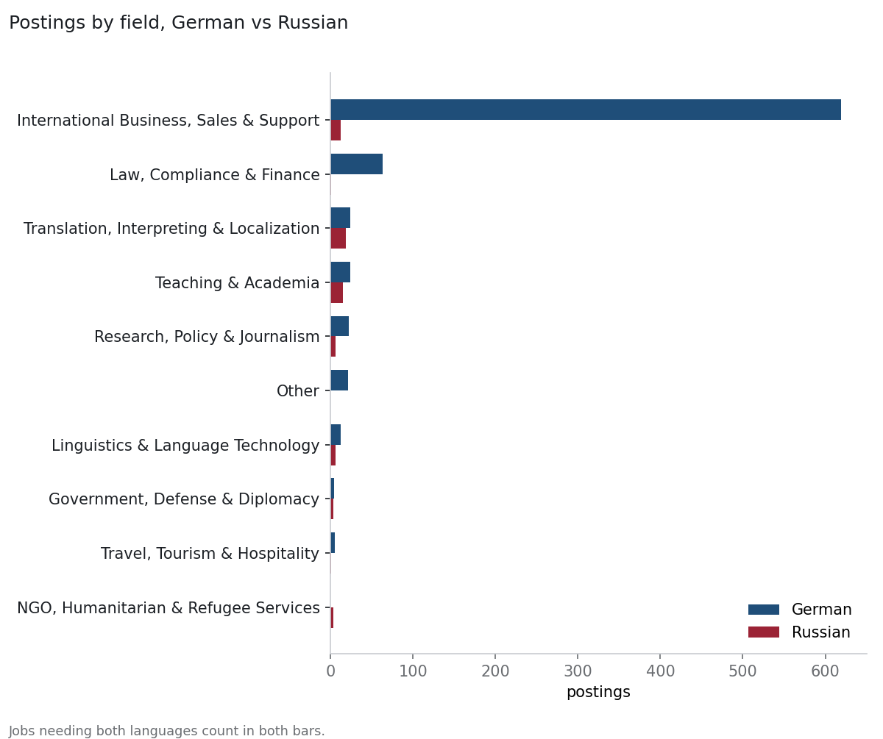

German
Postings that need German, or knowledge of Germany, Austria and Switzerland, across translation, teaching, international business, government and language technology.
- 794 current postings use German; in 395 the language is required or named in the job title.
- The largest field is International Business, Sales & Support (619 postings).
- Most postings are in Germany, —, Remote.
- 718 of 794 postings don't ask for a graduate degree.
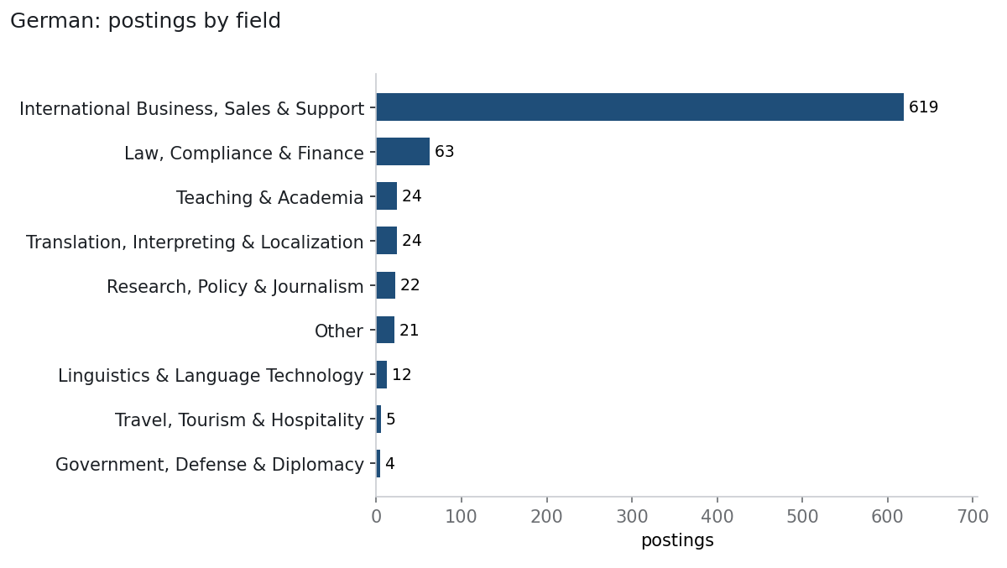
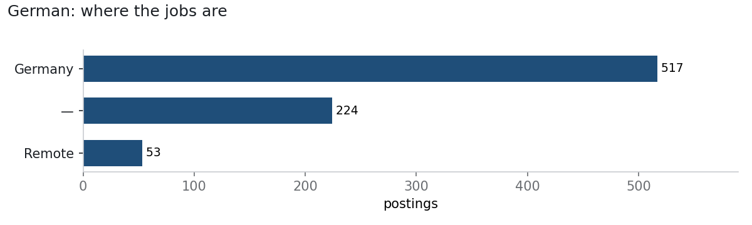
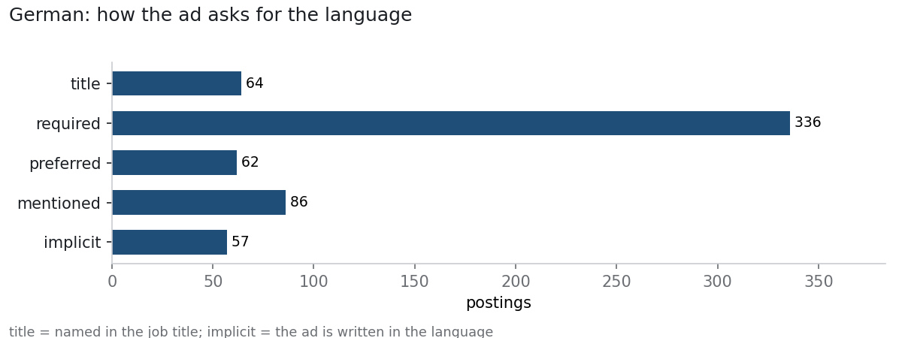

International Business, Sales & Support
619 postings · US median — · top employers: celonis (100), hellofresh (37), sumup (17), n26 (13)
- Junior Account Executive, Enterprise - German speaker — 1Global (DE)
- (Strategic) Account Executive - Retail / CPG — celonis ()
- AI & Management Consulting Intern (Value Engineering - DACH Market) — celonis ()
- Account Executive - Public Sector Germany - Defense (Bundeswehr) — celonis ()
- Account Executive - Public Sector Germany - Police (Polizei) — celonis ()

Law, Compliance & Finance
63 postings · US median — · top employers: n26 (10), SwissPeak Partners GmbH (6), Wavestone Germany AG (5), Callista Group AG (4)
- Senior Legal Counsel Banking Law — n26 ()
- Commercial Legal Counsel, EMEA — Airwallex (DE)
- KYC EDD Operations Agent (German) — sumup ()
- Praktikant/in M&A / Transaction Services (100%) — Forvis Mazars (DE)
- Senior AML/CFT Compliance Officer — RULEMATCH AG (DE)

Teaching & Academia
24 postings · US median — · top employers: Nachhilfeunterricht (4), FindTutors (2), The University of Texas at Austin (1), Scripps College, Department of German Studies (1)
- The University of Texas at Austin - Assistant Professor in Applied Linguistics – German – Department of European and Eurasian Studies — The University of Texas at Austin ()
- Visiting Assistant Professor in German Studies Fall 2027/Spring 2028 — Scripps College, Department of German Studies ()
- German Tutor for Arabic Speakers – Flexible Hours | Online & In Person — Nachhilfeunterricht (Remote)
- Cornell University - Assistant/Associate Teaching Professor — Cornell University, Department of German Studies ()
- Research Associate (m/f/d) - Language Teacher in the Modern Foreign Languages Program Area. Teacher at the Language Center specializing in Russian, Spanish and other Romance languages — RWTH Aachen University, Sprachenzentrum ()

Translation, Interpreting & Localization
24 postings · US median — · top employers: hellofresh (2), ANGEHEUERT GmbH (2), Novar Nederland BV (2), Gaia, Inc. (1)
- German Language Lead — Gaia, Inc. ()
- Übersetzerin / Übersetzer (m/w/d) Ukrainisch mit Russisch — Bundessprachenamt (Federal Office of Languages) ()
- 🌍 Lingtopia is hiring: Remote Polish, German & Turkish Medical Interpreters — Lingtopia ()
- Projektentwickler:in Cooperations & Development – BESS /Wind /PV (Deutschland) (m/w/d) — Tion Services GmbH (DE)
- (Senior) Oracle Data Warehouse / BI-Developer (m/w/d) — virtual7 GmbH (DE)

Research, Policy & Journalism
22 postings · US median — · top employers: SwissPeak Partners GmbH (4), hellofresh (3), dkbcodefactory (1), capco (1)
- Junior UX Researcher (x,f,m) — dkbcodefactory (DE)
- Senior Business Analyst* – Wealth Management & Advisory Platforms — capco (DE)
- Business Process Risk Analyst Trading Desks IB — coni+partner AG (DE)
- Senior Data Scientist, MNO Data — GiveDirectly (Remote)
- Junior Recipe Developer (all genders) — hellofresh ()

Other
21 postings · US median — · top employers: MY Humancapital GmbH (8), PraxisEins (2), Hywax GmbH (1), Armstark Handels-GmbH (1)
- HR Generalist / Personalreferent (m/w/d) & Services — Hywax GmbH (DE)
- Produktmanager / Qualitätsmanager (m/w/d) — Armstark Handels-GmbH (DE)
- HR Generalist (m/w/d) — MY Humancapital GmbH (DE)
- Berechnungsingenieur Strukturanalyse (m/w/d) — MY Humancapital GmbH (DE)
- German Speaker Wanted – Flexible Teaching Role — Tusclasesparticulares (Remote)

Linguistics & Language Technology
12 postings · US median — · top employers: Welo Global (5), Invisible Technologies (2), Concordia Language Villages (1), mercor (1)
- English to German (Germany or Switzerland) Linguist & Copy Editor for Product, M — Welo Global (Remote)
- AI Trainers Network - German — Welo Global (Remote)
- German Cultural & Language Specialist — Concordia Language Villages ()
- German Language Specialist - Freelance AI Trainer Project — Invisible Technologies (Remote)
- German Language Specialist - Fully Remote | Upto $50/hr — mercor (Remote)

Travel, Tourism & Hospitality
5 postings · US median — · top employers: TripActions (2), SwissPeak Partners GmbH (2), Roadsurfer (1)
- Business Travel Consultant (Berlin or Remote) (Geschäftsreiseexperte) — TripActions (Remote)
- Business Travel Consultant - German — TripActions (Remote)
- NÜRNBERG - Standortleitung (m/w/d) — Roadsurfer (DE)
- Senior Network Engineer — SwissPeak Partners GmbH (DE)
- IoT Embedded Systems Engineer — SwissPeak Partners GmbH (DE)

Government, Defense & Diplomacy
4 postings · US median — · top employers: MARGO (2), Netlight (1), Comand Ai (1)
- Working Student - Talent Acquisition — Netlight (DE)
- Business Strategist - DACH — Comand Ai (DE)
- Data Scientist | Machine Learning Engineer – Practice IA MARGO — MARGO (DE)
- DevOps - H/F — MARGO (DE)

Russian
Postings that need Russian, or knowledge of Russia, Ukraine, the Caucasus, Central Asia and the Baltics, across government, translation, research and policy, NGOs and teaching.
- 66 current postings use Russian; in 52 the language is required or named in the job title.
- The largest field is Translation, Interpreting & Localization (19 postings).
- Most postings are in —, Remote, Germany.
- 54 of 66 postings don't ask for a graduate degree.
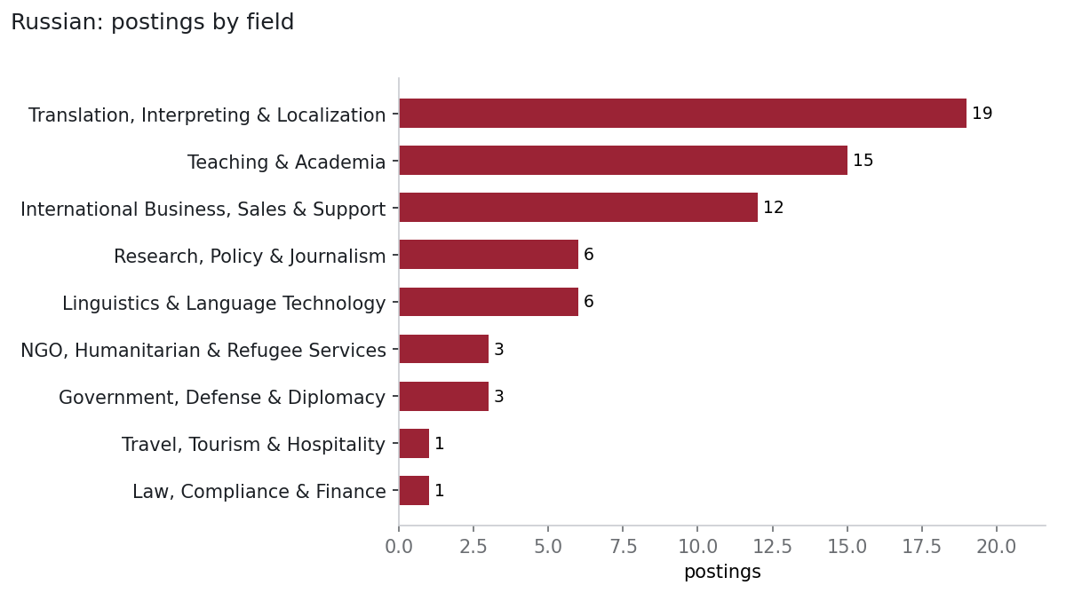
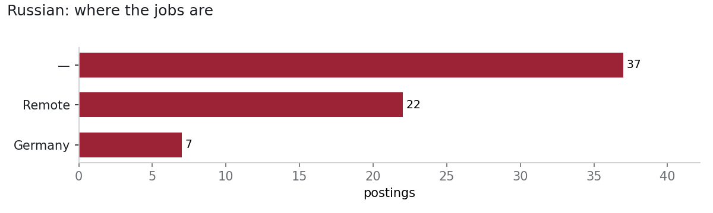
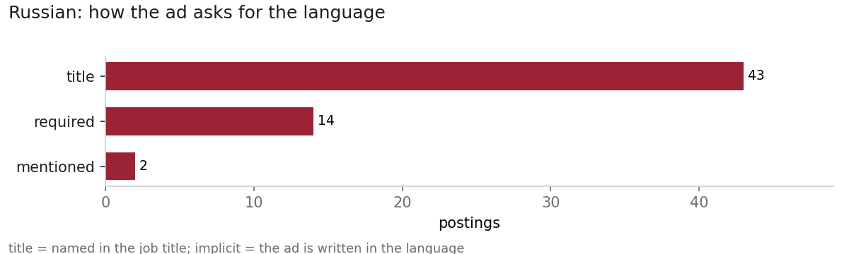

Translation, Interpreting & Localization
19 postings · US median — · top employers: AetherCore (5), ContactLink Solutions (3), UNFPA - United Nations Population Fund (1), Bundessprachenamt (Federal Office of Languages) (1)
- UNFPA EECARO : Russian-English Interpreters and Translators Roster — UNFPA - United Nations Population Fund ()
- Übersetzerin / Übersetzer (m/w/d) Ukrainisch mit Russisch — Bundessprachenamt (Federal Office of Languages) ()
- Bilingual Russian-English Interpreter-Work from Home — AetherCore (Remote)
- Experienced Native Russian Translators (Finance & Payments) — Language Bear (Remote)
- Freelance Translators - Russian to English - Neurology — Ulatus (Remote)

Teaching & Academia
15 postings · US median — · top employers: Binghamton University (SUNY), Department of German and Russian Studies (1), RWTH Aachen University, Sprachenzentrum (1), ICA Language Services (1), The University of Hong Kong (1)
- Assistant or Associate Professor of Russian Studies — Binghamton University (SUNY), Department of German and Russian Studies ()
- Research Associate (m/f/d) - Language Teacher in the Modern Foreign Languages Program Area. Teacher at the Language Center specializing in Russian, Spanish and other Romance languages — RWTH Aachen University, Sprachenzentrum ()
- Russian Language Instructor - DLIFLC Monterey — ICA Language Services ()
- The University of Hong Kong - Lecturer in Russian and Turkish (Global and Area Studies) in the School of Modern Languages and Cultures — The University of Hong Kong ()
- Visiting Assistant Professor — University of Kansas, Department of Slavic, German, and Eurasian Studies ()

International Business, Sales & Support
12 postings · US median — · top employers: micro1 (1), Elastic (1), United Nations, Department of Global Communications (1), Maximus (1)
- Russian Bilingual Expert — micro1 (Remote)
- Junior Public Sector Account Executive — Elastic (DE)
- News Writing / Reporting - Public Information Intern - News and Content - Russian — United Nations, Department of Global Communications ()
- Bilingual Russian Customer Service Representative (Remote - New York, NY) — Maximus ()
- Strategic Account Executive (Eastern Europe) — Pingidentity (DE)

Research, Policy & Journalism
6 postings · US median — · top employers: Radio Free Europe/Radio Liberty (RFE/RL) (3), Language Bear (1), OSCE Office for Democratic Institutions and Human Rights (ODIHR) (1), Civitta (1)
- Investigative Journalist – Russian Investigative Unit, Riga — Radio Free Europe/Radio Liberty (RFE/RL) ()
- Journalist, North Caucasus Unit — Radio Free Europe/Radio Liberty (RFE/RL) ()
- Experienced Native Russian Editors (Finance & Payments) — Language Bear (Remote)
- Associate Gender Officer (P2) — OSCE Office for Democratic Institutions and Human Rights (ODIHR) ()
- Senior Social Media Editor, Riga — Radio Free Europe/Radio Liberty (RFE/RL) ()

Linguistics & Language Technology
6 postings · US median — · top employers: Portland State University, Department of World Languages and Literatures (1), Altamira Technologies Corporation (1), CACI (1), Invisible Technologies (1)
- Russian Flagship Program Coordinator — Portland State University, Department of World Languages and Literatures ()
- Russian Language Crypto-Linguist — Altamira Technologies Corporation ()
- Russian Linguist — CACI ()
- Russian Voice Actor - Freelance AI Trainer Project — Invisible Technologies (Remote)
- Russian Operational Language Analyst — SOSi ()

NGO, Humanitarian & Refugee Services
3 postings · US median — · top employers: MSF International - Médecins Sans Frontières (1), IRC - International Rescue Committee (1), IREX (1)
- Humanitarian Representative - Russia — MSF International - Médecins Sans Frontières ()
- Caseworker (Ukrainian or Russian speaking) — IRC - International Rescue Committee ()
- Program Officer — IREX ()

Government, Defense & Diplomacy
3 postings · US median — · top employers: Elastic (1), Comand Ai (1), Bundesnachrichtendienst (Federal Intelligence Service) (1)
- Senior Information Security Infrastructure Engineer - Security Architecture - InfoSec — Elastic (DE)
- Business Strategist - DACH — Comand Ai (DE)
- Mitarbeiterinnen/Mitarbeiter (w/m/d) für die Auswertung, AS-2026-170 — Bundesnachrichtendienst (Federal Intelligence Service) ()

Travel, Tourism & Hospitality
1 postings · US median — · top employers: Ulatus (1)
- Freelance Translators - English to Russian - Travel and Tourism — Ulatus (Remote)

Law, Compliance & Finance
1 postings · US median — · top employers: sumup (1)
- (Senior) Backend Engineer (Golang) - Bank — sumup ()

Tips for students
- Name your proficiency precisely on the resume: CEFR level (B2, C1), ACTFL OPI rating, or ILR level.
- Pair the language with a second skill employers search for: data, writing and editing, business, teaching licensure, or a security clearance path.
- Many of the best jobs never post to aggregators: check the Search-by-hand list (federal careers, UN and EU, Goethe-Institut, DAAD, American Councils).
- A semester abroad, an internship, or translation samples count as experience; list them as such.

Search these by hand
- LinkedIn Jobs — Search 'German speaking' / 'Russian speaking'; export and use --import
- Indeed — Same searches; also de.indeed.com
- StepStone (DE) — Largest German private board
- XING Jobs — German professional network
- Make it in Germany — Official portal for international applicants
- Bund.de / Interamt — German federal and state public-sector jobs
- EURES — EU job mobility portal
- EU Careers (EPSO) — EU institutions; German is a working language
- UN Careers — Russian is a UN official language (translators, interpreters, précis-writers)
- Impactpool — UN agencies, OSCE, development banks
- OSCE Jobs — Vienna HQ and field missions in Eastern Europe/Central Asia
- NATO Careers —
- Devex — International development
- careers.state.gov — Foreign Service; Russian is a hard-language incentive
- IntelligenceCareers.gov — NSA, CIA, DIA language analysts
- FBI Jobs (Language) — Contract linguists and language analysts
- USAGM / RFE/RL / VOA — Russian- and German-service journalism
- American Councils — Exchanges and language programs in Eurasia
- IREX — Education and media development, Eurasia
- CRDF Global — Science diplomacy, nonproliferation
- Goethe-Institut — German teaching and culture
- DAAD — Academic exchange
- Fulbright ETA (Germany, Austria) — English teaching assistantships
- CIEE — Study abroad and exchange
- MLA Job List — German and Russian faculty positions
- ASEEES Jobs — Slavic, East European & Eurasian studies
- AATSEEL — Slavic teachers' association job list
- AATG — German teachers' association
- H-Net Job Guide — Humanities and area-studies academic jobs
- ProZ.com — Freelance translation (DE/RU pairs)
- ATA — American Translators Association; certification
- Wilson Center / Kennan Institute — Russia/Eurasia research
- hh.kz / hh.uz — Central Asia jobs (Russian-language); check employer and sanctions rules

