Prediction of dopaminergic response in Parkinson‘s Disease patients using surface Electromyography

### Authors:

1Urs Kleinholdermann, Max Wullstein, David Pedrosa

1 Klinik für Neurologie, Universitätsklinikum Gießen und Marburg, Standort Marburg, Baldingerstr., 35041 Marburg

### Correspondence to:

Dr. med. David Pedrosa, Klinik für Neurologie, Universitätsklinikum Gießen und Marburg, Standort Marburg, Baldingerstr., 35041 Marburg, Tel: +49 (0)6421 – 58 2490 email: [david.pedrosa@staff.uni-marburg.de](mailto:david.pedrosa@staff.uni-marburg.de)

### Abbreviated title: XXX

|  |  |  |
| --- | --- | --- |
| Target-Journal | Word count | References: |
| XXX | Abstract: XXX; Manuscript: XXX; Figures: X; Table: X | XX |

# Abstract

XXX

### Key words:

Idiopathic Parkinson syndrome, wearables, surface electromyography, Regression, Machine Learning, levodopa, UPDRS

# Abbreviations

EDC – *Musculus extensor digitorum communis*

FDS – *Musculus flexor digitorum superficialis*

EMG – Electromyography

IMU – Inertial measurement unit

iPS – idiopathic Parkinson Syndrome

PCA – Principal component analysis

UPDRS – Unified Parkinson’s Disease Rating Scale

# Introduction

Parkinson’s disease (PD) is a neurodegenerative disorder in which affected subjects develop bradykinesia with additional rigidity, tremor or a combination thereof (Postuma et al. 2015) A pronounced asymmetry, relatively slow progress and response to dopaminergic medication indicate idiopathic Parkinson's syndrome while lack of any of these indicate atypical syndromes. Especially significant levodopa response is of paramount importance, as it allows the possibility of medical treatment.

Extrapyramidal motor symptoms in PD result from dopaminergic depletion of neurons in the *Substantia nigra.* Consecutive dysregulation of interactions between basal ganglia and cortical areas determine disease progression fundamentally (Poewe et al. 2017). Motor affection is highly individual and requires regular clinical assessment for satisfactory medical or invasive treatment. Yet, pharmacokinetics and drug interactions may hamper objective and long-lasting assessments (Nutt et al. 2008). Moreover, as the disease progresses fluctuations of dopaminergic treatments may impede finding the right dosages of medication (Quelle?). Phases with good ("ON") and poor mobility ("OFF") may then alternate rapidly, which is perceived as highly disturbing and often results in complicated medication schedules (Stocchi et al. 2008). Precise temporal assessment of bradykinesia or tremor during the course of PD would facilitate tailored therapies.

The severity of PD is usually quantified with the Unified Parkinson's Disease Rating Scale (UPDRS, Goetz et al. 2007). Yet its application only provides a snapshot of the symptoms and may thus be insufficient and misleading, especially for patients suffering from fluctuations. Besides, the assessment is resource-intensive and interrater-reliability is considerable, especially for unexperienced examiners (Goetz et al. 2004). Patient diaries, on the other hand, allow quick and regular assessments at low expenses but at the cost of subjective assessments due to anosognosia of PD-symptoms (Maier et al. 2017). Modern sensors and mobile technologies are gaining importance for continuous determination of symptom severity with objective results.

The spread of smart phones and watches has facilitated recording continuous movement profiles. The majority of commercially available devices already contain an accelerometer and a gyroscope, so that data collection is fairly easy and unobstrusive. Great efforts are being undertaken to use these wearables in healthy subjects but also in PD-patients (for reviews see Rovini et al. 2017 and Kleinholdermann et al. 2019). In the remaining article, we present an approach to measure PD-patients’ changes in motor disability via wireless surface EMGs (sEMG) after levodopa intake. We postulate that prediction of UPDRS changes and therefore easily applicable monitoring of motor affection and therapeutic effects is possible using sEMG. For this purpose, 40 PD-patients were recorded in the OFF- and ON-condition during a tapping task. Different regression models were applied and then tested for the ability to predict clinical changes in motor symptoms. To validate our results, five additional subjects were tested and the UPDRS model prediction was matched to the clinically evaluated scores.

.

# Methods

The study was approved by the local Ethics committee and carried out in accordance with the Declaration of Helsinki. All patients had given their written informed consent prior to participating.

### Patients and clinical evaluation

In total, 45 PD-patients according to recent diagnostic criteria (Postuma et al. 2015) were recruited from in- and outpatient services of a tertiary care hospital. Motor symptom burden ranged from mild to severe (for demographics and clinical details see Table 1). The aim of the study was to analyse interindividual differences between OFF and ON states, that is when medication was washed out and after levodopa intake, respectively. Motor affection was assessed in both conditions by two experienced raters with the MDS-UPDRS (Unified Parkinson’s Disease Rating Scale, Goetz et al. 2008) using video recordings.

The first forty patients served as a test group, for which relationships between changes in UPDRS and those in sEMG-derived features were first trained and later tested. To test for external validity, five additional PD-patients were recruited and regression performance was tested separately on them.

### Experimental setup

Participants were seated in an armchair with backrest. The motor paradigm consisted of a simple tapping task, i.e. subjects were asked to tap with the index finger of the more affected side on a table as quickly as possible. The task was started by a signal on a notebook screen at a distance of approximately 60 cm with a countdown of 3 secs. The tapping interval lasted 5 secs following the display of a green cross. After 18 repetitions in the OFF-condition, patients were asked to take 100-200mg Levodopa in a soluble formulation (approximately 1.5 times the morning dose) and the test was repeated 60-90 minutes later (termed hereafter the ON-condition). For the OFF-condition subjects were asked to discontinue dopaminergic medication for at least 12 hours

All data was recorded by using a commercially available armband (Myo Gesture armband, Thalmic Myo Labs), which records eight concentrically arranged sEMGs along with kinetographic data. For this study only the sEMG was analysed. The armband was placed 3 cm distal from the elbow with contact four (marked by an LED) on the tendon of the *M. extensor digitorum communis* (EDC, for a schematic see Figure 1). Data was sampled at 200 Hz using the included software development kit (SDK) in combination with custom Matlab scripts (Mathworks).

### Pre-processing and feature extraction

Data was extracted and cut into epochs of 8 secs. Thereafter, visual inspection ensured that no artifacts were present and that activity corresponded to the tapping task. Consequently, data was high-pass filtered with a cutoff frequency of 10 Hz (Butterworth filter of 3rd order) and an adaptive notch-filter at 50 Hz to reduce main grid interference. From preprocessed sEMG signals (see below), data features were extracted. A moving window of 100 samples (~500 ms) and steps of 250 ms was used during the above calculations. All analyses are developed from works of Kaczmarek et al. (2019).

### Feature sets and splitting

Three distinct features sets were used: a) Hudgins’s (Hudgins et al. 1993), b) Du’s (Du et al. 2010) and c) root mean square (RMS) of sEMG data. This choice represents some of the most frequent features currently used for EMG classification [Hakonen et al. 2015, Phinyomark et al. 2012]. Hudgins’ feature vector consists of the Mean Absolute Value (MAV), Zero Crossings (ZC), Waveform Length (WL) and Slope Sign Change (SSC). Former studies have proven a high insensitivity to window size and computational complexity is rather low [Oskoei et al. 2008]. Du’s feature set comprises integrated Electromyogram (iEMG), sEMG variance (VAR), WL, ZC, SSC and Willison Amplitude (WAMP). It has been reported to perform more accurate than Hudgins’ set [Phinyomark et al. 2012]. Even though Hudgins’ and Du’s sets are computed in the time domain, they represent amplitude, frequency, and complexity of the signal [Hakonen et al. 2015]. Formulae of the metrics can be found in the Supplementary material.

Data of every subject was divided into training and test datasets (ratio = .2), and 10-fold validation splits were used to provide more accurate results.

## Regression models

The main goal of this study was the regression of changes between ON- and OFF in the UPDRS on changes in the extracted features. Different forms of regression were compared: a) linear regression, b) Lasso Regression, c) Support vector machine regression (SVR) with a Gaussian kernel function, d) SVR with a polynomial kernel function and k-nearest Neighbours Algorithm (kNN). Hyperparameters were tuned using a “grid search” to minimise mean squared error using the *sklearn* package (Pedregosa et al. 2011). Besides, principal component analyses were used according to the high colinearity (see Figure 1).

# Results

## Clinical data

In total 45 patients (10 female) at an age of 61.1 ± 9.6 years suffering from iPS for 6.6 ± 4.1 years and with a mean Hoehn and Yahr stage of 2.8 ±1.3 were included. Without medication, subjects had on average 46.0 ± 22.6 points on part III of the MDS-UPDRS and levodopa equivalence dose (LEDD) was 731.6 ± 561 mg (Tomlinson et al. 2010). Clinical details are displayed in Table 1. For the training and test dataset 631 recordings were included, which were subjected to 10-fold cross-validation. For the validation on an independent dataset, xxx recordings of five additional subjects were included.

Table 1: Demographics and clinical data

|  |  |
| --- | --- |
| N | 40 |
| Gender' | 10 female |
| Age [in years] | 61.18 ± 9.61 |
| Levodopa equivalent dose [in mg] | 731.6 ± 561.5 |
| Hoehn & Yahr stage | 2.8 ± 1.3 |
| Disease duration [in yrs] | 6.6. ± 4.1 |
| UPDRS OFF | 46.00 ± 22.57 |
| UPDRS ON | 35.53 ± 20.26 |

### Feature regression

The armband recorded eight different channels, of which only three were related to active superficial muscles during tapping – M. extensor digitorum communis (EDC) and M. flexor digitorum superficialis (FDS). Hence, only channels 4, 5 and 8 were selected for further analysis. Figure 1 displays the correlation between all features used in this study. As a metric for the regression performance we calculated the root mean squared error (RMSE, see Figure 2.). Using a two-way ANOVA we found significant main effects for regression method and feature set but also for the interaction (all <0.001). *Post-hoc* tests using Tukey HSD method showed no significant difference between linear regression, lasso regression and SVR-poly regression but significant differences for all other regression method comparisons (all familiy-wise error corrected  < 0.001). kNN-regression showed the smallest errors and thus predicted changes in UPDRS due to medication using the changes in sEMG features most accurately. For the feature set post-hoc comparisons there was no advantage in using Dus or Hudgins feature-set, yet , both exceeded significantly using solely RMS ( < 0.001). Moreover, there was very high correlation of true and predicted UPDRS values using kNN regression using Du’s (r=.959) and Hudgins (r=.957) feature sets, respectively. The identified hyperparameters providing the best results for kNN-regression were .

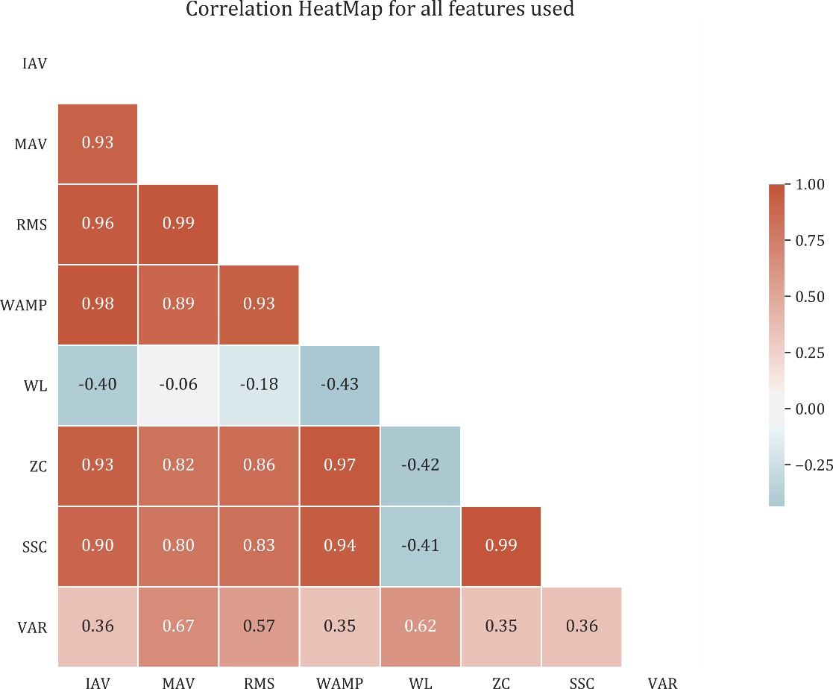

Figure 1: Correlation between the extracted features for iPS patients during tapping task. There was moderate to high correlation between the features at all conditions.

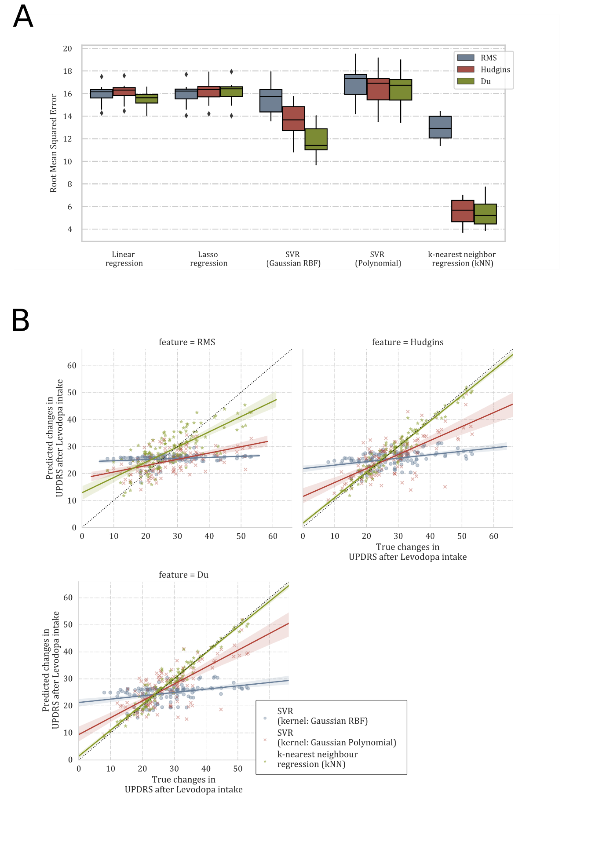

# Discussion

We show that features derived from sEMG during a tapping task may be useful for predicting PD-patients’ response to levodopa. By subjecting these features to different regression techniques, we demonstrate a correlation between changes in sEMG activity and changes in UPDRS scores. For that purpose, ‘machine learning’ techniques were applied and results evaluated using cross-validation. External validity and relevance of our findings was determined in a set of PD-patients unrelated to test or validation data.

A growing body of evidence supports the usefulness of mobile sensors for parkinsonian patients. Hence machine learning approaches have been used for diagnosing PD (). Nevertheless, to date no consensus exists about the best marker neither for diagnostic purposes nor for tracking the disease course. Surface EMG may be one candidate, as it may successfully discriminate PD-patients form healthy control subjects (Jia et al. 2014, Eskofier et al. 2016, Djurić-Jovičić et al. 2016). To our knowledge this work shows for the first time that clinical ratings of PD-patients correlate with sEMG features, demonstrating its suitability for tracking therapeutic effects. Particularly, the meticulous clinical testing including withdrawal of medication and video-based UPDRS scoring, along with a relatively high number of participants indicate reliable results. Recorded continuously, our approach may thus help to quantify treatment success or the need for therapy adaptation and, therefore, offer opportunities to reduce side-effects and to lower hospitalisation rates (Quelle??). Nevertheless, before establishing wearables as markers measuring therapeutic success, questions about practicability and possible alternatives to sEMG need to be addressed first.

Surface EMGs comprise easy applicable and non-invasive recordings of muscular activity. Yet several problems may be contemplated in future studies. First, it remains unclear if distinct EMG derived data could be more specific. We restricted our analyses to standard sEMG features (Phinyomark et al. 2012) to test for feasibility. The high redundancy demonstrated in PCA results indicate that simpler feature combinations might perform comparably. Another important aspect worth mentioning is that generalisability in terms of PD-subtypes remains to be ascertained, given the distinct phenotype and clinical course of tremordominant vs. bradykinetic-rigid patients (Eggers and Pedrosa et al. 2012). Most importantly, however, is the question about the use for everyday life. Correct and reliable placement of the armband used in this study is of paramount importance for comparability. Future sEMG studies data could consider smart clothes (Niazmand et al. 2011) or gloves as alternative source of data (Rovini et al. 2017) to overcome this issue. In a similar vein, despite our excellent prediction of UPDRS changes with sEMG features during a tapping task, it remains to be elucidated whether tasks closer to everyday-life may be similarly useful yet less artificial. In this context, Block et al. showed the possibility of classifying ON and OFF phases and predicting falls based on PD-patients’ walking (Block et al. ??). That being said, measuring kinetographic data may be a feasible alternative to sEMG as well. With the incursion of these easy to apply sensors and ubiquitously present devices, collection of several symptoms could be possible, which could provide a more holistic picture of the symptoms PD-patients suffer from (Quelle??).

In summary, we have identified sEMG features and their use along with a nearest neighbour regression techniques to predict PD-patients’ decrease in motor disability after levodopa intake. With a relatively high sample of PD-patients suffering from a varying severity, accurate predictions were possible even in subjects not being present in the test dataset. This precludes the possibility of overfitting and corroborates the use of our results for predicting motor disability with commercially available sEMG. Hence, we lend considerable support to the notion that peripheral sensor data may be used for tailored therapies for PD in a future.

# Tables and Figures:

**Table** 2**:** General demographics for iPS patients

**Figure 1:**

# Acknowledgements

We are grateful to all of the study participants for their patience and cooperation.

### Documentation of authors’ roles:

Urs Kleinholdermann participated in the conception and organization of the research project, the programming of the motor paradigms, the data assessment and data analysis, the conception and execution of the statistical analysis and the writing and critical review of the manuscript.

Max Wullstein participated in the organization and execution of the research project, the data assessment and data analysis, the execution of the statistical analysis and the writing of the manuscript.

David J. Pedrosa participated in the conception, organization and execution of the research project, the programming of the motor paradigms, the data assessment and data analysis, the conception and execution of the statistical analysis and the writing and critical review of the manuscript. Moreover, he had full access to all of the data in the study and takes responsibility for the integrity of the data and the accuracy of the data analysis.

### Conflict of Interest statement/Financial disclosure:

U.K. reports no conflicts of interest

M.W. reports no conflicts of interest

D.J.P. reports no conflicts of interest

Apart from the above, the authors report no financial conflict of interest and do not have to disclose any commercial considerations, such as an equity interest, patent rights, or corporate affiliation, including consultantships, for any product or process mentioned in the submission.

# References

XXX

Supplementary Material

### Definition of the features used throughout this paper:

* The integrated amplitude (IAV) of the sEMG expressed as summation of its absolute values’ amplitude:
* Mean absolute value (MAV) as an average of absolute values of the signal in a specific segment:
* Root Mean Squared (RMS), which can be defined as:
* Variance (VAR) of the sEMG as a metric for power, which may be defined as:
* Variance (VAR) of the sEMG as a metric for power, which may be defined as:
* Variance (WL) of the sEMG as a metric for power, which may be defined as: