# Implementation and testing of an energy-conserving viscoelastic DEM contact model

D. Peinado1,3, C. Kloss2

1 Intrame SA, Madrid, Spain

2 Christian-Doppler Laboratory on Particulate Flow Modelling, JKU Linz, Austria

3 UC3M, Madrid, Spain

# Abstract

This paper considers the implementation of a Discrete Element Method (DEM) contact model. The model we propose is a viscoelastic contact model with a constant coefficient of restitution and is termed XXX model. It is know that most of the DEM models used in literature suffer from problems regarding energy conservation. The simple problem of an oblique binary collision between two particles is used to study the energy conservation. It is shown that the XXX model conserves total energy, irrespective of the ratio between normal and tangential spring stiffness. We compare the performance against the simple HM model

**Keywords:** Particle Simulation, Discrete Element Method, Contact Mechanics, …

# Nomenclature

XXX…

# Introduction

Granular flows are of great importance in nature and to process industry (Bates, 2006; Ennis, 2004). There are two main strategies to model granular flows: The continuum approach (e.g. (Rao and Nott, 2008). considers the bulk of particles as an artificial continuum. It is based on the solution of conservation equations, using finite volume or finite element techniques. Naturally, this approach does not account for the local behaviour of the individual particles. In general, such continuum models are derived for a specific flow regime (rapid granular flow, slow granular flow). Despite of a long tradition in continuum models for granular flow, some aspects are still poorly understood (Campbell, 2006).

The second modelling approach simulates the motion of each particle (or a set of representative particles) individually, with a detailed handling for collisions. Most prominently, the ‘Discrete Element Method’ (DEM) is an emerging method to simulate the behavior of granular materials. Originally proposed by Cundall and Strack (1977), it is widely applied to model granular flow and coupled fluid granular flow, including chute flow, hopper flow, bulk solids handling, pharmaceutical processes, geomechanical flows, fluidized beds, pneumatic conveying, heat transfer in industrial vessels (Chaudhuri et al, 2006), material sintering (Luding, 2005).

Particle non-sphericity is an important topic to be addressed. Multiple approaches exist, such as using superquadric particle shapes (Cleary, 1997), or to use triangulated particles (Poeschel and Schwager, 2005). The multi-sphere approach considers a non-spherical particle as a clump of multiple spheres (Kruggel-Emden et al, 2008).

In order to extend the applicability of the DEM to large-scale industrial processes, coarse graining schemes have been proposed (Bierwisch, 2009). Also, thanks to advancing computational power, the DEM has become more and more accessible lately. On actual desktop computers, simulations of up to a million particles can be performed. On clusters, the trajectories of hundreds of millions of particles can be computed (Plimpton; Walther and Sbalzarini, 2009). Also, spearheaded by the field of molecular dynamics (Stone et al., 2010) GPU implementation is being employed for DEM simulations (e.g. Xu et al, 2011).

Despite of these versatile fields of application of DEM, some basic aspects of contact modelling are still being discussed in literature. We will now give an overview of contact modelling approaches. For the sake of simplicity, we will restrict ourselves to spherical particle shapes.

# Review of DEM contact models and discussion of energy conservation

It is widely recognized (Thornton et al, 2011; 2nd REFERENCE) that the elastic contact of two spheres is well described by the theory of Hertz (1882) for the normal direction in combination with the work of Mindlin and Derecewiezc (1953) for the tangential direction. This model is often termed HMD model in the literature.

Many simpler models with less computation effort have been proposed in the literature, such as

*****

Described Viscoelastic vs. hysteretic models

Linear spring model etc

*****

However, these models suffer from numerical issues. Regarding the normal force in the simple linear spring-dash-pot model, the damping force may be larger than the elastic repulsion force, resulting in artificial particle attraction - this is called the artificial force effect (Pöschel and Schwager, 2005). Techniques to overcome this have been proposed for the linear spring-dashpot model (Schwager and Poeschel, 2007) and for the non-linear Hertz law (Schwager and Poeschel, 2008)

Regarding the tangential force, it is know that most of the simple DEM models used in literature suffer from problems regarding energy conservation. This is due to the fact that the energy that is stored in the tangential spring is ‘lost’ as soon as the particles lose contacts.

A remedy that is often suggested in literature (Deen et al, 2007; Thornton et al, 2011) is to choose the ratio of tangential to normal spring stiffness,  so to match the contact times for normal and tangential contact, i.e. the tangential spring is completely unloaded at the time that the particles loose contact. This technique will work well in the regime of binary collisions (e.g. in fluidized beds). However, it is obvious that for multi-particle contacts this strategy is no longer feasible, as the contact times do not obey a simple analytical solution, so in general the tangential spring will be loaded at the time that the particles loose contact.

Cite examples for different ways of handling slippage:

|fs|<µ Fn eg edem

|fe|<µ Fn eg lammps

Some approaches use the total tangential force for this criterion (Silbert et al, 2002a; Sandia, 2011). Others use only the elastic part (e.g. DEM Solutions, 2008)

* 1. Discussion of energy conservation

The problems with energy conservation for the simpler DEM models are often not addressed because granular systems are dissipative and such behaviour is often not considered a problem for bulk systems.

For some cases, it is not ok – show examples (pathological cases integral HM model)

If a non-linear contact model is used, the tangential force must be updated incrementally. This is owed to the fact that the stiffness of the tangential spring changes during the contact as a consequence of the varying normal force.

.

To keep track of the different energy terms accurately, it is necessary to model sub-step for the time-step slip will occur.

How to track energy terms? Split t in 2 terms: deformation t,d and slippage t,s, in general it can be written , being the former the actual elastic deformation of the materials, and the later the slippage between both surfaces.

Granular matter is modelled as a macroscopic system composed by granules that are themselves composed by molecules. We will focus on the macroscopic description, so we will analyze the macroscopic kinetic (translational and rotational), and potential (gravitational, electrostatic, etc ...) energies. The microscopic energies are grouped in the internal energy comprising the thermal and the elastic potential terms.

The energy is transferred between particles by collisions. Some of the macroscopic kinetic energy is redistributed among the particles participating in the collision, some other is stored as elastic potential energy during the collision (it is a microscopic term, but it can be modelled as macroscopic), and another part is transformed or dissipated (as this part disappears from the macroscopic description) into other forms of internal energy, mainly thermal energy.

We will track the following terms: translational and rotational kinetic energy, normal potential energy, work done by the tangential elastic forces, viscous dissipated energy associated with normal deformation, viscous dissipated energy associated with tangential dissipation, and frictional dissipated energy associated to tangential slippage.

The kinetic and gravitational terms are obvious, and the interaction terms are computed as follows for each interaction between particles:

, for LM and for HM.

# The proposed model (How shall we call it?)

* 1. Normal force model.

Describe the normal force model.

* 1. Tangential force model.

The force calculation is made in an incremental way for both the linear and the non linear spring model.

The tangential deformation in the contact patch is modelled (Brendel and Dippel 1998) as:

In the numerical implementation we have as the previous tangential deformation in the contact patch, and related to this value, the elastic tangential force, stored in the incremental Hertz-Mindlin model, and calculated as in the Linear Model

In the new time step, the tangential displacement increment is given by . The tangential force increment on the contact patch is composed by the elastic and the viscous terms.

The values for the new time step are:

This holds if . Then there is no slipping in all the new time step, and then , and .

The contribution for the energy terms associated to this time step are:

The next step is the substep determination of where the slippage begins. If , but it was in the previous step, somewhere in between the slippage would begin (there is a case in which the slippage begins from the very first moment as we will see later-reference to subsection). It is also worth to note that in this new time step, the would have changed in general as can be positive, negative or zero. Also in the non linear model, the value of would have changed too.

As in the figure 1 is shown, if the current methods are used, then direction of the new tangential force would be the same than the one obtained if the slippage would not have occurred. Only the magnitude is adjusted so . The same phenomenon happens to the elastic tangential deformation. To determine which direction has the tangential force when the slippage begins, it is proposed to calculate an intermediate point so the magnitude of the force equals the friction limit.

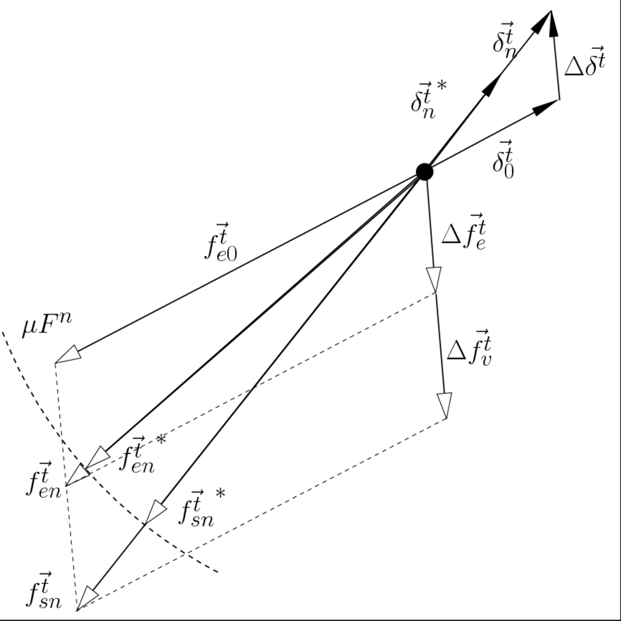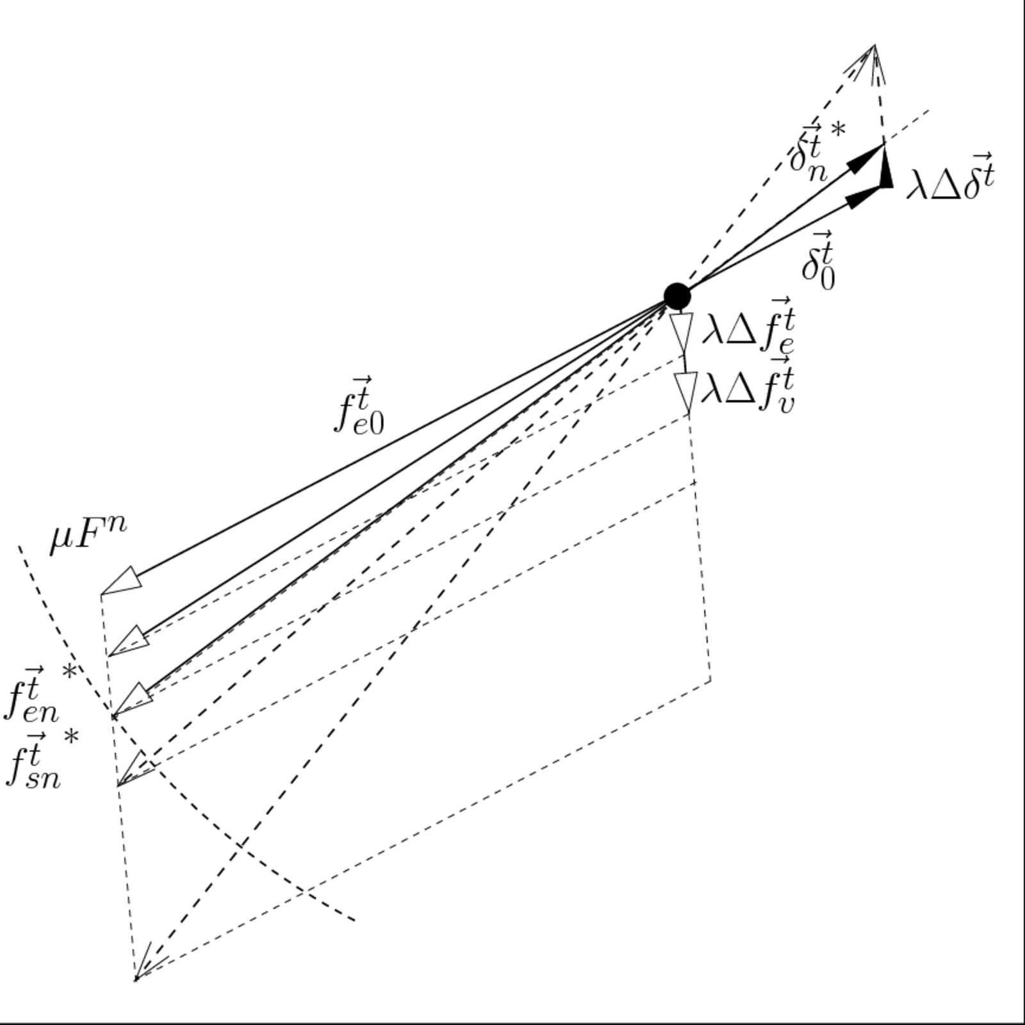

Figure 1: Substep friction limit determination. The friction limited terms are shown in the figure with a *superscript.

The force is modelled as , with being determined by the condition . The result for is:

This model has only sense if , so there must be . If this last condition holds, then the deformation and the slipping parts of the tangential displacement are calculated as:

With these values, the new values for the rest of the magnitudes are calculated as:

If , then . This is caused because as the collision evolves, , and then as the result of the last time step, the friction limit is reached. The model we propose is that the slip progress from the initial point of this new step. So, , but there is also a tangential spring unloading effect until the friction limit is reached from above. An elastic recuperation is produced, and this also contributes to the total slipping displacement. In figure 2, the model is shown. First of all, it is defined . The new tangential deformation in the contact patch, and the other magnitudes are:

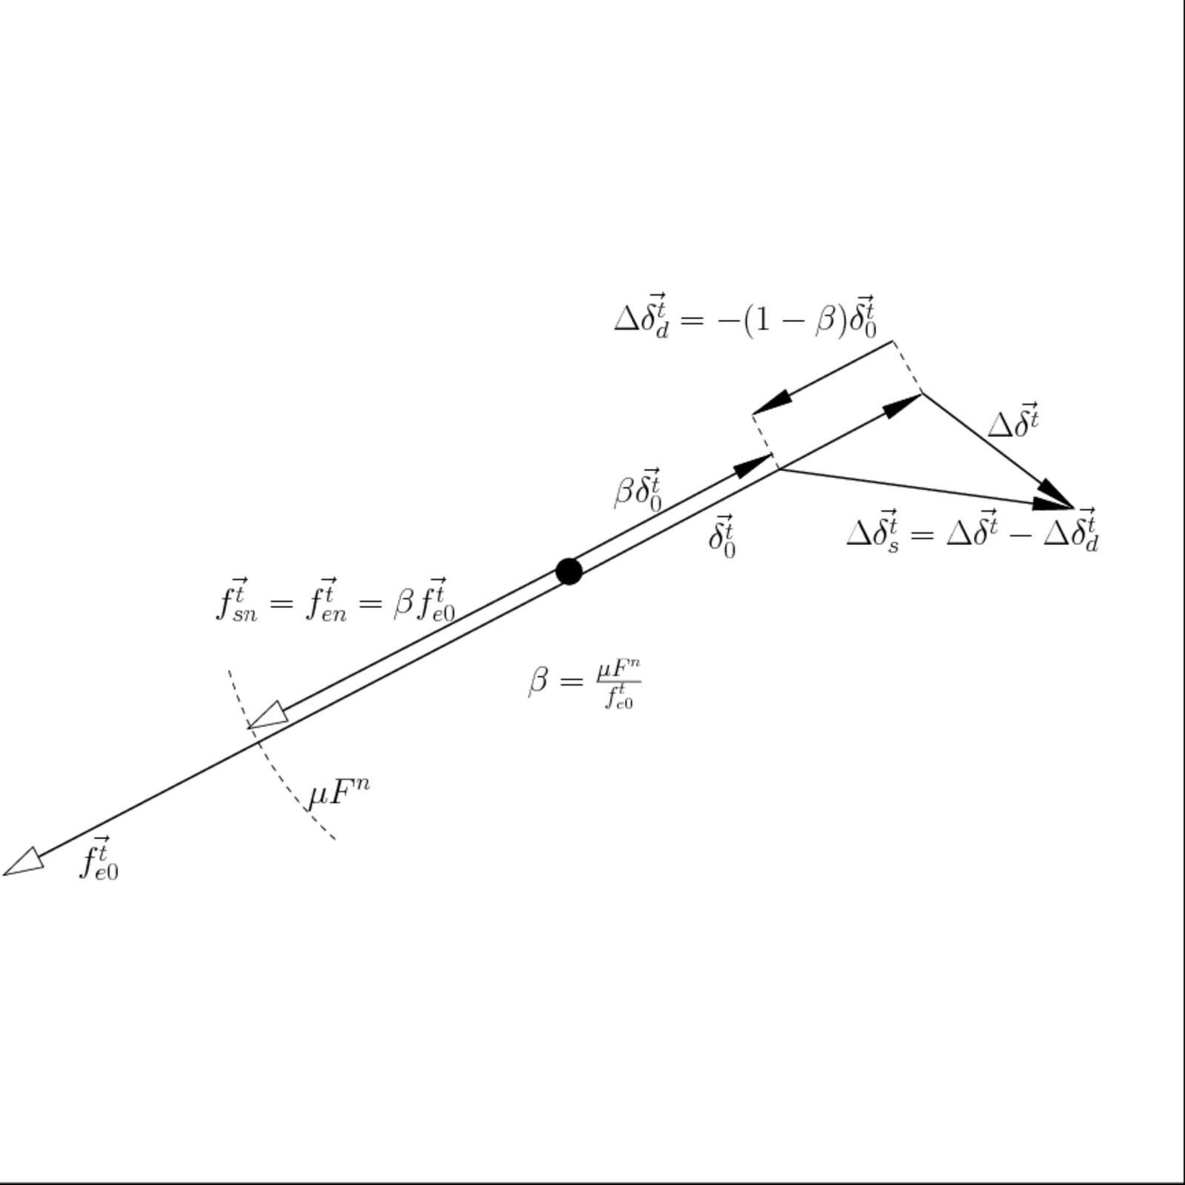

Figure 2

Up to now there are three different cases: when no slip takes place, when slip progress, and when slip is from the beginning of the time step because the previous step tangential elastic force has a higher value than for this new step.

But, there is a pathological case that occurs when there is a tangential movement reversal and also . In this situation , and then , so it happens that while , is . When the friction limit is reached, then the model switches from the first case to the third directly with a sudden large slippage. This behaviour is not physical. It has no sense that the tangential elastic elongation would be larger than the corresponding to the friction limit. (Here a reference to model which takes into account for checking the friction limit only the elastic part). Nevertheless, if the viscous term is physically interpreted as the force that opposes to a deformation due to external action taking increasingly values as this action is imposing faster deformation, then in the restoring phase of the collision, due to the internal forces only, perhaps do not have sense to include this viscous term, as no external action is the cause. In the figure 3, a simplified sketch of a tangential loading between two plane solids is shown. When a deformation with an imposed time scale is produced, in the zone of interface between solids, the viscous force is acting and increasing the interfacial shear force. When it is unloading the Solid 1 and the Solid 2 are restoring each one from their own elastic forces, and although probably some dissipation occurs, it is not imposed through the interface between both solids. In this case seems that the viscous term has not to be included in the friction limit calculation.

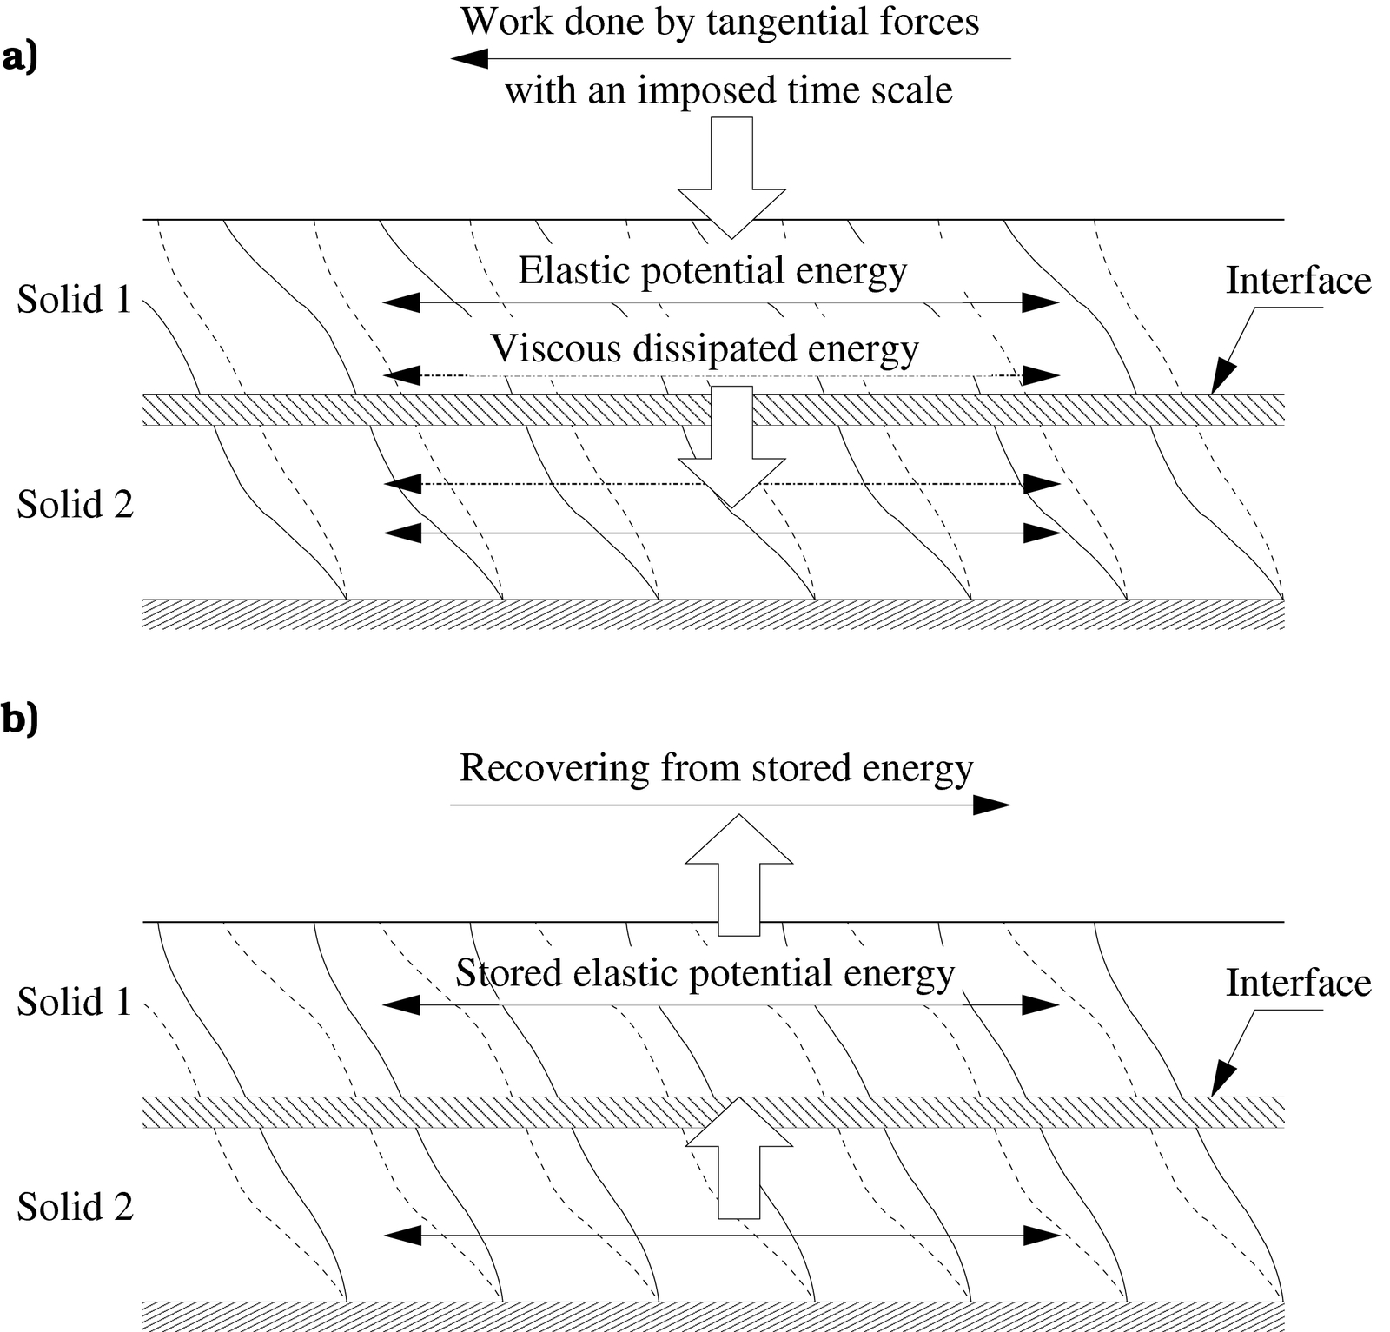

Figure 3

If the viscous term is not included in the check for the friction limit, and is instead of as in reference (XXXX) the friction limit condition, then the previous derivation holds except that the expression for is slightly different. Now it reads as:

With this implementation, there is no such a sudden large slip. To analyze the behaviour of the system when a tangential movement reversal happens, we will determine which are the relative values of , and .

The expressions and are used as well as the fact that in the linear model, the tangential elastic force and the tangential deformation displacement are collinear. The derivation made only holds for the Linear Model, but the results can be generalized to the Hertz-Mindlin model also, although then the values depends on the history of the movement. We get the following expressions:

So four cases appears:

i) :

ii) :

iii) :

iv) :

Depending on the sign and value of , the relative magnitude of these vectors varies. When the plane contained binary collision studied as the main case begins, then case i) holds, elastic and viscous force have the opposite directions, so . When the tangential unloading begins, then , and as then , so the case that holds is the iv) from the beginning of the reversal and it will progress through cases iii), ii) and finally the case i) approaching from negative values. If the collision still continues a new loading occurs in the opposite tangential direction.

In a general case where a 3D collision takes place, see figure 4, the value for the tangential relative velocity can have a finite value when the condition begins. Also, at first is , so . The result is that in this case the case i) continues, then the ii), and so forth as the 3D collision evolves.

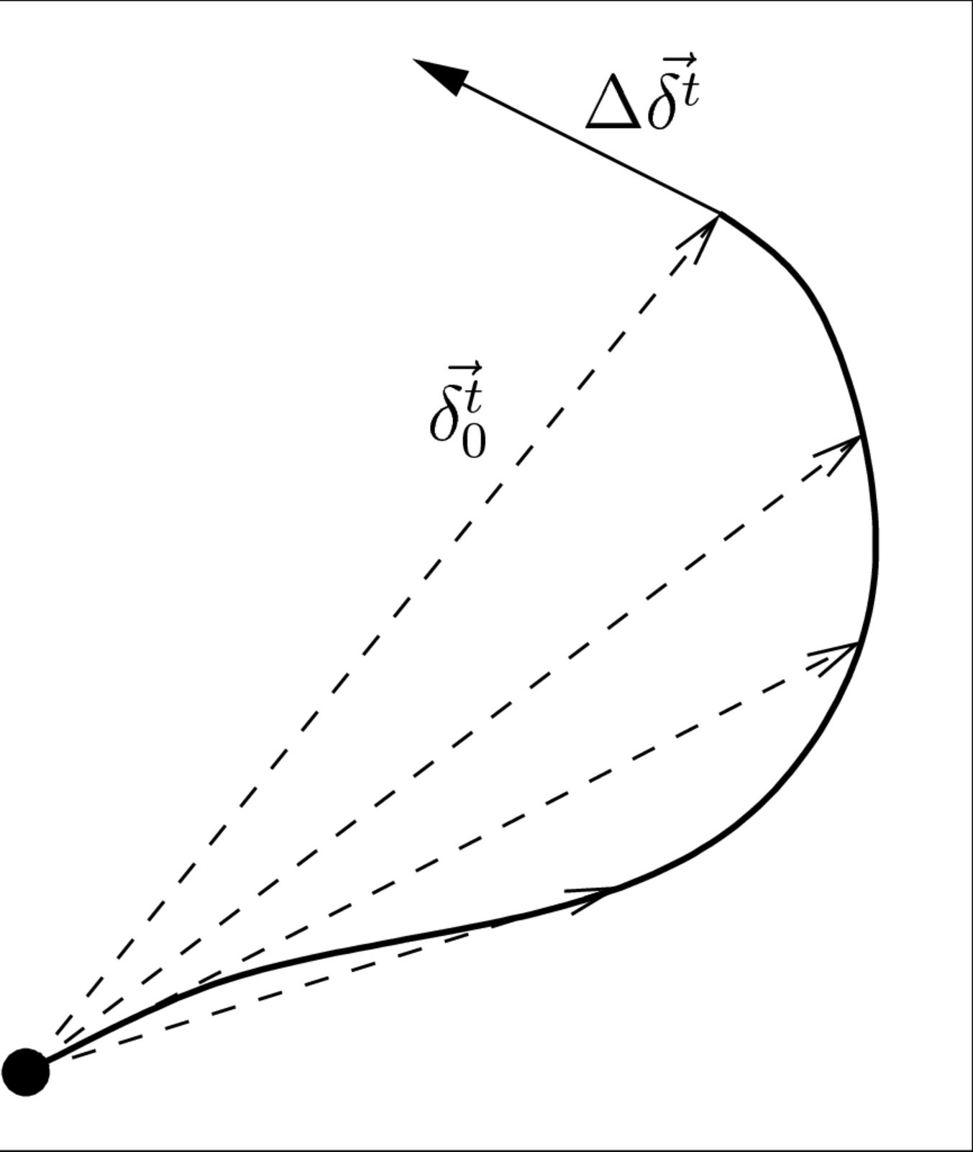

Figure 4: Tangential deformation in the tangential plane.

Looking how the forces evolves during the collision seems natural to model the Coulomb attrition condition as , and to use the corresponding expression for calculation.

# Implementation Framework

The model has been implemented in LIGGGHTS (Kloss et al, 2010; Kloss et al, 2011).

Describe LIGGGHTS .

For granular simulations, LAMMPS offers implementations for both linear (Hooke) and non-linear (Hertz) granular potentials along with efficient algorithms for detecting and calculating the pair-wise interaction forces. LAMMPS has been used to study avalanching flow [5-7], static granular packings [8-10], granular drainage [11-14], granular shear and its relation to constitutive modeling [15-19], and granular segregation [20].

# Results

Show collision of two particles with HD Integral model

Show results for our model

Performance comparison: HM model as implemented in LIGGGHTS vs. proposed model

For perf. comparison, make the compute function a template to energy is not tracked

Maybe also show collision of 3 particles?

# Conclusions

Bla

# References

Bates, L. (2006): “The need for industrial education in bulk technology", Bulk Solids Handl., 26, 464-473.

Bierwisch, C., Kraft, T., Riedel, H., Moseler, M. (2009), „Die filling optimization using three-dimensional discrete element modeling", Powder Technology, 196 (2),169-179

Bertrand, F., Leclaire, L.-A. , Levecque, G., (2005): „DEM-based models for the

Campbell, C. S. (2006): „Granular Material Flows - An Overview", Powder Technology,

162, 208-229.

Chaudhuri, B., Muzzio, F.J., Tomassone, M.S. (2006): „Modeling of heat transfer in granular flow in rotating vessels", Chem. Eng. Sci., 61, 6348 - 6360.

CHU K.W., WANG B., YU A.B. and VINCE A. (2009) CFD-DEM modelling of multiphase flow in dense medium cyclones, *Powder Technology*, Vol. 193, pp.235-247.

P.W. Cleary, N. Stokes, Efficient collision detection for three dimensional superellipsoidal

particles, Computational Techniques and Applications, CTAC97 Singapore, 1997.

CROWE C.T., SOMMERFELD M. and TSUJI Y. (1998): Multiphase Flows with Droplets and Particles, *CRC Press LLC*, Boca Raton.

CUNDALL P.A and STRACK O.D.L. (1972), A discrete numerical model for granular assemblies, *Geotechnique,* No. 29 (1), pp.47-65.

DEM Solutions, 2008, EDEM user manual

Deen, N.G., Van Sint Annaland, M., Van der Hoef, M.A., Kuipers, J.A.M. (2007): „Review of discrete particle modeling of fluidized beds", Chemical Engineering Science, 62, 28 - 44.

Di Renzo, A., Di Maio, F. P. (2004): „Comparison of contact-force models for the simulation of collisions in DEM-based granular flow codes", Chemical Engineering Science, 59, 525 - 541.

Ennis, B. J., Green, J., Davies, R. (1994): „Particle technology. The legacy of neglect in the U.S.", Chem. Eng. Prog., 90, 32-43.

van der Hoef, M.A., van Sint Annaland, M., Deen, N.G., Kuipers, J.A.M. (2008): „Numerical Simulation of Dense Gas-Solid Fluidized Beds: A Multiscale Modeling Strategy", Annual Review of Fluid Mechanics, 40, 47-70.

Hertz, H. (1882): „ Über die Berührung fester elastischer Körper", J. für die reine angewandte Mathematik, 92, 136.

Hoomans, B., Kuipers, J., Briels, W., van Swaaij, W. (1996): „Discrete Particle Simulation of bubble and slug formation in a two-dimensional gas-fluidized bed: Ahard-sphere approach", Chem Eng Sci, 51(1), 99-108.

Kafui, K.D., Thornton, C., Adams, M.J. (2002): „Discrete particle-continuum modelling of gas-solid fluidised beds", Chemical Engineering Science, 57, 2395 - 2410.

KLOSS, C., GONIVA, C., KLOSS (2010), “LIGGGHTS – A New Open Source DEM Simulation Software”, *Proc. 5th Intl. Conf. on Discrete Element Methods*, London, August 25-26.

KLOSS, C., GONIVA, C., PIRKER, S. (2010): “Open Source DEM and CFD-DEM with LIGGGHTS and OpenFOAM®” *Proc. Open Source CFD International Conference* , Munich, 4th - 5th November 2010.

KLOSS, C., GONIVA, C. (2011): “LIGGGHTS - Open Source DEM Simulations of Granular Materials Based on LAMMPS” *Proc. Open Source CFD International Conference* , San Diego, 27th February – 3rd March.

Kruggel-Emden H., Rickelt S., Wirtz S., Scherer V.: A study on the validity of the multi-sphere Discrete Element Method, Powder Technology 188 (2008) 153–165

Luding, S. (2005): „A discrete model for long time sintering", Mechanics and Physics of Solids, 53, 445-491

Mindlin, R., Deresiewicz, H. (1953): „Elastic spheres in contact under varying oblique forces", J. Applied Mechanics, 20, 327.

PLIMPTON, S. J. (1995): “Fast Parallel Algorithms for Short-Range Molecular Dynamics", J. Comp. Phys., 117, 1-19.

Online resource: Plimpton, S. J. et. al.: LAMMPS user manual, benchmarks and

documentaion, http://lammps.sandia.gov/, accessed in December 2010.

PÖSCHEL, T., SCHWAGER, T. (2005): Computational Granular Dynamics, Springer.

RAO, K., NOTT, P. (2008): *An introduction to Granular Flow*, Cambridge Series in Chemical Engineering, Cambridge.

di RENZO, A., di MAIO, F. P. (2004): “Comparison of contact-force models for the simulation of collisions in DEM-based granular flow codes", *Chemical Engineering Science*, 59, 525 - 541.

Sandia, 2011, LAMMPS user manual, <http://lammps.sandia.gov/doc/Manual.html>

Schwager and Poeschel (2007), "Coefficient of restitution and linear dashpot model revisited" Granular Matter, 9, 465-469

Schwager and Poeschel (2008), "Coefficient of Restitution for Viscoelastic Spheres: The Effect of Delayed Recovery", Phys. Rev. E, 78, 051304

Silbert L. E., Ertas D., Grest G. S., Halsey T. C., and Levine D. (2002a), ‘Geometry of frictionless and frictional sphere packings’, Phys. Rev. E, 65, 031304,

John E. Stone, David J. Hardy, Ivan S. Ufimtsev, Klaus Schulten (2010), “GPU-accelerated molecular modeling coming of age”, Journal of Molecular Graphics and Modelling, 29 116–125

Thornton C, Cummins S J, Cleary P W: An investigation of the comparative behaviour of alternative contact force models during elastic collisions, Powder Technology 210 (2011) 189–197

Walther, J., Sbalzarini, I. (2009): “Large-scale parallel discrete element simulationsof granular flow", Int. J. Computer aided Engineering and Science, 26 (6).

Ji Xu, Huabiao Qi, Xiaojian Fang, Liqiang Lu, Wei Ge, Xiaowei Wang, Ming Xu, Feiguo Chen, Xianfeng He, Jinghai Li: “Quasi-real-time simulation of rotating drum using discrete element method with parallel GPU computing”, Particuology, In Press, Corrected Proof, Available online 1 June 2011

ZHU, H.P., ZHOU, Z.Y, YANG, R.Y., YU, A.B. (2007): “Discrete particle simulation of particulate systems: Theoretical Developments", *Chemical Engineering Science*, 62, 3378-3396

1. L. E. Silbert, D. Ertas, G. S. Grest, T. C. Halsey, D. Levine, S. J. Plimpton, ‘Granular flow down an inclined plane: Bagnold scaling and rheology’, *Phys Rev E*, **64**, 051302, 2001
2. L. E. Silbert, J. W. Landry, and G. S. Grest, ‘Granular flow down a rough inclined plane: Transition between thin and thick piles’, *Phys. Fluids*, **15**, 1, 2003
3. R. Brewster, G. S. Grest, J. W. Landry, and A. J. Levine: ‘Plug flow and the breakdown of Bagnold scaling in cohesive granular flows’, *Phys. Rev. E*, **72**, 061301, 2005
4. L. E. Silbert, D. Ertas, G. S. Grest, T. C. Halsey, and D. Levine, ‘Geometry of frictionless and frictional sphere packings’, *Phys. Rev. E*, **65**, 031304, 2002a
5. L. E. Silbert, G. S. Grest, and J. W. Landry, ‘Statistics of the contact network in frictional and frictionless granular packings’, *Phys. Rev. E*, **66**, 061303, 2002b
6. J. W. Landry, G. S. Grest, L. E. Silbert, and S. J. Plimpton, ‘Confined granular packings: Structure, stress, and forces’, *Phys. Rev. E*, **67**, 041303, 2003
7. H. P. Zhu and A. B. Yu, ‘Steady-state granular flow in a three-dimensional cylindrical hopper with flat bottom: microscopic analysis’, *J. Phys. D*, **37**, 1497, 2004
8. C. H. Rycroft, M. Z. Bazant, G. S. Grest, and J. W. Landry, ‘Dynamics of random packings in granular flow’, *Phys. Rev. E*, **73**, 051306, 2006
9. C. H. Rycroft, G. S. Grest, J. W. Landry, and M. Z. Bazant, ‘Analysis of granular flow in a pebble-bed nuclear reactor’, *Phys. Rev. E*, **74**, 021306, 2006.
10. J. W. Landry, G. S. Grest, S. J. Plimpton, ‘Discrete element simulations of stress distributions in silos: Crossover from two to three dimensions’, *Powder Technology*, **139**, 233-239, 2004
11. X. Cheng, J. B. Lechman, A. Fernandez-Barbero, G. S. Grest, H. M. Jaeger, G. S. Karczmar, M. E. Mobius, and S. R. Nagel, ‘Three-Dimensional Shear in Granular Flow’, *Phys. Rev. Lett.*, **96**, 038001, 2006
12. K. Kamrin, C. H. Rycroft, and M. Z. Bazant, ‘The stochastic flow rule: a multi-scale model for granular plasticity’, *Model. Simul. Mater. Sci. Eng.*, **15**, 449, 2007
13. M. Depken, J. B. Lechman, M. van Hecke, W. van Saarloos, and G. S. Grest, ‘Stresses in smooth flows of dense granular media’, *Europhys. Lett*., **78**, 58001, 2007
14. C. H. Rycroft, K. Kamrin, and M. Z. Bazant, ‘Assessing continuum postulates in simulations of granular flow’, *J. Mech. Phys. Solids*, **57**, 828, 2009
15. L. E. Silbert, G. S. Grest, S. J. Plimpton, D. Levine: ‘Boundary effects and self-organization in dense granular flows’, *Physics of Fluids*, **14**, 2637-2646, 2002
16. J. Sun, F. Battaglia, and S. Subramaniam, ‘Dynamics and structures of segregation in a dense, vibrating granular bed’, *Phys. Rev. E*, **74**, 061307, 2006

|  |  |
| --- | --- |
|  | () |
| , | () |
| , | () |
| , | () |

Table 1: Mass and momentum balance as well as Reynolds Stress turbulence model of the continuous gas phase; further details can be found in Fluent (2006) and literature cited therein

Table 6: Special equations of the EUgran+ model

|  |  |  |  |  |
| --- | --- | --- | --- | --- |
| Material combination |  |  |  |  |
| Glass – glass | 0.96 | 0.4 | 0.1 | 1° |
| Glass – steel | 0.9 | 0.3 | 0.15 | 4° |
| Glass – aluminium | 0.9 | 0.3 | 0.15 | 2° |

Table 7: Restitution coefficients, static and dynamic coefficients of friction as well as the characteristic virtual angle for different material combinations and 1 mm glass particles.

|  |  |  |  |  |  |  |
| --- | --- | --- | --- | --- | --- | --- |
| Model | DP | DP+ | DEM | EUgran | EUgran+ | DDPM |
| Gas-particle interaction | + | + | + | ~ | ~ | + |
| Interparticle collisions | -- | + | ++ | + | + | + |
| Wall roughness | -- | ++ | -- | -- | ++ | - |
| Particle rotation | -- | + | ++ | -- | + | - |
| Qualitative agreement | - | ++ | + | -- | ++ | ++ |
| Quantitative agreement | - | + | - | -- | ++ | + |
| Computational efficiency | ++ | + | -- | ~ | ~ | + |

Table 8: Model evaluation matrix

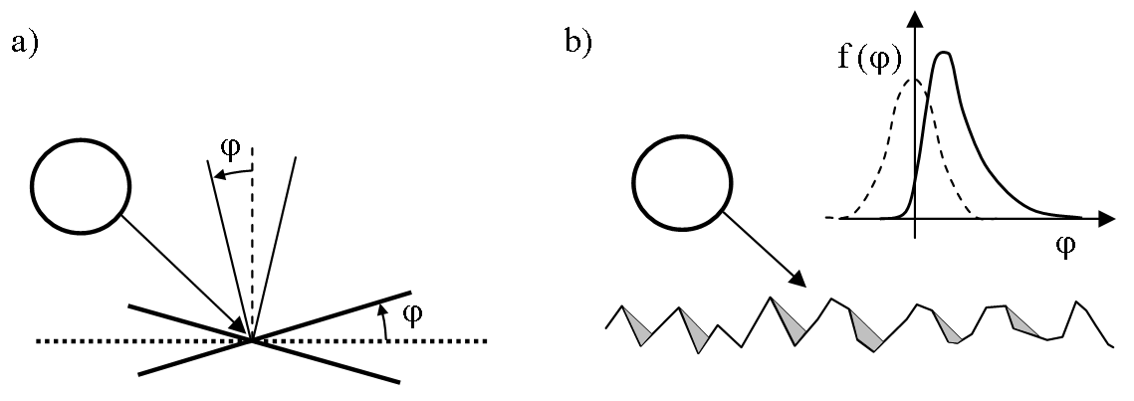

c)

Figure 1: Sketch of particle-wall collision modelling; a) virtual wall concept, b) shadow effect, c) hybrid EUgran+ model: a smooth Eulerian particle reflection is adopted in order to meet a mean Lagrangian particle rebound at a rough wall