Reproducible Research: Peer Assessment 1

David Pelcyger

January 6, 2017

## Loading and preprocessing the data

1. Load the data

##Set working directory   
setwd("C:/Users/david/Desktop/reproducibleresearch/courseproject1")  
  
##download activity file  
download.file("https://d396qusza40orc.cloudfront.net/repdata%2Fdata%2Factivity.zip","activity.zip")  
  
##unzip activity file  
unzip("activity.zip")   
  
##load activity file into df  
df <- read.csv("activity.csv",sep=",")

1. Process/transform the data (if necessary) into a format suitable for your analysis

##Convert date to as.Date data type  
df$date <- as.Date(df$date)

##Provide information about data frame df  
str(df)

## 'data.frame': 17568 obs. of 3 variables:  
## $ steps : int NA NA NA NA NA NA NA NA NA NA ...  
## $ date : Date, format: "2012-10-01" "2012-10-01" ...  
## $ interval: int 0 5 10 15 20 25 30 35 40 45 ...

##Print top records in data frame  
head(df)

## steps date interval  
## 1 NA 2012-10-01 0  
## 2 NA 2012-10-01 5  
## 3 NA 2012-10-01 10  
## 4 NA 2012-10-01 15  
## 5 NA 2012-10-01 20  
## 6 NA 2012-10-01 25

##Print last records in data frame  
tail(df)

## steps date interval  
## 17563 NA 2012-11-30 2330  
## 17564 NA 2012-11-30 2335  
## 17565 NA 2012-11-30 2340  
## 17566 NA 2012-11-30 2345  
## 17567 NA 2012-11-30 2350  
## 17568 NA 2012-11-30 2355

## What is mean total number of steps taken per day?

1. Calculate the total number of steps per day

total <- aggregate(steps ~ date, df, sum )

1. Make a histogram of the total number of steps taken per day

plot(total$steps ~ total$date, type="h", lwd = 5, ylab="Frequency (steps)", xlab="Activity Days")

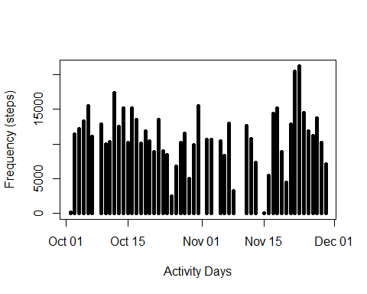  
 3. Calculate and report the mean and median of the total number of steps taken per day

mean(total$steps)

## [1] 10766.19

median(total$steps)

## [1] 10765

## What is the average daily activity pattern?

1. Make a time series plot (i.e. type = "l") of the 5-minute interval (x-axis) and the average number of steps taken, averaged across all days (y-axis)

##calculate mean steps by interval   
df_interval <- aggregate(steps ~ interval, df, mean)  
##plot line chart and label  
plot(df_interval$steps ~ df_interval$interval, type="l", xlab="5-min Intervals", ylab="Average Steps Taken")

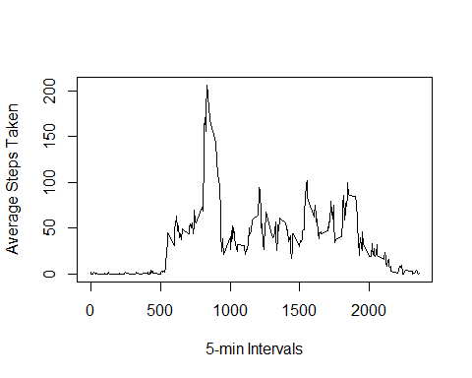  
 2. Which 5-minute interval, on average across all the days in the dataset, contains the maximum number of steps?

##select interval which contains maximum number of steps  
max_steps <- max(df_interval$steps)  
df_interval$interval[df_interval$steps==max_steps]

## [1] 835

## Imputing missing values

1. Calculate and report the total number of missing values in the dataset

sum(is.na(df$steps))

## [1] 2304

1. Devise a strategy for filling in all of the missing values in the dataset.

* Fill in missing values(NA) with 0

1. Create a new dataset that is equal tothe original dataset then replace missing data (NA) with 0.

df_imputed <- df  
df_imputed$steps[is.na(df_imputed$steps)] <- 0

##Make sure there are no more NA's  
sum(is.na(df_imputed$steps))

## [1] 0

1. Make a histogram of the total number of steps taken each day

##sum the steps per day in total_imputed   
total_imputed <- aggregate(steps ~ date, df_imputed, sum)  
##plot histogram and label  
plot(total_imputed$steps ~ total_imputed$date, type="h", lwd = 5, ylab="Imputed Frequency (steps)", xlab="Imputed Activity Days")

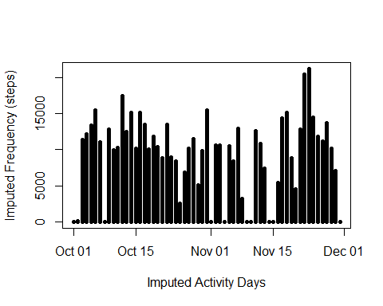  
 Calculate and report the mean and median total number of steps taken per day.

mean(total_imputed$steps)

## [1] 9354.23

median(total_imputed$steps)

## [1] 10395

d. Do these values differ from the estimates  
 from the first part of the assignment?  
   
 Yes  
  
 e. What is the impact of imputing missing data on the  
 estimates of the total daily number of steps?  
  
 Both estimates decreased:  
 mean decreased from 10766,19 to 9354.23  
 median decreased from 10765 to 10395

## Are there differences in activity patterns between weekdays and weekends?

1. Create a new factor variable in the dataset with two levels - "weekday"  
    and "weekend" indicating whether a given date is a weekday or weekend day.

##create vector wkdays   
wkdays <- c('Monday', 'Tuesday', 'Wednesday', 'Thursday', 'Friday')  
  
##convert to `factor` and specify the `levels/labels`  
df_imputed$partofweek <- factor((weekdays(df_imputed$date) %in% wkdays)+1L,  
 levels=1:2, labels=c('weekend', 'weekday'))  
##sum steps for 'weekend' and 'weekday'  
aggregate(steps ~ partofweek, df_imputed, sum, na.rm=TRUE)

## partofweek steps  
## 1 weekend 173692  
## 2 weekday 396916

1. Make a panel plot containing a time series plot (i.e. type = "l") of the 5-minute interval (x-axis) and the average number of steps taken, averaged across all weekday days or weekend days (y-axis).

##Make two panel plot  
par(mfrow=c(2,1))  
  
##Subset weekday data   
weekday <- df_imputed[df_imputed$partofweek=="weekday",]  
##calculate weekday mean  
wkday_interval <- aggregate(steps ~ interval, weekday, mean, na.rm=TRUE)  
##plot average interval graph for weekdays  
plot(wkday_interval$steps ~ wkday_interval$interval, type="l", xlab="Weekday 5-min Interval", ylab="Average Steps")  
  
##Subset weekend data   
weekend <- df_imputed[df_imputed$partofweek=="weekend",]  
##calculate weekend mean  
wkend_interval <- aggregate(steps ~ interval, weekend, mean, na.rm=TRUE)  
##plot the average interval graph for weekends  
plot(wkend_interval$steps ~ wkend_interval$interval, type="l", xlab="Weekend 5-min Interval", ylab="Average Steps")

