Calder Agreement Review Project Plan
Presence identification baseline and deployment plan
Version 1.6.0 | 15 September 2026
Prepared for the MIST 7590E project team

Decision. Ship a complete human-in-the-loop application that identifies provision presence, returns source evidence and an evidence-based confidence indicator, and remains operational when hosted AI is disabled. Standard positions, deviation analysis, risk severity, and gap detection are deliberately deferred to stretch work.
This plan incorporates the project brief, Sponsor Change Notice 1, the professor's implementation clarifications, and the CUAD Commercial Contracts Labeling Handbook. It also records the implemented architecture, evaluation evidence, release controls, and remaining deployment work.
Release evidence | Result
Automated application tests | 21 passed
Production build | Passed
CUAD presence evaluation | 510 contracts and 10 mapped provisions
PDF extraction benchmark | 509 matched pairs; median recall 1.00; pass rate 1.00
Fallback modes | General model, optional classifier, deterministic, manual

Executive summary
Calder is a role-aware vendor-agreement workflow, not an autonomous legal decision maker. A Requester declares the agreement type and submits a searchable PDF. The application validates the text layer, stores the agreement and intake audit event, identifies which active provision categories are present, and routes source-linked findings to a Reviewer. Every finding requires a human disposition and reason. Approvers resolve escalations; Administrators manage roles and active categories.
The required scope is presence identification only. A non-result means not detected, not absent. The release therefore never turns a missed match into a gap and never asks an extractor to decide whether a term is acceptable. This reduces false legal conclusions and protects the manual workflow when models or hosted services fail.

Scope and success criteria
Required baseline | Deferred stretch
Intake, searchable-PDF validation, and storage | Calder standard-position authoring
Presence identification across 10 categories | Deviation characterization
Exact supporting source text | Automated gap detection
Evidence-based confidence indicator | Risk severity rules
Human review, disposition, audit, and reporting | Condition-task owner and due-date screen
Roles enforced by database policies | DOCX and OCR ingestion

Product outcome
A deployed user can submit an agreement, retrieve attributable review decisions months later, see which provisions occur most often, and continue working through deterministic or manual identification when AI is unavailable. Review decisions and audit events are never deleted by the application.

Application workflow
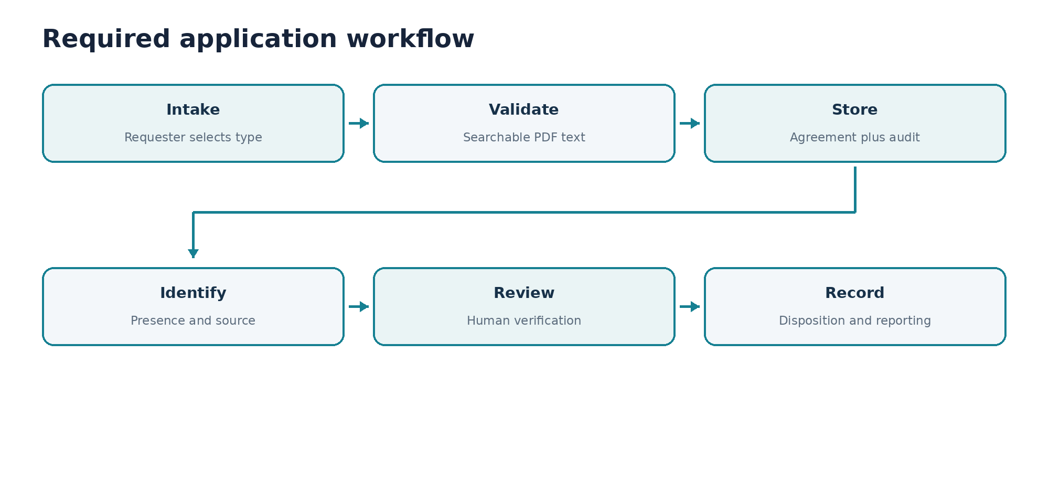
Figure 1 Required application workflow
- Requester signs in. Every new account starts as Submitter.
- Requester selects one of Calder's seven procurement agreement types and uploads a PDF.
- PDF.js verifies that the PDF has searchable text. An image-only PDF is rejected before storage.
- The file, agreement metadata, and intake audit event are stored before analysis begins.
- The selected contract-type playbook supplies the active presence categories.
- The general-purpose extractor attempts strict presence and source output. If unavailable, the optional classifier may run; deterministic retrieval then provides the automatic fallback.
- Reviewer verifies the category and source, then accepts, dismisses, or escalates with a required reason.
- Approver resolves escalations. Reporting counts provision frequency; audit history preserves who did what and when.

Fallback workflow
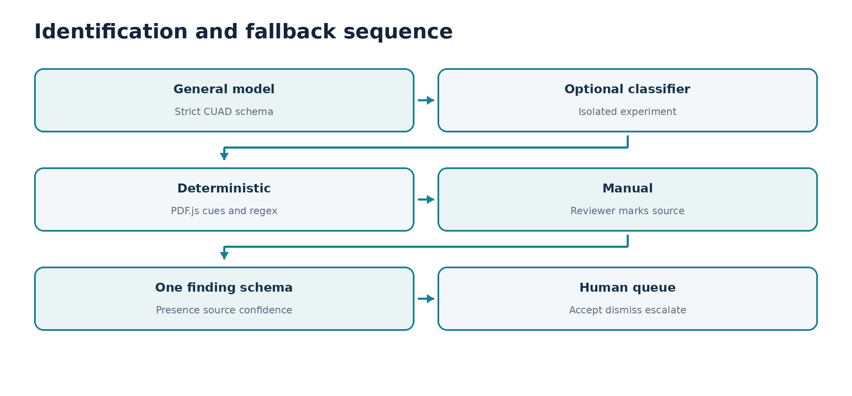
Figure 2 Every path produces the same human-review input
The general-purpose model is the recommended hosted path. Its output contains only a provision name, present=true, and an exact source span. Calder ignores model self-confidence. It assigns 75 when the span occurs in the document and 90 when deterministic retrieval independently identifies the same category. Deterministic scores increase with the number of matched CUAD-informed cues. Manual findings retain reviewer-entered confidence and source text.

Architecture
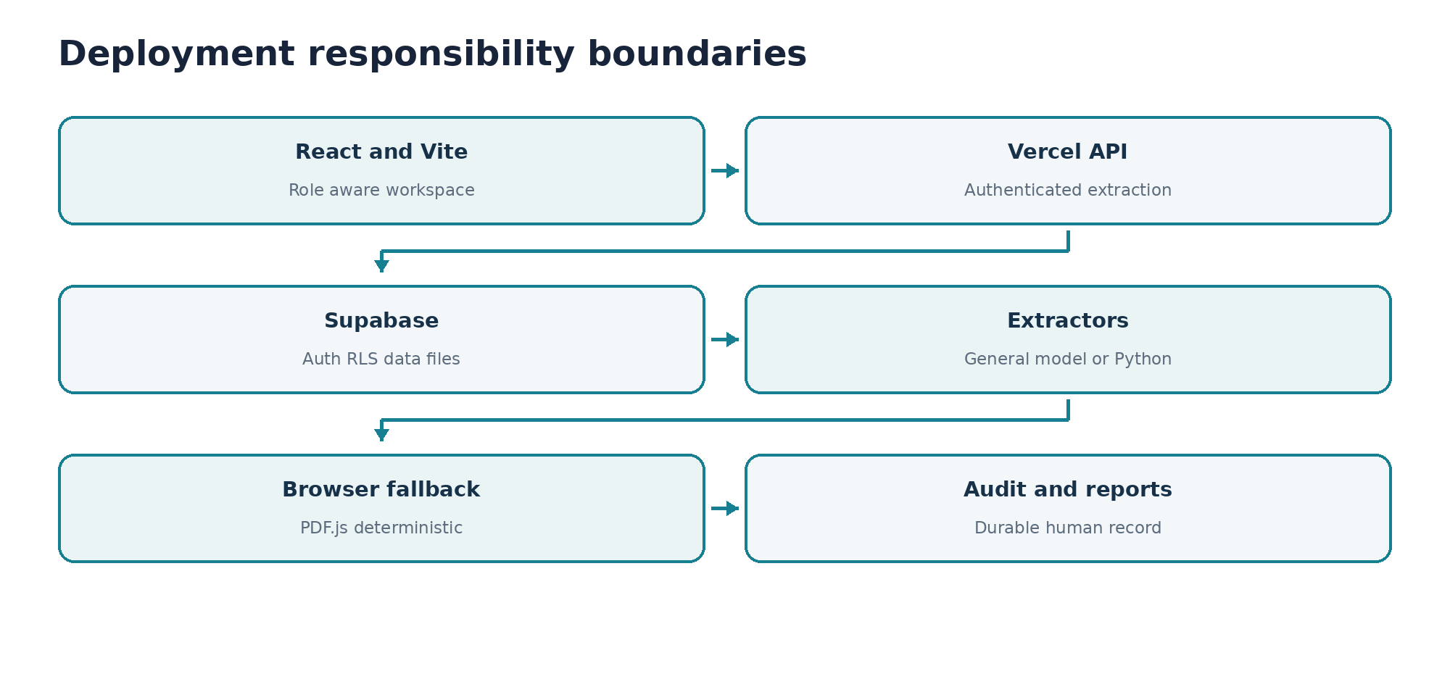
Figure 3 Hosting and responsibility boundaries
Component | Responsibility | Boundary
React and Vite | Responsive role-aware intake, queue, playbooks, reports, audit, and profile UI | Navigation visibility is not authorization
PDF.js | Browser-side searchable PDF extraction and segmentation | No OCR or scan interpretation
Vercel API | Authenticates the caller and invokes hosted extraction with a strict schema | No risk or final legal decision
Supabase | Password auth, expiring sessions, PostgreSQL, RLS, and private file storage | No SSO, MFA, reset, or verification requirement
General model | Presence and verbatim source span using CUAD definitions and exclusions | No values, severity, deviations, gaps, or self-confidence
Optional Python service | Isolated CUAD-trained QA experiment | Disabled by default and not scored on training contracts
Human reviewer | Verifies evidence and records disposition | No silent automated disposition

Identity authorization and records
Supabase Auth stores password hashes and issues expiring sessions. The application creates a profile row with Submitter access. An Administrator changes roles through a security-definer database function that first verifies the caller's role. PostgreSQL row-level security protects agreements, findings, audit events, playbooks, and files even when a user attempts a direct API call.
Role | Permitted capabilities
Submitter | Submit agreements, run the selected identification path, and view owned agreements and outcomes
Reviewer | Submitter capabilities plus organization review queue, manual findings, and accept dismiss escalate decisions
Approver | Reviewer capabilities plus resolution of escalated findings
Administrator | All capabilities plus role assignment, playbook activation, reporting, and audit access

Deletion is not exposed. Database foreign keys use restrict behavior for agreements, findings, and audit events so deleting a user or agreement cannot cascade into review history. If an authorized retention process later removes a document, the surviving decision record keeps the agreement identity, category, source span, actor, date, disposition, reason, method, and confidence and states that the full document is no longer retained.

Agreement types and playbooks
Calder defines the agreement types. The Requester selects the value at intake; the system does not infer it. The playbook selects which presence categories to run. It does not make required baseline risk decisions.
Agreement type | Active category examples
Software Subscription | Cap on Liability, Auto Renewal, Renewal Notice, Governing Law, Exclusivity
Professional Services | Cap on Liability, Termination for Convenience, Insurance, Warranty Duration, Governing Law
Licensing | Cap on Liability, Auto Renewal, Renewal Notice, Governing Law, Exclusivity, Assignment Control
Logistics and Freight | Cap on Liability, Termination for Convenience, Insurance, Governing Law
Data Processing Addendum | Cap on Liability, Audit Rights, Insurance, Assignment Control, Governing Law
Mutual NDA | Governing Law and Assignment Control
Other | Cap on Liability, Termination for Convenience, Insurance, Assignment Control, Governing Law

CUAD mapping and category selection
The team mapped every CUAD category to Calder's taxonomy or explicitly marked it out of scope. Ten categories were selected because they address recurring vendor-agreement review and have measurable CUAD positives. Renewal Term is a partial mapping to Calder's narrower Auto Renewal category. Assignment Control combines CUAD Anti Assignment and Change Of Control. Uncapped Liability is not treated as evidence that a cap is present.
Calder provision | CUAD positives | Precision | Recall | F1
Cap on Liability | 275 | 0.955 | 0.545 | 0.694
Auto Renewal | 176 | 0.916 | 0.619 | 0.739
Renewal Notice | 111 | 0.415 | 0.396 | 0.406
Governing Law | 437 | 0.948 | 0.998 | 0.972
Exclusivity | 180 | 0.436 | 0.978 | 0.603
Termination for Convenience | 183 | 0.469 | 0.700 | 0.561
Assignment / Control | 376 | 0.880 | 0.973 | 0.924
Audit Rights | 214 | 0.861 | 0.318 | 0.464
Insurance | 166 | 0.941 | 0.675 | 0.786
Warranty Duration | 75 | 0.707 | 0.387 | 0.500

Deterministic baseline micro precision is 0.7443, micro recall is 0.7378, and micro F1 is 0.7410. These are candidate-retrieval results over all 510 CUAD contracts, not legal-review accuracy and not classifier results. Category-level weaknesses remain visible so the team can tune or route uncertain cases to people.

Evaluation plan
Evaluation | Method | Release evidence
Application regression | Lint, 21 Node tests, TypeScript compilation, Vite production build | All passed
CUAD presence | Document-category predictions compared with expert CUAD spans | Precision, recall, F1, TP, FP, FN, TN for 10 categories
PDF ingestion | PDF.js tokens compared with matching CUAD plaintext | 509 pairs; median recall 1.00; 100 percent at or above 0.80
Modified agreements | Ten deliberately modified Bonterms or Common Paper forms with expert labels | Required before final model claim; no standard-position inference
Authorization | Direct API and table requests using each role | Submitter denied Reviewer and Administrator capabilities
Outage | Disable hosted keys and classifier URL | Deterministic retrieval and manual findings remain available

The predeclared ingestion gate is median token recall of at least 0.90 and at least 95 percent of documents reaching token recall 0.80. The observed result passed, so development may continue. A future CUAD-trained classifier must use a documented holdout that was not used for training; otherwise the result measures leakage or memorization.

Delivery work plan
Phase | Deliverable | Exit criterion
1 Complete | Scope change, taxonomy, ambiguity log | Ten justified categories and stretch items recorded
2 Complete | Manual-first application shell | Intake through audit and reports works without AI
3 Complete | Authentication and authorization | New users are Submitters; RLS blocks direct privilege bypass
4 Complete | PDF.js ingestion and deterministic retrieval | Searchable PDF validation and fallback work
5 Complete | CUAD evaluation harness | Per-category metrics reproducible offline
6 Complete | Optional hosted extraction interfaces | Strict schema and evidence verification; outage falls back
7 Next | Deployed integration smoke test | Vercel and Supabase production roles, files, and policies verified
8 Next | Ten modified standard-form agreements | Independent expert labels and documented results
9 Next | Presentation and final acceptance evidence | Live demo, limitations, and reproducible test packet

Zero budget hosting decision
Option | Use | Decision condition
Vercel and Supabase | Baseline UI, authenticated API, Auth, RLS, database, and private files | Use after representative cold and warm contract timing succeeds within current free limits
Netlify and Supabase | Equivalent front-end and function alternative | Use only if Vercel constraints fail and the same timing test passes
Render or Railway | Optional Python classifier container | Experimental only; confirm current free availability, memory, model startup, and end-to-end duration

For each host, run at least five cold and five warm analyses using the same representative PDF. Record upload-to-findings time, cold start, warm time, errors, and contract size. Calder writes analysis duration to its audit event. Recheck current provider terms before final deployment because free-tier limits can change.

Risks known issues and controls
Risk or limitation | Control or disposition
Image-only or scanned PDF | Reject before storage with a clear message; OCR is out of scope
False positive candidate | Show exact source and evidence score; require human verification
Miss mistaken for absence | Never create a baseline gap; report only positive findings
Hosted extractor outage | Automatic deterministic fallback and guided manual identification
CUAD model leakage | General-purpose model is recommended; isolate the CUAD-trained experiment and use a true holdout
Unauthorized URL or API use | Database RLS and security-definer role checks, not UI hiding
Uploaded malware | No virus scan in classroom scope; record as a mandatory production gap
Condition never completed | Future condition entity needs owner, due date, status, completion actor, and reporting
Document retention | Classroom files retained for project duration; proposed production period is seven years after closure; decisions remain indefinitely

Requirements traceability
Requirement | Implemented evidence
Presence source and confidence | Single presence finding schema, verbatim span verification, evidence-derived score
Human disposition | Accept dismiss escalate actions with required reason and audit event
Manual operation without AI | Manual mode and manual source-linked finding form
Deterministic fallback | PDF.js extraction, clause segmentation, CUAD-informed cues, and regex-like phrase matching
Roles on server | Supabase RLS policies and administrator-only assign_user_role function
Seven agreement types | Requester dropdown and type-specific active category data
Reporting | Provision-frequency counts by category and agreement type
Category metrics | Offline CUAD precision and recall artifacts for 10 provisions
Durable decisions | No delete policies and restrict foreign keys for review records
No-text PDF handling | Searchable text threshold and rejection before storage
Zero-cost deployment | Vercel and Supabase baseline plus measured host comparison protocol
Scope change | Change log and disabled stretch backlog preserve prior work without shipping it

Local verification and deployment

Run locally
- Install Node.js 22 and unzip the application.
- Open a terminal in the calder-portable folder.
- Run npm install.
- Run npm run check and require lint, tests, and production build to pass.
- Run npm run dev and open http://localhost:5173.
- Without environment variables, use the seeded local demonstration mode to test automatic fallback, deterministic mode, and manual mode.

Connect Supabase and Vercel
- Create a Supabase project and run the complete supabase/schema.sql file.
- Set VITE_SUPABASE_URL and VITE_SUPABASE_ANON_KEY to the project URL and browser-safe publishable key. Never use a secret or service-role key in the browser.
- Push calder-portable to GitHub. In Vercel set Root Directory only when the application is a repository subfolder.
- Use Vite, npm run build, and dist. Add the two browser variables and their server aliases SUPABASE_URL and SUPABASE_ANON_KEY.
- Optionally set OPENAI_API_KEY and OPENAI_MODEL. Leave CUAD_CLASSIFIER_URL unset unless the isolated service is intentionally deployed.
- Create a Submitter account, promote test users through an Administrator, and run the direct authorization and outage checks in TESTING.md.

Definition of done
- A searchable PDF can move from intake through attributable disposition and reporting.
- All seven agreement types and ten active presence categories are available.
- Every automated positive includes source text and an evidence-based confidence indicator.
- No miss becomes a gap and no baseline extractor assigns risk, a standard, or a deviation.
- Submitter, Reviewer, Approver, and Administrator access is enforced through server-side policies.
- Hosted analysis can be disabled without stopping deterministic or manual work.
- CUAD precision and recall and PDF extraction accuracy are reproducible from included scripts.
- The application passes npm run check and the deployed URL passes role, upload, review, audit, and outage smoke tests.
- The ten modified Bonterms or Common Paper agreements are independently labeled and evaluated before final model claims.

References
- MIST 7590E Fall 2026 Project Brief version 1.
- Sponsor Change Notice 1 and professor clarifications supplied to the project team.
- CUAD Commercial Contracts Labeling Handbook, 9 September 2021.
- The Atticus Project CUAD repository, https://github.com/The-Atticus-Project/cuad.
- CUAD v1 archive and metadata, https://zenodo.org/records/4595826.

