ChemFlow-ED: A Generalized, Open-Source Computational Workflow for Teaching Structure-Based Drug Discovery in Advanced Medicinal Chemistry
Donna H. Perygin*
Department of Chemistry and Geosciences, Jacksonville State University, Jacksonville, Alabama 36265
ABSTRACT
Structure-based drug discovery is now central to modern medicinal chemistry, yet most instructional docking exercises still ask students to reproduce a published protein–ligand complex rather than generate and evaluate their own hypotheses about an unliganded target. This paper presents ChemFlow-ED (Chemistry Flow for Education and Drug Discovery), a modular, open-source computational workflow that lets advanced undergraduate and graduate students carry out authentic structure-based drug discovery beginning with nothing more than an experimentally determined protein structure. Students identify candidate binding pockets, build a receptor-derived pharmacophore directly from the protein rather than a known ligand, run pharmacophore-based virtual screening, execute automated molecular docking, analyze protein–ligand interactions, and prioritize candidates for future experimental evaluation. A companion suite of Python scripts automates receptor and ligand preparation, docking, affinity extraction, and interaction analysis, so student effort is spent on interpretation rather than file management. ChemFlow-ED was implemented as the capstone project in a senior-level undergraduate medicinal chemistry course and is illustrated here using the canine Cu/Zn superoxide dismutase E40K mutant (PDB ID: 7WX0), a structural model for canine degenerative myelopathy. The workflow itself, not this case study, is the contribution: because it begins with protein structure alone, it is transferable to essentially any experimentally determined target and is especially suited to proteins that lack known ligands or inhibitors. ChemFlow-ED integrates several complementary computational methods into one inquiry-driven investigation, giving students a research experience that mirrors early-stage medicinal chemistry practice while relying exclusively on free, open-source software.
Keywords: medicinal chemistry education; structure-based drug discovery; pharmacophore modeling; molecular docking; virtual screening; computational chemistry; AutoDock Vina; PyMOL

Introduction
Computational methods are now woven into every stage of pharmaceutical research. During early drug discovery, structure-based drug discovery (SBDD), molecular docking, pharmacophore modeling, virtual screening, and molecular dynamics simulation routinely identify candidate ligands, prioritize compounds for experimental follow-up, and rationalize protein–ligand recognition, often at a fraction of the cost of experimental screening.^{1–3} As these methods have matured, students entering medicinal chemistry, computational chemistry, and structural biology are increasingly expected to arrive with hands-on experience in them.
Chemistry curricula have responded by incorporating molecular visualization, protein structure analysis, and docking into advanced coursework, aided by free structural databases and open-source modeling software.^{4–9} Yet most of these activities remain organized around a single technique rather than the integrated process of drug discovery. A common design gives students a protein with a co-crystallized ligand already bound and asks them to reproduce the published pose or rank a short list of compounds — effective for teaching docking software, but since the binding site and expected answer are already known, students spend their effort operating software rather than weighing competing hypotheses.^{10,11}
This gap is most visible for proteins with no experimentally characterized ligand at all — a category that includes many targets associated with rare genetic disorders, protein-misfolding diseases, and newly identified therapeutic mechanisms. For these targets, computational methods propose candidate binding sites, generate testable hypotheses about molecular recognition, and prioritize compounds for future experimental work, rather than reproduce a known interaction. Teaching students to work in this open-ended mode is a more faithful introduction to contemporary medicinal chemistry than exercises built around previously solved complexes.
One application that depends on exactly this kind of ligand-independent reasoning is the search for pharmacological chaperones — small molecules that bind a conformationally unstable protein and stabilize its native fold.^{12–16} Unlike conventional inhibitors, pharmacological chaperones typically improve thermodynamic stability, restore trafficking, or reduce aggregation; because the proteins they target frequently lack any endogenous small-molecule ligand, identifying candidates requires starting from protein structure alone. A workflow organized around this problem gives students authentic exposure to molecular recognition and structural biology while working on the kind of open target that increasingly defines modern lead discovery.
The goal of this work was to build a generalized computational workflow that lets students carry out structure-based drug discovery from protein structure alone, using only free software and web resources, without a previously characterized ligand. The workflow — hereafter ChemFlow-ED (Chemistry Flow for Education and Drug Discovery) — integrates protein structure analysis, binding-pocket prediction, receptor-derived pharmacophore generation, virtual screening, automated molecular docking, protein–ligand interaction analysis, and candidate prioritization into one investigation. A companion suite of Python scripts automates receptor and ligand preparation, docking execution, affinity extraction, and interaction analysis, while leaving every intermediate result open for inspection, so automation accelerates the project without turning it into a black box.
ChemFlow-ED is intentionally protein-centered: an investigation can begin with an experimentally determined structure rather than a known ligand or inhibitor. It was developed as the capstone project for a senior-level undergraduate medicinal chemistry course and is illustrated throughout this paper using the canine Cu/Zn superoxide dismutase E40K mutant (PDB ID: 7WX0), a structural model associated with canine degenerative myelopathy.^{17,18} That target appears here purely as a worked example; the paper's contribution is the workflow itself, designed from the outset to be independent of any single protein, disease area, or therapeutic mechanism, and equally suited to undergraduate research, graduate instruction, independent study, and early-stage computational drug discovery more broadly.
The sections that follow describe the educational rationale and learning objectives, the theoretical basis for each computational stage, the ChemFlow-ED workflow itself, its software architecture and automation framework, classroom implementation, a representative application to the SOD1 case, and its significance, limitations, and future development.
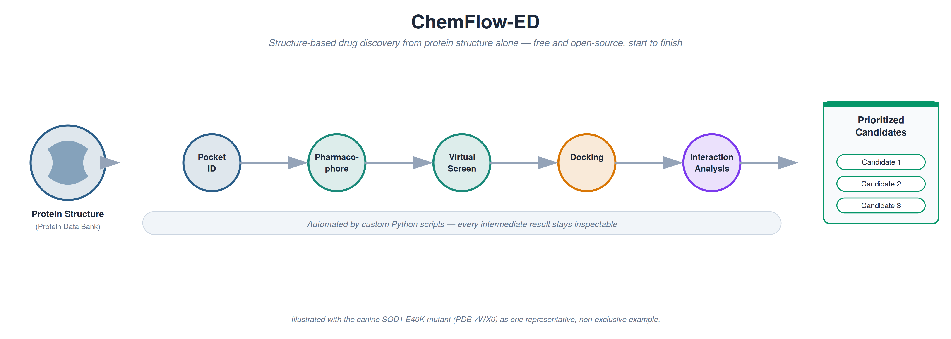
Figure 1. Graphical Abstract. ChemFlow-ED begins with protein structure alone and ends with a prioritized, evidence-based set of candidate ligands, using only free and open-source computational tools.

Educational Context and Learning Objectives
ChemFlow-ED was designed to give students an authentic structure-based drug discovery experience that goes beyond proficiency with any one software package. Rather than teaching tools in isolation, it integrates multiple methodologies into a single research-style project that mirrors how medicinal chemists actually work, drawing on structural biology, biochemistry, medicinal chemistry, and computational chemistry at once while developing the judgment to evaluate computational evidence critically.
Traditional docking laboratories that start from a protein with a bound ligand are efficient for teaching software mechanics, but because the binding site and a "correct" answer are already known, they leave little room for independent inquiry. ChemFlow-ED addresses this by starting from the protein structure alone: students identify candidate pockets, build a receptor-derived pharmacophore, refine a virtual screen, evaluate docking results, and weave the results into a coherent argument for candidate selection. At each stage, computational output is evidence that informs the next decision, not an answer key to be confirmed.
This structure mirrors how medicinal chemistry research actually proceeds. Models are refined as new structural information arrives, hypotheses are revised in light of docking and interaction results, and candidates are compared before any are carried forward — an iterative process rather than a fixed sequence of software commands. Because every tool in the pipeline is free, the workflow is accessible to institutions with limited computational infrastructure, and students can continue using the same software after the course ends. Its modular organization also gives instructors flexibility: individual stages can be dropped into an existing course, or the full sequence can serve as a semester project, capstone experience, or graduate assignment, since each stage produces a well-defined output feeding the next.

Learning Objectives
On completing ChemFlow-ED, students should be able to:
- Explain the role of structure-based drug discovery in modern medicinal chemistry.
- Retrieve, evaluate, and prepare experimentally determined protein structures from the Protein Data Bank.
- Identify and justify candidate ligand-binding pockets using computational pocket-prediction algorithms.
- Construct a receptor-derived pharmacophore model directly from binding-site residues.
- Perform pharmacophore-based virtual screening of commercially available compound libraries.
- Conduct automated molecular docking with open-source software.
- Analyze predicted protein–ligand interactions using structural visualization and automated tools.
- Integrate docking scores, interaction analyses, and structural observations to prioritize candidate ligands.
- Communicate computational findings through publication-quality figures, reports, and presentations.
- Critically evaluate the capabilities and limitations of computational drug discovery methods.
These objectives center on scientific reasoning and communication rather than procedural software operation, distinguishing this project from conventional docking exercises.
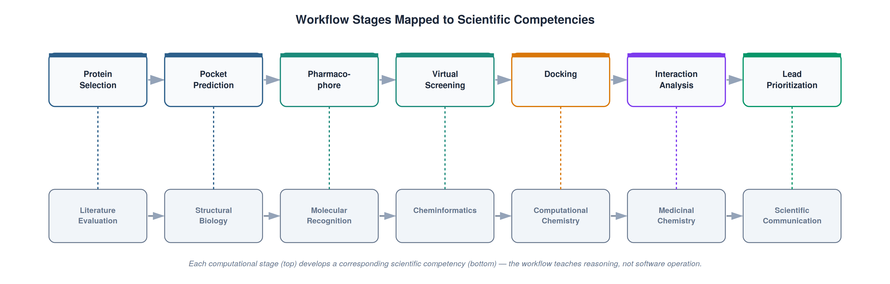
Figure 2. Relationship between workflow stages and learning objectives. Each stage of ChemFlow-ED is paired with a specific scientific competency, underscoring that the project teaches reasoning, not software operation.

Table 1. Learning Objectives Mapped to Workflow Stages
Workflow Stage | Primary Skill Developed | Software | Principal Output
Protein Selection | Literature analysis, target justification | Protein Data Bank | Protein structure
Binding Pocket Identification | Structural biology, ligandability assessment | DoGSiteScorer (ProteinsPlus) | Candidate binding pocket(s)
Pharmacophore Generation | Molecular recognition | PharmacoForge | Receptor-derived pharmacophore
Virtual Screening | Cheminformatics, chemical database searching | Pharmit | Candidate compound library
Molecular Docking | Computational chemistry | AutoDock Vina, MGLTools | Docking poses and affinities
Interaction Analysis | Medicinal chemistry interpretation | PyMOL, Python scripts | Interaction summaries
Candidate Prioritization | Scientific reasoning, communication | Integrated workflow | Publication-style manuscript

Instructor Implementation Note
ChemFlow-ED was first implemented as the capstone project in a senior-level undergraduate medicinal chemistry course. Students completed individual four-week projects, each investigating a different therapeutic target, while applying the same computational methodology and preparing an ACS-style manuscript describing the biological background, computational methods, results, and interpretation. Although only three students took part in this initial offering, completing three independent, disease-distinct projects successfully within a single instructional module is evidence that the workflow is transferable across protein systems and feasible on this time scale. This implementation is presented as proof of feasibility, not a formal educational assessment.

Theoretical Foundation
Structure-based drug discovery of the kind ChemFlow-ED teaches requires several complementary computational methods, each contributing a different kind of evidence about molecular recognition. Rather than treating molecular docking as a stand-alone exercise, ChemFlow-ED combines protein structural analysis, binding-pocket prediction, receptor-derived pharmacophore modeling, virtual screening, docking, and interaction analysis into a single investigative strategy, in which each stage's output becomes the next stage's input. Understanding the theoretical basis for each stage lets students treat computational predictions as evidence to be weighed, rather than absolute truth.

Structure-Based Drug Discovery
Structure-based drug discovery (SBDD) uses an experimentally determined three-dimensional protein structure to identify, evaluate, and optimize candidate ligands.^{1,2} Advances in X-ray crystallography, NMR, and cryo-EM have expanded the number of high-resolution structures available for this kind of analysis, and the Protein Data Bank (PDB) is the central public archive from which they are drawn.⁴ Unlike ligand-based drug discovery, which starts from known active compounds, SBDD starts from the target itself: computational methods characterize candidate binding regions and predict which compounds are likely to interact favorably with them before any experimental testing occurs — especially valuable for targets with no known inhibitor or endogenous ligand.

Binding Pocket Prediction
The first computational challenge in ligand discovery is identifying which regions of a protein surface can bind a small molecule; most cavities and grooves cannot. Pocket-prediction algorithms evaluate protein geometry alongside physicochemical descriptors — cavity volume, depth, enclosure, hydrophobicity, and solvent accessibility — to flag regions with characteristics associated with druggable sites. In ChemFlow-ED, binding pockets are predicted with the DoGSiteScorer module of the ProteinsPlus web server, which combines a difference-of-Gaussian geometric search with a support-vector-machine druggability classifier trained on a benchmark set of more than 1,000 targets.^{19–22} Rather than accepting the top-ranked pocket by default, students compare several candidate cavities using both computational descriptors and visual inspection in PyMOL, introducing the concept of ligandability and making clear that computational rankings require scientific interpretation rather than automatic acceptance.

Receptor-Derived Pharmacophore Modeling
A pharmacophore is the three-dimensional arrangement of molecular features required for favorable binding — hydrogen-bond donors and acceptors, hydrophobic and aromatic regions, and charged groups arranged in a specific geometry.^{23,24} Classical pharmacophore models are built from an experimentally determined protein–ligand complex or a set of known active compounds sharing a common scaffold, neither of which is available when no ligand has been characterized. ChemFlow-ED instead uses receptor-derived pharmacophore modeling, inferring favorable interaction features directly from the amino acid residues lining a predicted pocket, using PharmacoForge.²⁵ The resulting model describes the chemical environment of the receptor rather than the properties of a previously known ligand, extending structure-based methods to unliganded targets while reinforcing a central medicinal chemistry idea: binding is governed by complementarity between a ligand's functional groups and the receptor's local chemical environment, not resemblance to a known drug.

Pharmacophore-Based Virtual Screening
The pharmacophore is submitted to Pharmit, an interactive web platform that screens millions of commercially available compounds against pharmacophore and shape queries in seconds to minutes, using sub-linear search algorithms that support rapid, iterative refinement within a single session.⁹ Because an initial query typically returns far too many or far too few compounds, students learn to adjust individual features — tightening or relaxing a hydrogen-bond constraint, adding or removing a hydrophobic feature — and observe how each change reshapes the size and chemical diversity of the hit list: a direct, hands-on introduction to how molecular recognition constraints govern a virtual screen.

Molecular Docking
Molecular docking predicts how a small molecule is oriented within a binding site and estimates its relative binding affinity using an empirical scoring function.^{2,3,26,27} ChemFlow-ED uses AutoDock Vina, an open-source docking engine that couples an efficient search algorithm with a scoring function trained against experimental structures, achieving substantially faster performance than its predecessor while improving pose accuracy.⁵ Docking scores are useful for ranking candidates but are estimates, not measurements: scoring functions do not fully capture solvation, entropy, or protein flexibility, and a favorable score does not by itself establish a biologically meaningful binding mode.²⁶ Emphasizing this distinction keeps students from over-interpreting a single numerical output.

Protein–Ligand Interaction Analysis
A docking score alone says little about why a ligand is predicted to bind. ChemFlow-ED therefore pairs docking with a structural interaction analysis — identifying hydrogen bonds, hydrophobic contacts, aromatic interactions, and electrostatic contacts within the binding pocket — using PyMOL with custom Python routines. This step turns a numerical ranking into a structural argument that can be compared across candidates and communicated visually, bringing quantitative and qualitative evidence together for candidate prioritization.

The ChemFlow-ED Workflow
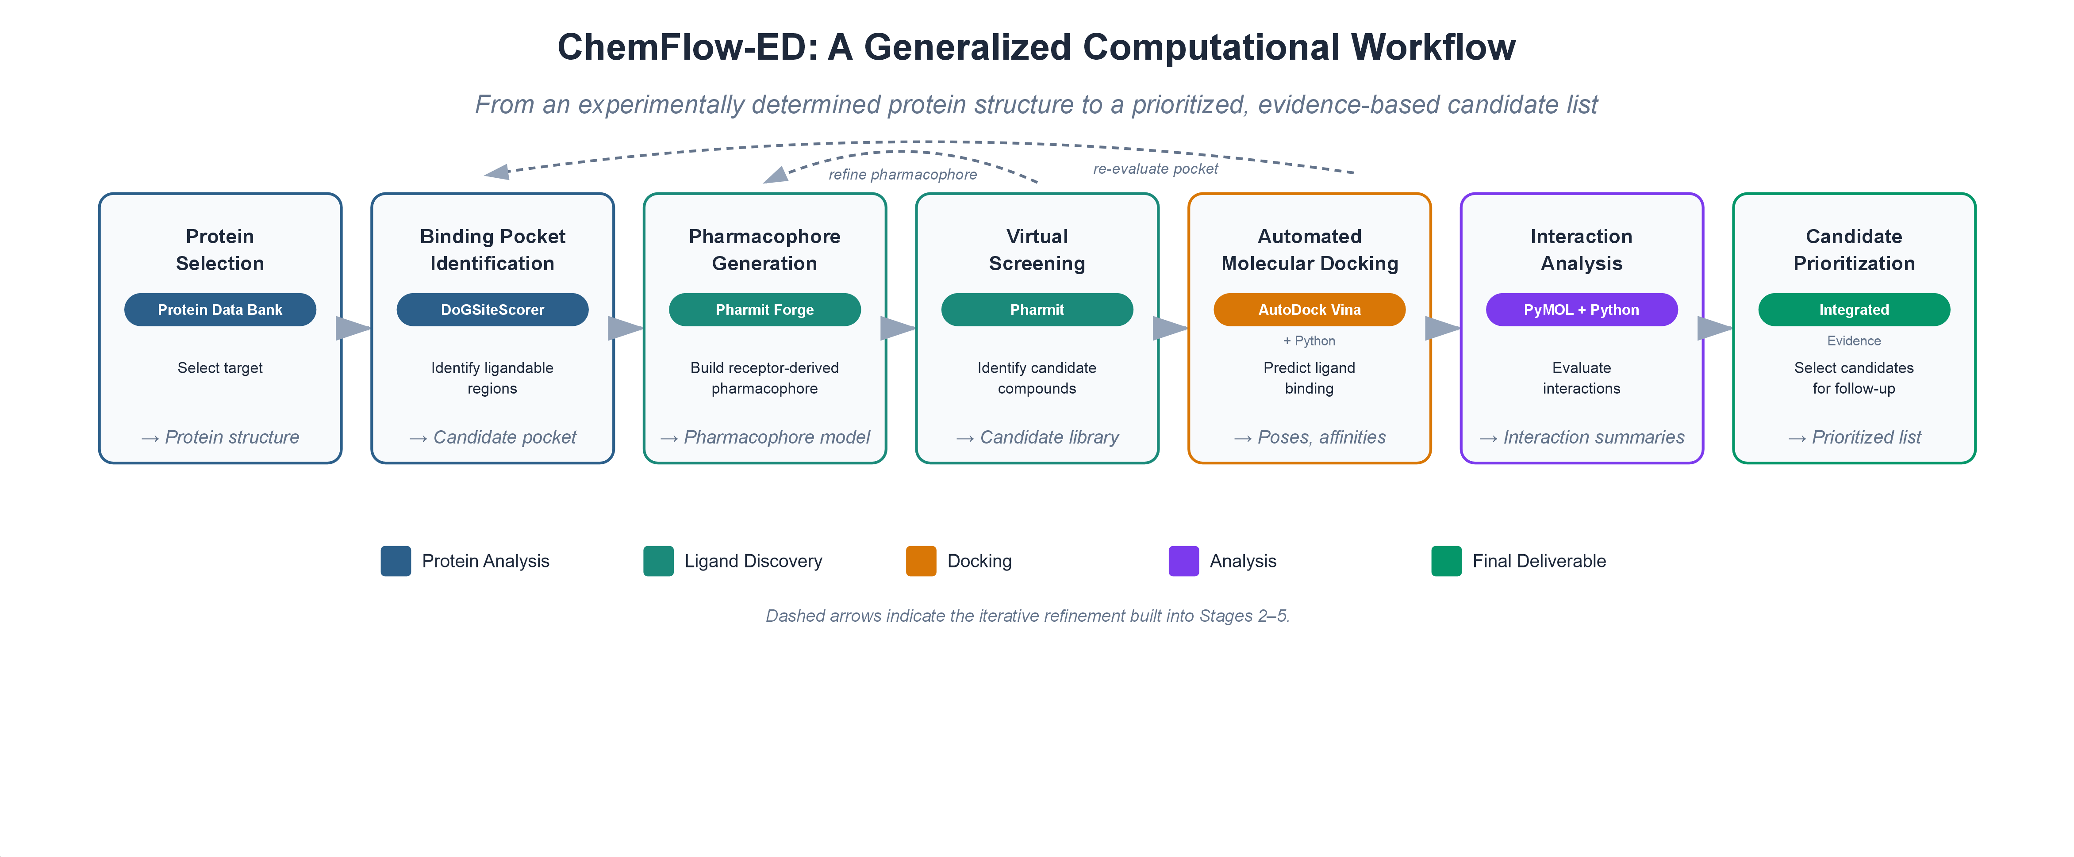
Figure 3. ChemFlow-ED overview. The complete ChemFlow-ED workflow, from protein structure to a prioritized candidate list. Dashed arrows indicate the iterative refinement built into Stages 2–5.

Table 2. Overview of the ChemFlow-ED Workflow
Stage | Scientific Objective | Primary Software | Output
1. Protein Selection | Select a therapeutically relevant target | Protein Data Bank | Protein structure
2. Binding Pocket Identification | Identify ligandable regions | DoGSiteScorer | Candidate binding pocket
3. Pharmacophore Generation | Construct a receptor-derived pharmacophore | PharmacoForge | Pharmacophore model
4. Virtual Screening | Identify candidate compounds | Pharmit | Candidate ligand library
5. Molecular Docking | Predict ligand binding | AutoDock Vina + Python automation | Docking poses and affinities
6. Interaction Analysis | Evaluate protein–ligand interactions | PyMOL + Python scripts | Interaction summaries
7. Candidate Prioritization | Integrate computational evidence | Multiple tools | Prioritized candidate ligands

Stage 1. Protein Selection
The workflow begins with a therapeutically relevant structure from the Protein Data Bank, chosen for biological significance, structural quality, and suitability for computational analysis. Targets are drawn preferentially from inherited metabolic disorders, neurodegenerative disease, cancer, infectious disease, or other areas where a stabilizing or modulating small molecule would have therapeutic value. Proteins with a co-crystallized ligand may also be used, but ChemFlow-ED was designed specifically to work in their absence, so an unliganded structure is a fully valid — and often more instructive — starting point. Selection is itself part of the investigation: literature review of the protein’s function, disease relevance, and structural biology establishes the context for every downstream computational decision.

Stage 2. Binding Pocket Identification
Candidate pockets are predicted with DoGSiteScorer, which scores each candidate cavity on volume, surface area, enclosure, hydrophobicity, and predicted druggability. Because a structure typically yields several plausible pockets, students are asked to evaluate multiple candidates with both the computational descriptors and visual inspection in PyMOL rather than defaulting to the top-ranked hit — a direct demonstration that computational output requires scientific interpretation and that more than one structurally reasonable hypothesis can exist. The residues defining the selected pocket are exported to the pharmacophore stage.
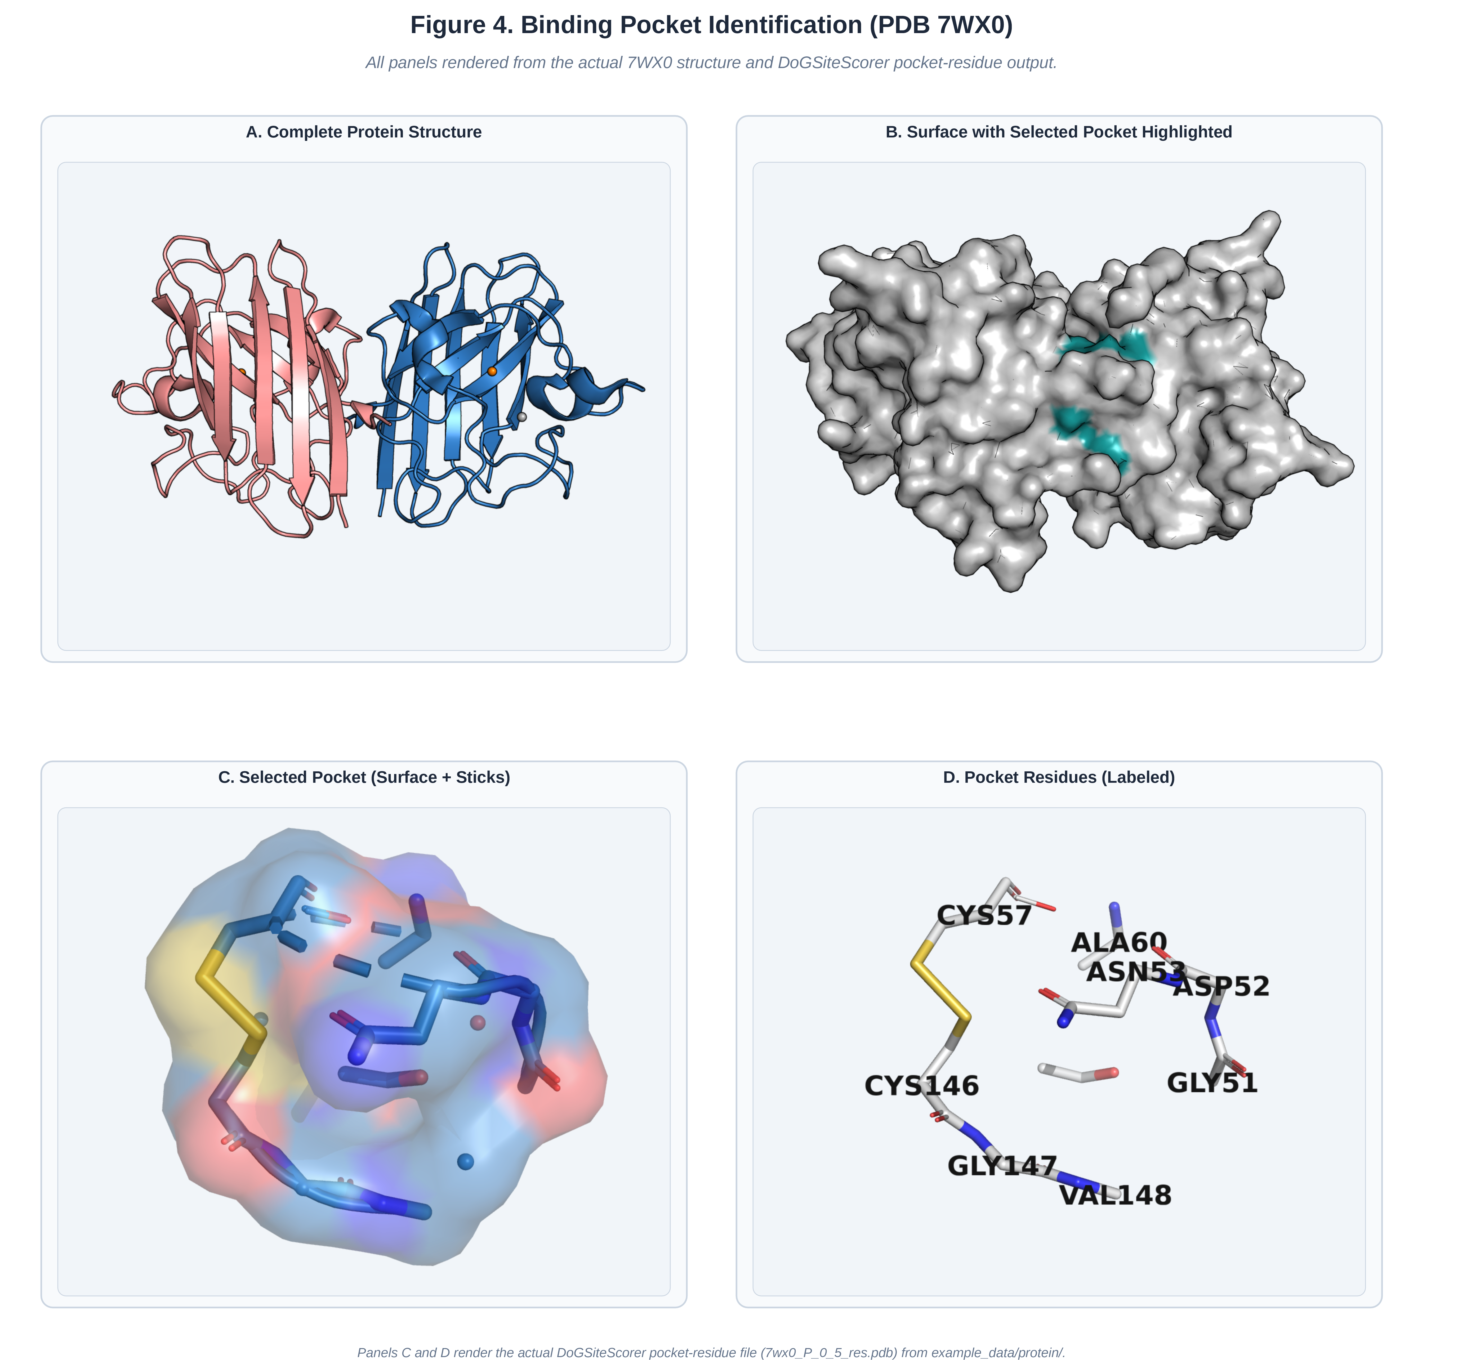
Figure 4. Binding pocket identification. Binding-pocket identification for PDB 7WX0. (A) Complete protein homodimer (chain A, blue; chain B, salmon; Cu/Zn ions as spheres). (B) Protein surface with the selected pocket highlighted (teal). (C–D) Close-up of the selected pocket and its lining residues, rendered directly from the DoGSiteScorer output (example_data/protein/7wx0_P_0_5_res.pdb).

Stage 3. Receptor-Derived Pharmacophore Generation
Pocket residues are imported into PharmacoForge, which identifies hydrogen-bond donor and acceptor sites, hydrophobic and aromatic features, and charged interaction points directly from the surrounding side chains. The initial model typically requires several rounds of refinement — features added, removed, or resized — to balance chemical specificity against the number of compounds the pharmacophore will return during screening. This refinement is one of the most instructive parts of the project: it shows students that a computational model evolves through repeated evaluation rather than being generated once and used unchanged.
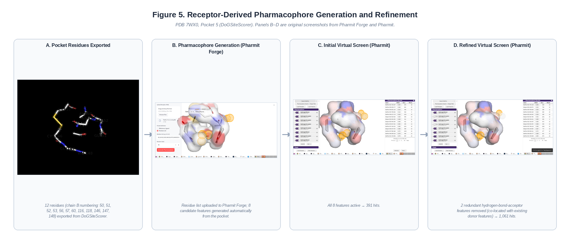
Figure 5. Receptor-derived pharmacophore generation and refinement. Generation and refinement of a receptor-derived pharmacophore for PDB 7WX0, Pocket 5. (A) The 12 pocket residues exported from DoGSiteScorer. (B) The 8 candidate interaction features generated automatically in PharmacoForge from those residues. (C) Initial virtual screen with all 8 features active (391 hits). (D) Refined screen after removing two hydrogen-bond-acceptor features that were co-located with existing donor features at the same coordinates (1,061 hits). Panels B–D are original screenshots from PharmacoForge and Pharmit.

Stage 4. Pharmacophore-Based Virtual Screening
The refined pharmacophore is submitted to Pharmit for screening against libraries of commercially available compounds. Initial queries often return an impractical number of hits or almost none, and adjusting individual features shows students, in real time, how molecular recognition constraints shape a virtual screen. Selected candidates are downloaded in SDF format for the docking pipeline.
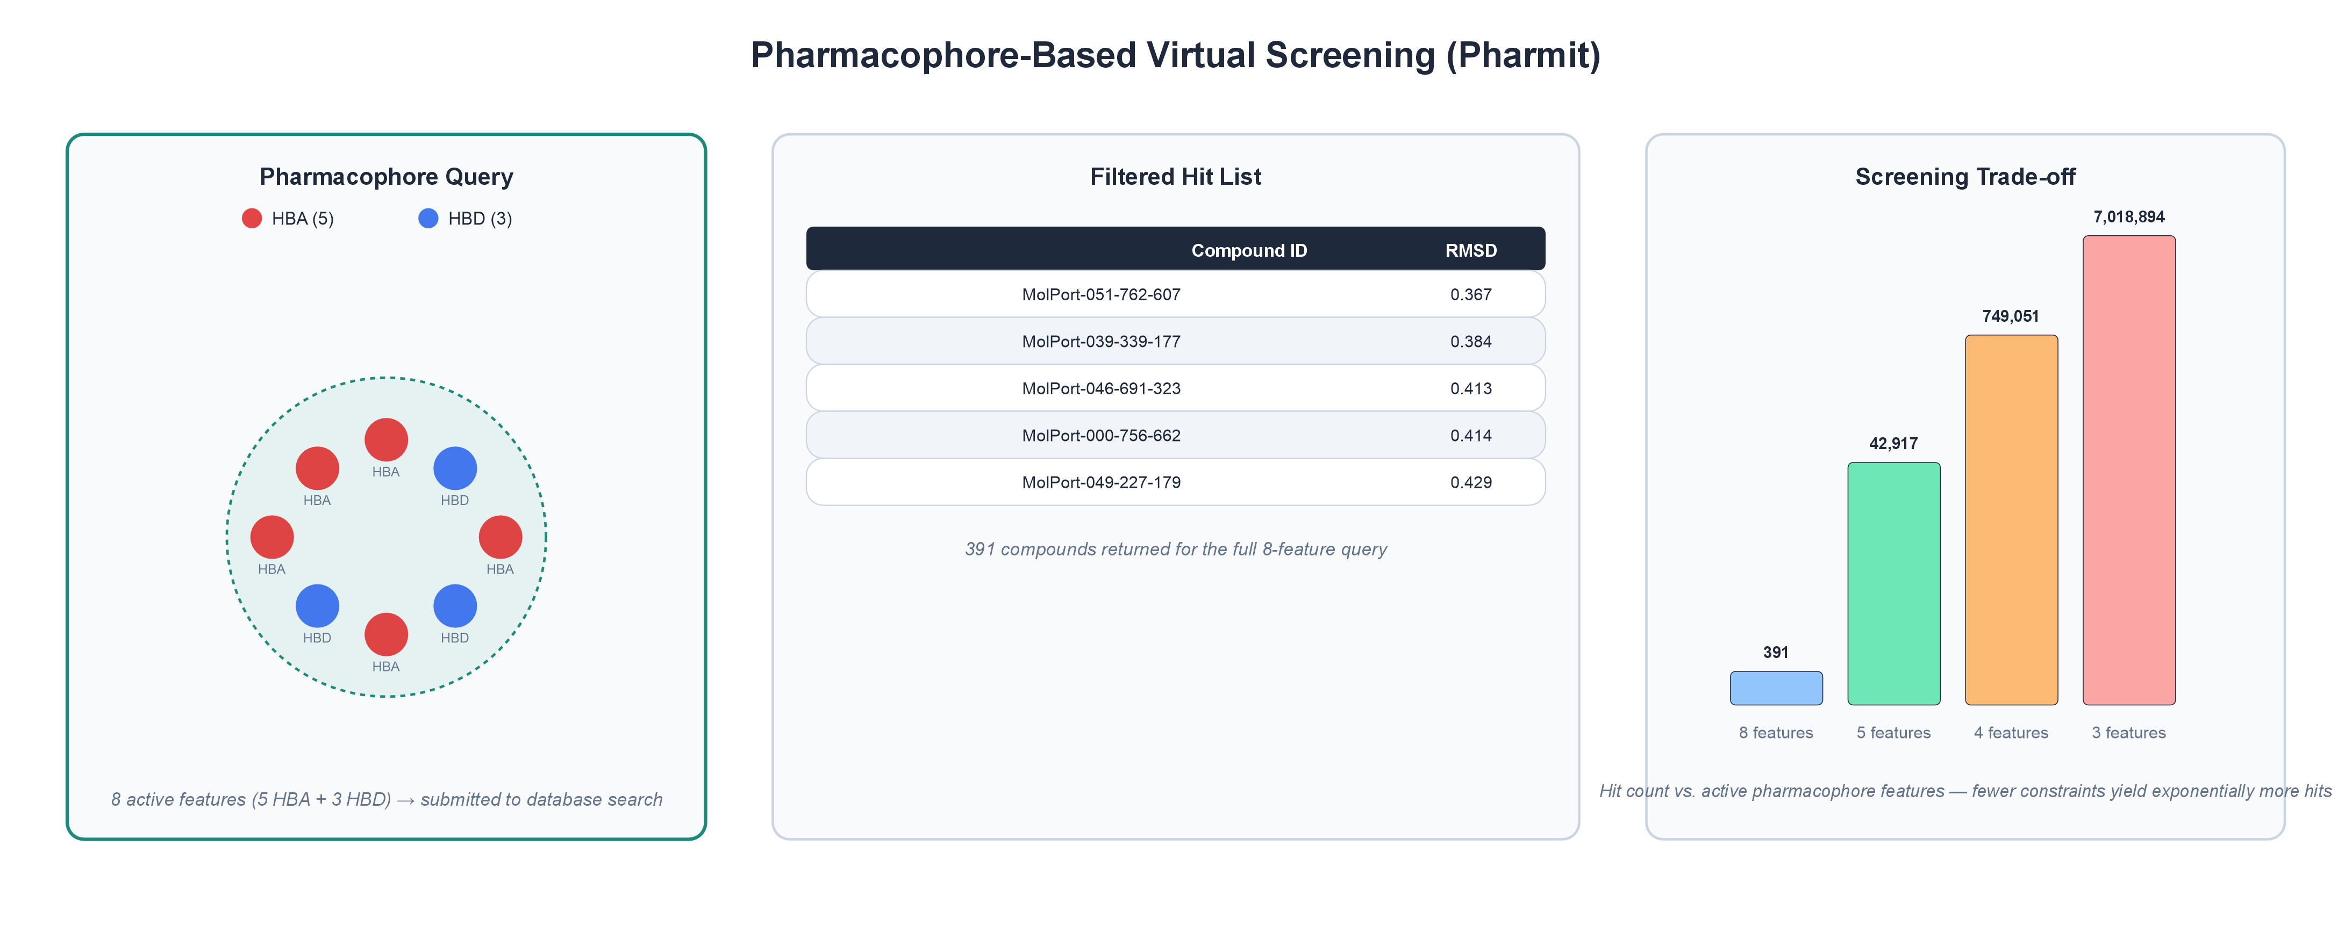
Figure 6. Virtual screening. Pharmacophore-based virtual screening in Pharmit. Adjusting individual features changes both the number and chemical diversity of retrieved compounds.

Table 3. Computational Outputs Generated at Each Stage
Stage | Output Generated | Feeds Into
Protein Selection | Protein structure | Pocket prediction
Binding Pocket Identification | Pocket residues | Pharmacophore generation
Pharmacophore Generation | Pharmacophore model | Virtual screening
Virtual Screening | Candidate ligand library (SDF) | Molecular docking
Molecular Docking | Docking poses, binding affinities | Interaction analysis
Interaction Analysis | Interaction summaries (CSV), PyMOL sessions | Candidate prioritization
Candidate Prioritization | Ranked, justified candidate list | Final manuscript

Stage 5. Automated Molecular Docking
Candidate compounds are docked using an automation pipeline built specifically for ChemFlow-ED, which coordinates PyMOL Open Source, AutoDock Vina, and MGLTools.^{5,6} Receptor preparation removes crystallographic waters, irrelevant heteroatoms, and any co-crystallized ligand while preserving protein structure, adds hydrogens, and converts the result to AutoDock-compatible PDBQT format. Ligand SDF files from Pharmit are split automatically into individual molecules, assigned identifiers, and converted through the same pipeline. AutoDock Vina then docks every ligand into a search box centered on the selected pocket, producing multiple ranked poses and affinities per compound. Because the pipeline is applied identically to every ligand and every intermediate file is retained, differences in the results reflect ligand chemistry rather than inconsistencies in preparation, and any stage can be inspected without repeating the calculation.
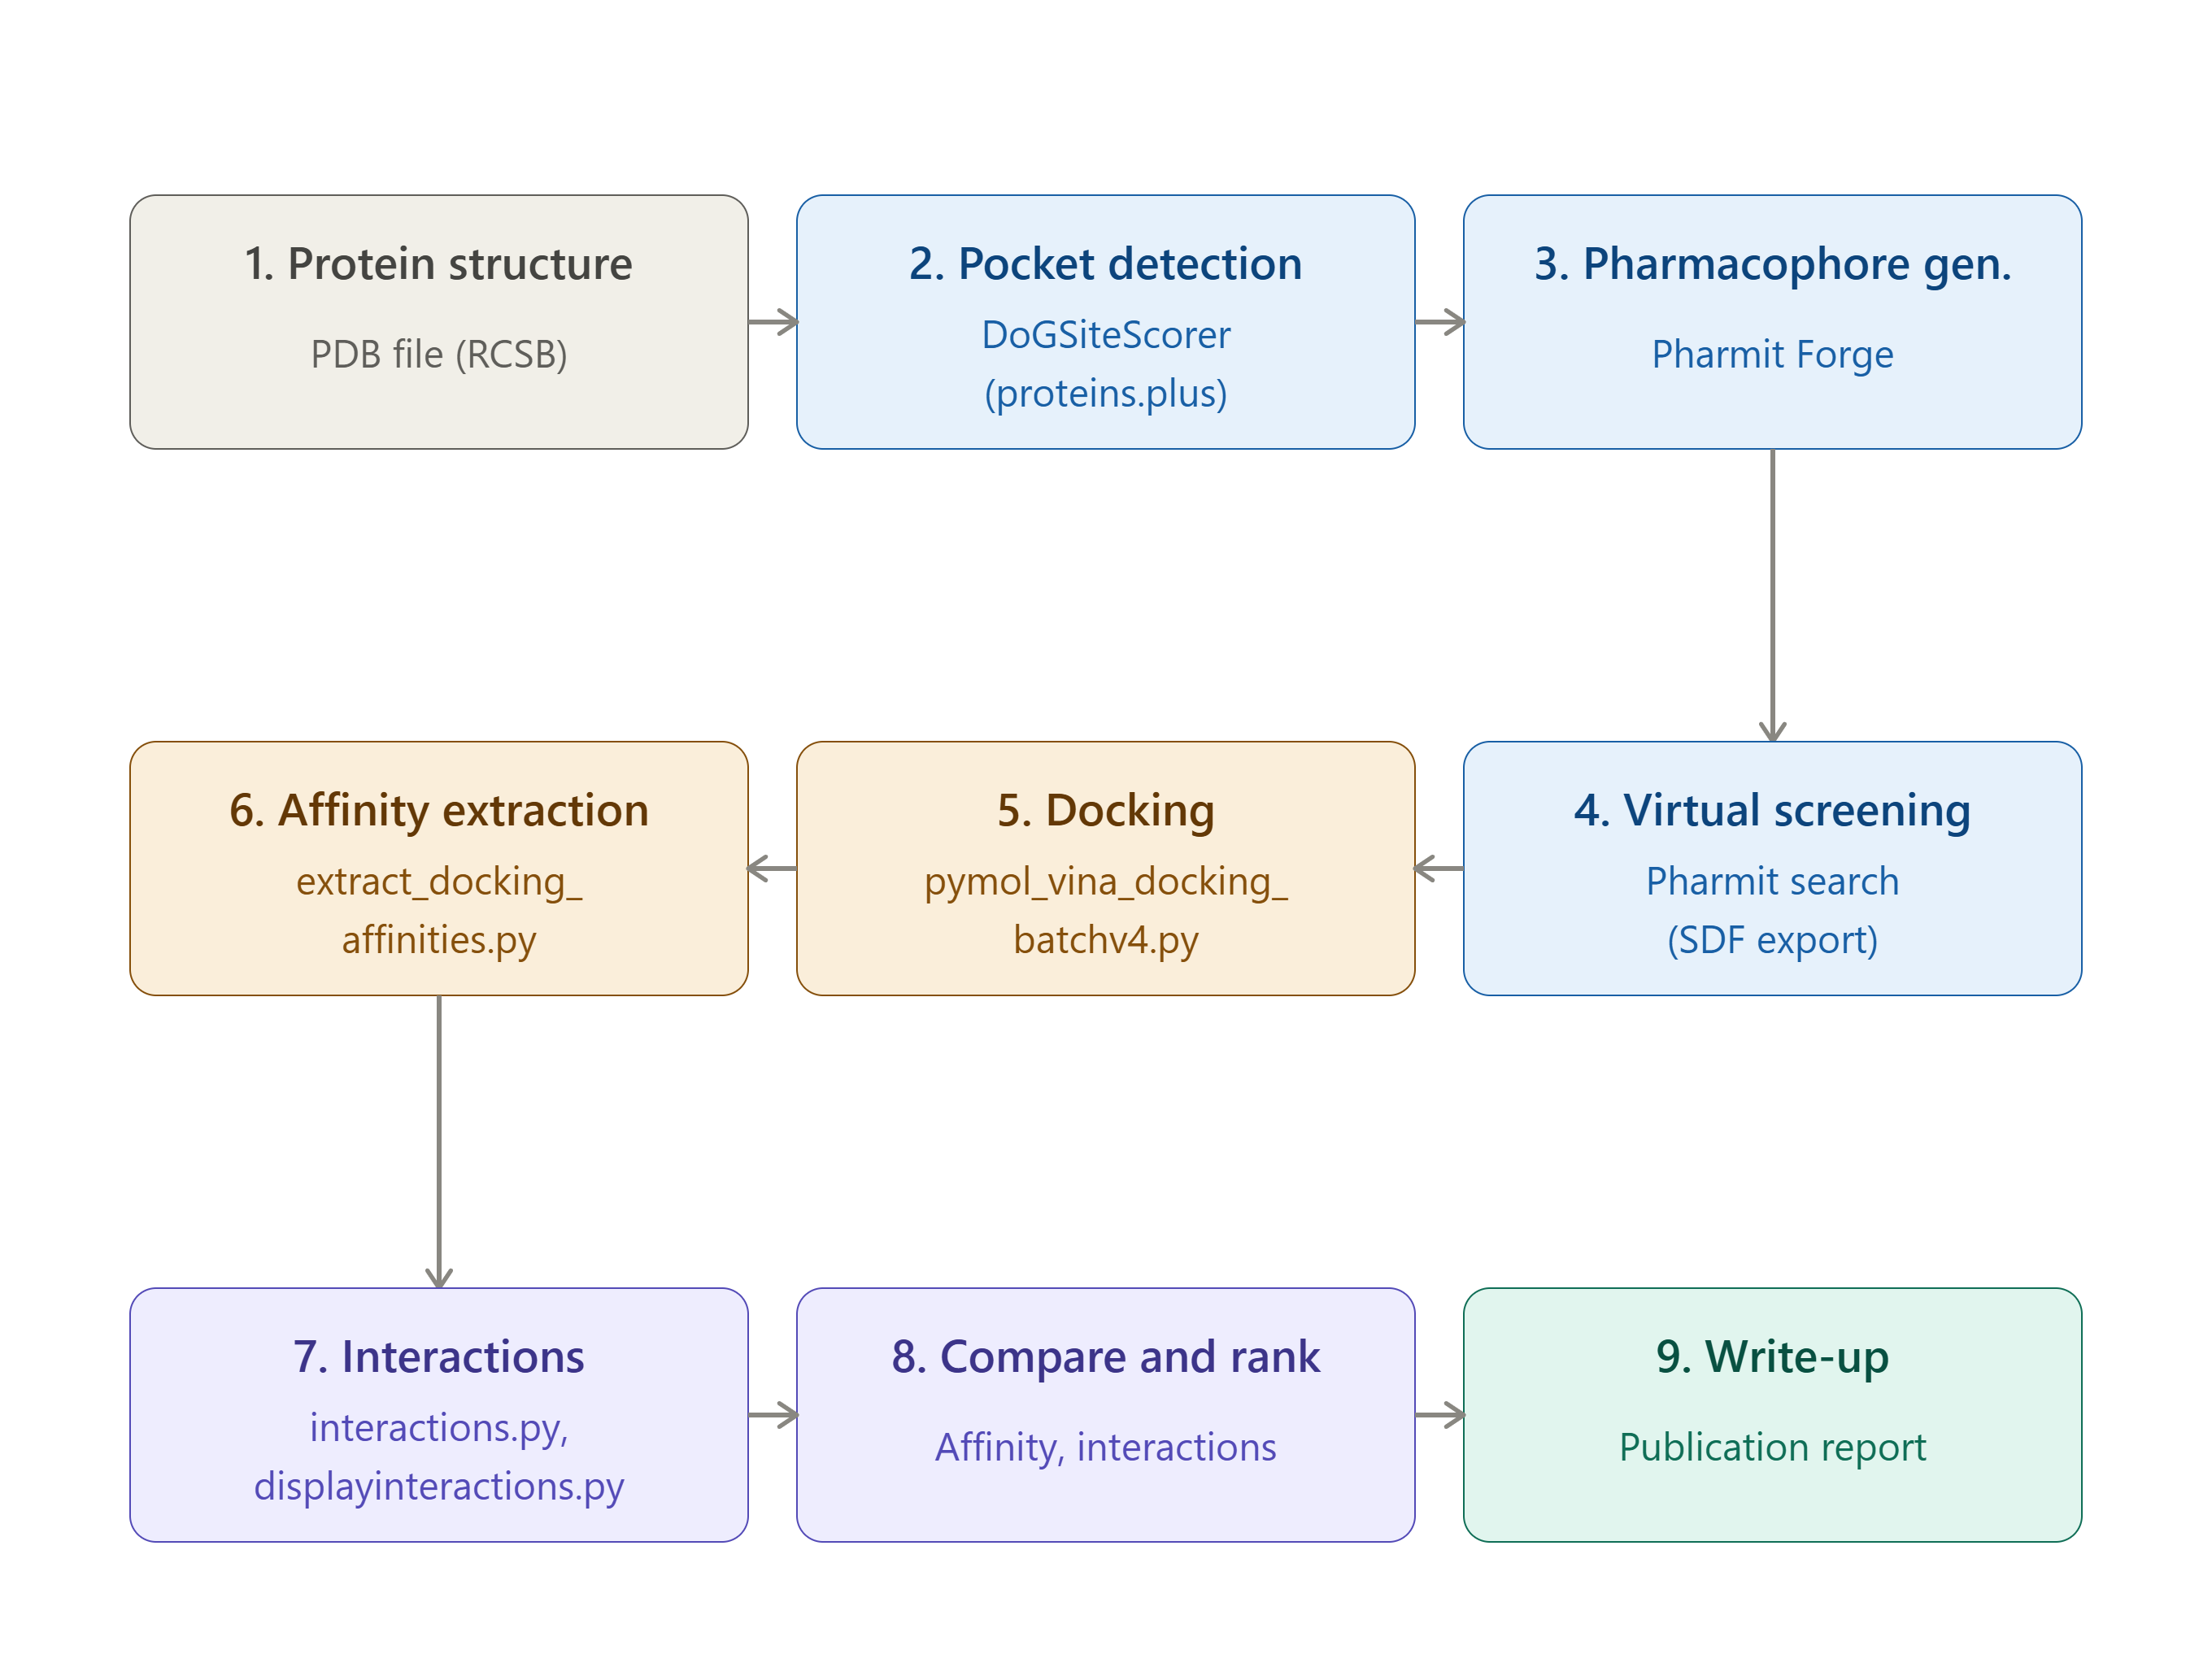
Figure 7. ChemFlow-ED computational workflow. The pipeline proceeds from protein structure retrieval through pocket detection, pharmacophore-guided virtual screening, automated docking, and interaction analysis to final candidate prioritization and write-up. Gray denotes the initial input; blue denotes steps performed in web-based tools that require visual inspection and iterative refinement by the user; amber denotes fully automated steps executed via custom Python scripts; purple denotes synthesis steps in which results are evaluated and prioritized by the user; and teal denotes the final output. Arrows indicate the direction of data flow through the pipeline.

Stage 6. Protein–Ligand Interaction Analysis
Docking affinities alone provide limited insight into why a pose is favorable, so a second automated stage examines each docking pose structurally. Custom Python routines identify neighboring residues and characterize hydrogen bonds, hydrophobic contacts, aromatic interactions, and electrostatic contacts, exporting the results as CSV summaries alongside PyMOL session files for publication-quality visualization. This lets students combine a quantitative docking score with a qualitative structural argument — reinforcing that similar affinities can arise from very different interaction patterns, and that a favorable score does not, by itself, establish a biologically meaningful binding mode.²⁶
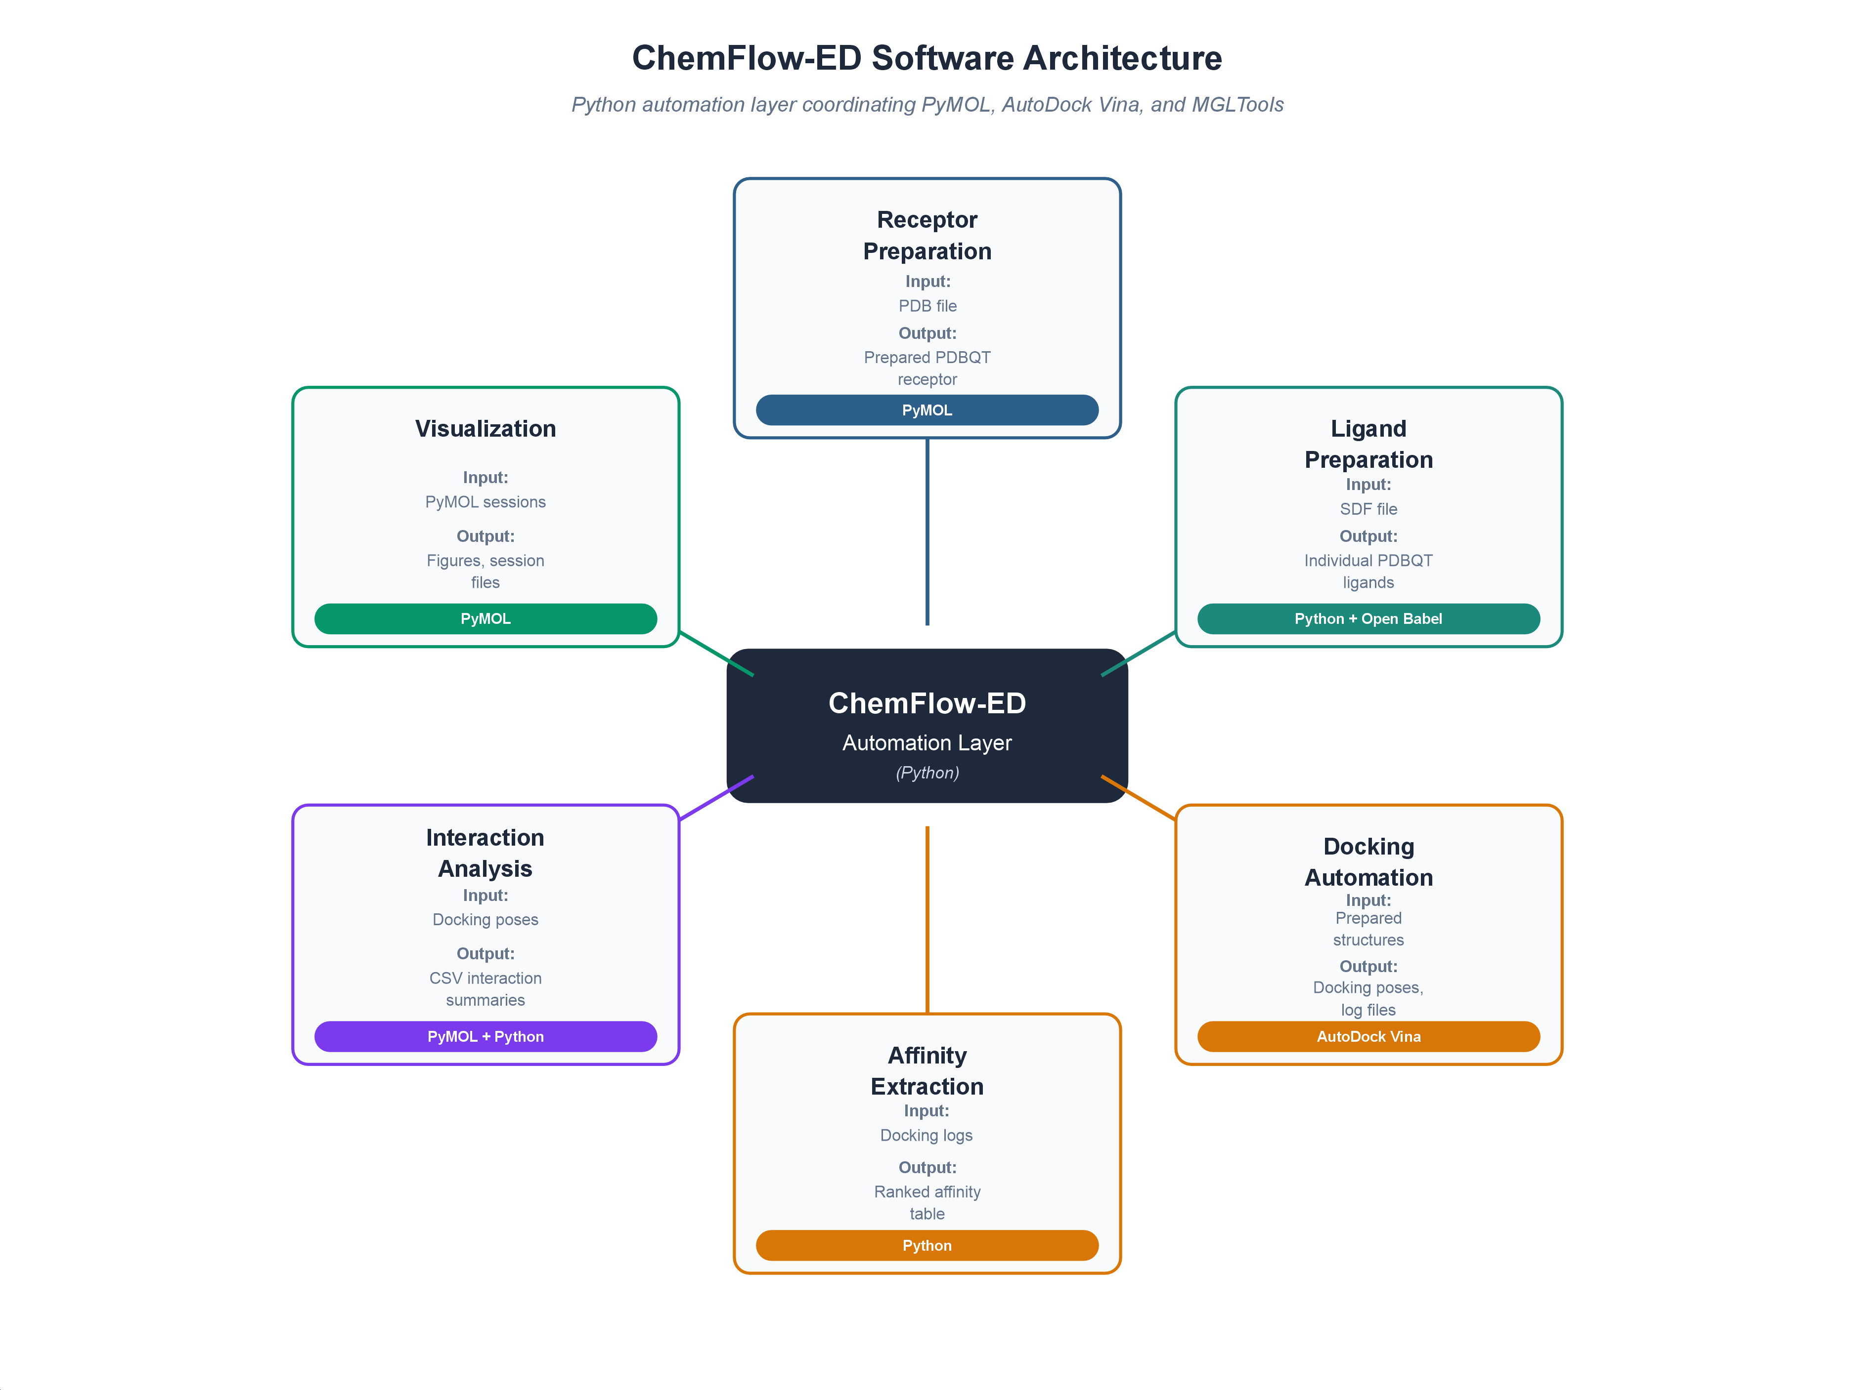
Figure 8. Software architecture. Software architecture of the ChemFlow-ED automation framework. Python scripts function as an orchestration layer coordinating PyMOL, AutoDock Vina, and MGLTools rather than replacing them.
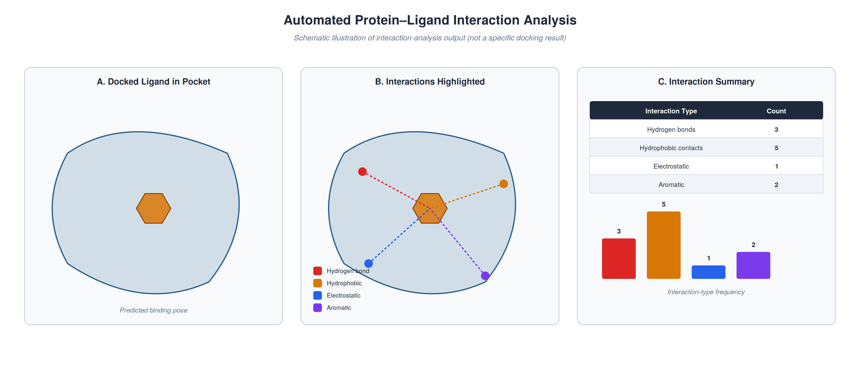
Figure 9. Interaction analysis. Automated protein–ligand interaction analysis. A single computational pass produces both a structural visualization and a quantitative interaction summary. (Schematic illustration; not a specific docking result.)

Stage 7. Candidate Prioritization
The final stage integrates every line of evidence gathered so far — predicted affinity, interaction pattern, pharmacophore satisfaction, structural complementarity, and visual inspection of the pose — into a scientific argument for which compounds merit further attention. ChemFlow-ED deliberately does not resolve to one “correct” answer; several candidates may be defensible depending on the biological objective, so prioritization is expressed as justified reasoning rather than a single numerical ranking. The final deliverable is a publication-style report integrating biological background, computational methodology, docking and interaction results, and medicinal chemistry interpretation — serving simultaneously as the culminating assignment and as a record of the full investigation.

Table 4. Suggested Four-Week Instructional Sequence
Week | Activities
1 | Protein selection, literature review, structural analysis
2 | Binding pocket identification, pharmacophore generation, virtual screening
3 | Automated molecular docking, interaction analysis
4 | Candidate prioritization, manuscript preparation, presentation

Software Architecture and Workflow Automation
A defining feature of ChemFlow-ED is that its component software packages are unified by a purpose-built automation layer rather than operated independently. Each stage of the workflow can, in principle, be run manually, but manual execution scales poorly once a virtual screen returns more than a handful of compounds: receptor preparation, ligand conversion, docking, directory management, affinity extraction, and interaction analysis are all repetitive and error-prone by hand, and none of them contributes directly to scientific interpretation. The Python automation framework developed for ChemFlow-ED coordinates data exchange among PyMOL Open Source, AutoDock Vina, MGLTools, and Pharmit output files, functioning as an orchestration layer that standardizes file preparation, executes docking, organizes outputs, and produces analysis-ready datasets — without replacing any of the underlying software or hiding its intermediate results from students.

Modular Design
Each component of the framework performs one well-defined task and produces a standardized output for the next: receptor preparation always yields a PDBQT structure suitable for docking regardless of the downstream ligand set, and ligand preparation always yields uniformly formatted docking inputs regardless of compound source. Because modules communicate only through these standardized files, any one component can be modified, replaced, or extended without redesigning the rest of the pipeline — which also lets instructors scale the project up or down. A course emphasizing structural biology might use only the protein-analysis and pharmacophore modules; one emphasizing computational chemistry might run the complete automated docking and interaction-analysis pipeline.

Receptor and Ligand Preparation Modules
Receptor preparation uses PyMOL Open Source to strip crystallographic solvent, non-essential heteroatoms, and any co-crystallized ligand, then converts the resulting structure to PDBQT format with MGLTools. Because this step is performed once per investigation, every subsequent docking calculation uses identical receptor coordinates, which both improves reproducibility and removes one of the most common sources of student error — inconsistent receptor preparation between runs.
Ligand preparation automatically imports the multi-compound SDF file from Pharmit, splits it into individual molecules, assigns standardized identifiers, and converts each ligand to PDBQT format, ensuring that every candidate is prepared identically and that subsequent comparisons reflect chemical differences among ligands rather than preparation artifacts.

Docking and Affinity Extraction Modules
The docking module runs AutoDock Vina sequentially against every prepared ligand using a search box centered on the selected pocket, and each resulting docking directory retains the receptor and ligand structures, poses, predicted affinities, Vina log files, and a PyMOL session for immediate visualization — a standardized organization that makes any single result easy to retrieve later. A companion script then parses the Vina output logs recursively, extracts the predicted binding affinity for every mode of every ligand, and consolidates them into a single ranked spreadsheet, so that the full candidate set can be screened at a glance before any individual pose is inspected in detail.

Table 5. Functional Organization of the Automation Framework
Module | Function | Input | Output
Receptor Preparation | Standardize protein structure | PDB file | Prepared PDBQT receptor
Ligand Preparation | Process candidate compounds | SDF file | Individual PDBQT ligands
Docking Automation | Execute AutoDock Vina | Prepared structures | Docking poses, log files
Affinity Extraction | Rank docking results | Docking logs | Consolidated affinity table
Interaction Analysis | Identify protein–ligand contacts | Docking poses | CSV interaction summaries
Visualization | Generate publication figures | PyMOL sessions | Figures, session files

Reproducibility, Transparency, and Extensibility
Standardized directory organization and automated naming mean that every docking run is documented and independently verifiable — a small-scale application of the same good practices that underlie reproducible computational research more broadly.^{28,29} Because every intermediate file remains accessible, automation accelerates the workflow without turning any stage into a black box, which is a deliberate design choice: time saved on file preparation is meant to be redirected toward structural interpretation and evidence-based decision-making, not removed from the student’s experience altogether. The same modular architecture leaves room for future expansion — molecular dynamics, MM/PBSA or MM/GBSA free-energy estimates, or machine-learning-based rescoring could all be added as additional modules without altering the existing pipeline, keeping the framework adaptable as computational medicinal chemistry continues to evolve.³⁰

Classroom Implementation
ChemFlow-ED was implemented as the capstone project in a senior-level undergraduate medicinal chemistry course, enrolling three students who each completed an independent four-week investigation. Every student applied the identical computational methodology described above to a different, self-selected therapeutically relevant protein target, which meant that while the biological questions varied, common procedures for pocket prediction, pharmacophore generation, screening, docking, and interaction analysis anchored shared classroom discussion throughout the module. Rather than reproducing a previously published docking study, each student began from an experimentally determined structure and the supporting biological literature, and computational output was treated throughout as evidence supporting a hypothesis rather than a definitive measure of biological activity.
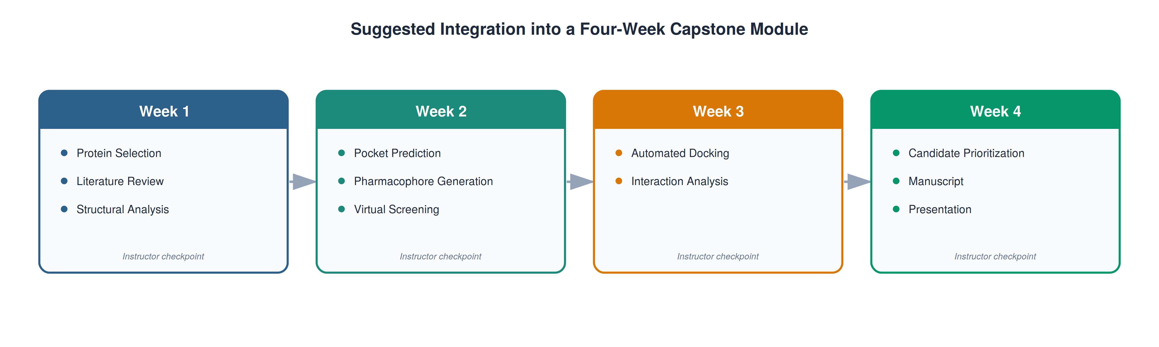
Figure 10. Educational integration. Suggested integration of ChemFlow-ED into a four-week capstone module.

Ethical Considerations
Student participation in ChemFlow-ED was part of required coursework in an existing capstone course and did not constitute a formal human-subjects research study; no data were collected from students beyond normal course assessment, and no identifiable student information is reported in this manuscript. Consistent with institutional guidance on the use of student work in scholarly publications, the example student manuscript provided in the Supporting Information has been redacted to remove all student-identifying information, and student consent for use of their coursework was obtained prior to submission.

Computational Resources
Every tool required for ChemFlow-ED — the Protein Data Bank, ProteinsPlus/DoGSiteScorer, PharmacoForge, Pharmit, PyMOL Open Source, AutoDock Vina, MGLTools, Open Babel, and the accompanying Python scripts — is free and runs on a standard desktop or laptop computer, with no dependency on institutional software licenses or high-performance computing. That accessibility also means students can continue using the same tools for undergraduate research or independent projects after the course ends.

Table 6. Computational Resources Required for Implementation
Resource | Function | Cost
Protein Data Bank | Source of protein structures | Free
ProteinsPlus / DoGSiteScorer | Binding-pocket prediction | Free
PharmacoForge | Receptor-derived pharmacophore generation | Free
Pharmit | Virtual screening | Free
PyMOL Open Source | Molecular visualization, structure preparation | Free
AutoDock Vina | Molecular docking | Free
MGLTools | Docking-format conversion | Free
Open Babel | Chemical file-format interconversion | Free
ChemFlow-ED Python scripts | Workflow automation | Free (open source)

Table 7. Script Organization within the ChemFlow-ED Repository
Script | Function
pymol_vina_docking_batchv4.py / docking_batch_with_create_results_file.py | Batch receptor/ligand preparation and AutoDock Vina docking from single ligands or multi-compound SDF files
pymol_vina_docking.py | Single-ligand receptor/ligand preparation and AutoDock Vina docking with a manually specified search box; the single-compound predecessor to the batch workflow above
extract_docking_affinities.py | Recursively parses Vina docking-summary logs and consolidates binding affinities into a ranked CSV
interactions.py / displayinteractions.py | Identify neighboring residues and classify hydrogen-bond, hydrophobic, and electrostatic contacts within PyMOL
pymol_docking_analysis.py | Generates multi-panel summary plots of docking scores and contact statistics across a ligand set
verify_installation.py | Checks that Python, PyMOL, AutoDock Vina, and MGLTools are correctly installed before a session begins
INSTALLATION_GUIDE.md / QUICK_START_GUIDE_batch.md | Step-by-step setup and batch-docking instructions for students and instructors

Adaptability
Although developed for an advanced undergraduate medicinal chemistry course, ChemFlow-ED’s modular organization supports adaptation to structural biology, biochemistry, computational chemistry, cheminformatics, and undergraduate research settings alike. For shorter modules, instructors can supply a preselected pocket or pharmacophore and retain only the screening, docking, and interaction-analysis stages; for graduate courses or research experiences, the workflow can be extended with molecular dynamics, free-energy calculations, or experimental follow-up. Because the emphasis throughout is on scientific reasoning rather than mastery of a specific software package, the workflow remains usable even as the underlying tools continue to change.

Table 8. Suggested Adaptations for Different Instructional Settings
Setting | Suggested Scope
Advanced Undergraduate Medicinal Chemistry | Complete workflow (capstone project)
Graduate Medicinal Chemistry | Complete workflow + molecular dynamics
Computational Chemistry | Emphasize automation, docking, and scoring
Structural Biology | Protein analysis and pharmacophore generation only
Undergraduate Research | Complete workflow with experimental follow-up
Independent Study | Self-paced implementation with instructor checkpoints

Representative Application: Canine SOD1
To illustrate ChemFlow-ED in practice, the canine Cu/Zn superoxide dismutase E40K mutant (PDB ID: 7WX0) was used as one representative target. The E40K mutation is the principal cause of canine degenerative myelopathy, a naturally occurring, ALS-like neurodegenerative disease in dogs that shares clinical and structural features with human SOD1-linked familial ALS; the mutation disrupts a stabilizing salt bridge between residues E40 and K91, destabilizing the native fold and promoting aggregation.^{17,18,31} The protein was chosen because it is a biologically relevant, conformationally unstable target that currently lacks any established small-molecule stabilizer suitable for an instructional docking exercise — precisely the situation ChemFlow-ED is designed for. The purpose of this case study is to demonstrate the workflow’s methodology and decision-making process, not to report the discovery of a specific therapeutic lead; accordingly, the emphasis below is on how each computational stage was applied rather than on the biological significance of any single candidate compound.
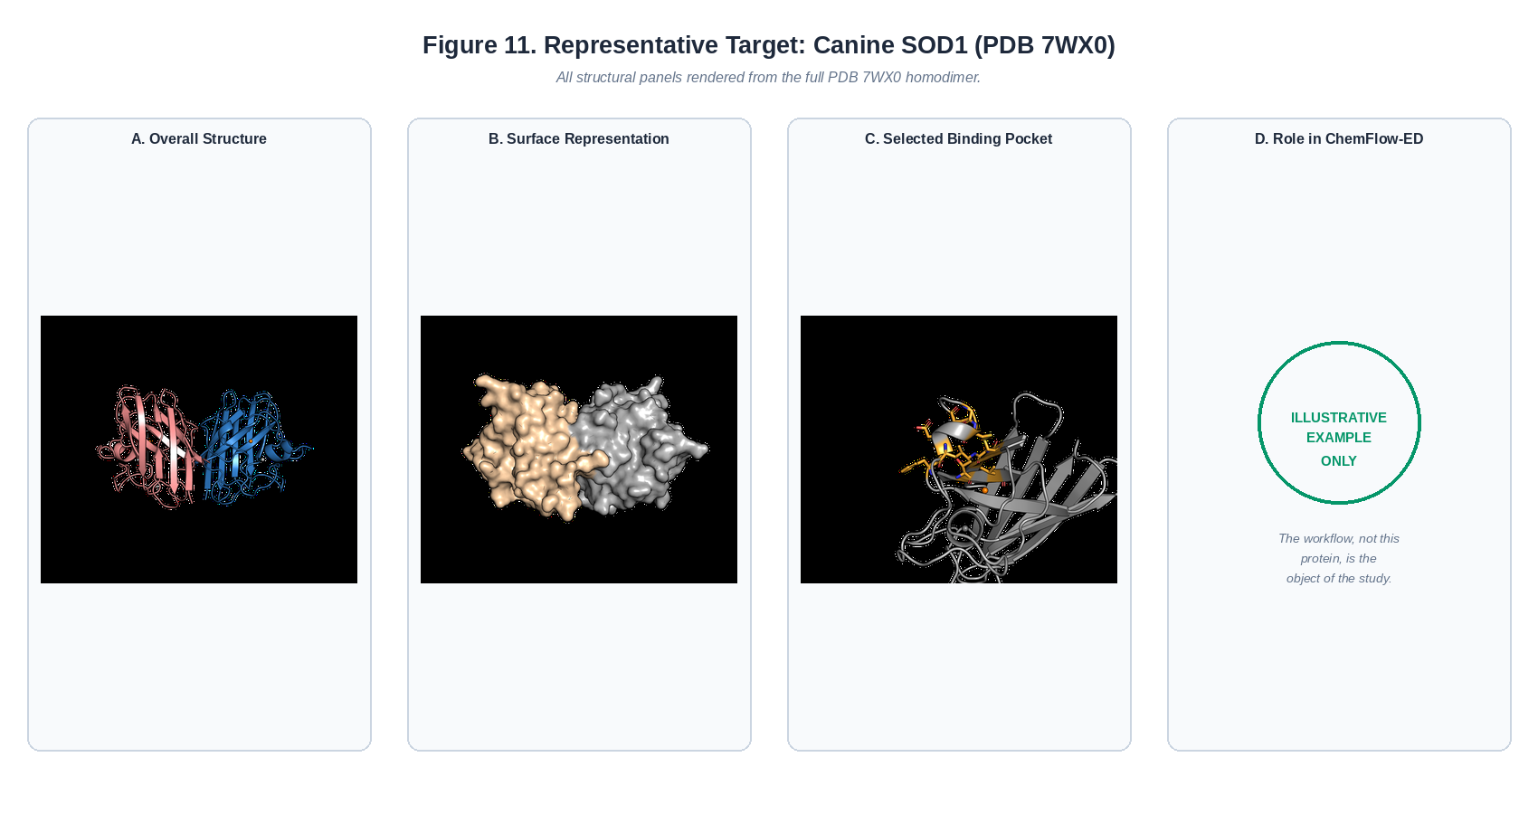
Figure 11. Representative application. Canine SOD1 (PDB 7WX0), the representative target used to illustrate ChemFlow-ED. (A) Overall homodimer structure. (B) Surface representation. (C) The selected binding pocket in structural context. The workflow itself, not this protein, is the object of the study.

Protein Selection and Structural Evaluation
The crystal structure of canine SOD1 E40K was retrieved from the PDB and examined in PyMOL Open Source to characterize its tertiary structure, dimer interface, and secondary-structure organization. Literature on SOD1 biology, the structural consequences of the E40K mutation, and the relationship between destabilization and disease provided the context for every downstream computational choice; because the goal was conformational stabilization rather than enzymatic inhibition, the workflow was directed toward a structurally favorable region that might support the native fold, rather than toward the enzyme’s catalytic site.

Binding Pocket Identification and Pharmacophore Generation
DoGSiteScorer identified several candidate cavities with favorable geometric and physicochemical characteristics. Rather than choosing by druggability score alone, the candidates were compared visually in PyMOL for accessibility and proximity to regions plausibly involved in structural stabilization — again illustrating that computational predictions inform, but do not replace, scientific judgment. The residues defining the selected pocket (Pocket 5; 12 residues) were exported to PharmacoForge, which generated eight candidate interaction features directly from the surrounding side chains. Two of these features — hydrogen-bond acceptors positioned at the same coordinates as existing hydrogen-bond donor features — were judged redundant and removed. Screening with the complete eight-feature model returned 391 hits; removing the two redundant acceptor features relaxed the query and returned 1,061 hits. This modest adjustment illustrates the iterative character of pharmacophore development described throughout this manuscript: a small, chemically justified change in feature composition can substantially reshape the size of a virtual screen (Figure 5).

Virtual Screening, Docking, and Interaction Analysis
The refined pharmacophore was submitted to Pharmit, and the resulting candidate compounds were processed through the automated docking pipeline exactly as described above, so that every compound received identical receptor and ligand preparation, docking, affinity extraction, and visualization. Interaction analysis of the resulting poses showed that compounds with comparable predicted affinities frequently differed substantially in interaction pattern — some forming extensive hydrogen-bond networks, others relying primarily on hydrophobic contact — despite similar Vina scores, a direct illustration of why docking score alone is an unreliable basis for prioritization.
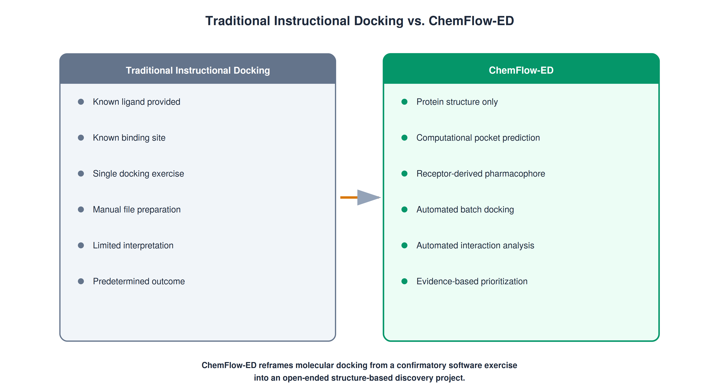
Figure 12. Traditional docking exercise vs. ChemFlow-ED. ChemFlow-ED reframes molecular docking from a confirmatory software exercise into an open-ended structure-based discovery project.

Candidate Prioritization and Generalization
The final stage integrated literature context, pharmacophore satisfaction, predicted affinity, structural complementarity, and interaction analysis to identify a defensible set of candidates for future experimental evaluation — not a single “correct” compound. The same sequence of steps, applied without modification to the computational methodology, was also used successfully by classmates investigating unrelated targets associated with phenylketonuria and Pompe disease during the same instructional module, which is the clearest evidence available that ChemFlow-ED generalizes across protein classes rather than being tailored to this one case study.

Table 9. Representative Computational Outputs from the 7WX0 Case Study
Stage | Output
Protein Selection | Retrieved and annotated 7WX0 structure
Pocket Identification | Selected binding pocket and lining residues
Pharmacophore Generation | Refined receptor-derived pharmacophore
Virtual Screening | Candidate compound library (SDF)
Molecular Docking | Ranked poses and predicted affinities for all candidates
Interaction Analysis | CSV interaction summaries and PyMOL sessions
Candidate Prioritization | Justified shortlist for future experimental evaluation

Discussion
ChemFlow-ED was built to reflect contemporary structure-based drug discovery more closely than the software-operation exercises that still dominate many computational chemistry laboratories. Its defining characteristic is that it is protein-centered rather than ligand-centered: it identifies candidate pockets directly from protein structure, then moves through pharmacophore generation, screening, docking, and interaction analysis — a sequence that mirrors early-stage discovery, where computation generates hypotheses rather than reproduces known results.^{1,2} Because the methodology does not depend on any specific disease, protein family, or therapeutic mechanism, it can be pointed at essentially any PDB structure, widening the range of available instructional projects and letting investigations track emerging targets, orphan diseases, or an instructor's own research interests.

Integration of Complementary Methods
The workflow's principal strength is that no single technique carries the whole argument: pharmacophore models guide the screen, docking predicts orientation, and interaction analysis explains why a pose is favorable, with candidate prioritization following from synthesizing this evidence rather than any one score. Refining a pharmacophore, revisiting a pocket choice, or comparing alternative poses in light of new evidence all show that a computational investigation, like an experimental one, proceeds iteratively rather than along a fixed script.

Educational Value of Automation
Contemporary computational medicinal chemistry relies increasingly on automated pipelines to improve reproducibility and reduce repetitive work, and the same logic applies in the classroom: time spent on file preparation and software configuration is time not spent on interpretation.^{28,29} The Python automation framework built for ChemFlow-ED reallocates that time without concealing the underlying methodology: every intermediate file remains inspectable, so automation accelerates the project without turning any stage into a black box.

Reproducibility and Accessibility
Because every tool in the pipeline is free and applied identically across an investigation, ChemFlow-ED requires no commercial licenses, specialized infrastructure, or high-performance computing; its standardized directory structure and automated naming make any result independently verifiable — a classroom-scale application of the good-practice principles now standard in reproducible computational research.^{28,29,32}

Limitations
Several limitations deserve emphasis. Molecular docking estimates relative binding affinity and plausible orientation; it does not predict biological activity directly, and protein flexibility, solvation, entropy, and the approximations built into any empirical scoring function can all affect accuracy.^{26,27} Computational output from ChemFlow-ED should therefore be treated as a hypothesis requiring experimental validation, not evidence of efficacy. Receptor-derived pharmacophore modeling is likewise only one of several strategies; ligand-based pharmacophores, fragment-based design, molecular dynamics, and machine-learning-assisted screening can all provide complementary information depending on the system under study.³⁰ The workflow also assumes a foundation in organic chemistry, biochemistry, and molecular interactions, and while individual modules can be shortened or preselected, the full sequence needs enough instructional time for genuine interpretation rather than rapid task completion.

Future Directions
The modular architecture leaves clear room for expansion. Molecular dynamics could follow docking to probe the conformational stability of predicted complexes, and machine-learning-based rescoring or generative ligand design could be incorporated as those methods mature.³⁰ Future versions might also add modules on cheminformatics, quantitative structure–activity relationships, or lead optimization; because each stage already produces a standardized intermediate output, new methods can be added without disturbing the rest of the pipeline. Public distribution of the scripts, installation guides, and example datasets through a version-controlled repository (described under Data and Software Availability, below) is intended to support exactly this kind of extension by other instructors and institutions.

Conclusions
ChemFlow-ED provides a reproducible, open-source framework for teaching structure-based drug discovery as an inquiry-driven research experience rather than a sequence of software tutorials. By integrating protein structural analysis, binding-pocket prediction, receptor-derived pharmacophore generation, virtual screening, automated molecular docking, protein–ligand interaction analysis, and candidate prioritization into one investigation, it introduces students to computational strategies used routinely in contemporary medicinal chemistry, using only free software and web-based resources. Because it begins with protein structure alone rather than a known ligand, it lets students work on genuinely open questions — including therapeutically important but poorly liganded targets — while developing the evidence-based reasoning that distinguishes authentic research from confirmatory exercise. The accompanying Python automation framework standardizes the workflow’s repetitive computational steps without concealing them, and its modular design allows individual stages to be adopted piecemeal or the full sequence to serve as a capstone project, research experience, or graduate module, independent of any single disease or protein target. As computational methods continue to reshape pharmaceutical research, chemistry curricula will need to move beyond isolated software demonstrations toward exactly this kind of authentic, inquiry-based investigation — cultivating not only technical competence but the interdisciplinary judgment that the next generation of medicinal chemists will need.

Associated Content
Supporting Information. The Supporting Information is available free of charge on the ACS Publications website and includes: complete workflow instructions and an installation/configuration guide for all software; the Python automation scripts described in this manuscript; representative input and output files, including an example Pharmit pharmacophore model, an example docking dataset, an example interaction-analysis dataset, and example PyMOL session files; a suggested student assignment and grading rubric; a representative four-week project timeline; and an example final student manuscript (redacted for student privacy).

Author Information
Corresponding Author Donna H. Perygin — Department of Chemistry and Geosciences, Jacksonville State University, Jacksonville, Alabama 36265; orcid.org/0009-0000-6979-6033; Email: dperygin@jsu.edu
Author Contributions. The manuscript was written by the author, who conceived the instructional workflow, developed the computational methodology, designed the Python automation framework, implemented the workflow in an advanced undergraduate medicinal chemistry course, and prepared the manuscript.
Notes. The author declares no competing financial interest.

Funding
None reported.

Data and Software Availability
All computational resources used in ChemFlow-ED are freely available from their respective developers (Protein Data Bank, ProteinsPlus/DoGSiteScorer, Pharmit/PharmacoForge, PyMOL Open Source, AutoDock Vina, MGLTools, and Open Babel). The custom Python automation scripts, representative datasets, workflow documentation, and instructional materials developed for this work are deposited in a public GitHub repository (https://github.com/dperygin/ChemFlow-ED) under the MIT License and archived via Zenodo (version v1.0.2) to ensure long-term accessibility and reproducibility: DOI 10.5281/zenodo.21302160 (https://doi.org/10.5281/zenodo.21302160).

Acknowledgments
The author thanks the students enrolled in the advanced undergraduate medicinal chemistry course whose participation contributed to refining the workflow described here, and gratefully acknowledges the developers of the open-source software and freely available computational resources on which ChemFlow-ED depends.
Artificial intelligence tools were used in the preparation of this work. Claude (Anthropic) and ChatGPT (OpenAI) were used to assist with editing and revising manuscript text, generating and refining figures, and assisting in the development, debugging, and documentation of the Python automation scripts accompanying this workflow. All AI-assisted output was reviewed, verified, and edited by the author, who takes full responsibility for the accuracy, scientific content, and integrity of the final manuscript, figures, and code.

(1) Anderson, A. C. The Process of Structure-Based Drug Design. Chemistry & Biology 2003, 10 (9), 787–797. https://doi.org/10.1016/j.chembiol.2003.09.002.
(2) Kalyaanamoorthy, S.; Chen, Y.-P. P. Structure-Based Drug Design to Augment Hit Discovery. Drug Discovery Today 2011, 16 (17), 831–839. https://doi.org/10.1016/j.drudis.2011.07.006.
(3) Lionta, E.; Spyrou, G.; Vassilatis, D. K.; Cournia, Z. Structure-Based Virtual Screening for Drug Discovery: Principles, Applications and Recent Advances. Current Topics in Medicinal Chemistry 2014, 14 (16), 1923–1938.
(4) Berman, H. M.; Westbrook, J.; Feng, Z.; Gilliland, G.; Bhat, T. N.; Weissig, H.; Shindyalov, I. N.; Bourne, P. E. The Protein Data Bank. Nucleic Acids Res 2000, 28 (1), 235–242. https://doi.org/10.1093/nar/28.1.235.
(5) Trott, O.; Olson, A. J. AutoDock Vina: Improving the Speed and Accuracy of Docking with a New Scoring Function, Efficient Optimization, and Multithreading. Journal of Computational Chemistry 2010, 31 (2), 455–461. https://doi.org/10.1002/jcc.21334.
(6) Morris, G. M.; Huey, R.; Lindstrom, W.; Sanner, M. F.; Belew, R. K.; Goodsell, D. S.; Olson, A. J. AutoDock4 and AutoDockTools4: Automated Docking with Selective Receptor Flexibility. Journal of Computational Chemistry 2009, 30 (16), 2785–2791. https://doi.org/10.1002/jcc.21256.
(7) O’Boyle, N. M.; Banck, M.; James, C. A.; Morley, C.; Vandermeersch, T.; Hutchison, G. R. Open Babel: An Open Chemical Toolbox. J Cheminform 2011, 3 (1), 33. https://doi.org/10.1186/1758-2946-3-33.
(8) Schrödinger, LLC. The PyMOL Molecular Graphics System, Version 3.1.8, 2026.
(9) Sunseri, J.; Koes, D. R. Pharmit: Interactive Exploration of Chemical Space. Nucleic Acids Res 2016, 44 (W1), W442–W448. https://doi.org/10.1093/nar/gkw287.
(10) Clent, B. A.; Wang, Y.; Britton, H. C.; Otto, F.; Swain, C. J.; Todd, M. H.; Wilden, J. D.; Tabor, A. B. Molecular Docking with Open Access Software: Development of an Online Laboratory Handbook and Remote Workflow for Chemistry and Pharmacy Master’s Students to Undertake Computer-Aided Drug Design. J. Chem. Educ. 2021, 98 (9), 2899–2905. https://doi.org/10.1021/acs.jchemed.1c00289.
(11) Acuna, V. V.; Hopper, R. M.; Yoder, R. J. Computer-Aided Drug Design for the Organic Chemistry Laboratory Using Accessible Molecular Modeling Tools. J. Chem. Educ. 2020, 97 (3), 760–763. https://doi.org/10.1021/acs.jchemed.9b00592.
(12) Muchowski, P. J.; Wacker, J. L. Modulation of Neurodegeneration by Molecular Chaperones. Nat Rev Neurosci 2005, 6 (1), 11–22. https://doi.org/10.1038/nrn1587.
(13) Convertino, M.; Das, J.; Dokholyan, N. V. Pharmacological Chaperones: Design and Development of New Therapeutic Strategies for the Treatment of Conformational Diseases. ACS Chem. Biol. 2016, 11 (6), 1471–1489. https://doi.org/10.1021/acschembio.6b00195.
(14) Ringe, D.; Petsko, G. A. Q&A: What Are Pharmacological Chaperones and Why Are They Interesting? J Biol 2009, 8 (9), 80. https://doi.org/10.1186/jbiol186.
(15) Parenti, G.; Andria, G.; Valenzano, K. J. Pharmacological Chaperone Therapy: Preclinical Development, Clinical Translation, and Prospects for the Treatment of Lysosomal Storage Disorders. Molecular Therapy 2015, 23 (7), 1138–1148. https://doi.org/10.1038/mt.2015.62.
(16) Lindquist, S. L.; Kelly, J. W. Chemical and Biological Approaches for Adapting Proteostasis to Ameliorate Protein Misfolding and Aggregation Diseases–Progress and Prognosis. Cold Spring Harb Perspect Biol 2011, 3 (12), a004507. https://doi.org/10.1101/cshperspect.a004507.
(17) Awano, T.; Johnson, G. S.; Wade, C. M.; Katz, M. L.; Johnson, G. C.; Taylor, J. F.; Perloski, M.; Biagi, T.; Baranowska, I.; Long, S.; March, P. A.; Olby, N. J.; Shelton, G. D.; Khan, S.; O’Brien, D. P.; Lindblad-Toh, K.; Coates, J. R. Genome-Wide Association Analysis Reveals a SOD1 Mutation in Canine Degenerative Myelopathy That Resembles Amyotrophic Lateral Sclerosis. Proceedings of the National Academy of Sciences 2009, 106 (8), 2794–2799. https://doi.org/10.1073/pnas.0812297106.
(18) Nakamae, S.; Kobatake, Y.; Suzuki, R.; Tsukui, T.; Kato, S.; Yamato, O.; Sakai, H.; Urushitani, M.; Maeda, S.; Kamishina, H. Accumulation and Aggregate Formation of Mutant Superoxide Dismutase 1 in Canine Degenerative Myelopathy. Neuroscience 2015, 303, 229–240. https://doi.org/10.1016/j.neuroscience.2015.06.066.
(19) Volkamer, A.; Kuhn, D.; Rippmann, F.; Rarey, M. DoGSiteScorer: A Web Server for Automatic Binding Site Prediction, Analysis and Druggability Assessment. Bioinformatics 2012, 28 (15), 2074–2075. https://doi.org/10.1093/bioinformatics/bts310.
(20) Fährrolfes, R.; Bietz, S.; Flachsenberg, F.; Meyder, A.; Nittinger, E.; Otto, T.; Volkamer, A.; Rarey, M. ProteinsPlus: A Web Portal for Structure Analysis of Macromolecules. Nucleic Acids Res 2017, 45 (W1), W337–W343. https://doi.org/10.1093/nar/gkx333.
(21) Ehrt, C.; Schulze, T.; Graef, J.; Diedrich, K.; Pletzer-Zelgert, J.; Rarey, M. ProteinsPlus: A Publicly Available Resource for Protein Structure Mining. Nucleic Acids Res 2025, 53 (W1), W478–W484. https://doi.org/10.1093/nar/gkaf377.
(22) Schöning-Stierand, K.; Diedrich, K.; Fährrolfes, R.; Flachsenberg, F.; Meyder, A.; Nittinger, E.; Steinegger, R.; Rarey, M. ProteinsPlus: Interactive Analysis of Protein–Ligand Binding Interfaces. Nucleic Acids Res 2020, 48 (W1), W48–W53. https://doi.org/10.1093/nar/gkaa235.
(23) The IUPAC Compendium of Chemical Terminology: The Gold Book, 5th ed.; Gold, V., McNaught, A., The International Union of Pure and Applied Chemistry (IUPAC), Eds.; International Union of Pure and Applied Chemistry (IUPAC): Research Triangle Park, NC, 2025. https://doi.org/10.1351/goldbook.
(24) Yang, S.-Y. Pharmacophore Modeling and Applications in Drug Discovery: Challenges and Recent Advances. Drug Discovery Today 2010, 15 (11–12), 444–450. https://doi.org/10.1016/j.drudis.2010.03.013.
(25) Flynn, E. L.; Shah, R.; Dunn, I.; Aggarwal, R.; Koes, D. R. PharmacoForge: Pharmacophore Generation with Diffusion Models. Front Bioinform 5, 1628800. https://doi.org/10.3389/fbinf.2025.1628800.
(26) Warren, G. L.; Andrews, C. W.; Capelli, A.-M.; Clarke, B.; LaLonde, J.; Lambert, M. H.; Lindvall, M.; Nevins, N.; Semus, S. F.; Senger, S.; Tedesco, G.; Wall, I. D.; Woolven, J. M.; Peishoff, C. E.; Head, M. S. A Critical Assessment of Docking Programs and Scoring Functions. J. Med. Chem. 2006, 49 (20), 5912–5931. https://doi.org/10.1021/jm050362n.
(27) Pagadala, N. S.; Syed, K.; Tuszynski, J. Software for Molecular Docking: A Review. Biophys Rev 2017, 9 (2), 91–102. https://doi.org/10.1007/s12551-016-0247-1.
(28) Wilson, G.; Bryan, J.; Cranston, K.; Kitzes, J.; Nederbragt, L.; Teal, T. K. Good Enough Practices in Scientific Computing. PLOS Computational Biology 2017, 13 (6), e1005510. https://doi.org/10.1371/journal.pcbi.1005510.
(29) Sandve, G. K.; Nekrutenko, A.; Taylor, J.; Hovig, E. Ten Simple Rules for Reproducible Computational Research. PLOS Computational Biology 2013, 9 (10), e1003285. https://doi.org/10.1371/journal.pcbi.1003285.
(30) Jiménez-Luna, J.; Grisoni, F.; Weskamp, N.; Schneider, G. Artificial Intelligence in Drug Discovery: Recent Advances and Future Perspectives. Expert Opinion on Drug Discovery 2021, 16 (9), 949–959. https://doi.org/10.1080/17460441.2021.1909567.
(31) Wakayama, K.; Kimura, S.; Kobatake, Y.; Kamishina, H.; Nishii, N.; Takashima, S.; Honda, R.; Kamatari, Y. O. Molecular Mechanisms of Aggregation of Canine SOD1 E40K Amyloidogenic Mutant Protein. Molecules 2022, 28 (1), 156. https://doi.org/10.3390/molecules28010156.
(32) Wilkinson, M. D.; Dumontier, M.; Aalbersberg, Ij. J.; Appleton, G.; Axton, M.; Baak, A.; Blomberg, N.; Boiten, J.-W.; da Silva Santos, L. B.; Bourne, P. E.; Bouwman, J.; Brookes, A. J.; Clark, T.; Crosas, M.; Dillo, I.; Dumon, O.; Edmunds, S.; Evelo, C. T.; Finkers, R.; Gonzalez-Beltran, A.; Gray, A. J. G.; Groth, P.; Goble, C.; Grethe, J. S.; Heringa, J.; ’t Hoen, P. A. C.; Hooft, R.; Kuhn, T.; Kok, R.; Kok, J.; Lusher, S. J.; Martone, M. E.; Mons, A.; Packer, A. L.; Persson, B.; Rocca-Serra, P.; Roos, M.; van Schaik, R.; Sansone, S.-A.; Schultes, E.; Sengstag, T.; Slater, T.; Strawn, G.; Swertz, M. A.; Thompson, M.; van der Lei, J.; van Mulligen, E.; Velterop, J.; Waagmeester, A.; Wittenburg, P.; Wolstencroft, K.; Zhao, J.; Mons, B. The FAIR Guiding Principles for Scientific Data Management and Stewardship. Sci Data 2016, 3 (1), 160018. https://doi.org/10.1038/sdata.2016.18.

