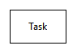

Represents a task or work in a workflow



Represents that these tasks are executed sequentially



Represents functions which are provided by other systems

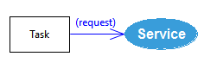

Represents that a task ask for service of a system with input data, which names are put between bracelet (request)

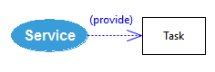

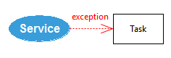Represents that a service of a system responses a request with output data, which names are put between bracelet (provide)

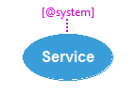Represents that a service of a system cannot response a request

Represents that the service is provided by the system

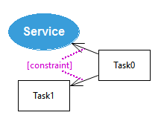

The purple text and dotted arrows represent properties of related elements; e.g., services, tasks, flows, request, provide and exception.

Based on the properties, tasks or services can be executed or requested sequentially or selectively.