Project Proposal

on

**Online Examination System**

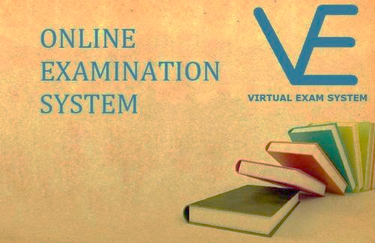

Durga Gairhe

0017014

Computing Project

Level 5 in Computing

Softwarica College of IT and E-Commerce

Kathmandu, Nepal

April 9th, 2019

Submitted To: Niman Maharjan

Table of Contents

Introduction: 3

Project Introduction 3

Justification for the project 3

Chapter 2: Scope of the project: 4

1. Scope: 4

2. Limitation: 4

3. Aims: 4

4. Objectives: 4

5. Overview of the project: 5

Chapter 3: Development Methodology 5

1. Waterfall Model: 5

2. Design Pattern: 5

3. System Architecture: 6

Chapter 4: Project Plan: 7

1. WBS 7

2. Milestones: 8

3. Scheduling 9

A. Time estimation Table: 10

B. Gantt Chart: 10

Chapter 5: Risk Management 11

Chapter 6: Configuration Management: 13

Chapter 8: References: 14

# Chapter1: Introduction

To speed up the examination method, the use of technology plays the vital role in todays world. This project reduces paper work and the full of activity of taking exam method manually. Response about result will be checked automatically and instantly. It will also reduce student suffer from anxiety.

1. Project Introduction: The online examination system will allow to take or give online examination which manage master information and result out different reports about test. Basic users of our project are student, teacher and the system user or administrator. From the view of end-user our project consists of two main functionalities as member registration and take their examination according to their module upon with manages their own profile. Whereas admin manages the members, question for each member and view their reports.
2. Justification for the project: Before the day many people using traditional approach to measure knowledge level of any person in any topic called as examination.

### Background of the project

The system will allow candidate or student and admin to login into the website where they will be able to take each other exams. Based on the information of the exam module of the student will be able to find them. Only the admin will approve the registered to give exam or student to make sure that they are genuine.

### Problem statement:

* + - The current examination system is very time consuming.
    - The chance of paper leakage is more in current system as compared to proposed system.
    - Resulting processing makes more time as it is done manually.
    - Reduces the paper work due to this there is more chance of error.

## Description of the project

The system will allow student and admin to login into the website where they will be able to take each other exams. Based on the information of the exam module of the student will be able to find them. Only the admin will approve the registered to give exam or student to make sure that they are genuine.

## Features

* Easy to use
* No need of examiner.
* Reliable and accurate.
* Secure
* Login system for admin, teacher and student.
* Admin will approve the teachers and student.
* Data filtering for best result.

# Chapter 2: Scope of the project:

## Scope:

The scope of the project is are described below:

* Used for educational purpose in educational institutions or in corporate world.
* The web-based application can be used anywhere or in any time because the user location does not matter.
* No need of examiner or must be present when candidate take their exam.
* Design to provide services only for user and administrator.
* It also helps to generate reports and handle all the operations by the system.
* Only multiple question will be included.

## Limitation:

In todays market there are huge amount of online examination projects and they are lunching the website which were accessed by the user. The main limitation is that the project is the project only can run in single server inside the educational institute but not via internet.

## Aims:

* Developing a web application that will make improved online examination between students.
* Ensuring the quality of the website and developing a trust between the website and its users by approving only genuine candidate and student

## Objectives:

* + - It reduces the hectic job of accessing the answer given by the candidate manually.
    - It also reduces paper work being an integrated online examination system.
    - To allow faculty to create test and answer key.
    - To allow automatically grading and manual grading which can be recorded per test.
    - Random generation of the test question timed exam.

## Overview of the project:

# Chapter 3: Development Methodology

## Waterfall Model:

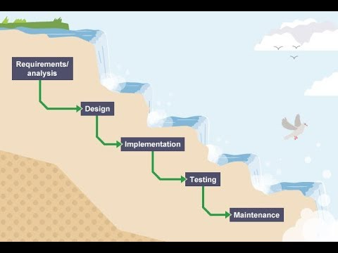

Figure 1: Water fall Model

Waterfall approach is a sort of software development methodlogy most appropriate for little task where prerequisite is surely knowing. This approach expresses that each phase of the project must be finished before starting the following stage and toward the finish of each stage there will be an audit of it to guarantee that the undertaking is on the correct heading.

The explanation for picking the waterfall procedure for the undertaking is on the grounds that as a matter of first importance it is straightforward and use and since each task will be given a specific time point of confinement and should be done inside the expressed time waterfall strategy will permit full consummation of each tasks since we can't go to another task without finishing the earlier.

## Design Pattern:

The design pattern that will be utilized for the undertaking will be MVC design. MVC represents Model View Controller. This plan example will isolate the task into three interconnected parts Model, View and Controller.

Model: It will determine the logical structure of data for this undertaking and the high state class that will be related with it.

View: View will render the model into a structure that will be appropriate for interaction. Numerous views will exist for a single model for various reason.

Controller: Controller will go about as the interface among model and view parts. It will get info and start a reaction by making model display objects.

Figure 2: MVC design pattern

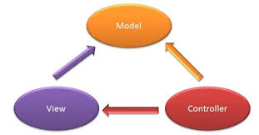

I will utilize MVC design for this undertaking since it will be a quicker development process where the code duplication will be limited, and change won't influence the whole model since model parts does not depend upon the view parts.

## System Architecture:

System architecture is the model that handles the general structure, views and the execution of the System. Here, I have utilized three level structure for the task.

Explanation for utilizing three level structure is on the grounds that for essential primary it improves self-ruling and after that reliability. Additionally, it also increments the execution by reducing the load on the application and data levels and afterward decrease the system utilization.

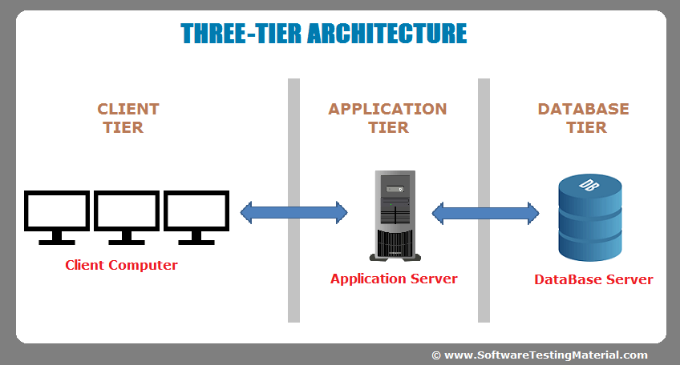

Figure 3: Three tier architecture

# Chapter 4: Project Plan:

Project planning is a subject for expressing how to finish a task inside a certain time span with characterized organizes and assigned assets. Project planning will separate the action into:

* Setting up targets
* Planning the calendar
* Implementing structure and
* Making supporting plans

## WBS

Work breakdown structure is a progressive tree structure that traces the undertaking and separates it into smaller sensible portion with the goal that each level of projet can be understood.

The high state exercises that will be performed are:

* Proposal
* Analysis
* Design
* Testing
* Documentation

The work breakdown structure for this venture is appeared in the following page:

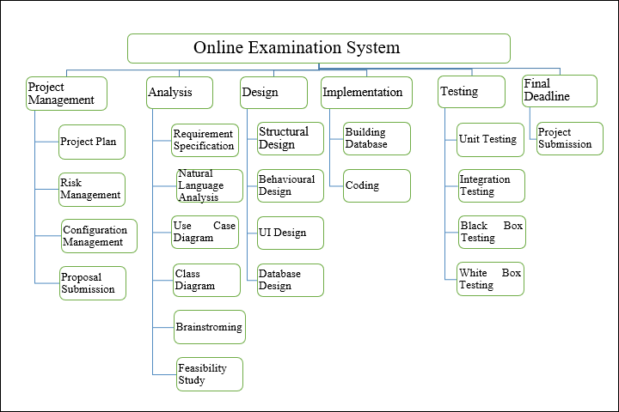

Figure 4: WBS Diagram

## Milestones:

Milestone is a point in time inside a project lifecycle used to measure the progress of a project towards its definitive goals.

This proposal will begin the twenty-fifth March 2019. Out and out 107 days will be isolated between six distinct milestone and the project will finish on seventh of July 2019.

The table below will quickly represent my milestone for this task.

|  |  |  |
| --- | --- | --- |
| WBS | TASK NAME | NUM OF DAYS |
| 0 | Online Examination System | 107 |
| 1  1.1  1.2  1.3 | **PROJECT PROPOSAL**  Project Plan  Risk Management  Configuration  Proposal Submission | 16  7  4  4  1 |
| 2  2.1  2.2  2.3  2.4  2.5  2.6 | **ANALYSIS**  Requirement Specification  Natural Language Analysis  Use case  Architecture(Initial class diagram)  Brainstorming  Feasibility study | 28  7  2  2  2  4  11 |
| 3  3.1  3.2  3.3  3.4 | **DESIGN**  Structural Design  **Behavioural Model**  **UI Design**  **Database Design** | 26  1  3  15  7 |
| 4  4.1  4.2 | **IMPLEMENTATION**  **Building Database**  **Coding** | **20**  **5**  **15** |
| 5  5.1  5.2  5.3  5.4 | **TESTING**  UNIT TESTING  Integration Testing  Blackbox Testing  Whitebox Testing | **8**  **3**  **2**  **2**  **1** |
| 6 | **FINAL DOCUMENTATION**  Project Submission | **11** |

Figure 5: Milestone with schedule

## Scheduling

The scheduling task will be done by using Project libre which is an open source project management software. A table will show all the activities that will be required to complete this project with their start and end dates and days that it will occupy altogether.

### Time estimation Table:

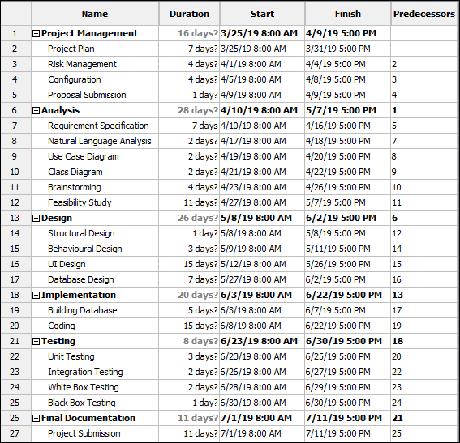

Figure 6: Time estimation Table

## Gantt Chart:

Gantt chart is a chart that shows the amount of work done in a period in relation to the amount planned for those periods.

The illustration of the Gantt chart for the proposed project will be as shown in the figure:

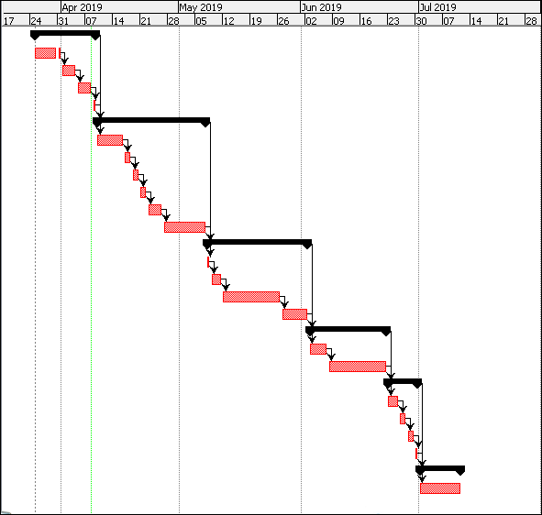

Figure 7: Gantt Chat

# Chapter 5: Risk Management

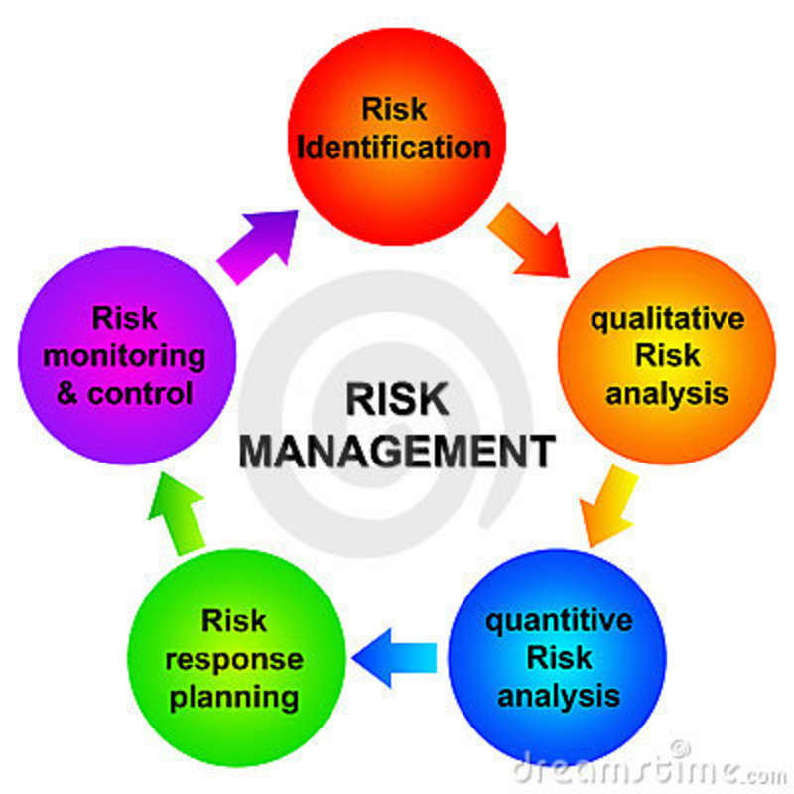

Risk management is the way toward recognizing, observing and dealing with the possible risks to decrease the negative effect they may have on a project. A successful risk management procedure will help recognize which risks represent the greatest threat to the task and give action to dealing with them.

To assess the likelihood, consequence and impact of the risk that may happen during the lifecycle of this project I will utilize the risk assessment matrix technique.

The following guideline will be utilized in this method:

Impact = Likelihood * consequence

Therefore, two tables with probability and results alongside their values will be made individually.

|  |  |
| --- | --- |
| **Likelihood** | **Values** |
| **Low** | **1** |
| **Medium** | **2** |
| **High** | **3** |

|  |  |
| --- | --- |
| **Consequences** | **Values** |
| **Very low** | **1** |
| **Low** | **2** |
| **Medium** | **3** |
| **High** | **4** |
| **Very High** | **5** |
|  |  |

Risks might be occurred during development of project are listed below with their impact and actions to minimize their consequences.

|  |  |  |  |  |  |
| --- | --- | --- | --- | --- | --- |
| S. No | Risks | Likelihood | Consequences | Impact | Solution |
| 1 | Lack of skilled manpower | 1 | 3 | 3 | New skilled member should be added in team. Training should be given. |
| 2 | Failure of server | 1 | 5 | 5 | Uses of cloud for back up of data should be done. |
| 3 | System down | 1 | 3 | 3 | System should be checked time to time and maintenance should be done properly. |
| 4 | Low availability of working resources | 2 | 3 | 6 | Resources should be calculated and found out properly and should made available in time. |
| 5 | Requirement Failure | 2 | 5 | 10 | Requirements analysis should be properly done, and planning should be made. |
| 6 | Network down | 2 | 2 | 4 | Multiple network should made available and power system should made available for back up. |
| 7 | Employee theft | 2 | 4 | 8 | Maintaining trust between working staffs and satisfaction of employee should be targeted. |

# Chapter 6: Configuration Management:

Configuration management is the procedure of efficiently dealing with changes to the scope of work such that it keeps up integrity after some time.

Configuration management will assist the project with achieving a superior consistency by arranging the files in a sorted order so they can be effectively accessed. Further these files will be regularly backed up on the One Drive repository for data recovery.

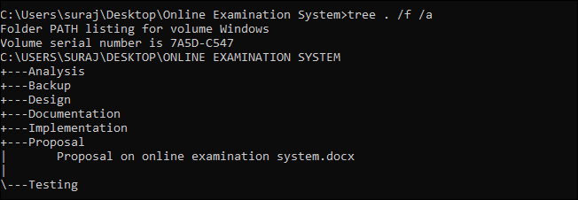

Figure 8: Configuration Management

# Conclusion:

This project has a good and easy graphical design which will help the user to use the system very easily and there will no any problem for any user with the working of the system. User or student can take their exam while admin could add exams notice easily, check the grade and messages from student. Hence, the project proposal is completed, and I will be further moving for analysis, design and other processes.

# Chapter 8: References:

associates, p. a. (2018). Retrieved from poms and associates: http://www.pomsassoc.com/6-fundamental-techniques-risk-control/

Watt, b. a. (2018). Retrieved from https://opentextbc.ca/projectmanagement/chapter/chapter-16-risk-management-planning-project-management/

workbreakdownstructure. (2018). Retrieved from workbreakdownstructure: https://www.workbreakdownstructure.com/