To Setup first floor time in page type localhost/index.php

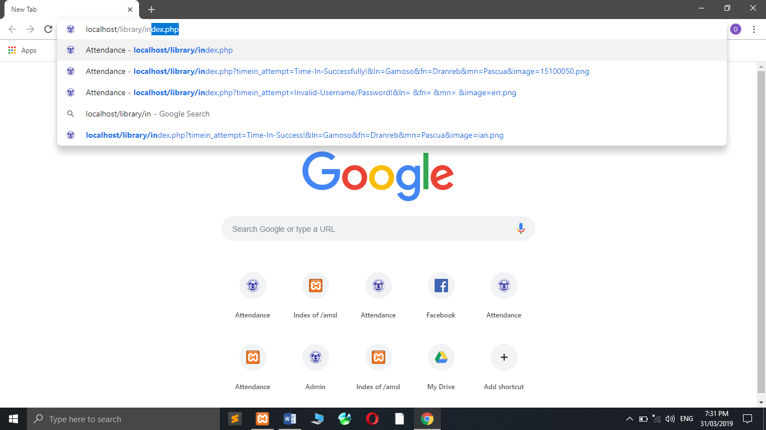

And this will Appear.

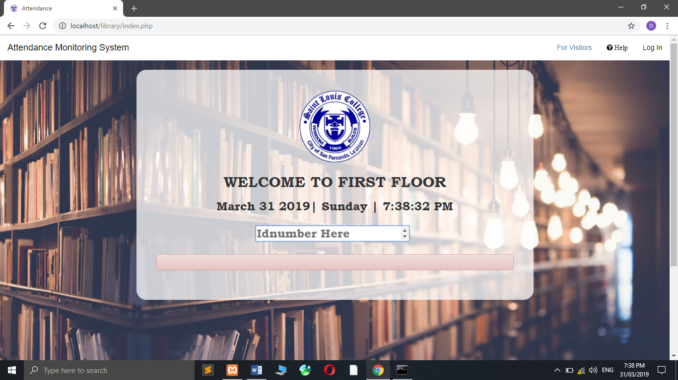

To Setup Second floor time in page you must get the ip address of the computer in the firstpage.

To get the ip address(IPv4Address) of the computer please open CMD and type “ipconfig” then hit enter.

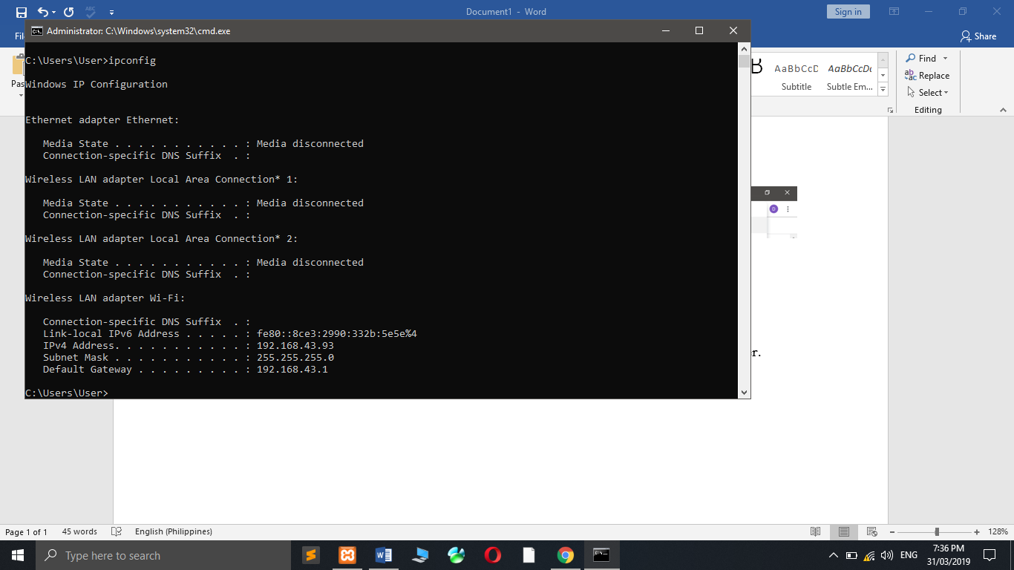

Now type 192.168.43.93/library/2ndfloor.php and second floor time in pge will appear.

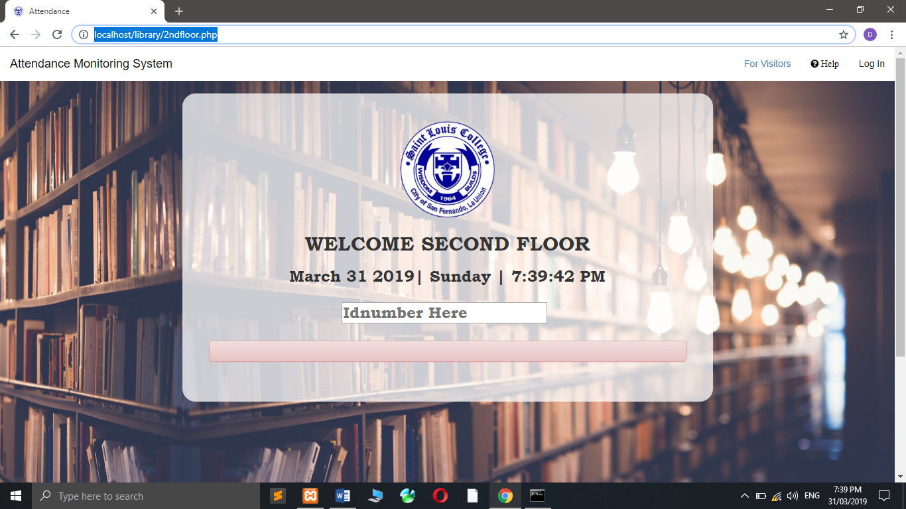

Repeat the step on how to show the second page and change it to 3rdfloor.php to show the thirdfloor timein page.

**TO TIME IN** Scan/Enter your ID number in the Textbox.



After Entering ID number you will get verification message.

You will see your information after a sucessful time in.



If error occurred then this will appear.

