Peter Parianos

HW4

Dr. Shirazi

Question 1

1. The overfitting problem and the underfitting problem in Machine learning is when the function that is being fit to some data point has too much error (Example would be if the data clearly has a plateau and you fit a linear regression equation to it with only one variable), or the function fits the data with too many variables will leave too many curves. (Example would be if you were to fit a power of 4 polynomial to a data that should have been fitted to an exponential function.)
2. You will add if minJ(w,b)
3. You would use Linear Regression when you want to fit a function to a dataset and predict values that might appear there.

Question 2

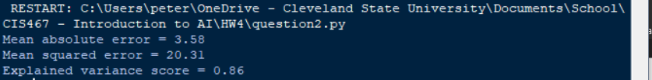

The difference between the mean squared error and mean absolute error is mean squared error is more useful when large errors are not wanted. This is because the errors are squared before they are averaged.

Question 3

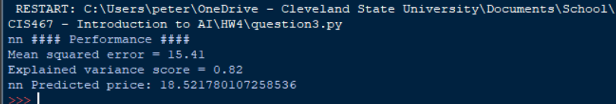

Question 4

