

CSCI 410-A
The Green Team
Architecture Assignment Document

Gabriel Windham
Danny Pham
Joey Green
Alex Thompson

McNeese State University

November 30th,2016
Contents
UML Class Diagrams 3
Login UML Diagram 3
Time Stamp UML Diagram 4
Search Time Sheets UML Diagram 5
Export Time Sheet UML Activity Diagram 6
WebFlow UML Diagram 7
The Four Process Views 8
The Logical View 8
The Process View 8
The Development View 8
The Physical View 9
Context Diagram 10
Process Models 11
Architecture Pattern 14
Design Patterns 15
Facade 15
Chain of Responsibility 16
Finite State Machine 17
Github 21
Essay 22

UML Class Diagrams

Login UML Diagram

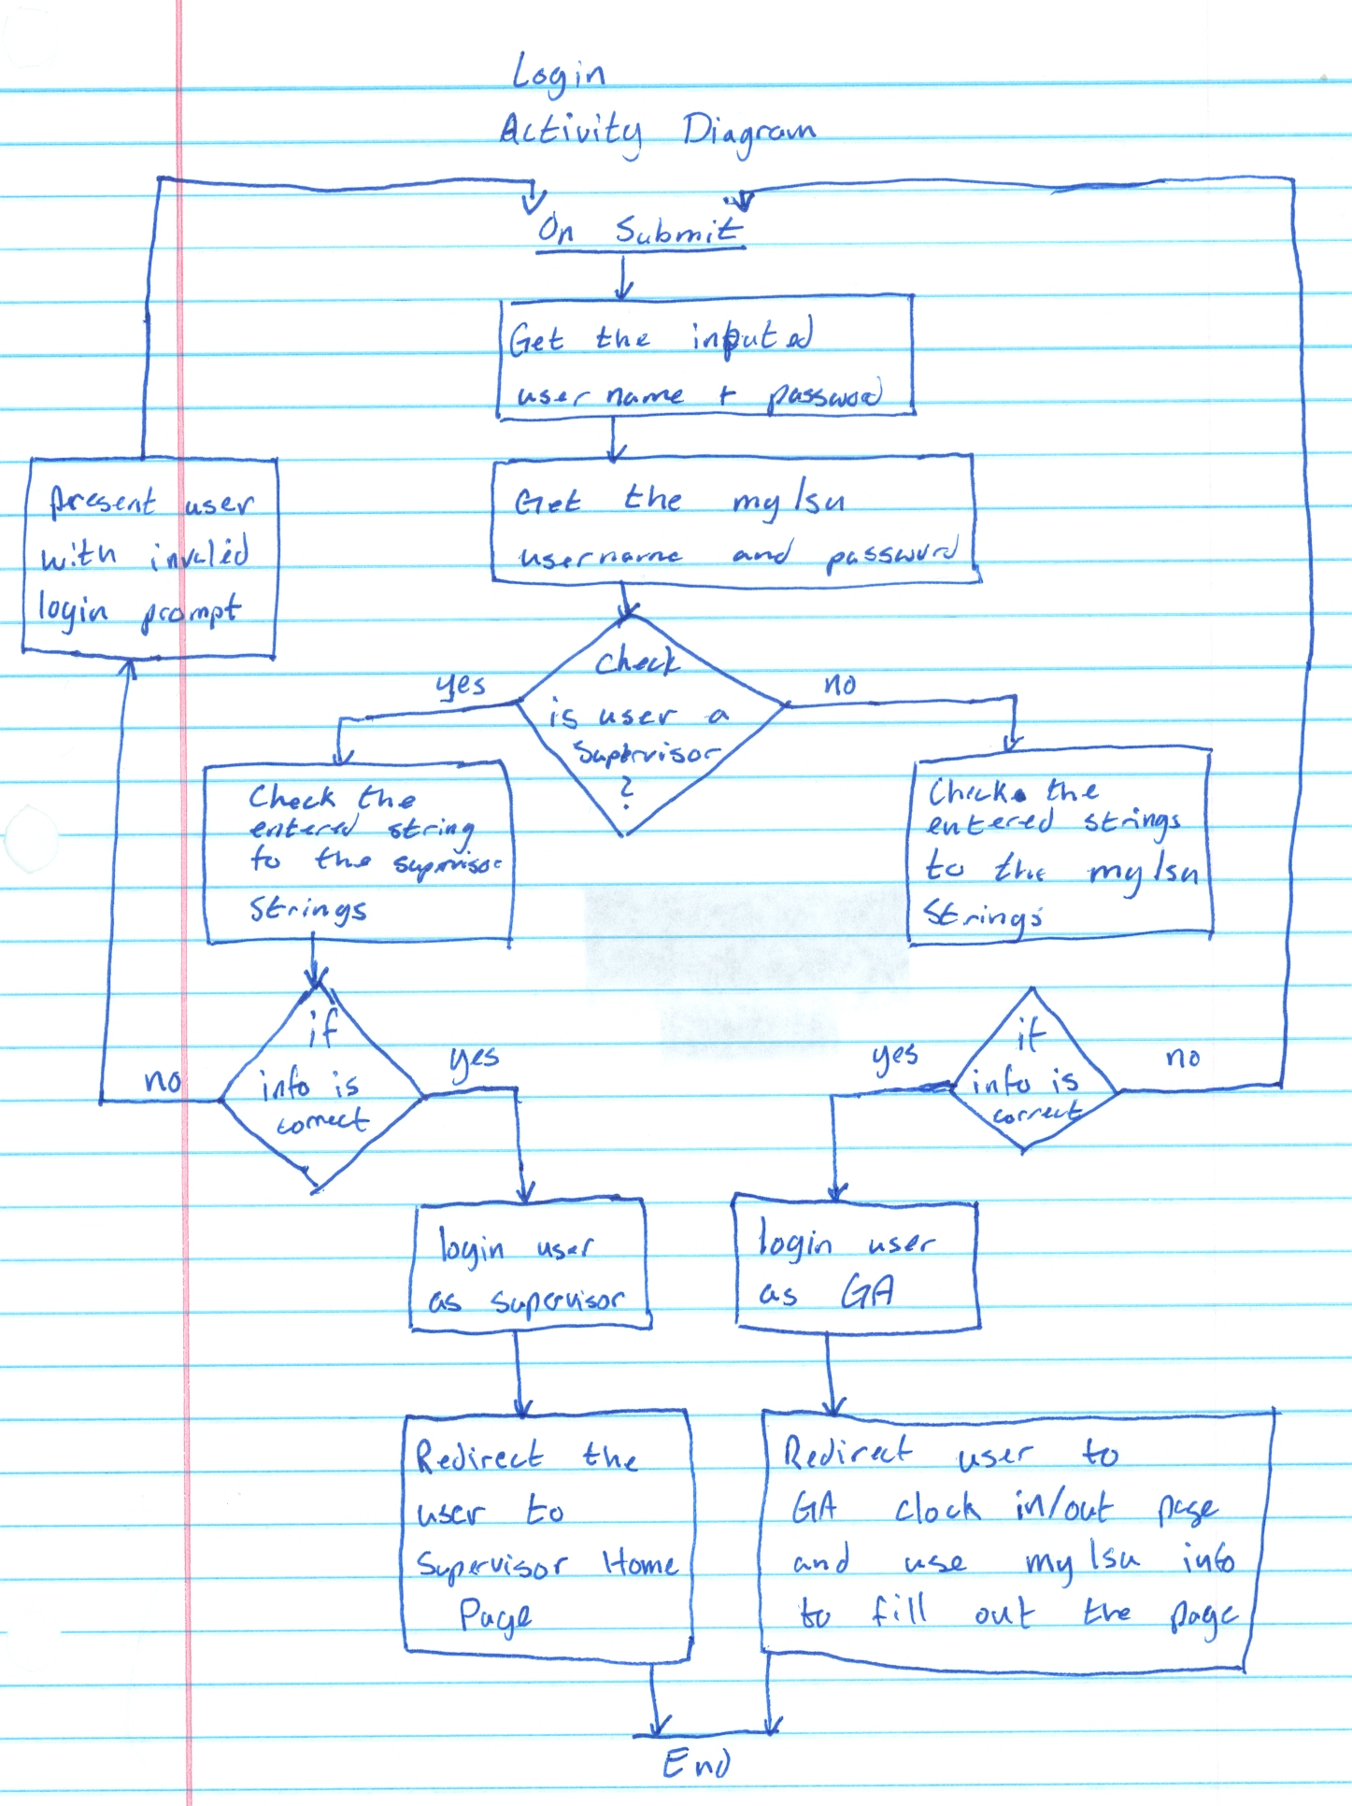

Time Stamp UML Diagram

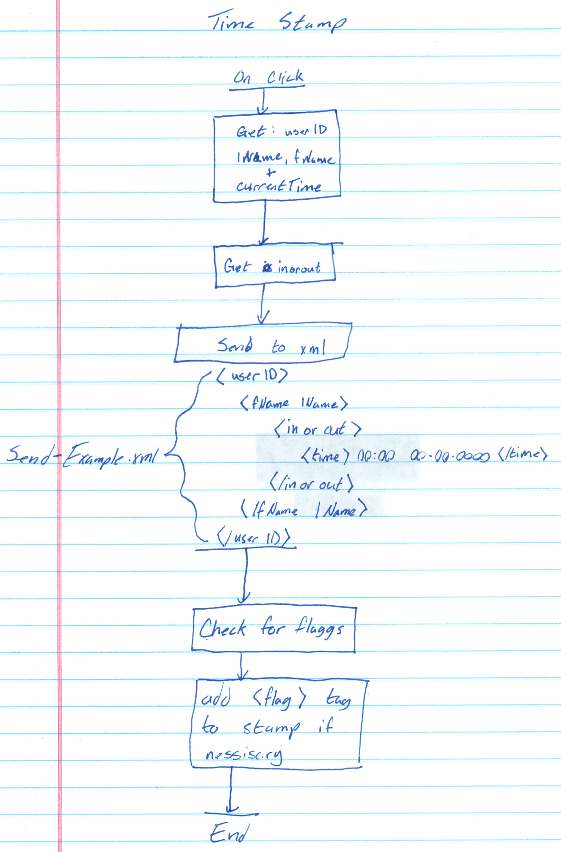

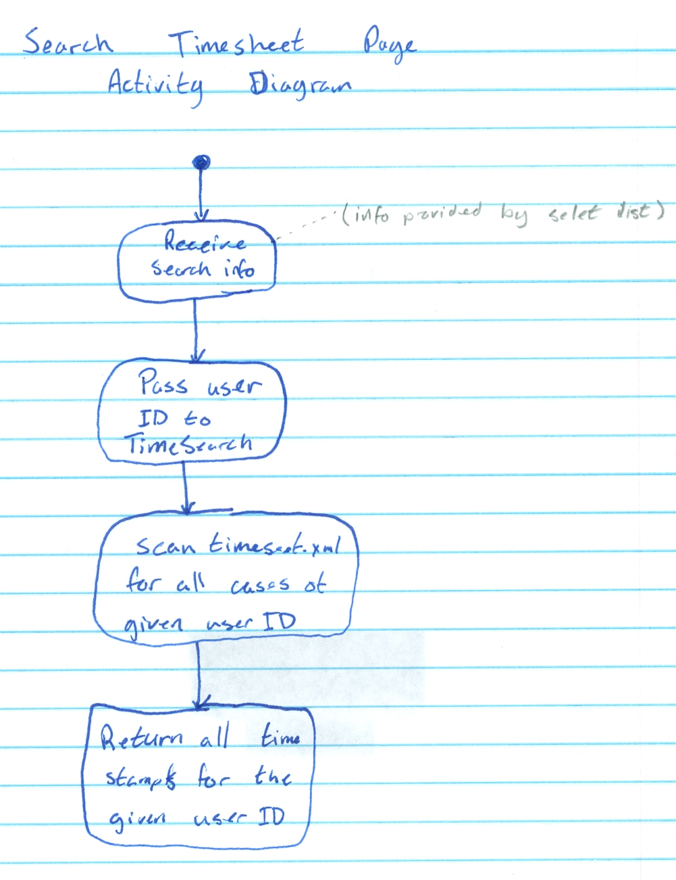
Search Time Sheets UML Diagram

Export Time Sheet UML Activity Diagram
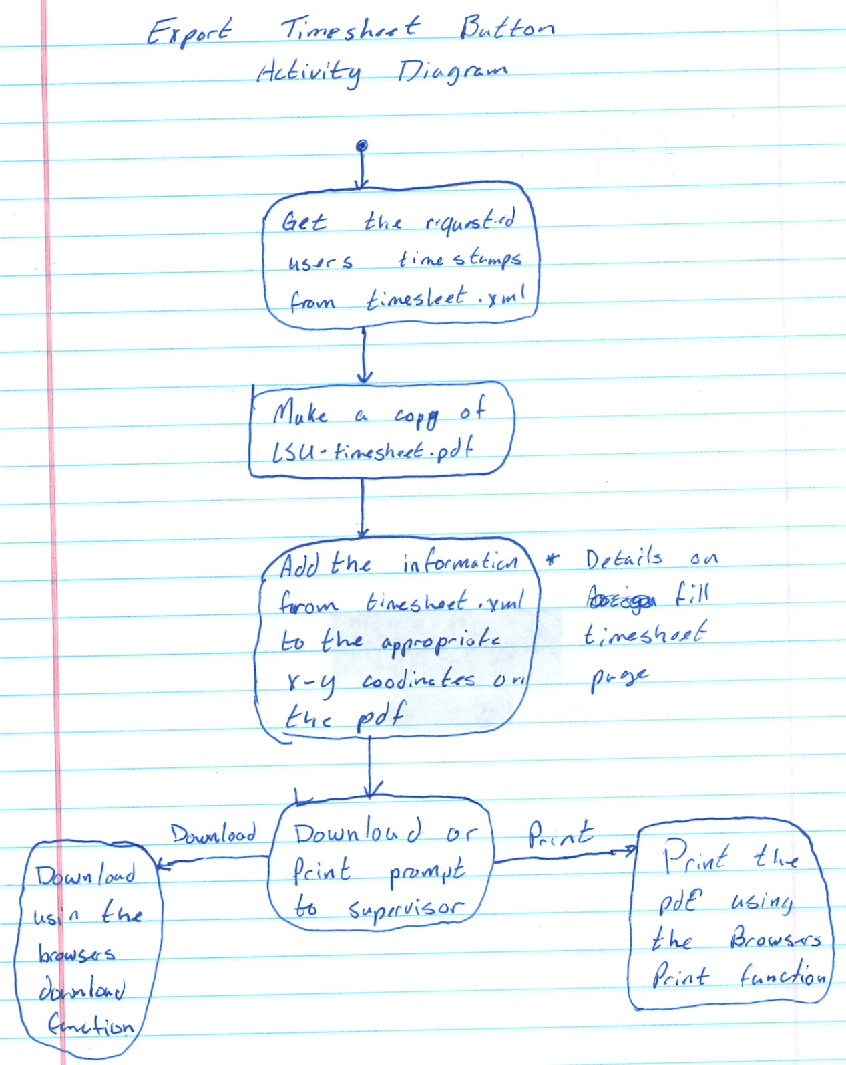

WebFlow UML Diagram
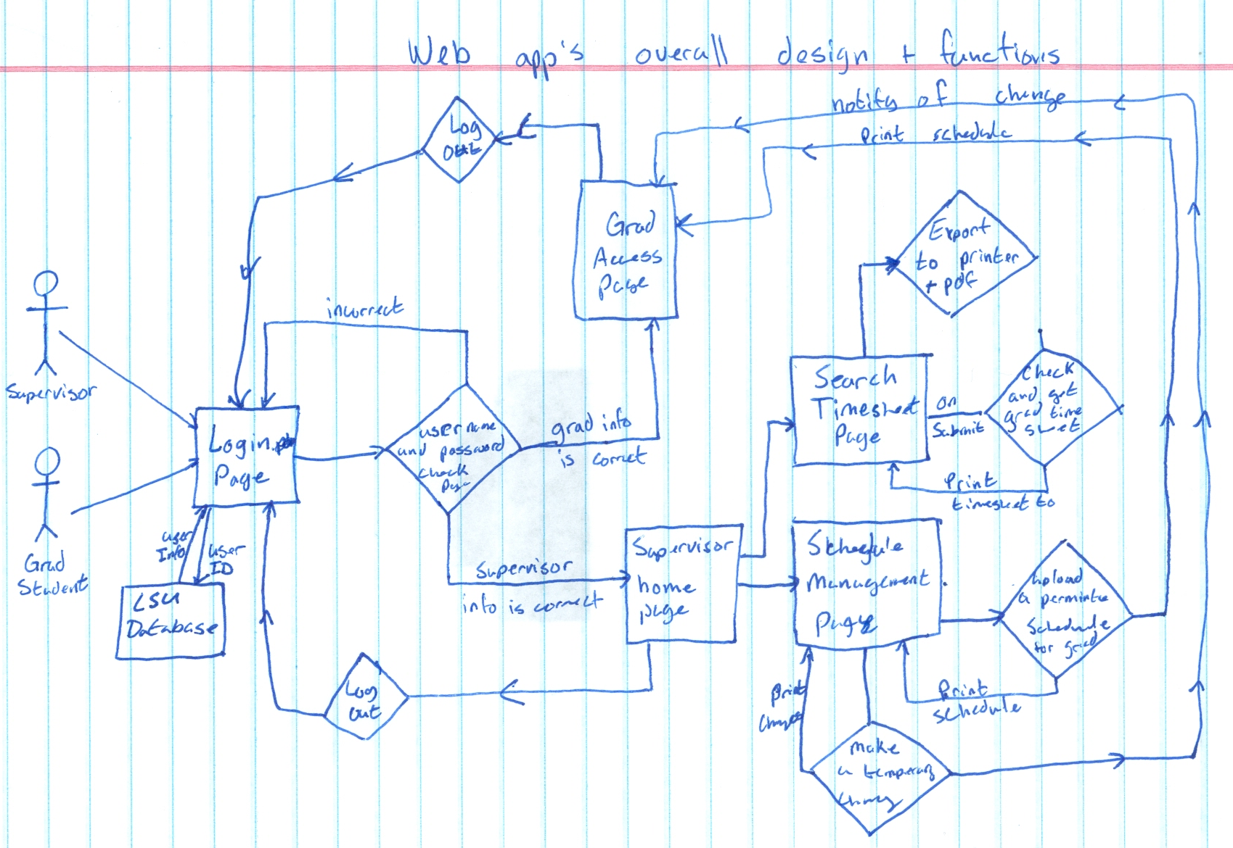

The Four Process Views

The Logical View
This process view provides us with the ability to figure out the functional requirements of our system. For example, our requirement regarding the ability for users to enter their login information and then handle that data can be visualized through a logical process view. The logical view allows us to visualize our components into manageable objects. For instance, we can use a logical view to show the relationship between our requirement state above with our requirement to make the system be able to compute if the user is a graduate student or if they are the supervisor. Logical views can also organize theses objects into object classes to improve efficiency. Diving deeper into the logical view process model showed us a way to diagram our system into object interactions very similar to the relationship between the data entered by the users and who they are according to our system.

The Process View
This process view helps us visualize the entire system into a single visualization. Our single visualization for our project shows how the system works from the login page to when the user logs out. The visualization can single out subsystems and refine each one that is needed. This process can show us what would happen to the whole system if changes are made to a component in the system. If we wanted to add another component to add another layer of security we would move that subsystem before our graduate access page. Process views can also utilize UML diagrams (like activity diagrams) to show the static and dynamic aspects of the system. For example our time stamp cannot be changed by the graduate students, which would mean that the information is static to them. Although that information is dynamic for the supervisor if he or she needs to edit time stamps. Both of these examples can be used with the process view by using a UML for each scenario.

The Development View
This process view can help us manage our software in a software engineer's perspective. We can decompose the system to fit the environment. For example if this system is going to move to another university we would decompose it and find the components needed to be edited to fit that university's standards and technologies. Using this process view, we can make it easier for other software developers that will work on the system. If done correctly, every developer working on the system can better understand the dependencies and relationships between the system modules. If we did move this system but we ourselves did not become part of the new team, a development view will help the new developers.

The Physical View
This process view will show how our system is organized in a physical point of view. For example, the user interaction in our system involves him/her to type on the keyboard and enter their information to login. With the physical process view it will create a visualization of how information is passed from the keyboard to each of the components in the system. Administrators and system designers that take care of the system will be able to understand: the physical locations of the software, the physical connections between nodes, and how to deployment and installation the system.

Context Diagram
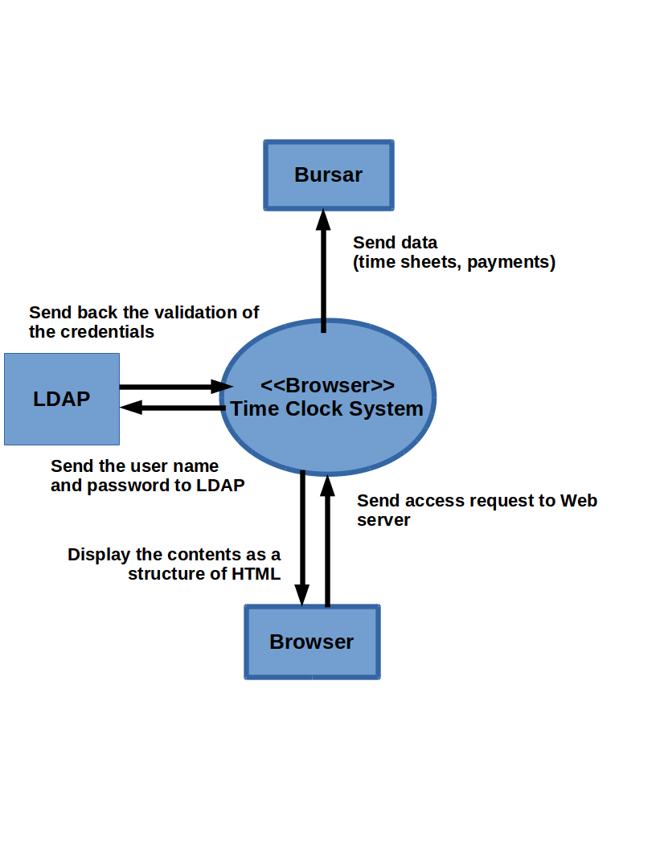

Process Models
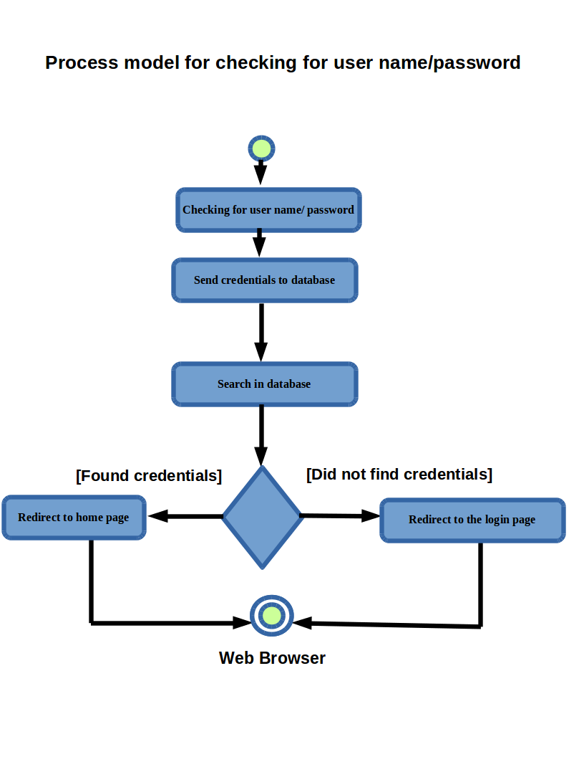

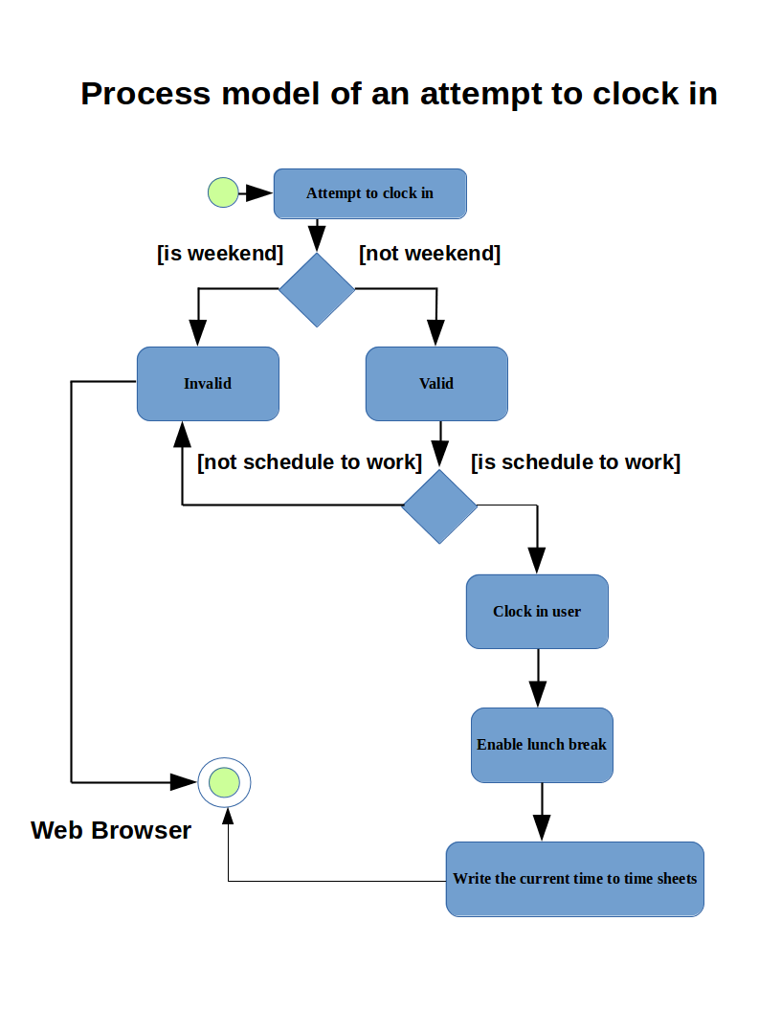
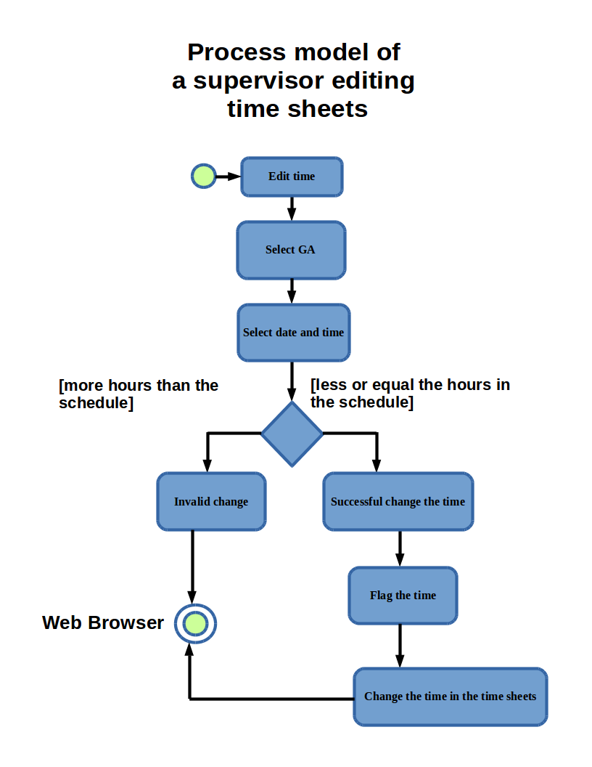

Architecture Pattern
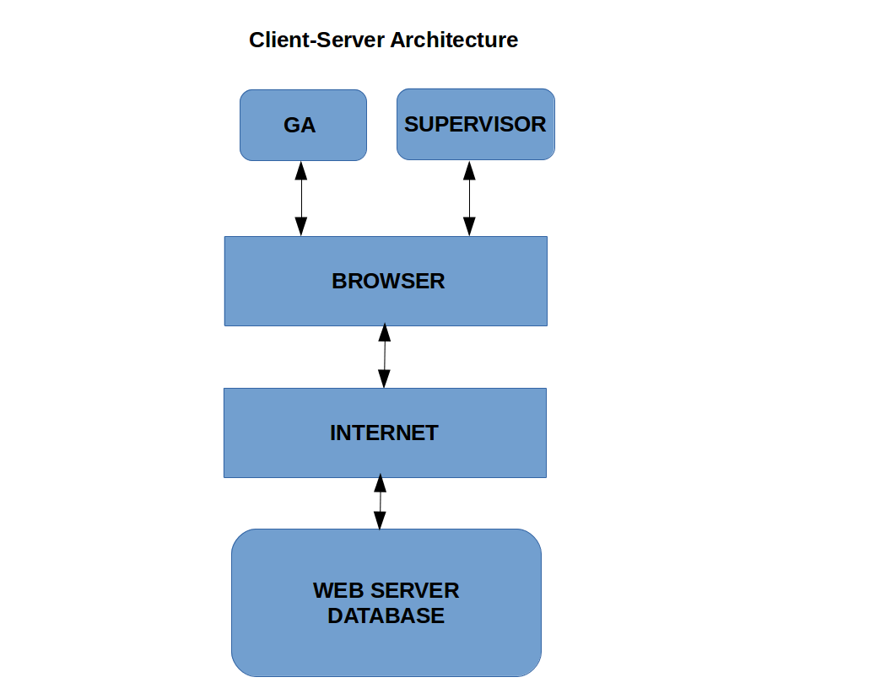

Design Patterns

Facade
The facade design pattern provides a unified interface to a set of interfaces in a subsystem. Facade defines a higher-level interface that makes the subsystem easier to use. We choose this pattern because its good to describe how the system can give the supervisor authority over the graduate students. The subsystems that used this design pattern are the following: the system to let the supervisor edit time sheets, the clock in and out system for the graduate students, and our messaging system for the supervisor to send messages to the graduate students.
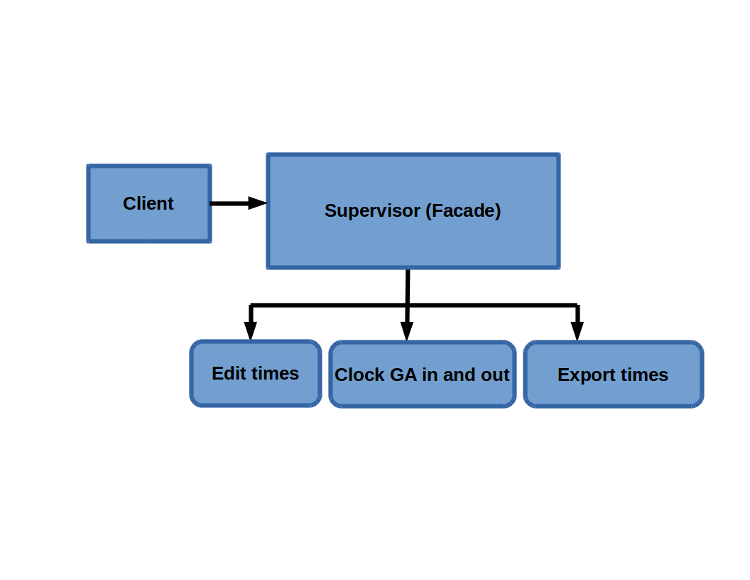

Chain of Responsibility
The Chain of Responsibility allows us to avoid coupling the sender a request to its receiver by giving more than one object a chance to handle the request. we choose this pattern because it describes the way how the request can be send and can be handle by the system. The subsystems that used this design pattern are the following: the clock in and out system for the graduate students, the button allowing the workers to clock in their lunch breaks, and the system that calculates the time worked considering the workers lunch breaks and other variables..
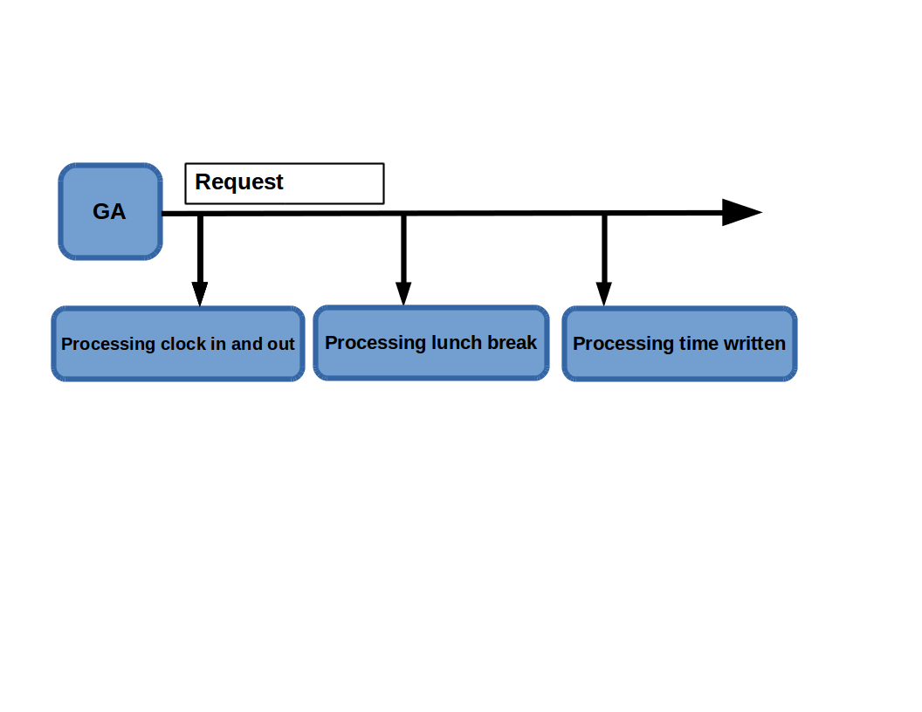

Finite State Machine

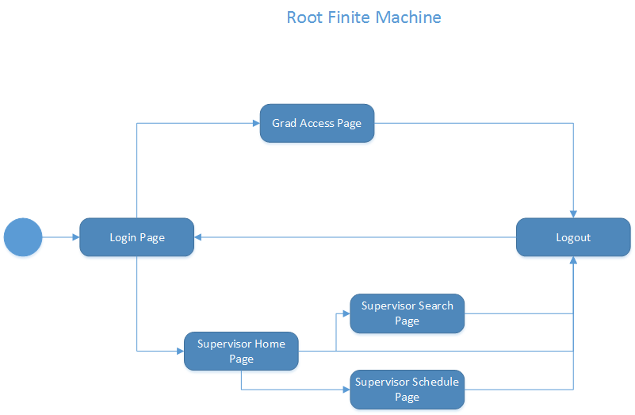
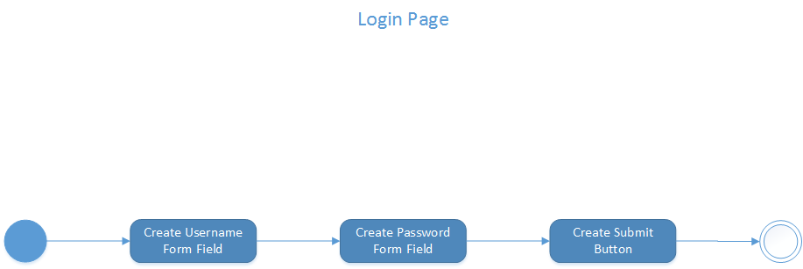

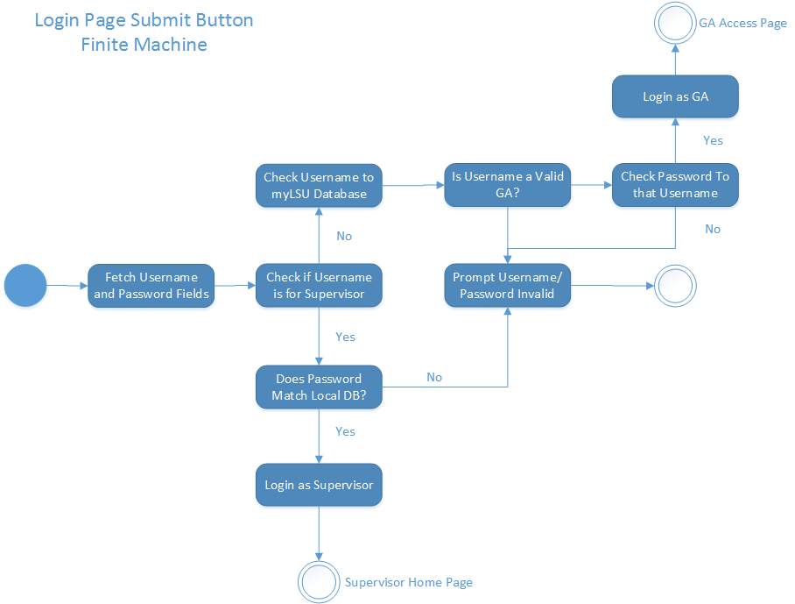

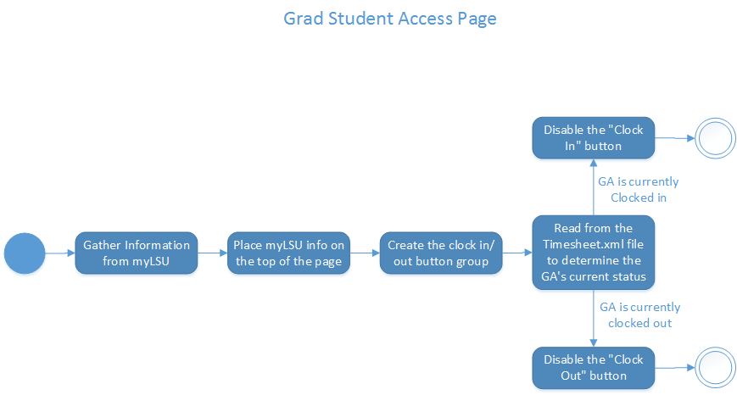

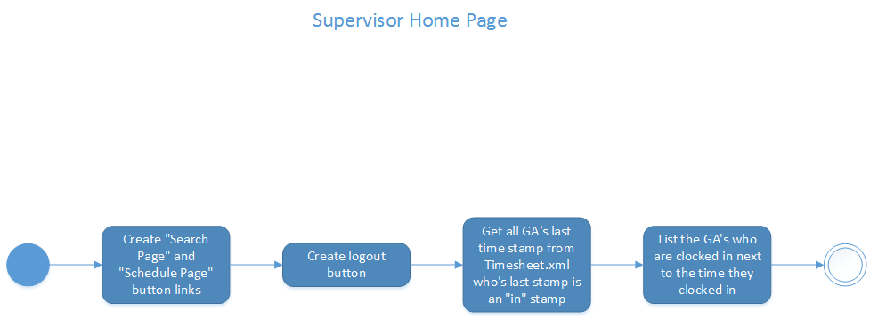
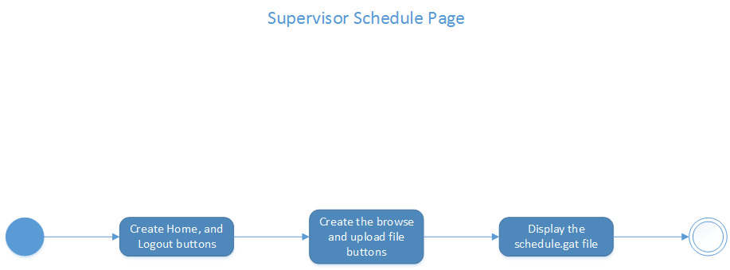
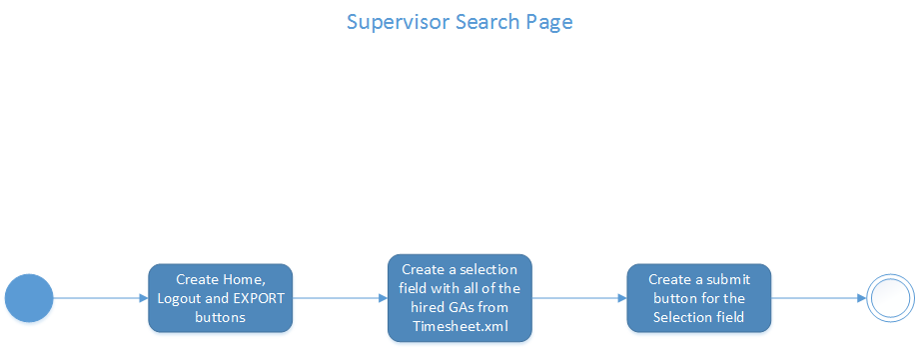

Short Answer

What you learned during this process?

What software did you use to do the models in?

Was the software difficult to learn?

How did you like the software? Was it easy to use, helpful, stable, etc.?

Which models were the most difficult to create for this project?

Which models were the easiest?

Do you feel these models would help you actually implement a system like this?

What models do you feel would be the most helpful during implementation?

What models would be the least useful during implementation?
State models would be one of the least useful models to use for our system. The state model would over complicate our system since all of our objects are simple. The extra detail in state models would be unnecessary. Another design model that would not be beneficial to our system would be the aggregation design model. They reason why it wouldn't be useful is that our system is too small to utilize aggregation. Aggregation would be useless for a system that is so small. Merging our components would be nearly impossible.

How hard was it to use Git?
It was actually pretty difficult using Git. Some of us didn't really see the real benefit using Git when all what we had to do was upload our work by dragging and dropping it into the GitHub repository on our web browsers. Some of us had a better experience because they are used to working in a Linux environment were they use terminal quite often.
Did your team see the benefit in using version control or did it just seem to get in the way?

Would you use Git again? Would you use some other form of version control?
We wouldn't really need to use Git again because dragging and dropping our files and manually editing the files inside the repository in browser is less strenuous.

Did your team use version control?
We did use some version control though. Some of us added what version of a file we uploaded by adding a “v” and a number representing what version it was to the file name before uploading.

