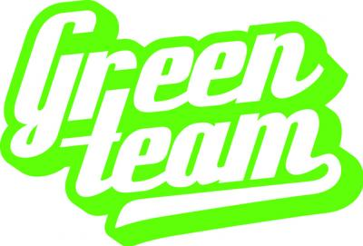

CSCI 410-A
The Green Team
Architecture Assignment Document

Gabriel Windham
Danny Pham
Joey Green
Alex Thompson

McNeese State University

November 30th,2016
Contents
UML Class Diagrams 3
Login UML Diagram 3
Time Stamp UML Diagram 4
Search Time Sheets UML Diagram 5
Export Time Sheet UML Activity Diagram 6
WebFlow UML Diagram 7
The Four Process Views 8
The Logical View 8
The Process View 8
The Development View 8
The Physical View 9
Context Diagrams 10
Process Models 11
Architecture Pattern 12
Design Patterns 13
Facade 13
Chain of Responsibility 14
Finite State Machine 15
Github 16
Essay 17

UML Class Diagrams

Login UML Diagram

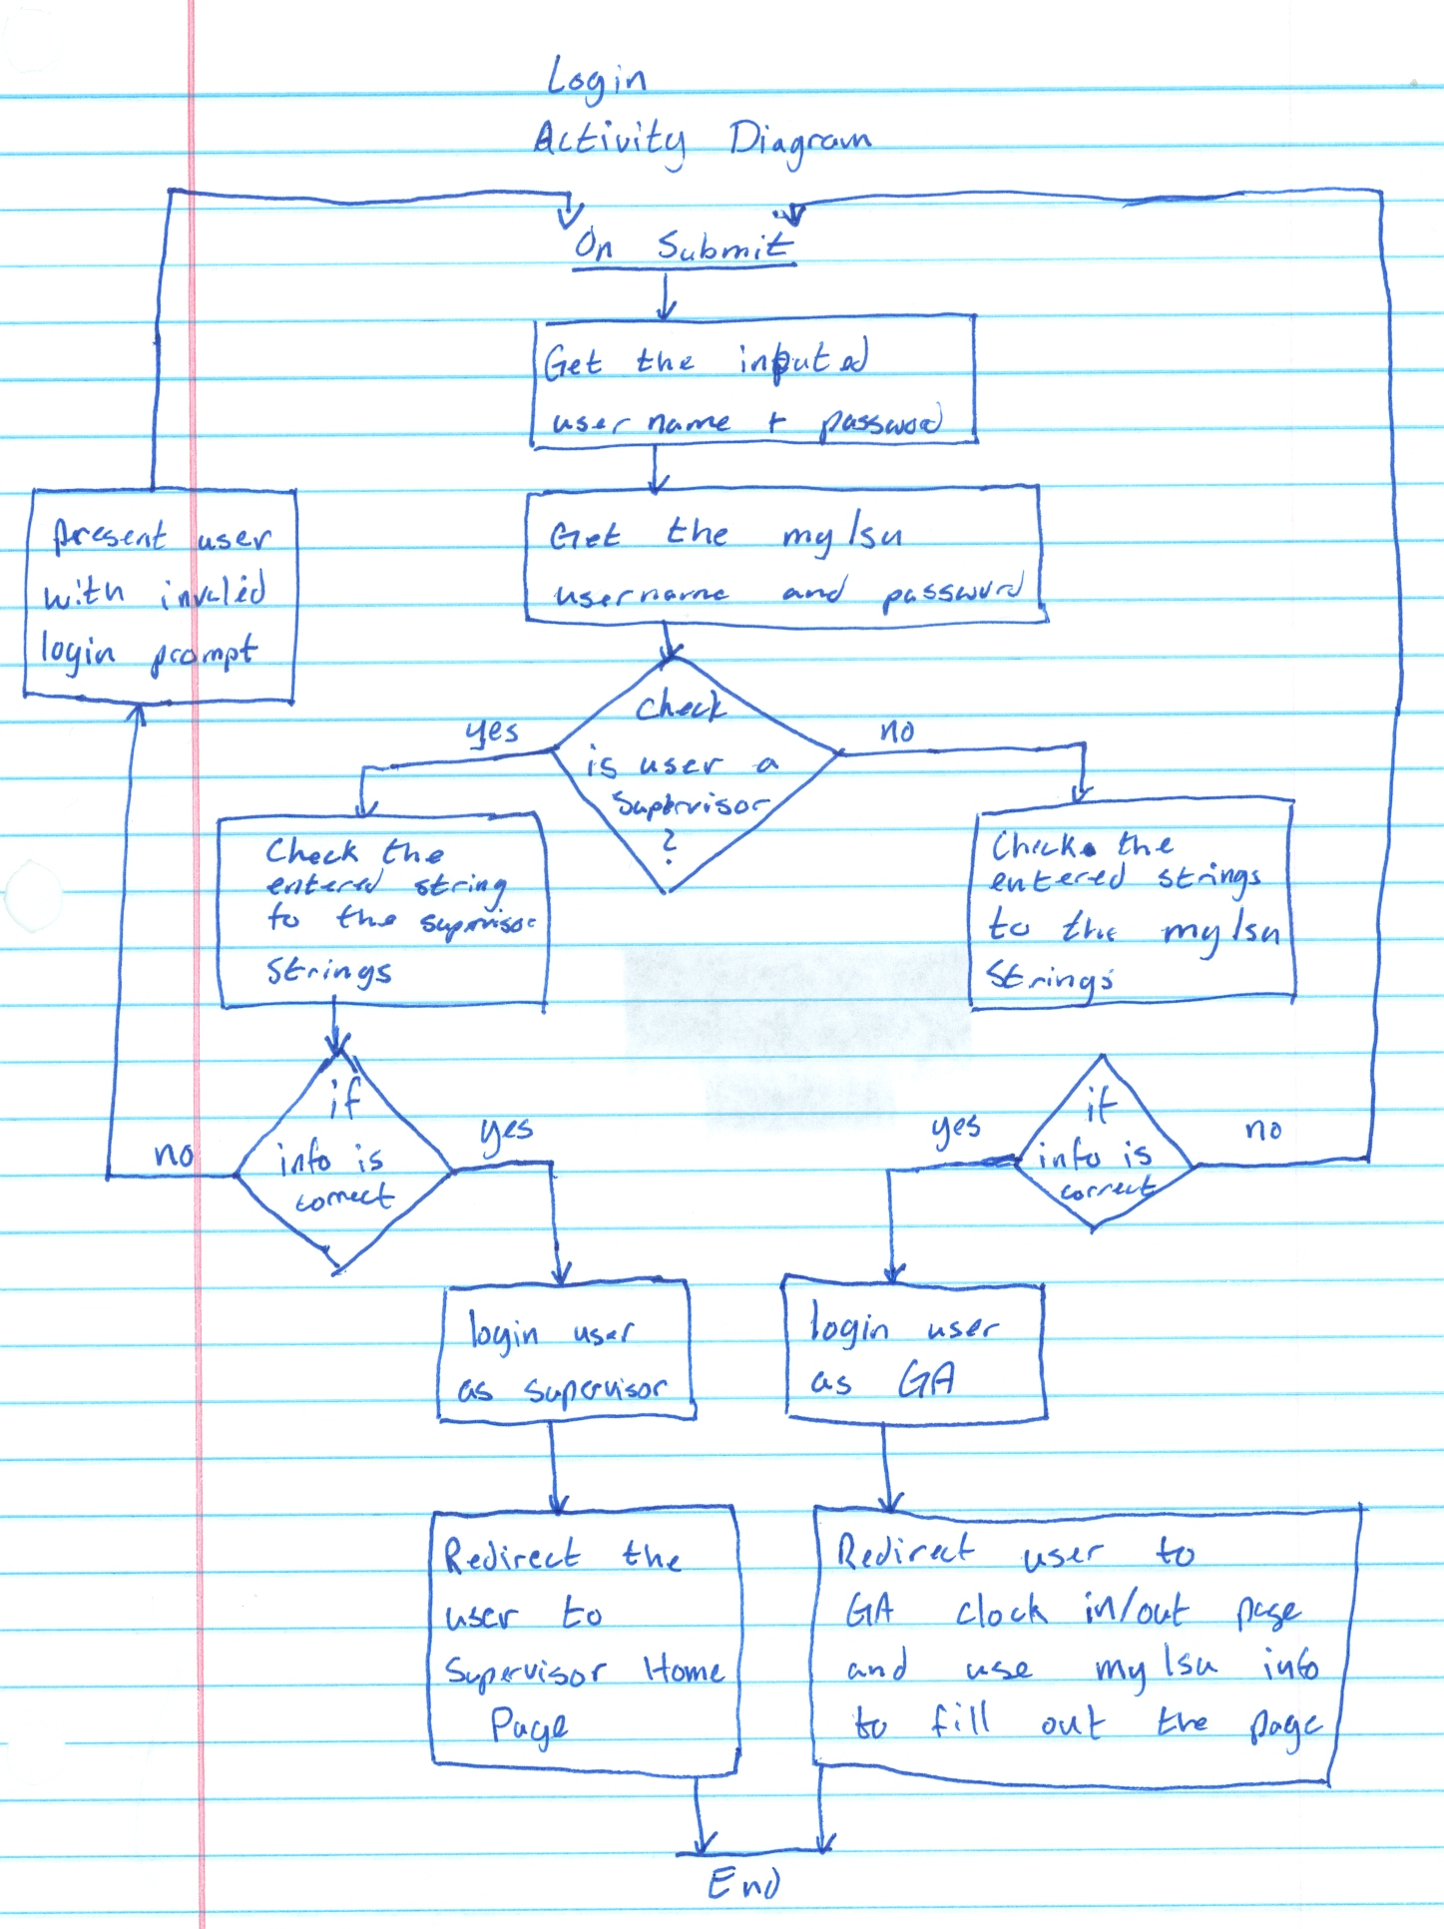

Time Stamp UML Diagram

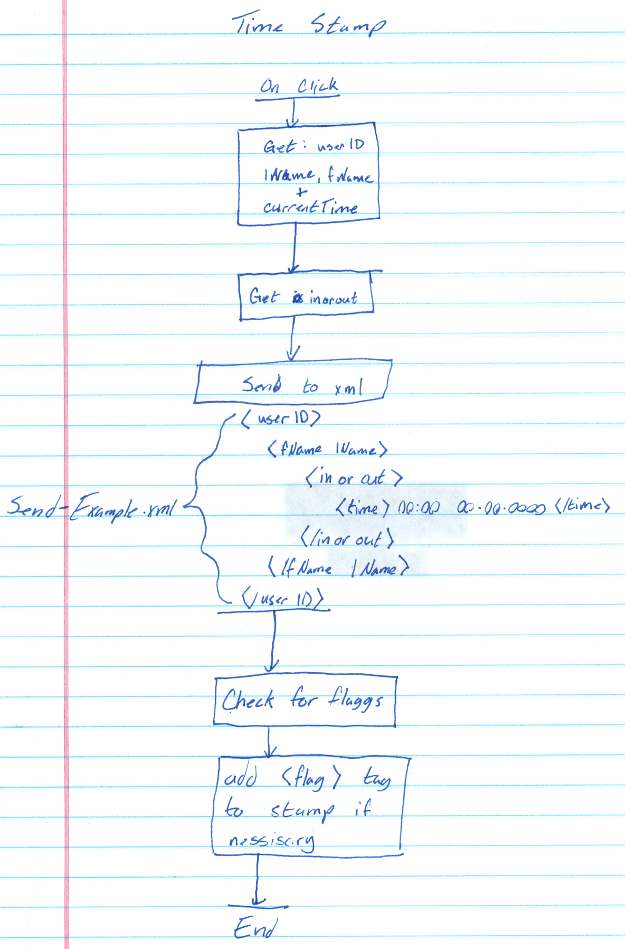

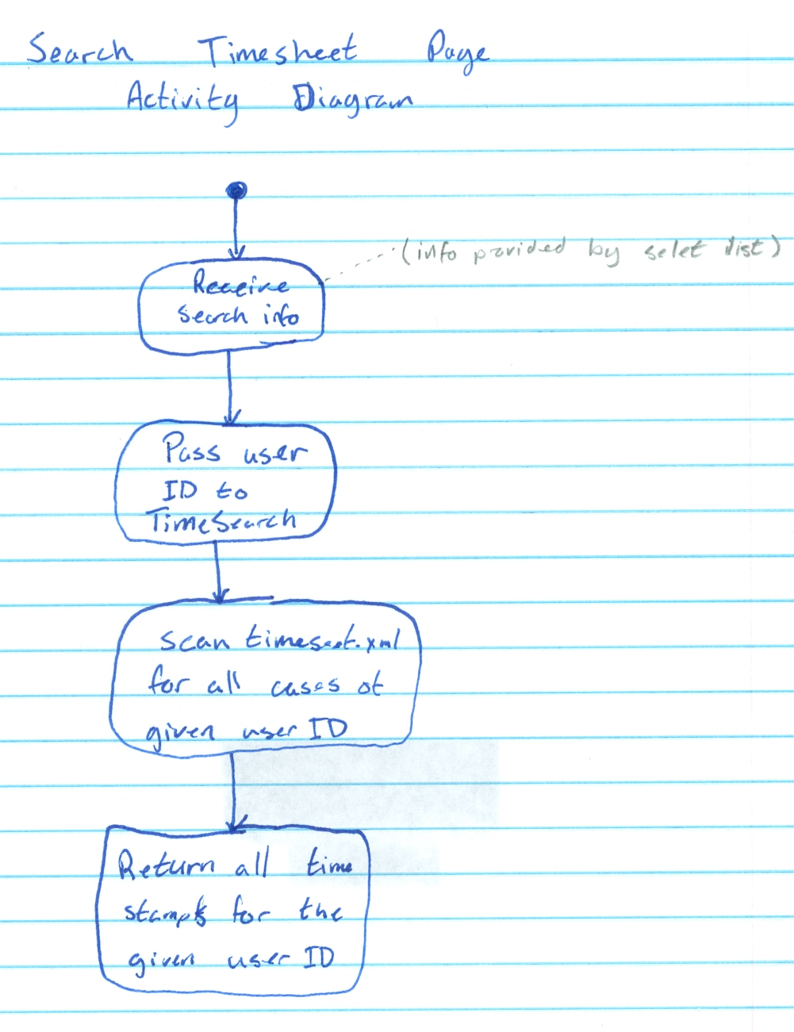
Search Time Sheets UML Diagram

Export Time Sheet UML Activity Diagram
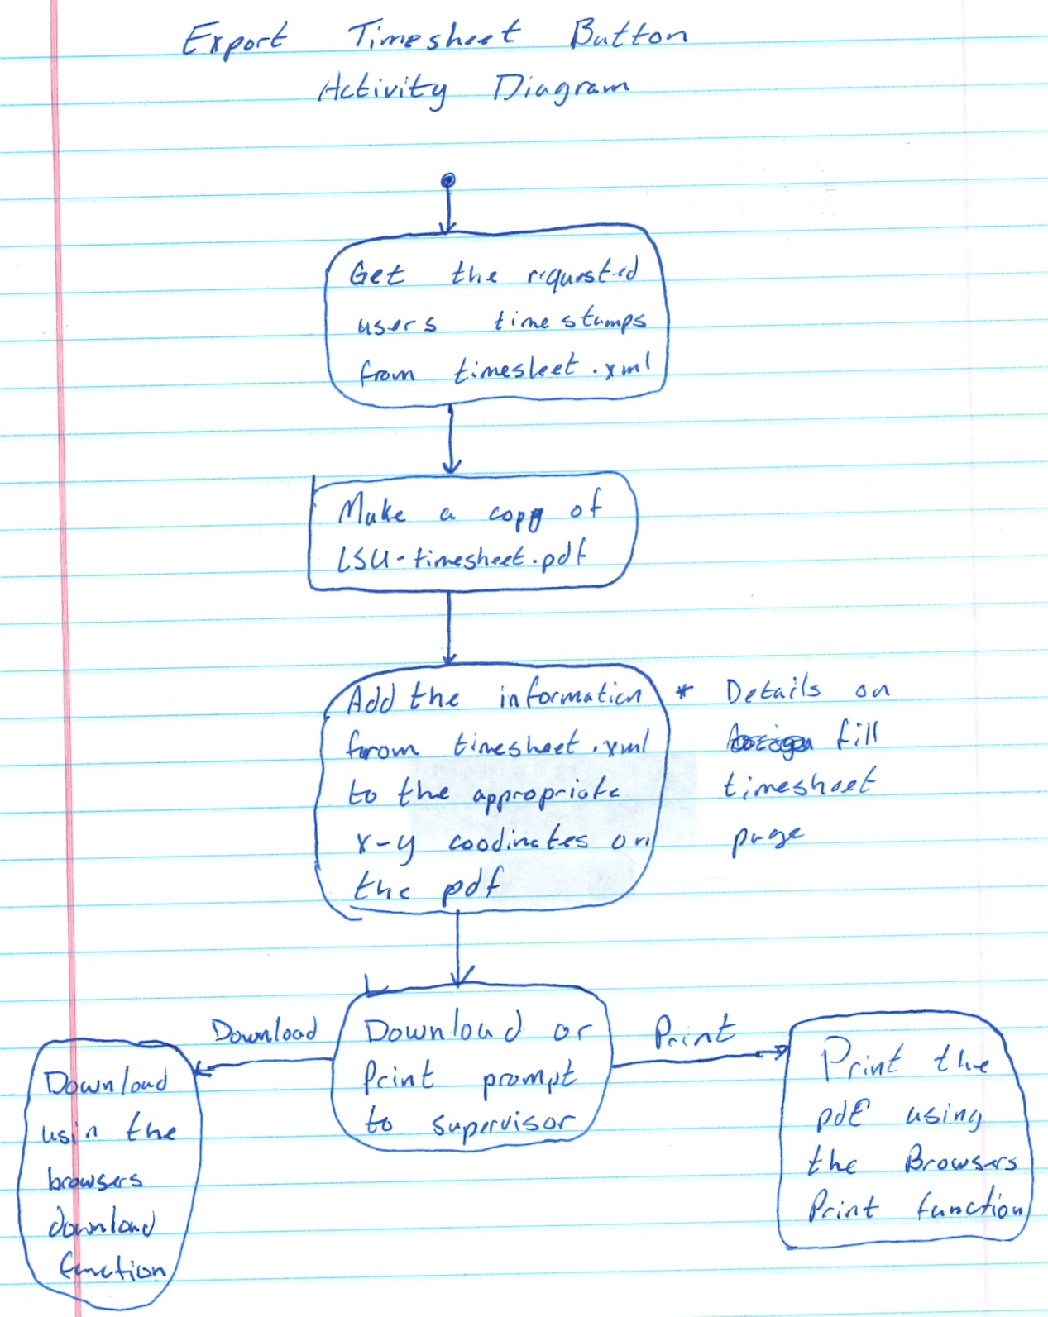

WebFlow UML Diagram
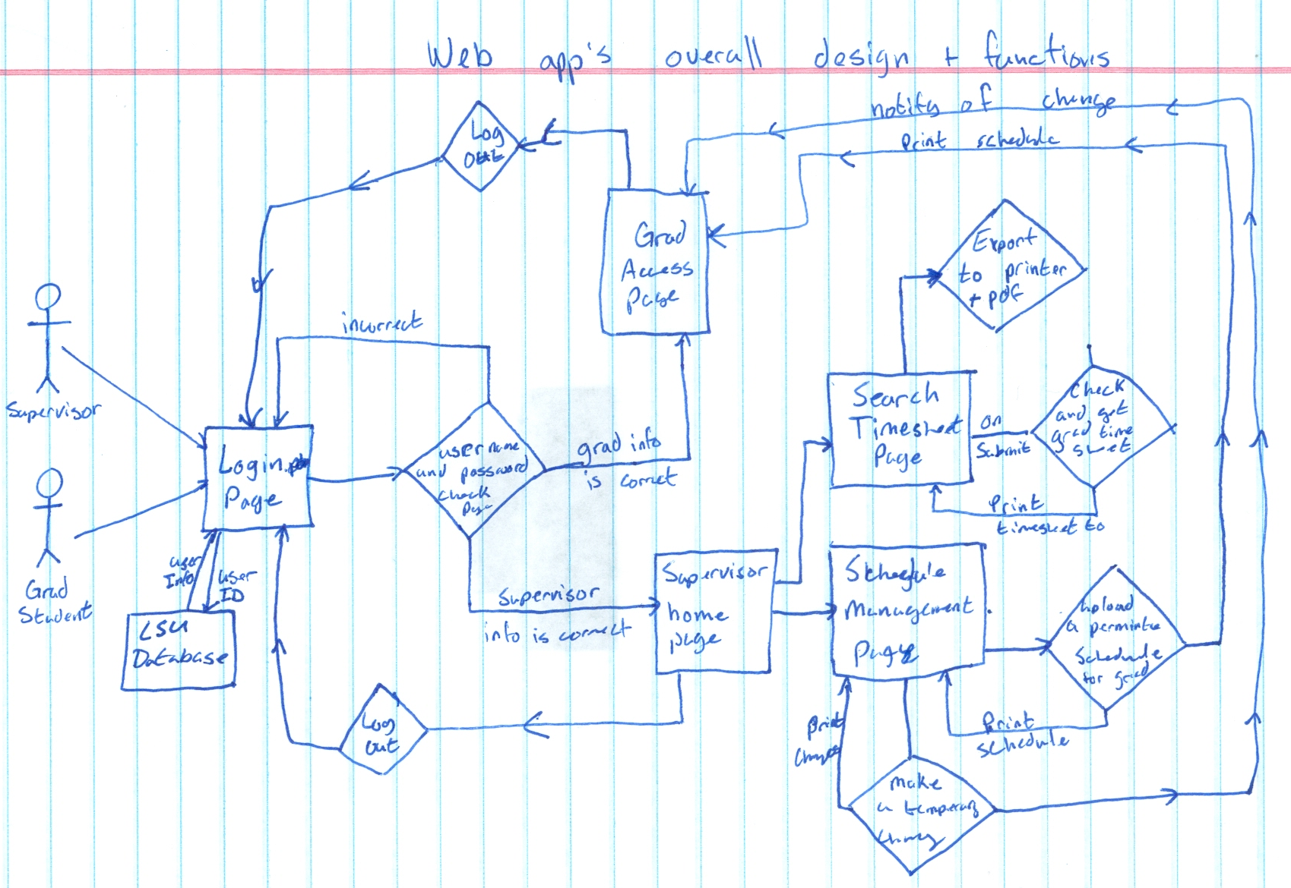

The Four Process Views

The Logical View
This process view provides us with the ability to figure out the functional requirements of our system. For example, our requirement regarding the ability for users to enter their login information and then handle that data can be visualized through a logical process view. The logical view allows us to visualize our components into manageable objects. For instance, we can use a logical view to show the relationship between our requirement state above with our requirement to make the system be able to compute if the user is a graduate student or if they are the supervisor. Logical views can also organize theses objects into object classes to improve efficiency. Diving deeper into the logical view process model showed us a way to diagram our system into object interactions very similar to the relationship between the data entered by the users and who they are according to our system.

The Process View
This process view helps us visualize the entire system into a single visualization. Our single visualization for our project shows how the system works from the login page to when the user logs out. The visualization can single out subsystems and refine each one that is needed. This process can show us what would happen to the whole system if changes are made to a component in the system. If we wanted to add another component to add another layer of security we would move that subsystem before our graduate access page. Process views can also utilize UML diagrams (like activity diagrams) to show the static and dynamic aspects of the system. For example our time stamp cannot be changed by the graduate students, which would mean that the information is static to them. Although that information is dynamic for the supervisor if he or she needs to edit time stamps. Both of these examples can be used with the process view by using a UML for each scenario.

The Development View
This process view can help us manage our software in a software engineer's perspective. We can decompose the system to fit the environment. For example if this system is going to move to another university we would decompose it and find the components needed to be edited to fit that university's standards and technologies. Using this process view, we can make it easier for other software developers that will work on the system. If done correctly, every developer working on the system can better understand the dependencies and relationships between the system modules. If we did move this system but we ourselves did not become part of the new team, a development view will help the new developers.

The Physical View
This process view will show how our system is organized in a physical point of view. For example, the user interaction in our system involves him/her to type on the keyboard and enter their information to login. With the physical process view it will create a visualization of how information is passed from the keyboard to each of the components in the system. Administrators and system designers that take care of the system will be able to understand: the physical locations of the software, the physical connections between nodes, and how to deployment and installation the system.

Context Diagrams

Process Models

Architecture Pattern

Design Patterns

Facade
Provide a unified interface to a set of interfaces in a subsystem. Facade defines a higher-level interface that makes the subsystem easier to use. We choose this pattern because its good to describe how the system can give the supervisor authority over the graduate students. The subsystems that used this design pattern are the following: the system to let the supervisor edit time sheets, the clock in and out system for the graduate students, and our messaging system for the supervisor to send messages to the graduate students.
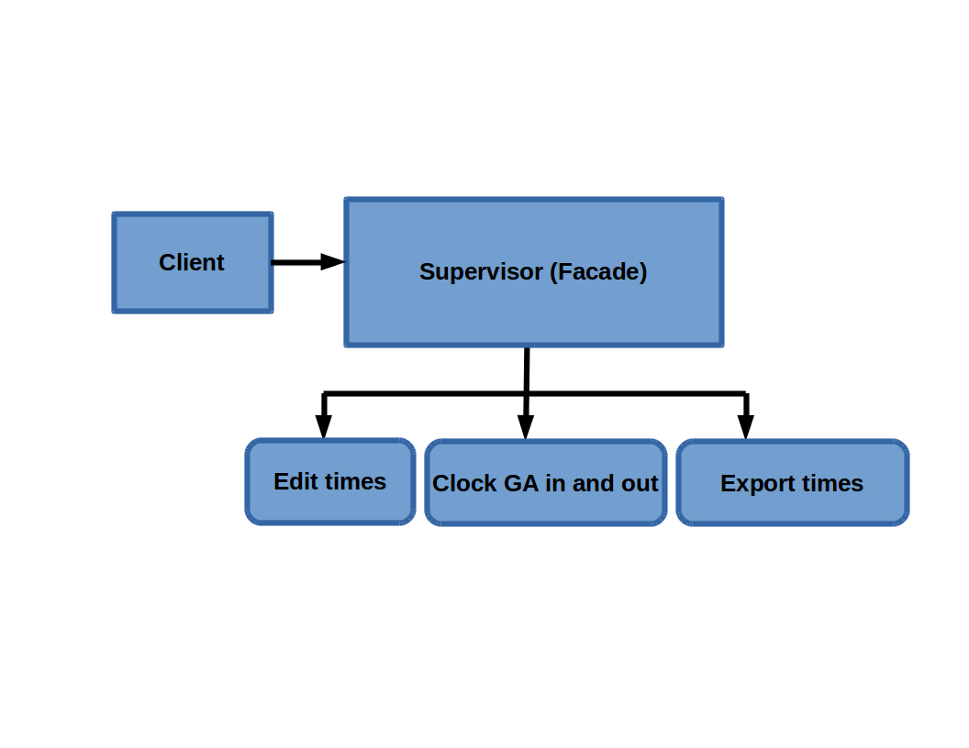
-Sub-systems: Edit times , Clock in and out GA, Export time, Send messages to GA.

Chain of Responsibility
Avoid coupling the sender a request to its receiver by giving more than one object a chance to handle the request. I choose this pattern because it describe the way how the request can be send and can be handle by the system.
-Sub-system: Clock in and clock out, lunch break, write time down, minus the total time.
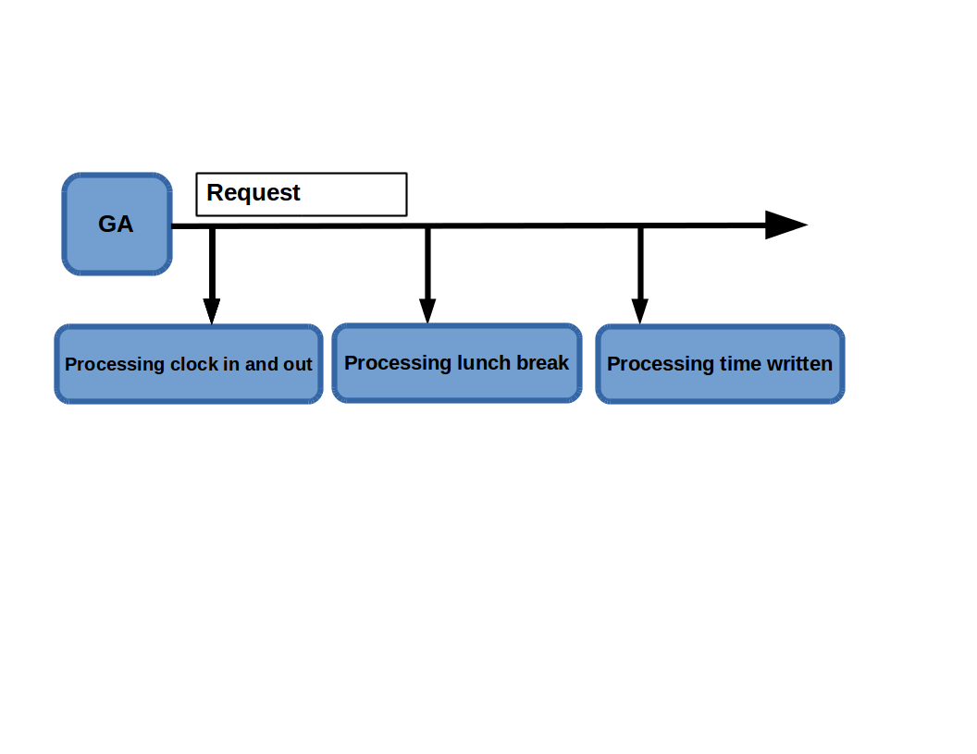

Finite State Machine

Github

Essay

The Requirements Engineering assignment was slightly daunting at first because none of us had ever done an assignment quite like this before. However, as we continued forward as a group, it started to become straightforward and simpler to accomplish. We started the assignment by compiling the list of functional and nonfunctional requirements. This wasn't terribly problematic and was a good starting point. After finishing the list, we decided to go ahead and put together a prototype early to show to our client right away and get some feedback. We presented the prototype to the client and collected feedback to keep in mind for the next iteration of the prototype. Next, with the feedback from the first prototype in mind, the group began working out the UML diagrams for the use cases and the sequence diagram. This was probably the most difficult part for us but only due to being slightly more inexperienced in this aspect of the assignment. After completing the UML diagrams, we began working on the second iteration of the prototype to submit to the client. We used the first prototype as a starting point and made use of the feedback provided by the client to make the changes he desired to see in this next iteration. The second prototype was then polished, and the group divided up tasks to begin working on finishing the document to submit for grading.

During the process of completing this assignment, there were definitely a few things we learned. Firstly, we learned the most important lesson of this activity. This was that the client is not always sure what it is that they want from the software, and they will sometimes change their mind on features they want to be included in the software. We also learned that using the first iteration of a prototype is very beneficial for saving time on completing the second iteration of a prototype. The second iteration had a lot of changes to it in order to be more polished and adapt to the changes the client requested but using the first iteration as a skeleton was very useful in completing it in the timely manner. Lastly, we learned, toward the end of the assignment, that dividing up work instead of collectively working on a single part of the assignment was more efficient. In retrospect, splitting up tasks and later checking and conferring as a group on what should be different was a much faster way to work.

Possibly the best decision we made as a group was to work on the first iteration of the prototype fairly early in order to spend more time working on the second iteration of the prototype and analyze the feedback from the client. We already had an adequate amount of information to begin working on the prototype, and it was suited to our agile approach of completing the assignment. Also, the UML use cases were very beneficial for developing the second iteration of the prototype. Being able to visualize a little better what the user of the software would be doing with the program helped the group to polish up the second iteration to be much more superior to the first. Another good decision we made was starting with compiling the functional and nonfunctional requirements right off the bat. By doing so, we were able to start very quickly on the first iteration of the prototype and had a good foundation to start the assignment in general. Seeing as how it too us the longest to complete as well, it also took a large part of the burden off of our shoulders fairly early on in the activity.

Nonetheless, there were still things the group wished that we would have done differently during this assignment. Most importantly, as I mentioned earlier, division of labor was something we learned a little late in the game. Nearly all the work we did during the beginning and middle parts of completing this assignment was done when we all met together and worked on a single segment of the giant puzzle this assignment became. It was nice to collaborate and get ideas from everyone as we pushed forward, but ultimately, it slowed us down and made the assignment take more time than it probably should have to complete. Another decision we feel we should have done differently was that we should have worked out two different versions of the UML diagrams. Having the UML diagrams before working on our second prototype was immensely helpful for completing the second prototype. If we had done them for for the first iteration of the prototype and possibly adjusted or tweaked them for the second iteration, it would have made the process a little bit easier on us in the long run. We were a little too concerned with churning out the first iteration as quickly as possible, and it may have come out a little better with the additional visualization of the software as a whole.

Acquiring the the requirements in a simulated real world situation was without a doubt an interesting part of this assignment. It was not necessarily hard, but at times it did somewhat feel like we were prodding out information or even negotiating with the client to find out what he wanted from the software. There was even one meeting with the client in which we didn’t receive any new information. At that point, we tried to come together as a group to collaborate on new ways to ask questions and attempt to decipher questions we were forgetting to ask or just missing. When we presented the first iteration of our prototype to the client, he seemed very impressed by it and only had a few comments about changes. During the meeting after that, however, the client gave us much more insight on what the group should be changing for the second iteration of the prototype after we had some deeper, carefully crafted questions instead of just presenting the prototype for him to review. All in all, there were times when it was easy to collect information and times when we didn’t really learn anything new. The deciding factors seemed to be working together as a group to generate questions, trying to brainstorm as many questions as possible before the meeting with the client, and pondering on what important questions we may be forgetting to ask.

In conclusion, Team Green is proud of the work we have put into the Requirements Engineering assignment. We learned the importance of group work while also learning how to work better as a group in general. The group also learned a lot about how to deal with a real world client, and how difficult it can be at times. We determined what we feel like the best course of action would be on future endeavors such as this one by making a few mistakes and learning from them. Most importantly, Team Green gained some very important experience that will no doubt be used by each of us in our futures.

