Documentation for using the AOG Logging system with the Program Admin.

Add the program to the Program Admin:

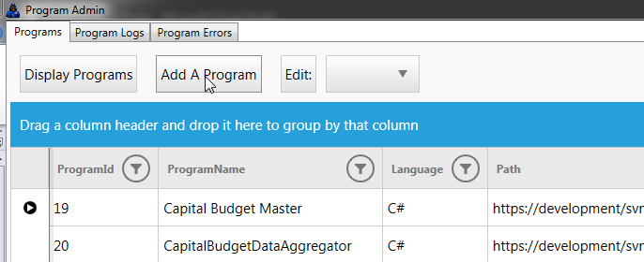

Fill in the required information:

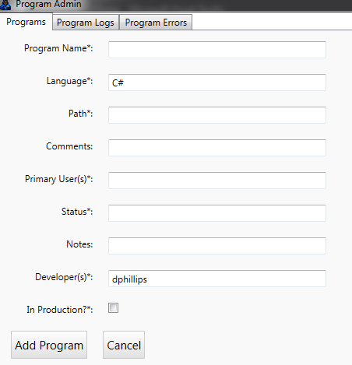

Path refers to the subversion path that it is stored at, Comments and Notes are whatever the developer wants to store. Status is whether it is in development, production, halted, etc.

Click the “Add Program” button to save.

Find the program that you added in the list, and make a note of its ProgramId, you’ll need this later.

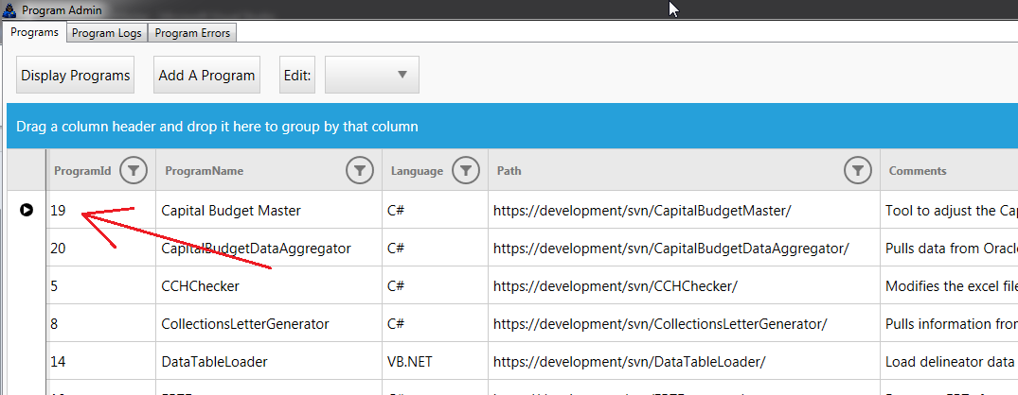

Now you can use the AOGLogger class library.

Pull the AOGLogger.dll from the subversion repository “DLLs”;

Add a reference to that dll in the project that you are working on.

Go to your “App.config” file and add a section for “appSettings” with the programId that you got from the Program Admin, as follows:

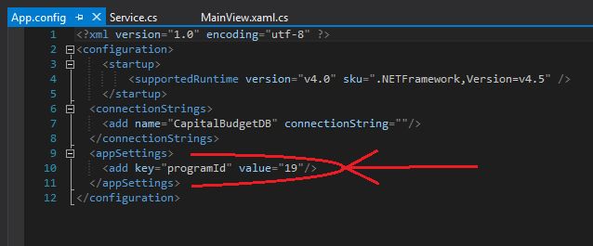

It will need to look exactly like the previous image, except that the value would be changed to your program’s id.

Instantiate the logging classes and place them where the entire class can use them:

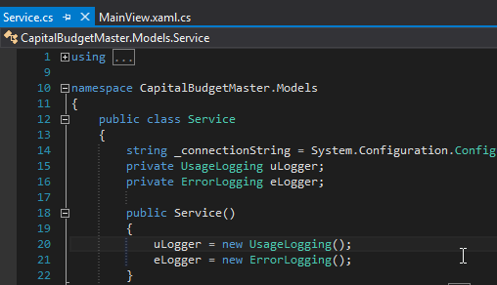

From this point, all that is needed to log anything is to call the “LogThis” method in either of the classes. With the usage logger, you can save any information that you wish in the database. It is mainly for the developer to reference later, so anything that you think might be relevant for figuring out what the user did can be logged. As for the error logging, you can just pass in the Exception object and it will log all of it, as well as the user and time stamp.

Usage logger example:

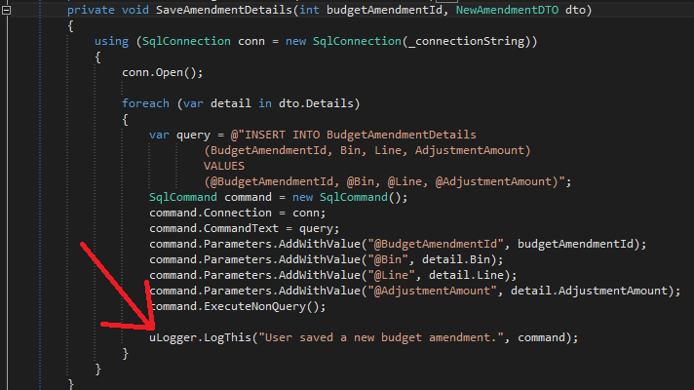

Error logger example:

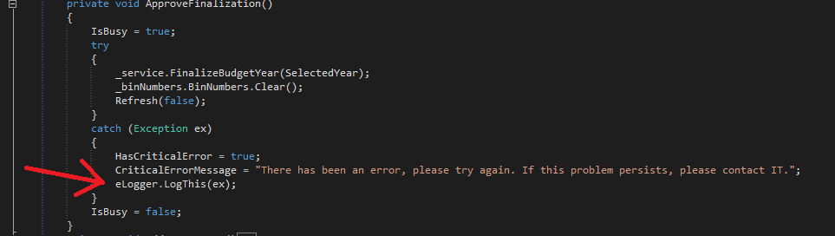

If you want your program to log any unhandled exceptions, as well as when it is started and closed, you can refer to the code in “App.xaml.cs” in the ProgramAdmin solution. You should be able to copy and paste straight into your program from the code that is there.