STAT4100 HW1

Cody Frisby

January 10, 2016

# Chapter 1 Homework (Experiment Design):

### Optimized microwave settings and popcorn brand

#### Response Variable will be the count of unpopped kernels without burning

#### The factos will be as follows:

|  |  |  |
| --- | --- | --- |
| Power Setting | Time Setting (minutes) | Popcorn Brand |
| Low | 2:00 | Costco |
| High | 2:30 | Pop Secret |

Here's a table with a random run order:

## Power Time Brand  
## 2 Low 2 Costco  
## 8 Low 2.5 PopSecret  
## 4 Low 2.5 Costco  
## 1 High 2 Costco  
## 5 High 2 PopSecret  
## 3 High 2.5 Costco  
## 7 High 2.5 PopSecret  
## 6 Low 2 PopSecret

# Chapter 2 Homework:

## No.1

Note: Group A will be treated with 95 C. Group B will be treated with 100 C

A <- c(11.176, 7.089, 8.097, 11.739, 11.291, 10.759, 6.467, 8.315)  
B <- c(5.263, 6.748, 7.461, 7.015, 8.133, 7.418, 3.772, 8.963)  
D <- as.data.frame(cbind(A, B))  
t <- t.test(B, A, var.equal = TRUE, conf.level = 0.95)  
t

##   
## Two Sample t-test  
##   
## data: B and A  
## t = -2.6751, df = 14, p-value = 0.01812  
## alternative hypothesis: true difference in means is not equal to 0  
## 95 percent confidence interval:  
## -4.5404257 -0.4995743  
## sample estimates:  
## mean of x mean of y   
## 6.846625 9.366625

1. There is evidence to suggest there is a meaningful difference between the two baking temperatures. At alpha = 0.05 level we would reject the null hypothesis.
2. The p-value for the test is 0.018118. This is well below 0.05.
3. The confidence interval for this test is [-4.5404257, -0.4995743]. Zero is not contained within this interval. This means it is a statistically significant result.
4. QQ plots below: 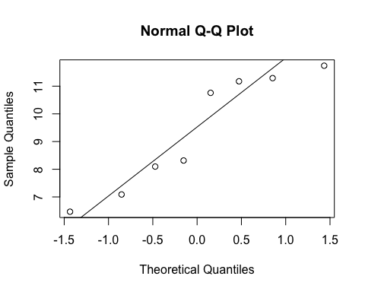

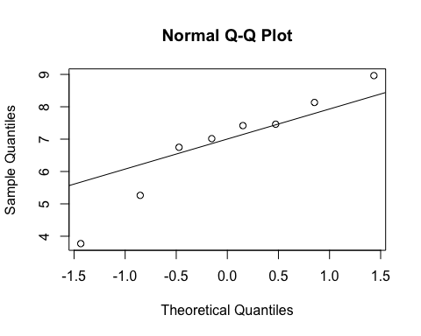

# Shapiro test for normaility  
shapiro.test(A)

##   
## Shapiro-Wilk normality test  
##   
## data: A  
## W = 0.87501, p-value = 0.1686

shapiro.test(B)

##   
## Shapiro-Wilk normality test  
##   
## data: B  
## W = 0.9348, p-value = 0.5607

boxplot(D, col = "green", ylab = "kA")

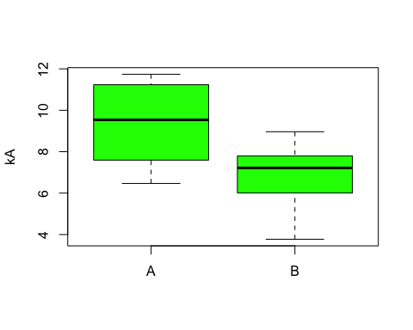

## No.2

y1 <- 93  
y2 <- 102  
s1 <- 12.9  
s2 <- 6.1  
n1 <- 10  
n2 <- 12  
# Note: variances cannot be assumed to be equal:  
# adjussted degrees of freedom:  
v <- (((s1^2/n1) + (s2^2/n2))^2) / ((((s1^2/n1)^2)/(n1-1)) + ((s2^2/n2)^2/(n2-1)))  
# t test statistic:  
t0 <- (y1 - y2) / sqrt((s1^2/n1) + (s2^2/n2))  
t0 # t statistic

## [1] -2.025577

pt(t0, df = v) #compute p-value.

## [1] 0.03251861

The test statistic for this test is t = -2.0255771. The critical value, with d.f = 12.3166609, is = -1.3541908. We would reject the null hypothesis at alpha = 0.1. There is evidence to suggest that there are less particulates in a non-smokers home than in a smokers home.