Final Project

Daniel Pipkin

5/6/2021

## Introduction

This report is based on research conducted by Justin Hilman. For a journalism research project, Justin shared a poll with Harding students to learn about their news consumption habits.

Justin asked questions about people’s social, political, and economic beliefs to get a basis of people’s biases.

Justin then asked questions about whether people think that the Washington Post and Fox News are credible and whether they tell the whole story.

After getting preliminary information about people’s biases, Justin asks for the student’s opinion on a headline and whether they would verify the headline using an outside source. This was done a total of four times. With two headlines per news outlet. One headline was an actual headline, the other was one that was fake.

The variables that are used from the data set are as follows:

* PoliticalLean: Factor, The political stance of the respondent (Very Liberal,Somewhat Liberal, Independent, Somewhat Conservative, Very Conservative)
* SocialLean: Factor, The social stance of the respondent (Very Liberal,Somewhat Liberal, Independent, Somewhat Conservative, Very Conservative)
* EconomicLean: Factor, The economic stance of the respondent (Very Liberal,Somewhat Liberal, Independent, Somewhat Conservative, Very Conservative)
* WaPoCredible: Factor, How credible the respondent thinks the Washington Post is (Strongly agree, Somewhat agree, Somewhat disagree, Strongly disagree)
* WaPoWhole: Factor, How much of the story the respondent thinks The Washington Post tells. (Strongly agree, Somewhat agree, Somewhat disagree, Strongly disagree)
* FoxCredible: Factor, How credible the respondent thinks Fox News is. (Strongly agree, Somewhat agree, Somewhat disagree, Strongly disagree)
* FoxWhole: Factor, How much of the story the respondent thinks Fox News tells. (Strongly agree, Somewhat agree, Somewhat disagree, Strongly disagree)

Other variables used:

* meanPolitical: Numeric, The mean of PoliticalLean for the data set.
* meanSocial: Numeric, The mean of SocialLean for the data set.
* meanEconomic: Numeric, The mean of EconomicLean for the data set.
* overallMean: Numeric, a value generated by taking meanPolitical, meanSocial, and meanEconomic, used to generate an overall feel for a mean lean of the data set.
* indivMean: Numeric, the mean of meanPolitical, meanSocial, and meanEconomic per respondent. Used to generate an overall political bias.
* HDCon: Dataset filtered with indivMean values greater than 3.5.
* HDLib: Dataset filtered with indivMean values less than 2.5.

The following section of variables are based off of the following 4 questions:

Washington Post:

1. “How would you rate the following Washington Post Headline:”President Biden vows to dedicate four trillion dollars to climate change science""
2. “How would you rate the following Washington Post headline:”Biden’s messed-up math comparing war deaths to covid deaths""

Fox News:

1. “How would you rate the following Fox News headline:”Biden makes statement claiming that all transgender women should be able to compete in women’s sports""
2. “How would you rate the following Fox News headline:”Biden ‘optimistic’ about bipartisan work to ‘end cancer as we know it’""

The variables that correspond with the questions are as folllows:

* WaPoRate[1/2]: Factor, the respondent’s rating of how true they believe the headline to be.
* FoxRate[1/2]: Factor, the respondent’s rating of how true they believe the headline to be.

## Analysis

The question that is to be examined in this data set is: Does overall bias play a factor in whether one believes a news outlet is credible or not.

To achieve this, a Chi-Squared Hypothesis Test will be used.

The test will be run twice. Once testing the independence of individual bias with the Washington Post, and once with Fox News.

## Warning in chisq.test(as.numeric(HD$indivMean), as.numeric(HD$WaPoCredible)):  
## Chi-squared approximation may be incorrect

##   
## Pearson's Chi-squared test  
##   
## data: as.numeric(HD$indivMean) and as.numeric(HD$WaPoCredible)  
## X-squared = 53.136, df = 36, p-value = 0.03272

## [1] "As shown, the p-value is less than 0.05, thus the null hypothesis that one's bias plays a factor in determining whether or not the Washington Post cannot be rejected."

## Warning in chisq.test(as.numeric(HD$indivMean), as.numeric(HD$FoxCredible)):  
## Chi-squared approximation may be incorrect

##   
## Pearson's Chi-squared test  
##   
## data: as.numeric(HD$indivMean) and as.numeric(HD$FoxCredible)  
## X-squared = 38.626, df = 36, p-value = 0.3518

## [1] "As shown, the p-value is above 0.05, thus the null hypothesis that one's bias plays a factor in determining whether or not Fox News is a credible source cannot be rejected"

## Visualizations

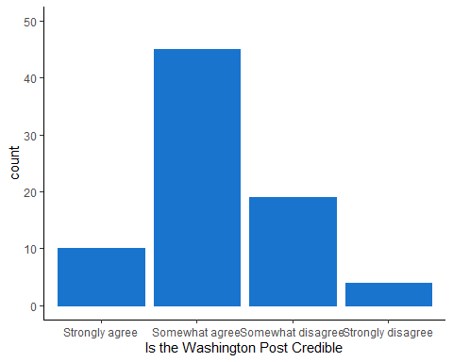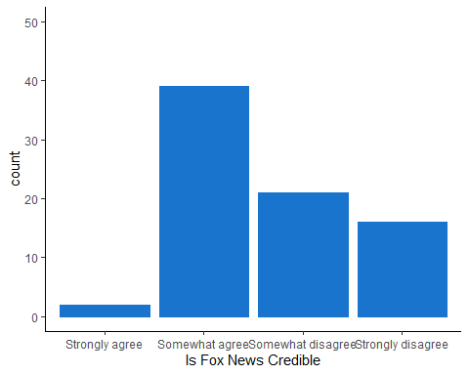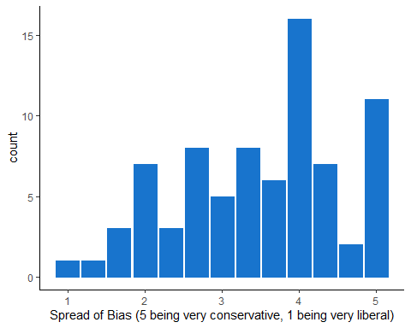

## Results

After examining the data, it can be concluded that bias plays a role in determining whether some news outlets are credible or not. When comparing the first and second graphs, there is a noticeable difference in the “somewhat disagree” column. As the third visualization shows, there are more respondents who are conservative than liberal. With this information, it makes logical sense, that those who have a conservative bias are going to be biased towards fox news, and those who have a liberal bias are going to be biased against fox news.