Columns:

- №
- Action
- Expected result
- Pass/Fail
- Comment

№ | Action | Expected result | Pass/Fail | Comment
1 | Empty the database by running the script emptyDb.sh.
2 | Launch PCC by executing command mvn jetty:run. | There are no processes in the Processes tab of the PCC (see image № 1 below).
3 | Add a new resource DP with following data:  resource R1210 "DP"  {  limits { dailymax 8.00h }  }
4 | Add a new task with following data:  task T2010 "Some interesting task"  {  start ${now}  priority 200  allocate R1210  effort 2.50h  }
5 | Schedule the processes by pressing the Schedule button in the Scheduling tab. | Tasks are scheduled without problems.
6 | Open Daily plan tab.
7 | Select Estimated completion dates tab. | Table contains one entry for the task from step 4.
8 | Select the day, on which the entered task is assumed to be completed (see step 7). | Table Daily goals contains one entry for the task from step 4.  Table Schedule contains one entry for task from step 4.

Images

Image № 1

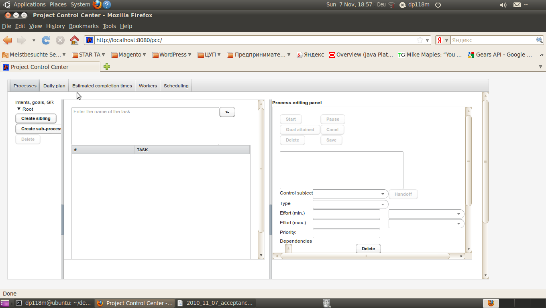

Image № 2

