**Stock Broker Management System**

This is a Stock Broker Management System that allows customers to buy and sell shares through a stock broker.

This system has two users, Broker and Customer.

Broker can view and manage customers, stocks and transactions.

Customer can buy and sell stocks, view stocks and transactions, and add or withdraw funds to and from their wallet.

UI for user access

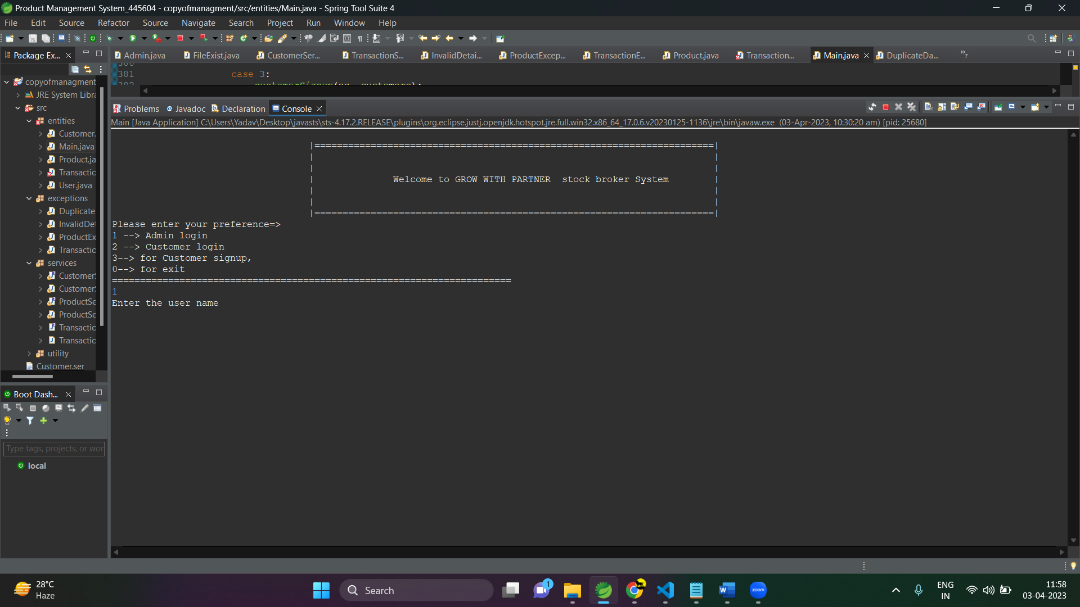

1-for admin login

2-customer login.

3-customer singnup

0-for exit

**How to use the system**

Broker Login

Open the system.

Enter the username and password for the Broker account.

Singel broker access

Username:”admin”;

Password:”admin”;

Broker Menu

View Customers: This option allows the Broker to view all the customers registered in the system.

Add Stocks: This option allows the Broker to add new stocks to the system.

View Stocks: This option allows the Broker to view all the stocks in the system.

Delete Customer: This option allows the Broker to delete a customer. When a customer is deleted, the total amount of all the stocks is credited to their wallet, and the account is set to inactive.

Delete Stock: This option allows the Broker to delete a stock.

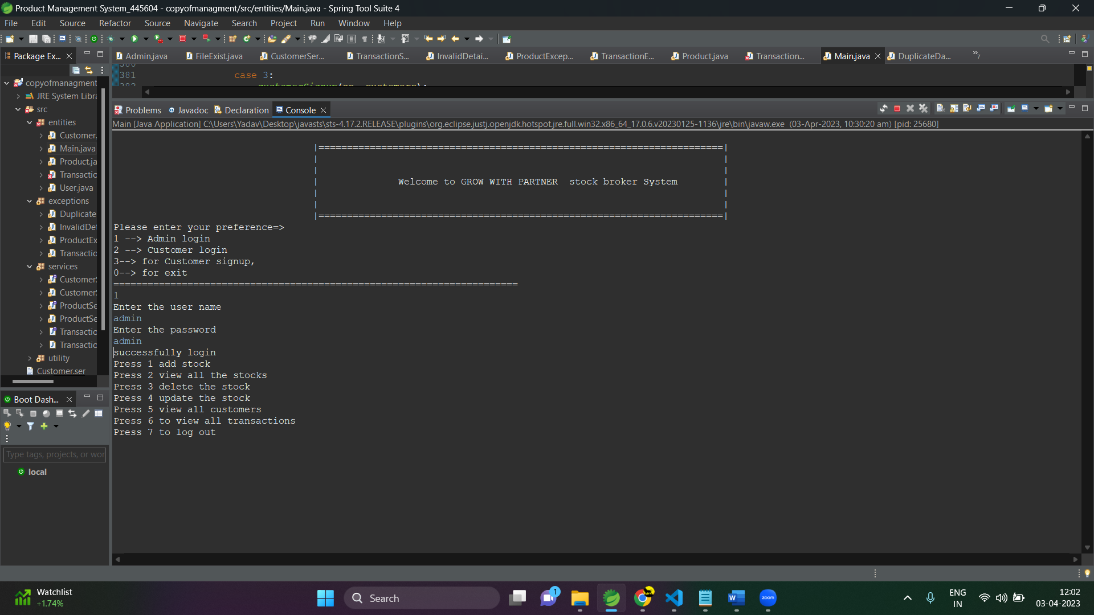

**Customer Sign-Up**

If you are new user just sign up by giving input 1.

Enter the required details like first name, last name, username, password, address, mobile number, and email.

Then enter

Customer Login

Open the system.

Enter the username and password given by the admin.

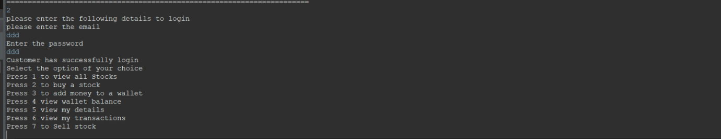

**Customer Menu**

View Stocks: This option allows the Customer to view all the stocks in the system.

Buy Stocks: This option allows the Customer to buy stocks from the available stocks.

View Transaction History: This option allows the Customer to view their transaction history.

Add Funds: This option allows the Customer to add funds to their wallet.

Sell Stocks: This option allows the Customer to sell the stocks they have purchased.

**Installation**

Clone the repository to your local machine.

bash

Copy code

Clone it.

Open the project in your preferred Java IDE.

**Usage**

Build and run the project in your IDE.

* You will be prompted to log in as either a customer or a broker.
* If you are logging in as a customer, you will be asked to sign up first. Enter your first name, last name, username, password, address, mobile number, and email.
* Once logged in, you will see the list of available stocks and can buy or sell stocks, view your transaction history, and add or withdraw funds to/from your wallet.
* If you are logging in as a broker, you will need to enter the username and password for the admin account ('admin' and 'admin', respectively).
* Once logged in, you can view all the customers, add new stocks, view all the stocks, view consolidated reports for a stock, delete customers (crediting their wallet and setting the account as inactive), and delete stocks (crediting the customer's wallet and marking the stock as deleted from the database).