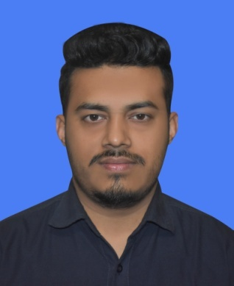 Curriculum Vitae

of

Sourov Kumar Pramanik

**Mailing Address**

Sourov Kumar Pramanik

House#20, Road#02, Block-G,Section-2,Mirpur,Dhaka-1216.

**Contact No: 01728677037 , 01521200696**

* **Career Objective**

Looking for a good and challenging position where skill and efficiency can be utilized to achieve both the corporate and personal goals.

* **Education**

**B.Sc. (Engg.)** : B.Sc. engineering in CSE (2014-2018)

Institute : Bangladesh University of Business & Technology (BUBT),

Mirpur-2, Dhaka Commerce College Road, Dhaka-1216

Result : CGPA- 3.10 out of 4.00

**H.S.C** : Higher Secondary Certificate, 2013

Group : Science Group, Bengali Version

Institute : Aminur Rahaman College, Magura

Result : Jessore Board, GPA- 4.30

**S.S.C**  : Secondary School Certificate, 2011

Group : Science Group, Bengali Version

Institute : Rajpat High School, Magura

Result : Jessore Board , GPA- 5.0

* **Language Ability**

Bengali : MotherTongue (Speaking,Listening and Writing)

English : Good (Speaking, Listening and Writing)

* **Computer Literacy**

**Environment : Microsoft** Word2007, Microsoft Excel,Microsoft Power Point, Microsoft Outlook, Internet Browsing and other necessaries.

**Interest** : Traveling, Listening Music and Involvement with Social Activities.

* **Experience:** I am working at a data center which name is CoLoCity . I started work here from 1st June, 2018 as a junior support engineer. Still now, I am working here.
* **Personal Details**

Name : Sourov Kumar Pramanik

Father’s Name : Nimai Pramanik

Mother’s Name : Tripti Rani Pramanik

Permanent Address: Vill-Putia,Post-Goalbathan,Tha+Dist- Magura

Date of Birth : 30 June,1996

Nationality : Bangladeshi

Religion : Hinduism

Marital Status : Unmarried

* Reference

1. Palash Kumar Sen

Accountants officer of FCI group (BEPZ)

Contact: 01731317750

2. Manoj Mandol

Lecturer (Dept. of Botany),

Govt. Shaheed Suhrawardy college, Dhaka.

Contact: 01717236886

I certify that all information stated in this resume is true and complete to the best of my knowledge. I authorize you/your representative/agent to verify the information providedin this resume.

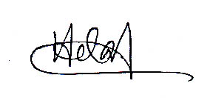**Date: ……./……/……………** **Signature**