***R***

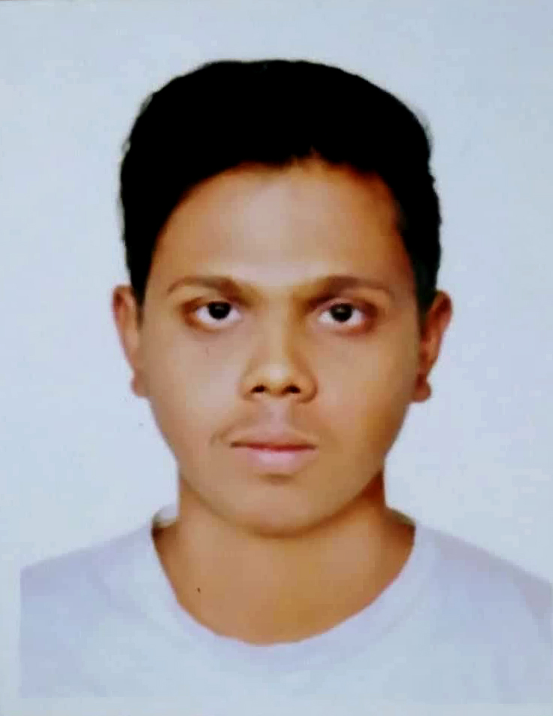

***Resume***

***Of***

***Adnan Rahman***

***Objective:***

“Seeking a position in a challenging environment, where there is a need for a variety of creative designing including – Video Editing, Graphics Design, 3D design and Modeling etc.

***Educational Qualification:***

|  |  |  |  |  |  |
| --- | --- | --- | --- | --- | --- |
| **Exam Title** | **Subjects/Group** | **Institute** | **Result** | **Pass Year** | **Board** |
| B.Sc. (Honors) | Multimedia & Creative Technology | Daffodil International University | CGPA 3.15  (Till 11th Sem) | Running (Last year) | Dhaka  Board |
| H.S.C | Science | College of Development Alterative (CODA) | GPA 2.70 | 2012 | Dhaka Board |
| S.S.C | Science | West End High Scool | GPA 4.06 | 2010 | Dhaka Board |

***Experience:***

Working as **Creative Designer** in “**Brothers Orchid LTD.**” from May 2018.

***Skills:***

**.** Creating special effects on raw footages.

. Simulation making on various TVC.

**.** Creating Motion Graphics & Logo through After Effects & Illustrator.

**.** Necessary support providing to the administration as deemed appropriate.

**.** Any other responsibilities as assigned by the management.

***Skills on Softwares :***

|  |
| --- |
| * Adobe After Effects * Adobe Premier Pro * Adobe Photoshop * Autodesk Maya * Autodesk 3Ds Max * Real flow * FL Studio * Adobe Audition * Adobe Illustrator * Substance Painter |

***Area of interest:***

* Travelling

Reading Books

|  |  |  |  |  |  |  |  |  |  |  |  |  |  |  |  |  |  |  |  |  |  |  |  |  |  |  |  |  |  |  |  |  |  |  |  |  |  |
| --- | --- | --- | --- | --- | --- | --- | --- | --- | --- | --- | --- | --- | --- | --- | --- | --- | --- | --- | --- | --- | --- | --- | --- | --- | --- | --- | --- | --- | --- | --- | --- | --- | --- | --- | --- | --- | --- |
| ***Personal Information:***   |  |  |  | | --- | --- | --- | | **Father’s Name Father's Name** | : | Md.Zeaul Haque | | **Mother's Name** | : | Late Ayesha Begum | | **Date of Birth** | : | August 29, 1995 | | **Gender** | : | Male | | **Marital Status** | : | Single | | **Nationality** | : | Bangladeshi | | **Religion** | : | Islam | | **Height** | : | 5’ 4’’ |   ***Mailing & Permanent Address:***   |  |  |  | | --- | --- | --- | | Road No | : | 52, Kazi Reajuddin Road | | P.O | : | Posta | | Thana | : | Lalbagh | | District  Cell no | :  : | Dhaka  01533345025  ---------------- | |  |