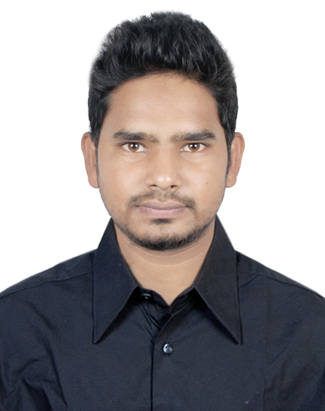

Curriculum Vitae of
Asif Rahman
77 gha, Shah ali road,Mirpur 1,
Mirpur, Dhaka-1216
Cell No: +88-01687730385
asifrahman.p@gmail.com

OBJECTIVE:

To build up career obtain a personal position in dynamic and challenging environment with excellent career development prospect where hard work, strict discipline and critical problem solution are the cornerstone of success.

ACADEMEC QUALIFICATION:

- Graduation
Bachelor of Business Studies (B.B.A)
Running
Name of the Degree : B.B.S (Bachelor of Business Studies)
University : National University
Institution : Govt. Bangla college
Mirpur, Dhaka
Board : Dhaka
Class/GPA : 2nd year

- Higher Secondary Certificate (H.S.C):
2014
Board : Board of Higher Education, Rajshahi.
Institution : Belkuchi Degree College
Belkuchi,Sirajagonj
Group : Commerce
Obtained GPA : 3.80 (A-)

- Secondary School Certificate (S.S.C):
2012
Board : Board of Secondary Education, Rajshahi.
Institution : Enayetpur Islamia High School
Enayetpur, Sirajgonj
Group : Commerce
Obtained GPA : 4.75 (A)

EXPERIENCEE :

(#) Executive Video Editor in AB24.TV and still working
(#) Chief video editor in Celltrone Electro manufacturing Service.
(#) Head of post production dept in "foto factor" 2 years experience.
(#) Assistant Video Editor at "Motion View"
(#) Freelance video editor, graphics designer in own panel.

(N.B.) Good at making Music video, Short film ,Promotional video, Wedding Promo Typography and others.

Computer Literacy :

- Strong Knowledge on operating MS. Word, MS. Excel, Internet etc.
- Adobe Photoshop
- Adobe premiere pro cc
- Adobe After Effect
- Adobe Audition .
- Digital marketing, Email marketing ,Youtube marketing and others.

EXTRA ACTIVITIES:

- To Hard Work & Sincerity.
- Able to Function Properly Under Pressure.
- Self Motivated, Self Confidence, Self-Assertive.

PERSONAL DETAILS:

Name : Md. Asif Rahman
Father’s name : Md. Afzal Hossain Tota
Mother’s name : Rina Begum
Permanent Address : Vill+ Post+Thana: Enayet pur Dist: Sirajgonj
Contact No : +88-01687730385
Date of Birth : 01/04/1997
Nationality : Bangladeshi (By birth)
Marital Status : Single.
Blood Group : B+(Possitive)
Religion : Islam.
Height : 5’-3”
Interest : Sports, Traveling And Watching Movie

LANGUAGE PROFICIENCY:

• Good Communication Skill in both Bengali & English.

I declare that the above information's are true to the extent of my knowledge.

……………………… Date :
Signature
Md. Asif Rahman

