CURRICULUM VITAE
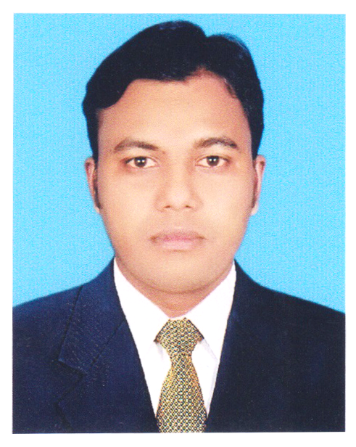
OF
MD. ANAMUL HOSSEN
Cell : 01760447389
01912638754

CAREER OBJECTIVE:

Motion Graphics professional with 4 years of experience specialized in Motion Graphics & Graphic designing as well as responsible for the growth of career thought optimal utilization of educational, experience and creativity. A desire to contribute effectively thought motivation, discipline and hard work to reach the top level. I want to utilize my academic knowledge by working in a reputed company / Institution / Organization under any kind of situation.

PERSONAL INFORMATION:

Name : MD. ANAMUL HOSSEN
Father name : Md. Badsha alam
Mother’s name : Renuara Begum
Id no : 19913918552000370
Date of birth : 18. 10. 1992
Religion : Islam
Marital Status : married
Sex : Male
Height & Weight : 5 ft 7 Inch & 76 kg
Blood Group : “A+” (A positive )
Nationality : Bangladeshi ( by birth )
Permanent Address : Vill - Karbari P.O - Sonotia Bazar
P.S - Sarishabari Dist – Jamalpur

Present Address : Ka-187, Joar Shahara, Jomog Road
Vatara thana, Dhaka, Bangladesh.

LANGUAGE PROFIENCY

Bengali : Fluently Speak & Written Bengali
English : Good in writing, moderately fluent in speaking.

EDUCATIONAL BACKGROUND
Degree : Secondary School Certificate. (Vocational )
School : Dhonbari Nawab Institute
Group : Electrical
Board : BTEB
Year of passing : 2008
CGPA : 4.41

Degree : Diploma –in- Engineering
College : Sherpur polytechnic Institute
Group : Computer
Board : BTEB
Year of passing : 2014
CGPA : 3.37
COPUTER SKILL

Adobe Photoshop CS6, CC
Adobe Illustrator CS6, CC
Adobe after effects cs6, CC
Adobe premiere pro cs6 CC
Wondershare Filmora. Camtasia Studio 8
Ms Word, Ms Excel & Other

EXPERIENCE ( PROFESSIONAL )
Designation : Graphics Designer.
Name of Companies : S-3 Textile.
Working period : 8 Month.

Designation : Graphics Designer & Motion Graphics.
Name of Companies : Webpers LTD.
Working period : 2015-2018 (About 3 Years)

Designation : Motion Graphics.
Name of Companies : Digidot LTD.
Working period : About 7 Month Running.

I am undersigned, hereby declare that I will be responsible for any wrong information provided here.

Signature
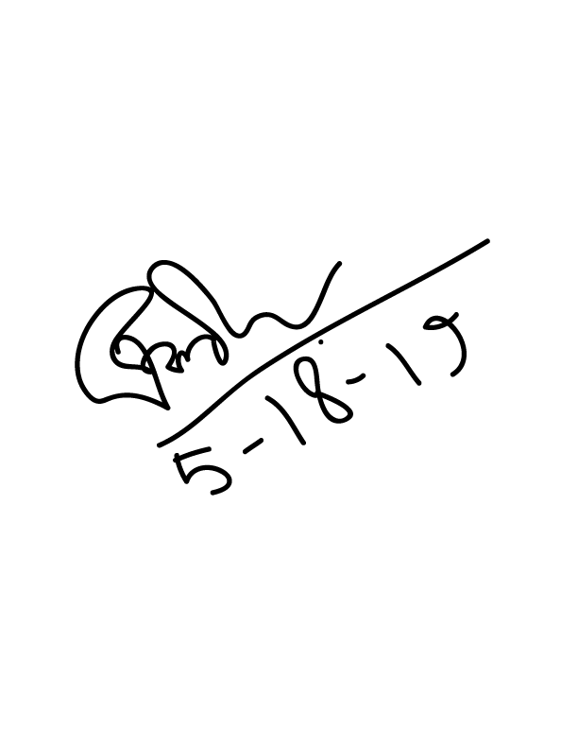
………………………..
Date:

