DevOps Assignment Report
Name: Deepak Kumar
Role: Fresher DevOps Engineer
Environment: Ubuntu Linux (VirtualBox)

1. Introduction
This report documents the setup of a secure, monitored, and well-maintained development environment for two developers, Sarah and Mike. The tasks include system monitoring, user management, and automated backup configuration for Apache and Nginx web servers.

2. Task 1: System Monitoring Setup
Tools Used:
- htop / nmon for CPU, memory, and process monitoring
- df and du for disk usage tracking
Steps Performed:
1. Installed monitoring tools using apt.
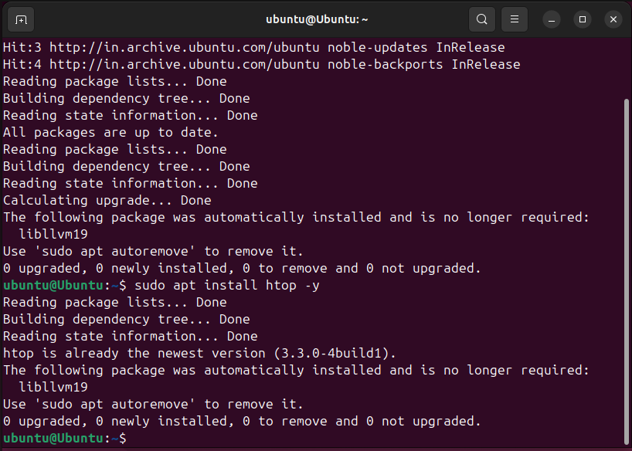
2. Used htop and nmon to monitor system performance.
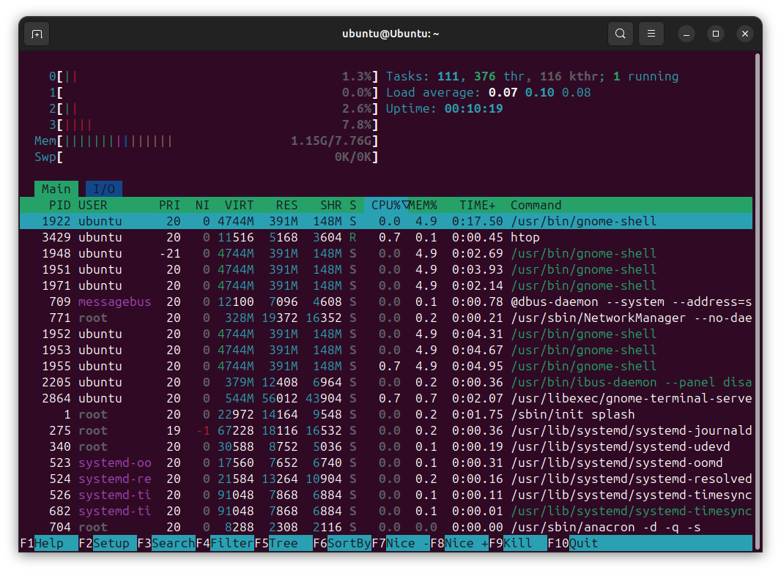
3. Used df -h and du -sh for disk usage analysis.
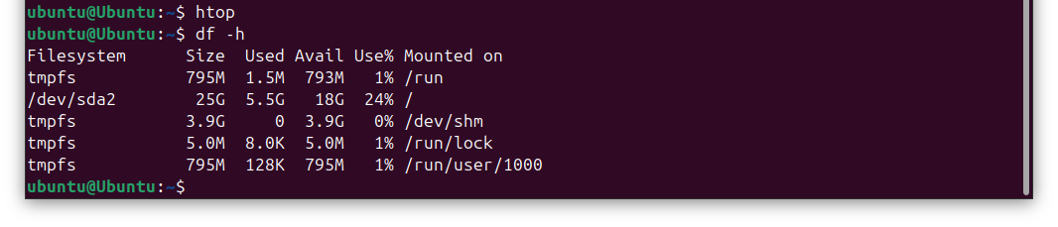
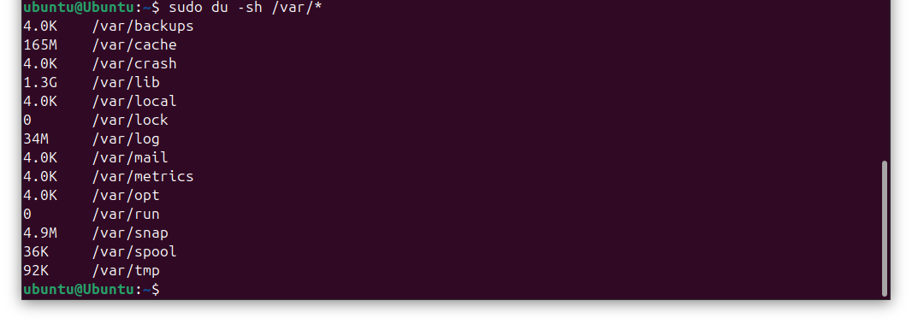
4. Saved command outputs for reporting and troubleshooting.
Challenges:

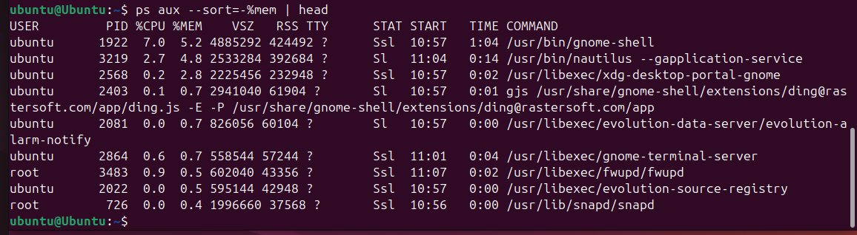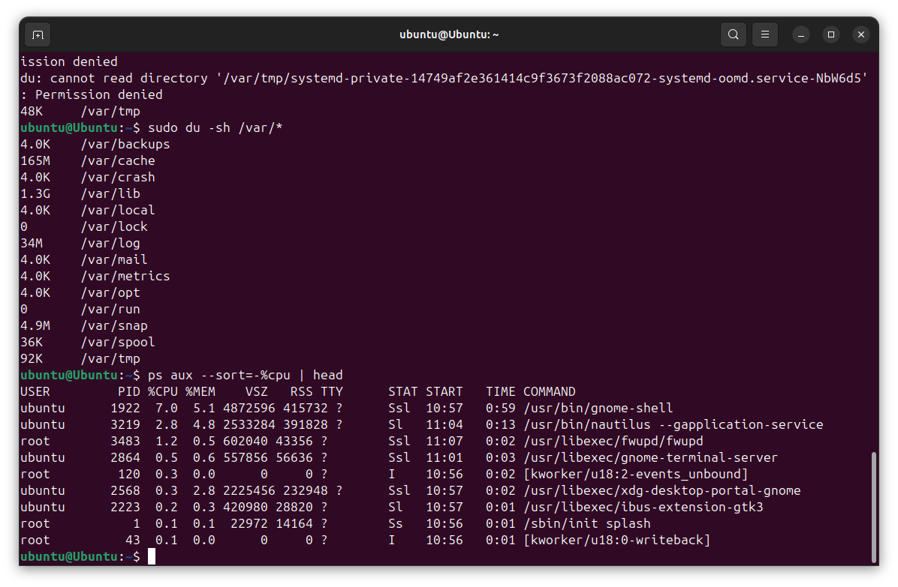
- Monitoring tools were not pre-installed and had to be installed manually.

3. Task 2: User Management and Access Control
Users Created:
- Sarah
- Mike
Steps Performed:
1. Created users using adduser.
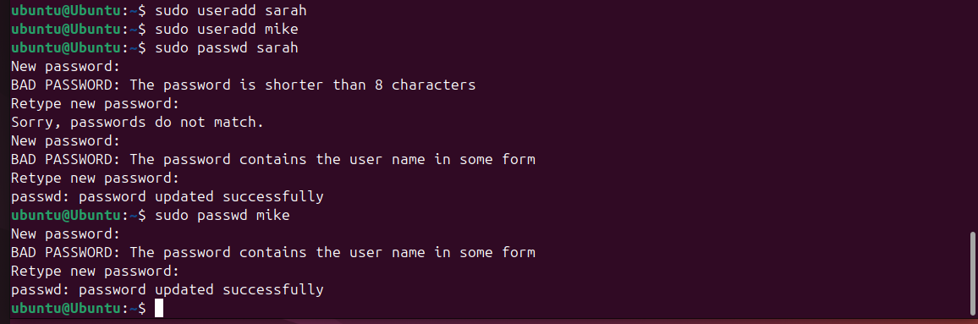
2. Created isolated workspace directories.
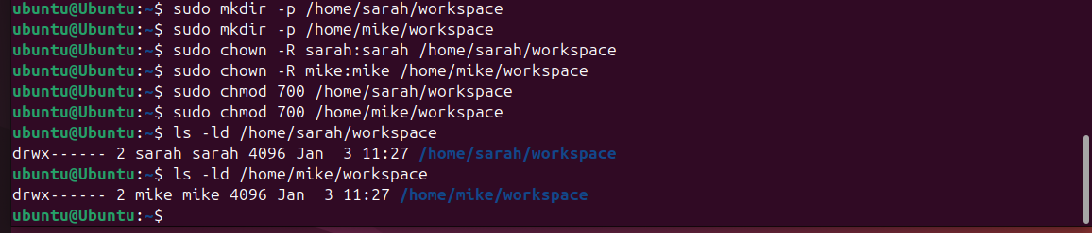
3. Set permissions so only the respective users can access their directories.
4. Enforced password expiration every 30 days using chage.
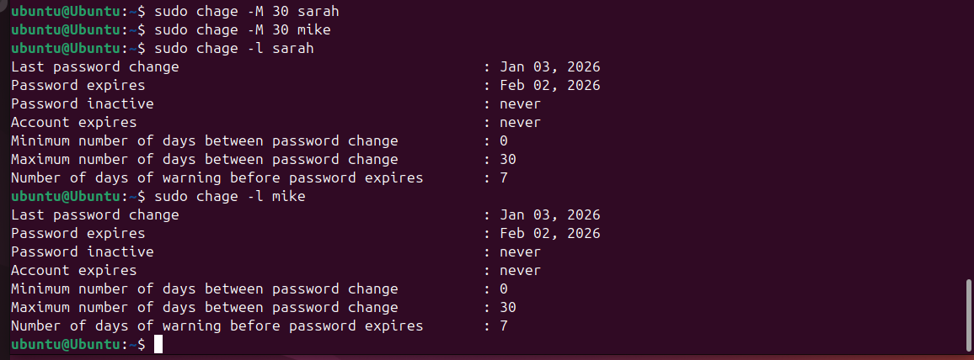
Challenges:
- Ensuring correct permissions to maintain isolation between users.

4. Task 3: Backup Configuration for Web Servers
Apache Backup:
- Directories: /etc/httpd, /var/www/html
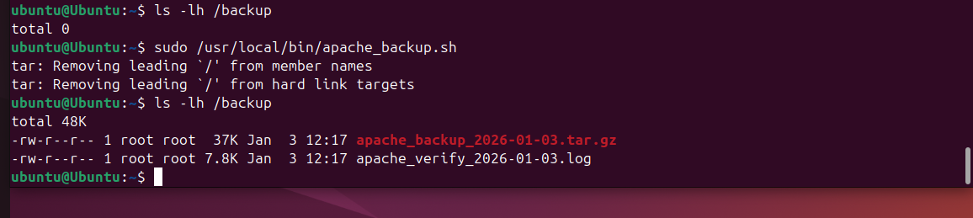
Nginx Backup:
- Directories: /etc/nginx, /usr/share/nginx/html
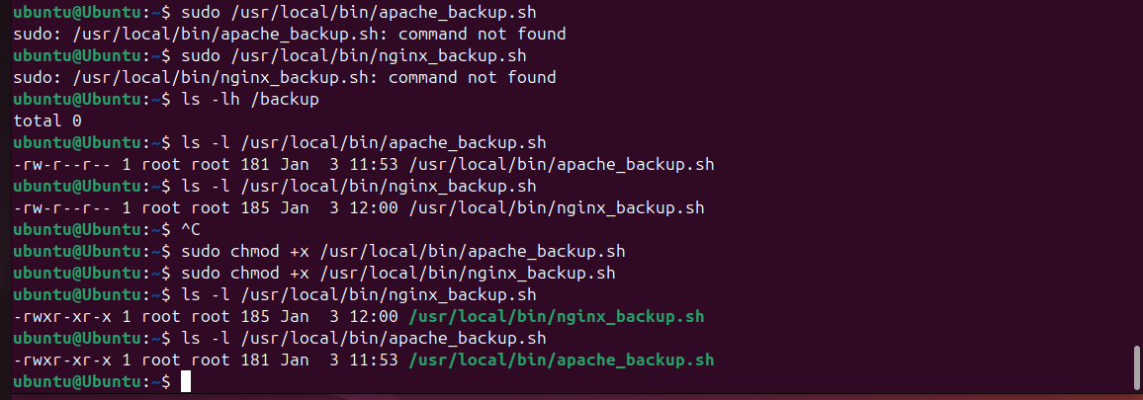
Steps Performed:
1. Created backup scripts for Apache and Nginx.
2. Stored backups in /backups directory with date-based naming.
3. Verified backups using tar -tzf.
4. Scheduled backups using cron to run every Tuesday at 12:00 AM.

Challenges:
- Nginx backup initially failed due to empty directories.
- Script errors occurred due to DOS line endings, resolved using dos2unix.

5. Cron Job Configuration
Cron Entries:
0 0 * * 2 /usr/local/bin/apache_backup.sh
0 0 * * 2 /usr/local/bin/nginx_backup.sh

6. Conclusion
All tasks were successfully completed. The system is now monitored, secure user access is enforced, and automated backups are configured for disaster recovery.

