**Using Desktop Flows from Cloud Flows**

**Scenario**

In this lab, you will build cloud flows which integrate with the desktop flows.

**High-level lab objectives**

* Use child flows to create a more maintainable cloud flow
* Use desktop flows from cloud flow

**Exercise #1: Lookup Loan Child flow**

**Task #1: Create child flow**

1. Navigate to <https://make.powerapps.com/> and make sure you are in the Dev environment.
2. Select **Solutions** and open the **Construction Funding** solution.
3. Click **+ New** and select **Automation | Cloud flow | Instant**.

[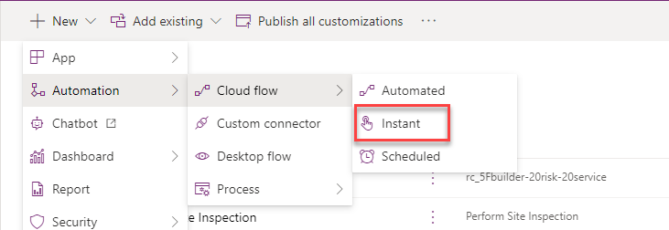](https://github.com/MicrosoftLearning/PL-500T00-Microsoft-Power-Automate-RPA-Developer/blob/master/Instructions/L03/media/image1.png)

1. Enter **CF Lookup Loan** for Flow name, select **Manually trigger a flow**, and click **Create**.

[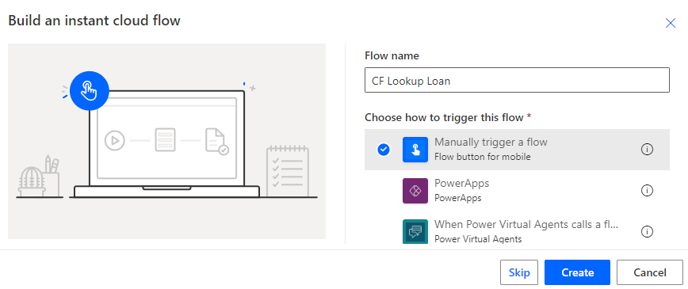](https://github.com/MicrosoftLearning/PL-500T00-Microsoft-Power-Automate-RPA-Developer/blob/master/Instructions/L03/media/image2.png)

1. Expand the trigger by clicking on **Manually trigger a flow**.
2. Select **+ Add an input**.

[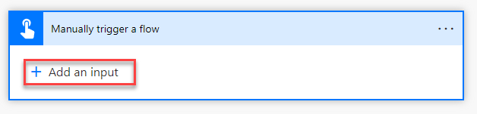](https://github.com/MicrosoftLearning/PL-500T00-Microsoft-Power-Automate-RPA-Developer/blob/master/Instructions/L03/media/image3.png)

1. Select **Text**.
2. Enter **LoanNumber** and click **+ New step**.

[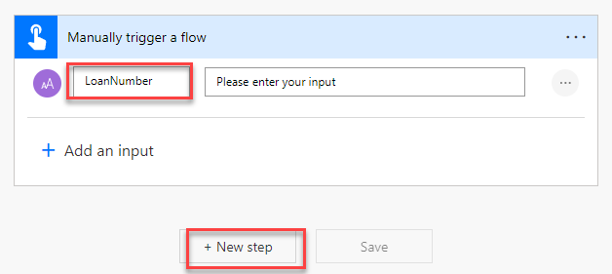](https://github.com/MicrosoftLearning/PL-500T00-Microsoft-Power-Automate-RPA-Developer/blob/master/Instructions/L03/media/image4.png)

1. Search for list rows and select **List rows Microsoft Dataverse**.

[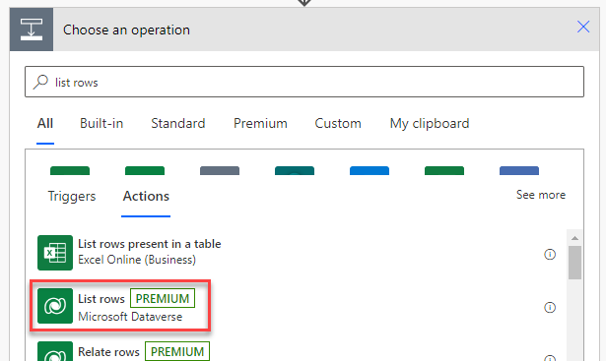](https://github.com/MicrosoftLearning/PL-500T00-Microsoft-Power-Automate-RPA-Developer/blob/master/Instructions/L03/media/image5.png)

1. Select **Loans** for Table name and click **Show advanced options**.

[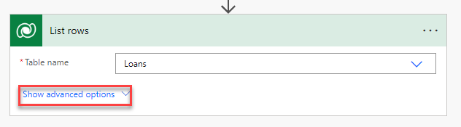](https://github.com/MicrosoftLearning/PL-500T00-Microsoft-Power-Automate-RPA-Developer/blob/master/Instructions/L03/media/image6.png)

1. Enter **rc_loannumber eq** for Filter rows and select **LoanNumber** from the dynamic content pane.

[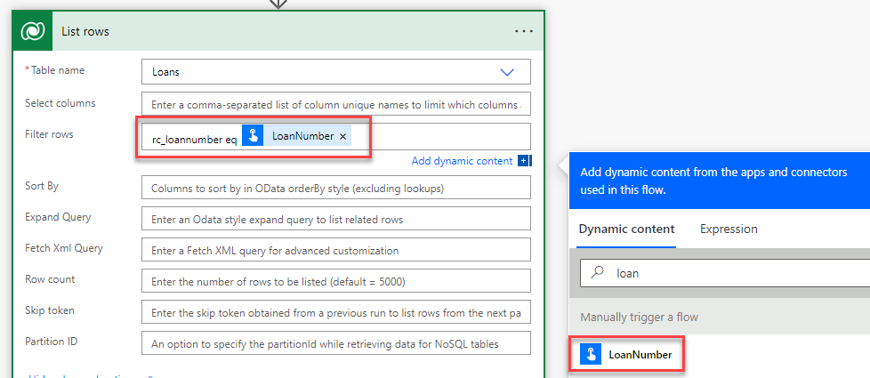](https://github.com/MicrosoftLearning/PL-500T00-Microsoft-Power-Automate-RPA-Developer/blob/master/Instructions/L03/media/image7.png)

[!alert] If you do not see the **Dynamic Content & Expression** pop-up, increase your browser width or zoom out slightly to reveal it (Keyboard shortcut: Ctrl + -).

1. Add single quotes (') before and after LoanNumber
2. Click **+ New step**.
3. Select **Condition**.

[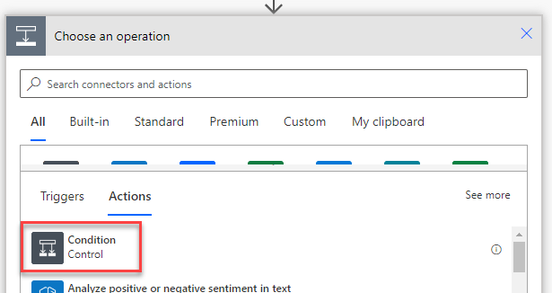](https://github.com/MicrosoftLearning/PL-500T00-Microsoft-Power-Automate-RPA-Developer/blob/master/Instructions/L03/media/image8.png)

1. Click to select the first operand field, go to the dynamic content pane, and select the expression tab.
2. Paste the expression below and click **OK**. This checks if any rows were returned.

empty(outputs('List_rows')?['body/value'])

[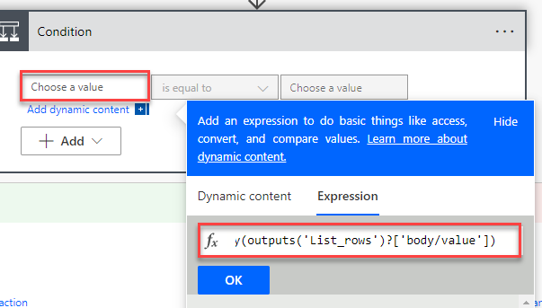](https://github.com/MicrosoftLearning/PL-500T00-Microsoft-Power-Automate-RPA-Developer/blob/master/Instructions/L03/media/image9.png)

1. Select **is equal to** for condition.
2. Click to select the second operand field, go to the dynamic content pane, and select the expression tab.
3. Type **true** and click **OK**.

[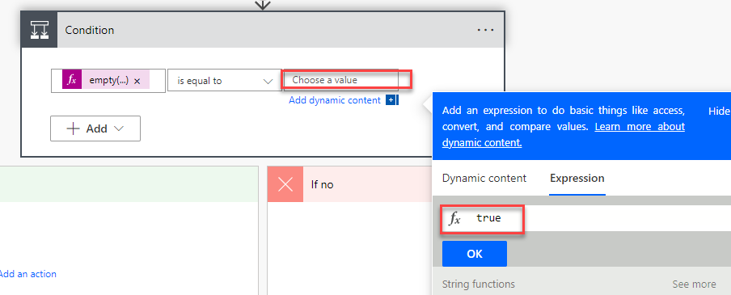](https://github.com/MicrosoftLearning/PL-500T00-Microsoft-Power-Automate-RPA-Developer/blob/master/Instructions/L03/media/image10.png)

1. Go to the **If yes** branch and click **Add an action**.

[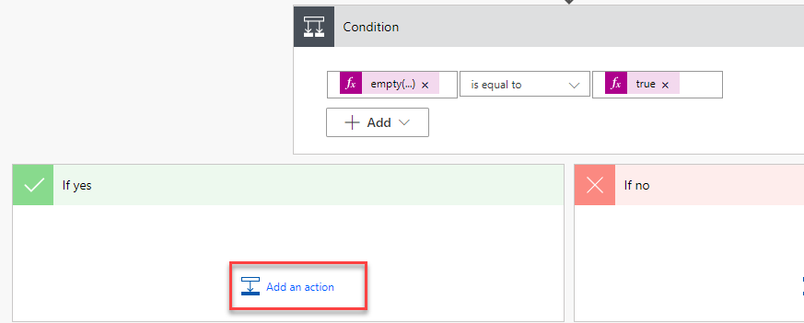](https://github.com/MicrosoftLearning/PL-500T00-Microsoft-Power-Automate-RPA-Developer/blob/master/Instructions/L03/media/image11.png)

1. Select **Respond to a PowerApp or flow**.

[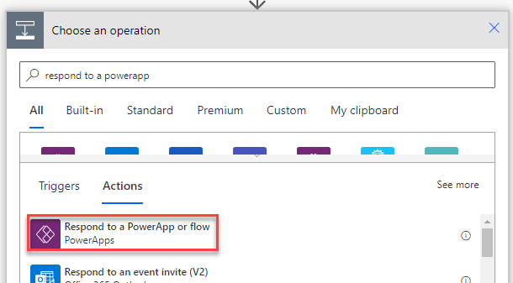](https://github.com/MicrosoftLearning/PL-500T00-Microsoft-Power-Automate-RPA-Developer/blob/master/Instructions/L03/media/image12.png)

1. Click **+ Add an output**.

[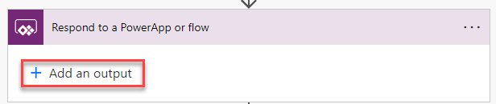](https://github.com/MicrosoftLearning/PL-500T00-Microsoft-Power-Automate-RPA-Developer/blob/master/Instructions/L03/media/image13.png)

1. Select **Yes/No**.
2. Enter **LoanFound** for title and click to select the value field.
3. Go to the Dynamic content pane and select the **Expression tab**.
4. Type **false** and click **OK**.

[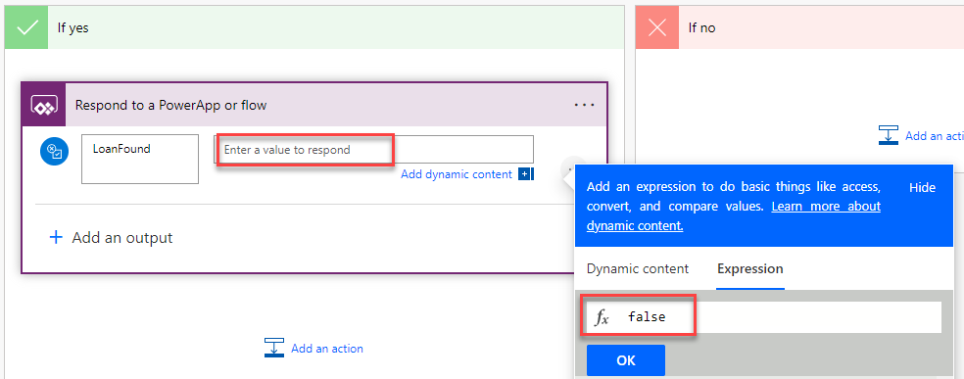](https://github.com/MicrosoftLearning/PL-500T00-Microsoft-Power-Automate-RPA-Developer/blob/master/Instructions/L03/media/image14.png)

1. Click **+ Add an output** again.
2. Select **Text**.
3. Enter **LoanID** for title.
4. Click on the value field, add an empty space.

[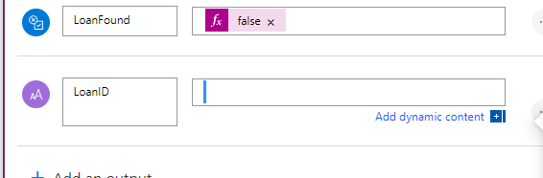](https://github.com/MicrosoftLearning/PL-500T00-Microsoft-Power-Automate-RPA-Developer/blob/master/Instructions/L03/media/image15.png)

1. Click on the **…** more actions button and select **Rename**.

[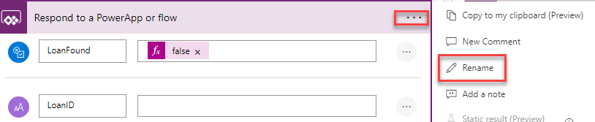](https://github.com/MicrosoftLearning/PL-500T00-Microsoft-Power-Automate-RPA-Developer/blob/master/Instructions/L03/media/image16.png)

1. Rename the step **Not found response**.
2. Go to the **If no** branch and click **Add an action**.

[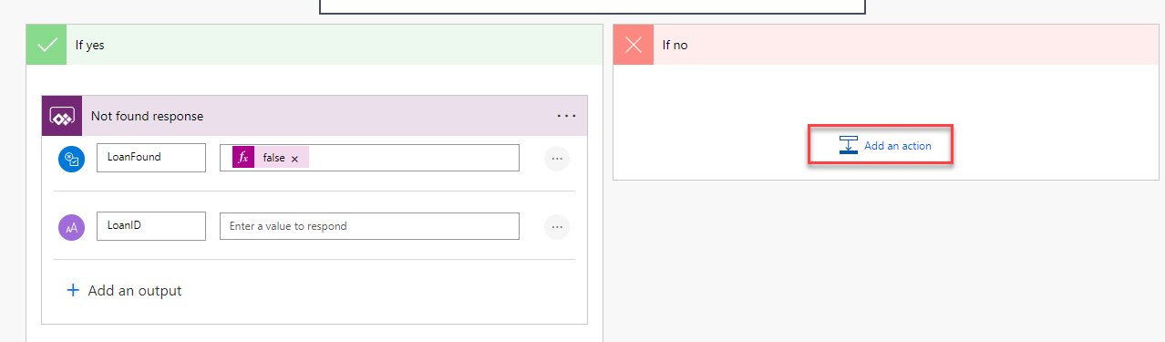](https://github.com/MicrosoftLearning/PL-500T00-Microsoft-Power-Automate-RPA-Developer/blob/master/Instructions/L03/media/image17.png)

1. Select **Respond to a PowerApp or flow**.

[](https://github.com/MicrosoftLearning/PL-500T00-Microsoft-Power-Automate-RPA-Developer/blob/master/Instructions/L03/media/image12.png)

1. Click **+ Add an output**.
2. Select **Yes/No**.
3. Enter **LoanFound** for title and click to select the value field.
4. Go to the dynamic content pane and select the **Expression tab**.
5. Type **true** and click **OK**.

[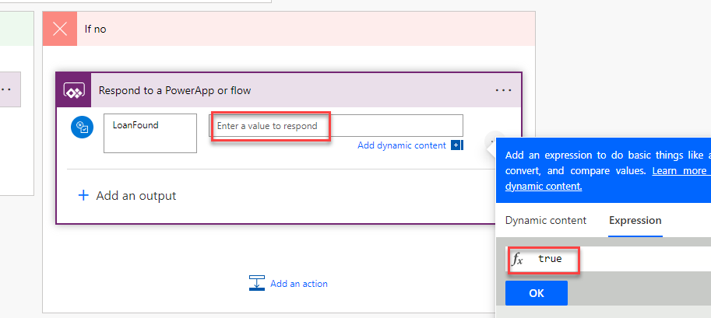](https://github.com/MicrosoftLearning/PL-500T00-Microsoft-Power-Automate-RPA-Developer/blob/master/Instructions/L03/media/image18.png)

1. Click **+ Add an output** again.
2. Select **Text**.
3. Enter **LoanID** for title.
4. Click to select the value field, go to the dynamic content pane, and select the **Expression** tab.
5. Paste the expression below and click *OK*. This gets the ID from the first row.

outputs('List_rows')?['body/value'][0]['rc_loanid']

[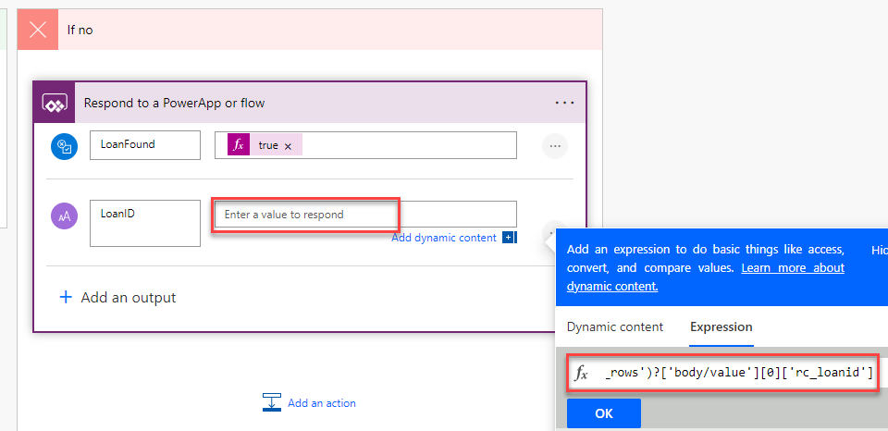](https://github.com/MicrosoftLearning/PL-500T00-Microsoft-Power-Automate-RPA-Developer/blob/master/Instructions/L03/media/image19.png)

1. Click on the … more actions button and select **Rename**.
2. Rename the step **Found response**.
3. Click **Save** to save the flow.

[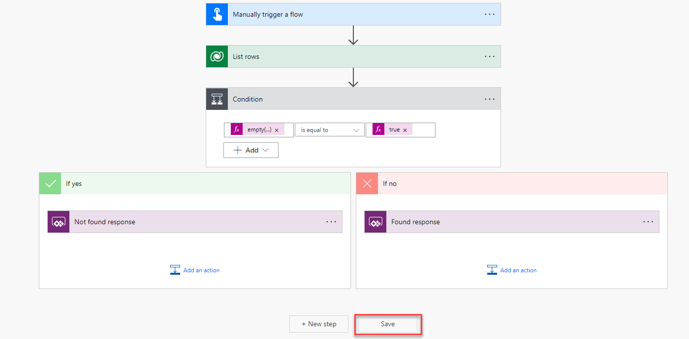](https://github.com/MicrosoftLearning/PL-500T00-Microsoft-Power-Automate-RPA-Developer/blob/master/Instructions/L03/media/image20.png)

1. Click **Test**.

[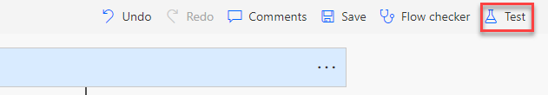](https://github.com/MicrosoftLearning/PL-500T00-Microsoft-Power-Automate-RPA-Developer/blob/master/Instructions/L03/media/image21.png)

1. Select **Manually** and click **Test**.
2. Enter **MC3747** for LoanNumber and click **Run flow**.

[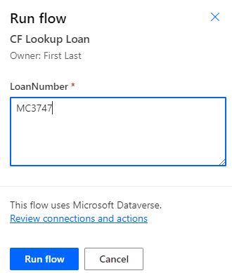](https://github.com/MicrosoftLearning/PL-500T00-Microsoft-Power-Automate-RPA-Developer/blob/master/Instructions/L03/media/image22.png)

1. Click **Done**.
2. Click to expand the response step.
3. Make sure the output body matches your expectation.

[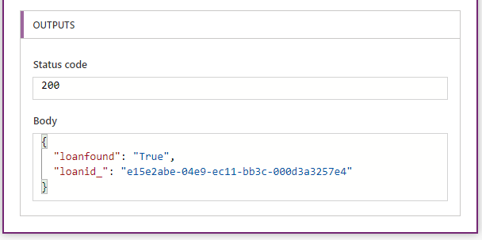](https://github.com/MicrosoftLearning/PL-500T00-Microsoft-Power-Automate-RPA-Developer/blob/master/Instructions/L03/media/image23.png)

1. You may close the flow

**Exercise #2: Inspection Child flow**

**Task #1: Setup Machine connection**

1. Navigate to <https://make.powerapps.com/> and make sure you are in the Dev environment.
2. Select **Solutions** and open the **Construction Funding** solution.
3. Click **+ New** and select **More | Connection Reference**.

[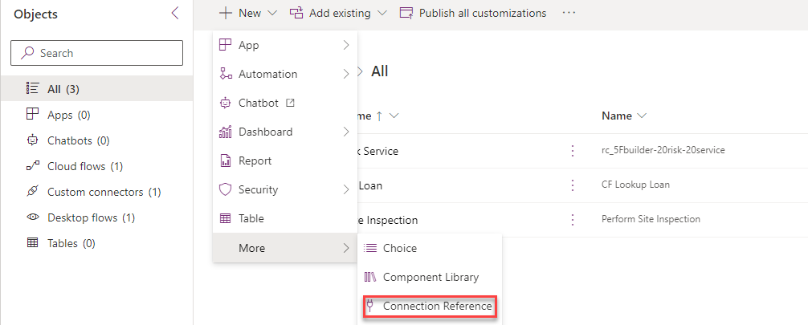](https://github.com/MicrosoftLearning/PL-500T00-Microsoft-Power-Automate-RPA-Developer/blob/master/Instructions/L03/media/image24.png)

1. Enter Desktop Flows for Display name, select Desktop flows for Connector, click on the Connection dropdown and select **+ New connection**.

[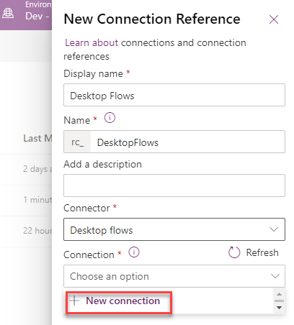](https://github.com/MicrosoftLearning/PL-500T00-Microsoft-Power-Automate-RPA-Developer/blob/master/Instructions/L03/media/image25.png)

1. Select **Connect with username and password** for Connect and select your desktop. If you don’t see your desktop here, go to desktop flow machine settings and make sure you have the Dev environment selected.

[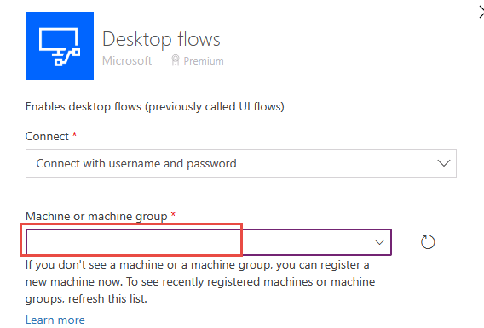](https://github.com/MicrosoftLearning/PL-500T00-Microsoft-Power-Automate-RPA-Developer/blob/master/Instructions/L03/media/image26.png)

1. Provide your username, password, and click **Create**. If your username doesn’t work try admin as the username.

[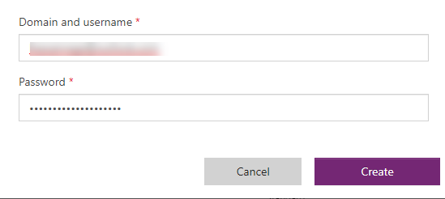](https://github.com/MicrosoftLearning/PL-500T00-Microsoft-Power-Automate-RPA-Developer/blob/master/Instructions/L03/media/image27.png)

1. Close the connection browser tab or window.
2. Click on the **Refresh** connection button.

[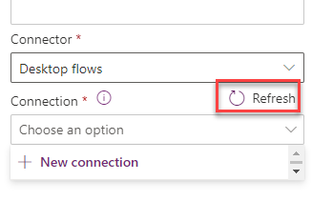](https://github.com/MicrosoftLearning/PL-500T00-Microsoft-Power-Automate-RPA-Developer/blob/master/Instructions/L03/media/image28.png)

1. Select the connection you created and click **Create**.

[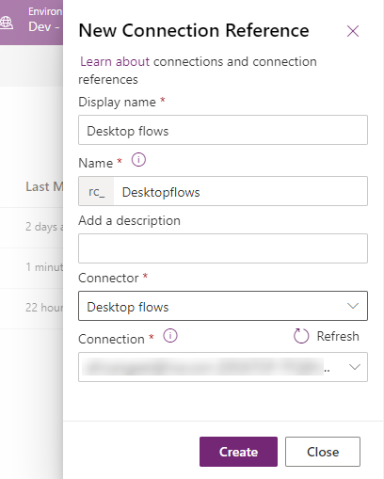](https://github.com/MicrosoftLearning/PL-500T00-Microsoft-Power-Automate-RPA-Developer/blob/master/Instructions/L03/media/image29.png)

**Task #2: Create child flow**

1. Navigate to <https://make.powerapps.com/> and make sure you are in the Dev environment.
2. Select **Solutions** and open the **Construction Funding** solution.
3. Click **+ New** and select **Automation | Cloud flow | Instant**.

[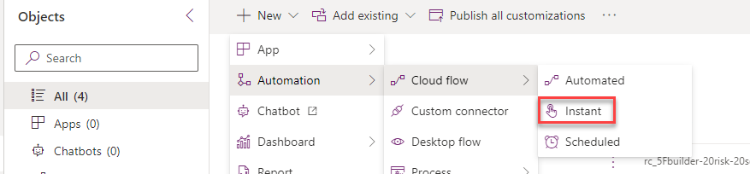](https://github.com/MicrosoftLearning/PL-500T00-Microsoft-Power-Automate-RPA-Developer/blob/master/Instructions/L03/media/image30.png)

1. Enter **CF Manage Inspection Process** for Flow name, select **Manually trigger a flow**, and click **Create**.
2. Expand the trigger and click **+ Add an input**.
3. Select **Text**.
4. Enter **PropertyAddress** and click **+ Add an input** again.

[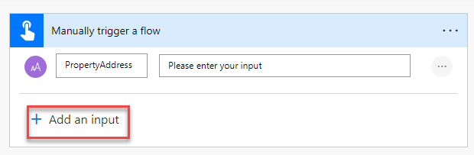](https://github.com/MicrosoftLearning/PL-500T00-Microsoft-Power-Automate-RPA-Developer/blob/master/Instructions/L03/media/image31.png)

1. Select **Text**.
2. Enter **LoanDrawID** and click **+ Add an input** one more time.
3. Select **Text**.
4. Enter **Work**. You should now have three input parameters. Click + New step.

[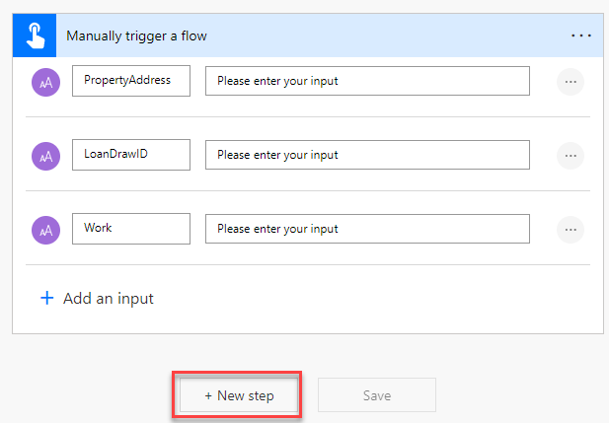](https://github.com/MicrosoftLearning/PL-500T00-Microsoft-Power-Automate-RPA-Developer/blob/master/Instructions/L03/media/image32.png)

1. Select **Run a flow built with Power Automate for desktop**.

[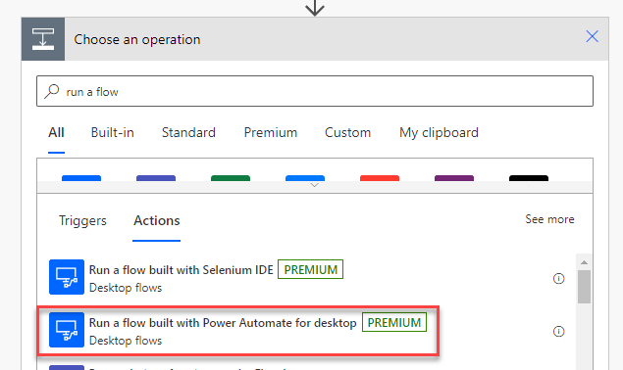](https://github.com/MicrosoftLearning/PL-500T00-Microsoft-Power-Automate-RPA-Developer/blob/master/Instructions/L03/media/image33.png)

1. Select **Perform Site Inspection** for Desktop flow and select **Attended** for Run Mode.
2. Click on the **WorkToInspect** field and select **Work** from the dynamic content pane.

[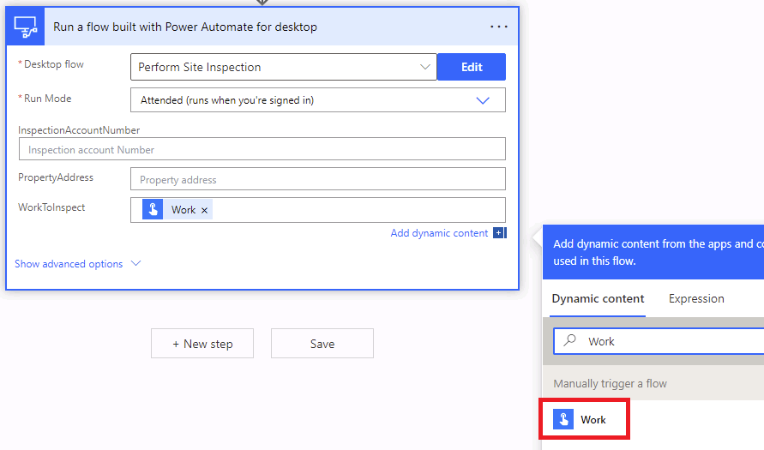](https://github.com/MicrosoftLearning/PL-500T00-Microsoft-Power-Automate-RPA-Developer/blob/master/Instructions/L03/media/image34.png)

1. Click on the **PropertyAddress** and select **PropertyAddress** from the dynamic content pane.
2. Enter your name for Inspection account number.

[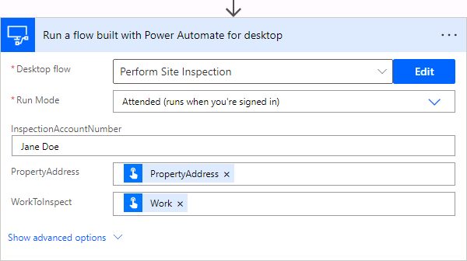](https://github.com/MicrosoftLearning/PL-500T00-Microsoft-Power-Automate-RPA-Developer/blob/master/Instructions/L03/media/image35.png)

1. Click **+ New step**.
2. Search the connectors and actions for **Parse JSON**. Select the **Parse JSON** action which is part of the **Data Operation** connector.

[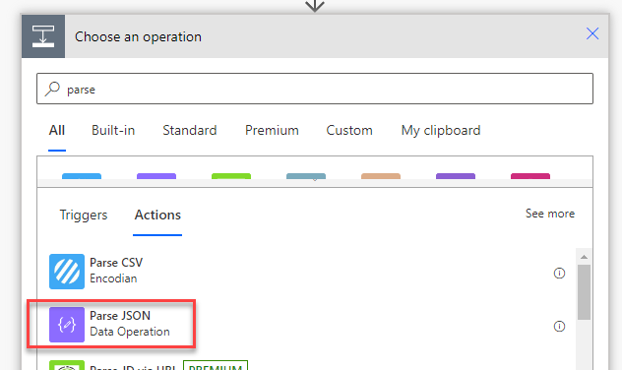](https://github.com/MicrosoftLearning/PL-500T00-Microsoft-Power-Automate-RPA-Developer/blob/master/Instructions/L03/media/image36.png)

1. Click on the **Content** field and select **SitePhotos** from dynamic content pane.

[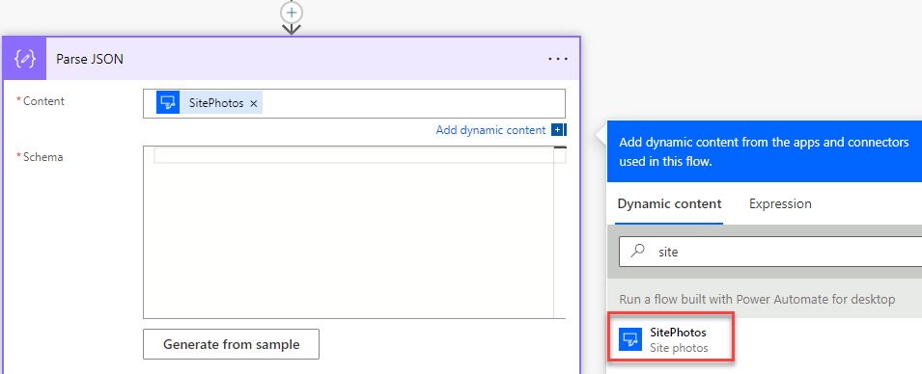](https://github.com/MicrosoftLearning/PL-500T00-Microsoft-Power-Automate-RPA-Developer/blob/master/Instructions/L03/media/image37.png)

1. Paste the JSON schema below in the **Schema** field and click **+ New step**. Typically, you would generate this from a sample of the data expected.
2. {
3. "type":"object",
4. "properties":{
5. "images":{
6. "type":"array",
7. "items":{
8. "type":"object",
9. "properties":{
10. "name":{
11. "type":"string"
12. },
13. "url":{
14. "type":"string"
15. }
16. },
17. "required":[
18. "name",
19. "url"
20. ]
21. }
22. }
23. }

}

[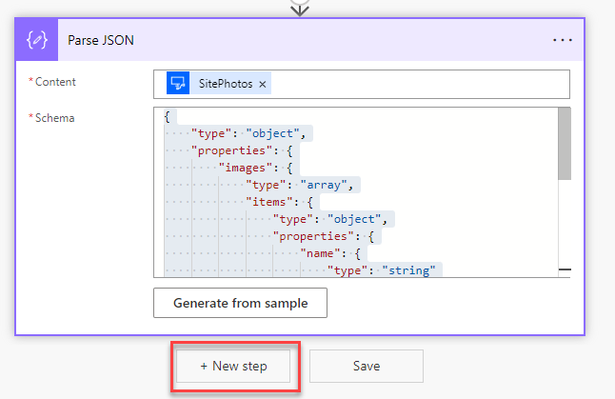](https://github.com/MicrosoftLearning/PL-500T00-Microsoft-Power-Automate-RPA-Developer/blob/master/Instructions/L03/media/image38.png)

1. Select the **HTTP** action.

](https://github.com/MicrosoftLearning/PL-500T00-Microsoft-Power-Automate-RPA-Developer/blob/master/Instructions/L03/media/image39.png)

1. Select **GET** for Method, click on the **URI** field, and select **url** from the dynamic content pane.

[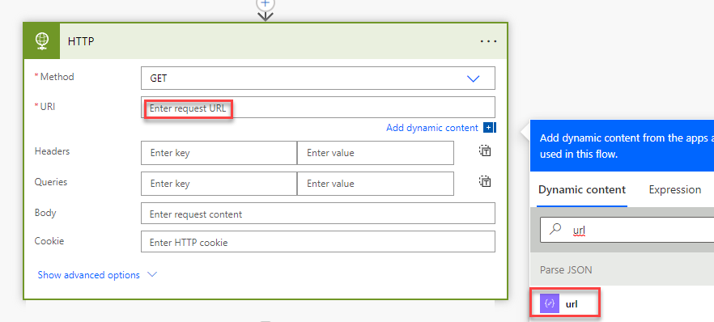](https://github.com/MicrosoftLearning/PL-500T00-Microsoft-Power-Automate-RPA-Developer/blob/master/Instructions/L03/media/image40.png)

1. Apply to each will be added automatically for you. Rename the Apply to each step **Apply to each image**.
2. Click **Add an action**.

[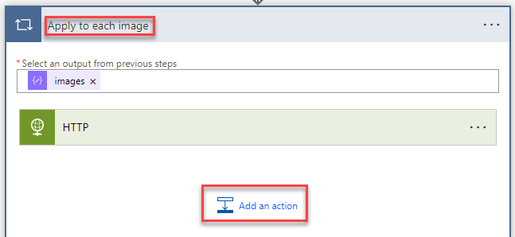](https://github.com/MicrosoftLearning/PL-500T00-Microsoft-Power-Automate-RPA-Developer/blob/master/Instructions/L03/media/image41.png)

1. Select the **Add a new row** action from the **Microsoft Dataverse** connector.

[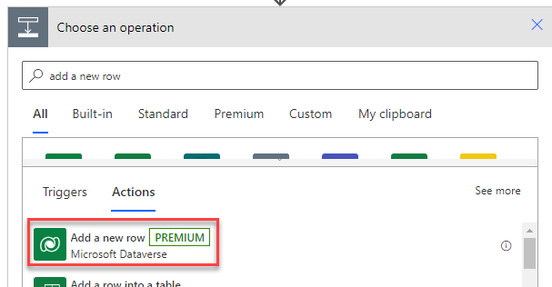](https://github.com/MicrosoftLearning/PL-500T00-Microsoft-Power-Automate-RPA-Developer/blob/master/Instructions/L03/media/image42.png)

1. Select **Inspection Photos** for Table name, click on the **Name** field, and select **name** from the dynamic content pane.

[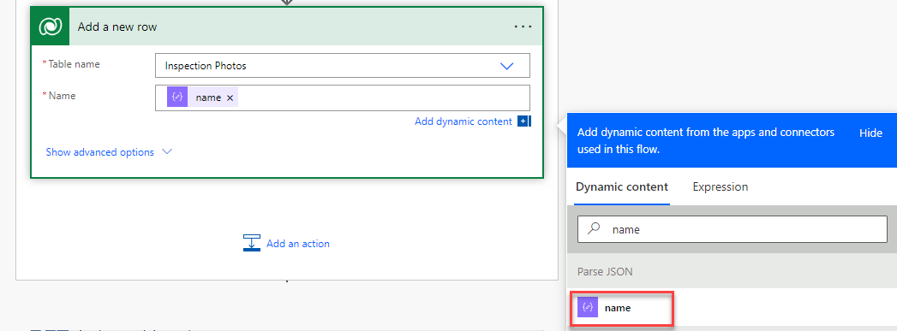](https://github.com/MicrosoftLearning/PL-500T00-Microsoft-Power-Automate-RPA-Developer/blob/master/Instructions/L03/media/image43.png)

1. Rename the "Add a new row" step to **Add inspection photo** and click **Show advanced options**.

[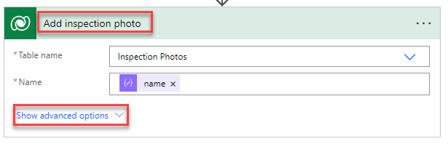](https://github.com/MicrosoftLearning/PL-500T00-Microsoft-Power-Automate-RPA-Developer/blob/master/Instructions/L03/media/image44.png)

1. Enter **rc_loandraws()** for Loan Draw, place your cursor inside the parentheses, and select **LoanDrawID** from the dynamic content pane.

[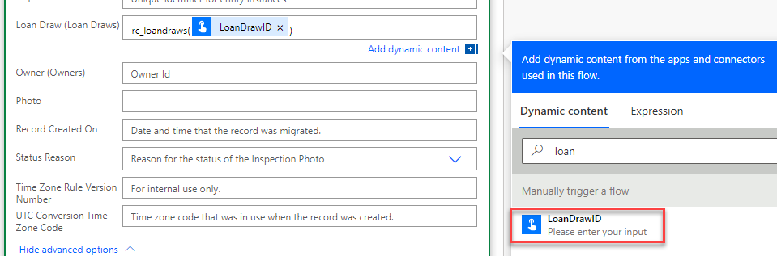](https://github.com/MicrosoftLearning/PL-500T00-Microsoft-Power-Automate-RPA-Developer/blob/master/Instructions/L03/media/image45.png)

1. Click on the **Photo** field, go to the dynamic content pane, and select the **Expression** tab.
2. Paste the expression below and click **OK**.

base64(body('HTTP'))

[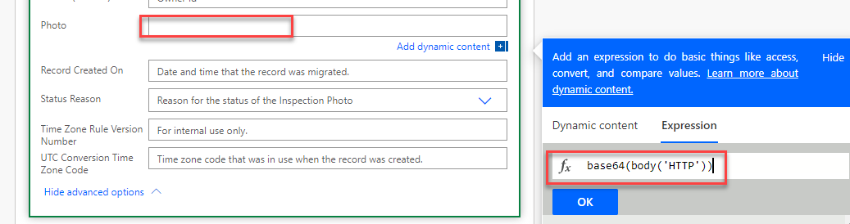](https://github.com/MicrosoftLearning/PL-500T00-Microsoft-Power-Automate-RPA-Developer/blob/master/Instructions/L03/media/image46.png)

1. Click **+ New step**.

[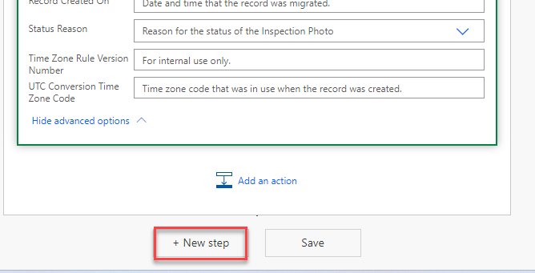](https://github.com/MicrosoftLearning/PL-500T00-Microsoft-Power-Automate-RPA-Developer/blob/master/Instructions/L03/media/image47.png)

1. Select the **Update a row** action from the **Microsoft Dataverse** connector.

[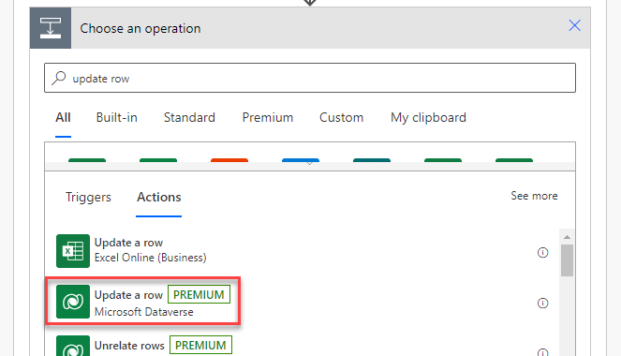](https://github.com/MicrosoftLearning/PL-500T00-Microsoft-Power-Automate-RPA-Developer/blob/master/Instructions/L03/media/image48.png)

1. Select **Loan Draws** for Table name, click on the **Row ID** field and select **LoanDrawID** from the dynamic content pane.
2. Click **Show advanced options**.

[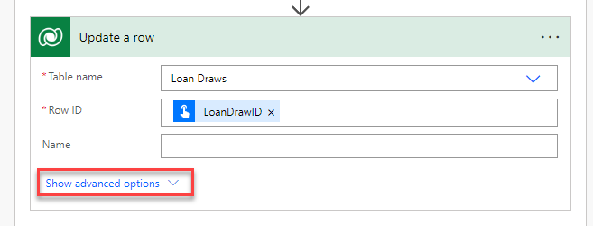](https://github.com/MicrosoftLearning/PL-500T00-Microsoft-Power-Automate-RPA-Developer/blob/master/Instructions/L03/media/image49.png)

1. Click on the **Inspected On** field, go to the dynamic content pane, select the **Expression** tab, type **utcNow()** and click **OK**.

[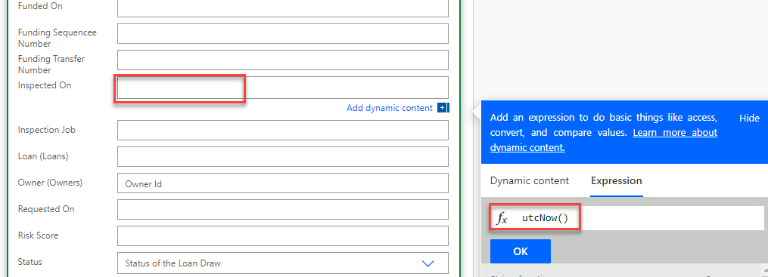](https://github.com/MicrosoftLearning/PL-500T00-Microsoft-Power-Automate-RPA-Developer/blob/master/Instructions/L03/media/image50.png)

1. Click on the **Inspection Job** field and select **JobNumber** from the dynamic content pane.

[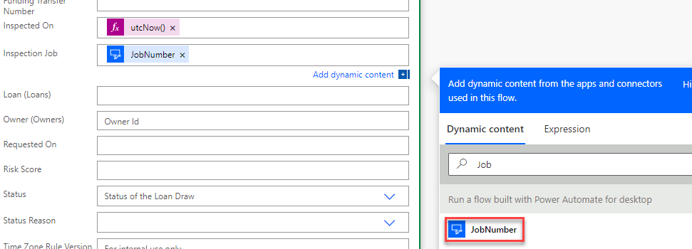](https://github.com/MicrosoftLearning/PL-500T00-Microsoft-Power-Automate-RPA-Developer/blob/master/Instructions/L03/media/image51.png)

1. Select **Inspection Completed** for Status Reason and click **Hide advanced options**.

[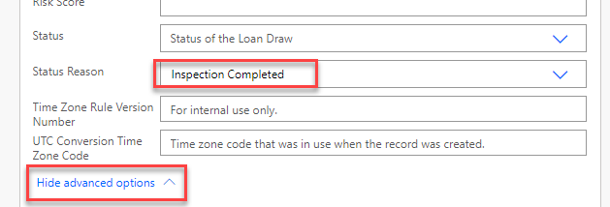](https://github.com/MicrosoftLearning/PL-500T00-Microsoft-Power-Automate-RPA-Developer/blob/master/Instructions/L03/media/image52.png)

1. Rename the step **Update loan draw** and click **+ New step**.
2. Select the **Respond to PowerApp or flow** action from the **PowerApps** connector.

[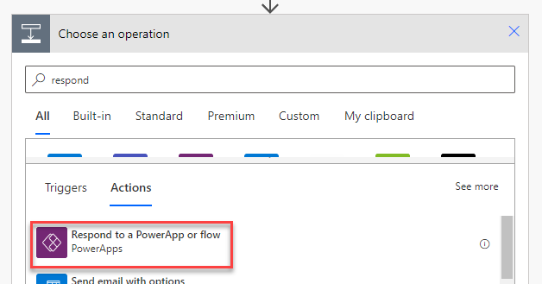](https://github.com/MicrosoftLearning/PL-500T00-Microsoft-Power-Automate-RPA-Developer/blob/master/Instructions/L03/media/image53.png)

1. Click **+ Add an output**.
2. Select **Text**.
3. Enter **InspectionStatus**, click on the value field and select **InspectionStatus** from the dynamic content pane.

[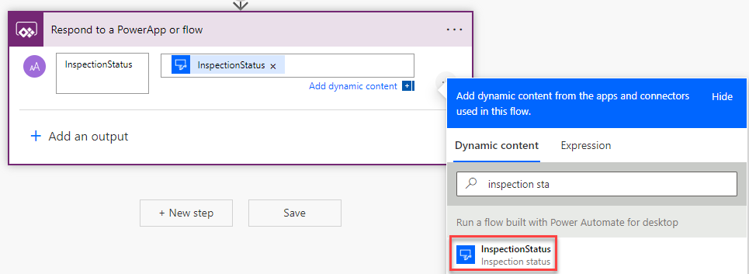](https://github.com/MicrosoftLearning/PL-500T00-Microsoft-Power-Automate-RPA-Developer/blob/master/Instructions/L03/media/image54.png)

1. Click **+ Add an output** again.
2. Select **Text**.
3. Enter **JobNumber**, click on the value field and select **JobNumber** from the dynamic content pane.

[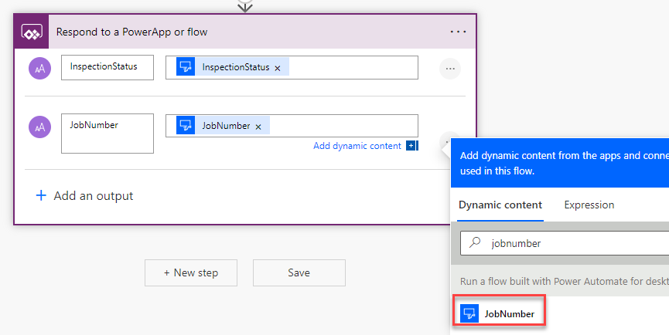](https://github.com/MicrosoftLearning/PL-500T00-Microsoft-Power-Automate-RPA-Developer/blob/master/Instructions/L03/media/image55.png)

1. Click **Save** to save the flow.
2. Click on the **back** arrow.

[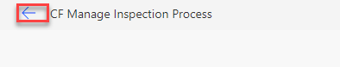](https://github.com/MicrosoftLearning/PL-500T00-Microsoft-Power-Automate-RPA-Developer/blob/master/Instructions/L03/media/image56.png)

1. Open the flow details.

[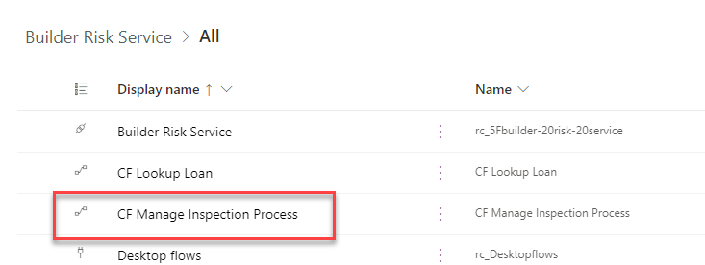](https://github.com/MicrosoftLearning/PL-500T00-Microsoft-Power-Automate-RPA-Developer/blob/master/Instructions/L03/media/image57.png)

1. Click **Run**.
2. If prompted, select **Manually** and click **Test** again.
3. Click **Continue**.

[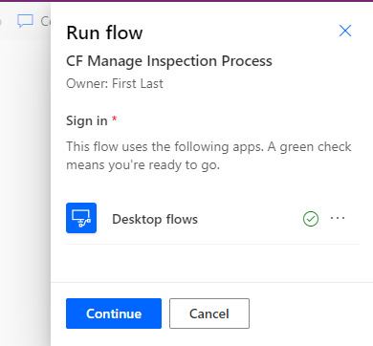](https://github.com/MicrosoftLearning/PL-500T00-Microsoft-Power-Automate-RPA-Developer/blob/master/Instructions/L03/media/image58.png)

1. **DO NOT** navigate away from this page.
2. Start a new browser instance and navigate to <https://make.powerapps.com/> and make sure you are in the Dev environment.
3. Select **Apps** and launch the **Loan Manager** application.

[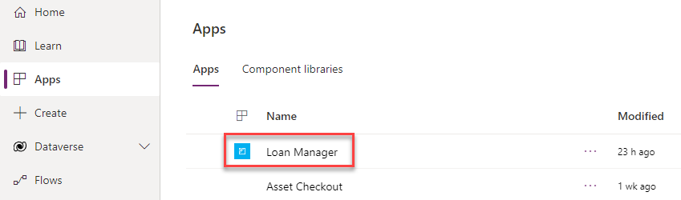](https://github.com/MicrosoftLearning/PL-500T00-Microsoft-Power-Automate-RPA-Developer/blob/master/Instructions/L03/media/image59.png)

1. Open the first loan record.
2. Click **Related** and select **Loan Draws**.

[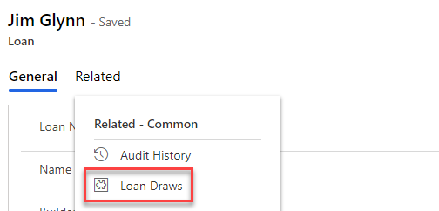](https://github.com/MicrosoftLearning/PL-500T00-Microsoft-Power-Automate-RPA-Developer/blob/master/Instructions/L03/media/image60.png)

1. Click **+ New Loan Draw**.

[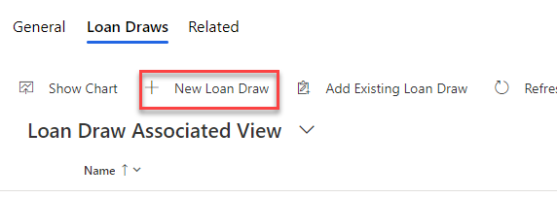](https://github.com/MicrosoftLearning/PL-500T00-Microsoft-Power-Automate-RPA-Developer/blob/master/Instructions/L03/media/image61.png)

1. Enter **Test Draw** for Name and click **Save**.
2. Go to the URL and copy the **id** GUID. Paste this id into Notepad, you will need it in future steps.

[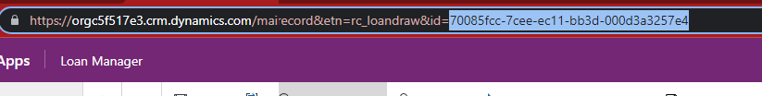](https://github.com/MicrosoftLearning/PL-500T00-Microsoft-Power-Automate-RPA-Developer/blob/master/Instructions/L03/media/image62.png)

1. Go back to the Cloud Flow and enter **123 Main Street** for PropertyAddress, paste the id you copied in the LoanDrawID field, type **Test work item** for Work, and click **Run flow**.

[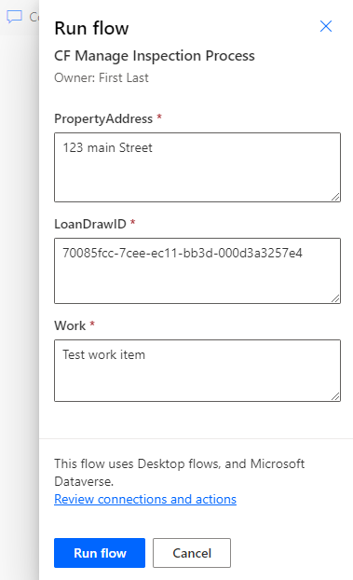](https://github.com/MicrosoftLearning/PL-500T00-Microsoft-Power-Automate-RPA-Developer/blob/master/Instructions/L03/media/image63.png)

1. **Wait** for the flow run to complete.
2. **Close** the run flow pane.
3. Go to the **28-day run history** and click **refresh** until the flow run shows as **Succeeded**.

[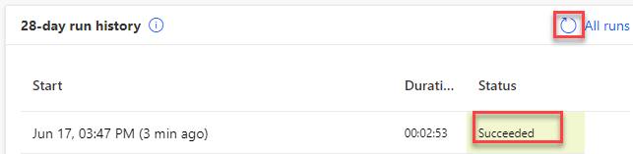](https://github.com/MicrosoftLearning/PL-500T00-Microsoft-Power-Automate-RPA-Developer/blob/master/Instructions/L03/media/image64.png)

1. Go back to the **Loan Manager** application, click **Related** and select **Inspection Photos**.

[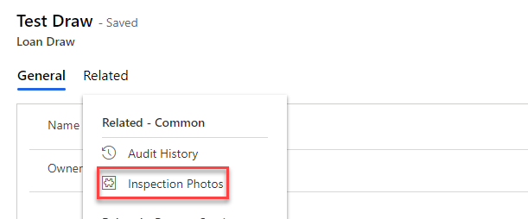](https://github.com/MicrosoftLearning/PL-500T00-Microsoft-Power-Automate-RPA-Developer/blob/master/Instructions/L03/media/image65.png)

1. You should see the inspection photos created by the flow.

[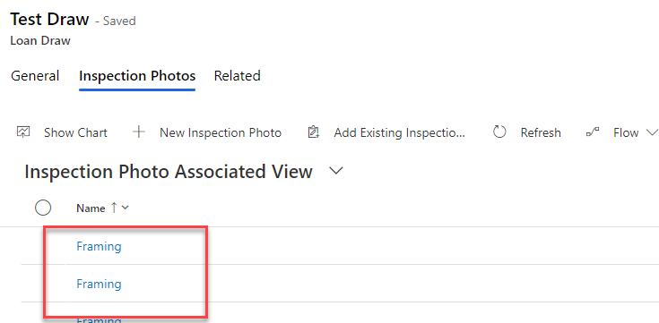](https://github.com/MicrosoftLearning/PL-500T00-Microsoft-Power-Automate-RPA-Developer/blob/master/Instructions/L03/media/image66.png)

**Exercise #3: Funding Child flow**

**Task #1: Create child flow**

1. Navigate to <https://make.powerapps.com/> and make sure you are in the Dev environment.
2. Select **Solutions** and open the **Construction Funding** solution.
3. Click **+ New** and select **Automation | Cloud flow | Instant**.
4. Enter **CF Manage Woodgrove Funding Process** for Flow name, select **Manually trigger a flow**, and click **Create**.

[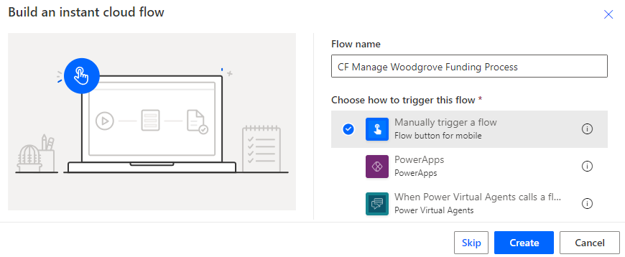](https://github.com/MicrosoftLearning/PL-500T00-Microsoft-Power-Automate-RPA-Developer/blob/master/Instructions/L03/media/image67.png)

1. Expand the trigger and click **+ Add an input**.

[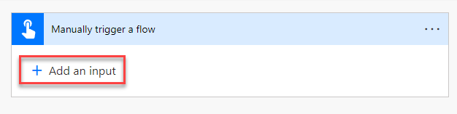](https://github.com/MicrosoftLearning/PL-500T00-Microsoft-Power-Automate-RPA-Developer/blob/master/Instructions/L03/media/image68.png)

1. Select **Text**.
2. Enter **LoanNumber** and click **+ Add an input** again.
3. Select **Text**.
4. Enter **LoanDrawID** and click **+ Add an input** again.
5. Select **Text**.
6. Enter **RequestedAmount** and click **+ Add an input** again.
7. Select **Text**.
8. Enter **InspectionJobID** and click **+ Add an input** again.
9. Select **Number**.
10. Enter **RiskScore**.
11. You should now have five inputs. Click **+ New step**.

[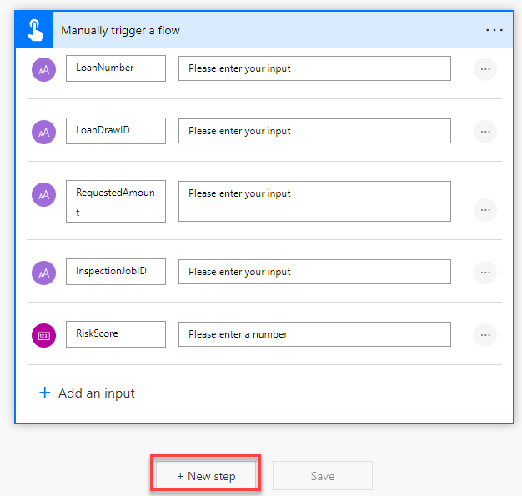](https://github.com/MicrosoftLearning/PL-500T00-Microsoft-Power-Automate-RPA-Developer/blob/master/Instructions/L03/media/image69.png)

1. Select the **Run a flow built with Power Automate for desktop** action.

[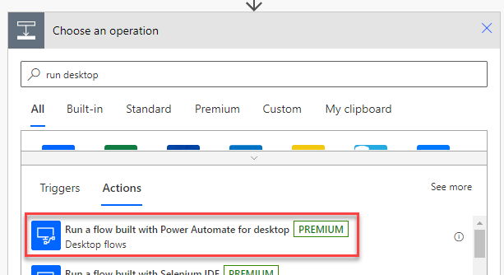](https://github.com/MicrosoftLearning/PL-500T00-Microsoft-Power-Automate-RPA-Developer/blob/master/Instructions/L03/media/image70.png)

1. Select **Woodgrove Funding Manager Draw** for Desktop flow and select **Attended** for Run Mode.
2. Click on the **LoanNumber** field and select **LoanNumber** from the dynamic content pane.

[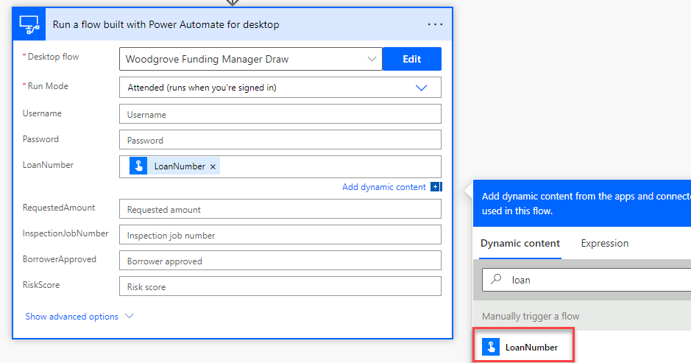](https://github.com/MicrosoftLearning/PL-500T00-Microsoft-Power-Automate-RPA-Developer/blob/master/Instructions/L03/media/image71.png)

1. Click on the **RequestedAmount** field and select **RequestedAmount** from the dynamic content pane.
2. Click on the **InspectionJobNumber** field and select **InspectionJobID** from the dynamic content pane.
3. Type **Yes** for BorrowerApproved.
4. Click on the **RiskScore** field and select **RiskScore** from the dynamic content pane.
5. Enter your name for Username, **pass@word1** for Password.
6. The run desktop flow should now look like the image below. Click **+ New step**.

[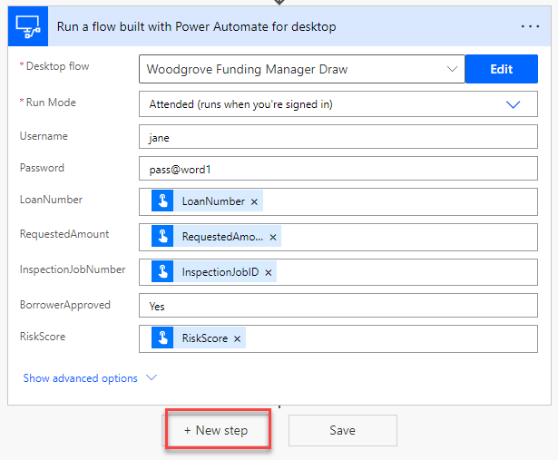](https://github.com/MicrosoftLearning/PL-500T00-Microsoft-Power-Automate-RPA-Developer/blob/master/Instructions/L03/media/image72.png)

1. Select the **Condition** action from the **Control** connector.
2. Click on the first operand and select **FundingStatus** from the dynamic content pane.

[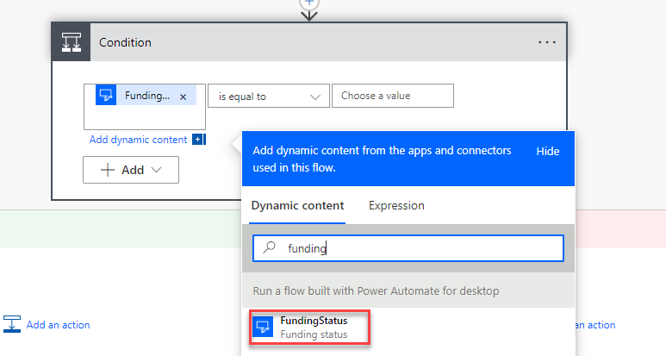](https://github.com/MicrosoftLearning/PL-500T00-Microsoft-Power-Automate-RPA-Developer/blob/master/Instructions/L03/media/image73.png)

1. Select **is equal to** for operator and enter **Approved** for the second operand.
2. Go to the **If yes** branch and click **Add an action**.

[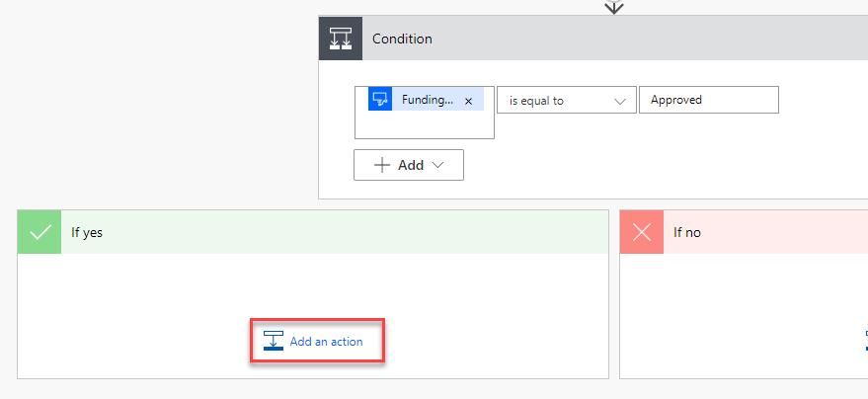](https://github.com/MicrosoftLearning/PL-500T00-Microsoft-Power-Automate-RPA-Developer/blob/master/Instructions/L03/media/image74.png)

1. Select the **Update a row** action from the **Microsoft Dataverse** connector.

[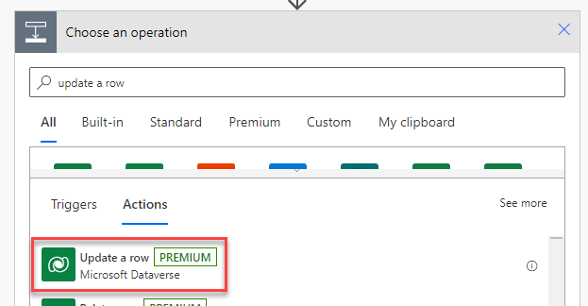](https://github.com/MicrosoftLearning/PL-500T00-Microsoft-Power-Automate-RPA-Developer/blob/master/Instructions/L03/media/image75.png)

1. Select **Loan Draws** for Table name, click on the Row ID field and select **LoanDrawID** from the dynamic content pane.

[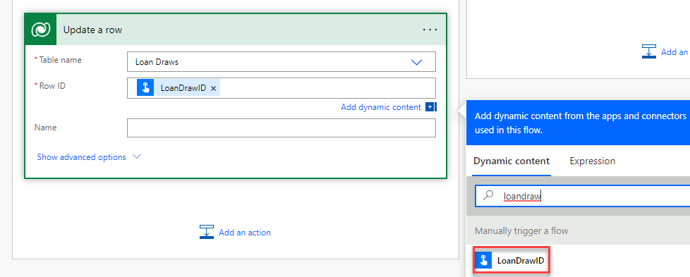](https://github.com/MicrosoftLearning/PL-500T00-Microsoft-Power-Automate-RPA-Developer/blob/master/Instructions/L03/media/image76.png)

1. Click **Show advanced options**.
2. Click on the **Amount Funded** field and go to the dynamic content pane and select the **Expression** tab.
3. Paste the expression below and click **OK**.

replace(outputs('Run_a_flow_built_with_Power_Automate_for_desktop')?['body/FundedAmount'], '$','')

[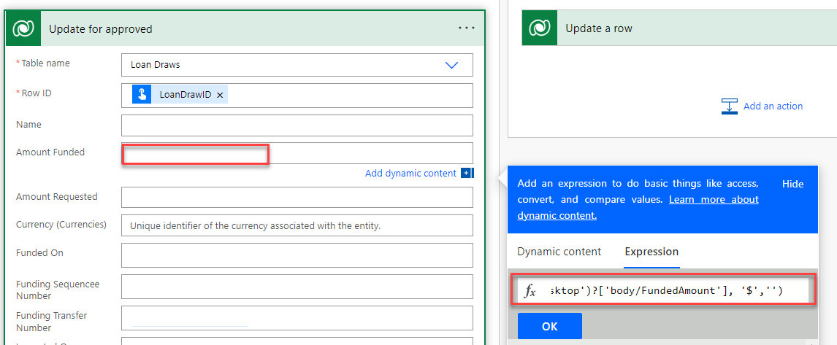](https://github.com/MicrosoftLearning/PL-500T00-Microsoft-Power-Automate-RPA-Developer/blob/master/Instructions/L03/media/image77.png)

1. Click on the **Funded On** field, go to the dynamic content pane, and select the **Expression** tab.
2. Type **utcNow()** and click **OK**.

[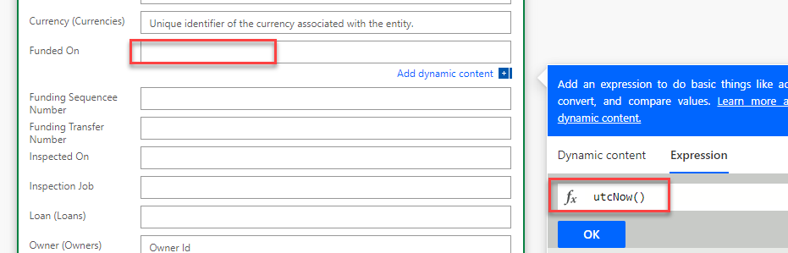](https://github.com/MicrosoftLearning/PL-500T00-Microsoft-Power-Automate-RPA-Developer/blob/master/Instructions/L03/media/image78.png)

1. Click on the **Funding Sequence Number** field and select **FundSequenceNumber** from the dynamic content pane.
2. Click on the **Funding Transfer Number** field and select **FundTransferNumber** form the dynamic content pane.
3. Click on the **RiskScore** field and select **RiskScore** form the dynamic content pane.
4. Select **Funding Approved** for Status Reason and click **Hide advanced options**.

[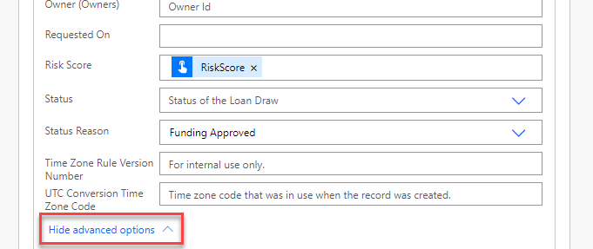](https://github.com/MicrosoftLearning/PL-500T00-Microsoft-Power-Automate-RPA-Developer/blob/master/Instructions/L03/media/image79.png)

1. Rename the step **Update for approved**.
2. Go to the **If no** branch and click **Add an action**.

[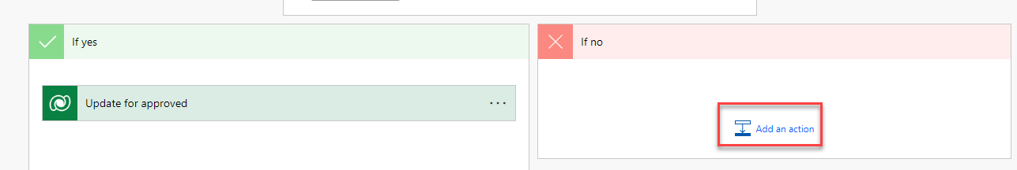](https://github.com/MicrosoftLearning/PL-500T00-Microsoft-Power-Automate-RPA-Developer/blob/master/Instructions/L03/media/image80.png)

1. Select the **Update a row** action from the **Microsoft Dataverse** connector.

[](https://github.com/MicrosoftLearning/PL-500T00-Microsoft-Power-Automate-RPA-Developer/blob/master/Instructions/L03/media/image75.png)

1. Select **Loan Draws** for Table name, click on the Row ID field and select **LoanDrawID** from the dynamic content pane.

[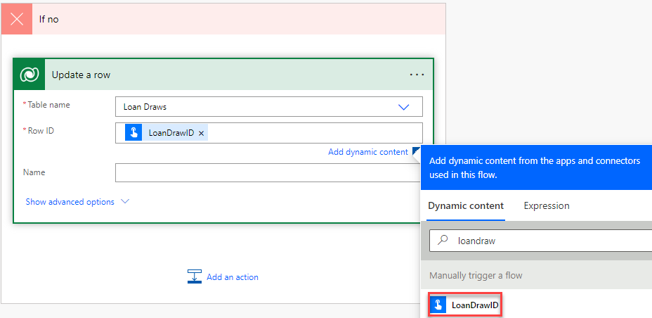](https://github.com/MicrosoftLearning/PL-500T00-Microsoft-Power-Automate-RPA-Developer/blob/master/Instructions/L03/media/image81.png)

1. Click **Show advanced options**.
2. Select **Funding Denied** for Status Reason and click **+ New step**.

[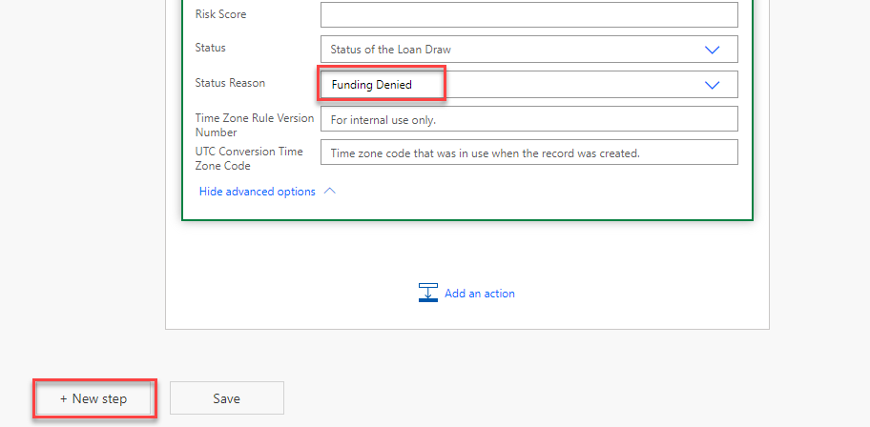](https://github.com/MicrosoftLearning/PL-500T00-Microsoft-Power-Automate-RPA-Developer/blob/master/Instructions/L03/media/image82.png)

1. Select the **Respond to PowerApps or flow** action from the **PowerApps** connector.

[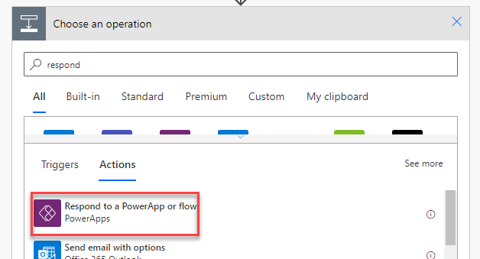](https://github.com/MicrosoftLearning/PL-500T00-Microsoft-Power-Automate-RPA-Developer/blob/master/Instructions/L03/media/image83.png)

1. Click **+ Add an output**.
2. Select **Text**.
3. Enter **FundingStatus**, click on the value field and select **FundingStatus** from the dynamic content pane.

[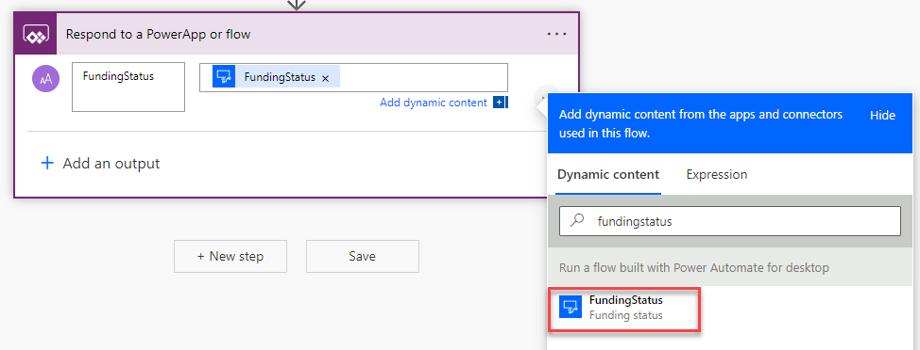](https://github.com/MicrosoftLearning/PL-500T00-Microsoft-Power-Automate-RPA-Developer/blob/master/Instructions/L03/media/image84.png)

1. Click **Save** and wait for the flow to be saved.
2. Click **Test**.
3. Select **Manually** and click **Test** again.
4. Click **Continue**.
5. Enter **JG7165** for LoanNumber, paste the id you copied in the previous exercise for LoanDrawID, enter **80000** for RequestedAmount, enter **123** for InspectionJobID, enter **50** for RiskScrore, and click **Run flow**.

[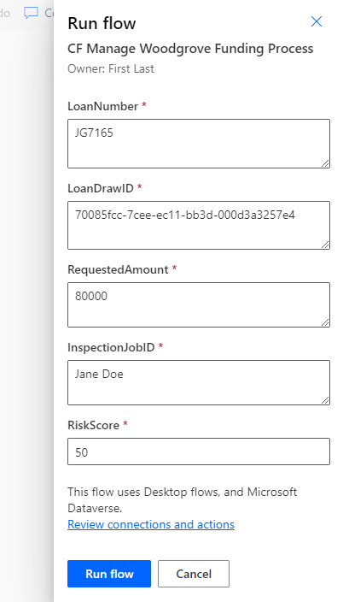](https://github.com/MicrosoftLearning/PL-500T00-Microsoft-Power-Automate-RPA-Developer/blob/master/Instructions/L03/media/image85.png)

1. **Wait** for the flow run to complete, the flow run should succeed. Click **Done** to review the flow run history.

**Exercise #4: Build Overall Process Flow**

**Task #1: Create a shared mailbox**

1. Navigate to <https://admin.microsoft.com/> and click **Show all**.

[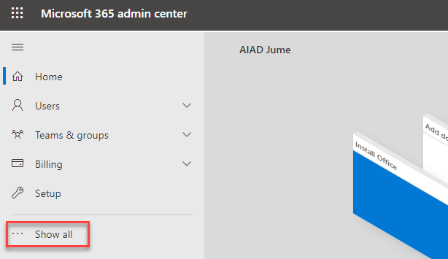](https://github.com/MicrosoftLearning/PL-500T00-Microsoft-Power-Automate-RPA-Developer/blob/master/Instructions/L03/media/image86.png)

1. Go to the **Admin centers** area and select **Exchange**.

[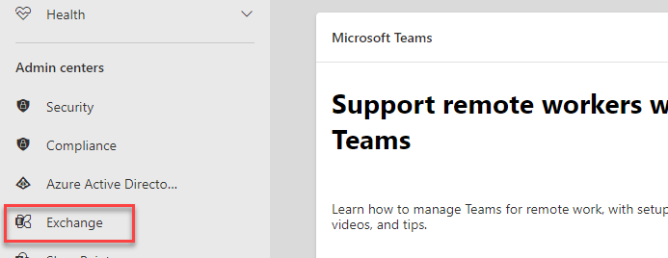](https://github.com/MicrosoftLearning/PL-500T00-Microsoft-Power-Automate-RPA-Developer/blob/master/Instructions/L03/media/image87.png)

1. In the left side menu under **Recipients** select **Mailboxes**.
2. Click **+ Add a shared mailbox**.

[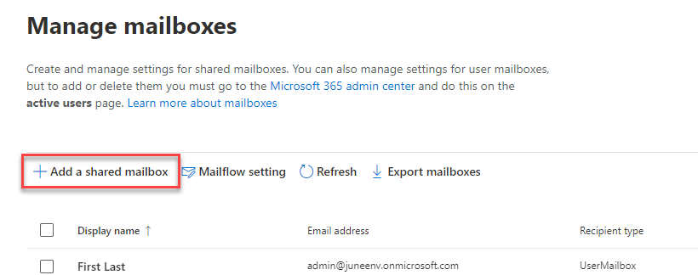](https://github.com/MicrosoftLearning/PL-500T00-Microsoft-Power-Automate-RPA-Developer/blob/master/Instructions/L03/media/image88.png)

1. Enter **Funding** for Display name, **Funding** for Email address, select your domain, and click **Create**.

[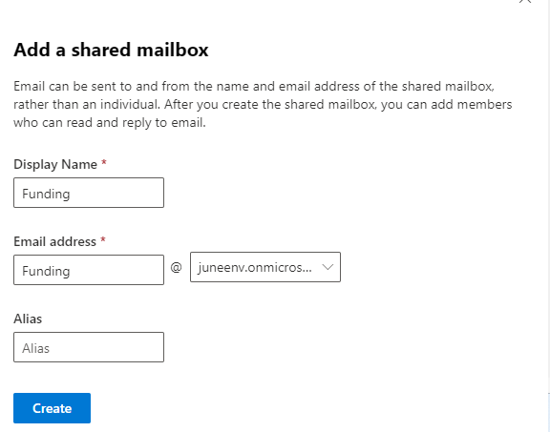](https://github.com/MicrosoftLearning/PL-500T00-Microsoft-Power-Automate-RPA-Developer/blob/master/Instructions/L03/media/image89.png)

1. Click **Add users to this mailbox**.

[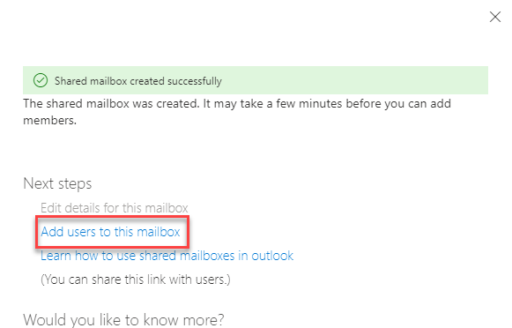](https://github.com/MicrosoftLearning/PL-500T00-Microsoft-Power-Automate-RPA-Developer/blob/master/Instructions/L03/media/image90.png)

1. Click **+ Add members**.
2. Select your user and click **Save**. You may add other users to the shared mailbox.

[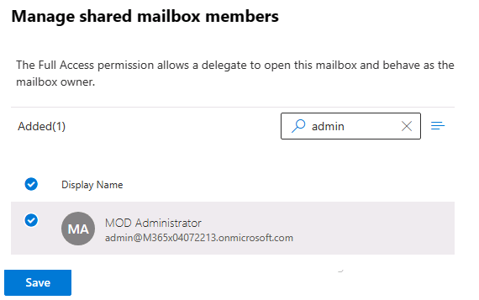](https://github.com/MicrosoftLearning/PL-500T00-Microsoft-Power-Automate-RPA-Developer/blob/master/Instructions/L03/media/image91.png)

1. Click **Confirm**.
2. Close the shared mailbox pane.

**Task #2: Create flow**

1. Navigate to <https://make.powerapps.com/> and make sure you are in the Dev environment.
2. Select **Solutions** and open the **Construction Funding** solution.
3. Locate and open the **CF Manage Inspection Process** child flow.

[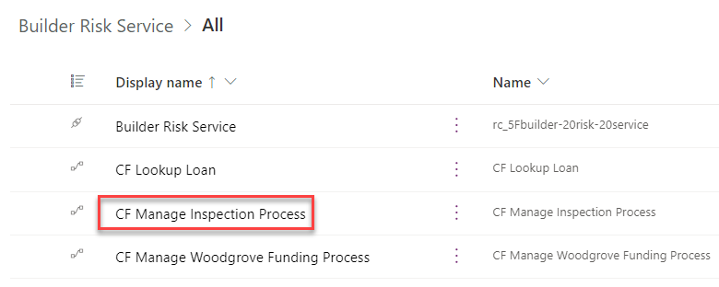](https://github.com/MicrosoftLearning/PL-500T00-Microsoft-Power-Automate-RPA-Developer/blob/master/Instructions/L03/media/image92.png)

1. Go to the **Run only users** section and click **Edit**.

[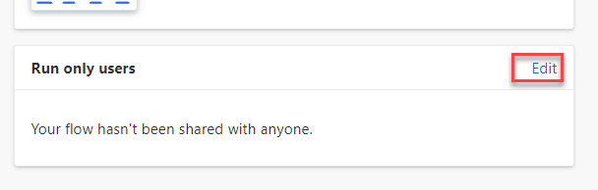](https://github.com/MicrosoftLearning/PL-500T00-Microsoft-Power-Automate-RPA-Developer/blob/master/Instructions/L03/media/image93.png)

1. Select the desktop connection you created and click **OK** on the popup.
2. Click **Save**.

[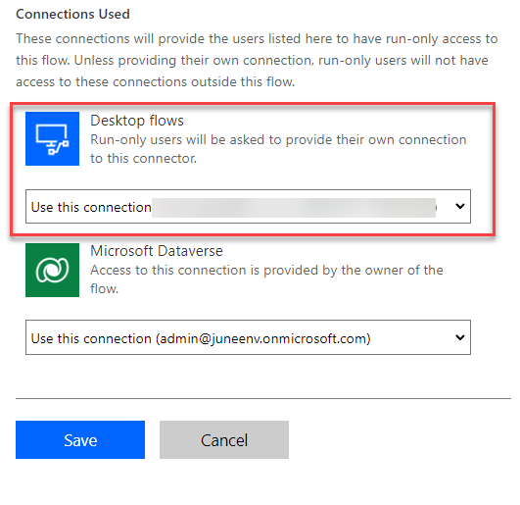](https://github.com/MicrosoftLearning/PL-500T00-Microsoft-Power-Automate-RPA-Developer/blob/master/Instructions/L03/media/image94.png)

1. Click on the browser back button.
2. Locate and open the **CF Manage Woodgrove Funding Process** child flow.

[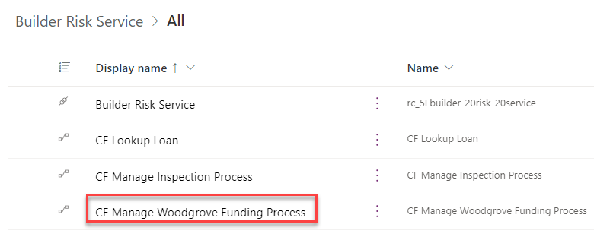](https://github.com/MicrosoftLearning/PL-500T00-Microsoft-Power-Automate-RPA-Developer/blob/master/Instructions/L03/media/image95.png)

1. Go to the **Run only users** section and click **Edit**.
2. Select the desktop connection you created and click **OK** on the popup.
3. Click **Save**.
4. Click on the browser back button.
5. Click **+ New** and select **Automation | Cloud flow | Automated**.

[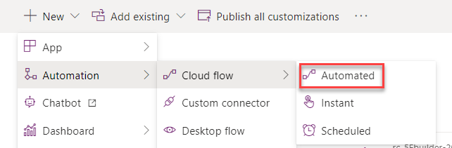](https://github.com/MicrosoftLearning/PL-500T00-Microsoft-Power-Automate-RPA-Developer/blob/master/Instructions/L03/media/image96.png)

1. Enter **Process Construction Funding Request** for Flow name, select the **When a new email arrives in a shared mailbox** trigger, and click **Create**.

[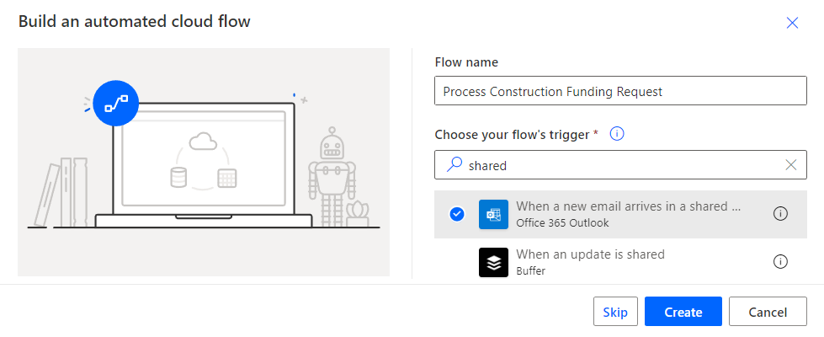](https://github.com/MicrosoftLearning/PL-500T00-Microsoft-Power-Automate-RPA-Developer/blob/master/Instructions/L03/media/image97.png)

1. Select the **Funding** shared email you created for **Original Mailbox Address**, select **Inbox** for Folder, and click **Show advanced options**.
2. Select **Yes** for Include attachments and click on the **…** button of the trigger.

[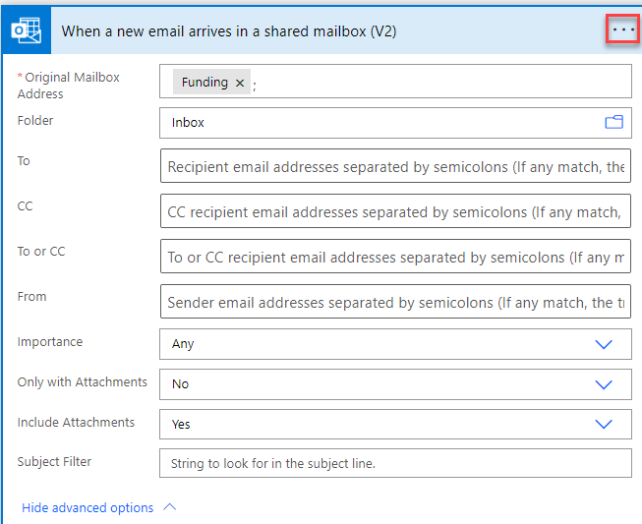](https://github.com/MicrosoftLearning/PL-500T00-Microsoft-Power-Automate-RPA-Developer/blob/master/Instructions/L03/media/image98.png)

1. Select **Rename**.
2. Rename the trigger to **When a new funding request email arrives**.
3. Click **+ New step**.
4. Select the **Run a Child Flow** action from the **Flows** connector.

[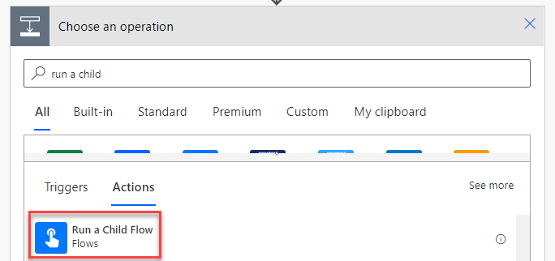](https://github.com/MicrosoftLearning/PL-500T00-Microsoft-Power-Automate-RPA-Developer/blob/master/Instructions/L03/media/image99.png)

1. Select **CF Lookup Loan** for Child flow.
2. Click on the **LoanNumber** field, go to the dynamic content pane, and select **Subject**.

[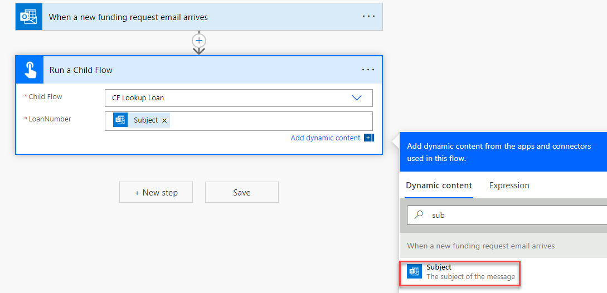](https://github.com/MicrosoftLearning/PL-500T00-Microsoft-Power-Automate-RPA-Developer/blob/master/Instructions/L03/media/image100.png)

1. Rename the step **Lookup loan number**.
2. Click **+ New step**.
3. Select the **Condition** action from the **Control** connector.
4. Click to select the first operand field, go to the dynamic content pane, and select **LoanFound**.

[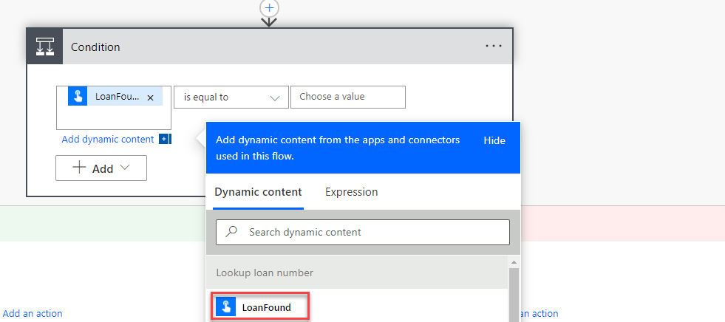](https://github.com/MicrosoftLearning/PL-500T00-Microsoft-Power-Automate-RPA-Developer/blob/master/Instructions/L03/media/image101.png)

1. Select **is equal to** for the operator and type True for the second operand field.
2. Rename the condition **Check if loan number found**.
3. Go to the **If no** branch and click **Add an action**.
4. Select the **Send an email from a shared mailbox (V2)** action from the **Office 365 Outlook** connector.

[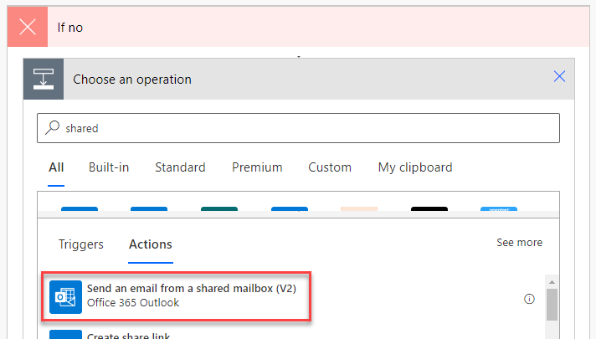](https://github.com/MicrosoftLearning/PL-500T00-Microsoft-Power-Automate-RPA-Developer/blob/master/Instructions/L03/media/image103.png)

1. Click on the **Original mailbox Address**, click **Add dynamic content** and select **To** from the dynamic content pane.

[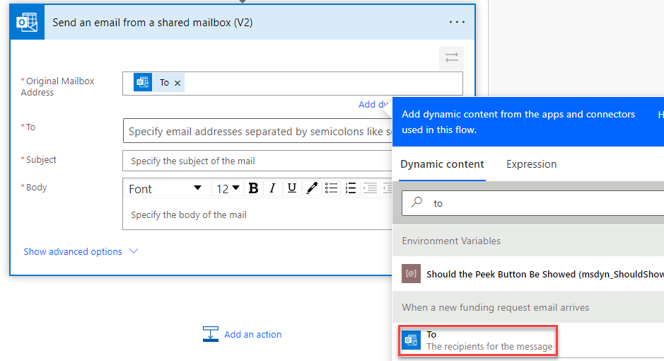](https://github.com/MicrosoftLearning/PL-500T00-Microsoft-Power-Automate-RPA-Developer/blob/master/Instructions/L03/media/image104.png)

1. Click on the **To** field, click **Add dynamics content** and select **From** from the dynamic content pane.
2. Type **Loan number not found** for Subject.
3. Type **Loan #** Body and select **Subject** from the dynamic content pane.

[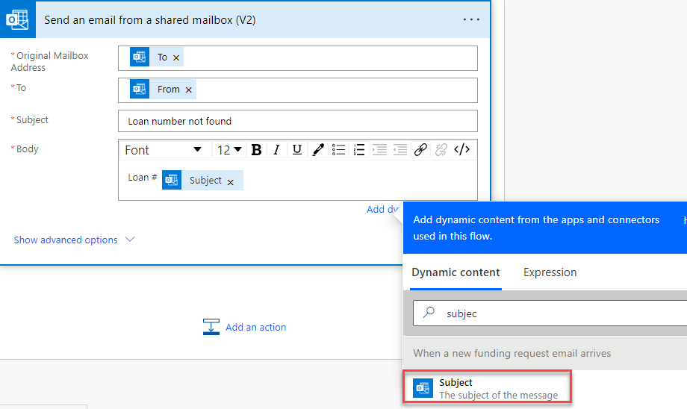](https://github.com/MicrosoftLearning/PL-500T00-Microsoft-Power-Automate-RPA-Developer/blob/master/Instructions/L03/media/image105.png)

1. Add **not found, contact your bank.** to the body.
2. Rename the reply **Send loan not found email** and click **Add an action**.

[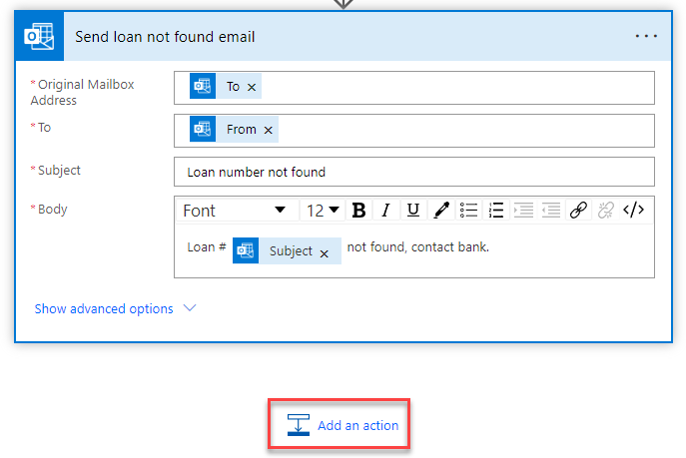](https://github.com/MicrosoftLearning/PL-500T00-Microsoft-Power-Automate-RPA-Developer/blob/master/Instructions/L03/media/image106.png)

1. Select the **Terminate** action from the **Control** connector.

[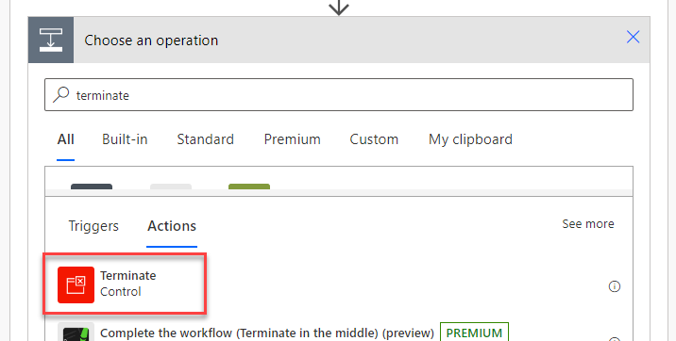](https://github.com/MicrosoftLearning/PL-500T00-Microsoft-Power-Automate-RPA-Developer/blob/master/Instructions/L03/media/image107.png)

1. Select **Succeeded** for Status.
2. Click **+ New step**.

[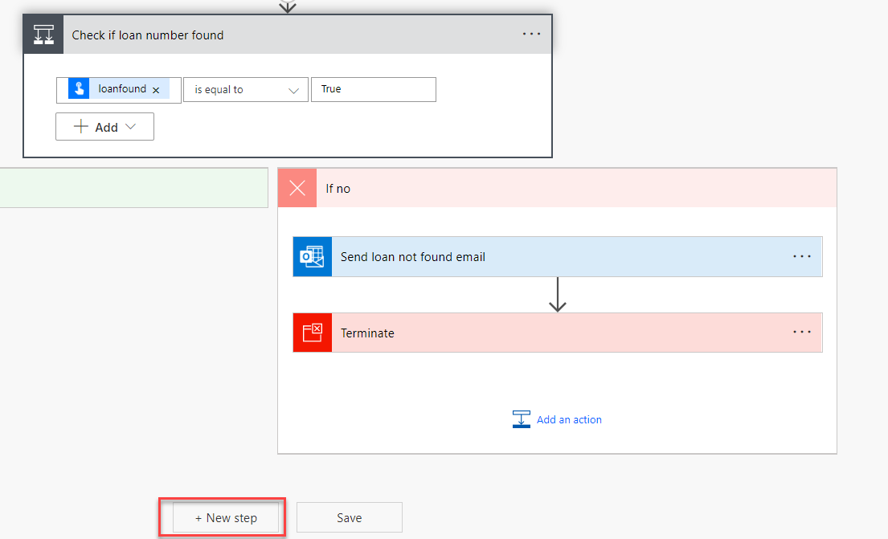](https://github.com/MicrosoftLearning/PL-500T00-Microsoft-Power-Automate-RPA-Developer/blob/master/Instructions/L03/media/image108.png)

1. Select the **Add a new row** action from the **Microsoft Dataverse** connector.

[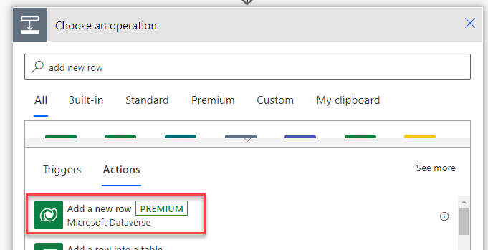](https://github.com/MicrosoftLearning/PL-500T00-Microsoft-Power-Automate-RPA-Developer/blob/master/Instructions/L03/media/image109.png)

1. Select **Loan Draws** for Table name.
2. Enter **Loan draw** for Name and click **Show advanced options**.

[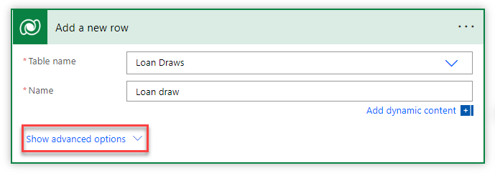](https://github.com/MicrosoftLearning/PL-500T00-Microsoft-Power-Automate-RPA-Developer/blob/master/Instructions/L03/media/image110.png)

1. Enter **80000** for Amount Requested.
2. Type **rc_loans()** for Loan (Loans), place your cursor inside the parentheses, and select **LoanID** from the dynamic content pane.

[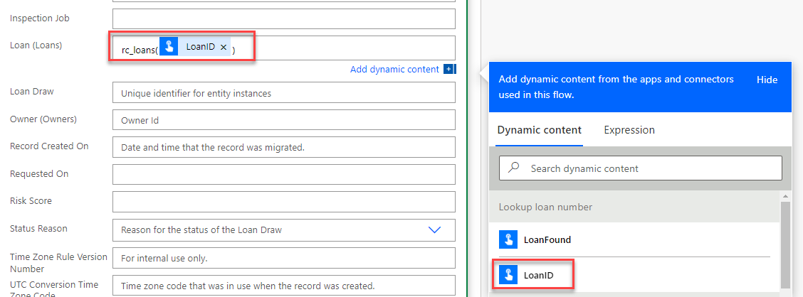](https://github.com/MicrosoftLearning/PL-500T00-Microsoft-Power-Automate-RPA-Developer/blob/master/Instructions/L03/media/image111.png)

1. Rename the step **Create new loan draw row**.
2. Click **+ New step.**
3. Select the **Run a Child Flow** action from the **Flows** connector.
4. Select **CF Manage Inspection Process** for Child flow.
5. Enter **123 Main Street** for PropertyAddress.
6. Click on the **LoanDrawID** field and select **Loan Draw** from the dynamic content pane.

[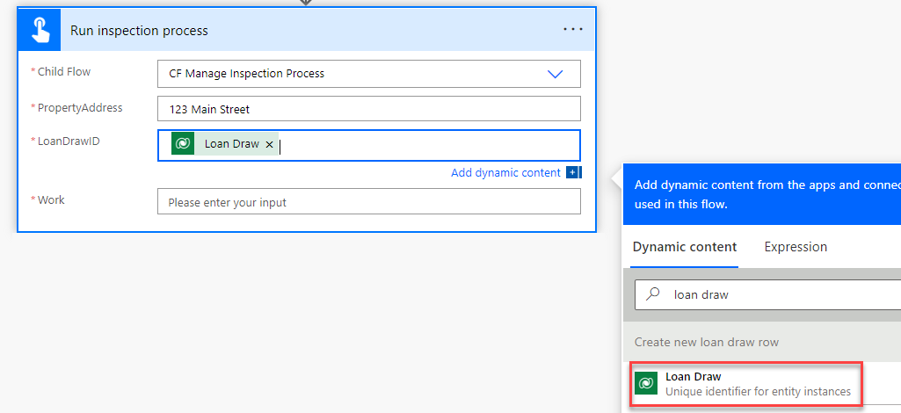](https://github.com/MicrosoftLearning/PL-500T00-Microsoft-Power-Automate-RPA-Developer/blob/master/Instructions/L03/media/image112.png)

1. Enter **Test work item** for Work.
2. Rename the child flow **Run inspection process** and click **+ New step**.

[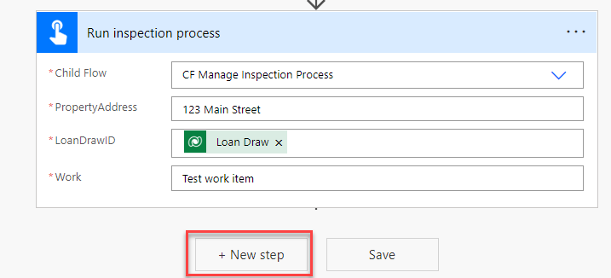](https://github.com/MicrosoftLearning/PL-500T00-Microsoft-Power-Automate-RPA-Developer/blob/master/Instructions/L03/media/image113.png)

1. Select the **Run a Child Flow** action from the **Flows** connector.
2. Select **CF Manage Woodgrove Funding Process** for Child flow.
3. Click on the **LoanNumber** field and select **Subject** from the dynamic content pane.
4. Click on the **LoanDrawID** field and select **Loan Draw** from the dynamic content pane.
5. Enter **80000** for RequestedAmount.
6. Click on the **InspectionJobID** field and select **JobNumber** from the dynamic content pane.
7. Enter **55** for **RiskScore**.
8. Rename the child flow **Run funding process**. Click **Save**.
9. Click **+ New step**.

[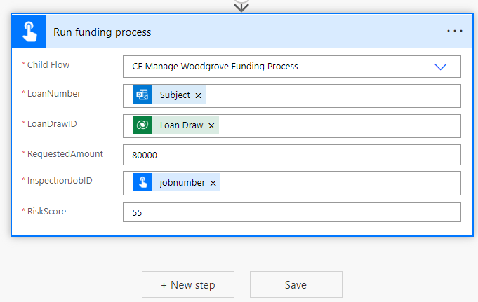](https://github.com/MicrosoftLearning/PL-500T00-Microsoft-Power-Automate-RPA-Developer/blob/master/Instructions/L03/media/image114.png)

1. Select the **Condition** action from the **Control** connector.
2. Click on the first operand and select **FundingStatus** from the dynamic content pane.

[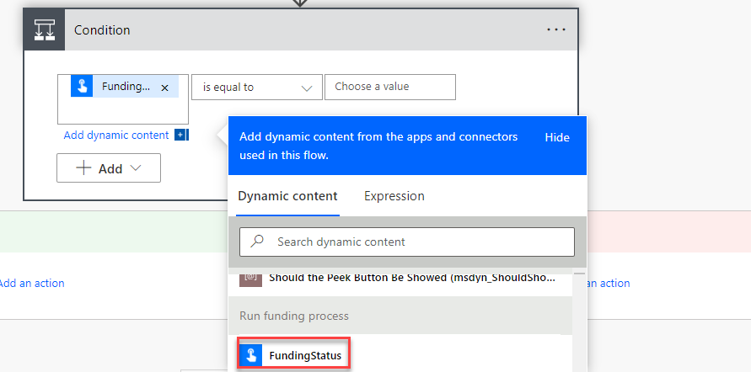](https://github.com/MicrosoftLearning/PL-500T00-Microsoft-Power-Automate-RPA-Developer/blob/master/Instructions/L03/media/image115.png)

1. Select **is equals to** for operator and enter **Approved** for the second operand.
2. Rename the condition **Check approval status**.
3. Go to the **If yes** branch and click **Add an action**.

[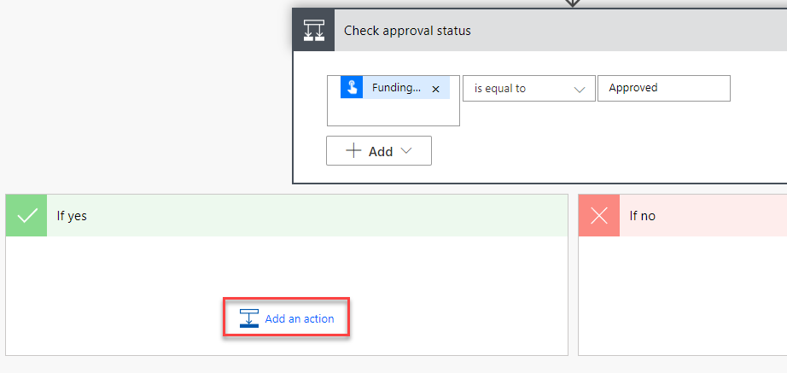](https://github.com/MicrosoftLearning/PL-500T00-Microsoft-Power-Automate-RPA-Developer/blob/master/Instructions/L03/media/image116.png)

1. Select the **Send an email from a shared mailbox (V2)** action from the **Office 365 Outlook** connector.
2. Click on the **Original Mailbox Address** field, click **Add dynamic content** and select **To** from the dynamic content pane.
3. Click on the **To** field, click **Add dynamics content** and select **From** from the dynamic content pane.
4. Enter **Draw Approved** for Subject.
5. Type **Your draw for** in the Body and select **Amount Funded** from the dynamic content pane.

[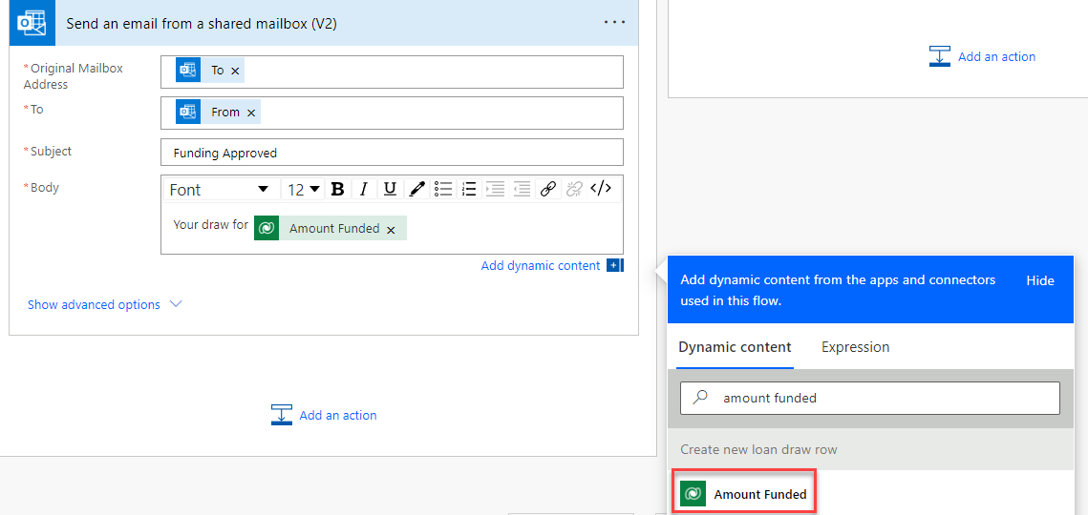](https://github.com/MicrosoftLearning/PL-500T00-Microsoft-Power-Automate-RPA-Developer/blob/master/Instructions/L03/media/image117.png)

1. Add **was approved** to the body.
2. Rename the step **Send approved draw email**.
3. Go to the **If no** branch and click **Add an action**.

[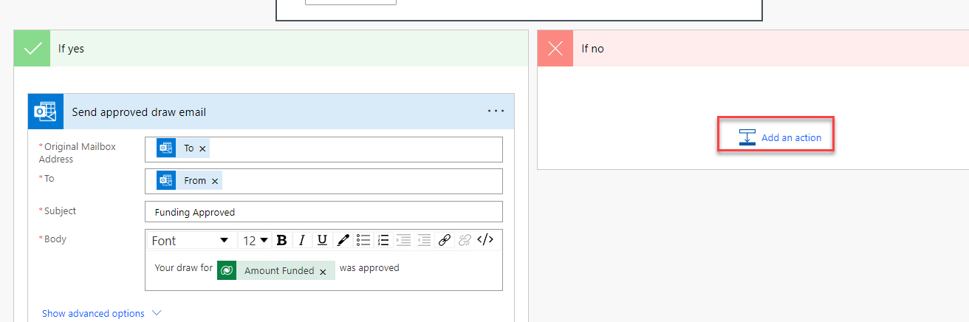](https://github.com/MicrosoftLearning/PL-500T00-Microsoft-Power-Automate-RPA-Developer/blob/master/Instructions/L03/media/image118.png)

1. Select the **Send an email from a shared mailbox (V2)** action from the **Office 365 Outlook** connector.
2. Click on the **Original Mailbox Address** field, click **Add dynamic content** and select **To** from the dynamic content pane.
3. Click on the **To** field, click **Add dynamic content** and select **From** from the dynamic content pane.
4. Enter **Draw was not approved** for Subject.
5. Type **Your draw for** in the Body and select **Amount Funded** from the dynamic content pane.
6. Add **was not approved, please contact bank.** to the body.
7. Rename the step **Send draw not approved email**.
8. Click **Save** and wait for the flow to be saved.

[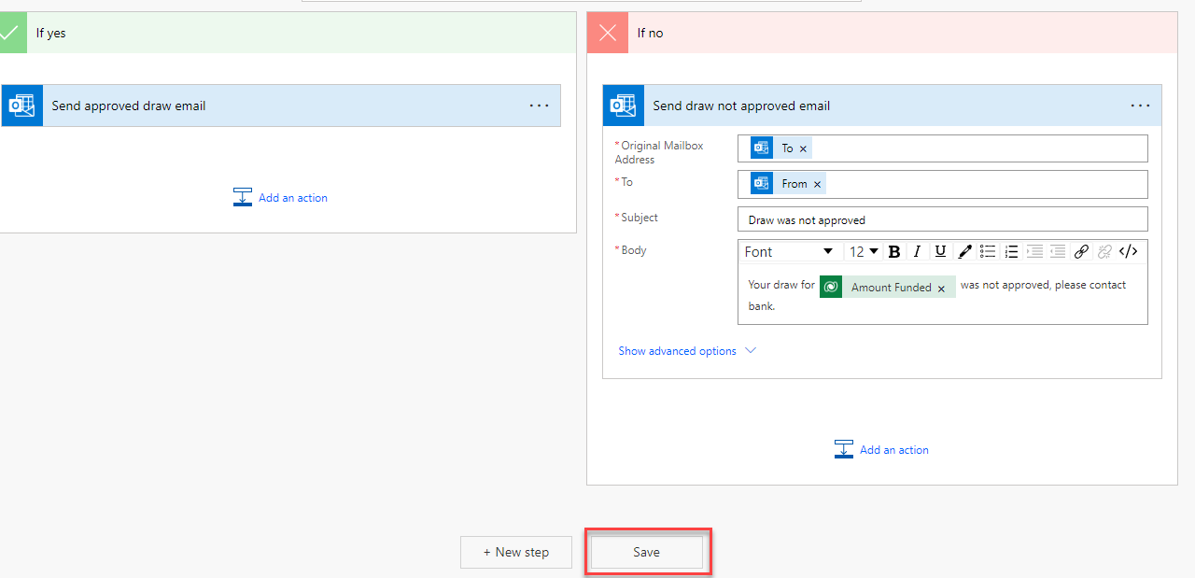](https://github.com/MicrosoftLearning/PL-500T00-Microsoft-Power-Automate-RPA-Developer/blob/master/Instructions/L03/media/image119.png)

**Task #3: Test flow**

1. Click **Test**.
2. Select **Manually** and click **Test** again.
3. Send an email with the subject **MC3747** from your email to the Funding shared email you created ([Funding@yourdomain.onmicrosoft.com](mailto:Funding@yourdomain.onmicrosoft.com)).
4. Wait for the flow to get triggered. Do not interact your computer while the flow is running.
5. The flow should run successfully.

[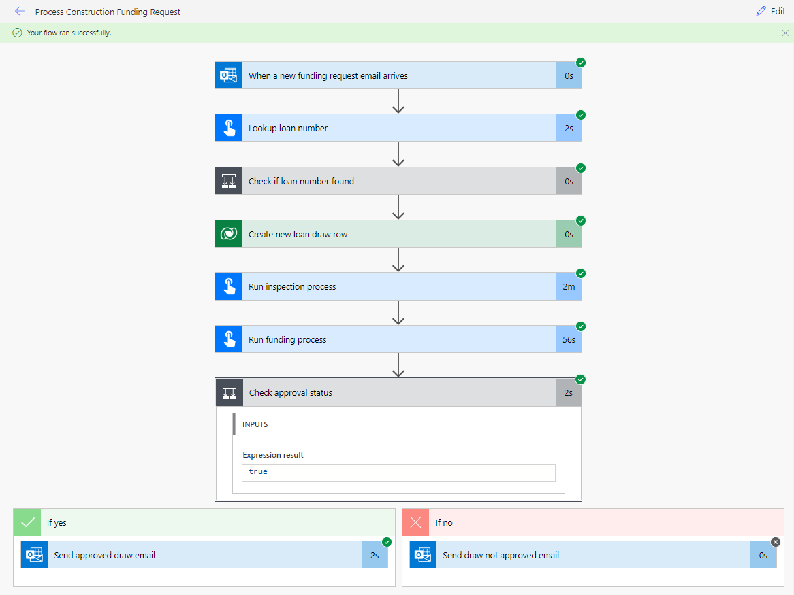](https://github.com/MicrosoftLearning/PL-500T00-Microsoft-Power-Automate-RPA-Developer/blob/master/Instructions/L03/media/image120.png)

1. You should receive an email with the subject **Draw Approved**.