**Custom Connectors**

**Scenario**

In this lab, you will build a custom connector for A Datum’s Risk Score API.

**High-level lab objectives**

* Build a custom connector
* Modify the cloud flow to use the connector

**Exercise #1: Create a custom connector**

**Task #1: Create a new solution**

1. Navigate to <https://make.powerapps.com/> and make sure you are in the Dev environment.
2. Select **Solutions** and click **+ New solution**. We are creating a new solution to keep the custom connector separate from the flow that uses it which is the current requirement of using a custom connector.
3. Enter **Builder Risk Service** for Display name, select **Relecloud** for Publisher, and click **Create**.

[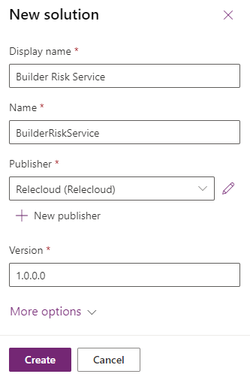](https://github.com/MicrosoftLearning/PL-500T00-Microsoft-Power-Automate-RPA-Developer/blob/master/Instructions/L04/media/image1.png)

**Task #2: Create custom connector**

1. Click **+ New** and select **Automation | Custom connector**.

[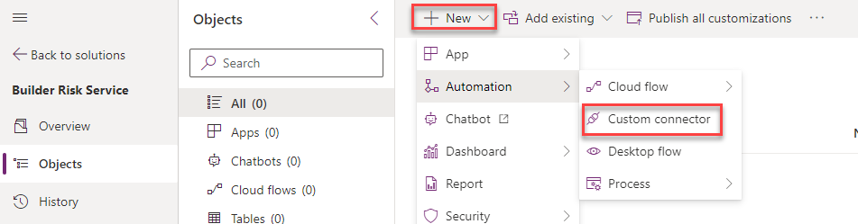](https://github.com/MicrosoftLearning/PL-500T00-Microsoft-Power-Automate-RPA-Developer/blob/master/Instructions/L04/media/image2.png)

1. Enter **Builder Risk Service** for Connector Name.

[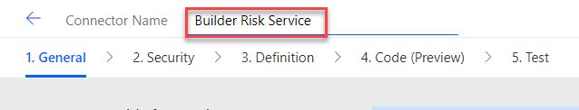](https://github.com/MicrosoftLearning/PL-500T00-Microsoft-Power-Automate-RPA-Developer/blob/master/Instructions/L04/media/image3.png)

1. Enter **Service for evaluating builder risk** for Description, enter **adatumbuilderrisktest.azurewebsites.net** for Host, and click **Create connector**.

[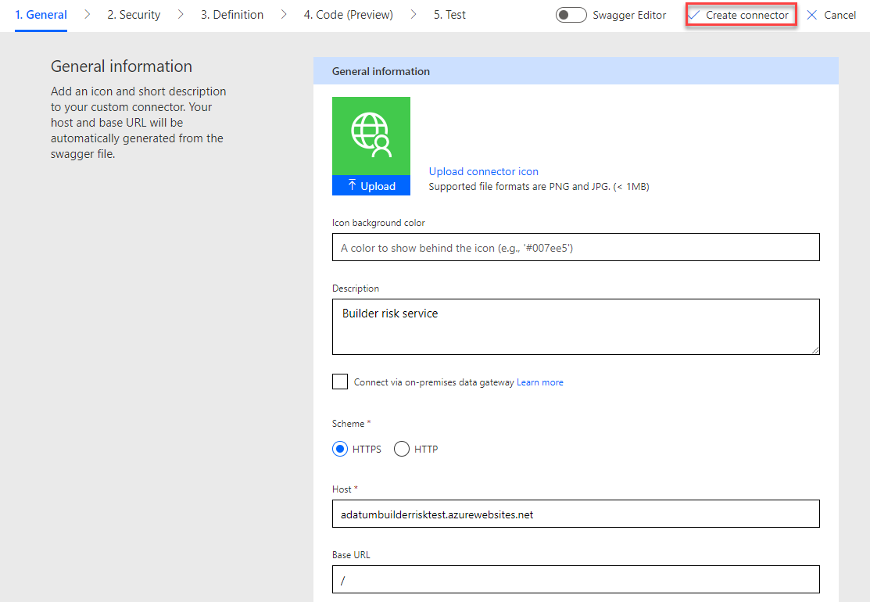](https://github.com/MicrosoftLearning/PL-500T00-Microsoft-Power-Automate-RPA-Developer/blob/master/Instructions/L04/media/image4.png)

**Task #3: Import Open API**

1. Navigate to <https://adatumbuilderrisktest.azurewebsites.net/>
2. Click **Download Logo** and save the logo on your machine.
3. Click on the **API Key** link.

[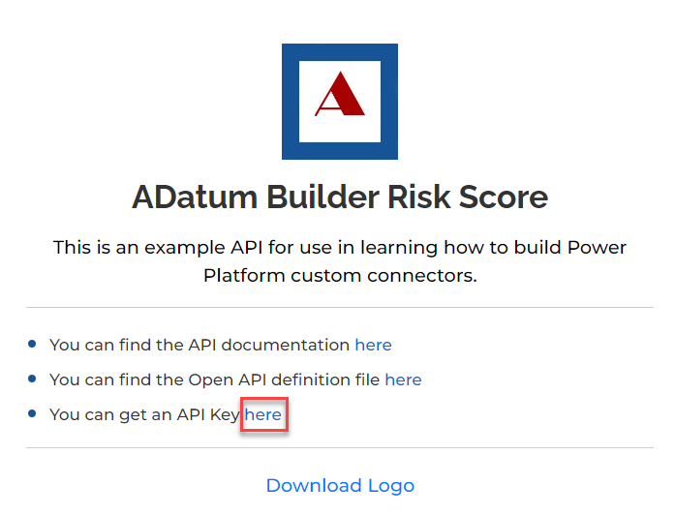](https://github.com/MicrosoftLearning/PL-500T00-Microsoft-Power-Automate-RPA-Developer/blob/master/Instructions/L04/media/image5.png)

1. Copy the **API Key** and save it on a notepad.
2. Click **Return to home**.
3. Click on the **API documentation** link.
4. Review the documentation.
5. Close the documentation browser tab or window, after you finish reviewing.
6. Click on the **Open API definition file** link.

[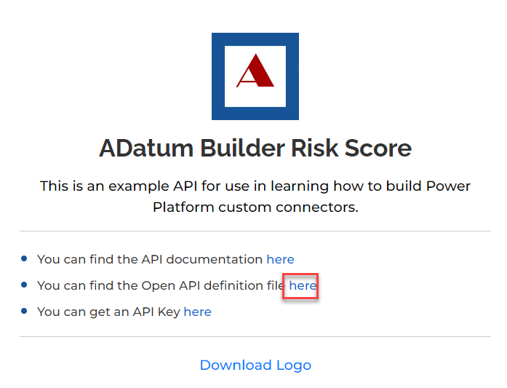](https://github.com/MicrosoftLearning/PL-500T00-Microsoft-Power-Automate-RPA-Developer/blob/master/Instructions/L04/media/image6.png)

1. On your keyboard press **CTRL + S** and select **Save**. Now the file is saved on your machine.
2. Navigate to <https://make.powerautomate.com/> and make sure you are in the Dev environment.
3. Click **More** and select **Discover all**.

[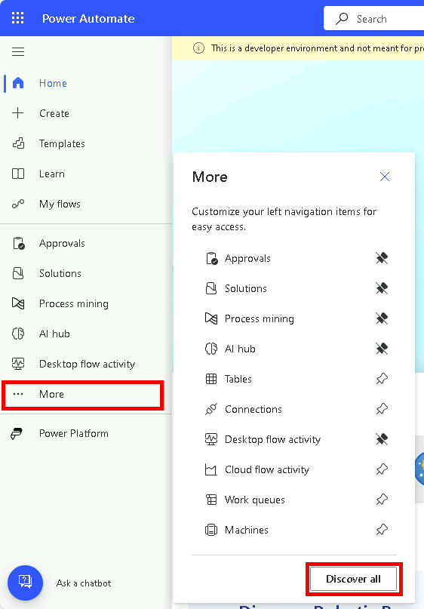](https://github.com/MicrosoftLearning/PL-500T00-Microsoft-Power-Automate-RPA-Developer/blob/master/Instructions/L04/media/image8.png)

1. Scroll down and select **Custom connectors** under data.

[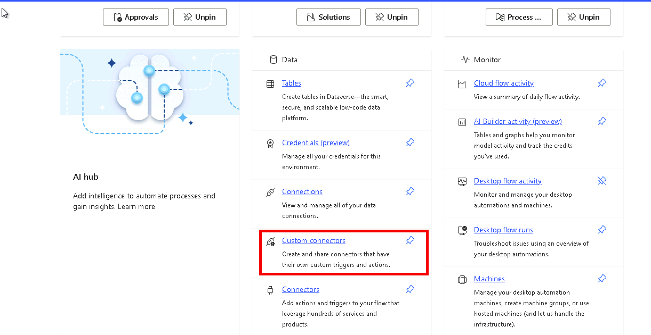](https://github.com/MicrosoftLearning/PL-500T00-Microsoft-Power-Automate-RPA-Developer/blob/master/Instructions/L04/media/image7.png)

1. Click on the **…** more actions button of the **Builder Risk Service** custom connector and select **Update from OpenAPI file**.

[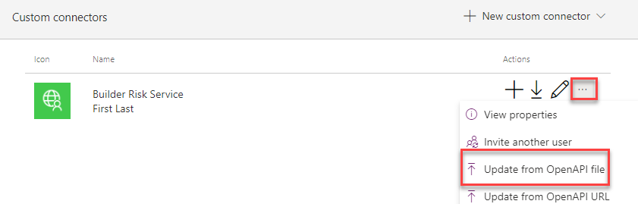](https://github.com/MicrosoftLearning/PL-500T00-Microsoft-Power-Automate-RPA-Developer/blob/master/Instructions/L04/media/image9.png)

1. Click **Import**.
2. Select the **swagger.json** file you saved to your machine and click **Open**.
3. Click **Continue**.

[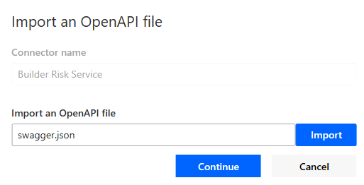](https://github.com/MicrosoftLearning/PL-500T00-Microsoft-Power-Automate-RPA-Developer/blob/master/Instructions/L04/media/image10.png)

1. Click **Upload** under the logo.
2. Select the logo you downloaded and click **Open**.
3. Enter **Service for evaluating builder risk** for Description, enter

**adatumbuilderrisktest.azurewebsites.net** for Host, and select **Security** from the breadcrumb navigation bar at the top of the screen.

[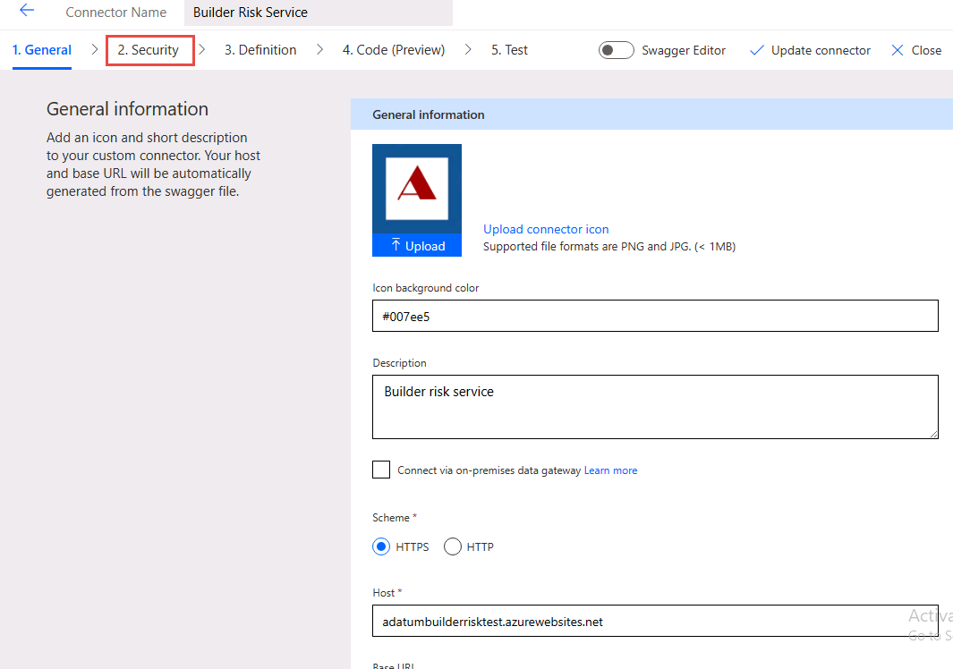](https://github.com/MicrosoftLearning/PL-500T00-Microsoft-Power-Automate-RPA-Developer/blob/master/Instructions/L04/media/image12.png)

1. Select **Definition** from the breadcrumb navigation bar at the top of the screen and see the operation imported.
2. Turn on **Swagger Editor**.

[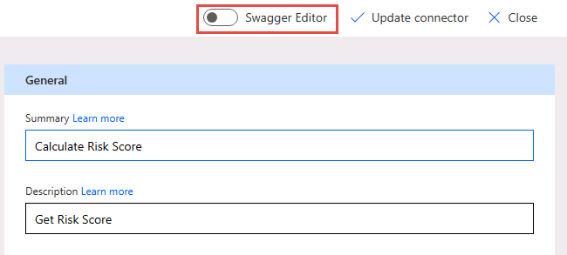](https://github.com/MicrosoftLearning/PL-500T00-Microsoft-Power-Automate-RPA-Developer/blob/master/Instructions/L04/media/image13.png)

1. Have a look at the Swagger Editor and then turn off the **Swagger Editor**.
2. Select **Update connector** and wait for the connector to be updated.
3. Do not navigate away from this page.

**Task #4: Test connector**

1. Select **Test** from the breadcrumb navigation bar at the top of the screen and click **+ New connection**.

[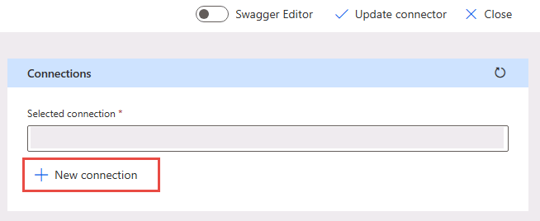](https://github.com/MicrosoftLearning/PL-500T00-Microsoft-Power-Automate-RPA-Developer/blob/master/Instructions/L04/media/image14.png)

1. Paste your **API Key** and click **Create connection**.
2. Click the **Refresh connections** button, on the right. The connection you just created should be the **Selected connection**.
3. Under CalcRiskScore, enter **Contoso** for builderName, **7165 Brock Lane Renton, WA 61795 U.S.** for propertyAddress, **JG7165** for loanNumber, **645000** for loanAmount, **500000** for creditAvailable, **100000** for drawAmount, and click **Test operation**.

[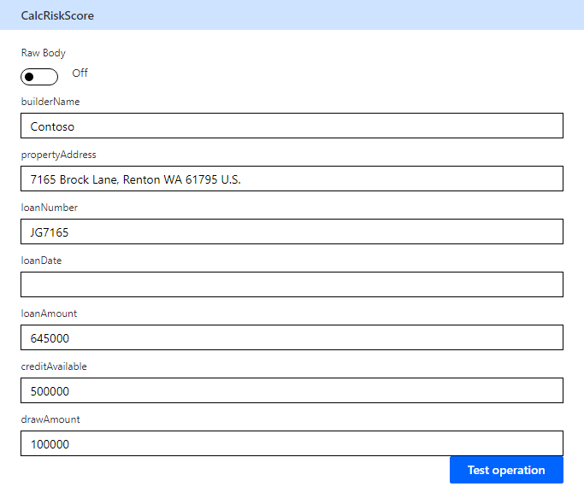](https://github.com/MicrosoftLearning/PL-500T00-Microsoft-Power-Automate-RPA-Developer/blob/master/Instructions/L04/media/image16.png)

1. The test should run successfully, and you should receive a score and a reason.

[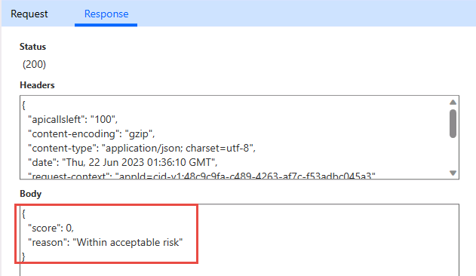](https://github.com/MicrosoftLearning/PL-500T00-Microsoft-Power-Automate-RPA-Developer/blob/master/Instructions/L04/media/image17.png)

1. Click **Close** to return to the list of Custom connectors.

**Exercise #2: Modify cloud flow to use connector**

**Task #1: Use custom connector in flow**

1. Navigate to <https://make.powerapps.com/> and make sure you are in the Dev environment.
2. Select **Solutions** and open the **Construction Funding** solution.
3. Select **Cloud flows**, select **Process Construction Funding Request** flow and click **Edit**.

[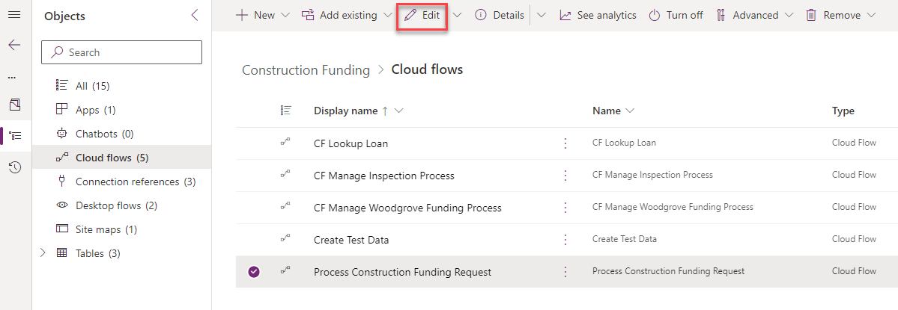](https://github.com/MicrosoftLearning/PL-500T00-Microsoft-Power-Automate-RPA-Developer/blob/master/Instructions/L04/media/image18.png)

1. Click **+** insert new step after the **Check if loan number found** condition and select **Add an action.**

[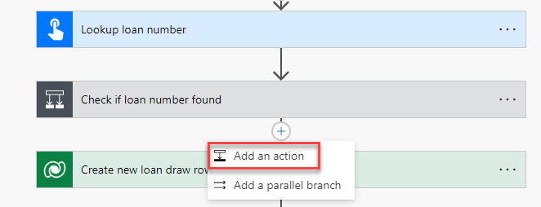](https://github.com/MicrosoftLearning/PL-500T00-Microsoft-Power-Automate-RPA-Developer/blob/master/Instructions/L04/media/image19.png)

1. Select **Get a row by ID** Microsoft Dataverse.

[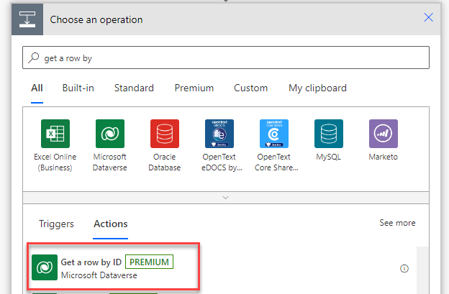](https://github.com/MicrosoftLearning/PL-500T00-Microsoft-Power-Automate-RPA-Developer/blob/master/Instructions/L04/media/image20.png)

1. Select **Loans** for Table name, click on the **Row ID** field and select **LoanID** from the dynamic content pane.

[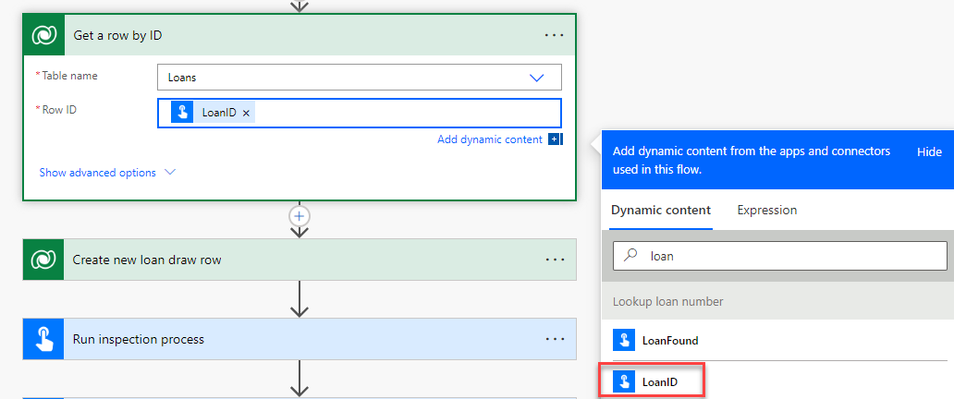](https://github.com/MicrosoftLearning/PL-500T00-Microsoft-Power-Automate-RPA-Developer/blob/master/Instructions/L04/media/image21.png)

1. Rename the step **Get loan**.
2. Go to the **+** Insert a new step button after the **Run inspection process** and select **Add an action**.

[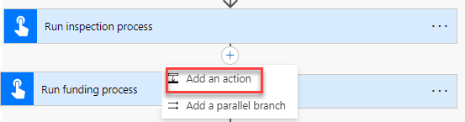](https://github.com/MicrosoftLearning/PL-500T00-Microsoft-Power-Automate-RPA-Developer/blob/master/Instructions/L04/media/image22.png)

1. Go to the **Custom** tab and select **Builder Risk Service**.

[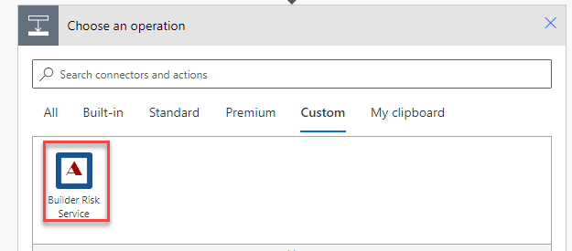](https://github.com/MicrosoftLearning/PL-500T00-Microsoft-Power-Automate-RPA-Developer/blob/master/Instructions/L04/media/image23.png)

1. Select the **Calculate Risk Score** action.
2. Enter **Risk Service** for Connection name, paste the API Key you copied earlier, and click **Create**.

[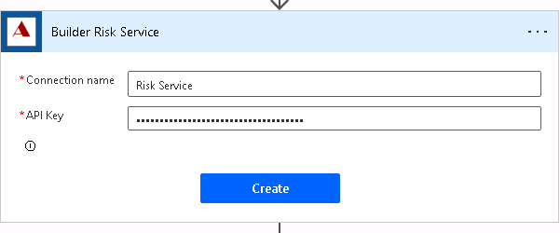](https://github.com/MicrosoftLearning/PL-500T00-Microsoft-Power-Automate-RPA-Developer/blob/master/Instructions/L04/media/image24.png)

1. Click on the **builderName** field and select **Builder** from the dynamic content pane.

[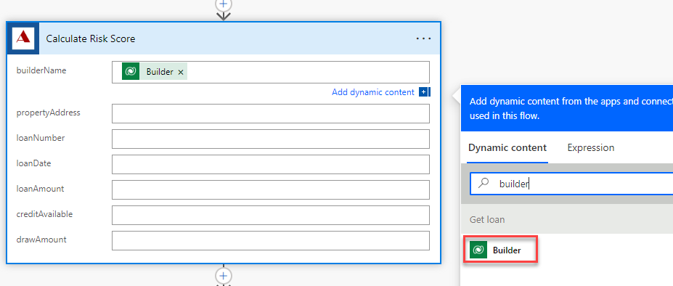](https://github.com/MicrosoftLearning/PL-500T00-Microsoft-Power-Automate-RPA-Developer/blob/master/Instructions/L04/media/image25.png)

1. Click on the **propertyAddress** field and select **Address** from the dynamic content pane.
2. Click on the **loanNumber** field and select **Loan Number** from the dynamic content pane.
3. Click on the **loanDate** field and select **Loan Date** from the dynamic content pane.
4. Click on the **loanAmount** field and select **Loan Amount** form the dynamic content pane.
5. Click on the **creditAvailable** field and select **Credit Available** from the dynamic content pane.
6. Enter **80000** for drawAmount.
7. The calculate risk score step should now look like the image below.

[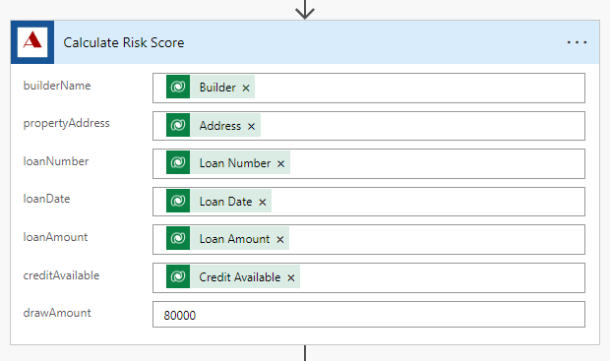](https://github.com/MicrosoftLearning/PL-500T00-Microsoft-Power-Automate-RPA-Developer/blob/master/Instructions/L04/media/image26.png)

1. Click on the **+** Insert a new step after the **Calculate Risk Score** step and select **Add an action**.

[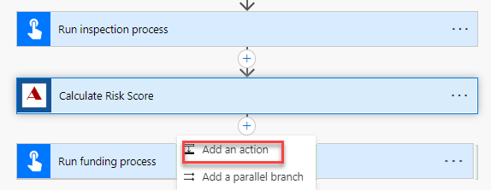](https://github.com/MicrosoftLearning/PL-500T00-Microsoft-Power-Automate-RPA-Developer/blob/master/Instructions/L04/media/image27.png)

1. Select **Update a row** Microsoft Dataverse.
2. Select **Loan Draws** for Table name, click on the **Row ID** field and select **Loan Draw** from the dynamic content pane.
3. Expand Show advanced options and Click on the **Risk Score** field and select **score** from the dynamic content pane.
4. Select **Risk Scored** for Status reason.
5. Rename the step **Update loan draw risk score**.
6. The update loan draw step should look like the image below.

[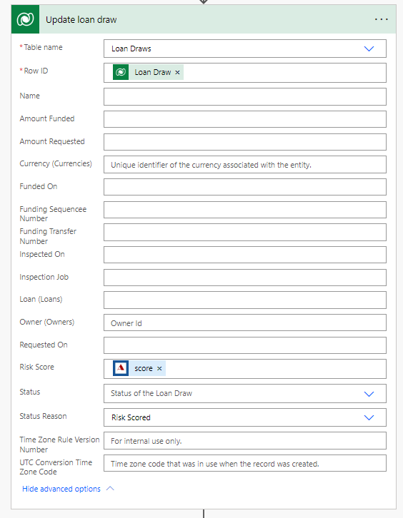](https://github.com/MicrosoftLearning/PL-500T00-Microsoft-Power-Automate-RPA-Developer/blob/master/Instructions/L04/media/image28.png)

1. Click to expand the **Run inspection process** step.
2. Remove the **PropertyAddress** value and select **Address** from the dynamic content pane.

[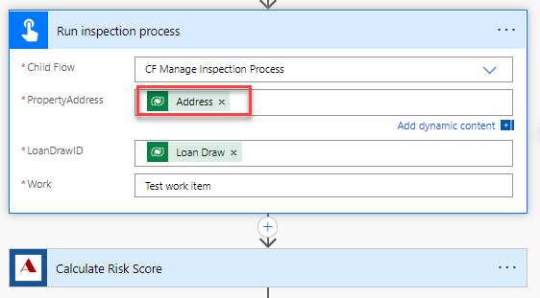](https://github.com/MicrosoftLearning/PL-500T00-Microsoft-Power-Automate-RPA-Developer/blob/master/Instructions/L04/media/image29.png)

1. Expand the **Run funding process** step.
2. Remove the **RiskScore** value and select **Score** from the dynamic content pane.

[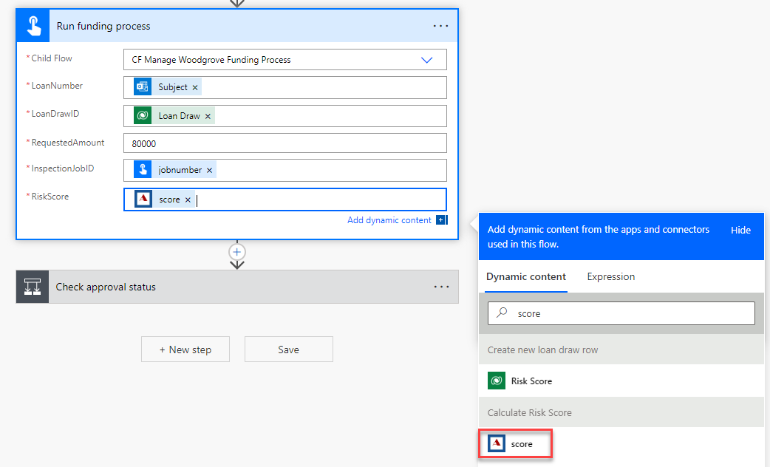](https://github.com/MicrosoftLearning/PL-500T00-Microsoft-Power-Automate-RPA-Developer/blob/master/Instructions/L04/media/image30.png)

1. Click **Save** and wait for the flow to be saved.

**Task #2: Test the flow**

1. Click **Test**.
2. Select **Manually** and click **Test**.
3. Send an email to [Funding@yourdomain.onmicrosoft.com](mailto:Funding@yourdomain.onmicrosoft.com) with the Subject line as **PS7765**.
4. The flow test should run and succeed.
5. On the **Run History** for the flow test, all steps should show a green tick. Expand the **Calculate Risk Score** step.
6. The output should look like the image below:

[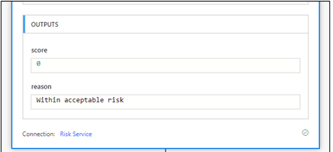](https://github.com/MicrosoftLearning/PL-500T00-Microsoft-Power-Automate-RPA-Developer/blob/master/Instructions/L04/media/image31.png)

1. You should receive an email with the subject **Draw Approved**.